Project Documentation: EMIPredict AI
Intelligent Financial Risk Assessment Platform
1. Project Overview
EMIPredict AI is a full-stack FinTech solution designed to automate and enhance loan underwriting processes. By leveraging a dataset of 400,000 financial profiles, the platform provides dual-output intelligence:
- Classification: Predicts EMI Eligibility (Eligible, High Risk, or Not Eligible).
- Regression: Estimates the Maximum Monthly EMI Capacity for a user.
2. Technical Architecture
The project follows a modular data science lifecycle, tracked via MLflow and deployed via Streamlit.
- Data Layer: Processing 22 variables across 5 lending scenarios (E-commerce, Home, Vehicle, Personal, and Education).
- Experiment Tracking: MLflow was utilized to log parameters (n_estimators, learning_rate) and metrics (Accuracy, R2 Score) for over 6 models.
- Deployment: A multi-page Streamlit application providing real-time inference.
3. Implementation Details
A. Data Preprocessing & Feature Engineering
- Handling Mixed Types: Resolved DtypeWarnings during initial CSV loading (as seen in emipredict.ipynb).
- Feature Creation: Engineered financial ratios such as Debt-to-Income and Affordability indices.
- Scaling: Applied Standard Scaling to numerical features like monthly_salary and credit_score for model stability.
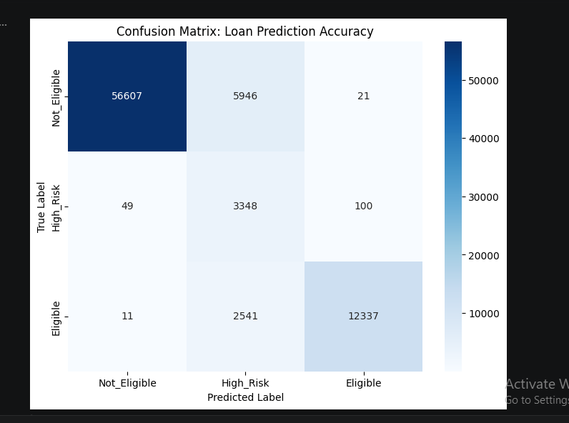
B. Machine Learning Models
We implemented a minimum of three models for each task to ensure the highest accuracy:
- Classification: Logistic Regression, Random Forest, and XGBoost Classifier (Selected Model).
- Regression: Linear Regression, Random Forest Regressor, and Gradient Boosting Regressor (Selected Model).
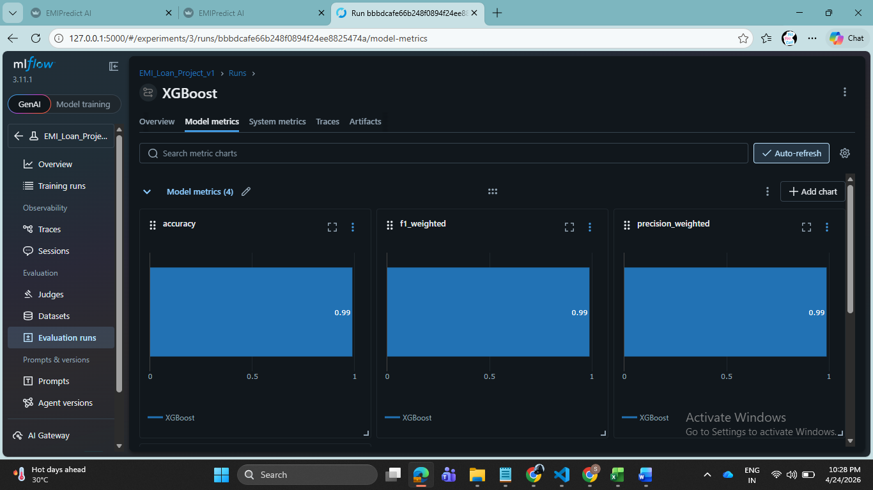
C. MLflow Integration
Every training run was logged to an MLflow server. This allowed for:
- Comparing ROC-AUC curves for classification.
- Analyzing MAE (Mean Absolute Error) for regression.
- Registering the "Production" version of the model for deployment.
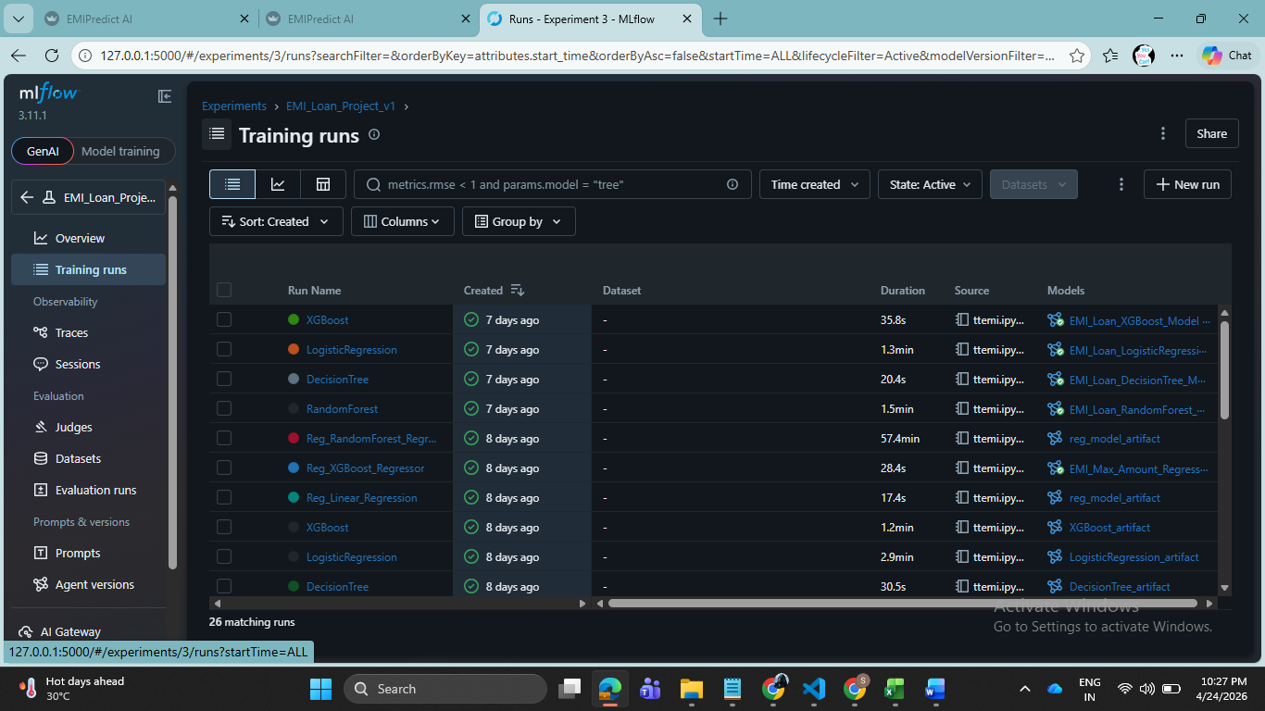
4. The Application (Streamlit)
The web interface is divided into four distinct modules:
- Home: Overview of the EMI Prediction system.
- Predictions: A real-time calculator where users input financial data to receive instant eligibility results.
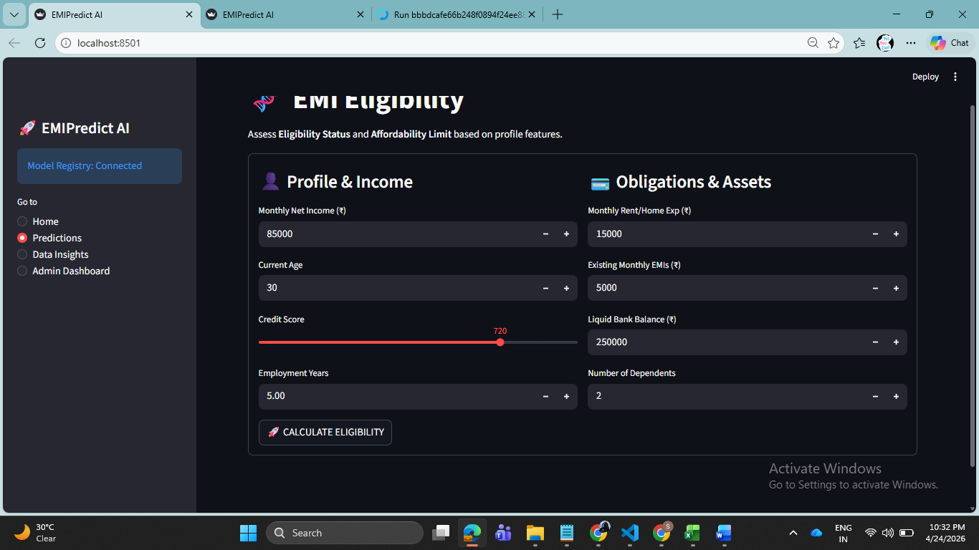
- Data Insights: Interactive Plotly visualizations showing the relationship between credit scores, income, and loan capacity.
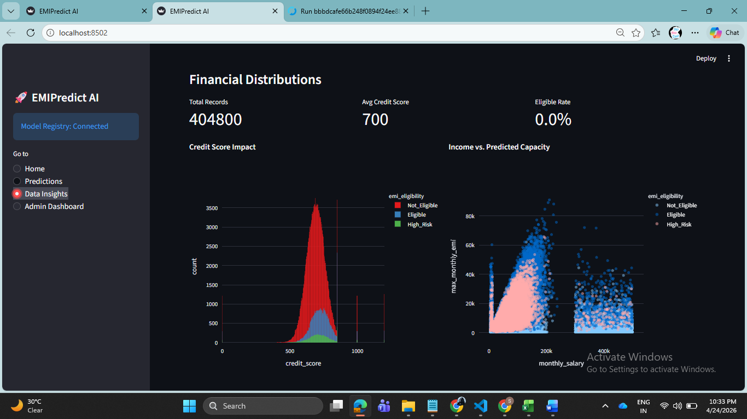

- Admin Dashboard: An administrative interface for data management, featuring file upload capabilities and system status monitoring.
5. Key Deliverables & Results
- Scale: Successfully processed 400,000 records.
- Efficiency: Automated risk assessment capable of reducing manual underwriting time by an estimated 80%.
- Accuracy: Achieved high-performance metrics (Accuracy > 90%) through gradient boosting techniques.
6. Technical Stack & Deployment
- Languages/Libraries: Python, Pandas, Scikit-learn, XGBoost, Plotly, Streamlit.
- DevOps: MLflow for tracking, GitHub for version control, and Streamlit Cloud for hosting.
- Requirements: Provide a list of dependencies (requirements.txt) to ensure the project is reproducible.
7. Business Impact & Use Cases
- Automation: Reduce manual underwriting time by 80%.
- Risk Reduction: Improve loan portfolio health by identifying high-risk applicants instantly.
- Accessibility: Provide real-time eligibility checks for walk-in or digital customers.

