Project Documentation: Intelligent Document Processing (IDP) System
An automated end-to-end document processing pipeline built using Python and Streamlit. The application ingests unstructured documents (PDFs and images), archives them securely on cloud storage, uses advanced computer vision techniques to preprocess the files, extracts structural text information via Optical Character Recognition (OCR), dynamically classifies the documents, and stores the structured metadata into a relational database.
1. System Architecture & Workflow
The architecture transitions files from raw, unorganized inputs into structured cloud assets and database records:
- Document Ingestion: The user uploads a file (.pdf, .png, .jpg, .jpeg) through a unified Streamlit interface.
- Cloud Archiving (AWS S3): The raw file is instantly uploaded and backed up into an Amazon S3 bucket, generating a persistent URL.
- Format Routing & Normalization: * If the file is a PDF, it is dynamically rasterized into a high-resolution PNG image layer in memory using PyMuPDF (fitz).
  - If it is a native image, it passes straight to the computer vision pipeline.
- Image Optimization (OpenCV): The document image is normalized through Gaussian blurring and adaptive threshold binarization to maximize OCR legibility.
- Text & Spatial Extraction (EasyOCR): The binarized matrix is evaluated by EasyOCR to retrieve structural text lines, bounding box coordinates, and model confidence scores.
- Heuristic Class Tagging: The application scans the extracted text using an RVL-CDIP alignment heuristic to classify the document into categorized classes (Invoice, Resume, ID Card, or Letter).
- Database Persistence (AWS RDS PostgreSQL): The final classification, average confidence scores, spatial bounding boxes, and raw text dumps are formatted into a JSON payload and committed to an Amazon RDS PostgreSQL cluster.

2. Technical Stack
Component | Technology | Purpose
Frontend UI | Streamlit | Provides an interactive web dashboard, file upload management, and real-time visualization of processing stages.
Document Processing | PyMuPDF (fitz) | Handles vector-to-raster conversions for PDF parsing completely in memory.
Computer Vision | OpenCV & NumPy | Executes grayscale conversions, Gaussian noise reduction, and adaptive thresholding.
AI / OCR Engine | EasyOCR | Implements Deep Learning models to execute textual and geometric extraction.
Cloud Storage | AWS S3 (boto3) | Hosts and archives raw files securely in the cloud.
Database Instance | AWS RDS PostgreSQL (psycopg2) | Stores operational metadata, validation status, and structured JSON extraction payloads.

3. Core Module & Function Definitions
convert_pdf_page_to_bytes(pdf_bytes, page_num=0)
- Purpose: Converts vector-based PDF files into uncompressed image layers to prepare them for computer vision processing.
- Process: Loads the document straight from the memory stream, targets the specified page, and applies a $2\times2$ scaling matrix to double the output DPI resolution for enhanced OCR textual sharpness.
- Returns: Standard PNG binary byte array, or None if an error occurs.
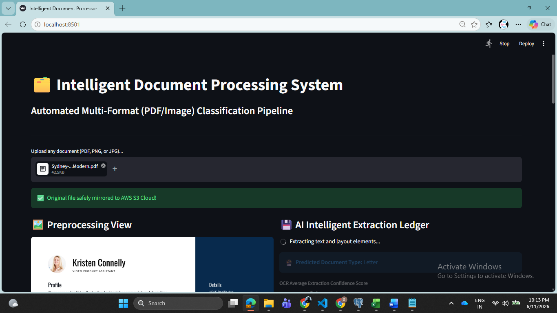
clean_image(image_bytes)
- Purpose: Cleans and normalizes variations in lighting, background noise, or scanner shadows.
- Process: Decodes file bytes into a BGR matrix, extracts a grayscale layer, applies a $3\times3$ Gaussian Blur kernel to filter high-frequency noise, and runs an Adaptive Gaussian Threshold to turn the page into a clean, black-and-white (binarized) pixel array.
- Returns: A tuple containing the original RGB image array and the binarized target matrix.
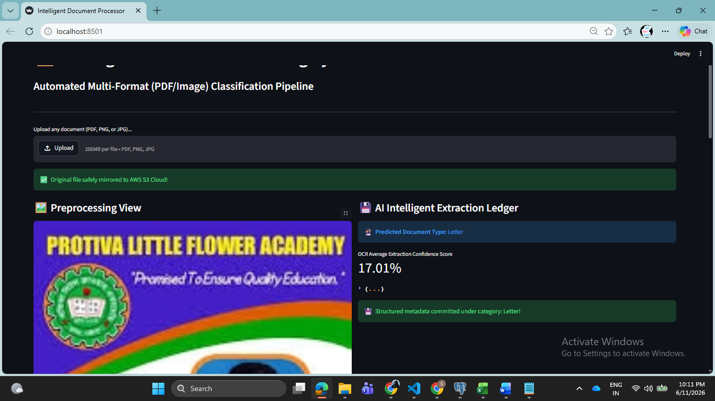
classify_document_rvl_cdip(ocr_results)
- Purpose: Heuristically determines the logical category of the document based on the vocabulary pulled by the OCR.
- Process: Flattens all captured strings into a lowercase block and scans for explicit identifier keywords corresponding to established document categories:
  - Invoice: invoice, total due, amount, tax invoice, subtotal, qty
  - Resume: resume, cv, education, experience, skills, projects, summary
  - ID Card: identity card, national id, dob, birth date, issuing authority, dl no
  - Letter: Default classification (Unclassified documents)
- Returns: A string defining the classification type.
upload_to_s3(file_bytes, filename, content_type)
- Purpose: Mirrors incoming files directly to remote cloud storage before any transformation takes place.
- Process: Initializes an authenticated S3 client using boto3 and pushes the object payload with appropriate MIME content-type settings.
- Returns: A status dictionary containing a success boolean and the final public S3 object URL link.
store_in_rds_sql(filename, s3_url, structured_payload, avg_confidence)
- Purpose: Commits processed extractions and metadata into operational tables.
- Process: Opens an explicit connection to the remote AWS RDS PostgreSQL database, sets up a write transaction, and inserts parameters into the database schema table (compliance_documents). It transforms the spatial object metadata payload directly into a native database jsonb field via psycopg2.extras.Json.
- Returns: A status dictionary confirmation.
4. Database Schema Structure
The application writes into a database table named compliance_documents. The structured payload maps into the relational fields as follows:
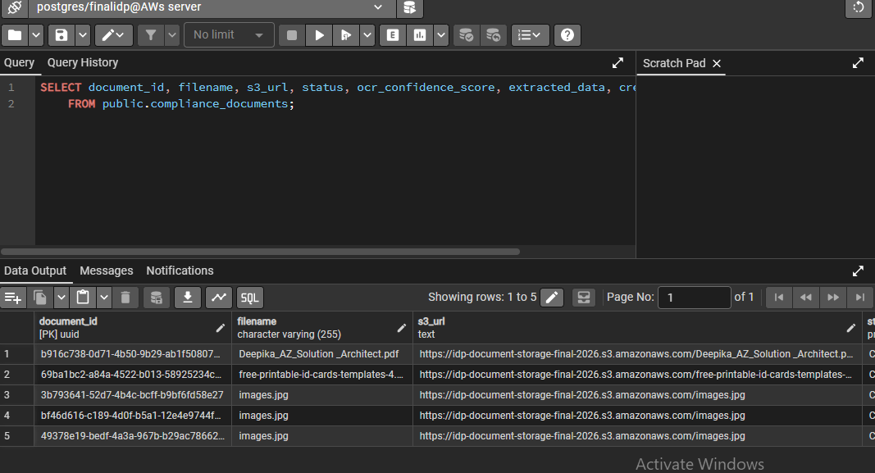

Extracted Data Payload (JSONB) Example
JSON
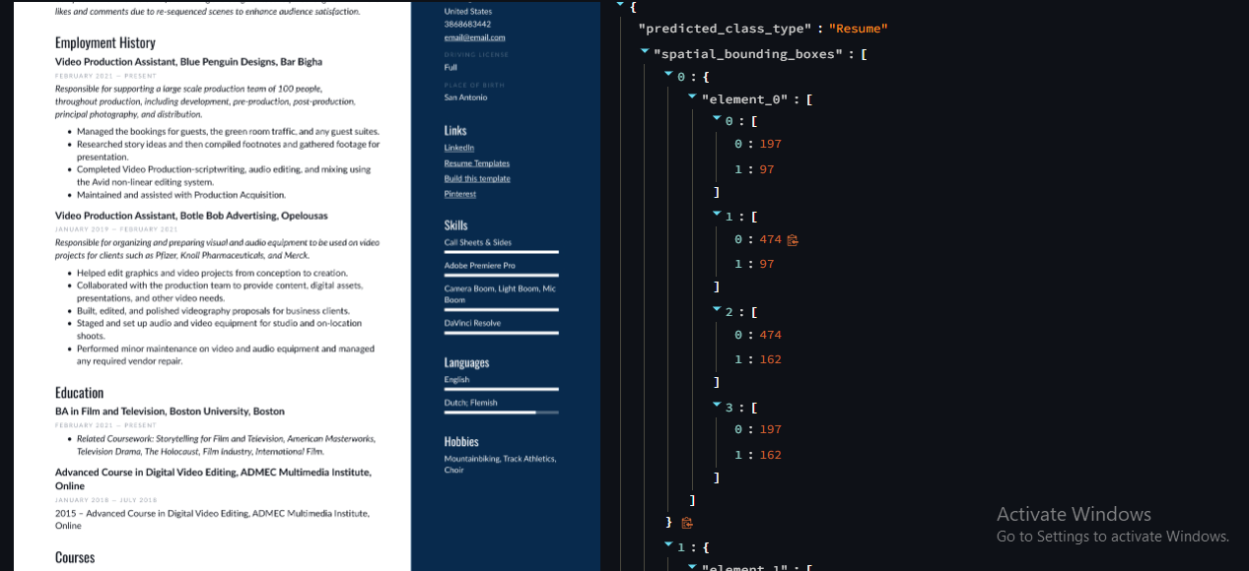
Achievements
- Successfully extracted text from multiple document formats.
- Automated identification of key entities.
- Reduced manual data entry effort.
- Generated structured output from unstructured documents.
- Created a user-friendly web interface.
- Successfully deployed the solution on cloud infrastructure.
5. Version Control & GitHub Repository Setup
- To securely host this project on GitHub without exposing sensitive cloud infrastructure credentials, the repository must be structured with explicit configuration boundaries.
── .gitignore # Prevents tracking of local secrets and cache files
── .streamlit/
── secrets.toml # Local encrypted credentials (NEVER commit to Git)
── app.py # Main Streamlit application source code
── requirements.txt # Project package dependencies
── README.md # System documentation

