🏏 Cricbuzz LiveStats
Introduction
The Cricbuzz LiveStats Platform is a high-performance sports analytics solution engineered to bridge the gap between volatile real-time match data and structured historical analysis. By architecting a seamless pipeline from the Cricbuzz RapidAPI to a PostgreSQL/MySQL backend, the system empowers users to transition from tracking live ball-by-ball updates to executing deep-dive statistical modeling within a single, unified interface.
Technical Stack
- Frontend: Multi-page interactive web application developed using Streamlit.
- Backend: Python 3.x utilizing the requests library for REST API integration and pandas for data transformation.
- Database: Persistent storage on a SQL Server (Deeps) using the cricbuzz database for historical tracking.
- API: Cricbuzz Cricket API (via RapidAPI) for fetching real-time match and player statistics.
Data Architecture & Pipeline
The project implements a sophisticated ETL (Extract, Transform, Load) process:
- Extraction: Real-time data is pulled from RapidAPI.
- Staging: The data is temporarily held in a Python DataFrame named q2024. This "Live Staging" allows the app to display data instantly without waiting for database commits.
- Loading: The staged data is then persisted into the cricbuzz SQL database to facilitate long-term analytical queries.
Live Match Dashboard (Real-time Integration)
The Live Dashboard serves as the dynamic entry point of the application, focusing on high-velocity data ingestion.
- API-Driven Agility: It consumes live JSON feeds from the Cricbuzz RapidAPI using Python’s requests library.
- The q2024 Staging Logic: To ensure the UI remains lightning-fast, data is stored in a localized memory variable named q2024. This acts as a Data Buffer, allowing the Streamlit frontend to refresh scorecards and match milestones instantly without waiting for disk-heavy database commits.
- User Experience: Provides real-time ball-by-ball context and live match status, essential for sports media and live commentary use cases.
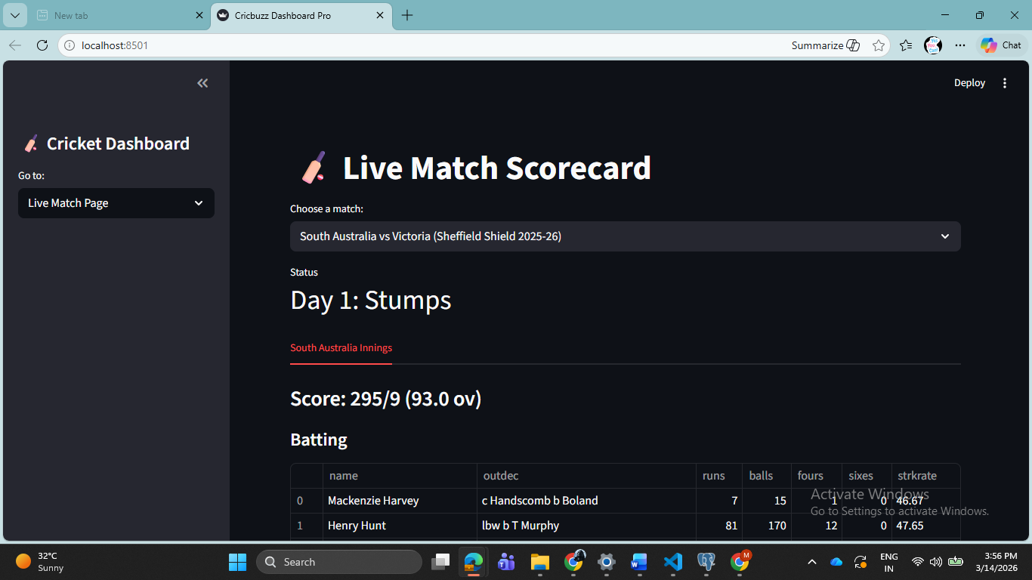
Player Statistics Hub (Multi-Format Career Mapping)
This module transforms raw API data into structured, format-specific career insights.
- Comprehensive Profiling: It aggregates performance metrics across Test, ODI, and T20I formats.
- Interactive Exploration: Built with Streamlit’s st.selectbox and st.dataframe components, users can filter by batting style, bowling role, or specific format.
- Analytics Bridge: Beyond just displaying numbers, this hub calculates live KPIs (Key Performance Indicators) such as Strike Rates and Batting Averages on the fly, providing a 360-degree view of player value.
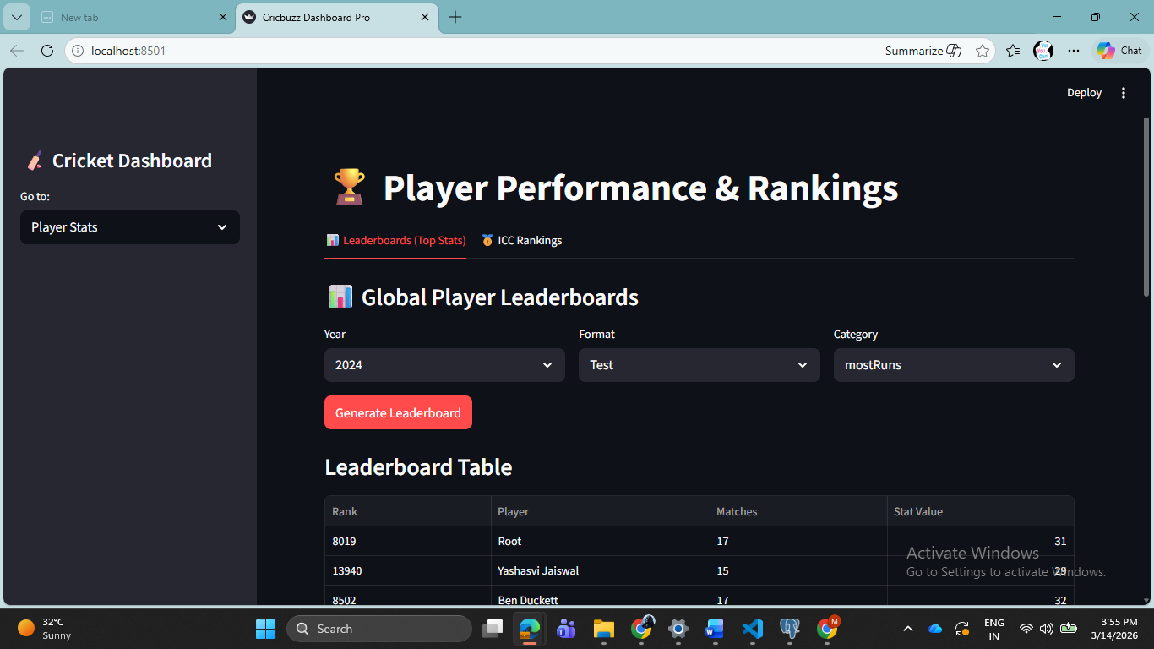
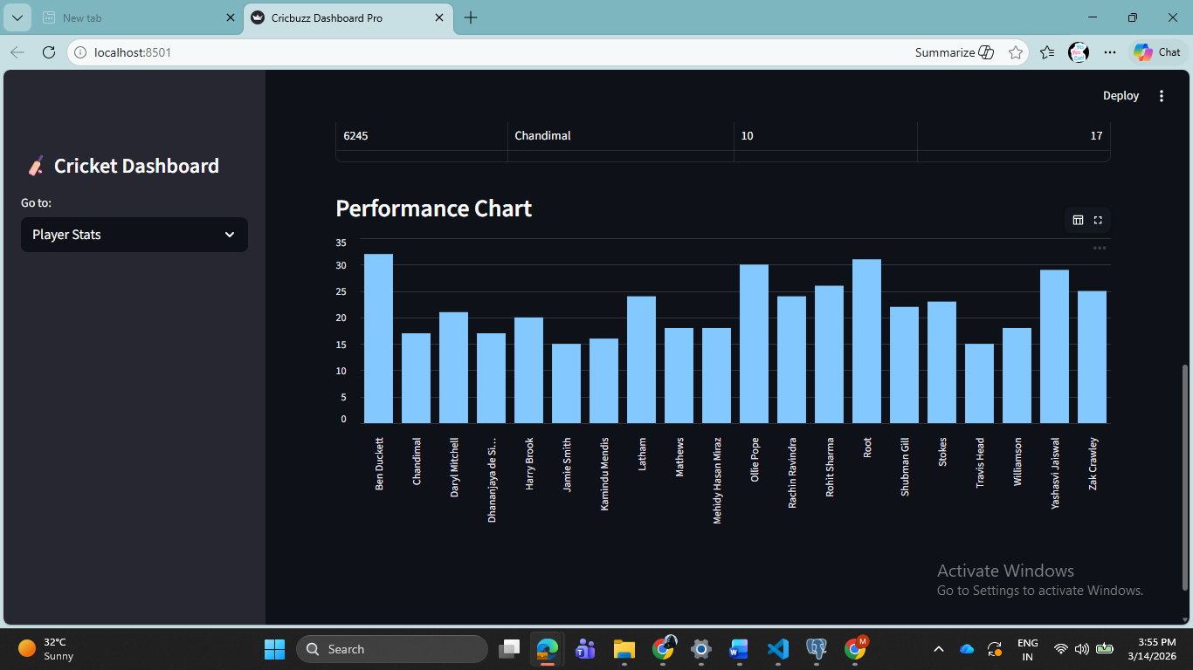

SQL Analytics Engine (Advanced Analytical Processing)
This is the "Brain" of the project, where historical data is turned into strategic intelligence.
- Interactive Query Selection: A centralized dropdown interface allows users to trigger any of the 25 specialized SQL queries.
- Professional SQL Techniques: * CTEs (Common Table Expressions): Used to break down complex logic into readable, modular steps (e.g., calculating player momentum).
  - Window Functions (RANK, STDDEV): Implemented to create "Hall of Fame" leaderboards and consistency ratings. For example, using Standard Deviation to identify the most reliable batsmen since 2022.
- Seamless Frontend-to-Backend: When a question is selected, the SQLAlchemy engine executes the script on the Deeps server and returns the results directly to the same screen, eliminating the need for page reloads.
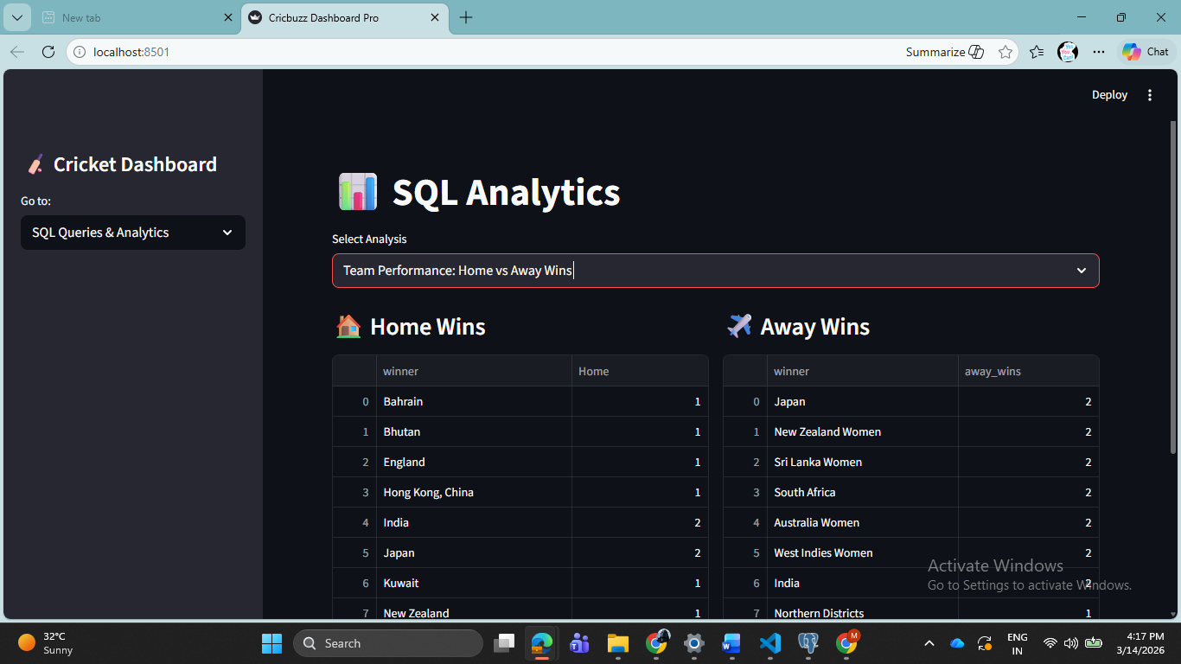
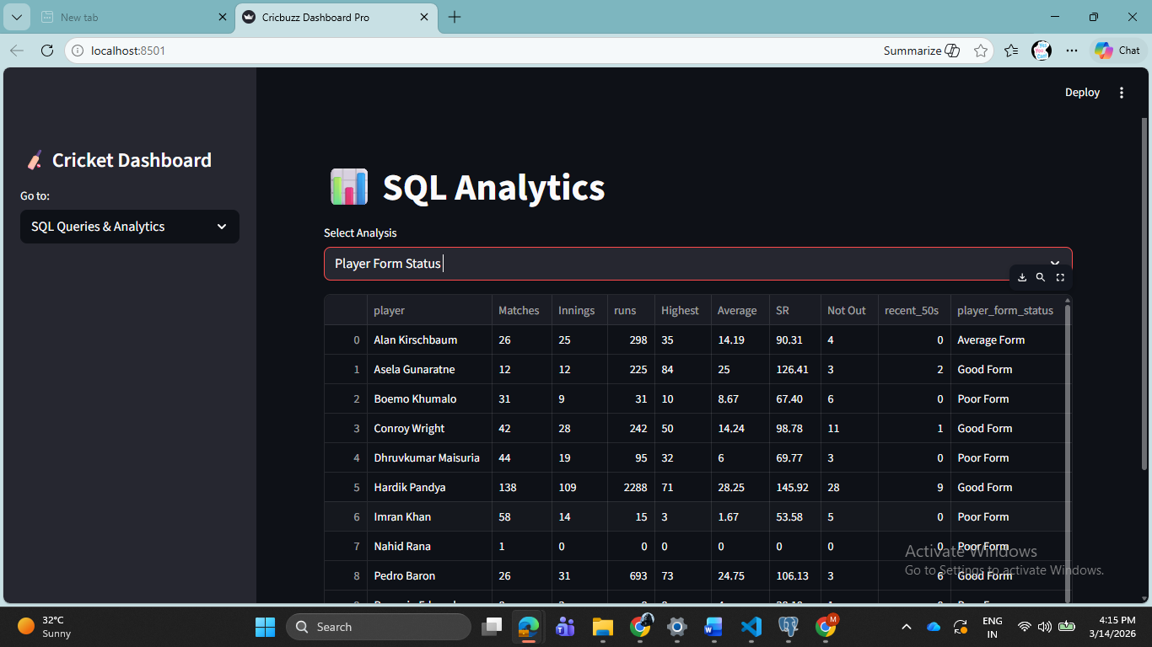
SQL Analytics – Level 1: Foundational Insights
- Q1: National Representation: Filters all players from India with their specific roles and styles. (public.q1_players_india)
- Q2: Recent Match Tracking: Real-time analysis of matches played recently, sorted by date. (public.q2_recent_matches)
- Q3: ODI Hall of Fame: Ranks the top 10 run-scorers in ODI history. (public.top10_odi)
- Q4: Venue Infrastructure: Analyzes global stadiums with seating capacities > 25,000. (q4_venu)
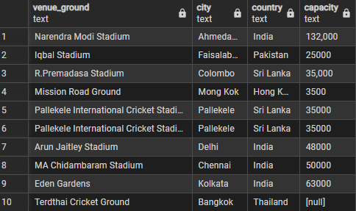
- Q5 & Q6: Team Wins & Roles: Aggregates total match wins per team and counts players by playing role. (public.q5_most_wins, public.q6_player_roles)
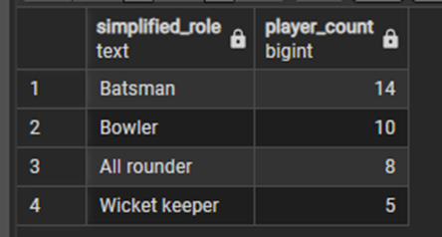
- Q7 & Q8: Formats & Series: Tracks highest scores per format and scans the 2024 cricket calendar. (q8_match_2024)
Slide 9: SQL Analytics – Level 2: Performance Metrics
- Q9: Elite All-Rounders: Identifies players with > 1000 runs AND > 50 wickets. (public.q9_allround_rank)
- Q10: Match History: Deep dive into the last 20 completed matches with victory margins. (public.q10_last20matches)
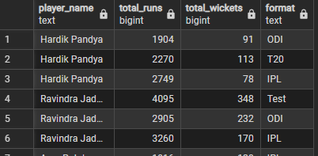
- Q11: Multi-Format Comparison: Compares batting performance across Tests, ODIs, and T20Is. (play_diff_match)
- Q12: Home vs. Away Advantage: Statistical study of win rates based on venue country. (q12_count_of_wins)
- Q14: Venue-Specific Bowling: Calculates economy rates and wickets for bowlers at specific grounds. (public.q14_bowler_perf)
- Q17: The Toss Factor: Investigates if winning the toss correlates with winning the match. (q17_toss)
- Q19: Consistency Analysis: Uses Standard Deviation to find the most reliable scorers since 2022. (q19_stddevi_2022)
SQL Analytics – Level 3: Advanced Modeling
- Q21: Weighted Performance Ranking: A custom algorithm combining batting, bowling, and fielding into one single performance score. (q21_players_ranking)
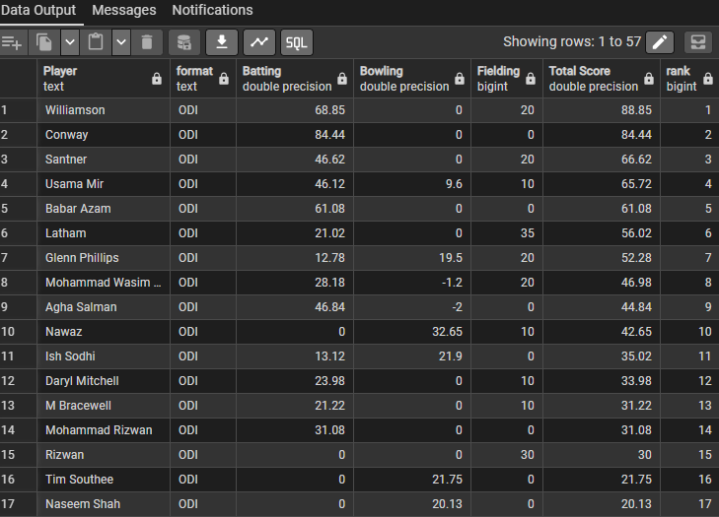
- Q22: Head-to-Head Predictor: Analyzes historical margins and win percentages between specific team pairs. (q22_final)
- Q23: Form Momentum: Uses a moving average of the last 10 innings to categorize players as "Excellent Form" or "Poor Form." (public.q23)
- Q24: Partnership Synergy (The Core Study): Analyzes the Success Rate of batting pairs based on 50+ stands and average runs. (public.q24_batting_partner)
- Q25: Career Trajectory: Quarterly time-series analysis to identify if a player is in an "Ascending," "Stable," or "Declining" phase. (q25_performance_trend)
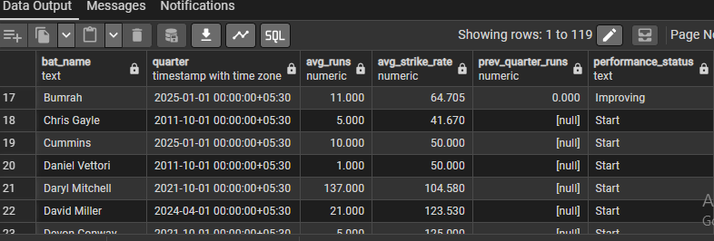

CRUD Operations (Administrative Control & Data Integrity)
This module represents the "Database Administrator" view of the platform.
- Full Lifecycle Management: * Create: Manually add new players or matches not yet in the API.
  - Read: Audit existing records in the cricbuzz database.
  - Update: Edit statistics or correct player roles.
  - Delete: Remove redundant or corrupted data entries.
- Direct Server Communication: Every action taken in this UI performs a direct DML (Data Manipulation Language) operation on the Deeps server.
- Security & Integrity: This ensures that the data used for the 25 SQL Analytics questions remains clean, accurate, and up-to-date, providing a fail-safe for API limitations.
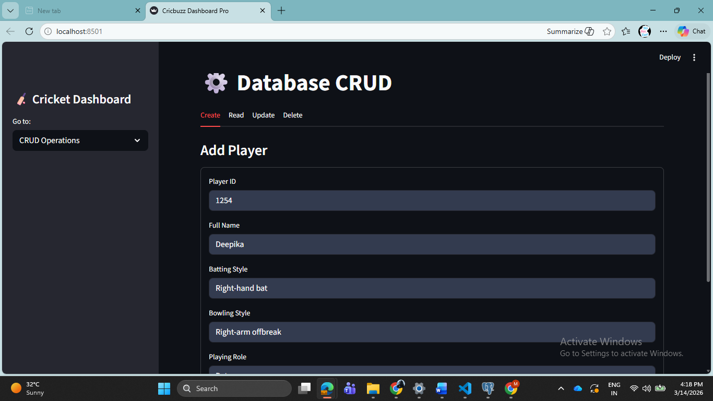
Conclusion
The Cricbuzz LiveStats project demonstrates a robust full-stack solution for sports data. By combining the speed of live API feeds with the depth of a structured SQL database, the platform provides actionable insights for sports media, fantasy platforms, and performance analysts.

