“Student Attendance Monitoring System in College of Social Sciences and Humanities at MSU-Main Campus"

CCC181 – TtUu1 Application Development and Emerging Technology
Presented to the Faculty of College of Information and Computing Sciences
In Partial Fulfillment of the Requirements for the Degree
Bachelor of Science in Information Technology

By

Abdulcader, Naimah T.
Dimaporo, Norhaimah Y.
Salubre, Monique Jean
Macondara, Enjirah M.
Pangandag, Yasmerah M.

Anuar D. Rakim Jr.
Professor

December 17, 2025
Introduction and Background

Some Professors of MSU CSSH is using a ttraditional paper-based attendance and it is time consuming to manage, vulnerable to errors or loss, and provide limited real-time visibility for instructors, administrators, and students. This project entitled “Student Attendance Monitoring System in College of Social Sciences and Humanities at MSU-Main Campus” is a computerized solution designed to streamline and strengthen the process of recording, tracking, and reporting student attendance across courses and programs. This project aims to replace or augment these manual methods with an efficient, reliable, and auditable digital system that supports daily class-taking, generates attendance reports, flags absenteeism trends, and integrates with existing academic records where appropriate. This system improves operational efficiency by reducing the time teachers spend on administrative tasks, increases accuracy of attendance data, and enables faster decision-making by department heads and academic offices. College of Social Sciences and Humanities (CSSH) at MSU-Main Campus serves a diverse student population and conducts a large number of courses each semester across multiple departments. Attendance management at CSSH has relied heavily on paper sheets or disparate digital spreadsheets, which leads to transcription errors, illegible records, and inconsistent formats across classes and instructors. While Students and authorized staff often have no direct, up-to-date view of attendance status, making it hard to address problems proactively.

Statement of the problem

The current student attendance monitoring process at CSSH MSU-Main faces several challenges that affect accuracy, efficiency, and security. Attendance is often recorded manually through paper-based logs or handwritten sheets, which leads to issues such as lost records, inaccurate data, and difficulty verifying student presence. These problems make it hard for instructors or administrators to track attendance trends and identify students with frequent absences. Because the college handles hundreds of students daily, the manual process becomes inefficient and prone to human error. There is no centralized system that stores attendance data, making it difficult for administrators to access accurate information when needed. Therefore, CSSH needs a more reliable, organized, and technology-based attendance monitoring system to improve accuracy, save time, and support better academic decision-making.

Objectives
The general objective of this project is to develop a simple, accurate, and reliable Student Attendance Monitoring System specifically for the College of Social Sciences and Humanities (CSSH) at MSU-Main Campus. This system aims to significantly improve attendance tracking efficiency and reduce errors commonly associated with manual recording methods. Furthermore, the students enable to record their own attendance using the System promptly and without hassle, ensuring a seamless and modern process for present registration.

Specifically, this project aims to:
1. To create a simple digital system that records and stores student attendance digitally.
2. To help professor check and monitor attendance faster and more easily.
3. To reduce mistakes caused by manual writing, lost papers, and incorrect attendance inputs.
4. To allow administrators or professor to view attendance.
5. To improve accuracy and ensure students are properly identified during attendance checking.

Scope and Limitation
The scope of this study focuses only on the College of Social Sciences and Humanities (CSSH) at MSU-Main Campus, Marawi. The system will record and monitor student attendance in selected department in CSSH and store the data in a central database. It will help teachers check attendance faster and avoid errors from manual recording. The study is limited only to CSSH students, teachers, and classrooms. It does not include other colleges or university-wide activities. The system also depends on working localhost, which may affect attendance tracking if problems occur.

System Requirements

A. Functional Requirements
- Student Attendance Entry: Enable students to personally register their attendance for class without needing the teacher on the time schedule.
- Teacher Control and check the attendance of student: Give teachers the ability to correct the attendance list for their classes and entry the attendance of student.
- Student Information Hub: Keep a master list of student data (like ID, name, course, and level).
- Course Selection: Allow teachers to identify the correct course or subject before managing attendance.
- Instant Record Keeping: Make sure all attendance changes are immediately saved and updated in the main record book.

B. Non-functional Requirements
- Performance - The system should load pages and save attendance within 2–3 seconds.
- Usability - The interface should be simple and easy to understand for teachers with little technical knowledge.
- Security - User accounts must be protected, and attendance data must not be accessible to unauthorized users.
- Reliability - The system should record attendance accurately and store data without loss.
- Availability - The system should be accessible during class hours without frequent downtime.
- Scalability - The system should be able to handle multiple CSSH classes and teachers using it at the same time.
- Maintainability - The system should be easy to update or fix when new features or improvements are needed.

Methodology

The development of the Student Attendance Monitoring System followed a structured methodology to ensure its efficiency, reliability, and successful deployment at the College of Social Sciences and Humanities (CSSH).

System Development Life Cycle

This project utilizes the Agile Model for its System Development Life Cycle (SDLC). This iterative and flexible approach allows for continuous feedback and adaptation, ensuring the system quickly meets the user requirements of CSSH.

SDLC Phase (Agile Adaptation) | Description
Planning & Analysis (Iteration 1) | Identifying the attendance problems in CSSH and studying current recording methods. Defines the initial high-priority features (like Student Attendance Entry and teacher Control ).
Design & Development (Sprints) | Iterative cycles of: Design (creating layout and database structure), Development (coding the system using PHP, MySQL, and other tools), and immediate Testing.
Testing (Alpha & Beta) | The system is tested rigorously in stages: Alpha Testing (internal testing by developers to find bugs ) and Beta Testing (evaluation by actual CSSH Teachers to confirm usability and efficiency ).
Implementation | Implementation (Deploying the fully tested system to the local server CSSH production environment ).
Table 1.1 System Dvelopment Life Ciycle

Development Tools and Technologies
The system is developed using a combination of standard web technologies and a reliable database management system.

Category | Tool / Technology
Database | MySQL
Backend Processing | PHP (like localhost/ tomcat)
Frontend/Interface | HTML, CSS
local Environment | Local server
Table 1.2 Devoplment tools and Technologies

Design
The design focuses on supporting the key functional requirements within the local CSSH environment.
- Core Modules: The design must accommodate the primary functions of the system, including Student Attendance Entry (self-registration) , Teacher Control , Student Information , and Course Selection.
- Data Structure: The database design must ensure that attendance changes are immediately saved and updated in the main record book.
- Deployment: The design is focused on local deployment, requiring the necessary software components to be installed and configured on the main CSSH local server.

System Design
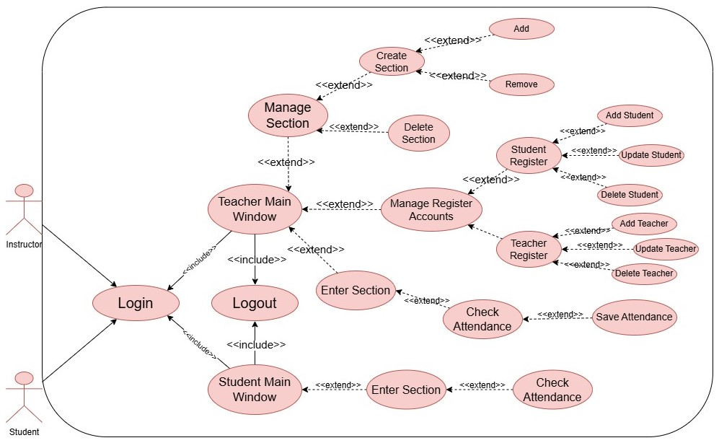
Use Case

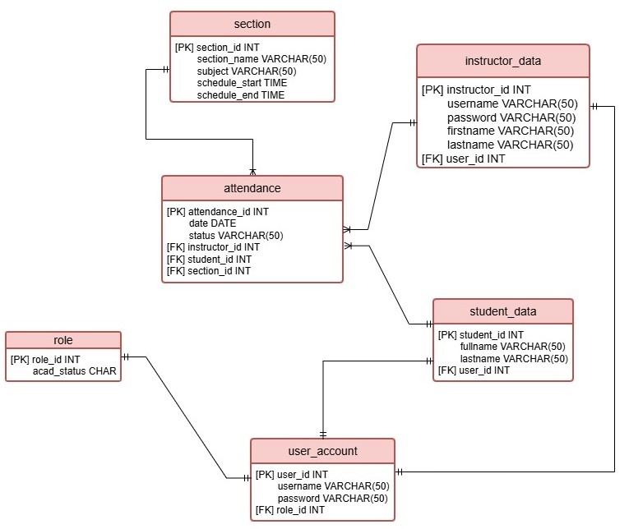
Entity Relationship Diagram
Data Flow Diagram
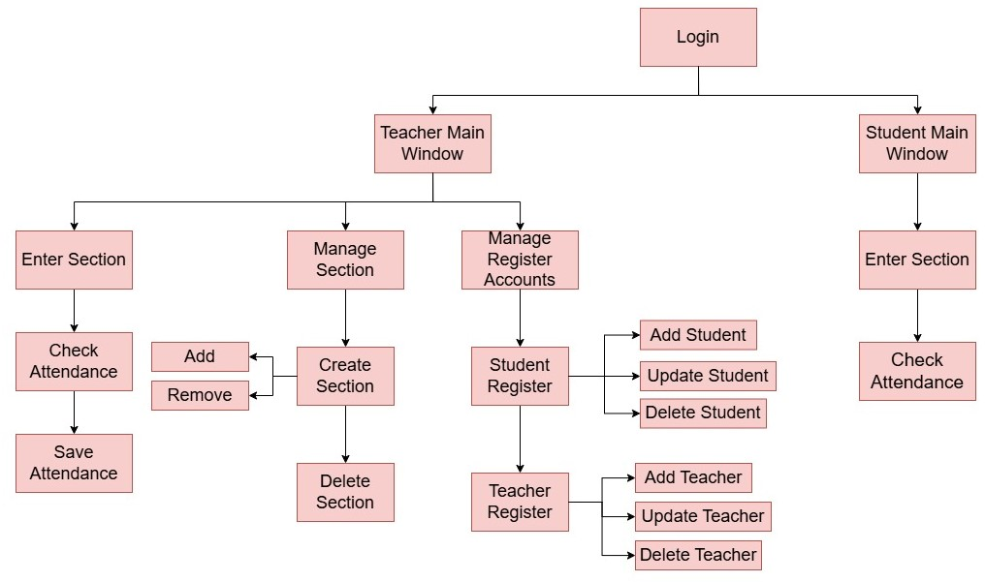

Application Test

Test Plan
Following the completion of the system's development, a comprehensive testing phase was initiated, aligning with the Testing stage of the System Development Life Cycle (SDLC) using the Agile Model. The testing ensures the Student Attendance Monitoring System for the College of Social Sciences and Humanities (CSSH) at MSU-Main Campus meets all specified functional and non-functional requirements. The whole system was tested based on its functionality, usability, user-friendly interface, and the overall behavior of the system.

Testing Procedures and Results
The testing phase was strictly divided into two procedures: Alpha Testing and Beta Testing. The core functionalities tested included Login/Authentication, Student Management, and Attendance Recording.

Alpha Testing
During Alpha Testing, the developers internally tested the locally manual test, simulating various scenarios and user interactions to identify issues in its functionality, usability concerns, and system bugs. These system issues and bugs discovered during testing were addressed and fixed as a top priority by the developer, ensuring the system's quality before proceeding to Beta Testing.

Results: Alpha Testing verified that core functions, such as teachers marking student attendance digitally, student can mark their own selves as a present or absent and data being automatically saved to the database in real-time, were working as intended. The system successfully passed tests for Login and User Authentication. The system also met the Performance non-functional requirement by demonstrating page loading and attendance saving within the required 2–3 seconds.

Beta Testing
The Beta Testing phase involved deploying a locally of the system to the client's environment at the College of Social Sciences and Humanities (CSSH). This session focused on assessing the Usability and User Experience of the platform through evaluation by actual end-users, specifically CSSH Teachers. The system is executed to determine the efficiency and accuracy of the platform. This test, based on the user experiences, is it well-organized content of overall performance of the behavior of the system. The developers visited the establishment and presented how the locally system worked.

Results: The system was confirmed to be reliable, simple, and efficient for daily attendance monitoring. Teachers successfully performed all day-to-day tasks, confirming its intended functionality.

Implementation and Deployment
The Implementation stage of the System Development Life Cycle (SDLC) is where the fully tested and functional Student Attendance Monitoring System transitions from the development environment to the local production environment at the College of Social Sciences and Humanities (CSSH) at MSU-Main Campus. Since the system is designed as a local web application, the deployment process is focused on setting up the necessary software stack on the college's designated local server or an isolated institutional network.

Local Deployment Plan
The local deployment process involves several key, non-online steps to ensure the system is functional and secure within the CSSH network:

- Preparation and Setup: The required software components for backend processing, MySQL for the database, and a local web server to host the application must be installed and configured on the main CSSH server. This ensures the environment is ready for the application code.

- Code Transfer and Configuration: The final, stable code base (including HTML, CSS, and servlet for the interface.) is transferred from the localhost/tomcat server to the CSSH production server. All configuration files are updated to point to the local MySQL database instance on the CSSH server.

- Database Migration: The MySQL database, which contains the tables for student records, teacher profiles, subjects, and attendance records, is created and populated on the local CSSH server. Initial data, such as faculty and student lists, is imported to ensure the system can function from day one.

- Final Validation: A final check is performed by the development team and the CSSH Professor to ensure all modules (Login, Attendance Recording) are working correctly on the live server. User accounts are created and activated for the faculty.

Conclusion and Recommendations

Conclusion
The Student Attendance Monitoring System developed for the College of Social Sciences and Humanities (CSSH) at MSU-Main Campus successfully addresses the challenges of manual paper attendance recording. The system improves accuracy, efficiency, and reliability by providing a centralized digital platform for recording and monitoring student attendance. Based on testing results, the system met both functional and non-functional requirements, allowing students and teachers to manage attendance easily and securely. Overall, the project demonstrates that a digital attendance system can significantly reduce errors, save time, and support better academic decision making within CSSH.

Recommendations
It is recommended that the Student Attendance Monitoring System be continuously maintained and enhanced to ensure long-term usability and reliability. Future improvements may include expanding the system to other colleges within the university, adding report analytics for better attendance monitoring, and improving system security features. Providing proper training for teachers and administrators is also recommended to maximize the system’s effectiveness. Additionally, upgrading the system from a local environment to a more stable network setup may further improve accessibility and performance.

Appendices

