Student Dropout Prediction
Using Machine Learning

Group Project Final Report
IT5022 – Fundamentals of Machine Learning



No. | Student Name | Registration Number
1 | Dissanayake D.D.S | MS26928456
2 | Kiriella K.G.A.K | MS26928524

Table of Contents
1. Introduction 3
1.1 Background 3
1.2 Problem Statement 3
1.3 Aim 3
1.4 Project Objectives 4
1.5 Scope of the Project 4
2. Dataset Description 4
2.1 Input Attributes 5
2.2 Target Variable 5
2.3 Relevance of the Dataset to the Project 5
3. Data Preprocessing 5
3.1 Identification of Categorical Variables 6
3.2 One-Hot Encoding 6
3.3 Feature Scaling 7
3.4 Maintaining Feature Consistency 7
3.5 Saving Preprocessing Information 7
3.6 Reusable Preprocessing 7
3.7 Final Preprocessed Dataset 8
4. Machine Learning Methodology 8
4.1 Supervised Classification Approach 8
4.2 Training and Testing Strategy 8
4.3 Logistic Regression 9
4.4 Random Forest 9
4.5 Identification of Random Forest Overfitting 9
4.6 Tuned Random Forest 10
4.7 Justification for Selected Algorithms 10
5. Model Evaluation 10
5.1 Training and Testing Performance 11
5.2 Evaluation Strategy 11
6. Results and Model Comparison 11
7. Random Forest Optimization 12
8. Final Model Evaluation 12
8.1 confusion Matrix 12
8.2 Manual Prediction Test 13
9. Critical Analysis and Discussion 13
9.1 Comparison of the Model Performance 13
9.2 Overfitting in the Original Random Forest 13
9.3 Effect of Random Forest Optimization 14
9.4 Difficulty in Predicting the Enrolled Class 14
9.5 Importance of Dropout Prediction Errors 14
9.6 Consideration of Logistic Regression as a Baseline Option 15
10. Limitations and Future Work 15
10.1 Dataset Generalisability 15
10.2 Difficulty Predicting the Enrolled Class 16
10.3 Limited Model Selection 16
10.4 Hyper parameter Optimization 16
10.5 Privacy and Ethical Considerations 16
10.6 Model Monitoring and Updating 17
11. Conclusion 17
References 18

1. Introduction

1.1 Background
Student dropout constitutes an important concern of higher education due to the negative consequences of this outcome to both students and institutions. Students who discontinue their studies prior to graduation risk underperformance in their subsequent professional and academic endeavors. To institutions, such a phenomenon may undermine academic planning, resource allocation and overall student performance. For this reason, recognition of students who are likely to dropout at the early stages of their studies can be beneficial in terms of enabling timely intervention.
During the course of admission and the educational process itself, institutions gather and store a variety of information pertaining to each student. This data can include demographical, academic, entrance-related, financial and other characteristics. For those records which concern already graduated students, the outcome of their academic endeavor can also be noted. Once such a dataset is sufficiently extensive, machine learning techniques can be applied to identify characteristic patterns of student behavior. By examining the interdependencies between multiple attributes at once, such an approach can uncover relationships which may not be evident at first.
With this idea in mind, the problem of academic outcome prediction was framed as a supervised multiclass classification task. Specifically, the focus was made on distinguishing between three possible outcomes: Dropout, Enrolled and Graduate. By leveraging the records of students who were already graduated, a predictive model was trained and tested on its ability to distinguish between the three possible outcomes. Notably, the focus was made not only on the accuracy of prediction but also on the degree to which a trained model can generalize its performance to the records which it has not processed yet.
Within the scope of this project, two classification algorithms were evaluated using the processed dataset. The first algorithm was Logistic Regression, which was used as a simple baseline. The second one was Random Forest, which is capable of learning more complex patterns in the input data. At the initial stage of experimentation, the test accuracy of the Random Forest was found to greatly exceed its training accuracy, which signifies a strong degree of overfitting. As a result, a separate optimization procedure was conducted to improve the generalization performance of the classifier.
Finally, alongside the solution of academic outcome prediction, the project also addressed the production deployment of the model. Within this scope, the preprocessing stage of model deployment was simulated using the saved version of the trained model and additional preprocessing steps. The model was linked to a simple prediction application which enables the user to input the relevant features in the same format as they were used for training. Following the preprocessing stage, the model outputs the predicted outcome of a given record.

1.2 Problem Statement
The question of student classification is complicated by the fact that their future success depends on many factors. Therefore, a student who eventually drops out cannot be reliably identified at the time of their enrollment based on a single characteristic, for example, the entrance exam result or age. Such a student may have several different characteristics, and these factors are correlated with their academic performance after enrollment.
The project will address this issue by constructing a machine learning model that uses historical student data to classify future students into three groups: Dropout, Enrolled, and Graduate. The project will also evaluate if building a more sophisticated ensemble model is beneficial in terms of prediction accuracy and if model optimization can make it generalize better without sacrificing much in terms of performance.

1.3 Aim
The main objective of this project is to design, implement and evaluate a machine-learning system capable of predicting student academic outcomes based on historical student data.
To accomplish this objective, the project prepares the original dataset for machine learning, trains Logistic Regression and Random Forest classification models, assesses their applicability using relevant classification, conducts an in depth investigation of overfitting in the Random Forest model, optimizes the model to enhance its generic applicability and integrates the selected model into a simple student outcome prediction application.

1.4 Project Objectives
The goals of the project are the following:
- Explore and prepare the students real world data containing demographic, admission, financial, academic, and economic information.
- Encode categorical and continuous variables to machine learning models-ready format.
- Build logistic regression and random forest classification models for student outcome prediction.
- Test classification models using test accuracy, precision, recall, F1-score, and confusion matrix.
- Compare the model performance across training and testing sets to evaluate overfitting.
- Tune the random forest classification to improve its performance and analyze if it generalizes better than others.
- Choose the best performing model based on the evaluation to make predictions.
- Package a simple model prediction application with the final model and preprocessed data.

1.5 Scope of the Project
The scope of this project is limited to predicting the three outcomes represented in the selected data set: Dropout, Enrolled, and Graduate. The predictions are based on the information contained in the available data set and therefore do not account for every possible factor influencing a student's academic progression.
The project is focused on conventional machine learning techniques, not deep learning approaches, as per the assignment's requirements. Therefore, the resulting system should be seen as a demonstration of how historical educational data can aid predictive analysis, not a tool for making automatic academic decisions about individual students.

2. Dataset Description
The data set provided for this project consists of information on higher education students and the outcome of their studies. The data set was chosen due to its nature of providing an appropriate real world example of multiclass classification, as it includes various attributes related to students’ backgrounds, admissions, economic factors, and academic performance, which provide a solid ground for prediction.
The data set includes 4,424 instances and 37 columns. Out of 37 columns, 36 attributes were used for prediction, while the other column was the target variable. Each instance represented a student record.

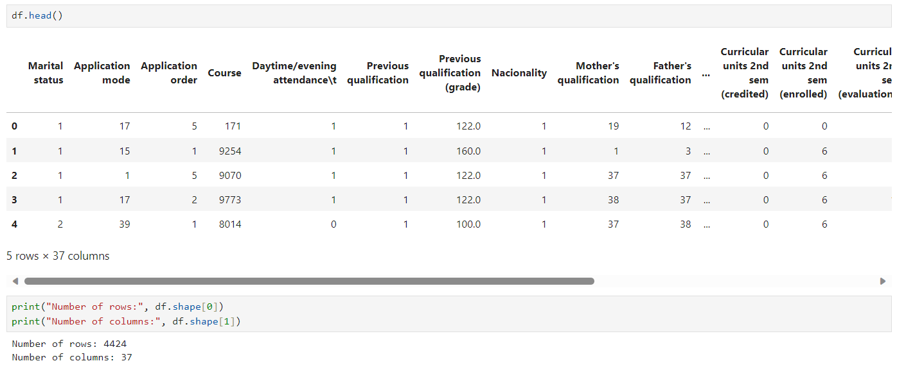

The target variable consisted of three classes:
• Dropout – the student did not continue to successful completion
• Enrolled – the student remained enrolled;
• Graduate – the student graduated.
Target variable classes included more than two classes, meaning that the problem was classified as multi-class.
The link to the data set can be found below:
Source: [1]

2.1 Input Attributes
The dataset contains a relatively wide range of attributes describing students at different stages of their studies. For clarity, the input variables were considered in several groups rather than discussing all 36 variables as one list.

Category | Example attributes
Personal / background | Marital status, nationality, gender, age at enrolment, international status
Admission | Application mode, application order, course, previous qualification, admission grade
Financial / support | Debtor, tuition fees up to date, scholarship holder, displaced, special needs
Academic – Semester 1 | Credited, enrolled, evaluations, approved, grade, without evaluations
Academic – Semester 2 | Credited, enrolled, evaluations, approved, grade, without evaluations
Economic | Unemployment rate, inflation rate, GDP

Table 1. Main categories of input attributes used for student outcome prediction.

2.2 Target Variable
The Target column was selected as the dependent variable for model training evaluation. It features the three labels Dropout, Enrolled and Graduate.
The remaining 36 columns formed the original predictor matrix. During preprocessing, some of these attributes required special treatment due the fact that numerical codes had been used to represent categories. For instance, an integer value that indicates a course or application mode should not be automatically interpreted as a continuous numerical measurement. This issue was resolved during preprocessing by identifying categorical variables and encoding them appropriately.

2.3 Relevance of the Dataset to the Project
This dataset was suitable for the project for a number of reasons. Firstly, its target variable directly corresponds to the problem being investigated: predicting student academic outcomes. Secondly, the 4,424 available records provide sufficient observations to train and test conventional machine-learning models within the scope of the project.
Another advantage is the variety of available predictors. Student outcomes are unlikely to be determined by a single factor, and the dataset features information on admission, background, financial circumstances, academic progress and economic conditions. This allows for an appropriated comparison between a relatively simple linear classifier and a more flexible ensemble-based classifier.
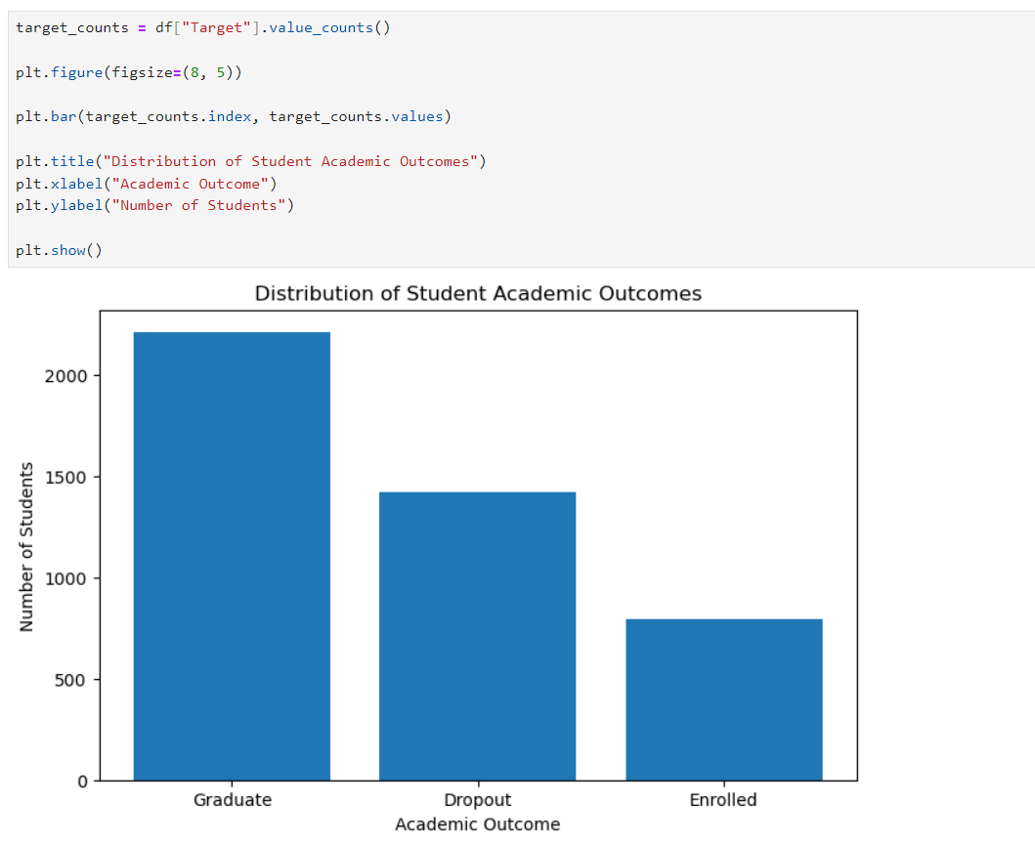
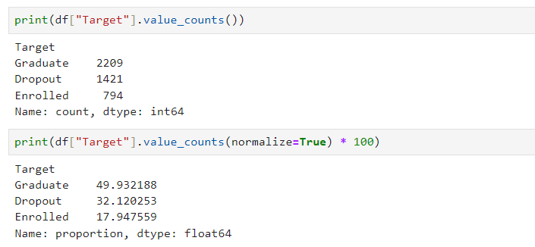
The dataset posed realistic preprocessing requirements as not every numerically stored variable represents a continuous numerical quantity. Identifying and correctly processing these categorical attributes formed an important part of preparing the dataset for machine learning.

3. Data Preprocessing

Prior to conducting the training process for the machine-learning models, the original data set was preprocessed to format the student records in a suitable numerical format that will be used by the training models. The need for this procedure came from the fact that the data set contained several records with different types of variables. Some columns in the data set contained genuine values, such as the admission grade, the student’s age, and semester grades. Other columns contained numerical values that were simply codes for categorical information.
It is incorrect to consider all variables as continuous values, primarily since there was a significant difference in the possible range of these variables. For instance, a higher score for the categorical column does not indicate that a student is better or more desirable in any objective sense. For this reason, categorical and numerical variables were separated during preprocessing. The original predictor matrix (36 input variables) was converted to a final training representation that contained 255 features.

3.1 Identification of Categorical Variables
In total, there were 17 input variables that were categorical in nature. These variables contained values that represented a category rather than a continuous numeric value.
The categorical variables included information such as:
- marital status
- application mode
- course
- daytime/evening attendance
- previous qualification
- nationality
- mother's qualification
- father's qualification
- mother's occupation
- father's occupation
- displaced status
- educational special-needs status
- debtor status
- tuition-fee status
- gender
- scholarship-holder status
- international status

3.2 One-Hot Encoding
Once the categorical attributes were identified, those columns were converted to numerical features using one-hot encoding.
Rather than maintaining the categorical variable as a single column with integer-coded values, one-hot encoding generates binary columns for each possible category. This avoids implying an artificial numerical order for categories.
However, this transformation significantly increased the feature space of the input vectors. In particular, although the original data set only contained 36 predictor attributes, the encoded version of the training data included 255 features.
This was not surprising since encoding categorical values such as course, application mode, nationality and occupation usually requires many additional columns since these fields often have several possible values.
The feature structure generated using one-hot encoding was used uniformly when training the classification models.

3.3 Feature Scaling
A StandardScaler was used as part of the preprocessing stage and a copy of the fitted scaler was retained for later use. Scaling the feature values transforms the data to have a similar distribution learned by the training data. This is essential if the input features differ in their natural numerical range. For example, economic indicators, grades, age and counts of curricular units are all measured in inherently different units.
Furthermore, it was important to retain the fitted scaler for later use when deploying student records into the prediction application. The scaling procedure should not be re-fitted every time a prediction request is made; instead, transformations should be applied using the same parameters identified at model-training time.

3.4 Maintaining Feature Consistency
One of the practical issues associated with one-hot encoding is that the model expects new records to have the same structure as the training samples used to fit the model.
For example, the new student records only have to contain a single value in the Course column. However, the fitted model may require a set of binary encoded features to represent the course. As a result, simply converting the record to a Data Frame may not be sufficient since the resulting object may not contain the 255 features that the model expects.
The solution was to retain the exact feature names and order identified during one-hot encoding. During prediction time, the transformed new records can therefore be aligned with the correct feature structure. This was important since having the correct values in the wrong columns could potentially produce inaccurate predictions.

3.5 Saving Preprocessing Information
The preprocessing stage was performed not only for model training but also for future use in the prediction application. Hence, several preprocessing components were saved using Joblib.
In particular, the saved information included the processed objects and auxiliary data required for rebuilding a similar input record, such as
- the exact final feature names and their order,
- the list of categorical columns,
- valid category values,
- the fitted StandardScaler.

This approach allowed for saving time and effort in re-defining the preprocessing steps when building a model in a production setting. Most importantly, it ensured that the records would be converted consistently during the prediction phase to the same representation that was used during training.

3.6 Reusable Preprocessing
The entire preprocessing workflow could be summarized in a few steps.

Original student record → identify categorical and numerical attributes → encode categorical variables → align encoded features → apply the required fitted transformations → provide the processed feature vector to the trained model.

It is notable that this procedure was essential for keeping the model-development process consistent with how data would actually be processed in a real-world scenario. Indeed, when a user submits a request to the final application, providing their course, scholarship status, age, admission grade, and grades, this information cannot be directly interpreted by the trained model. Rather, categorical values must first be encoded, and all attributes should be structured according to the preprocessing steps before being fed into the predict method. Thus, the described preprocessing steps served as an essential link between the raw data and the predictive model.

3.7 Final Preprocessed Dataset
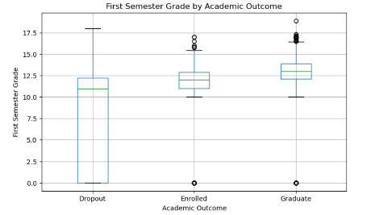
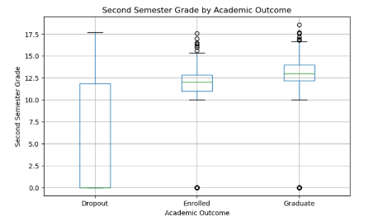
In effect, the 36 original predictors were transformed into 255 model features during preprocessing. These features were used to train the classifier, while the target variable was separated from the predictor matrix to form the three-class response variable Dropout, Enrolled and Graduate. In other words, the data used to develop the Logistic Regression and Random Forest classifiers was ready for exploration at the end of the preprocessing stage.
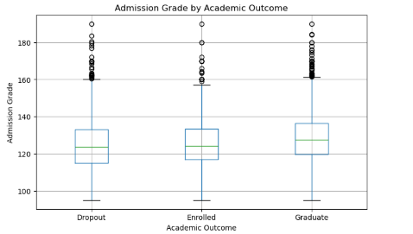

4. Machine Learning Methodology
The data set preprocessed in step 3 was used to train the student outcome prediction models. Since the target vector consists of three distinct classes (Dropout, Enrolled and Graduate), the problem was approached as a supervised multiclass classification task.
Two different machine-learning algorithms were used to build the prediction models: Logistic Regression and Random Forest. The decision to use two distinct classification algorithms is justified by the opportunity to compare a simple classification technique with an ensemble learning method. Moreover, the assignment instructions specifically state that two different algorithms should be used for a supervised-learning project.
In general, the modelling process comprised preparing the input features, separating the data into the training and testing sets, training the two classifiers, making predictions for unseen records, and evaluating the accuracy of the results using various classification metrics.

4.1 Supervised Classification Approach
The supervised learning approach was applied to train the student outcome prediction classifiers because all historical records consisted of the known outcomes. During the model training process, the patterns in the input-output data associations were identified by the algorithm.
Specifically, the 255-dimensional input feature vector preprocessed in step 3 was associated with one of the three possible output classes:
- Dropout
- Enrolled
- Graduate
Using multiclass classification was necessary because the project did not simply distinguish between students who dropped out and those who did not. The Enrolled class was retained as a separate outcome, allowing the models to distinguish between students who had dropped out, students who remained enrolled, and students who had graduated.

4.2 Training and Testing Strategy
In order to assess the ability of the identified models to generalize beyond the examples provided during learning, the entire dataset was split into two parts: training data and testing data.
The former was used to train the algorithm, which means that the computer learned the relationship between the processed independent variables and the target variable (student achievement). The latter portion of data was held out from the training process and used to evaluate how well the model performed on unseen examples. In other words, the model made predictions for the independent variables in the test set and compared them to the actual target values.
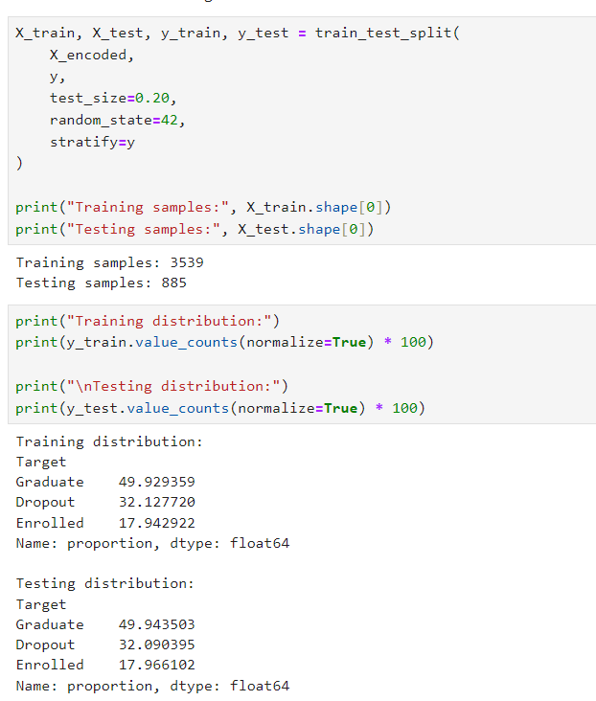
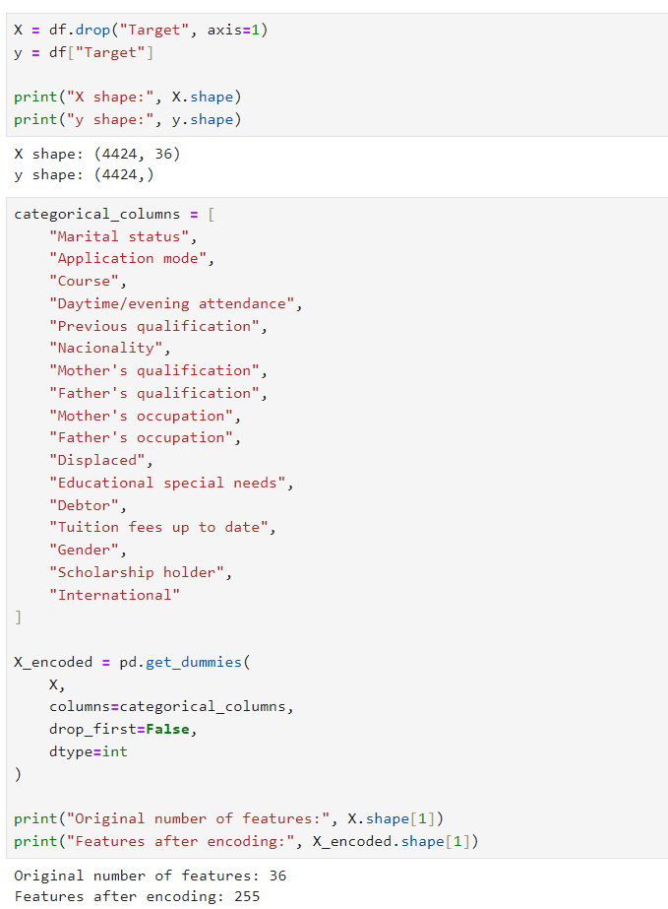
It is especially important to make this distinction when discussing the performance of the Random Forest method. For instance, a random forest classifier might show outstanding results when making predictions for the training set; however, the performance metrics for the test set can be significantly worse. Therefore, such a model would have been great at remembering the input-output relationships given to the algorithm but mediocre at actually solving the problem in practice.

4.3 Logistic Regression
Logistic Regression was implemented as the first classification algorithm and as the baseline model.
Though the name might suggest otherwise, Logistic Regression is mostly used for classification purposes. It estimates the probability of a class given a set of features. It is also possible to use Logistic Regression for multiclass classification problems, where more than two classes are present.
I chose Logistic Regression as the baseline model because the comparison with Random Forest, which I used as the second model, would be unfair otherwise. If a much more complex algorithm only provides slight improvements over Logistic Regression, it is not worth considering it as the final model.
The test accuracy of the Logistic Regression model was therefore a good starting point, at around 74.58%. I could later compare the performance of the Random Forest classifier against this value.
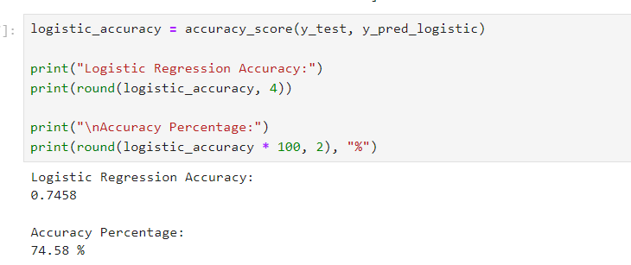
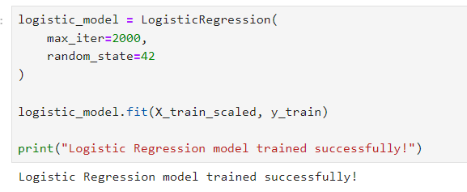

4.4 Random Forest
The second algorithm that I implemented was Random Forest.
Random Forest is an ensemble learning algorithm that combines the instances of many decision trees. Instead of using one decision tree for classification, the input data is classified by many trees, and the final result is determined by combining their results.
The reason why I chose to use Random Forest was related to the nature of the problem at hand. The relationship between the input features and the target variable might not be linear. For instance, the financial state of the student, or specific admissions-related features, may interact with other features in a non-linear way, thus making linear logistic regression inappropriate for the task.
Another benefit of using Random Forest was that it is suitable for high-dimensional data. As mentioned in the Data Preprocessing section, I had around 255 features due to the one-hot encoding of categorical variables. This was a good fit for the Random Forest approach.
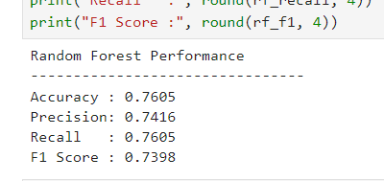
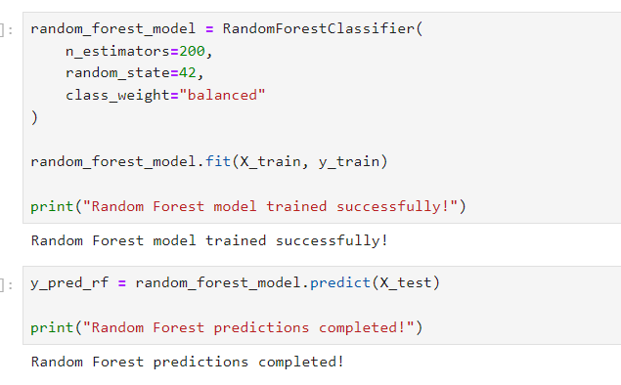
The first Random Forest model that I tested yielded the best accuracy so far, at 76.05%. However, accuracy was not the only factor that I considered when evaluating the model.

4.5 Identification of Random Forest Overfitting
The original Random Forest model that I tested yielded 100% accuracy on the training data, and 76.05% accuracy on the test data.
The difference between the training and the testing accuracy was therefore approximately
100.00% – 76.05% = 23.95%
This means that the model performed exceptionally well on the data that it was trained on, but somewhat worse on the unseen test data. This is an indication of overfitting, which would require further optimization steps.
It was therefore decided that the original Random Forest model was not optimal, and that a different set of hyper parameters should be considered.
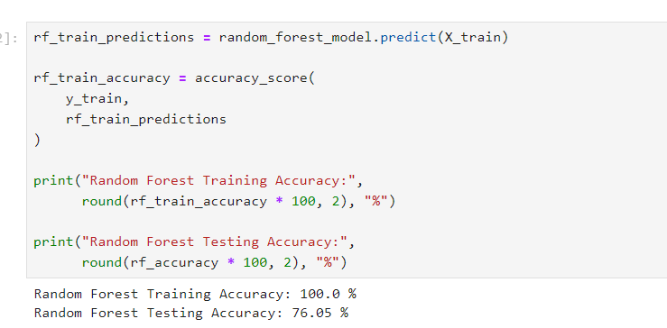
Model | Test Accuracy | Interpretation
Logistic Regression | 74.58% | Useful baseline with competitive performance.
Original Random Forest | 76.05% | Highest test accuracy, but showed strong overfitting.
Tuned Random Forest | 74.58% | Slightly lower test accuracy, but substantially reduced overfitting.

4.6 Tuned Random Forest
The original Random Forest achieved 100% training accuracy but only 76.05% test accuracy. This large difference indicated that the model had learned the training data too closely and was overfitting.
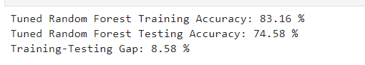
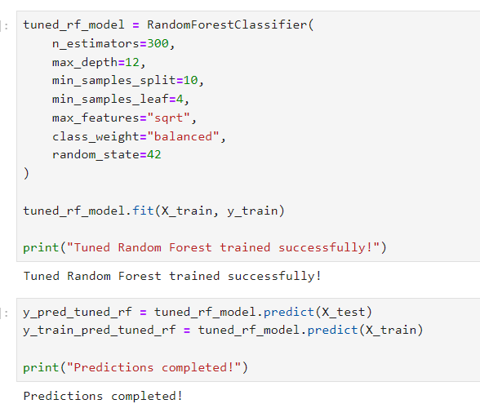

Model version | Training accuracy | Testing accuracy | Approx. gap
Original Random Forest | 100.00% | 76.05% | 23.95%
Tuned Random Forest | 83.16% | 74.58% | 8.58%

After tuning, training accuracy decreased to 83.16% while testing accuracy was 74.58%. Although the test accuracy was slightly lower than the original Random Forest, the training testing gap was reduced substantially. This is evidence of improved generalization behavior and reduced overfitting.

4.7 Justification for Selected Algorithms
The two algorithms were selected for different reasons.
Logistic Regression was a good baseline model due to its relatively simple classification structure. It helped to establish a reference point for comparison with a more complex algorithm.
In turn, Random Forest provided the flexibility needed to capture the possible complex and non-linear relationships between the characteristics of students. The facts that the data sets used for analysis contain the information from multiple domains (student’s background, admission data, financial details, academic performance, and economic indicators) make building such a relationship plausible. Therefore, the comparison between the algorithms was not only about achieving a higher accuracy score but also about finding if the increased flexibility would lead to improvements in performance and how much flexibility would lead to an unacceptable level of overfitting.

5. Model Evaluation
Once Logistic Regression and Random Forest were trained they were evaluated on the test set of data to assess their performance. The evaluation was necessary to estimate how well the model would perform when classifying the student records that have not been used for training.
Since the problem stated in this project has three possible outcomes; Dropout, Enrolled and Graduate, using only Accuracy might not be a good enough indicator of the model’s performance

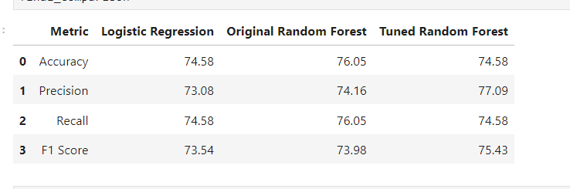
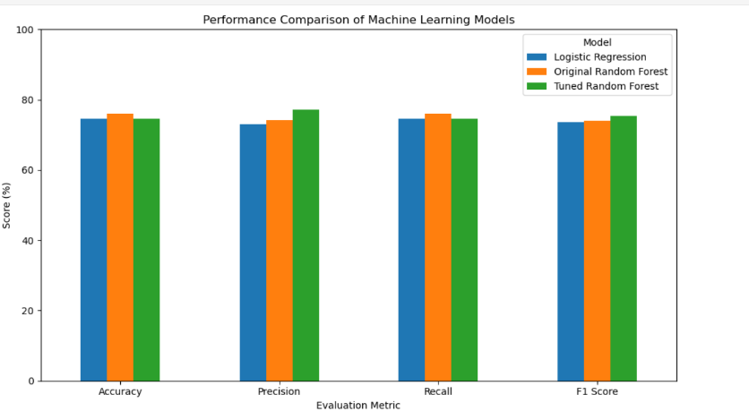
The models were evaluated on unseen test data using accuracy, precision, recall and F1-score. A confusion matrix was also used to inspect which outcome classes were correctly classified and where misclassification occurred.
Metric | Meaning in this project
Accuracy | Overall proportion of student outcomes predicted correctly.
Precision | How reliable the model's predictions are for a particular class.
Recall | How many actual cases of a class are successfully identified.
F1-score | Harmonic balance between precision and recall.
Confusion matrix | Detailed counts of correct and incorrect predictions for each class.

5.1 Training and Testing Performance
Another important part of the evaluation involved comparing training and testing accuracy.
The original Random Forest achieved:

Training accuracy: 100.00%
Testing accuracy: 76.05%

This produced a difference of approximately 23.95 percentage points.
Although its testing accuracy was the highest among the evaluated models, the perfect training accuracy combined with the much lower testing accuracy indicated that the model was strongly fitted to the training data.
After optimization, the Random Forest produced:

Training accuracy: 83.16%
Testing accuracy: 74.58%

The resulting difference was approximately 8.58 percentage points.
The test accuracy decreased slightly after tuning, but the much smaller training-testing gap suggested improved generalization behavior. This comparison became an important consideration when deciding which Random Forest version should be used as the final model.

5.2 Evaluation Strategy
The evaluation process therefore considered two different aspects of model performance.
Firstly, predictive performance was assessed using accuracy together with precision, recall, F1-score and the confusion matrix.
Secondly, generalization behavior was examined by comparing performance on training and unseen testing data.
This approach prevented the final model from being selected simply because it produced the largest accuracy value. Model performance was instead considered in terms of both correct classification and the extent of transfer of the learned patterns from the training data to unseen student records.

6. Results and Model Comparison
After training and testing the models, the performance of Logistic Regression classifier, original Random Forest and tuned Random Forest were compared on test set. The goal of this study was not only to find out what model had the best accuracy rate on test set but also to investigate if the models were capable of generalizing the patterns from the training set to the student records that were not seen by them.

The original Random Forest achieved the highest observed test accuracy at 76.05%. Logistic Regression and the tuned Random Forest each achieved approximately 74.58% test accuracy. However, accuracy alone was not used to judge the final model because training–testing behavior and class-specific performance were also considered.
Model | Test Accuracy | Interpretation
Logistic Regression | 74.58% | Useful baseline with competitive performance.
Original Random Forest | 76.05% | Highest test accuracy, but showed strong overfitting.
Tuned Random Forest | 74.58% | Slightly lower test accuracy, but substantially reduced overfitting.

7. Random Forest Optimization
The initial Random Forest yielded the highest test accuracy among all models considered. Yet, comparison of its training and test performance suggested the model was overfit. To counter this, an additional optimization step was undertaken prior to selecting the model to be used in the final prediction application.
The aim of this stage was not merely to improve test accuracy; rather, the optimization stage was intended to yield a model that retained a good level of predictive performance, but reduced the discrepancy between the performance of the model on the training data and unseen test data

The original Random Forest achieved 100% training accuracy but only 76.05% test accuracy. This large difference indicated that the model had learned the training data too closely and was overfitting.
Model version | Training accuracy | Testing accuracy | Approx. gap
Original Random Forest | 100.00% | 76.05% | 23.95%
Tuned Random Forest | 83.16% | 74.58% | 8.58%

After tuning, training accuracy decreased to 83.16% while testing accuracy was 74.58%. Although the test accuracy was slightly lower than the original Random Forest, the training–testing gap was reduced substantially. This is evidence of improved generalization behavior and reduced overfitting.

8. Final Model Evaluation
After the optimization stage, the performance of the Random Forest was analyzed in greater detail in order to obtain a more precise understanding of the model’s accuracy in terms of the three student outcome classes. Although the general test accuracy provides an essential overview of the model’s performance, individual analysis of each category is required in order to ensure that the model performs consistently well for all three classes of students, namely, Dropout, Enrolled, and Graduate.

8.1 confusion Matrix
For the tuned Random Forest, the confusion matrix showed 197 correctly predicted Dropout cases, 98 correctly predicted Enrolled cases and 365 correctly predicted Graduate cases. The Graduate class was identified most strongly, while the Enrolled class was more difficult for the model to separate from the other outcomes.
Actual class | Predicted Dropout | Predicted Enrolled | Predicted Graduate
Dropout | 197 | 60 | 27
Enrolled | 29 | 98 | 32
Graduate | 17 | 60 | 365

From the matrix, 660 of 885 test records were classified correctly, which corresponds to approximately 74.58% accuracy. The main source of confusion is the Enrolled class and the overlap between Enrolled and the two terminal outcomes.
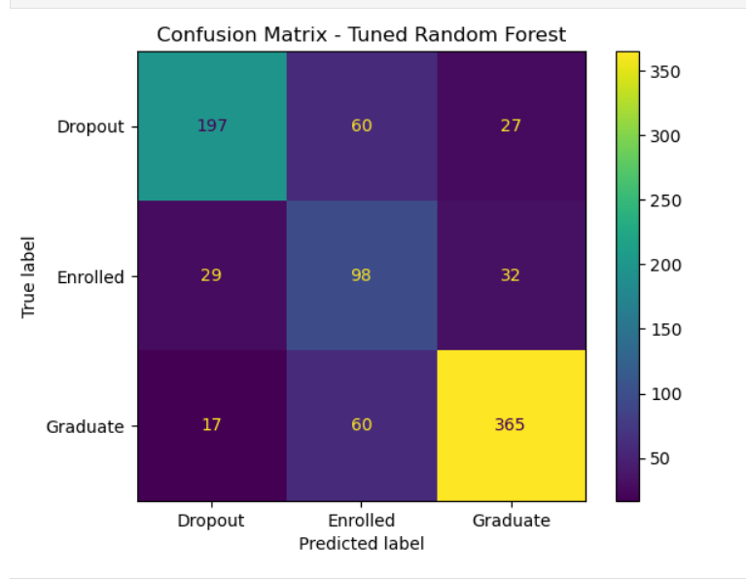

8.2 Manual Prediction Test
Several records were processed through the reusable prediction workflow. In this assessment, it is demonstrated that the stored preprocessing structure and the model can make predictions based on individual student records. Examples of checks included prediction of the Dropout, Graduate and Enrolled records correctly, at least one incorrect prediction, which is expected given the absence of 100% test accuracy of the model.
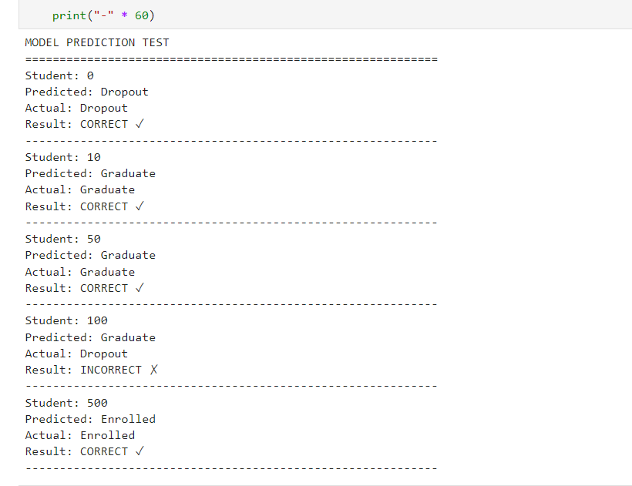
Example student index | Predicted | Actual | Result
0 | Dropout | Dropout | Correct
10 | Graduate | Graduate | Correct
50 | Graduate | Graduate | Correct
100 | Graduate | Dropout | Incorrect
500 | Enrolled | Enrolled | Correct

9. Critical Analysis and Discussion
The results of the experiments can help assess model performance beyond test accuracy. While the original Random Forest model had the best accuracy on the test set, the significant difference between training and test accuracy was observed. Moreover, the results show that the performance of the model differs for each of the three outcomes. This conclusion is critical in determining whether the developed model can be used in practice to predict the outcome for a new student.

9.1 Comparison of the Model Performance

Out of all the proposed models, the original random forest had the highest test set accuracy, which was 76.05%. The logistic regression and the tuned random forest had 74.58% each.

Therefore, the initial random forest model was the best-performing one at first glance. However, the difference between the best performer and the second one was only 1.47%. So, it was necessary to take into account the performance of the models during the training process.

9.2 Overfitting in the Original Random Forest

One of the most striking results was the behavior of the original Random Forest on the training data.
The model showed:

Training accuracy = 100.00%

Test accuracy = 76.05%

This means that the training-test gap was:

100.00% - 76.05% = 23.95 percentage points

The perfect training accuracy suggests that the original Random Forest fitted the original observations extremely closely. However, the substantially lower test accuracy suggests that the same level of performance was not achieved when the model was presented with unseen data.

This indicates overfitting. Basically, the model learned the training dataset extremely well, but some of what it learned did not generalize well to new student records.
This result shows why choosing the original Random Forest only because it achieved the highest test accuracy would have been an incomplete analysis.

9.3 Effect of Random Forest Optimization

The optimization step in order to reduce the overfitting of the Random Forest.
As a result, have obtained the following results:

Training accuracy = 83.16%
Test accuracy = 74.58%

The difference between training and test accuracy was thus 8.58%, compared to 23.95% for the initial (non-optimized) model. Thus, the optimization reduced the overfitting by about 15.37%.

On the other hand, there was a decrease in the test accuracy of about 1.47%. As such, it would be incorrect to claim that optimization improved the accuracy. However, I believe it is fair to say that the optimization reduced the overfitting significantly without reducing the test accuracy by much.

9.4 Difficulty in Predicting the Enrolled Class

The confusion matrix indicates that the Enrolled class was the most challenging to predict.

Out of actual Enrolled records, 29 were predicted as Dropout and 32 as Graduate. In addition, 60 actual Dropout records and 60 actual Graduate records were predicted as Enrolled.

One assumption is that Enrolled is a less certain category as compared to other classes. Dropout and Graduate are final outcomes, whereas Enrolled is a state of continuing education. Hence, some features found in the records of students who eventually become Dropout or Graduate can be found in students who are yet to complete their education.

Nevertheless, this experiment cannot conclusively determine the difficulty in prediction. Further analysis of the distribution of features and additional experiments are needed.

9.5 Importance of Dropout Prediction Errors
From the perspective of the problem statement of this project, errors associated with the Dropout class are of particular interest.

60 of the actual Dropout cases were predicted as Enrolled and 27 predicted as Graduate. Hence, some of the students who actually dropped out were not classified as such by the algorithm.

In a practical scenario, such an error would mean that a student, who requires additional help, is not picked up by the predictive system. Meanwhile, misclassifying a student as Dropout may lead to unwarranted intervention.
There is a need, therefore, to balance between ensuring that all at-risk students are flagged and not raising unwarranted alarms. As such, it is important to look at precision, recall and F1-score in addition to overall accuracy.

9.6 Consideration of Logistic Regression as a Baseline Option

The Logistic Regression model provided an invaluable baseline for the experiment. Its 74.58% test accuracy is barely lower than that of the original Random Forest and equal to the accuracy of the tuned Random Forest.

This result underlines the value of implementing a baseline model. Without it, the accuracy of the Random Forest would seem impressive on its own, while the comparison between the two algorithms highlight how little improvement was made with the original Random Forest.

On the other hand, equal accuracy does not necessarily imply equal performance. The algorithms can have vastly different precision-recall characteristics for different classes, and thus, a more informative comparison would have been to analyze the precision, recall, F1-score, and the confusion matrices of both algorithms in addition to overall accuracy.

10. Limitations and Future Work

Although the developed system achieved useful results in predicting student academic outcomes, there are several limitations that must be considered when interpreting its performance? These relate to the dataset, model evaluation, classlevel performance, preprocessing approach and potential use of the prediction application. Recognising these issues also identifies directions for future development.

10.1 Dataset Generalizability

One of the main limitations is that the models were trained using a specific historical student dataset of 4,424 records. The patterns learnt by the models therefore reflect the students, courses, academic structures and other conditions present in that dataset.

As a result, the reported performance cannot automatically be assumed to apply to students in a different university or educational system. Associated factors to dropout can vary between institutions due to differences in admission procedures, course structures, student support, economic conditions and assessment methods.

Future work could evaluate the trained approach using data from additional institutions or more recent student cohorts. External validation would provide stronger evidence that the identified patterns generalise beyond the dataset used in this project.

10.2 Difficulty Predicting the Enrolled Class
The final confusion matrix revealed that the prediction performance was not equal across the three target classes. The Enrolled class was the most challenging to identify, with approximately 61.64% recall, compared with approximately 69.37% for the Dropout class and 82.58% for the Graduate class.

This limitation is important because an acceptable overall accuracy can mask a weaker performance for a particular class.

Future research direction could explore the distribution of the target classes and characteristics of incorrectly classified Enrolled students. If class imbalance is found to contribute to the issue, appropriate resampling or class-weighting techniques could be investigated. Any such technique should be carefully evaluated to determine whether it improves the difficult class without substantially reducing performance for the others.

10.3 Limited Model Selection

The project focused on two main machine-learning algorithms: Logistic Regression and Random Forest. This choice provided a useful comparison between a relatively simple baseline classifier and a more flexible ensemble model, which satisfied the scope of the current project.

However, these algorithms do not represent every possible approach to the problem.

Future experiments could compare additional non-deep-learning machine-learning algorithms, where permitted by the assignment scope. For example, Gradient Boosting or XGBoost could be investigated and compared using the same test conditions and evaluation metrics.

This would help determine whether the observed performance represents a limitation of the current algorithms or whether similar performance is obtained across a wider range of classifiers.

10.4 Hyper parameter Optimization

The Random Forest optimization substantially reduced the observed training-test gap from 23.95 to 8.58 percentage points. However, further tuning may still improve the balance between predictive performance and generalization. A more systematic future optimization process could explore combinations of Random Forest hyper parameters rather than relying on a limited set of configurations. Techniques such as grid search or randomized search could be used to compare candidate configurations in a structured manner.

The objective should not simply be to maximize training accuracy. Instead, model selection should consider unseen-data performance, class-specific metrics and the difference between training and validation performance.

10.5 Privacy and Ethical Considerations

A real student prediction system would analyze potentially sensitive educational and personal information. The current application is only intended to be a project demonstration, but a practical implementation would need to handle data privacy and access control, and predict outcomes responsibly. It's also easy to mistake a prediction for an absolute certainty. Machine-learning predictions are only estimates based on past patterns and can be wrong, as illustrated by the confusion matrix.

This means that a production system should probably not make a single prediction indicating whether a student will be in Dropout, Enrolled or Graduate their next year, but rather use predictions as an indication and recommendation to qualified personnel.

10.6 Model Monitoring and Updating

School populations and conditions can change over time. A model trained on older records may stop being representative of the student population.

If the system were to be used in practice, its performance should be monitored on the data it is making predictions about. A gradual decrease in accuracy, recall or other metrics would be a signal to retrain the model. Retraining with recent data ensures that the model reflects the population it is predicting for in its features and statistics.

11. Conclusion

This project aimed to design, develop and evaluate a machine-learning system for predicting student academic outcomes. The supervised multiclass classification problem was approached using a dataset of 4,424 students with 36 initial predictors. These predictors captured student-related information on socio-demographic, admissions, financial, academic, and economic status.

Data Preprocessing was a significant stage in the current project since several numerical variables in the initial dataset actually represented categorical variables. Specifically, 17 numerical predictors were converted into categorical ones using one-hot encoding. As a result, the initial 36 predictors were converted into 255 model features. The preprocessing procedure was applied to the entire initial dataset, enabling future prediction requests from new students to undergo the same steps automatically.

As a result, two supervised machine-learning models Logistic Regression and Random Forest were evaluated to address the current classification problem. Trained Logistic Regression achieved a test accuracy of 74.58%, and Random Forest, which initially had the best test accuracy (76.05%), had a huge difference (23.95%) between its training (100%) and test accuracy. Thus, a high variance of the model was identified, which decreased the reliability of its results. Therefore, hyper parameter tuning was performed to reduce overfitting, which reduced the training accuracy to 83.16% and test accuracy to 74.58%. Although the test accuracy decreased, the variance between the training and test accuracy decreased significantly (to 8.58%). Consequently, the best-performing model – Random Forest – was selected for further steps.

An analysis of the final model’s performance revealed the importance of accuracy beyond overall classification. Specifically, the confusion matrix indicated that the model was best at predicting Graduate students and had issues distinguishing between Enrolled and Dropout students. Thus, it is essential to consider precision, recall, F1-score, and other metrics when analyzing a classification model’s performance, especially when dealing with multiple classes.

Finally, the best model and the preprocessing steps were implemented into a web application that allows submitting a student request and receiving the student’s predicted academic outcome (Dropout, Enrolled, or Graduate). In conclusion, the current project accomplished its stated goals by creating a machine-learning model for predicting student academic outcomes. However, the model’s performance should be analysed with care due to accuracy overfitting and imbalanced classes. Therefore, the model can be suggested for implementation as a decision-making aid in real-life situations with an understanding of its limitations and potential benefits.

References

[1] | C. Y. J. L. K. L. &. I. G. M. Peng, " An Introduction to Logistic Regression Analysis and Reporting.," The Journal of Educational Research, p. 96, 2002.
[2] | Scikit-Learn, "RandomForestClassifier," in Machine learning, scikit-learn developers, 2007 - 2026.
[3] | A. G. A. R. B. F. B. C. Beatriz Duro, "Understanding and Preventing Student Dropout in Higher Education: A Literature Review,," Procedia Computer Science, vol. Volume 278, pp. Pages 109-116, 2026.
[4] | C. &. N.-W. E. Gehart, " University dropout intentions and early prevention.," European Journal of Higher Education, p. 1–20., 2025.
[5] | R. Kaur and P. Kumar, "A Data-Driven Interpretable Approach for Identifying Determinants of Student Dropout in Higher Education," 2026 9th International Conference on Computing Methodologies and Communication (ICCMC), Erode, India, pp. 2054-2061, 2026.
[6] | M. V. M. J. M. a. L. B. V. Realinho, "Predict Students' Dropout and Academic Success,," UCI Machine Learning Repository, 2021. [Online], 2021.
[7] | scikit-learn, LogisticRegression, scikit-learn developers, 2007 - 2026.
[8] | Y. -N. T. a. C. -C. Fang, "A System Dynamics Approach to Modeling Student Dropout Behavior and Evaluating Educational Policy Interventions," in IEEE Access, pp. 216053-216068, 2025.
[9] | A. R. W. M. V. A. Petkovic D, "Improving the explainability of Random Forest classifier - user centered approach," Pac Symp Biocomput, pp. 204-215, 2018.

