|  |  |  |  |
| --- | --- | --- | --- |
| **CS102** | **Fall 2016/2017** | Project Group | 9 |
| Instructor: | **Öznur Taştan Okan** |
| Assistant: | Halil İbrahim Kayım |

|  |  |  |
| --- | --- | --- |
| **Criteria** | **TA/Grader** | **Instructor** |
| Presentation |  |  |
|  |  |  |
|  |  |  |
|  |  |  |
| Overall |  |  |

~ Happy Real Estate ~

Happy_Koalas

Burak Erkılıç 21501035

Deniz Evrensel 21401841

Özlem Yıldız 21502657

Selim Fırat Yılmaz 21502736

Mert Yurdakul 21401628

|  |
| --- |
| **User Interface Report**  ( Version 1.0 )  27 December 2016 |

# Introduction

As we are in the 21st century, people have no time to go to a real estate in order to have a look at the house options while today’s technology allows us to even e-demonstration for houses. Therefore, why don’t we allow an online map that contains houses on sale or for rent? This desktop program is on purpose of house buyers, of the ones who sell their house, and of real estate agents. Via this map the user will be given a chance to observe houses without struggling to visit them in person.

# Details

## Product Features

### Map

Map will help user to perceive appropriately the location of the house. User will be able to browse around the area which houses are in and explore the advantages of the surrounding of the house. When a user decides to buy a house, the contact information of the seller will be available to this user.

### Different marks for houses on sale or for rent

Every mark will have different features. With the help of that feature, users are able to perceive what situation a house is in. To exemplify, green will represent sales and red will represent renting. In that regard, users will be able to differentiate houses properly.

### Searching and filtering for different properties

Almost every buyer have own criteria before making a purchase, that is why in that program, we allow users to filter houses according to desired properties. So that they would be able to find efficiently list of houses which fits them better by that feature. Also, the candidate properties which are appropriate to the desired criteria will be highlighted on the map.

Properties:

* + The size of the house
  + The number of rooms
  + The age of building
  + The price range

### Sale announcement

We are providing an interface for each real estate agent and individuals to let them easily create an announcement for their house on sale or for sale. User (a real estate agent or an individual) chooses the properties of his/her house and defines the price of the house and also user can upload the photos of the house. Sale announcements are also modifiable, removable for when user desires.

### Price estimation

In that desktop program, we allow users to create their own announcement, which means a person, who do not know how much money is his/her house worth, can also decide the best price for his/her property. These people do not have to go through each real estate in order to have an idea. This feature will calculate a reasonable price according to given properties of house and offer it to owner of announcements. Kumar, et al, reports these properties as “... mainly consists of construction structure, style, level, facilities, and construction quality. The two most crucial factors are location and environments” [3] (174).

### Data protection and collection

Data protection and collection is a very important concept of our project, since our users would choose and use that program for these data. After each announcement created, we will get data in a server where only admin could reach which means protection of data; however we are also aware that real estate prices can be changed by external factors such as economic crisis or by internal factors such as emergency of money of and announcement owner. That is why we will let users to update their property in a meaningful way. For example price of house can be augmented or decremented; but age of building is not.

## Product Usage

### Selling a house

When a seller wants to create a sale of his/her house, he/she logins to the system and selects the “Sell House” button. Then, he/she enters the details of the house and upload the photos of the house.

### Searching a house

When a user wants to buy or rent a house, he/she simply opens application and browse around the map. He/she also can filter houses on map.

### Buying a house

Happy Real Estate only provides the contact information of the seller of the house for buyers. Except for contact information, buyer will be able to send a mail to the seller through this program. In other words, money is not in the scope of Happy Real Estate.

### Menu

The reason of this menu is to ease the way of program’s usage and enhance the user experience.

In this menu,

* Searching
* Filtering
* The creation of the announcement
* A guidance to the map

will exist.

## Roles

### User

All users

* Can download the application
* Can register and create a profile

Registered users

* Can edit his/her profile
* Can delete his/her profile

All users are also buyers whereas only registered users are sellers.

### Client (Buyer / Tenant)

A buyer or tenant might be both registered or an unregistered user.

All buyers and tenants

* Can seek for a real estate
* Can access the details of the house on sale or for rent and see the contact information of the seller.
* Can access the seller through this program by sending message to him/her.
* Can set the time of rent. (If that house is for rent)

### Seller (landlord)

A seller must be a registered user.

All sellers

* Can add a new house on sale or for rent.
* Can edit the details of his/her houses on sale or for rent.
* Can delete his/her houses on sale or for rent.

**2.4.4 User Interface in Detail:**

**2.4.4.1 Main page**

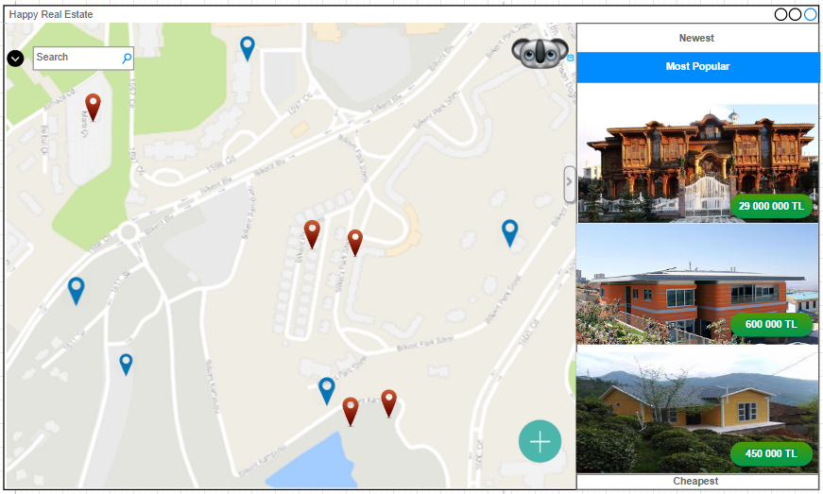

This is “Happy Real Estate” main page. Top left corner contains our program name while top right corner has standard application actions such as minimize,maximize and close button.

On the middle there exists our map which shows user where the houses are located by tags whose colors represent whether the house is for rent or it is on sale.On top left of the map there exist search button which is for user to search specific house. The black button which is left of the search button is for filtering the search. After pressing that black arrow button, some properties pop up and user can arrange these properties according to desired house’s properties.

On the right column houses on sale or for rent could be seen as well as their photos and price. Moreover this house announcements are grouped in a few concepts: popularity, newest publication and cheapness. User could list house announcements according these concepts by clicking on “most popular”, “newest”, “cheapest”.

On top right corner of map there exist a koala button which stem from our group name. This button is designed for user who has an account in our program; however it has different features for those who has an account and for those who has not.

On bottom right corner of the map there exist a button which is represented by a green plus icon is designed to add new properties where users are able to create a new announcement.

As an important note, if the user who has no account clicked on “add new properties” or “koala” button,they would be redirected to login page; however if a user who has an account these button works how they are designed.

**2.4.4.2 Main Page 2:**

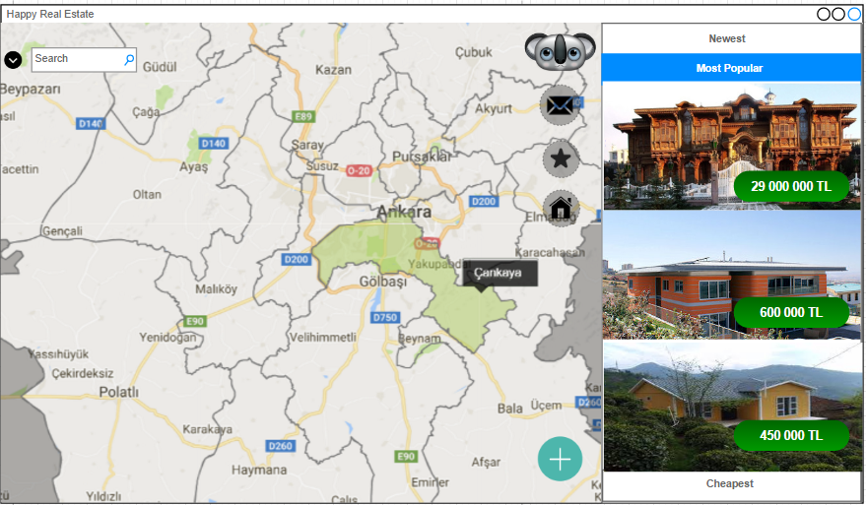

This is still main page while map is zoomed out. Now you can see what happens when a user who has account click on koala button. 3 different options are listed. First one is represented by a letter icon and it is the messaging feature between users with an account in order to communicate. Second one is represented by a star and it is the favorites feature which shows house announcements which were added to favorites. By this feature, user has an easy access to his/her favorites. Third and the last one is represented by an house icon and it is for showing own properties for the users with an account. After clicking own property button own properties page is opened where user is able to edit or delete them.

**2.4.4.3 Messages Page:**

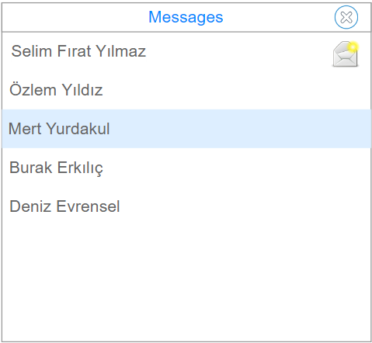

On this page, those who sent messages are seen by their name and surname. By clicking on the name user can message. On top right corner there exists close button as well. These letter icon is for visualisation.

**2.4.4.4 Favorites Page:**

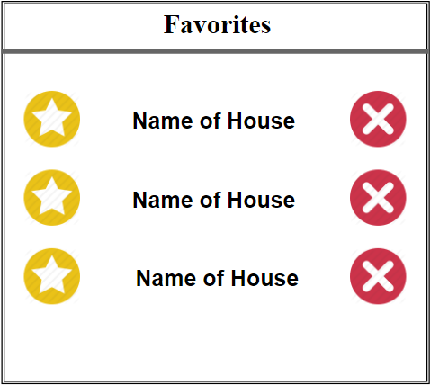

This is how favorite’s page is going to be displayed. The house announcement that have already been tagged as favorite are listed on the page. User is always able to extract any announcement by just clicking on the cancel button which is located end of the name of house. Yellow favorite icon is just for an image.

**2.4.4.5 House Announcement View :**

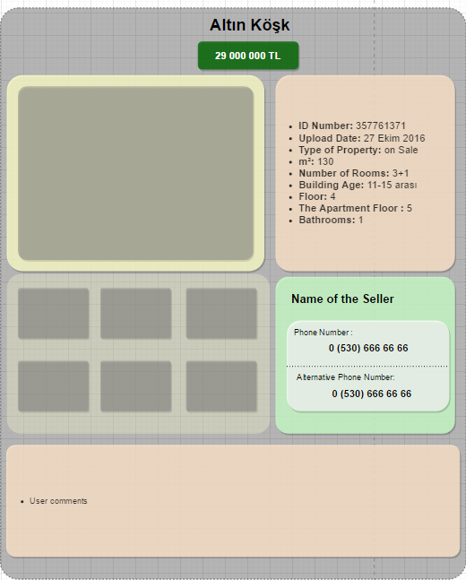

This is house view page where user is able to see information about house, about saler and also images of the house. The name of house is seen on very top. The price is displayed on the top while house information is on top right, information about saler is on right bottom. Seller is also puts some comment on bottom. The message icon next to seller name allows to send message to another user who interest with the house.

**2.4.4.6 Add new Property:**

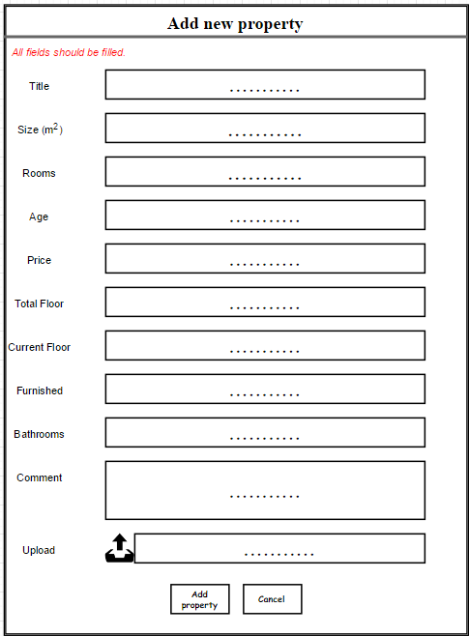

A user with an account is able to create an announcement. After clicking “add new property” button, this page is going to be displayed. Seller should fill all these blank space according to house’s properties. Program returns an error message on top of the page by red color.

User can upload image by clicking black button which is next to upload option. If user click on that icon upload image page is going to pop up.

**2.4.4.7 Upload Image Page:**

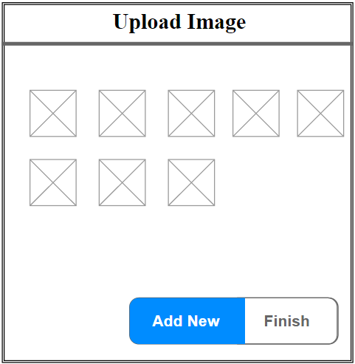

User can select image by clicking add new button. By repeating this action user can upload more than one picture. When all images that are wanted to be uploaded, user presses finish button to end uploading image.

**2.4.4.8 Own Properties Page:**

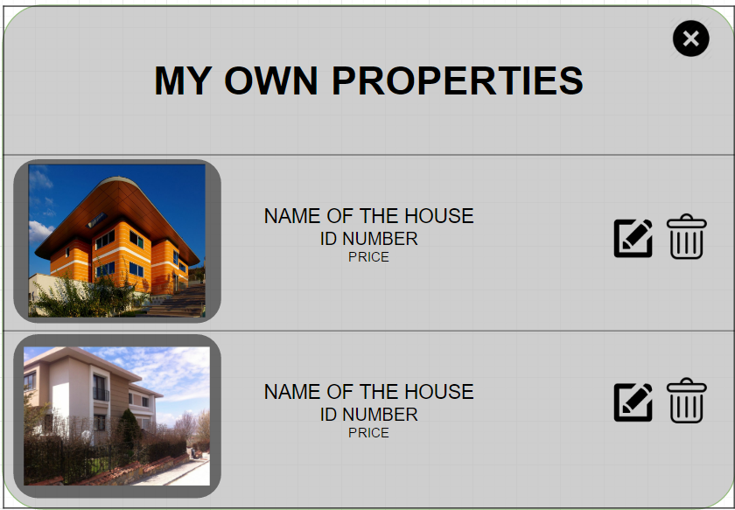

Under koala button, if own properties button is pressed this page is pop-up. User can edit its own announcements or delete them. this page has also close button on the left top corner.

**2.4.4.9. Login page:**

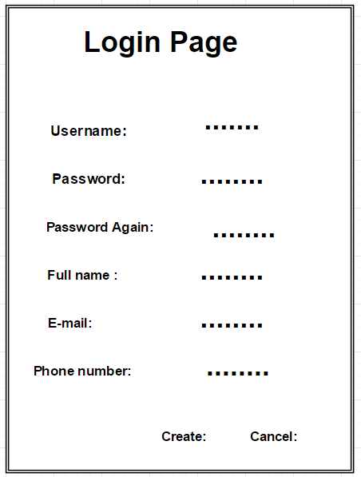

User can create their account by that login page. User should fill all blank space otherwise, program display an error message to warn user.

**Map:**

Main

Add New Property

House

Announcement

Favorites

Message

My Own Properties

Upload Image

Login Page

# Summary & Conclusions

[1]

To sum up, when people are looking for new houses to buy, rent or sale, they may not find time due to their daily routines. Therefore, by that program they will save time by uploading “Happy Real Estate” to decide which house is advantageous for them. In that regard, technology have an important role; This program aims to help people in finding a house, selling it in the proper price or renting it for a specific period of time. In contrary to other programs, this one allows its users to see the location of a house in the map. Incase sellers are not able to determine the price, the ability of estimating the price would help user to specify his/her house’s price. Additionally, in this program, what is on sale and what is for rent can be found easily; the reason is that they have different marks on the map. Another advantage is that user can search and filter houses according to his/her priorities and mark them differently than the rest too.

Sahibinden.com [] and Hürriyetemlak.com [2] are some websites which have same aim as our program “Happy Real Estate”. 2D map, filtering search, colorful marks, viewing house’s images are the similarities. Also, users can generate sale announcements of their own properties both in these websites and in our program. However, “Happy Real Estate” provides rookie users to define reasonable prices for their announcements with the aid of Machine Learning.

1. "Sahibinden Satılık, Kiralık, Emlak, Oto, Alışveriş Ürünleri." N.p., n.d. Web. https://www.sahibinden.com/. Accessed 20 Oct. 2016.

   "Hürriyet Emlak – Türkiye'nin En Büyük Emlak Sitesi." N.p., n.d. Web. http://www.hurriyetemlak.com/. Accessed 20 Oct. 2016.

   Anil Kumar KM, Anil B, Anand CU, Aniruddha S, Rajath Kumar U.Machine Learning Approach to Predict Real Estate Prices. *Discovery*, 2015, 44(205), 173-178