Intermediate Project Report

Iris Flower Classification Using Machine Learning

Author: Shanet P Roy
Course: Introduction to Python Programming for Machine Learning
Instructor: Durga Sharma

1. Introduction
The Iris Flower Classification project is a widely used beginner dataset in machine learning. This project demonstrates data cleaning, exploratory data analysis, visualization, and machine learning classifier modeling.

2. Objective
- Analyze the Iris dataset
- Explore feature relationships
- Visualize patterns
- Build ML models
- Evaluate accuracy

3. Dataset Description
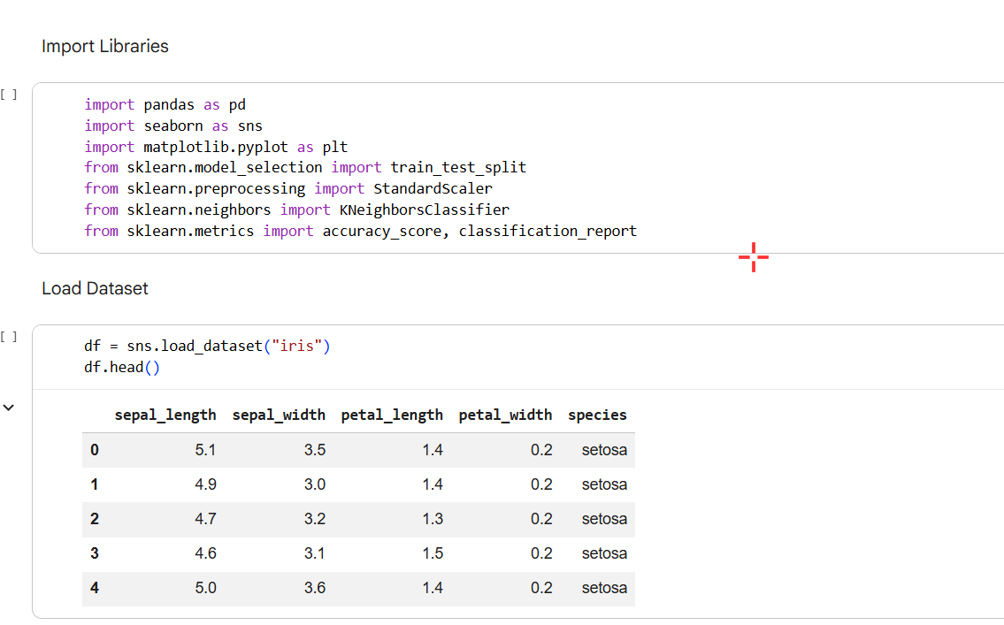
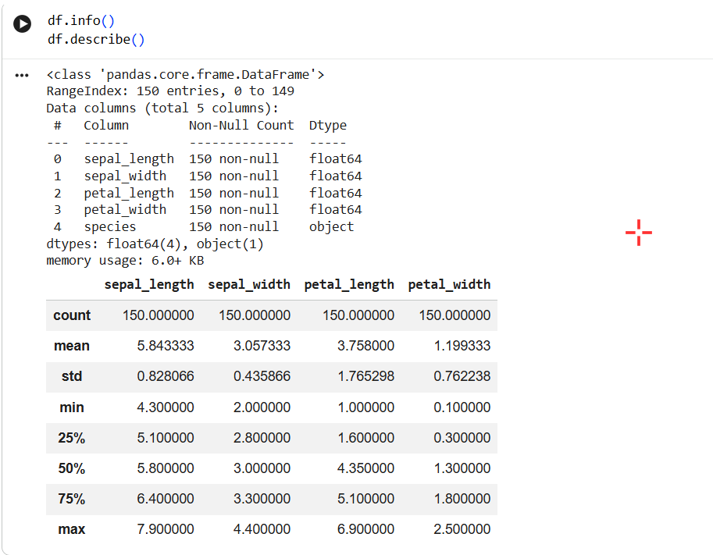
Total samples: 150
Features: Sepal Length, Sepal Width, Petal Length, Petal Width
Targets: Setosa, Versicolor, Virginica
Source: Kaggle / Scikit-learn

4. Methodology
Steps followed:
1. Data Import
2. Data Cleaning
3. Exploratory Data Analysis
4. Visualization
5. Model Building
6. Evaluation

5. Data Cleaning
Dataset contains no missing values. Structure and data types verified.

6. Exploratory Data Analysis (EDA)
Insights:
- Petal features separate species well.
- Setosa is clearly distinguishable.
- Versicolor and Virginica overlap slightly.

7. Visualizations
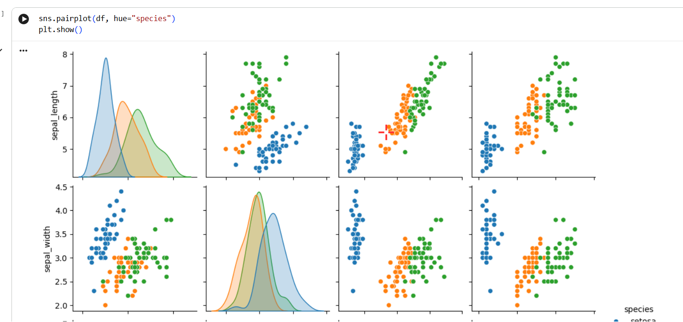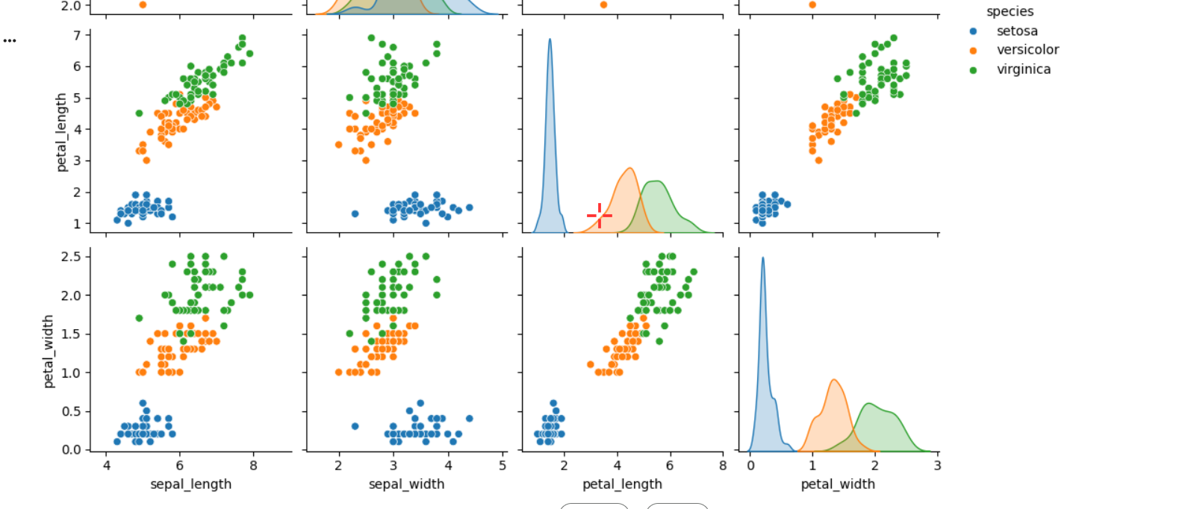- Pairplot
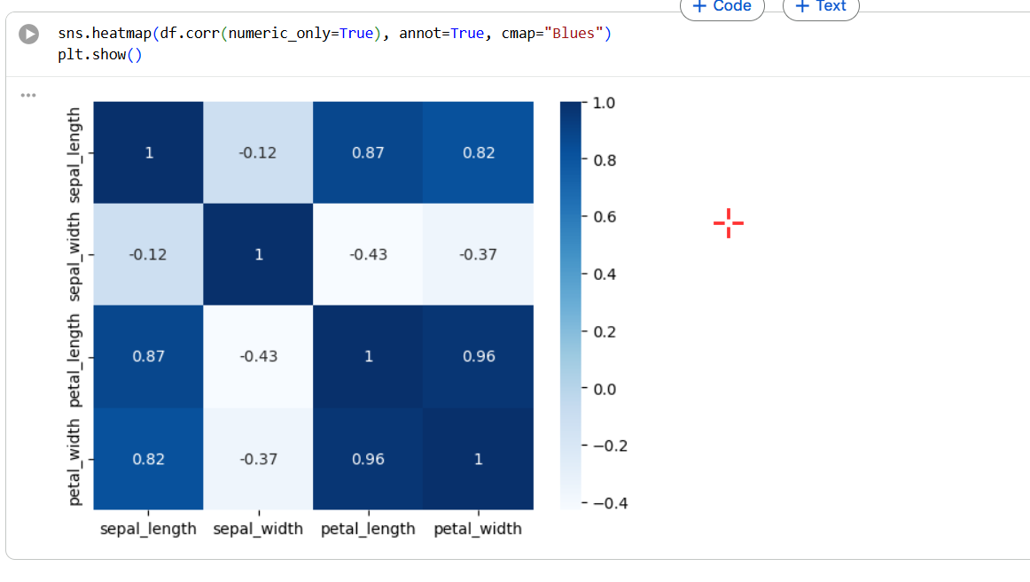- Heatmap
- Scatter plots
- Countplot

8. Model Building
Models Used:
1. Logistic Regression — Accuracy ~95%
2. K-Nearest Neighbors — Accuracy: 96–100%

Train-test split: 80/20

9. Results
KNN performed the best. Petal Length and Petal Width were strong predictors.
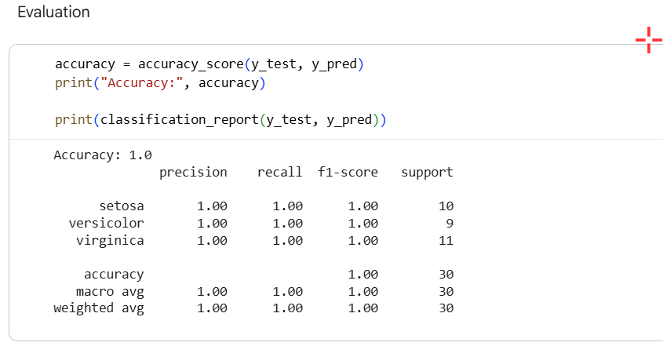

10. Tools Used
Python, Google Colab, Pandas, NumPy, Matplotlib, Seaborn, Scikit-learn

11. Conclusion
This project successfully achieved high accuracy in classifying iris species. It demonstrates data analysis, visualization, and machine learning fundamentals.

12. References
- Scikit-learn documentation
- Kaggle Iris Dataset

