VIRTUAL PLANT MONITOR – A JAVA-BASED IoT SIMULATION
Student Name: Shanet P. Roy
Course: Summer C – Computing
Instructor: Dr. Najathulla B. C
Institution: Golden Gate University
Date: 30 November 2025



ABSTRACT
The Virtual Plant Monitor is a Java-based simulation designed to demonstrate real-time plant health monitoring using virtual sensor values. Instead of physical IoT hardware, Java classes generate simulated readings for temperature, soil moisture, and light intensity.
These readings are displayed in a Swing-based graphical interface and update automatically every few seconds. Using defined thresholds, the system evaluates plant health and displays color-coded indicators representing Healthy, Warning, or Critical conditions.
This project provides an accessible introduction to IoT concepts, GUI design, and real-time programming using Java, allowing students to simulate plant monitoring without requiring hardware.

INTRODUCTION
Environmental conditions such as temperature, light, and soil moisture play a crucial role in plant growth. IoT systems help monitor these conditions in real time, enabling timely intervention and better care.
However, building a physical IoT system requires sensors, wiring, calibration, and microcontrollers which may not be accessible to all students.
The Virtual Plant Monitor solves this problem by simulating an IoT system entirely in software using Java Swing. It generates realistic sensor values and updates them in real time, demonstrating the core principles of IoT plant monitoring.
Java’s object-oriented programming structure and built-in GUI tools make it suitable for creating such simulations. This project introduces IoT concepts in a beginner-friendly, accessible format and prepares the foundation for future hardware integration.
Problem Statement:
Real IoT plant monitoring systems require physical sensors to measure soil moisture, temperature, and light intensity. This setup involves wiring, calibration, and hardware knowledge, which can be challenging for students without electronics experience.
Research Question: Can plant health monitoring be simulated entirely in Java software while maintaining realistic behavior and real-time updates?
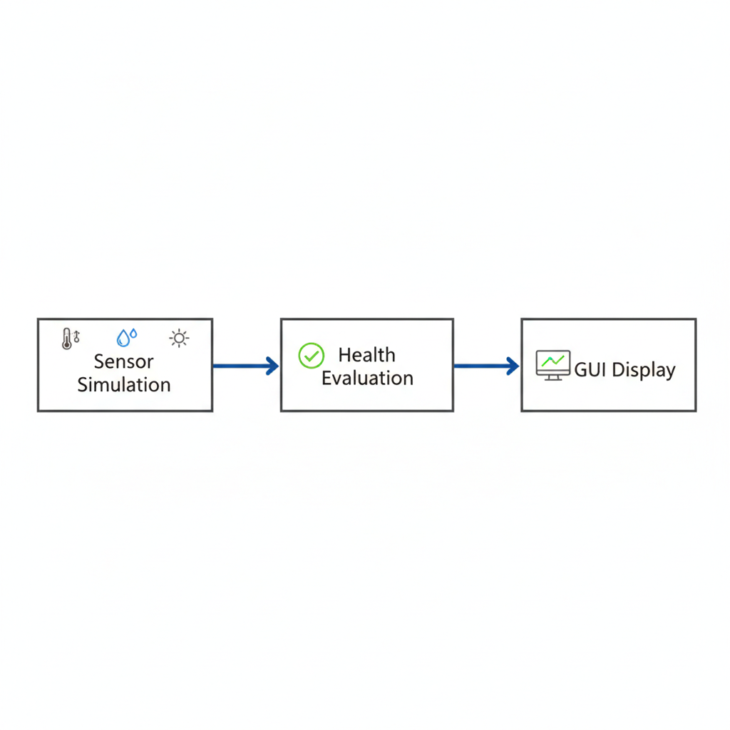

Methodology: 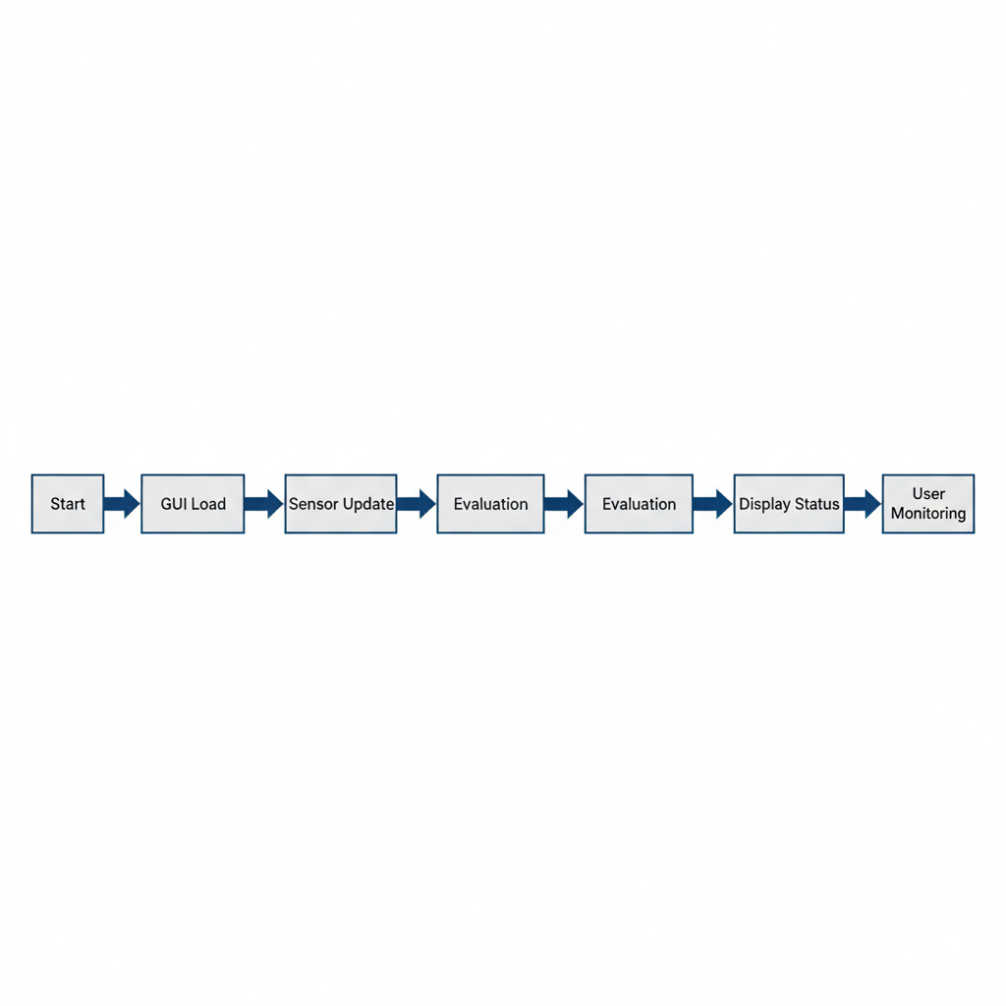
Tools and Technologies:
- Java JDK 17
- IntelliJ IDEA Community Edition
- Java Swing
- Object-Oriented Programming
- Swing Timer

Approach:
- Simulate sensor readings for temperature, soil moisture, and light using Java Random class.
- Evaluate the plant health using thresholds to assign Healthy, Warning, or Critical status.
- Display the data and status in a real-time graphical interface.
Example Code Snippet (Sensor Simulation):
Random random = new Random();
int temperature = 20 + random.nextInt(11); // 20-30°C
int moisture = 30 + random.nextInt(41); // 30-70%
int light = 100 + random.nextInt(201); // 100-300 lx

System Architecture
The system has three main components:
- Sensor Simulation: Generates dynamic readings for temperature, soil moisture, and light.
- Health Evaluation: Compares sensor values to thresholds and determines plant health status.
- GUI Display: Updates and shows sensor readings and health status in real time using Java Swing.
Example Code Snippet (Health Evaluation):
if(temperature < 15 || temperature > 35) status = "Critical";
else if(temperature < 20 || temperature > 30) status = "Warning";
else status = "Healthy";

Process Flow
- Application starts → GUI loads
- Timer triggers updates every 3 seconds
- Sensor values are generated
- Health evaluation logic runs
- Color-coded status displayed
- User views real-time data
Flow Diagram:
Application Start → GUI Load → Sensor Update → Evaluation → Display Status → User Monitoring

Individual Contribution
I completed this project independently. My responsibilities included:
- Writing all Java code for sensor simulation and GUI.
- Implementing real-time updates using Swing Timer.
- Developing the health evaluation logic with thresholds.
- Preparing this report to document methodology, results, and future enhancements.
This project enhanced my understanding of Java programming, object-oriented design, GUI development, and IoT simulation concepts.

Results

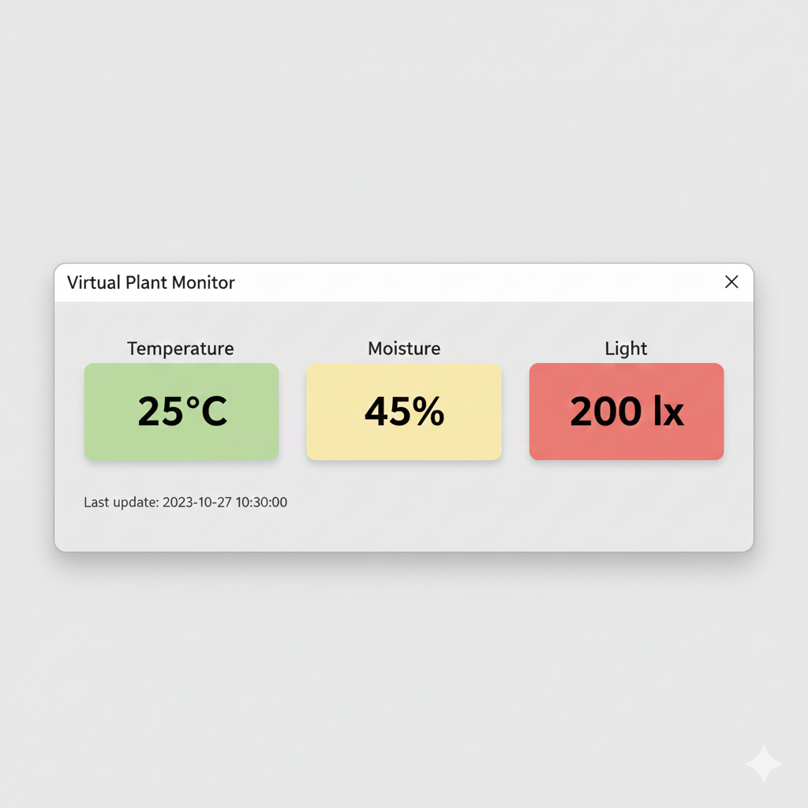
The system successfully simulates plant monitoring in real time. Key results include:
- Automatic updates of temperature, moisture, and light.
- Smooth GUI interface displaying values and status clearly.
- Accurate evaluation of plant health using thresholds.
- Color-coded status: green for Healthy, yellow for Warning, red for Critical.
Sample Output:
Temperature: 25°C (Healthy)
Moisture: 45% (Healthy)
Light: 200 lx (Warning)
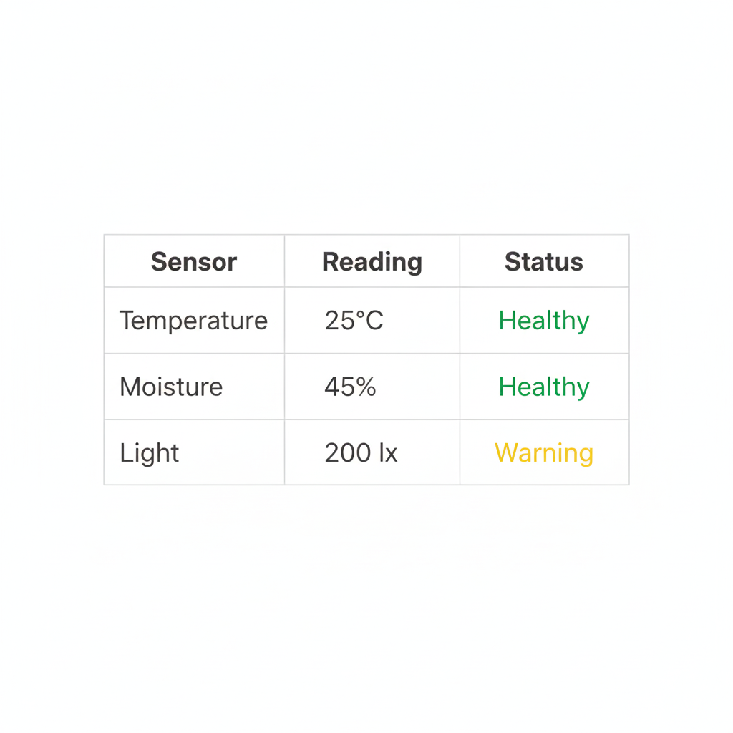

Conclusion
The Virtual Plant Monitor demonstrates that plant health monitoring can be simulated entirely in Java without physical hardware. Through this project, I gained practical experience in GUI design, random data simulation, and real-time programming. The simulation accurately represents IoT functionality and provides a strong foundation for future enhancements.

Future Enhancements
- Integrating real sensors using Arduino or ESP32.
- Adding cloud storage for long-term data logging.
- Creating a mobile app interface for remote monitoring.
- Implementing AI-based plant care suggestions.
- Monitoring multiple plants simultaneously.

