Testing: 10/02/2020

- Create profile is not working “error”
- Picture is not viewing on the selection time on Create Profile.
- On watchlist show page share popup autosearchcontainer hide the buttons.
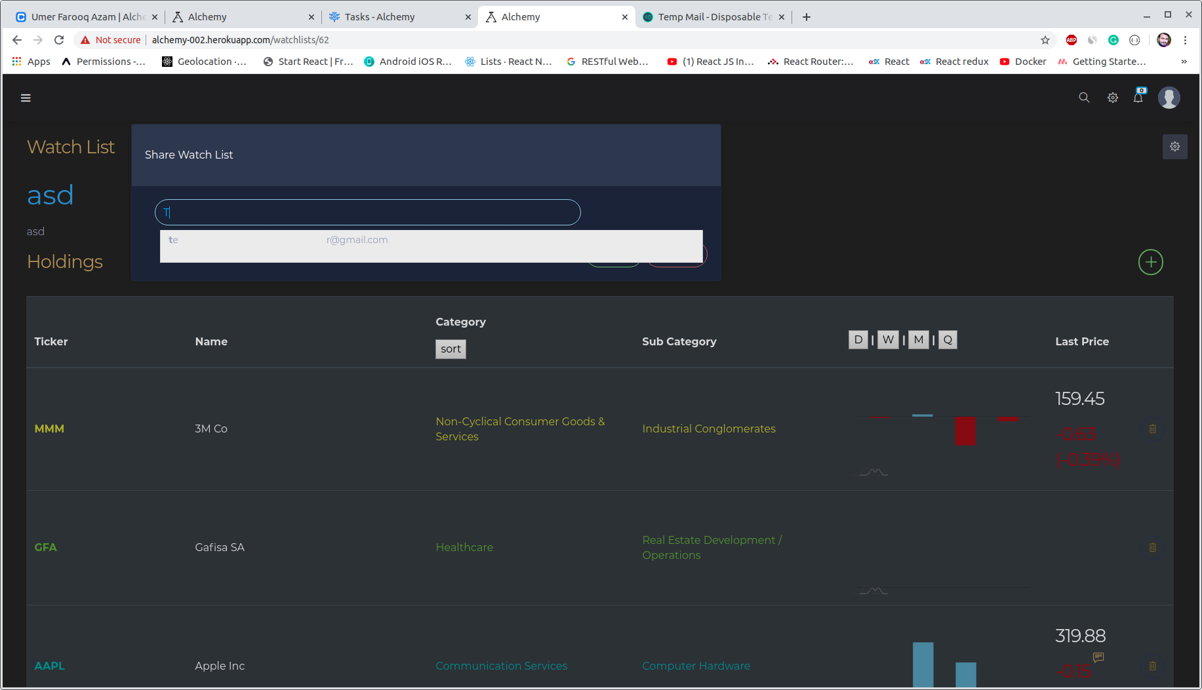

- Fields widths is not customized:
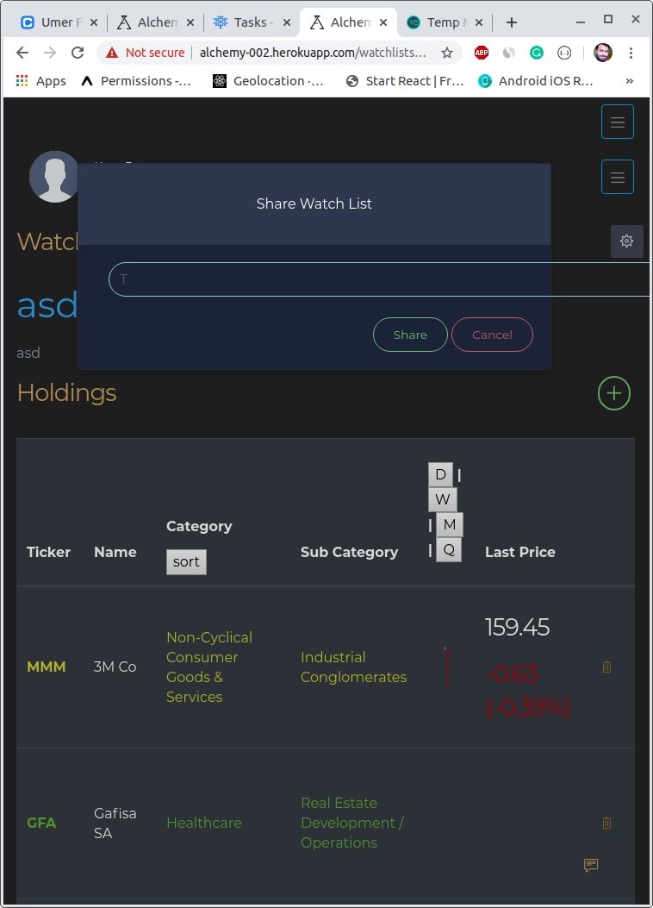

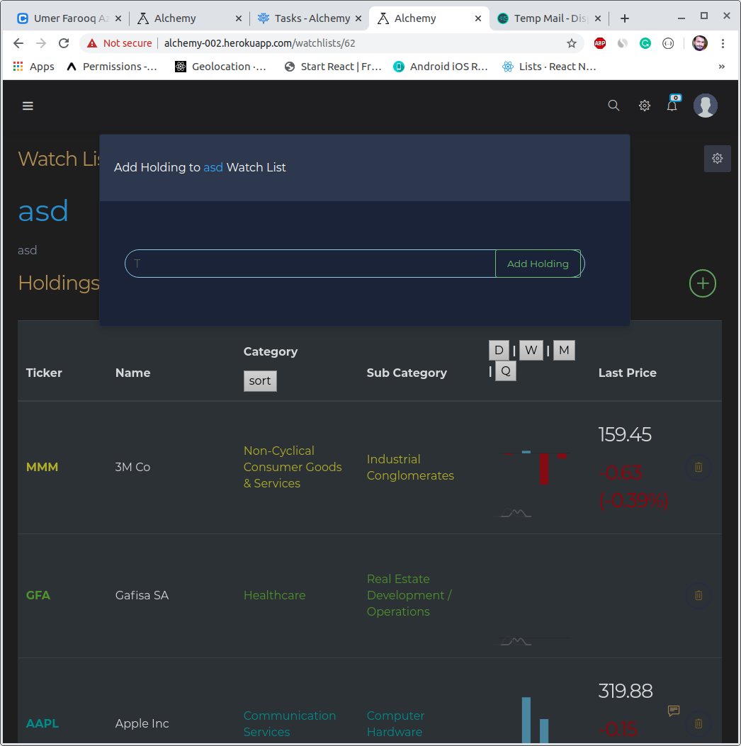

- On Rolling return page:
Table and graphs should be full-width size and the buttons to change the background is not present and option in selection tab is not changed.
this is same for the both 12 month and 24 months and once the 12 or 24 month selected unable to select one month…
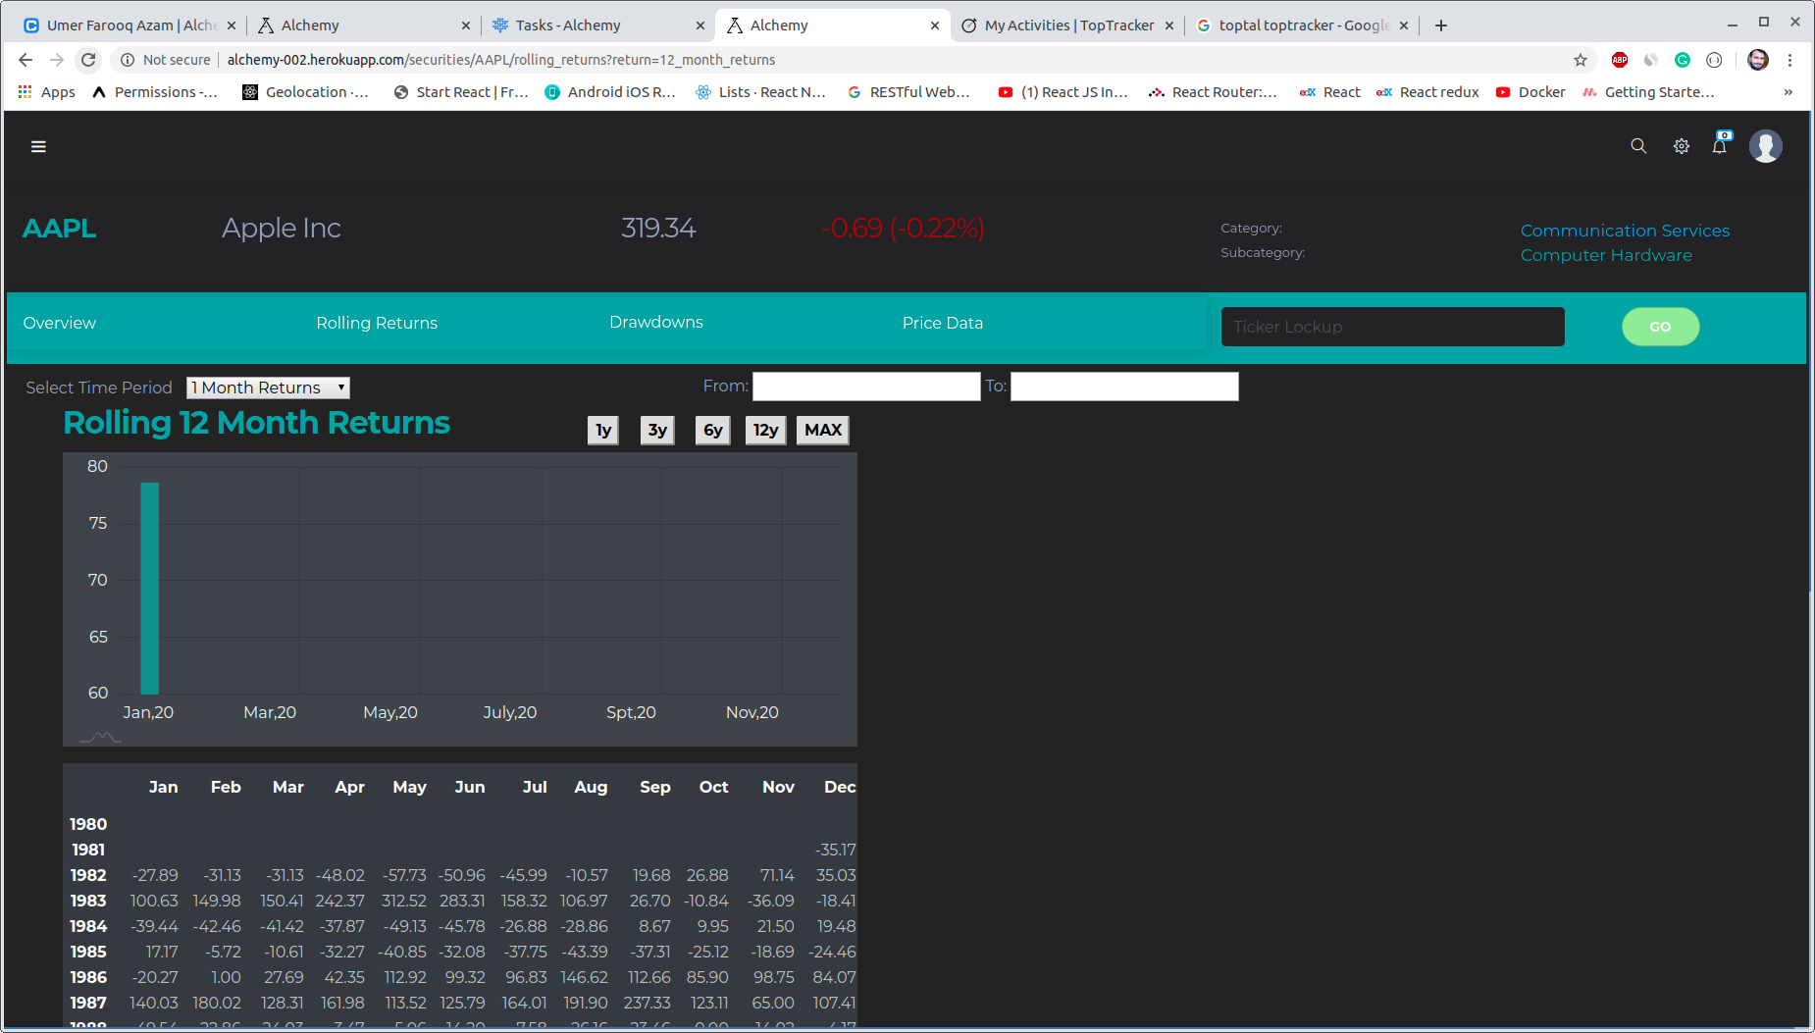

- On watch list index page open and edit link are not wroing..

- Customization required

