**Business Math Week 1 Additional Notes/Notation**

**Definition:** A function is a relationship (x,y) so that for every value of x there can be only one value of y. On a graph we call this the vertical line test.

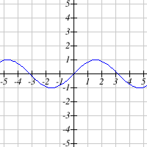 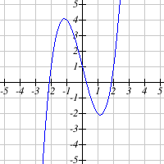

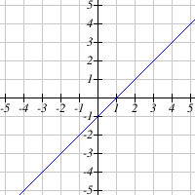 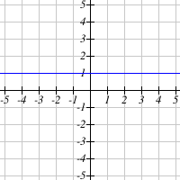

These are all functions.

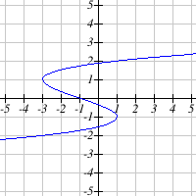 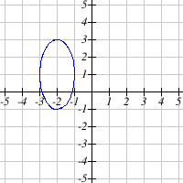

These two graphs are not functions (because they fail the vertical line test).

Given a table of (x,y) values, we can tell if a relationship is a function, and then also is it “one-to-one” if each “x” value appears once and each “y” value also only appears once!

|  |  |  |  |
| --- | --- | --- | --- |
| $$x$$ | 3 | 10 | 12 |
| $$y$$ | 4 | 7 | 14 |
|  |  |  |  |
| $$x$$ | 3 | 10 | 12 |
| $$y$$ | 4 | 7 | 7 |
|  |  |  |  |
| $$x$$ | 3 | 10 | 10 |
| $$y$$ | 4 | 7 | 14 |

< -- here we see an example of a function that is also one-to-one

< -- here we see a function, but it is not one-to-one because 7 repeats

< -- here we see a relationship that is not a function.

++++++++++++++++++++++++++++++++++++++++++++++++++++++++++

The plot below represents the function $f\left(x\right)$  
  
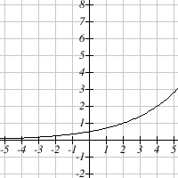 First let’s list some (x,y) points from the graph.

We can estimate if needed.

(0, ½) is on the graph. This means we say “f(0)=1/2”

(2, 1) and (4, 2) are also on the graph.

Anything more we’d have to estimate.

When we ask “what is f(2)” we are looking for the y value when x = 2. Looking at the points we listed, we have (2, 1) $f\left(2\right)=$ 
  
 1

When asked to solve $f\left(x\right)=2$, we are looking for a point ( **?** , 2 ). In other words, it is y = 2, what is x ? Looking at points we listed above, we have ***(4, 2)***  
For f(x) = 2 , ***this is really saying*** y = 2. Therefore, the answer is: $x$ = 4

+++++++++++++++++++++++++++++++++++++++++++++++++++++++++++

|  |  |  |  |  |  |  |  |  |  |  |
| --- | --- | --- | --- | --- | --- | --- | --- | --- | --- | --- |
| $$x$$ | 0 | 1 | 2 | 3 | 4 | 5 | 6 | 7 | 8 | 9 |
| $f\left(x\right)$ =y | 96 | 68 | 7 | 1 | 94 | 58 | 51 | 36 | 85 | 25 |

What if we have a table?   
  
Evaluate $f\left(7\right)$ Solve f(x) = 1 (same thing as y = 1) $f\left(7\right)$ 
  
 = y when x is 7 = 36 x = 3 (look for an x that is paired with 1)

**Evaluate** and **Solve** (what is the difference):

When $f\left(x\right)=9x^{2}-4x+1$, evaluate $f\left(-5\right)$

“Evaluate” means use the formula and calculate the value $f\left(-5\right)=$ $9⋅{\left(-5\right)}^{2}-4⋅\left(-5\right)+1$
  
   = $9⋅25+20+1$ = 246

Given $f\left(x\right)=-7x+1$. When convenient we use “y” in place of “f(x)”.  
  
Solve $f\left(x\right)=29$“Solve” also means to calculate a value. We are “solving” for x.

$$y=-7x+1 with y=29$$

$$29=-7x+1$$

$$28=-7x$$

$28÷\left(-7\right)=x$ which means $x=-4$

+++++++++++++++++++++++++++++++++++++++++++++++++++++++++

Here is another time we are asked to evaluate something.

The total cost (in dollars) to produce $q$ units of a good is given by the function:

$$C\left(q\right)=6.9q+42000q=7100$$ units? Answer: $6.9⋅7100+42000$  
  
Cost = $ 90,990

++++++++++++++++++++++++++++++++++++++++++++++++++++++++++

**Domain/Range**

Find the domain and range of the function graphed below.  
  
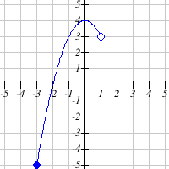Domain:

left is a [ and on the right is )... $[-3, 1)$

Range:  lower and upper are both included, so [ and ]

Answer: $[-5, 4]$

With practice this gets easier...

***The following will only be on the Week 1 quiz. You will not see these on the test or on future tests/quizzes. It’s only so you can have some experience with it.***

Given a split function, what does this mean?

$f\left(x\right)=\left\{\begin{matrix}8x+9 & x<0 \\ 8x+18 & x≥0\end{matrix}\right.$

“ $x < 0$” means “x is negative” and “ $x ≥0$” means “x is 0 or positive”

More descriptive way of stating this function:

IF x is negative, choose the equation **y = 8x + 9**

Otherwise, IF x is 0 or x is positive, choose the equation **y = 8x + 18**  
  
Some examples of how this works: $f\left(-1\right)=___$ 
 ? **x is $-1$**  so we choose **y = 8x + 9**. $f\left(-1\right)=8⋅\left(-1\right)+9=-8+9=1$

Answer: $f\left(-1\right)=1$

These two values of x are 0 and positive, so choose the equation $y=8x+18$

$f\left(0\right)=$ $8⋅0+18=18$ $f\left(2\right)=$ $8⋅2+18=34$

   
  

++++++++++++++++++++++++++++++++++++++++++++++++++

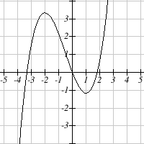**Increasing/Decreasing Always use ( )**  
  
The function graphed is:  
  
Increasing on the interval(s) $(-∞,-2)∪(1,∞)$   
  
 When the graph goes off the page we assume infinity, either $-∞$ or $∞$

Decreasing on the interval(s) $(-2, 1)$

 

Increasing is “going up” from left to right.

Decreasing is “going down” from left to right.