A Complete Shop Solution System

( By Shubham Tiwari )

**SNAPSHOTS**

Homepage

Figure : Homepage loads on application launch

Figure : User Redirects to Invoice Generate page through which user can generate invoices

Figure : Sample Invoice – Details are blurred due to privacy concerned

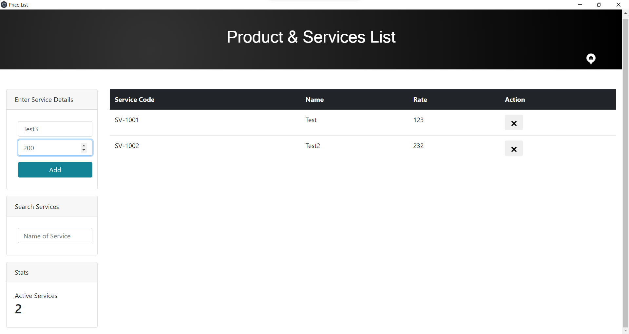

Figure : User can add, modify & track the list of products & services

Figure : Sales Report