**R-One Gripper Project**

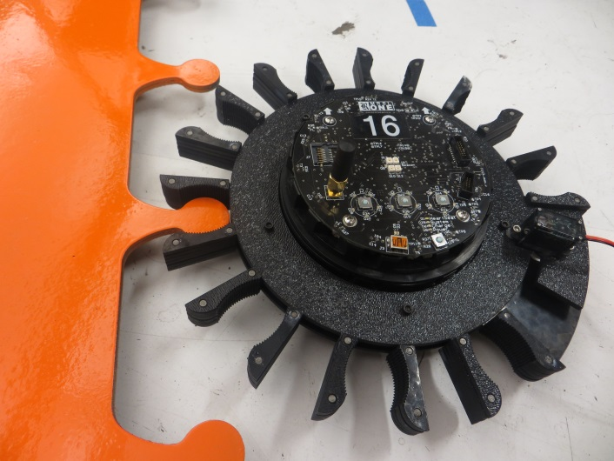

[cover.jpg]

The purpose of this project is to give the current r-one robots an improved capacity to interact with their environment and each other through an externally attached gripper apparatus.

By creating a free rotating, omni-directional gripper, the r-ones can now

* Grab and move objects to desired locations.
* Assist one another in moving objects that require more than one robot.
* Travel in a variety of formations, including linear and close-packed configurations.

Motivation

Ultimately, we want our r-one robots to interact with their environment and accomplish tasks autonomously. The first step in this endeavor is to grant them the ability to grab on to things. One can imagine a future scenario where thousands of small swarm robots dig through rubble after an earthquake in search of survivors. For now, we operate in a quasi-2D environment. As such, the grippers are optimized for moving and gripping objects in this simplified world.

Notes on design

All black ABS plastic parts were designed in SolidWorks and fabricated using an X-660 Laser Cutter. Most assemblies used some combination of screws, nuts, nylon spacers, dowel pins, or super glue.

Mark 1

The Mark 1 gripper was optimized for small, cylindrical objects, such as a pen or screwdriver. This gripper was comprised of three planar pieces of 1/8” ABS plastic (the rest use the same material). The central piece was free rotating such that a slot and servo mechanism could open and close the gripper.

Pros: Simple, omnidirectional

Cons: No robot-robot interconnect functionality; hard to release objects; not free rotating.

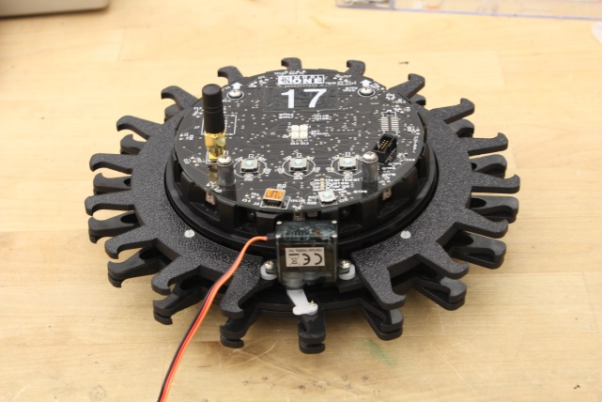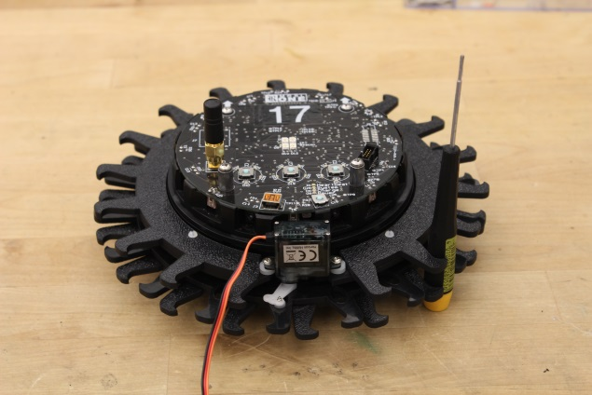

[MK1_1.jpg] [MK1_2.jpg]

Mark 2

The Mark 2 continued the trend of cylindrical object optimization, and serrations were added in order to increase the applied pressure and prevent unwanted rotation of an object when gripped. Furthermore, this gripper utilized six layers of laser-cut plastic with dowel pins at the tips of the gripper hooks. These alternating pins allowed the robots to successfully connect to one another and move in unison.

Pros: Retained/improved gripper functions; robot-robot connections now possible. Roomba functionality (see video).

Cons: Bulky, complicated, not free rotating.

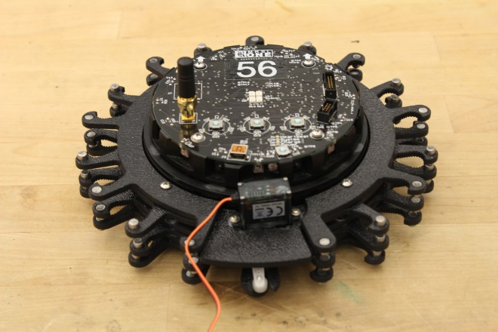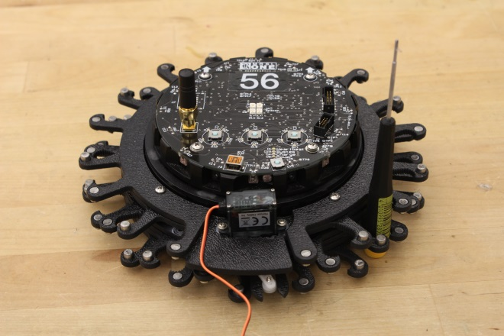

[MK2_1.jpg] [MK2_2.jpg]

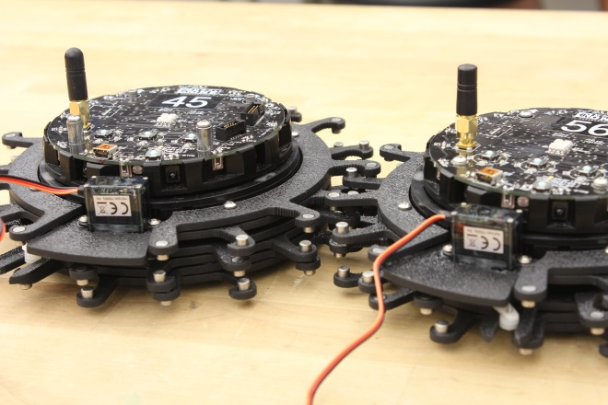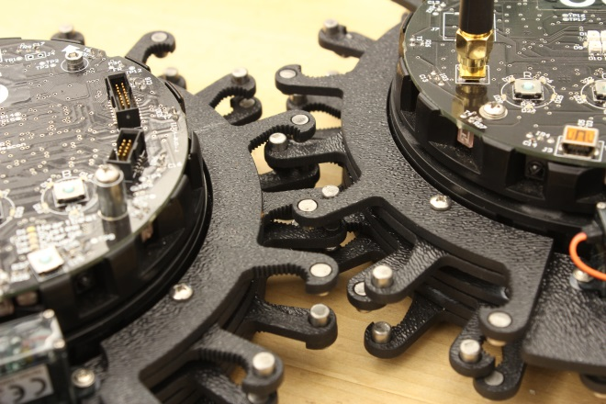

[MK2_3.jpg] [MK2_4.jpg]

Mark 3

The Mark 3 uses a much less “hooky” design. Serrated and slightly curved, the clamps are used in place of the gripper hooks. The prototype boasts a free rotating assembly that rests on other pieces of plastic; the friction of free rotation is minimal. The Mark 3A utilizes a conventional servo and slot mechanism for closing and opening the gripper, and the Mark 3B uses a pin gear assembly with a brushless DC motor instead.

Pros: Free rotating with 180 degree limit stop, can grip a variety of larger objects, retains robot-robot connection and allows for close-packed formations.

Cons: The assembly is a bit large, which slightly hinders the balance of the r-one. The size is determined by the spacer tolerances and the limitations on the ring width of the bottom gripper (if this ring were two thin, the gripper pieces might snap off).

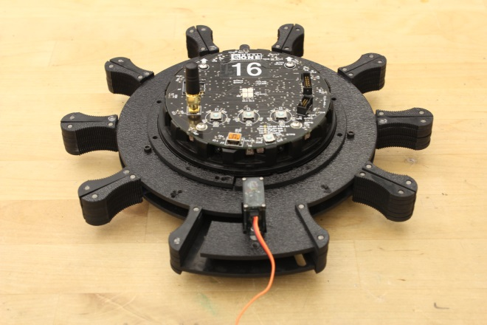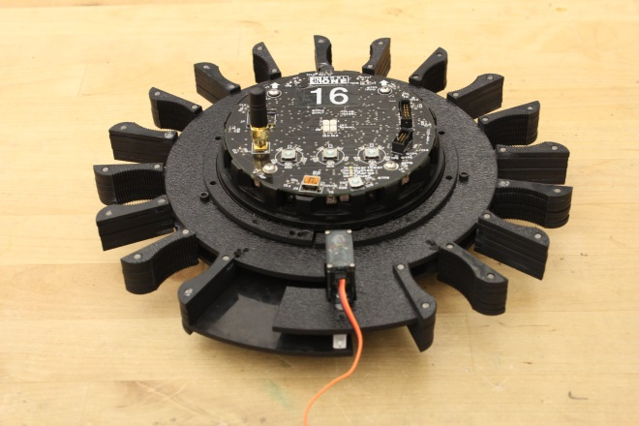

[MK3A_1.jpg] [MK3A_2.jpg]

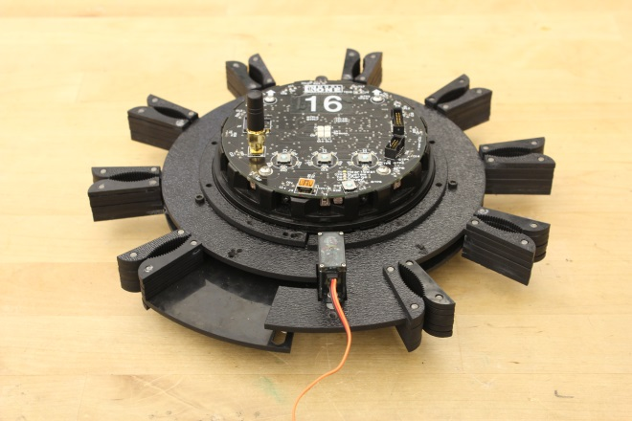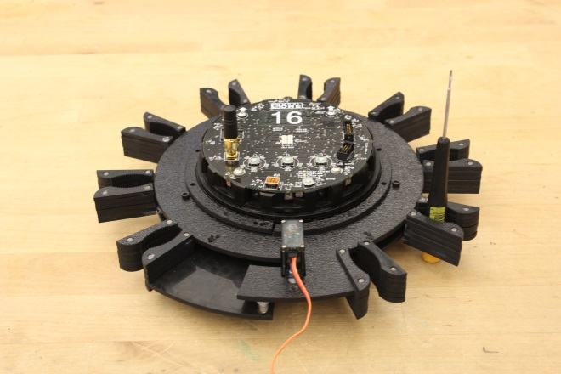

[MK3A_3.jpg] [MK3A_4.jpg]

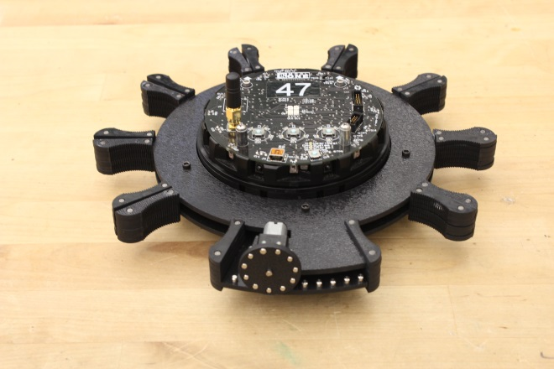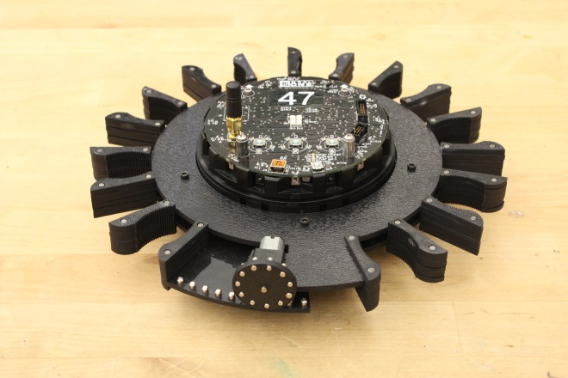

[MK3B_1.jpg] [MK3B_2.jpg]

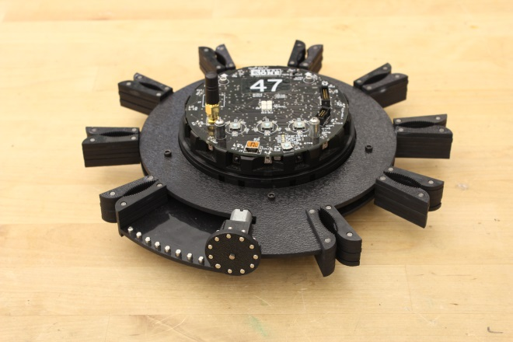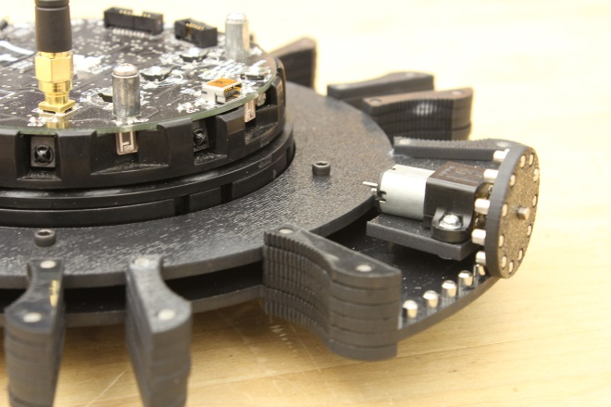

[MK3B_3.jpg] [MK3B_4.jpg]

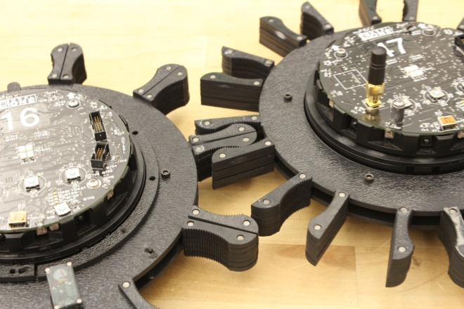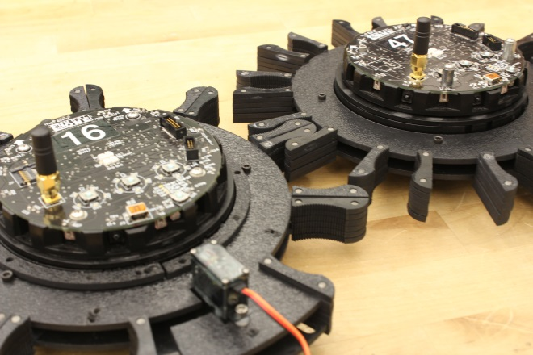

[MK3_1.jpg] [MK3_2.jpg]

Future Plans

The Mark 3 will soon feature a mechanism that will lock the servo or motor in the default position at the rear of the robot. This addition will also return the motor to the default position when needed. In this way, we can choose when the gripper is free-rotating or not, depending on the application. Down the line, a final prototype will be made with injection molding in mind for simplified mass-production.