specs / pin usage
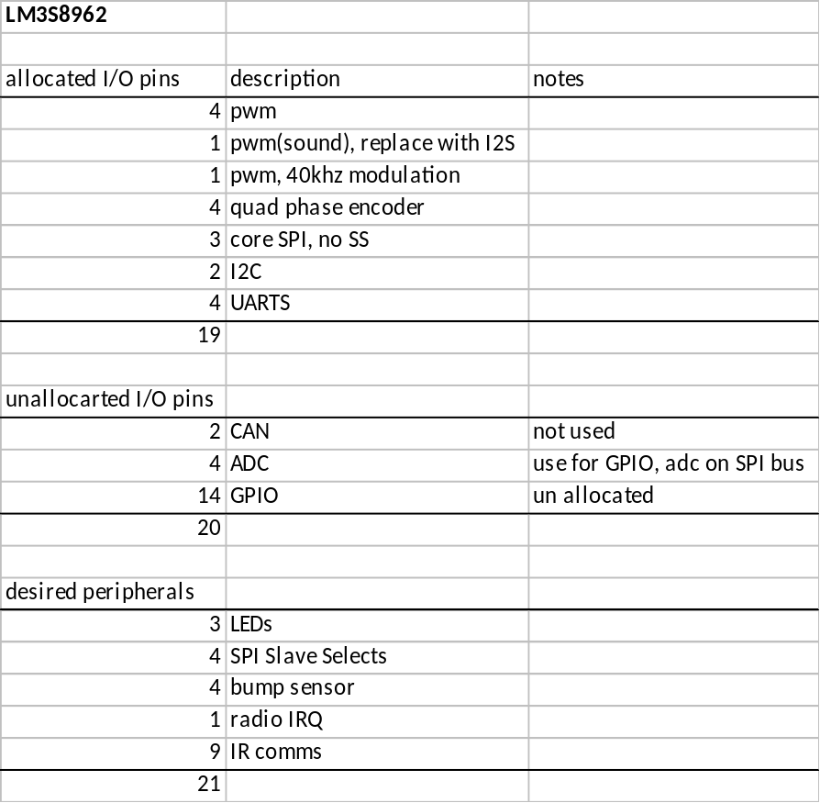

schedule

2010-04-09 rev 0.1 out
8962 cpu
single cell LiPo battery
new power supply with USB charger
motors w/ pololu encoders
new motor controllers
space for new motors with extended axles
radio prototyping section
positioning LED emitter
(separate board for IR comms testing)
(separate board for motor driver/encoder testing)

2010-04-23 rev 0.1 received

2010-05-17 rev 0.2 out
motors with extended shafts
new encoders
top board:
color LED emitters
IR comms system

2010-06-07 rev 0.2 received

2010-07-05 rev 1.0 out

2010-08-02 rev 1.0 received
PCB back from fab

2010-08-23 Rice classes start

expansion feature list
ax-12 servo
gumstix cpu
text-based LCD screen I2C

personal

ENGI1XX
James McLurkin
Scott Rixner
Marcia O'Malley <omalleym@rice.edu>
Andrew Lynch, ?
Joshua Rykowski, radio network
Thomas Barr, Python interpreter
Dennis Qian, server, game designer
Siegfried Bilstien, low-level C code
Alvin Chou, sensor design, testing, encoders, IR comms, bump sensors
Hyun Jin Kim, sensor design, testing, encoders (not summer)
Brian Shields, client UI
(ARTSI) Brandon Heath, camera processing?
(ARTSI) James Hill, camera processing?
(Rixner Firstyear) Lan Li, client UI
(Rixner Firstyear) Kathleen Foster, programming python – doing the assignments, write part of the API, write lab handouts
(Rixner Firstyear) Joan Chao, ?

mrone
James McLurkin
Scott Rixner
Ed Olsen
Paul Grayson
Andrew Lynch, ?
Thomas Barr, Python interpreter
Joshua Rykowski, radio network
Alvin Chiu, sensor design, testing, encoders, IR comms, bump sensors

Tasks
* some write specification of server protocol

