Table A.3.1 Basic Information

SITE INFORMATION
VISN | $job_num$
VA Medical Center Location | $va_loc$
Contact Information | $va_contact$
Phone | $va_contact_phone$
Email | $va_contact_email$
Evaluators | $evaluators$
Date | $insp_date$
BOILER DESCRIPTION
Boiler # | $boiler_num$
Manufacturer | $boiler_mfr$
Model and Capacity | $boiler_model$
Serial #: National Board # | $boiler_sn$
Typical Operating Pressure | $boiler_op_press$
Design Pressure | $boiler_dgn_press$
Date of Manufacture | $boiler_mfr_date$
BOILER CONTROL DESCRIPTION
Manufacturer | $boiler_ctl_mfr$
Model | $boiler_ctl_model$
Date of Manufacture | $boiler_ctl_mfr_date$
BURNER DESCRIPTION
Manufacturer | $boiler_burner_mfr$
Model # | $boiler_burner_model$
Fuels | $boiler_burner_fuels$
Date of Manufacture | $boiler_burner_mfr_date$

$va_loc$ | Boiler $boiler_num$

REPORT CERTIFICATION (All Pass)

I certify that I have properly tested all applicable safety devices listed in this report for boiler #$boiler_num$ and its associated equipment and I certify that all of these tests confirm that every device tested “passed” as defined by the following question: Did the device fail or pas the 3 question criteria?

$evaluator_lead$
PRINTED NAME |  | SIGNATURE |  | DATE
$evaluator_lead_title$ |  | Caldaia Controls, LLC
Position Title |  | Company

I certify that I have properly witnessed all applicable safety devices listed in this report for boiler #$boiler_num$ and its associated equipment and I certify that all of these tests confirm that every device tested “passed” as defined by the following question: Did the device fail or pas the 3 question criteria?

$va_witness$
PRINTED NAME |  | SIGNATURE |  | DATE
$va_witness_title$
Position Title

$va_loc$ | Boiler $boiler_num$

REPORT CERTIFICATION (Failures)

I certify that I have properly tested all applicable safety devices listed in this report for boiler #$boiler_num$ and its associated equipment and I certify that some of these tests failed as defined by the following question: Did the device fail or pas the 3 question criteria? More details of these failures are given in Appendix F (Comments on each individual test)

$evaluator_lead$
PRINTED NAME |  | SIGNATURE |  | DATE
$evaluator_lead_title$ |  | Caldaia Controls, LLC
Position Title |  | Company

I certify that I have properly witnessed all applicable safety devices listed in this report for boiler #$boiler_num$ and its associated equipment and I certify that some of these tests failed as defined by the following question: Did the device fail or pas the 3 question criteria? More details of these failures are given in Appendix F (Comments on each individual test)

$va_witness$
PRINTED NAME |  | SIGNATURE |  | DATE
$va_witness_title$
Position Title

$va_loc$ | Boiler $boiler_num$
Contents
REPORT CERTIFICATION (All Pass) 5
REPORT CERTIFICATION (Failures) 6
1. Low Water Alarm and Cutoffs on Boiler [$lwa_lwco_alwco_result_status$] 9
2. High Water Alarm on Boiler [$hwa_result_status$] 11
3. High Boiler Steam Pressure Limit and High-High Boiler Steam Pressure Limit Switches (HP) [$rbspls_nrbspls_result_status$] 13
4. Steam Safety Valves on Boiler (HP) [$svb_result_status$] 15
5. High Boiler Steam Pressure Limit and High-High Boiler Steam Pressure Limit Switches (LP) [$rbspls_nrbspls_lp_result_status$] 17
6. Steam Safety Valves on Boiler (LP) [$svb_lp_result_status$] 19
7. Low Fuel Gas Pressure Cutoff Switch [$lfgpcs_result_status$] 21
8. High Fuel Gas Pressure Cutoff Switch [$hfgpcs_result_status$] 23
9. Automatic Fuel Gas Shutoff Valves & Solenoid Vent Valve Seat Leakage [$afgsov_afgsvv_result_status$] 25
10. Automatic Pilot Fuel Gas Shutoff Valves & Automatic Pilot Fuel Gas Solenoid Vent Valve Seat Leakage [$apfgsov_apfgsvv_result_status$] 27
11. Proof of Closure on Automatic Fuel Shutoff Valves [$pocafgsov_result_status$] 29
12. Flame Scanner For Main Flame Out [$fsmf_result_status$] 30
13. Flame Scanner Not Sensing Igniter Spark [$fsnsis_result_status$] 31
14. Igniter Timing [$it_result_status$] 33
15. Main Flame Ignition Timing [$mfit_result_status$] 34
16. Pre-Purge and Post-Purge Timing [$ppt_result_status$] 36
17. Low-Fire Proving Switch [$lfps_result_status$] 37
18. Forced Draft Damper Wide-Open Pre-Purge Proving Switch [$fddwops_result_status$] 39
19. Combustion Air Pressure Switch – Variable Speed [$capsvs_result_status$] 40
20. Combustion Air Pressure Switch – Constant Speed [$capscs_result_status$] 42
21. Purge Airflow Proving Switch [$paps_result_status$] 44
22. Forced Draft Motor Interlock Switches [$fdmis_result_status$] 46
23. Outlet Stack Damper Position Interlock Switch [$osdpi_result_status$] 48
24. Furnace Pressure Interlock [$fpi_result_status$] 49
25. Low Pilot Fuel Gas Pressure Cutoff Switch [$lpfgpcs_result_status$] 51
26. Low Pilot Fuel Gas Pressure Cutoff Switch 2 [$lpfgpcs2_result_status$] 53
27. Flue Gas Recirculation Damper Interlock [$fgrdi_result_status$] 55
28. Low Flue Gas Oxygen Level Interlock [$lfgoli_result_status$] 56
29. Low Fuel Oil Pressure Cutoff Switch [$lfopcs_result_status$] 57
30. High Fuel Oil Pressure Cutoff Switch [$hfopcs_result_status$] 59
31. Low Atomizing Media Pressure Switch [$lamps_result_status$] 61
32. Low Atomizing Media Pressure Switch [$lamps_amc_result_status$] 64
33. Low Atomizing Media Differential Pressure Switch [$lamdps_result_status$] 66
34. Secondary Low Atomizing Media Pressure Switch [$slamps_result_status$] 68
35. Secondary Low Atomizing Media Pressure Switch [$slamps_amc_result_status$] 70
36. Automatic Fuel Oil Shutoff Valves [$afosov_result_status$] 72
37. Proof of Closure on Automatic Fuel Oil Shutoff Valves [$pocafosov_result_status$] 74
38. Oil Burner Position Switch [$obps_result_status$] 75
39. Control Air Pressure Interlock [$capi_result_status$] 76
40. Low Water Cutouts - Hot Water [$lwcohw_result_status$] 78
41. Liquid Relief Valves - Hot Water [$lrvhw_result_status$] 80
42. High Water Temperature Switch [$hwts_result_status$] 82
43. Flow Switch [$fs_result_status$] 84
44. Liquid Relief Valve on Economizer [$lrve_result_status$] 85
45. Propane Pilot Backup System [$ppbs_result_status$] 87
Appendix F: Comments 88

$va_loc$ | Boiler $boiler_num$

1. Low Water Alarm and Cutoffs on Boiler [$lwa_lwco_alwco_result_status$]
(LWA/LWCO/ALWCO) (For Steam Boiler System only)

Item | Make | Float / Probe
LWA | $lwa_make$ | $lwa_type$
LWCO | $lwco_make$ | $lwco_type$
ALWCO | $alwco_make$ | $alwco_type$

- An Independent shunt (bypass) switch is required to be installed for each LWCO
- The VA requires one float and one probe low water cutoff. No automatic re-start after a low water cut out is allowed by the VA.
- Visible separation of water level in sight glass between all alarms is required. Water level in sight glass is required to be visible for all alarms and cutouts.

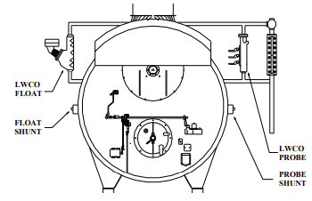

- IN PERFORMING TEST NEVER LET WATER LEVEL LEAVE SIGHT GLASS!!!
- Drain sight glass without draining alarm column. Quickly close drain valve. Water level should quickly rise in sight glass indicating good communication with boiler.
- If poor communication, clean lines and begin with the step above.
- With boiler in manual at low fire, close the feedwater valve to generate a slow drain. You may “crack” the blowdown valve but do not exceed a drain rate of 1 inch per minute. Use water level in sight glass to observe alarm point. The alarm should sound first.
- Continue to drain until the primary cutoff activates.
- If shunt (bypass switch) exists, verify that it ONLY isolates the LWCO.
- Shunt (use bypass switch) the primary cutoff, restart the boiler, and set up drain as described above until the secondary cutoff activates.

$va_loc$ | Boiler $boiler_num$

Result | Y/N | Water Level
Correct installation including shunts? | $lwa_lwco_alwco_result_1$
Did the LWA work correctly? Record Level. | $lwa_lwco_alwco_result_2$ | $lwa_lwco_alwco_result_3$
Did the Primary cutoff work correctly? Record Level. | $lwa_lwco_alwco_result_4$ | $lwa_lwco_alwco_result_5$
Did the secondary cutoff work correctly and require manual reset of BMS? Record Level | $lwa_lwco_alwco_result_6$ | $lwa_lwco_alwco_result_7$
Was the alarm point above the primary and secondary cutoff point? | $lwa_lwco_alwco_result_8$

Did the device fail or pass the 3 Question Criteria (section 1.3.1)? [$lwa_lwco_alwco_result_status$]
If boiler is to be operated with failed safety device, a properly approved ISM is required.
Describe safety device failure/remedy in Appendix F.

$va_loc$ | Boiler $boiler_num$

2. High Water Alarm on Boiler [$hwa_result_status$]
(HWAB) (For Steam Boiler System only)

Item | Make | Float / Probe
HWA | $hwa_make$ | $hwa_type$
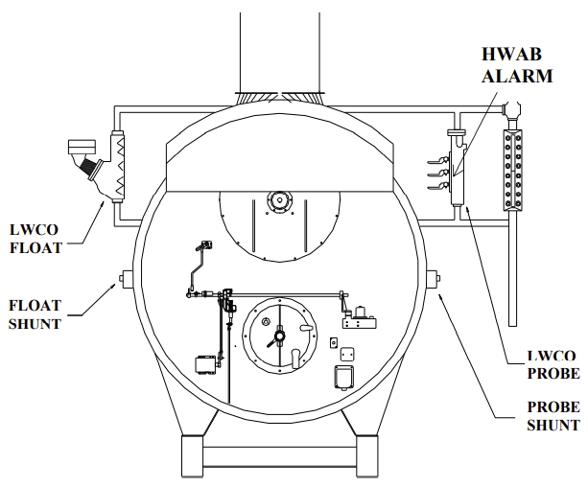

- Drain sight glass without draining alarm column and quickly close drain valve. Water level should quickly rise in sight glass indicating good communication with boiler.
- If poor communication, clean lines and begin with the step above.
- With boiler off, open the bypass feedwater valve to fill the boiler. Use water level in sight glass to observe alarm point. The alarm should sound before water level leaves sight glass.
- DO NOT ALLOW WATER LEVEL TO LEAVE SIGHT GLASS
- Close the bypass on feedwater line

$va_loc$ | Boiler $boiler_num$

Result | Y/N | Water Level
Correct Installation? | $hwa_result_1$
Did the high water alarm work correctly? Record Level. | $hwa_result_2$ | $hwa_result_3$

Did the device fail or pass the 3 Question Criteria (section 1.3.1)? [$hwa_result_status$]
If boiler is to be operated with failed safety device, a properly approved ISM is required.
Describe safety device failure/remedy in Appendix F.

$va_loc$ | Boiler $boiler_num$

3. High Boiler Steam Pressure Limit and High-High Boiler Steam Pressure Limit Switches (HP) [$rbspls_nrbspls_result_status$]
(HBSPLS & HHBSPLS) (For Steam Boiler System only)

Item | Make | Range | Switch Setpoint | Normal  Steam  Pressure | Lowest  SVB  Setpoint
HBSPLS | $rbspls_make$ | $rbspls_range$ | $rbspls_sp$ | $boiler_op_press$ | $lowest_svb_sp$
HHBSPLS | $nrbspls_make$ | $nrbspls_range$ | $nrbspls_sp$
Pressure Gauge | $rbspls_nrbspls_gauge_make$ | $rbspls_nrbspls_gauge_range$

- HBSPLS setpoint is required to be 10 psi or more above normal steam pressure.
- HHBSPLS setpoint is required to be 5 psi or more above the HBSPLS pressure setpoint & 5 psi or more less than the lowest SVB setpoint. No boiler shall restart automatically after activation of either steam limit switch. Manual reset is required after activation of either steam limit switch.

HBSPLS TEST
- Never exceed the boiler MAWP during this test.
- Place boiler in minimum fire and manually close the steam supply valves from the boiler.
- Raise the steam pressure slowly by firing the boiler.
- Raise until HBSPLS activates – record activation pressure in table below.

HHBSPLS TEST
- Jumper the recycle switch out of the circuit.
- Fire boiler and raise the steam pressure slowly.
- Raise until HHSBPLS activates – record activation pressure in table below.

Result | Y/N | Trip Pressure
Is the HBSPLS setpoint 10 psi or more above normal steam pressure.? Record Pressure. | $rbspls_nrbspls_result_1$ | $rbspls_nrbspls_result_2$
Is the HHBSPLS setpoint 5 psi or more above the HBSPLS pressure setpoint & 5 psi or more less than the lowest SVB setpoint? Record Pressure. | $rbspls_nrbspls_result_3$ | $rbspls_nrbspls_result_4$
Did both switches work correctly? | $rbspls_nrbspls_result_5$

$va_loc$ | Boiler $boiler_num$

Did the device fail or pass the 3 Question Criteria (section 1.3.1)? [$rbspls_nrbspls_result_status$]
If boiler is to be operated with failed safety device, a properly approved ISM is required.
Describe safety device failure/remedy in Appendix F.

$va_loc$ | Boiler $boiler_num$

4. Steam Safety Valves on Boiler (HP) [$svb_result_status$]
(SVB) (For Steam Boiler System only)

Item | Make | Capacity (lb/hr) | Range | SVB  Setpoint | Normal  Steam Pressure
SVB 1 | $svb_1_make$ | $svb_1_capacity$ |  | $svb_1_sp$ | $boiler_op_press$
SVB 2 | $svb_2_make$ | $svb_2_capacity$ |  | $svb_2_sp$
SVB 3 | $svb_3_make$ | $svb_3_capacity$ |  | $svb_3_sp$
Pressure Gauge | $svb_gauge_make$ |  | $svb_gauge_range$

SVB1 is required to be set 5 psig higher than HHBSPLS & no more than 30 psig higher than normal operating pressure. SVB2 is required to be set 5 psig or higher than SVB1 & at least 5 psig or more below boiler MAWP. Each SVB is required to be separately and directly vented outside. Vent lines are required not to contact drip pan ells when hot. Drip Pan ell drains must be piped separately not combined. Steam safety valves on high pressure boilers must be of steel construction.

Item | MAWP (psi) | Capacity (lb/hr)
Boiler | $boiler_mawp$ | $boiler_capacity$
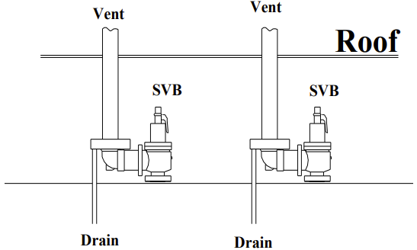

- NEVER ALLOW BOILER PRESSURE TO EXCEED MAWP
- With boiler off, jumper high and high-high steam pressure switches.
- Close the steam supply valves from the boiler and test the drains on the safety valve drip pan ells by pouring water into them and noting that water flows freely. Unstop drains before proceeding.
- Raise the steam pressure slowly by firing the boiler at low fire.
- Note the pressure that the first & subsequent safety valves opened. (may require increasing firing rate).
- Place boiler in high fire and determine if steam pressure rises with both SVB open (Accumulation Test).
- Shut boiler off and note the pressures that the safety valves close.

$va_loc$ | Boiler $boiler_num$

Result | Y/N | Lift (P) | Reseat (P)
Is the Lift & Reseat Pressure correct for #1 SVB? Record Pressures. (See info below for correct values) | $svb_result_1$ | $svb_result_2$ | $svb_result_3$
Is the Lift & Reseat Pressure correct for #2 SVB? Record Pressures. (See info below for correct values) | $svb_result_4$ | $svb_result_5$ | $svb_result_6$
Is the Lift & Reseat Pressure correct for #3 SVB? Record  Pressures. (See info below for correct values) | $svb_result_7$ | $svb_result_8$ | $svb_result_9$
Did annual accumulation test meet requirement listed below? Maximum pressure during accumulation test? | $svb_result_10$ | $svb_result_11$
Is SVB vent and drain plumbing separate and venting adequate? | $svb_result_12$

- Max lift pressure of 3% higher than rated lift pressure. Reset pressure must be prior to reset point of the first steam limit switch.
- Maximum accumulation pressure seen with all SVB’s open and boiler in high fire should not exceed 110% of highest SVB setpoint and never exceed boiler rated pressure.
- The safety relief valve with the lowest setpoint must have a relief capacity of approximately 80% of boiler steam capacity. The safety valve with the higher set pressure must have a relief capacity of at least 100% of boiler steam generating capacity.

Did the device fail or pass the 3 Question Criteria (section 1.3.1)? [$svb_result_status$]
If boiler is to be operated with failed safety device, a properly approved ISM is required.
Describe safety device failure/remedy in Appendix F.

$va_loc$ | Boiler $boiler_num$

5. High Boiler Steam Pressure Limit and High-High Boiler Steam Pressure Limit Switches (LP) [$rbspls_nrbspls_lp_result_status$]
(HBSPLS & HHBSPLS) (For Steam Boiler System only)

Item | Make | Range | Switch Setpoint | Normal  Steam  Pressure | Lowest  SVB  Setpoint
HBSPLS | $rbspls_lp_make$ | $rbspls_lp_range$ | $rbspls_lp_sp$ | $boiler_op_press$ | $lowest_svb_sp$
HHBSPLS | $nrbspls_lp_make$ | $nrbspls_lp_range$ | $nrbspls_lp_sp$
Pressure Gauge | $rbspls_nrbspls_lp_gauge_make$ | $rbspls_nrbspls_lp_gauge_range$

HBSPLS setpoint is required to be 1 psig or more above normal steam pressure. HHBSPLS setpoint is required to be 1 psig or more above the HBSPLS pressure setpoint & 1 psig or more less than the lowest SVB setpoint. No boiler shall restart automatically after activation of either steam limit switch. Manual reset is required after activation of either steam limit switch.

HBSPLS TEST
- Never exceed the boiler MAWP during this test.
- Place boiler in minimum fire and manually close the steam supply valves from the boiler.
- Raise the steam pressure slowly by firing the boiler.
- Raise until HBSPLS activates – record activation pressure in table below.

HHBSPLS TEST
- Jumper the recycle switch out of the circuit.
- Fire boiler and raise the steam pressure slowly.
- Raise until HHSBPLS activates – record activation pressure in table below.

Result | Y/N | Trip Pressure
Is the HBSPLS setpoint 1 psi or more above normal steam pressure.? Record Pressure. | $rbspls_nrbspls_lp_result_1$ | $rbspls_nrbspls_lp_result_2$
Is the HHBSPLS setpoint 1 psi or more above the HBSPLS pressure setpoint & 1 psi or more less than the lowest SVB setpoint? Record Pressure. | $rbspls_nrbspls_lp_result_3$ | $rbspls_nrbspls_lp_result_4$
Did both switches work correctly? | $rbspls_nrbspls_lp_result_5$

$va_loc$ | Boiler $boiler_num$

Did the device fail or pass the 3 Question Criteria (section 1.3.1)? [$rbspls_nrbspls_lp_result_status$]
If boiler is to be operated with failed safety device, a properly approved ISM is required.
Describe safety device failure/remedy in Appendix F.

$va_loc$ | Boiler $boiler_num$

6. Steam Safety Valves on Boiler (LP) [$svb_lp_result_status$]
(SVB) (For Steam Boiler System only)

Item | Make | Capacity (lb/hr) | Range | SVB  Setpoint | Normal  Steam Pressure
SVB 1 | $svb_lp_1_make$ | $svb_lp_1_capacity$ |  | $svb_lp_1_sp$ | $boiler_op_press$
SVB 2 | $svb_lp_2_make$ | $svb_lp_2_capacity$ |  | $svb_lp_2_sp$
SVB 3 | $svb_lp_3_make$ | $svb_lp_3_capacity$ |  | $svb_lp_3_sp$
Pressure Gauge | $svb_lp_gauge_make$ |  | $svb_lp_gauge_range$

- SVB1 is required to be set 5 psi higher than HHBSPLS & 10 psi below boiler MAWP.
- SVB2 is required to be set 5 psi or higher than SVB1 & 5 psi or more below boiler MAWP.
- Each SVB is required to be directly vented outside.
- Vent lines are required not to contact drip pan ells when hot.
- Drip Pan ell drains must be piped separately not combined.

Item | MAWP (psi) | Capacity (lb/hr)
Boiler | $boiler_mawp$ | $boiler_capacity$


- NEVER ALLOW BOILER PRESSURE TO EXCEED MAWP
- With boiler off, jumper high and high-high steam pressure switches.
- Close the steam supply valves from the boiler and test the drains on the safety valve drip pan ells by pouring water into them and noting that water flows freely. Unstop drains before proceeding.
- Raise the steam pressure slowly by firing the boiler at low fire.
- Note the pressure that the first & subsequent safety valves opened. (may require increasing firing rate).
- Place boiler in high fire and determine if steam pressure rises with both SVB open (Accumulation Test).
- Shut boiler off and note the pressures that the safety valves close.

$va_loc$ | Boiler $boiler_num$

Result | Y/N | Lift (P) | Reseat (P)
Is the Lift & Reseat Pressure correct for #1 SVB? Record Pressures. (See info below for correct values) | $svb_lp_result_1$ | $svb_lp_result_2$ | $svb_lp_result_3$
Is the Lift & Reseat Pressure correct for #2 SVB? Record Pressures. (See info below for correct values) | $svb_lp_result_4$ | $svb_lp_result_5$ | $svb_lp_result_6$
Is the Lift & Reseat Pressure correct for #3 SVB? Record  Pressures. (See info below for correct values) | $svb_lp_result_7$ | $svb_lp_result_8$ | $svb_lp_result_9$
Did accumulation test meet requirement listed below? Maximum pressure during accumulation test? | $svb_lp_result_10$ | $svb_lp_result_11$
Is SVB vent and drain plumbing separate and venting adequate? | $svb_lp_result_12$

- Max lift pressure of 3% higher than rated lift pressure. Reset pressure must be prior to reset point of the first steam limit switch.
- Maximum accumulation pressure seen with all SVB’s open and boiler in high fire should not exceed 110% of highest SVB setpoint and never exceed boiler rated pressure.
- The safety relief valve with the lowest setpoint must have a relief capacity of approximately 80% of boiler steam capacity. The safety valve with the higher set pressure must have a relief capacity of at least 100% of boiler steam generating capacity.
- Note: VA specification requires low pressure steam boilers to have a MAWP of 50 psig.

Did the device fail or pass the 3 Question Criteria (section 1.3.1)? [$svb_result_status$]
If boiler is to be operated with failed safety device, a properly approved ISM is required.
Describe safety device failure/remedy in Appendix F.

$va_loc$ | Boiler $boiler_num$

7. Low Fuel Gas Pressure Cutoff Switch [$lfgpcs_result_status$]
(LFGPCS)

Item | Make | Range  (inwc/psi) | Switch  Setpoint  (inwc/ psi) | Regulated Pressure  (inwc/psi)
LFGPCS | $lfgpcs_make$ | $lfgpcs_range$ | $lfgpcs_sp$ | $lfgpcs_reg_pres$
Pressure Gauge | $lfgpcs_gauge_make$ | $lfgpcs_gauge_range$

- LFGPCS is required to be downstream of PRV and upstream of AFGSOV with a setpoint of 80% or higher than regulated pressure. The use of snubbers or dampeners on LFGPCS is prohibited. LFGPCS activation must generate a boiler safety shutdown, annunciate, and require manual reset of the flame safeguard or burner management system.

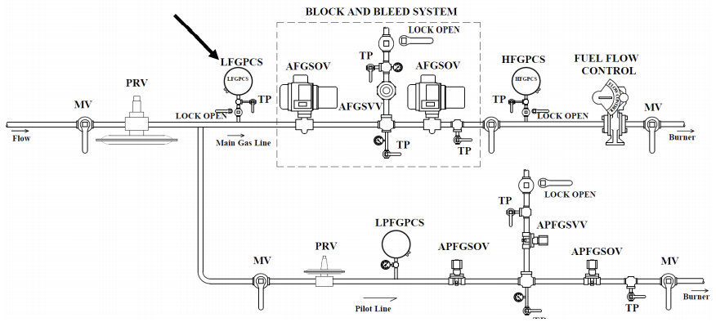

- Connect a line containing a test pressure Gauge followed by a manual needle or globe bleed valve to the test port. The manual valve should be closed.
- Open test port valve.
- With boiler in low fire close lockable manual valve isolating the LFGPCS.
- Slowly open manual bleed valve to reduce pressure until boiler trips offline.

$va_loc$ | Boiler $boiler_num$

Result | Y/N | Pressure
Correct location? Is LOOP Valve and test port in place? | $lfgpcs_result_1$
Did the switch work correctly? Record trip pressure. | $lfgpcs_result_2$ | $lfgpcs_result_3$
Is switch trip point 80% or more of regulated pressure? | $lfgpcs_result_4$
Are snubbers or dampeners not used? | $lfgpcs_result_5$
Did boiler shutdown, annunciate, and require manual reset of system? | $lfgpcs_result_6$

Did the device fail or pass the 3 Question Criteria (section 1.3.1)? [$lfgpcs_result_status$]
If boiler is to be operated with failed safety device, a properly approved ISM is required.
Describe safety device failure/remedy in Appendix F.

$va_loc$ | Boiler $boiler_num$

8. High Fuel Gas Pressure Cutoff Switch [$hfgpcs_result_status$]
(HFGPCS)

Item | Make | Range  (inwc/psi) | Switch  Setpoint  (inwc/psi) | Regulated Pressure  (inwc/psi)
HFGPCS | $hfgpcs_make$ | $hfgpcs_range$ | $hfgpcs_sp$ | $hfgpcs_reg_pres$
Pressure Gauge | $hfgpcs_gauge_make$ | $hfgpcs_gauge_range$

- HFGPCS is required to be downstream of PRV & upstream of flow control with setpoint less than 120% of regulated pressure. HFGPCS activation must generate a boiler safety shutdown, annunciate, and require manual reset of the flame safeguard or burner management system.
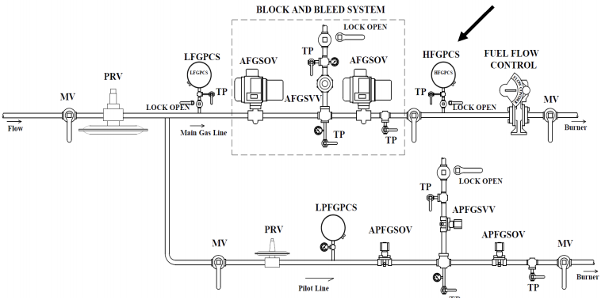

- Connect a line containing a test pressure gage and pump setup to the test port.
- Open test port valve and manual valve in the line connected to test port.
- With boiler in low fire close lockable manual valve isolating the HFGPCS.
- Use a hand air pump to slowly raise the pressure on the HFGPCS but NO HIGHER THAN 120% OF REGULATED PRESSURE.

$va_loc$ | Boiler $boiler_num$

Result | Y/N | Switch Trip Point
Correct location? Is LOOP Valve and test port in place? | $hfgpcs_result_1$
Did switch work correctly? Record Pressure | $hfgpcs_result_2$ | $hfgpcs_result_3$
Is switch trip point 120% or less of regulated pressure? | $hfgpcs_result_4$
Did boiler shutdown, annunciate, and require manual reset of system? | $hfgpcs_result_5$

Did the device fail or pass the 3 Question Criteria (section 1.3.1)? [$hfgpcs_result_status$]
If boiler is to be operated with failed safety device, a properly approved ISM is required.
Describe safety device failure/remedy in Appendix F.

$va_loc$ | Boiler $boiler_num$

9. Automatic Fuel Gas Shutoff Valves & Solenoid Vent Valve Seat Leakage [$afgsov_afgsvv_result_status$]
(AFGSOV & AFGSVV) – Main Gas Line

Item | Make | Range (inwc/psi)
AFGSOV | $afgsov_make$
AFGSVV | $afgsvv_make$
Pressure Gauge | $afgsov_afgsvv_gauge_make$ | $afgsov_afgsvv_gauge_range$

- Maximum allowable leak rate is zero bubbles in 2 minutes.

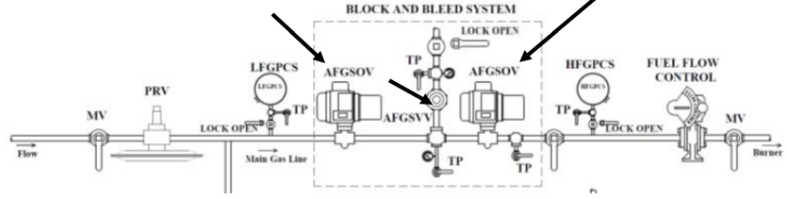

Vent Valve Leak Test
- Connect flexible tubing (approximately ¼ inch diameter and approximately 3 feet long) to the test port in the vent line. Place the open end of the flexible tubing approximately ¼ inch deep in a cup of water.
- With the boiler running in low fire, close the manual lockable valve in the vent line and open the test port valve. If no bubbles appear in the water within a two-minute time period, the vent valve passes.
Upstream AFGSOV Leak Test
- Connect a pressure Gauge to the test port downstream of the two AFGSOV’s and open the test port valve. With the boiler running in low fire, close the manual lockable valve in the vent line and then quickly close the manual valve in the main gas line downstream of the two AFGSOV’s. Observe the pressure Gauge to make sure the manual valve does not leak. Bleed the pressure by briefly opening and then re-closing both the manual vent valve and the manual main gas line valves.
- Connect flexible tubing to the test port located between the AFGSOV’s and place the open end of the tubing approximately ¼ inch deep in a cup of water.
- Open the test port valve and observe for bubbles in the water. If there are no bubbles in a two-minute time period, the upstream AFGSOV passes the leak test.
- With the boiler off line, close the manual lockable valve on the vent line and the manual valve in the main gas line downstream of the second AFGSOV.
$va_loc$ | Boiler $boiler_num$

Downstream AFGSOV Leak Test
- Connect flexible tubing to the test port on the main gas line downstream of the second AFGSOV and place the open end of the tubing approximately ¼ inch deep in a cup of water.
- Pressurize the space between the two AFGSOV’s to approximately the normal gas pressure by using an air pump with pressure Gauge connected to the test port between the two AFGSOV’s.
- Open the test port valve and observe for bubbles in the water. If there are no bubbles in two minutes, the downstream AFGSOV passes the leak test.

Result | Y/N
Correct Installation? Is LOOP Valve and test port in place? | $afgsov_afgsvv_result_1$
Did upstream AFGSOV leak? | $afgsov_afgsvv_result_2$
Did downstream AFGSOV leak? | $afgsov_afgsvv_result_3$
Did AFGSVV leak? | $afgsov_afgsvv_result_4$
Did AFGSVV open with boiler off? | $afgsov_afgsvv_result_5$

Did the device fail or pass the 3 Question Criteria (section 1.3.1)? [$afgsov_afgsvv_result_status$]
If boiler is to be operated with failed safety device, a properly approved ISM is required.
Describe safety device failure/remedy in Appendix F.

$va_loc$ | Boiler $boiler_num$

10. Automatic Pilot Fuel Gas Shutoff Valves & Automatic Pilot Fuel Gas Solenoid Vent Valve Seat Leakage [$apfgsov_apfgsvv_result_status$]
(APFGSOV & APFGSVV) – Pilot Line

Item | Make | Range (inwc/PSI)
APFGSOV | $apfgsov_make$
APFGSVV | $apfgsvv_make$
Pressure Gauge | $apfgsov_apfgsvv_gauge_make$ | $apfgsov_apfgsvv_gauge_range$

- Maximum allowable leak rate is zero bubbles in 2 minutes.
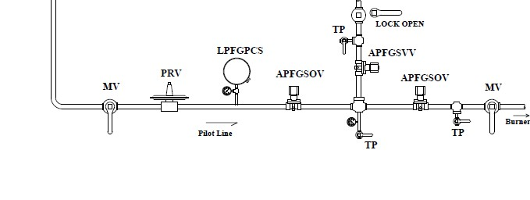

Vent Valve Leak Test
- Connect flexible tubing (approximately ¼ inch diameter and approximately 3 feet long) to the test port in the vent line. Place the open end of the flexible tubing approximately ¼ inch deep in a cup of water.
- During boiler pilot trial for ignition place boiler in pilot hold, close the manual lockable valve in the vent line and open the test port valve. If no bubbles appear in the water within a two-minute time period, the vent valve passes.
Upstream APFGSOV Leak Test
- Connect a pressure Gauge to the test port downstream of the two APFGSOV’s and open the test port valve. With the boiler running in low fire, close the manual lockable valve in the vent line and then quickly close the manual valve in the main gas line downstream of the two APFGSOV’s. Observe the pressure Gauge to make sure the manual valve does not leak. Bleed the pressure by briefly opening and then re-closing both the manual vent valve and the manual main gas line valves.
- Connect flexible tubing to the test port located between the APFGSOV’s and place the open end of the tubing approximately ¼ inch deep in a cup of water.
- Open the test port valve and observe for bubbles in the water. If there are no bubbles in a two-minute time period, the upstream APFGSOV passes the leak test.

$va_loc$ | Boiler $boiler_num$

Downstream APFGSOV Leak Test

- Connect flexible tubing to the test port on the main gas line downstream of the second APFGSOV and place the open end of the tubing approximately ¼ inch deep in a cup of water.
- Pressurize the space between the two APFGSOV’s to approximately the normal gas pressure by using an air pump with pressure Gauge connected to the test port between the two APFGSOV’s.
- Open the test port valve and observe for bubbles in the water. If there are no bubbles in two minutes, the downstream APFGSOV passes the leak test.

Result | Y/N
Correct Installation? Is LOOP Valve and test port in place? | $apfgsov_apfgsvv_result_1$
Did upstream APFGSOV leak? | $apfgsov_apfgsvv_result_2$
Did downstream APFGSOV leak? | $apfgsov_apfgsvv_result_3$
Did APFGSVV leak? | $apfgsov_apfgsvv_result_4$
Did APFGSVV open with boiler off | $apfgsov_apfgsvv_result_5$

Did the device fail or pass the 3 Question Criteria (section 1.3.1)? [$apfgsov_apfgsvv_result_status$]
If boiler is to be operated with failed safety device, a properly approved ISM is required.
Describe safety device failure/remedy in Appendix F.

$va_loc$ | Boiler $boiler_num$

11. Proof of Closure on Automatic Fuel Shutoff Valves [$pocafgsov_result_status$]
(POCAFGSOV) – Natural Gas

Item | Make
POC-AFGSOV | $pocafgsov_make$

- Switch is required to open with a very slight opening of the valve (no indicated pressure).
- Switches is required to be wired in series.

- Close manual fuel valve downstream of AFGSOV. Perform the following test on each AFGSOV separately. Disconnect power.
- Remove cover on both automatic shut off valves to provide access to two wires connected across proof of closure switch. Can also access wires in appropriate junction box. Disconnect both leads from switch/terminals going to control circuit.
- Temporarily connect the two wires that were disconnected from the POC switch/terminal to a toggle switch jumper in order to electrically bypass the switch. Place toggle switch in ON/closed position. Place multimeter across POC switch terminals and set to continuity (OHMS). Place pressure gage or connect tubing into test port immediately downstream of AFGSOV. Restore power to system.
- Start boiler and verify that switch opens before the AFGSOV opens to the point of allowing flow by measuring resistance across switch. Verifying that switch opens before the AFGSOV allows flow can be done by measuring pressure or flow immediately downstream of switch. Infinite resistance (OL) across the switch should occur before pressure is measured or flow is detected.
- Shut boiler down and switch toggle switch to OFF / open position. Try to start boiler and verify that the boiler does not allow start up sequence to begin.
- Repeat procedure for switch on 2nd valve.

Result | Y/N
Is POC present in both valves wired in series? | $pocafgsov_result_1$
Did either POC being open prevent the boiler from firing? | $pocafgsov_result_2$
Did switch on each AFGSOV open before the AFGSOV opened (no indicated pressure)? | $pocafgsov_result_3$

Did the device fail or pass the 3 Question Criteria (section 1.3.1)? [$pocafgsov_result_status$]
If boiler is to be operated with failed safety device, a properly approved ISM is required.
Describe safety device failure/remedy in Appendix F.

$va_loc$ | Boiler $boiler_num$

12. Flame Scanner For Main Flame Out [$fsmf_result_status$]
(FSMFO)

Item | Make | Model
FSMFO | $fsmf_make$ | $fsmf_model$

- Maximum allowable timing is 4 sec.
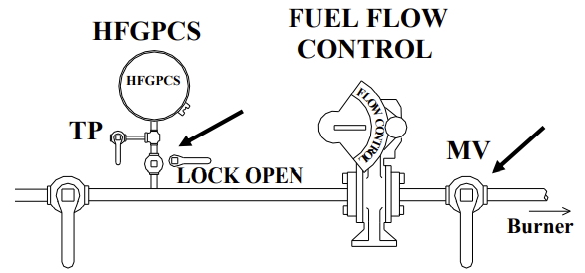
- Only a UV– Self checking scanner is VA compliant. *The scanner is required to not be rebuilt.

- Operate boiler in low fire.
- Close the lockable manual valve between the fuel line and the HFGPCS.
- Quickly close the manual valve in fuel line before burner.
- Observe the time required for the flame scanner to close the automatic fuel gas shutoff valves. (Valves should close within 3 to 4 seconds from the time the flame goes out in the firebox).

Result | Y/N | Time (seconds)
Is scanner UV, self-checking and not rebuilt? | $fsmf_result_1$
Did the scanner work correctly? | $fsmf_result_2$
Time to close fuel valves? |  | $fsmf_result_3$

Did the device fail or pass the 3 Question Criteria (section 1.3.1)? [$fsmf_result_status$]
If boiler is to be operated with failed safety device, a properly approved ISM is required.
Describe safety device failure/remedy in Appendix F.

$va_loc$ | Boiler $boiler_num$

13. Flame Scanner Not Sensing Igniter Spark [$fsnsis_result_status$]
(FSNSIS)

Item | Make | Model
Programmer | $fsmf_make$ | $fsmf_model$

- The scanner is required to not indicate a voltage/flame for duration igniter spark is on, a voltage/flame indicates that scanner senses spark.
- Only a UV– Self checking scanner is VA compliant. *The scanner is required to not be rebuilt.

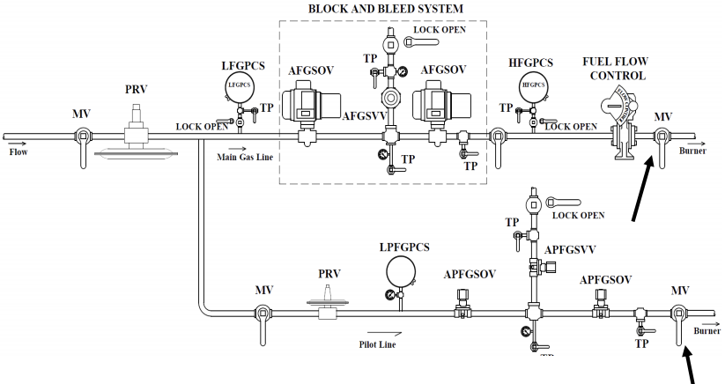

- Close manual valve in main fuel line after the second (AFGSOV) and before the HFGPCS and the manual valve in the pilot gas line downstream of the second APFGSOV.
- Attempt to start boiler. The boiler should go through pilot trial for ignition.
- Determine if the scanner output indicates a voltage/flame during pilot trial for ignition.

$va_loc$ | Boiler $boiler_num$

Result | Y/N
Is scanner UV, self-checking and not rebuilt? | $fsnsis_result_1$
Did the scanner work correctly? (No voltage /flame signal indicated.) | $fsnsis_result_2$

Did the device fail or pass the 3 Question Criteria (section 1.3.1)? [$fsnsis_result_status$]
If boiler is to be operated with failed safety device, a properly approved ISM is required.
Describe safety device failure/remedy in Appendix F.

$va_loc$ | Boiler $boiler_num$

14. Igniter Timing [$it_result_status$]
(IT)

Item | Make | Model
Programmer | $fsmf_make$ | $fsmf_model$

- Maximum allowable duration is 10 sec.

- Close manual valve in main fuel line after the second (AFGSOV) and before the HFGPCS and the manual valve in the pilot gas line downstream of the second APFGSOV.
- Attempt to Start boiler.
- View igniter by means of furnace front or back view port and time the ignition spark. (You can hear the igniter click on and off so that it may not be necessary to view the spark if not easily visible).
- Observe the duration of the ignition spark with a stopwatch.
- Reset BMS and restart boiler.
- Observe the duration of the pilot valves open to close during pilot trial for ignition. Note time.

Result | Y/N | Time (seconds)
Did the scanner work correctly by locking out on flame failure? | $it_result_1$
Igniter timing? |  | $it_result_2$
Was ignitor timing 10 secs or less? | $it_result_3$
What was the pilot valve timing? |  | $it_result_4$
Did the pilot valves close in 10 seconds or less? | $it_result_5$

Did the device fail or pass the 3 Question Criteria (section 1.3.1)? [$it_result_status$]
If boiler is to be operated with failed safety device, a properly approved ISM is required.
Describe safety device failure/remedy in Appendix F.

$va_loc$ | Boiler $boiler_num$

15. Main Flame Ignition Timing [$mfit_result_status$]
(MFIT)

Item | Make | Model
Programmer | $fsmf_make$ | $fsmf_model$

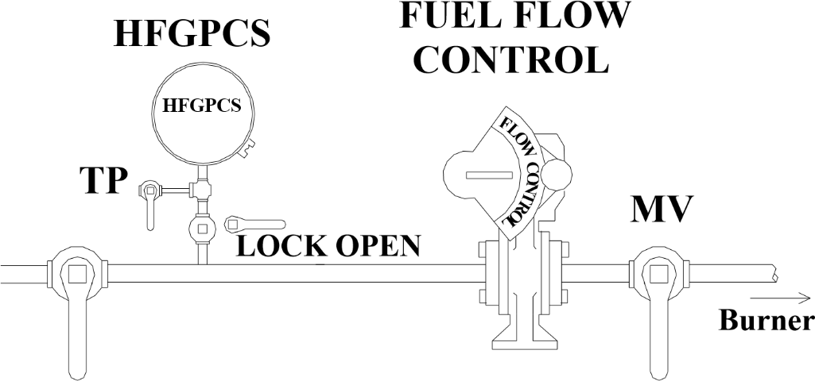
- Maximum timing is required to be 14 seconds from attempt to start boiler until AFGSOVs close.

- Close the lockable manual valve in the fuel line after the second (AFGSOV) and before the HFGPCS .
- Close manual valves in main fuel line.
- Attempt to start boiler.
- Time the AFGSOV from the time they begin to open until they close with a stopwatch.

Result | Y/N | Time (seconds)
Did the programmer work correctly? | $mfit_result_1$
Time to AFGSOVs? |  | $mfit_result_2$
Was ignition timing 14 secs or less? | $mfit_result_3$

Did the device fail or pass the 3 Question Criteria (section 1.3.1)? [$mfit_result_status$]
If boiler is to be operated with failed safety device, a properly approved ISM is required.
Describe safety device failure/remedy in Appendix F.

$va_loc$ | Boiler $boiler_num$

16. Pre-Purge and Post-Purge Timing [$ppt_result_status$]
(PPT)

 | Item | Make | Model
 | Purge Timer | $fsmf_make$ | $fsmf_model$
Boiler make | Fire Tube / Water tube |  | Boiler Fireside Volume (ft³)
$boiler_mfr$ | $boiler_type$ |  | $boiler_fireside_volume$

- Eight air changes are required for a water tube boiler and 4 air changes for a fire tube boiler.

The method to calculate required purge time is:

- Let V_{fireside} = volume of boiler fireside measured in cubic feet = $boiler_fireside_volume$
- Let m = maximum boiler capacity in lb/hr of steam = $boiler_capacity$
- Let AC = required air changes (4 for a fire tube boiler and 8 for a water tube boiler) = $ppt_result_8$
- Required minimum purge time = (AC x V_{fireside} x 270) / m
= ($ppt_result_8$ x $boiler_fireside_volume$ x 270) / $boiler_capacity$ = $ppt_result_9$

- Start up boiler and record the pre-purge time in the table below.
- Repeat this step for post purge cycle.

Result | Time (sec) | Y/N
Adjustable Timing? |  | $ppt_result_1$
Low fire to high fire? | $ppt_result_2$
Time in high fire? | $ppt_result_3$
High fire to low fire? | $ppt_result_4$
Time in post purge? | $ppt_result_5$
Equivalent High Purge Time? | $ppt_result_6$
Is purge adequate? |  | $ppt_result_7$

- Equivalent pre-purge is all time spent at high fire plus half of the time spent in getting to high fire and returning to low fire.

Did the device fail or pass the 3 Question Criteria (section 1.3.1)? [$ppt_result_status$]
If boiler is to be operated with failed safety device, a properly approved ISM is required.
Describe safety device failure/remedy in Appendix F.

$va_loc$ | Boiler $boiler_num$

17. Low-Fire Proving Switch [$lfps_result_status$]
(LFPS)

Item | Make | Model
LFPS of gas valve position | $lfps_gas_make$ | $lfps_gas_model$
LFPS on oil valve position | $lfps_oil_make$ | $lfps_oil_model$
LFPS on forced draft damper | $lfps_fd_damper_make$ | $lfps_fd_damper_model$

- The LFPS is required to be open at a position no more than 10% above the light off position. Actuator potentiometer feedback used as actuator control feedback is not allowed to be used to prove low fire position.
- For single point positioning control systems, only one LFPS is required to determine the position of the fuel flow control valves and air damper (To use one LFPS for this situation, all linkages to the oil valve and air damper are required to be drilled and pinned. If the LFPS is mounted in the drive motor or on linkages connecting the drive motor to the LFPS, the linkage to the gas valve must be drilled and pinned).
- For parallel positioning systems (with no mechanical connection between the fuel flow control valves and the inlet air damper) a LFPS is required on the gas flow control valve, the oil flow control valve, and the inlet air damper. Actuator connections to valve/damper must be square connection, keyed, or drilled and pinned to prevent slip. Any cam, lever, or linkage that is used to actuate a low fire proving switch must be drilled and pinned.

- Perform the following test for each of the required LFPS.
- Disconnect power from boiler. Access wires across the low fire proving switch. Remove wires going to the control circuit. Place a toggle switch jumper across the wires going back to BMS. Place toggle switch jumper to on position. Place multimeter across switch terminals. Set multimeter to continuity (Ohms).
- Restore power and start boiler. Note light off position. Slowly increase firing rate. Measure the resistance across the switch as boiler load is increased. Increase firing rate until switch opens (OL). Note position.
- Turn boiler off, set toggle switch to off position, and try to restart boiler. Boiler should not allow pilot ignition sequence to begin.

$va_loc$ | Boiler $boiler_num$

Result | Y/N | Y/N | Y/N
 | Gas | Oil | Air
Correct switch for all required valve/damper positions? Are Linkages / connections square, keyed, or drilled and pinned? | $lfps_result_1$ | $lfps_result_6$ | $lfps_result_7$
Did all the required switches work correctly? Did boiler not allow the ignition sequence to begin? | $lfps_result_2$ | $lfps_result_8$ | $lfps_result_9$
 | Switch Trip Point
What was the switch trip point for gas valve position? | $lfps_result_3$
What was the switch trip point for oil valve position? | $lfps_result_5$
What was the switch trip point for the forced draft damper position? | $lfps_result_4$

Did the device fail or pass the 3 Question Criteria (section 1.3.1)? [$lfps_result_status$]
If boiler is to be operated with failed safety device, a properly approved ISM is required.
Describe safety device failure/remedy in Appendix F.

$va_loc$ | Boiler $boiler_num$

18. Forced Draft Damper Wide-Open Pre-Purge Proving Switch [$fddwops_result_status$]
(FDDWOPS)

Item | Make | Model
FDDWOPS | $fddwops_make$ | $fddwops_model$

- Is required to be open at positions with damper vanes less than 90% wide open.
- All connections in linkages must be square, keyed or drilled and pinned.

- Disconnect power from boiler. Access wires across the FDDWOPS. Remove wires going to the control circuit. Place a toggle switch jumper across the wires going back to BMS. Place toggle switch jumper to off position. Place multimeter across switch terminals. Set multimeter to continuity (Ohms).
- Restore power and start boiler. As the forced draft damper moves to the wide open purge position, measure the resistance across the FDDWOPS. Note position at which the FDDWOPS closes (circuit makes).
- The purge count should not commence. Set toggle switch to on position and purge count should begin. Switch toggle switch to off again, purge count should stop.

Result | Y/N | % Load that  switch closes.
If switch is not actuated by damper itself, are all required connections drilled and pinned? | $fddwops_result_2$
Did the switch work correctly? Did purge count hold with switch circuit open? Record % damper position. | $fddwops_result_3$ | $fddwops_result_4$

Did the device fail or pass the 3 Question Criteria (section 1.3.1)? [$fddwops_result_status$]
If boiler is to be operated with failed safety device, a properly approved ISM is required.
Describe safety device failure/remedy in Appendix F.

$va_loc$ | Boiler $boiler_num$

19. Combustion Air Pressure Switch – Variable Speed [$capsvs_result_status$]
(CAPSVS)

THIS TEST IS APPLICABLE ONLY TO A VARIABLE SPEED
FORCED DRAFT FAN SETUP

Item | Make | Low Pressure Tap Location | High Pressure Tap Location | Switch Range (inwc) | Switch Setpoint (inwc)
CAPSVS | $capsvs_make$ | $capsvs_lp_tap_loc$ | $capsvs_hp_tap_loc$ | $capsvs_range$ | $capsvs_sp$

- CAPS is required to activate if pressure drops to less than 35% of the pressure difference measured at purge. It will be necessary to limit the fan speed turndown to achieve this requirement. VFD applications must be set up so that the pressure difference measured across the fan is at least 43% of the pressure difference across the fan at wide open purge. This minimum pressure difference must be maintained at all firing rates. Upon switch activation boiler must shut down and lock out.
- Switch taps are required to be across fan with no variable damper between as shown.

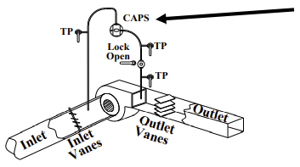

- Connect flex tubing / tee -bleed setup to high pressure test port closest to switch and high pressure side of monometer. Connect tubing from low pressure test port to low pressure side of manometer. Pinch / close off bleed line. Open test ports.
- Start the boiler and record the pressure difference read by manometer during purge.
- With boiler running, close the lockable manual valve to isolate the CAPS. Decrease the pressure in the high pressure leg by slowly opening the bleed line and observe the pressure at which the switch opens and shuts off boiler. It may be necessary to apply suction/vacuum to the line.
- Record value of pressure difference at which switch tripped.
$va_loc$ | Boiler $boiler_num$

Result | Pressure (inwc) | Y/N
Pressure Difference during purge | $capsvs_result_1$
Record Switch Trip (Break) Point. Is it more than 35% of purge pressure. | $capsvs_result_2$ | $capsvs_result_5$
Proper installation with test ports and LOOP valve? |  | $capsvs_result_3$
Did switch shut boiler down, lockout, and properly annunciate? |  | $capsvs_result_4$

Did the device fail or pass the 3 Question Criteria (section 1.3.1)? [$capsvs_result_status$]
If boiler is to be operated with failed safety device, a properly approved ISM is required.
Describe safety device failure/remedy in Appendix F.

$va_loc$ | Boiler $boiler_num$

20. Combustion Air Pressure Switch – Constant Speed [$capscs_result_status$]
(CAPSCS)

THIS TEST IS APPLICABLE ONLY TO A CONSTANT SPEED
FORCED DRAFT FAN SETUP

Item | Make | Low Pressure Tap Location | High Pressure Tap Location | Switch Range (inwc) | Switch Setpoint (inwc)
CAPSCS | $capscs_make$ | $capscs_lp_tap_loc$ | $capscs_hp_tap_loc$ | $capscs_range$ | $capscs_sp$

- CAPS should activate if pressure drops to 80% of minimum pressure difference. Boiler must shut down and lock out.
- Switch taps are required to be across fan with no variable damper between as shown.
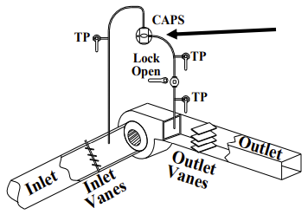

- Connect flex tubing / tee -bleed setup to high pressure test port closest to switch and high pressure side of monometer. Connect tubing from low pressure test port to low pressure side of manometer. Pinch / close off bleed line. Open test ports.
- Start the boiler and record the minimum pressure difference read by manometer during purge.
- With boiler running, close the lockable manual valve to isolate the CAPS. Decrease the pressure in the high pressure leg by slowly opening the bleed line and observe the pressure at which the switch opens and shuts off boiler. It may be necessary to apply suction/vacuum to the line.
- Record value of pressure difference at which switch tripped.

$va_loc$ | Boiler $boiler_num$

Result | Pressure (inwc) | Y/N
Minimum Pressure Difference during purge? | $capscs_result_1$
Record Switch Trip (Break) Point. Is it 80% or more of purge pressure. | $capscs_result_2$ | $capscs_result_5$
Proper installation with test ports and LOOP valve? |  | $capscs_result_3$
Did switch shut boiler down, lockout, and properly annunciate? |  | $capscs_result_4$

Did the device fail or pass the 3 Question Criteria (section 1.3.1)? [$capscs_result_status$]
If boiler is to be operated with failed safety device, a properly approved ISM is required.
Describe safety device failure/remedy in Appendix F.
.

$va_loc$ | Boiler $boiler_num$

21. Purge Airflow Proving Switch [$paps_result_status$]
(PAPS)

Item | Make | Low Pressure Tap Location | High Pressure Tap Location | Switch Range (inwc) | Switch Setpoint (inwc)
PAPS | $paps_make$ | $paps_lp_tap_loc$ | $paps_hp_tap_loc$ | $paps_range$ | $paps_sp$

- PAPS is required to make at 80% or more of maximum differential pressure signal at high fire.
- Switch taps are required to be in inlet to combustion chamber after any variable damper and in the boiler stack before any variable damper.
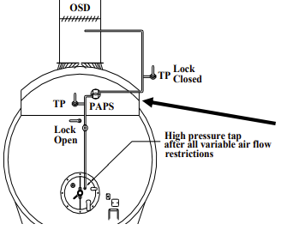

- Connect flex tubing / tee setup to high pressure test port closest to switch and high pressure side of monometer. Connect tubing from low pressure test port to low pressure side of manometer. Bleed line should be open. Open test ports. Close lockable isolation valve in high pressure leg to isolate PAPS.
- Start boiler. Observe that boiler purge count does not begin.
- Open lockable isolation valve and pinch / close bleed line. Observe maximum stable pressure seen on the manometer.
- Stop boiler. Place multimeter across PAPS switch terminals (Common/Normally Open).
- Close lockable isolation valve and use bleed line to slowly pressurize the switch. Place manometer beside multimeter. Observe the pressure at which the PAPS switch makes by observing on the multimeter when the switch closes. (Shows no voltage or shows continuity on multimeter).

$va_loc$ | Boiler $boiler_num$

Result | Pressure (inwc) | Y/N
Maximum Pressure Difference from low to high fire | $paps_result_1$
Record Switch Trip (make) Point. Is switch make point 80% or more of Max pressure difference above? | $paps_result_2$ | $paps_result_5$
Is switch installed correctly with test ports and LOOP valve in place? |  | $paps_result_3$
Did switch work correctly by not allowing purge count to begin? |  | $paps_result_4$

Did the device fail or pass the 3 Question Criteria (section 1.3.1)? [$paps_result_status$]
If boiler is to be operated with failed safety device, a properly approved ISM is required.
Describe safety device failure/remedy in Appendix F.

$va_loc$ | Boiler $boiler_num$

22. Forced Draft Motor Interlock Switches [$fdmis_result_status$]
(FDMIS)

Item | Make | Type of Switch: Aux. Contact  Phase Monitor  Current Relays
FDMIS | $fdmis_make$ | $fdmis_type$

The FDMIS are required to be current relays (one on each of the three phase legs) that can be unlatched and removed for testing (split-core, hinged, clamp-on). Current relays must be located in a separate enclosure with no exposed 3 phase contacts.
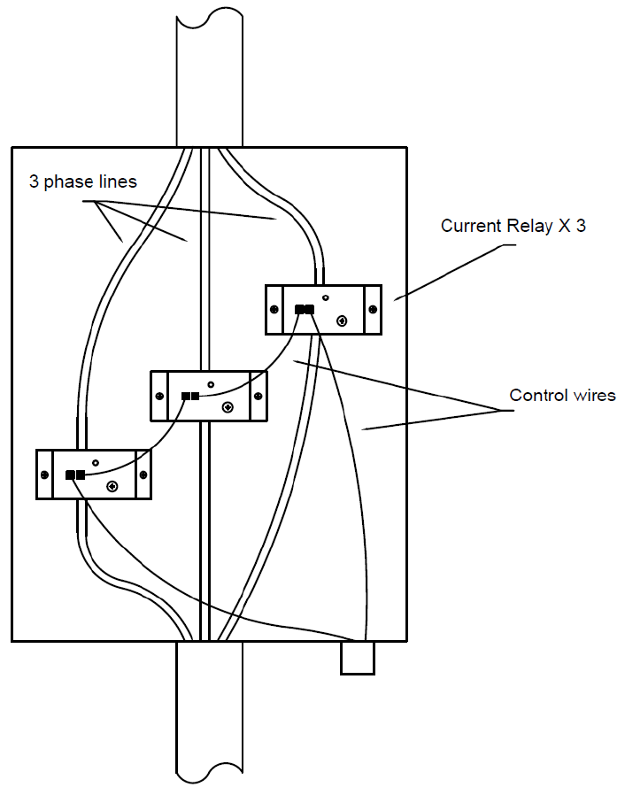

- Be certain to follow NFPA 70E requirements as the forced draft power supply has significant shock and potential arc flash.
- With power to fan off, unclamp and remove one current relay from around one power lead feeding the fan. When complete, restore power.
- Attempt to start boiler. Boiler should shut down.
- Replace the current transformer and repeat above process for each of three power leads to fan.

$va_loc$ | Boiler $boiler_num$

Result | Y/N
Correct switch type? | $fdmis_result_1$
Did the boiler shutdown, lockout, and annunciate properly? | $fdmis_result_2$

Did the device fail or pass the 3 Question Criteria (section 1.3.1)? [$fdmis_result_status$]
If boiler is to be operated with failed safety device, a properly approved ISM is required.
Describe safety device failure/remedy in Appendix F.

$va_loc$ | Boiler $boiler_num$

23. Outlet Stack Damper Position Interlock Switch [$osdpi_result_status$]
(OSDPI)

Item | Make | Modulating Damper Y/N
OSDPI | $osdpi_make$ | $osdpi_modulating$

The OSDPI is required to be open if damper is not at least 80% open. For a modulating damper, the OSDPI is required to prevent start of and interrupt purge if the damper is not at least 80% open. For a non-modulating, operable damper, an open OSDPI is required to shut down the boiler during any mode of operation. No OSDPI is required if the damper is welded or locked in the in the open position. Any linkages between the switch and damper must be square, keyed, or drilled and pinned.

- Disconnect power to boiler. Locate OSDPI switch and remove wires from switch. Place a toggle switch jumper across the wires removed from switch. Place toggle switch to On or closed position.
- Place multimeter across switch terminals (C, NO). Set multimeter to continuity (OHMs).
- Restore power and start boiler. During purge note and record damper position at which switch closes. (multimeter shows continuity). During purge switch toggle switch to OFF/Open position. If a non modulating damper is used boiler should shut down. If a modulating damper is used purge count should stop.

Result | Y/N | Trip Position
If OSDPI is required, is it present? | $osdpi_result_1$
Are linkages square, keyed, or drilled and pinned? | $osdpi_result_2$
Did the switch work correctly? Record trip position. | $osdpi_result_3$ | $osdpi_result_4$
Is switch close/make position 80% or more of wide open damper position? | $osdpi_result_5$

Did the device fail or pass the 3 Question Criteria (section 1.3.1)? [$osdpi_result_status$]
If boiler is to be operated with failed safety device, a properly approved ISM is required.
Describe safety device failure/remedy in Appendix F.

$va_loc$ | Boiler $boiler_num$

24. Furnace Pressure Interlock [$fpi_result_status$]
(FPI)

Item | Make | Low Pressure  Tap Location | High Pressure  Tap Location | Switch Setpoint (inwc)
FPI | $fpi_make$ | $fpi_lp_tap_loc$ | $fpi_hp_tap_loc$ | $fpi_sp$

- FPI is only required on boilers with a modulating outlet stack damper
- Required trip point is less than the greater of 1 inwc or 120% of maximum boiler furnace pressure measured during operation.
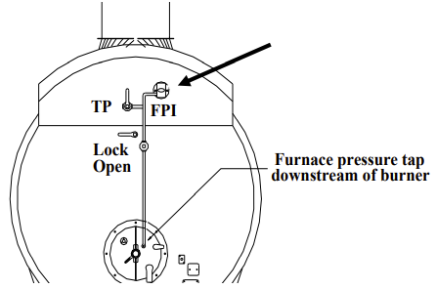

- Connect a manometer using appropriate flex tubing to the high pressure test port with other side of manometer open to atmosphere. Open TP valve.
- Start the boiler and record the pressure sensed by the switch over the entire firing rate.
- Return the boiler to low fire.
- Close manual lockable valve isolating switch from furnace pressure.
- Test rig must provide means to pressurize system and a manometer to read the gage pressure.
- Slowly pressurize the switch.
- Note the pressure that the boiler trips off line.

$va_loc$ | Boiler $boiler_num$

Result | Pressure (inwc) | Y/N
Maximum Furnace Pressure from low to high fire | $fpi_result_1$
Switch Trip (Break) Point | $fpi_result_2$
Is switch installed correctly? Is LOOP Valve and test port in place? |  | $fpi_result_3$
Is setpoint 120% or less of maximum furnace pressure? |  | $fpi_result_5$
Did switch work correctly? |  | $fpi_result_4$

Did the device fail or pass the 3 Question Criteria (section 1.3.1)? [$fpi_result_status$]
If boiler is to be operated with failed safety device, a properly approved ISM is required.
Describe safety device failure/remedy in Appendix F.

$va_loc$ | Boiler $boiler_num$

25. Low Pilot Fuel Gas Pressure Cutoff Switch [$lpfgpcs_result_status$]
(LPFGPCS)

Item | Make | Range  (inwc/psi) | Switch Setpoint | Regulated Pressure
LPFGPCS | $lpfgpcs_make$ | $lpfgpcs_range$ | $lpfgpcs_sp$ | $lpfgpcs_reg_pres$
Pressure Gauge | $lpfgpcs_gauge_make$ | $lpfgpcs_gauge_range$

- LPFGPCS Switch setpoint is required to be 80% of regulated pressure and switch is required to be after the PRV as shown. No dampeners, snubbers, or other such devices are allowed. LPFGPCS may not be wired in series with the pilot automatic shut off valves.
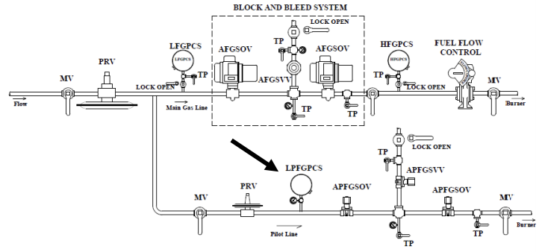

- Close the manual valve in the gas line after the fuel control valve and allow the pilot burner to light. Place programmer in check mode while holding in the pilot cycle.
- In low fire throttle manual valve upstream of the LPFGPCS slowly until switch trips the boiler offline due to low pilot fuel pressure.
- Open the manual valve upstream of the LPFGPCS and again put boiler in check mode with pilot lit. Slowly close manual valve upstream of the LPFGPCS and regulate the pilot gas pressure to a value of less than 10% above trip point pressure.
- Open the manual valve in the gas line after the fuel control valve, place the programmer in the “run” mode, and carefully observe that the main burner ignites immediately and smoothly. Repeat light off for three consecutive smooth light offs to prove a stable pilot lightoff.
- Be prepared to stop the burner immediately with E Stop if this does not occur.
$va_loc$ | Boiler $boiler_num$

Result | Y/N | Switch Trip Point
Correct switch location/installation? | $lpfgpcs_result_1$
Is switch trip point 80% of regulated pilot pressure or higher? Record LPFGPCS trip pressure. | $lpfgpcs_result_2$ | $lpfgpcs_result_3$
Did boiler shutdown, lockout, and properly annunciate? | $lpfgpcs_result_4$
Did the boiler light smoothly 3 times with low pilot gas pressure? | $lpfgpcs_result_5$

Did the device fail or pass the 3 Question Criteria (section 1.3.1)? [$lpfgpcs_result_status$]
If boiler is to be operated with failed safety device, a properly approved ISM is required.
Describe safety device failure/remedy in Appendix F.

$va_loc$ | Boiler $boiler_num$

26. Low Pilot Fuel Gas Pressure Cutoff Switch 2 [$lpfgpcs2_result_status$]
(LPFGPCS-2)

Item | Make | Range  (inwc/psi) | Switch Setpoint | Regulated Pressure
LPFGPCS | $lpfgpcs2_make$ | $lpfgpcs2_range$ | $lpfgpcs2_sp$ | $lpfgpcs2_reg_pres$
Pressure Gauge | $lpfgpcs2_gauge_make$ | $lpfgpcs2_gauge_range$

- LPFGPCS Switch setpoint is required to be 80% of regulated pressure and switch is required to be after the PRV as shown. No dampeners, snubbers, or other such devices are allowed. LPFGPCS may not be wired in series with the pilot automatic shut off valves.


- Close the manual valve in the gas line after the fuel control valve and allow the pilot burner to light. Place programmer in check mode while holding in the pilot cycle.
- In low fire throttle manual valve upstream of the LPFGPCS slowly until switch trips the boiler offline due to low pilot fuel pressure.
- Open the manual valve upstream of the LPFGPCS and again put boiler in check mode with pilot lit. Slowly close manual valve upstream of the LPFGPCS and regulate the pilot gas pressure to a value of less than 10% above trip point pressure.
- Open the manual valve in the gas line after the fuel control valve, place the programmer in the “run” mode, and carefully observe that the main burner ignites immediately and smoothly. Repeat light off for three consecutive smooth light offs to prove a stable pilot lightoff.
- Be prepared to stop the burner immediately with E Stop if this does not occur.
$va_loc$ | Boiler $boiler_num$

Result | Y/N | Switch Trip Point
Correct switch location/installation? | $lpfgpcs2_result_1$
Is switch trip point 80% of regulated pilot pressure or higher? Record LPFGPCS trip pressure. | $lpfgpcs2_result_2$ | $lpfgpcs2_result_3$
Did boiler shutdown, lockout, and properly annunciate? | $lpfgpcs2_result_4$
Did the boiler light smoothly 3 times with low pilot gas pressure? | $lpfgpcs2_result_5$

Did the device fail or pass the 3 Question Criteria (section 1.3.1)? [$lpfgpcs_result_status$]
If boiler is to be operated with failed safety device, a properly approved ISM is required.
Describe safety device failure/remedy in Appendix F.

$va_loc$ | Boiler $boiler_num$

27. Flue Gas Recirculation Damper Interlock [$fgrdi_result_status$]
(FGRDI)

Item | Make | Manufacturer Required FGRDI Position on Purge
FGRDI | $fgrdi_make$ | $fgrdi_mfr_req_pop$

- Open FGRDI switch is required to prevent completion of the pre purge cycle.
- Dampers are required to be at least 80% open on purge if manufacturer requires an open damper on purge or it should be at least 80% closed if the manufacturer requires a closed damper on purge.
- If manufacturer requires an open damper on purge, consult manufacturer to determine if additional purge time is recommended.
- All linkages between the switch and damper must be square, keyed, or drilled and pinned.

- Connect a multi-meter across the switch and measure voltage.
- Start the boiler and monitor voltage across the switch. If damper moves during purge note the position at which the switch opens. If not raise the firing rate to get FGR damper to move so that trip point can be attained. Record damper position at which switch opens.
- Stop boiler and turn off power to controls.
- Disconnect one lead from switch. Start boiler. The boiler should not complete purge sequence.

Result | Y/N | Load that switch closes.
Are all connections square, keyed, or drilled and pinned? | $fgrdi_result_1$
Did the switch work correctly by not allowing boiler purge count to commence or resume? Record switch trip point. | $fgrdi_result_2$ | $fgrdi_result_3$
Is switch open within 20% of FGR damper purge position? | $fgrdi_result_4$

Did the device fail or pass the 3 Question Criteria (section 1.3.1)? [$fgrdi_result_status$]
If boiler is to be operated with failed safety device, a properly approved ISM is required.
Describe safety device failure/remedy in Appendix F.

$va_loc$ | Boiler $boiler_num$

28. Low Flue Gas Oxygen Level Interlock [$lfgoli_result_status$]
(LFGOLI)

Item | Make
LFGOLI | $lfgoli_make$

LFGOLI is required to be an alarm and interlock. LFGOLI is required to prevent boiler from operating with more than 200 ppm CO or combustibles in the flue gas.

- During the required 6 month tuning of boiler combustion by a qualified individual, this qualified individual must determine the minimum %Oxygen possible to hold the carbon monoxide and combustibles below 200 ppm. This value must consider both oil and gas firing.
- Start the boiler. Supply calibrated test gas through the sensor calibration test port at the minimum % oxygen concentration (determined in the six-month testing) per manufacturer’s instructions.
- Verify that the LFGOLI alarms and shuts down the boiler.

Min % Oxygen  from 6 month tuning | CO at minimum % Oxygen  from 6 month tuning
$lfgoli_result_1$ | $lfgoli_result_2$

Result | Y/N | Trip point %O₂
Correct Device with test gas ports and plumbing? | $lfgoli_result_3$
Is the proper test gas with correct O2 concentration available onsite? | $lfgoli_result_7$
Did the interlock work correctly? Did boiler shut down, lockout, and properly annunciate? Record % O2 at trip point. | $lfgoli_result_4$ | $lfgoli_result_5$
Did the LFGOLI activate with less than 200 ppm of CO/Combustibles? | $lfgoli_result_6$

Did the device fail or pass the 3 Question Criteria (section 1.3.1)? [$lfgoli_result_status$]
If boiler is to be operated with failed safety device, a properly approved ISM is required.
Describe safety device failure/remedy in Appendix F.

$va_loc$ | Boiler $boiler_num$

29. Low Fuel Oil Pressure Cutoff Switch [$lfopcs_result_status$]
(LFOPCS)

Item | Make | Range  (inwc/psi) | Switch Setpoint | Regulated Pressure
LFOPCS | $lfopcs_make$ | $lfopcs_range$ | $lfopcs_sp$ | $lfopcs_reg_pres$
Pressure Gauge | $lfopcs_gauge_make$ | $lfopcs_gauge_range$

- The LFOPCS location is required to be downstream of PRV and upstream of flow control valve with test setup shown. Trip point of LFOPCS is required to be equal to or greater than 80% of regulated pressure. LFOPCS activation must generate a boiler safety shutdown, annunciate, and require manual reset of the flame safeguard or burner management system. The use of snubbers or dampeners on LFOPCS is prohibited.
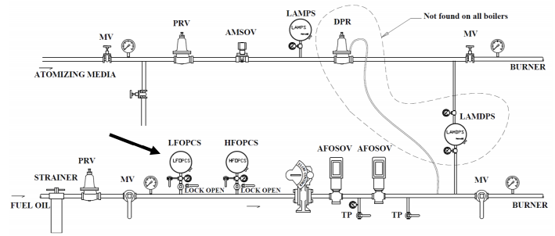

- Close lock open manual valve isolating the LFOPCS. Install appropriate tubing on test port. Bleed oil from space between lockable manual valve and LFOPCS into a container for proper disposal.
- Install hand pump or equivalent to the test port capable of supplying air or nitrogen pressure to space. Pressurize the space to above the switch setpoint.
- Start the boiler. At low fire, slowly bleed pressure from the LFOPCS until it trips boiler offline measuring pressure at trip point.

$va_loc$ | Boiler $boiler_num$

Result | Y/N | Switch Trip Point Pressure (inwc)
Snubber or dampeners not used? | $lfopcs_result_1$
Correct switch location/test setup with LOOP in place? | $lfopcs_result_2$
Did the switch work correctly? Record trip point pressure. | $lfopcs_result_3$ | $lfopcs_result_4$
Is switch setpoint 80% or more of regulated pressure? | $lfopcs_result_5$
Did boiler shutdown, lockout, and properly annunciate? | $lfopcs_result_6$

Did the device fail or pass the 3 Question Criteria (section 1.3.1)? [$lfopcs_result_status$]
If boiler is to be operated with failed safety device, a properly approved ISM is required.
Describe safety device failure/remedy in Appendix F.

$va_loc$ | Boiler $boiler_num$

30. High Fuel Oil Pressure Cutoff Switch [$hfopcs_result_status$]
(HFOPCS)

Item | Make | Range  (inwc/psi) | Switch Setpoint | Regulated Pressure
HFOPCS | $hfopcs_make$ | $hfopcs_range$ | $hfopcs_sp$ | $hfopcs_reg_pres$
Pressure Gauge | $hfopcs_gauge_make$ | $hfopcs_gauge_range$

- The HFOPCS location is required to be downstream of PRV and upstream of flow control valve with test setup shown.
- Trip point of HFOPCS is required to be equal to or less than 120% of regulated pressure.
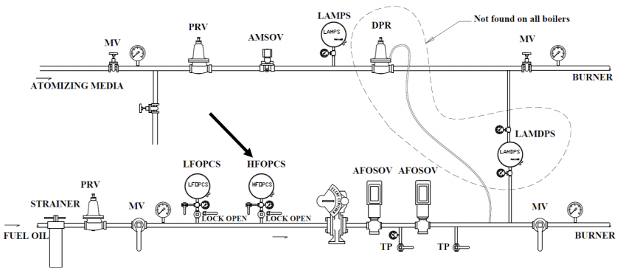

- Close lock open manual valve isolating the HFOPCS. Install appropriate tubing on test port. Bleed oil from space between lockable manual valve and HFOPCS into a container for proper disposal.
- Install hand pump or equivalent to the test port capable of supplying air or nitrogen pressure to space. Pressurize the space to above the switch setpoint.
- Start the boiler. At low fire, slowly raise pressure to the HFOPCS until it trips boiler offline measuring pressure at trip point.

$va_loc$ | Boiler $boiler_num$

Result | Y/N | Switch Trip Point Pressure
Correct switch location/test setup with LOOP valve in place? | $hfopcs_result_1$
Did the switch work correctly? Record trip point pressure. | $hfopcs_result_2$ | $hfopcs_result_3$
Is switch trip point 120% or less of regulated pressure? | $hfopcs_result_4$
Did boiler shutdown, lockout, and properly annunciate? | $hfopcs_result_5$

Did the device fail or pass the 3 Question Criteria (section 1.3.1)? [$hfopcs_result_status$]
If boiler is to be operated with failed safety device, a properly approved ISM is required.
Describe safety device failure/remedy in Appendix F.

$va_loc$ | Boiler $boiler_num$

31. Low Atomizing Media Pressure Switch [$lamps_result_status$]
(LAMPS) - Applications with differential pressure regulation or flow control on atomizing media

Item | Make | Range  (inwc/psi) | Switch Setpoint | Regulated Pressure
LAMPS | $lamps_make$ | $lamps_range$ | $lamps_sp$ | $lamps_reg_pres$
Pressure Gauge | $lamps_gauge_make$ | $lamps_gauge_range$

LAMPS setpoint is required to be 80% or more of the lowest atomizing media pressure upstream of the LAMPS seen during normal operation. LAMPS activation must generate a boiler safety shutdown, annunciate, and require manual reset of the flame safeguard or burner management system. LAMPS must be located downstream of any PRV and before any flow control device or differential pressure regulator.
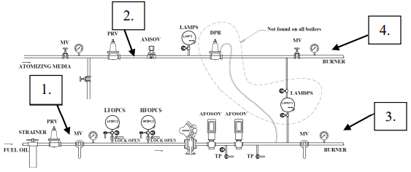

- Operate boiler and determine data in following table.

Item | Min Fire (psi) | Mid Fire (psi) | High Fire (psi)
Oil pressure at burner-state 3 | $lamps_min_oil_pres_3$ | $lamps_mid_oil_pres_3$ | $lamps_max_oil_pres_3$
Atomizing Pressure at burner-state 4 | $lamps_min_atm_pres_4$ | $lamps_mid_atm_pres_4$ | $lamps_max_atm_pres_4$
Oil pressure downstream PRV-state 1 | $lamps_min_oil_pres_1$ | $lamps_mid_oil_pres_1$ | $lamps_max_oil_pres_1$
Atomizing pressure downstream PRV-state 2 | $lamps_min_atm_pres_2$ | $lamps_mid_atm_pres_2$ | $lamps_max_atm_pres_2$
Differential Pressure at burner-state 4-state 3 | $lamps_min_dif_pres$ | $lamps_mid_dif_pres$ | $lamps_max_dif_pres$

$va_loc$ | Boiler $boiler_num$

- In purge throttle manual valve in atomizing media line or bleed pressure before the switch slowly until switch trips the boiler offline due to low atomizing media pressure.
Result | Y/N | Switch Trip Point
Correct switch location? | $lamps_result_1$
Did the switch work correctly? Record trip point pressure. | $lamps_result_2$ | $lamps_result_3$
Is switch setpoint 80% or more of lowest recorded regulated pressure? | $lamps_result_4$
Did boiler shutdown, lockout, and properly annunciate? | $lamps_result_5$

Did the device fail or pass the 3 Question Criteria (section 1.3.1)? [$lamps_result_status$]
If boiler is to be operated with failed safety device, a properly approved ISM is required.
Describe safety device failure/remedy in Appendix F.

$va_loc$ | Boiler $boiler_num$

32. Low Atomizing Media Pressure Switch [$lamps_amc_result_status$]
(LAMPS) - Dedicated Onboard Atomizing Media Compressor

Item | Make | Range  (inwc/psi) | Switch Setpoint | Regulated Pressure
LAMPS | $lamps_amc_make$ | $lamps_amc_range$ | $lamps_amc_sp$ | $lamps_amc_reg_pres$
Pressure Gauge | $lamps_amc_gauge_make$ | $lamps_amc_gauge_range$

In dedicated onboard compressor applications, the LAMPS must be located near the burner downstream of any valve. LAMPS setpoint is required to be no less than 80% of the lowest atomizing media pressure upstream seen during all modes of operation at the burner. LAMPS activation must generate a boiler safety shutdown, annunciate, and require manual reset of the flame safeguard or burner management system.
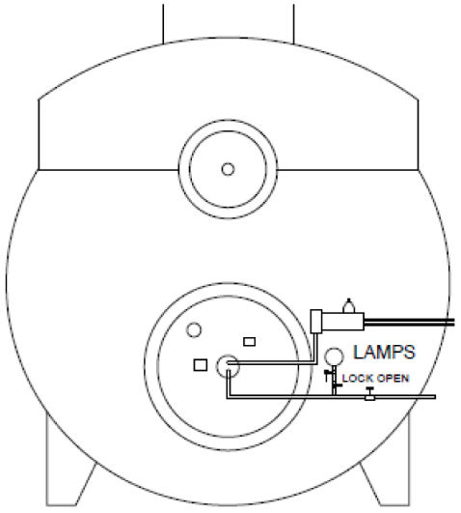
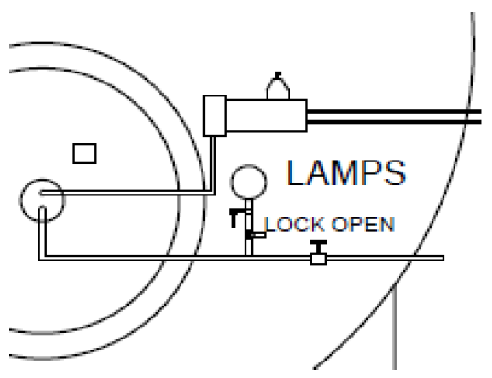

- Insert pressure gage into LAMPS test port if needed.
- Start Boiler. Record the atomizing media pressure at LAMPS switch during Purge and Low Fire. With boiler firing, isolate lockable only open isolation valve.
- Slowly bleed pressure until the LAMPS trips offline. Record activation pressure.
$va_loc$ | Boiler $boiler_num$

Result | Y/N | Switch Trip Point
Correct switch location? Is LOOP Valve in place? | $lamps_amc_result_1$
Did the switch work correctly? Record trip point pressure. | $lamps_amc_result_2$ | $lamps_amc_result_3$
Is switch setpoint 80% or more of lowest recorded regulated pressure? | $lamps_amc_result_4$
Did boiler shutdown, lockout, and properly annunciate? | $lamps_amc_result_5$

Did the device fail or pass the 3 Question Criteria (section 1.3.1)? [$lamps_amc_result_status$]
If boiler is to be operated with failed safety device, a properly approved ISM is required.
Describe safety device failure/remedy in Appendix F.

$va_loc$ | Boiler $boiler_num$

33. Low Atomizing Media Differential Pressure Switch [$lamdps_result_status$]
(LAMDPS)

Item | Make | Range | Switch Setpoint | Minimum Diff Pressure
LAMDPS | $lamdps_make$ | $lamdps_range$ | $lamdps_sp$ | $lamdps_min_dif_pres$
Pressure Gauge Fuel Oil Burner | $lamdps_oil_gauge_make$ | $lamdps_oil_gauge_range$
Pressure Gauge Atomizing media | $lamdps_atm_gauge_make$ | $lamdps_atm_gauge_range$

- The VA does not require a LAMPDS if, at some firing rates, the oil pressure is higher than the atomizing pressure (crossover). For crossover, a second atomizing media switch is required. If crossover does not occur, the VA required LAMDPS is a differential pressure switch that has the high pressure leg connected downstream of the differential pressure regulator and its low pressure leg in the oil supply line after the fuel flow control valve. Setpoint should be 80% or more of minimum differential pressure between oil and atomizing media.
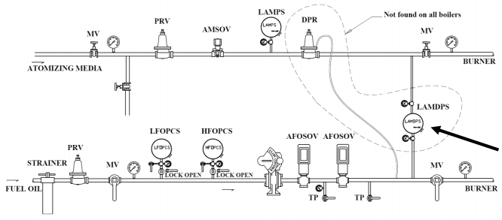

- Determine the minimum differential pressure from data table in LAMPS checklist and record in above table.
- In low fire throttle manual valve in atomizing media line before the LAMDPS slowly until switch trips the boiler offline due to low differential pressure but NO LOWER THAN 80% OF MINIMUM DIFFERENTIAL PRESSURE between oil and atomizing media.

$va_loc$ | Boiler $boiler_num$

Result | Y/N | Switch Trip point
Correct location/installation? | $lamdps_result_1$
Did the switch work correctly? Record Trip Point differential pressure | $lamdps_result_2$ | $lamdps_result_3$
Did boiler shutdown, lockout, and properly annunciate? | $lamdps_result_4$

Did the device fail or pass the 3 Question Criteria (section 1.3.1)? [$lamdps_result_status$]
If boiler is to be operated with failed safety device, a properly approved ISM is required.
Describe safety device failure/remedy in Appendix F.

$va_loc$ | Boiler $boiler_num$

34. Secondary Low Atomizing Media Pressure Switch [$slamps_result_status$]
(SLAMPS) - Applications with Differential Pressure Regulation and Crossover

Item | Make | Range (inwc/PSI) | Switch Setpoint | Minimum Diff Pressure
SLAMPS | $slamps_make$ | $slamps_range$ | $slamps_sp$ | $slamps_min_dif_pres$

In all applications at which oil pressure exceeds atomizing pressure (crossover) or atomizing media flow control is utilized, the VA requires a SLAMPS located in the atomizing media line downstream of any valves near the burner inlet. If the primary LAMPS switch is located near the burner downstream of any valves then the SLAMPS must be located near the atomizing media source. Setpoint should be no less than 80% of the minimum pressure measured at the switch in all modes of operation.

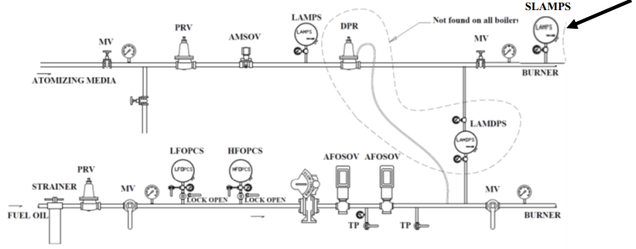

- In purge throttle manual valve in atomizing media line or bleed pressure before the SLAMPS slowly until switch trips the boiler offline due to low atomizing pressure. It may be necessary to place electrical jumper across other atomizing media switch to make sure the switch being tested is causing the shutdown.

$va_loc$ | Boiler $boiler_num$

Result | Y/N | Switch Trip Point Pressure
Correct Location/installation? | $slamps_result_1$
Did the switch work correctly? Record trip point pressure. | $slamps_result_2$ | $slamps_result_3$
Is switch setpoint 80% or more of lowest recorded regulated pressure at switch? | $slamps_result_4$
Did boiler shutdown, lockout, and properly annunciate? | $slamps_result_5$

Did the device fail or pass the 3 Question Criteria (section 1.3.1)? [$slamps_result_status$]
If boiler is to be operated with failed safety device, a properly approved ISM is required.
Describe safety device failure/remedy in Appendix F.

$va_loc$ | Boiler $boiler_num$

35. Secondary Low Atomizing Media Pressure Switch [$slamps_amc_result_status$]
(SLAMPS) - Dedicated Onboard Atomizing Compressor

Item | Make | Range (inwc/PSI) | Switch Setpoint | Minimum Diff Pressure
SLAMPS | $slamps_amc_make$ | $slamps_amc_range$ | $slamps_amc_sp$ | $slamps_amc_min_dif_pres$

In all applications at which oil pressure exceeds atomizing pressure (crossover) or atomizing media flow control is utilized, the VA requires a SLAMPS located in the atomizing media line downstream of any valves near the burner inlet. If the primary LAMPS switch is located near the burner downstream of any valves then the SLAMPS must be located near the atomizing media source. Setpoint should be no less than 80% of the minimum pressure measured at the switch in all modes of operation.
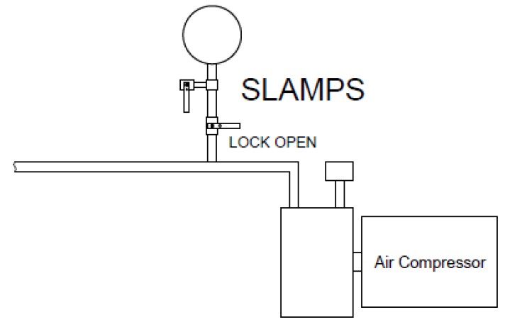

- In purge throttle manual valve in atomizing media line or bleed pressure before the SLAMPS slowly until switch trips the boiler offline due to low atomizing pressure. It may be necessary to place electrical jumper across other atomizing media switch to make sure the switch being tested is causing the shutdown.

$va_loc$ | Boiler $boiler_num$

Result | Y/N | Switch Trip Point Pressure
Correct Location/installation? | $slamps_amc_result_1$
Did the switch work correctly? Record trip point pressure. | $slamps_amc_result_2$ | $slamps_amc_result_3$
Is switch setpoint 80% or more of lowest recorded regulated pressure at switch? | $slamps_amc_result_4$
Did boiler shutdown, lockout, and properly annunciate? | $slamps_amc_result_5$

Did the device fail or pass the 3 Question Criteria (section 1.3.1)? [$slamps_amc_result_status$]
If boiler is to be operated with failed safety device, a properly approved ISM is required.
Describe safety device failure/remedy in Appendix F.

$va_loc$ | Boiler $boiler_num$

36. Automatic Fuel Oil Shutoff Valves [$afosov_result_status$]
(AFOSV) - for Seat Leakage

Item | Make | Range
AFOSV | $afosov_upstream_make$
AFOSV | $afosov_downstream_make$
Pressure Gauge | $afosov_gauge_make$ | $afosov_gauge_range$

- After drip rate is steady, leak rate is required to be less than one drop in 10 seconds.
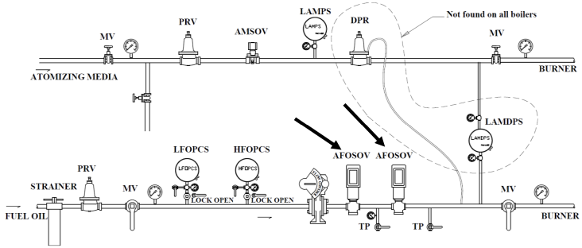

- While the boiler is firing quickly close the manual valve in oil line located after the automatic shut off valves.
- Place a container under the test port downstream of both automatic shut off valves. Open the test port valve and observe oil flow. In order to consider the valve as not leaking, oil flow should be less than 1 drop in 10 seconds. Some time is needed to establish a steady drip rate. Make sure that the pressure Gauge between the 2 auto shut off valves indicates pressure approximately equal to regulated pressure or higher.
- Place a container under the test port between the automatic shut off valves. Open the downstream test port valve between the automatic shut off valves and observe oil flow. In order to consider the valve as not leaking, oil flow should be less than 1 drop in 10 seconds. Some time is needed to establish a steady drip rate.
- Some manufacturers use a vent line between the two AFOSOV’s (not required and not shown). If the valve in this vent line is leaking and the two AFOSOV’s are not leaking, the pressure between the two AFOSOV’s will fall.
$va_loc$ | Boiler $boiler_num$

Result | Y/N
Did upstream AFOSV leak? | $afosov_result_1$
Did downstream AFOSF leak? | $afosov_result_2$

Did the device fail or pass the 3 Question Criteria (section 1.3.1)? [$afosov_result_status$]
If boiler is to be operated with failed safety device, a properly approved ISM is required.
Describe safety device failure/remedy in Appendix F.

$va_loc$ | Boiler $boiler_num$

37. Proof of Closure on Automatic Fuel Oil Shutoff Valves [$pocafosov_result_status$]
(POCAFOSV) – Oil

Item | Make
POC-AFOSV | $pocafosov_make$

- Switch should open with a very slight opening of the valve.
- Switches on the two valves must be wired in series.

- Close manual fuel valve downstream of both AFOSOV. Perform the following test on each AFOSOV separately.
- Disconnect power and remove cover on both automatic shut off valves to provide access to two wires connected across proof of closure switch. Can also access wires in appropriate junction box. Disconnect both leads from switch going to control circuit.
- Connect the two wires that were disconnected from the POC switch to toggle switch jumper, Set toggle switch to ON / closed position. Connect multimeter to switch terminals and set to continuity. Restore power.
- Start boiler and verify that switch opens before the AFOSOV opens to the point of allowing flow by measuring continuity across switch. Verifying that switch opens before the AFOSOV opens can be done by measuring pressure downstream of switch. Infinite (OL) resistance across the switch should occur before pressure or flow is measured.
- Shut boiler down and set toggle switch to OFF / open position. Try to start boiler and verify that the boiler does not allow ignition sequence to begin.
- Repeat procedure for switch on 2nd valve.

Result | Y/N
Is proof of closure present in both valves wired in series? | $pocafosov_result_1$
Did either valve being open allow the boiler to fire? | $pocafosov_result_2$
Did switch on each AFOSOV open with a very slight opening of AFOSOV? | $pocafosov_result_3$

Did the device fail or pass the 3 Question Criteria (section 1.3.1)? [$pocafosov_result_status$]
If boiler is to be operated with failed safety device, a properly approved ISM is required.
Describe safety device failure/remedy in Appendix F.

$va_loc$ | Boiler $boiler_num$

38. Oil Burner Position Switch [$obps_result_status$]
(OBPS)

Item | Make
OBPS | $obps_make$

- If no switch is present this test is not required and test is complete.

- Retract the gun enough to disengage the switch. Attempt to start the boiler. The boiler controls should not allow the purge process to begin. IF BOILER BEGINS TO MOVE TO THE PURGE POSTION, SHUT THE BOILER DOWN IMMEDIATELY. IN THIS CASE THE OBPS SWITCH IS DEFECTIVE.

Result | Y/N
Did the switch work correctly? | $obps_result_1$

Did the device fail or pass the 3 Question Criteria (section 1.3.1)? [$obps_result_status$]
If boiler is to be operated with failed safety device, a properly approved ISM is required.
Describe safety device failure/remedy in Appendix F.

$va_loc$ | Boiler $boiler_num$

39. Control Air Pressure Interlock [$capi_result_status$]
(CAPI)

Item | Make | Range  (psi) | Switch  Setpoint | Regulated Pressure | Minimum Required Pressure
HFGPCS | $capi_make$ | $capi_range$ | $capi_sp$ | $capi_reg_pres$ | $capi_min_req_pres$
Pressure Gauge | $capi_gauge_make$ | $capi_gauge_range$

- Setpoint is required to be more than minimum pressure required to actuate any pneumatic control device.
- CAPI is required to be after any pressure regulator in line serving pneumatic devices.
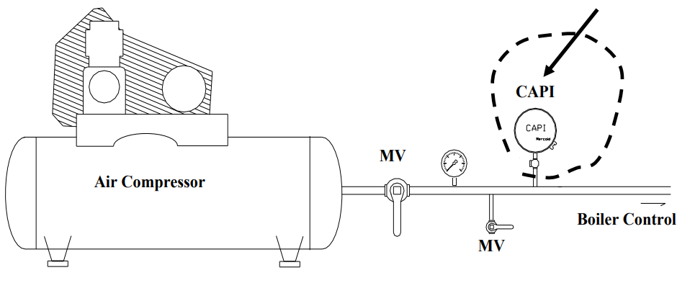

- Slowly close manual test valve to lower air supply pressure. Observe the pressure at which boiler shuts down. DO NOT LOWER PRESSURE BELOW REQUIRED PRESSURE TO ACTUATE ANY PNEUMATIC CONTROL DEVICE!

$va_loc$ | Boiler $boiler_num$

Result | Y/N | Switch Trip Point
Correct location? | $capi_result_1$
Did the CAPI work correctly? | $capi_result_2$
Is lockable manual test valve in place as shown in figure? | $capi_result_3$
What was the interlock trip point pressure? |  | $capi_result_4$
Is the setpoint higher than pressure required to actuate any  pneumatic control device? | $capi_result_5$

Did the device fail or pass the 3 Question Criteria (section 1.3.1)? [$capi_result_status$]
If boiler is to be operated with failed safety device, a properly approved ISM is required.
Describe safety device failure/remedy in Appendix F.

$va_loc$ | Boiler $boiler_num$

40. Low Water Cutouts - Hot Water [$lwcohw_result_status$]
(LRVHW)

Item | Manufacturer | Probe (Y/N) | Sight Glass in External Water Column (Y/N)
LWCOHW | $lwcohw_make$ | $lwcohw_probe$ | $lwcohw_sightglass$

- If factory setup has a water column containing a low water cutoff device and/or has points to install a sight glass, a sight glass must be installed. If factory setup is testable and utilized, then the LWCOHW device must shut the boiler down and lock out through the BMS at a water level visible in the sight glass and above the manufacturer designated minimum water level. One external probe water level cutout is required (LWCOHW) if there is no sight glass and method to test the factory unit provided by the manufacturer by draining the boiler water to verify activation. The external LWCOHW setup is shown below. The LWCOHW setup must be mounted in an accessible location in the hot water return line above the boiler and downstream (boiler side) of any isolation valve. It must contain a conductivity probe, a visible water level indicator, lockable only open isolation valves, a lock closed drain, and lock closed vent as shown below. This external setup will be independent of any factory installed low water device and must utilize a conductivity probe setup that upon activation must disconnect power to the boiler and require manual reset of relay to reenergize and operate boiler. The probe set point should activate and shutdown power to boiler with water level visible in the sight glass provided the bottom of the sight glass is higher than the min water level for the boiler.
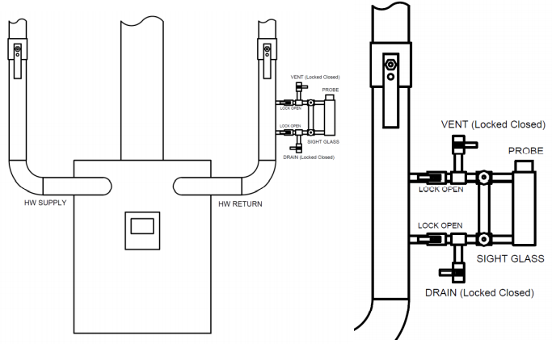

- If using factory unit refer to manufacturer provided procedure for proper test method. (Simply using factory test circuit button is inadequate).
- If using external unit, locate external LWCOHW water column in HW return piping.
- Remove locks and close external water column isolation valves to isolate water column.
- Slowly open column vent valve to allow column to be drained.
(HOT WATER, USE APPOPRIATE PPE !!!!)
- With boiler online, slowly open column drain valve and slowly drain water column until LWCOHW activates. Close drain.
- Upon activation record the water level in the sight glass at which the probe activates.
- Verify the boiler shuts off and has no power by verifying control panel is dead.
(Use multimeter if no power light indication)
- Slowly and slightly open bottom isolation valve to fill water column until water flows out of vent. Once water flows from vent, close vent, and open top isolation valve.
- Replace locks on isolation valves. Reset LWCOHW relay and return to normal operation.

Result | Y/N | Pressure (psi)
Correct installation? | $lwcohw_result_1$
Did the LWCOHW work correctly? Record Level. | $lwcohw_result_2$ | $lwcohw_result_3$
Did the LWCOHW shut down and lockout boiler if using factory setup or shutoff power to boiler and require manual reset if using external setup? | $lwcohw_result_4$
Was water level visible in sight glass and more than 1 inch above bottom of sight glass at activation point? | $lwcohw_result_5$

Did the device fail or pass the 3 Question Criteria (section 1.3.1)? [$lwcohw_result_status$]
If boiler is to be operated with failed safety device, a properly approved ISM is required.
Describe safety device failure/remedy in Appendix F.

$va_loc$ | Boiler $boiler_num$

41. Liquid Relief Valves - Hot Water [$lrvhw_result_status$]
(LRVHW)

Item | Make | Capacity (gal/hr) | Range | Set point | Normal Boiler Pressure
LRVHW | $lrvhw_make$ | $lrvhw_capacity$ |  | $lrvhw_sp$ | $lrvhw_norm_pres$
Pressure Gauge | $lrvhw_gauge_make$ |  | $lrvhw_gauge_range$

Item | Make | MAWP
Boiler | $boiler_mfr$ | $boiler_mawp$

- One liquid relief valve stamped with an ASME certification must be installed on the boiler. The LRVHW must be plumbed to drain to sewer while meeting local codes for sewer drain conditions. The drain line must be hard piped with a diameter equal to or greater than the outlet diameter of the LRVHW. A view port or other means to determine when the LRVHW opens must be available as well as a test port for connecting a hydrostatic test pump.
- The activation point of the LRVHW must be above normal boiler operating pressure and below the maximum allowable working pressure of boiler. The LRVHW must activate within +/-5% of set value or +/-2 psi whichever is higher.
- LOOP Isolation valves must be in place to isolate the incoming and exit water flow to and from boiler.

- With boiler offline close manual valves on inlet and exit water flow to isolate boiler. Use hydrostatic test pump to raise pressure in the boiler and open LRVHW. Note the pressure at which the LRVHW opens. DO NOT RAISE PRESSURE MORE THAN MAXIMUM ALLOWABLE BOILER PRESSURE!
- Open the two isolation valves, disconnect the hydrostatic pump and verify that the boiler is operational and that the LRVHW reseated.

$va_loc$ | Boiler $boiler_num$

Result | Y/N | Pressure (psi)
Correct installation? | $lrvhw_result_1$
Did the LRVHW work correctly? | $lrvhw_result_2$
What was the lift pressure for the LRVHW? |  | $lrvhw_result_3$
Did the LRVHW reseat? |  | $lrvhw_result_4$
View port or other means in place to view water flow thru relief valve and proper venting line and conditions? | $lrvhw_result_5$
Drain line proper? | $lrvhw_result_6$

Did the device fail or pass the 3 Question Criteria (section 1.3.1)? [$lrvhw_result_status$]
If boiler is to be operated with failed safety device, a properly approved ISM is required.
Describe safety device failure/remedy in Appendix F.

$va_loc$ | Boiler $boiler_num$

42. High Water Temperature Switch [$hwts_result_status$]
(HWTS)

Item | Make | Set point  DegF | Normal Boiler Temperature  DegF | Manufacturer  Recommended  Maximum Allowable  Temperature, DegF
HWTS | $hwts_make$ | $hwts_sp$ | $hwts_norm_pres$ | $hwts_mfr_max_temp$

- A switch mounted high in the boiler near the boiler water outlet to cutout the boiler in case of excessive temperature. The device must be separate from any device used to control temperature.
- The switch set point for shutting down the boiler should be no higher than 15 F above the normal boiler temperature and lower than the recommended maximum temperature set by manufacturer.
- LOOP Isolation valves must be in place to isolate the incoming and exit water flow to and from boiler. The boiler must be fitted with a temperature readout that measures the internal water temperature near boiler outlet

- This test should only be performed after the LRVHW has been tested and shown to Pass the 3 question Criteria.
- With boiler running, use an auxiliary means such as a contact thermometer to verify that the temperature readout on boiler water is accurate as compared to the auxiliary reading taken externally on the boiler water outlet. (An alternate approach is to use a recent calibration of the boiler water temperature readout.) Proceed only if the boiler water temperature reading is known to be accurate.
- Shut the boiler down and close the inlet and exit isolation valves and electrically by pass the flow switch
- Fire the boiler and slowly raise the water temperature. NEVER ALLOW THE WATER TEMPERATURE TO REACH THE MAXIMUM ALLOWABLE TEMPERATURE PROVIDED BY MANFACTURER!
- Note the temperature at which the switch shuts down the boiler.
- Remove flow switch jumper, open isolation valves, and verify the boiler is operational.

$va_loc$ | Boiler $boiler_num$

Result | Y/N | Switch Trip Point, DegF
Switch has correct location and is independent of Temperature control? | $hwts_result_1$
Did switch work correctly? Record Temperature | $hwts_result_2$ | $hwts_result_3$
Is switch trip point correct? | $hwts_result_4$

Did the device fail or pass the 3 Question Criteria (section 1.3.1)? [$hwts_result_status$]
If boiler is to be operated with failed safety device, a properly approved ISM is required.
Describe safety device failure/remedy in Appendix F.

$va_loc$ | Boiler $boiler_num$

43. Flow Switch [$fs_result_status$]
(FS)

Item | Make | Minimum Flow required by boiler manufacturer, gpm
Flow Switch | $fshw_make$ | $fshw_mfr_min_flow$

- A flow switch that is normally open and activates without a delay is required.
- The set point flow rate for the FS for shutting down the boiler should be 10% or more above the manufacturer’s required minimum flow.
- A method to measure flow of water through the boiler is required, such as a strap on flow meter or equivalent.

- With the boiler in low fire, use the inlet or exit isolation valve to slowly throttle the flow of water through the boiler. (If a VFD pump control is available, it is preferable to place the VFD in manual and use the VFD control to slow the water flow rather than throttling the water with a valve.)
- Monitor the water temperature to be sure it does not exceed the manufacturer’s maximum allowable temperature.
- Observe the flow rate that causes the boiler to trip off line due to low flow.
- Open the isolation valve used to throttle the flow (or place VFD in automatic) and start boiler to prove operable.

Result | Y/N | Flow Rate, gpm
Correct installation including non-adjustable set point? | $fshw_result_1$
Did the FS work correctly? | $fshw_result_2$
What was the trip point flow rate for the FS? |  | $fshw_result_3$

Did the device fail or pass the 3 Question Criteria (section 1.3.1)? [$fshw_result_status$]
If boiler is to be operated with failed safety device, a properly approved ISM is required.
Describe safety device failure/remedy in Appendix F.

$va_loc$ | Boiler $boiler_num$

44. Liquid Relief Valve on Economizer [$lrve_result_status$]
(LRVE)

Item | Make | Capacity  (gal/hr) | Range | LRVE  Set Point | Normal Boiler Pressure
LRVE | $lrve_make$ | $lrve_capacity$ |  | $lrve_sp$ | $boiler_op_press$
Pressure Gage | $lrve_gauge_make$ |  | $lrve_gauge_range$

- Setpoint is required to be less than the 90% of max allowable economizer pressure and at least 10% above the maximum feedwater pressure. The relief valve must lift in the range of ±3% of the setpoint pressure of the relief valve.

Item | Make | Max Stack Temp | MAWP
Economizer | $lrve_eco_make$ | $lrve_eco_mst$ | $lrve_eco_mawp$

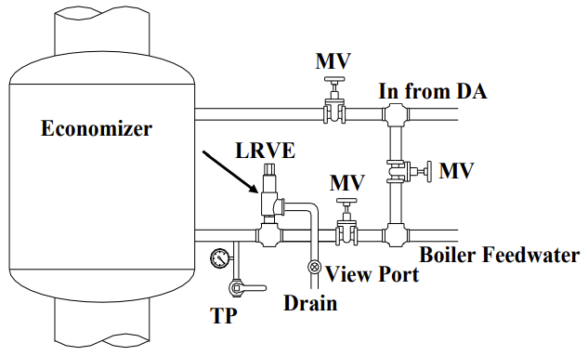

$va_loc$ | Boiler $boiler_num$

- With boiler offline use manual valves shown in above figure to isolate economizer and relief valve. Use hydrostatic test pump to raise pressure and open relief valve (use view port to determine when valve is open). DO NOT RAISE PRESSURE MORE THAN ALLOWABLE ECONOMIZER PRESSURE!

Result | Y/N | Pressure
Correct installation? | $lrve_result_1$
What is the stamped relief valve lift pressure on the LRVE? |  | $lrve_result_2$
What was the relief valve lift pressure? |  | $lrve_result_3$
Maximum allowable economizer pressure? |  | $lrve_result_4$
Maximum feedwater pump pressure? |  | $lrve_result_5$
Did the LRVE work correctly within required pressure limits? | $lrve_result_6$
View port in place to view water flow thru relief valve? | $lrve_result_7$

Did the device fail or pass the 3 Question Criteria (section 1.3.1)? [$lrve_result_status$]
If boiler is to be operated with failed safety device, a properly approved ISM is required.
Describe safety device failure/remedy in Appendix F.

$va_loc$ | Boiler $boiler_num$

45. Propane Pilot Backup System [$ppbs_result_status$]
(PPBS)

Note: This test ensures that backup fuel can be fired in the case of loss of natural gas to plant. This test is to determine the reliability of the backup pilot system in its ability to light the boiler when firing on fuel oil. The same safety devices as those used for a natural gas pilot are used to ensure the safety of this operation.

• Connect and/or align propane system to boiler.
• Attempt to light boiler FIRING ON FUEL OIL.

Result | Y/N
Is Propane Pilot Backup System in place and operable? | $ppbs_result_1$

Did the device fail or pass the 3 Question Criteria (section 1.3.1)? [$ppbs_result_status$]
If boiler is to be operated with failed safety device, a properly approved ISM is required.
Describe safety device failure/remedy in Appendix F.

$va_loc$ | Boiler $boiler_num$

Appendix F: Comments

Test | Comments:
1 | LWA-LWCO-ALWCO [$lwa_lwco_alwco_result_status$] - $lwa_lwco_alwco_comments$
2 | HWA [$hwa_result_status$] - $hwa_comments$
3 | RBSPLS-NRBSPLS (HP) [$rbspls_nrbspls_result_status$] - $rbspls_nrbspls_comments$
4 | SVB (HP) [$svb_result_status$] - $svb_comments$
5 | RBSPLS-NRBSPLS (LP) [$rbspls_nrbspls_result_status$] - $rbspls_nrbspls_comments$
6 | SVB (LP) [$svb_result_status$] - $svb_comments$
7 | LFGPCS [$lfgpcs_result_status$] - $lfgpcs_comments$
8 | HFGPCS [$hfgpcs_result_status$] - $hfgpcs_comments$
9 | AFGSOV-AFGSVV [$afgsov_afgsvv_result_status$] - $afgsov_afgsvv_comments$
10 | APFGSOV-APFGSVV [$apfgsov_apfgsvv_result_status$] - $apfgsov_apfgsvv_comments$
11 | POCAFGSOV [$pocafgsov_result_status$] - $pocafgsov_comments$
12 | FSMFO [$fsmf_result_status$] - $fsmf_comments$
13 | FSNSIS [$fsnsis_result_status$] - $fsnsis_comments$
14 | IT [$it_result_status$] - $it_comments$
15 | MFIT [$mfit_result_status$] - $mfit_comments$
16 | PPT [$ppt_result_status$] - $ppt_comments$
17 | LFPS [$lfps_result_status$] - $lfps_comments$
18 | FDDWOPS [$fddwops_result_status$] - $fddwops_comments$
19 | CAPSVS [$capsvs_result_status$] - $capsvs_comments$
20 | CAPSCS [$capscs_result_status$] - $capscs_comments$
21 | PAPS [$paps_result_status$] - $paps_comments$
22 | FDMIS [$fdmis_result_status$] - $fdmis_comments$
23 | OSDPI [$osdpi_result_status$] - $osdpi_comments$
24 | FPI [$fpi_result_status$] - $fpi_comments$
25 | LPFGPCS [$lpfgpcs_result_status$] - $lpfgpcs_comments$
26 | LPFGPCS2 [$lpfgpcs2_result_status$] - $lpfgpcs2_comments$
27 | FGRDI [$fgrdi_result_status$] - $fgrdi_comments$
28 | LFGOLI [$lfgoli_result_status$] - $lfgoli_comments$
29 | LFOPCS [$lfopcs_result_status$] - $lfopcs_comments$
30 | HFOPCS [$hfopcs_result_status$] - $hfopcs_comments$
31 | LAMPS [$lamps_result_status$] - $lamps_comments$
32 | LAMPS (AMC) [$lamps_amc_result_status$] - $lamps_amc_comments$
33 | LAMDPS [$lamdps_result_status$] - $lamdps_comments$
34 | SLAMPS [$slamps_result_status$] - $slamps_comments$
35 | SLAMPS (AMC) [$slamps_amc_result_status$] - $slamps_amc_comments$
36 | AFOSV [$afosov_result_status$] - $afosov_comments$
37 | POCAFOSV [$pocafosov_result_status$] - $pocafosov_comments$
38 | OBPS [$obps_result_status$] - $obps_comments$
39 | CAPI [$capi_result_status$] - $capi_comments$
40 | LWCOHW [$lwcohw_result_status$] - $lwcohw_comments$
41 | LRVHW [$lrvhw_result_status$] - $lrvhw_comments$
42 | HWTS [$hwts_result_status$] - $hwts_comments$
43 | FS [$fshw_result_status$] - $fshw_comments$
44 | LRVE [$lrve_result_status$] - $lrve_comments$
45 | PPBS [$ppbs_result_status$] - $ppbs_comments$
 | General Notes: $inspection_comments$

