Table A.3.1 Basic Plant Information

SITE INFORMATION
VISN | $job_num$
VA Medical Center Location | $va_loc$
Contact Information | $va_contact$
Phone | $va_contact_phone$
Email | $va_contact_email$
Evaluators | $evaluators$
Date | $insp_date$
DA TANK DESCRIPTION
Manufacture | $da_manufacture$
Type | $da_type$
Maximum Allowable Working  Pressure (MAWP) | $da_mawp$
Operating Pressure | $da_op_press$
Date of Manufacture | $da_manufacture_date$
CONDENSATE TANK DESCRIPTION
Manufacture | $cond_manufacture$
Maximum Allowable Working  Pressure (MAWP) | $cond_mawp$
Date of Manufacture | $cond_manufacture_date$

Table: A.4.1 Pretest Documentation Review
Checklist Items: | Y/N
Are any active Interim Safety Measures in place on any boiler or ancillary plant device to be tested? | $pretest_1$
Are all boilers in operation current (within the last year) with annual internal pressure vessel inspection performed by a National Board certified inspector? | $pretest_2$
Are all boilers in operation current (within the last year) with annual external pressure vessel inspection performed by a National Board certified inspector? | $pretest_3$
Is the Deaerator tank current (within last 6 years) with required Non-Destructive Testing (NDT- Wet mag and ultrasonic thickness) performed by qualified inspector? | $pretest_4$
Is the Deaerator tank current with required annual visual inspection and cleaning? | $pretest_5$
Is the Condensate tank current with required annual visual inspection and cleaning? | $pretest_6$
Are all boilers within their useful life thresholds? (30yr - Firetube, 40 yr - Watertube, 15 yr – Flex tube / other) | $pretest_7$
If boilers are outside useful life, has a boiler life / condition study been performed by qualified third party national board certified inspector? | $pretest_8$

Notes: $pretest_9$

Contents
1. High Water Alarm on Condensate Tank [$hwact_result_status$] 4
2. Low Water Alarm on Condensate Tank [$lwact_result_status$] 6
3. High Water Alarm on Deaerator Tank [$hwadt_result_status$] 8
4. Low Water Alarm on Deaerator Tank [$lwadt_result_status$] 10
5. Deaerator Overflow Drain System [$daods_result_status$] 12
6. Deaerator Safety Valve [$dasv_result_status$] 14
7. Steam Safety Valve Following PRV [$svfprv_result_status$] 16
8. Steam Safety Valve Following PRV (Other) [$svfprv2_result_status$] 18
9. Liquid Relief Valve on Oil Pump Set [$lrvops_result_status$] 20
10. Control Air Pressure Interlock [$capi_result_status$] 22
11. Carbon Monoxide and Combustible Gas Alarms in the Boiler Plant [$cocga_result_status$] 24
12. Outside Air Damper Interlock with Alarm [$oadia_result_status$] 25
13. Outside Air Makeup Unit Interlock with Alarm [$oamula_result_status$] 27
14. Emergency Stop/Panic Buttons [$espb_result_status$] 29
15. High Fuel Gas Pressure Alarm on Main Gas Line [$hfgpamg_result_status$] 30
16. High Fuel Gas Pressure Alarm on Propane Line [$hfgpalp_result_status$] 32
Appendix E: Checklist for General Plant Safety and Reliability 34
Appendix F: Comments 35

1. High Water Alarm on Condensate Tank [$hwact_result_status$]
(HWACT) (For Steam Boiler System only)

Item | Make | Model | Device  Type | Alarm  Setpoint | Condensate Tank Diameter
HWACT | $hwact_make$ | $hwact_model$ | $hwact_type$ | $hwact_sp$ | $hwact_diameter$

- Alarm set point is required to be below 2/3rds of tank height & at least 4” below the overflow actuation point. Alarm type is required to be a probe independent of water level control. Tank sight glass must cover full tank height.
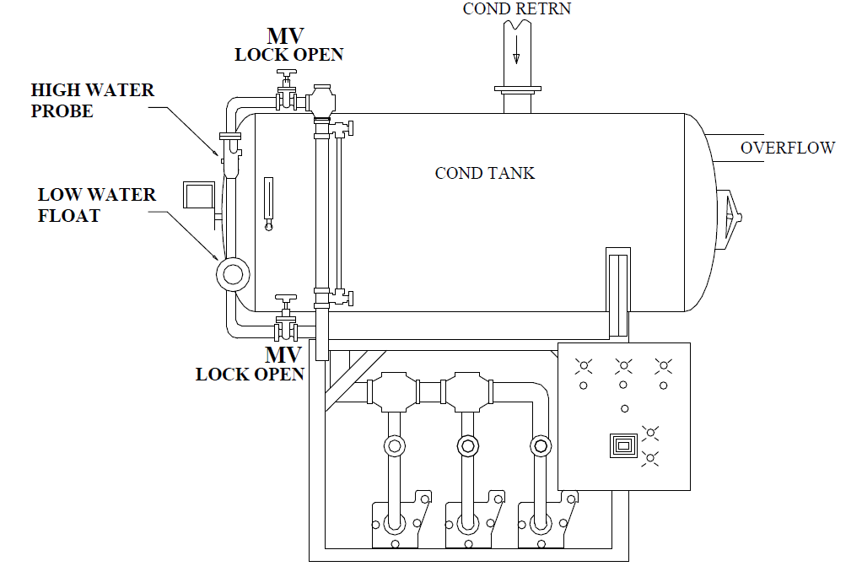

- Verify sight glass in clean and water is clearly visible. Drain sight glass without draining alarm column. Quickly close drain valve. Water level should quickly rise in sight glass indicating good communication with tank.
- If poor communication, clean lines and begin with the step above.
- Use soft water bypass valve to add water to the condensate tank at a rate not to exceed 1 inch per minute. Use water level sight glass to observe point that alarm sounds. Tank can be either offline or online. At no point should water level be allowed to go above the tank.
- Put maximum water supply to condensate tank and verify overflow can maintain water level. If water level continues to rise abort test.

Result | Y/N | Water Level
Correct device installation? Are any valves that can isolate alarm device LOOP? | $hwact_result_1$
Did the alarm work correctly? Record water level | $hwact_result_2$ | $hwact_result_3$
Did Overflow maintain water level? (Water level did not continue to rise.) | $hwact_result_4$

Did the device fail or pass the 3 Question Criteria (section 1.3.1)? $hwact_result_status$
If boiler is to be operated with failed safety device, a properly approved ISM is required.
Describe safety device failure/remedy in Appendix F.

2. Low Water Alarm on Condensate Tank [$lwact_result_status$]
(LWACT) (For Steam Boiler System only)

Item | Make | Model | Device  Type | Alarm  Setpoint | Condensate Tank Diameter
LWACT | $lwact_make$ | $lwact_model$ | $lwact_type$ | $lwact_sp$ | $lwact_diameter$

- Alarm set point is required to be above 1/3rd of tank height. Device type is required to be a probe or float independent of water level control.
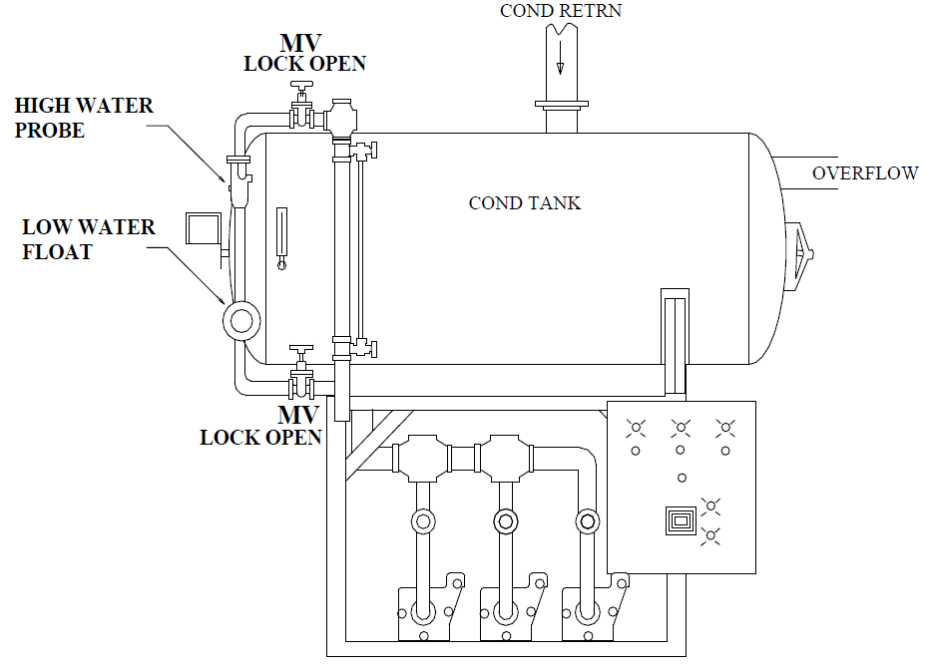

- Verify sight glass in clean and water is clearly visible. Drain sight glass without draining alarm column and then quickly close drain valve. Water level should quickly rise in sight glass indicating good communication with tank.
- If poor communication, clean lines and begin with the step above.
- Drain the water from the condensate tank at a rate not to exceeded 1 inch per minute. Use water level sight glass to observe alarm point. DO NOT ALLOW WATER LEVEL TO LEAVE SIGHT GLASS. Tank can be either offline or online.

Result | Y/N | Water Level
Correct device installation? Are any valves that can isolate alarm device LOOP? | $lwact_result_1$
Did the alarm work correctly? Record water level | $lwact_result_2$ | $lwact_result_3$

Did the device fail or pass the 3 Question Criteria (section 1.3.1)? $lwact_result_status$
If boiler is to be operated with failed safety device, a properly approved ISM is required.
Describe safety device failure/remedy in Appendix F.

3. High Water Alarm on Deaerator Tank [$hwadt_result_status$]
(HWADT) (For Steam Boiler System only)

Item | Make | Model | Device  Type | Alarm  Setpoint | DA Tank Diameter
HWADT | $hwadt_make$ | $hwadt_model$ | $hwadt_type$ | $hwadt_sp$ | $hwadt_diameter$

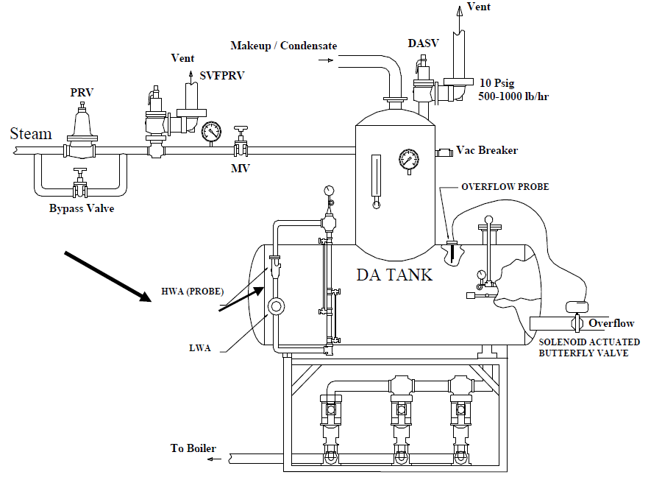
- Alarm set point is required to be below 2/3rds of tank height & at least 4” below the level at which the overflow valve actuates. Alarm type is required to be a probe independent of water level control. Tank sight glass must cover full tank height.

- Verify sight glass in clean and water is clearly visible. Drain sight glass without draining alarm column and then quickly close drain valve. Water level should quickly rise in sight glass indicating good communication with tank.
- If poor communication, clean lines and begin with the step above.
- Use bypass valve to add water to the deaerator at a rate not to exceed 1 inch per minute. Use water level sight glass to observe point that alarm sounds. DO NOT ALLOW WATER LEVEL TO LEAVE SIGHT GLASS.

Result | Y/N | Water Level
Correct device installation? Are any valves that can isolate alarm device LOOP? | $hwadt_result_1$
Did the alarm work correctly? Record water level | $hwadt_result_2$ | $hwadt_result_3$

Did the device fail or pass the 3 Question Criteria (section 1.3.1)? $hwadt_result_status$
If boiler is to be operated with failed safety device, a properly approved ISM is required.
Describe safety device failure/remedy in Appendix F.

4. Low Water Alarm on Deaerator Tank [$lwadt_result_status$]
(LWADT) (For Steam Boiler System only)

Item | Make | Model | Device  Type | Alarm  Setpoint | DA Tank Diameter
LWADT | $lwadt_make$ | $lwadt_model$ | $lwadt_type$ | $lwadt_sp$ | $lwadt_diameter$

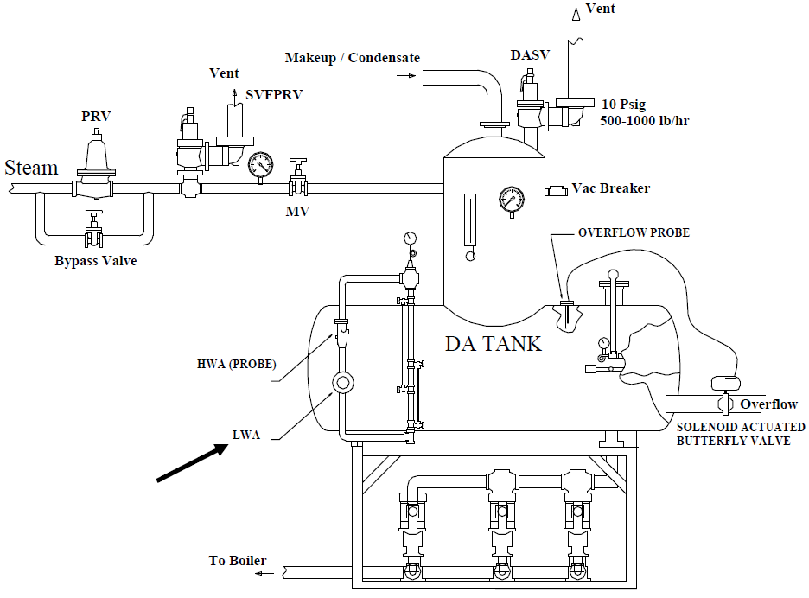
- Alarm set point is required to be above 1/3rd of tank height. Device type is required to be a probe or float independent of water level control.

- Verify sight glass in clean and water is clearly visible. Drain sight glass without draining alarm column and then quickly close drain valve. Water level should quickly rise in sight glass indicating good communication with tank.
- If poor communication, clean lines and begin with the step above.
- Use bypass valve to add water to the deaerator at a rate not to exceed 1 inch per minute. Use water level sight glass to observe point that alarm sounds. DO NOT ALLOW WATER LEVEL TO LEAVE SIGHT GLASS

Result | Y/N | Water Level
Correct device installation? Are any valves that can isolate alarm device LOOP? | $lwadt_result_1$
Did the alarm work correctly? Record water level | $lwadt_result_2$ | $lwadt_result_3$

Did the device fail or pass the 3 Question Criteria (section 1.3.1)? $lwadt_result_status$
If boiler is to be operated with failed safety device, a properly approved ISM is required.
Describe safety device failure/remedy in Appendix F.

5. Deaerator Overflow Drain System [$daods_result_status$]
(DAODS) (For Steam Boiler System only)

Item | Make | Model | Device  Type | Overflow  Setpoint | DA Tank Diameter
DAODS | $daods_make$ | $daods_model$ | $daods_type$ | $daods_sp$ | $daods_da_diameter$

- Overflow system is required to be a conductivity probe connected to an electronic valve that is not used in level control. Setpoint is required to be at least 4” below top of tank and 4 in higher than HWA. Overflow must be routed to adequate safe floor drain and tempered if necessary.
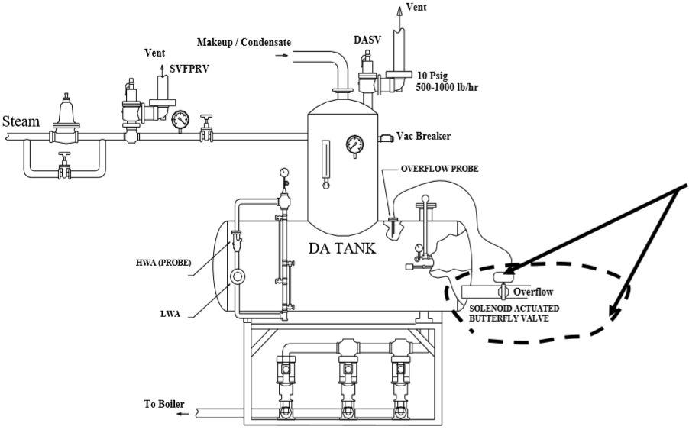

- Verify sight glass in clean and water is clearly visible. Drain sight glass without draining alarm column and then quickly close drain valve. Water level should quickly rise in sight glass indicating good communication with tank.
- Open manual bypass valve to supply feedwater at maximum rate.
- Determine that overflow valve has opened by using sight glass in drain line or visually observing drain. Use water level in sight glass on tank to observe whether overflow valve maintains water level visible in sight glass. DO NOT ALLOW WATER LEVEL TO LEAVE SIGHT GLASS.

Result | Y/N | Water Level
Correct device installation? Are any valves that can isolate alarm device LOOP? | $daods_result_1$
Did the alarm work correctly? (Water level does not continue to rise after overflow opens?) Record water level | $daods_result_2$ | $daods_result_3$
View port in place to view overflow? | $daods_result_4$

Did the device fail or pass the 3 Question Criteria (section 1.3.1)? $daods_result_status$
If boiler is to be operated with failed safety device, a properly approved ISM is required.
Describe safety device failure/remedy in Appendix F.

6. Deaerator Safety Valve [$dasv_result_status$]
(DASV) (For Steam Boiler System only)

Item | Make | Capacity | Range | DASV Set Point | DA Pres
DASV | $dasv_make$ | $dasv_capacity$ |  | $dasv_sp$ | $dasv_da_pres$
Pressure Gage | $dasv_gauge_make$ |  | $dasv_gauge_range$

- Setpoint is required to be 5 psig higher than normal DA pressure and no more than 15 psig. Capacity is required to be approximately (1000 lb/hr). DASV is required to be directly vented outside. Vent line is required not to contact drip pan ells when hot. Maximum lift pressure shall not exceed 2 psig above set pressure. Reseat pressure shall not exceed 4 psig below setpoint pressure.

Item | Make | Type | MAWP | NDT (date)
DAODS | $daods_make$ | $daods_type$ | $daods_mawp$ | $daods_ndt_date$
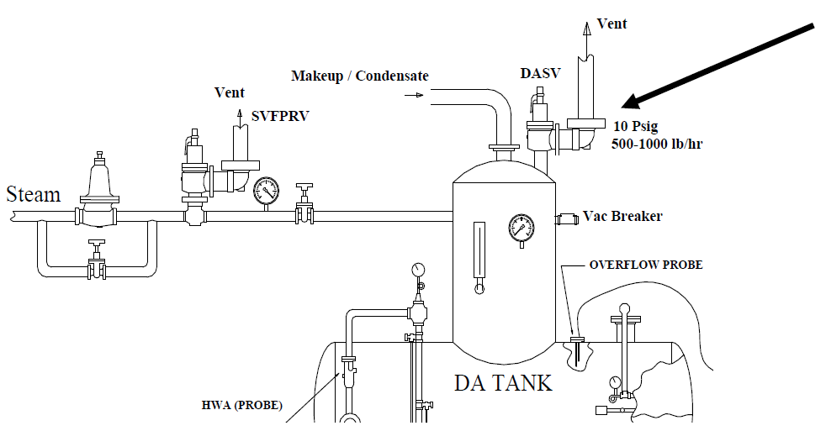

- Is NDT current within six years. If not obtain inspection before proceeding.
- Test the drains on the safety valve drip pan ells by pouring water into them and noting that water flows freely. Unstop drains before proceeding.
- Slowly open steam PRV bypass valve to raise pressure until safety lifts. DO NOT RAISE PRESSURE MORE THAN 2 PSIG ABOVE SET POINT PRESSURE.
- Record lift pressure
- After lifting valve, close bypass valve and allow safety to reseat. Record reseat pressure.

Result | Y/N | Pressure
Correct installation? | $dasv_result_1$
Did the safety valve work correctly? | $dasv_result_2$
What was the safety valve relief pressure? |  | $dasv_result_3$
What was the safety valve re-seat pressure? |  | $dasv_result_4$
Is vacuum breaker present (VA requirement)? | $dasv_result_5$
Is NDT current within the 6 year window? | $dasv_result_6$

Did the device fail or pass the 3 Question Criteria (section 1.3.1)? $dasv_result_status$
If boiler is to be operated with failed safety device, a properly approved ISM is required.
Describe safety device failure/remedy in Appendix F.

7. Steam Safety Valve Following PRV [$svfprv_result_status$]
(SVFPRV) (For Steam Boiler System only)

Item | Make | Capacity (lb/hr) | Range | SVFPRV Set Point | DA Pres
SVFPRV | $svfprv_make$ | $svfprv_capacity$ |  | $svfprv_sp$ | $svfprv_da_pres$
Pressure Gage | $svfprv_gauge_make$ |  | $svfprv_gauge_range$

- Setpoint must be 5 psig higher than DA safety set pressure and at least 5 psig below MAWP of DA tank. Maximum lift pressure shall not exceed 2 psig above set pressure. Reseat pressure shall not exceed 4 psig below set pressure.

Item | Make | Type | Size  (in) | Pressure  Upstream | Pressure  Downstream | Wide Open Flow Capacity
PRV | $svfprv_prv_make$ | $svfprv_prv_type$ | $svfprv_prv_size$ | $svfprv_prv_up_pres$ | $svfprv_prv_down_pres$ | $svfprv_prv_wofc$
Bypass | $svfprv_prv_bp_make$ | $svfprv_prv_bp_type$ | $svfprv_prv_bp_size$ |  |  | $svfprv_prv_bp_wofc$

- SVFPRV is required to relieve largest of wide open flow capacity, PRV (combined total if parallel PRV setup) or bypass valve. Manual valve downstream of SVFPRV is required. SVFPRV is required to be directly vented outside. Vent line is required not to contact drip pan ell when hot. Any valves with a setpoint of 15 psig or higher must be of steel construction.
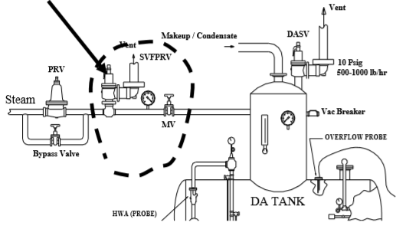

- Test the drains on the safety valve drip pan ells by pouring water into them and noting that water flows freely. Unstop drains before proceeding.
- Close the manual valve in steam line following the safety valve.
- Slowly open bypass valve to raise pressure until safety lifts. DO NOT RAISE PRESSURE MORE THAN 2 PSIG ABOVE SETPOINT PRESSURE.
- Use manufacturer data to determine wide open capacity of PRV and bypass valve.
- Open larger of the bypass valve or PRV completely and perform accumulation test. The pressure should rise no more than 6% above the setpoint pressure. After lifting valve, close bypass valve, open manual valve in steam line after PRV and allow safety to reseat

Result | Y/N | Pressure
Correct installation? | $svfprv_result_1$
Did the safety valve work correctly? Record relief Pressure | $svfprv_result_2$ | $svfprv_result_3$
What was the re-seat pressure? |  | $svfprv_result_4$
Did the steam pressure continue to rise with the safety valve lifted and the bypass valve wide open? | $svfprv_result_5$

Did the device fail or pass the 3 Question Criteria (section 1.3.1)? $svfprv_result_status$
If boiler is to be operated with failed safety device, a properly approved ISM is required.
Describe safety device failure/remedy in Appendix F.

8. Steam Safety Valve Following PRV (Other) [$svfprv2_result_status$]
(SVFPRV) (For Steam Boiler System only)

Item | Make | Capacity (lb/hr) | Range | SVFPRV Set Point | DA Pres
SVFPRV | $svfprv2_make$ | $svfprv2_capacity$ |  | $svfprv2_sp$ | $svfprv2_da_pres$
Pressure Gage | $svfprv2_gauge_make$ |  | $svfprv2_gauge_range$

- Setpoint must be 5 psig higher than normal delivered pressure. If valve setpoint is 15 psig or less, then maximum lift pressure shall not exceed 2 psig above set pressure and reseat pressure shall not exceed 4 psig below set pressure. If safety valve setpoint is greater than 15 psig, then maximum lift pressure shall not exceed 3% of set pressure and reseat pressure shall not exceed 6% of set pressure. Any valve with setpoint of 15 psig or more must be of steel construction.

Item | Make | Type | Size  (in) | Pressure  Upstream | Pressure  Downstream | Wide Open Flow Capacity
PRV | $svfprv2_prv_make$ | $svfprv2_prv_type$ | $svfprv2_prv_size$ | $svfprv2_prv_up_pres$ | $svfprv2_prv_down_pres$ | $svfprv2_prv_wofc$
Bypass | $svfprv2_prv_bp_make$ | $svfprv2_prv_bp_type$ | $svfprv2_prv_bp_size$ |  |  | $svfprv2_prv_bp_wofc$

- SVFPRV is required to relieve largest wide open flow capacity, PRV or bypass valve.
- Manual valve downstream SVFPRV is required
- SVFPRV is required to be directly vented outside.
- Vent line is required not to contact drip pan ell when hot.

- Test the drains on the safety valve drip pan ells by pouring water into them and noting that water flows freely. Unstop drains before proceeding.
- Close the manual valve in steam line following the safety valve.
- Slowly open bypass valve to raise pressure until safety lifts. DO NOT RAISE PRESSURE MORE THAN 2 PSIG ABOVE SETPOINT PRESSURE.
- Use manufacturer data to determine wide open capacity of PRV and bypass valve.
- Open larger of the bypass valve or PRV completely and perform accumulation test. The pressure should rise no more than 6% above the setpoint pressure. After lifting valve, close bypass valve, open manual valve in steam line after PRV and allow safety to reseat

Result | Y/N | Pressure
Correct installation? | $svfprv_result_1$
Did the safety valve work correctly? Record relief Pressure | $svfprv_result_2$ | $svfprv_result_3$
What was the re-seat pressure? |  | $svfprv_result_4$
Did the steam pressure continue to rise with the safety valve lifted and the bypass valve wide open? | $svfprv_result_5$

Did the device fail or pass the 3 Question Criteria (section 1.3.1)? $svfprv_result_status$
If boiler is to be operated with failed safety device, a properly approved ISM is required.
Describe safety device failure/remedy in Appendix F.

9. Liquid Relief Valve on Oil Pump Set [$lrvops_result_status$]
(LRVOPS)

Item | Make | Capacity  (gal/hr) | Range | LRVOPS  Set Point | Oil Supply Pressure
LRVOPS | $lrvops_make$ | $lrvops_capacity$ |  | $lrvops_sp$ | $lrvops_oil_supply_pres$
Pressure Gage | $lrvops_gauge_make$ |  | $lrvops_gauge_range$

- Setpoint is required to be less than the max allowable pump pressure and less than 10 psig above normal regulated oil supply pressure.
- LRVOPS is required not to be used as a backpressure regulator.
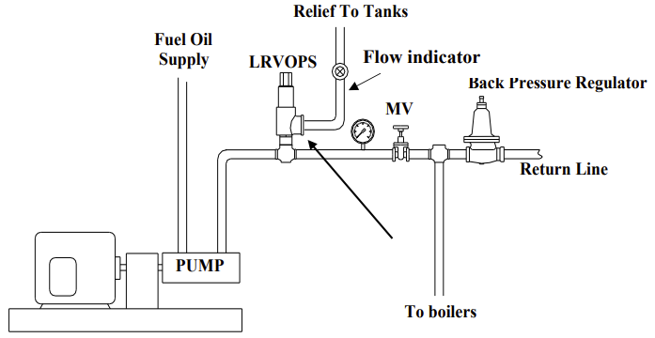

- Slowly close manual valve in oil line after relief valve or raise pressure regulator set pressure until relief valve lifts (use view port to determine if valve is open).
- The pressure should rise no more than 10 psig above normal regulated oil supply pressure.

Result | Y/N | Pressure
Correct installation? | $lrvops_result_1$
Are there any valves that can isolate the relief path not locked only in the open position? | $lrvops_result_8$
Did the relief valve work correctly? Record lift Pressure | $lrvops_result_2$ | $lrvops_result_3$
Did the valve re-seat? Record re-seat pressure? | $lrvops_result_4$ | $lrvops_result_5$
View port in place to view oil flow thru relief valve? | $lrvops_result_6$
Is a back pressure regulator present? | $lrvops_result_7$

Did the device fail or pass the 3 Question Criteria (section 1.3.1)? $lrvops_result_status$
If boiler is to be operated with failed safety device, a properly approved ISM is required.
Describe safety device failure/remedy in Appendix F.

10. Control Air Pressure Interlock [$capi_result_status$]
(CAPI)

Item | Make | Range  (psi) | Switch  Setpoint | Regulated Pressure | Minimum Required Pressure
HFGPCS | $capi_make$ | $capi_range$ | $capi_sp$ | $capi_reg_pres$ | $capi_min_req_pres$
Pressure Gauge | $capi_gauge_make$ | $capi_gauge_range$

- Setpoint is required to be more than minimum pressure required to actuate any pneumatic control device.
- CAPI is required to be after any pressure regulator in line serving pneumatic devices.
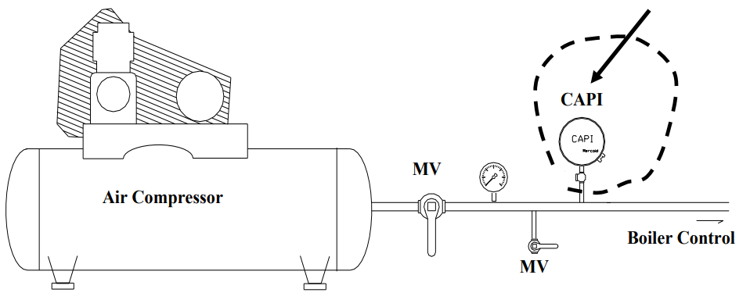

- Slowly close manual test valve to lower air supply pressure. Observe the pressure at which boiler shuts down. DO NOT LOWER PRESSURE BELOW REQUIRED PRESSURE TO ACTUATE ANY PNEUMATIC CONTROL DEVICE!

Result | Y/N | Switch Trip Point
Correct location? | $capi_result_1$
Did the CAPI work correctly? | $capi_result_2$
Is lockable manual test valve in place as shown in figure? | $capi_result_3$
What was the interlock trip point pressure? |  | $capi_result_4$
Is the setpoint higher than pressure required to actuate any  pneumatic control device? | $capi_result_5$

Did the device fail or pass the 3 Question Criteria (section 1.3.1)? [$capi_result_status$]
If boiler is to be operated with failed safety device, a properly approved ISM is required.
Describe safety device failure/remedy in Appendix F.

11. Carbon Monoxide and Combustible Gas Alarms in the Boiler Plant [$cocga_result_status$]

Item | Make | Number of  Alarms | Alarm Set Point
Combustible Alarm | $cocga_cga_make$ | $cocga_cga_no$ | $cocga_cga_sp$
CO Alarm | $cocga_co_make$ | $cocga_co_no$ | $cocga_co_sp$

- CO setpoint is required to be 50 ppm or less.
- Combustible set points are required to be 10% or less of the LEL.
- Test gasses for CO is required to be 50 ppm or less and for combustibles is required to be 10% or less of the Lower Explosive Limit (LEL)
- Location and number of CO and combustible sensors defined by VA Design Manual.

- Use test gases in accordance with manufacturer’s recommendation to test alarms.

Result | Y/N | Alarm Set Point
Correct test gas? | $cocga_result_1$
Did the combustibles alarm work correctly? | $cocga_result_2$ | $cocga_result_3$
Did the CO alarm work correctly? | $cocga_result_4$ | $cocga_result_5$
Are the number and locations of the sensors adequate? | $cocga_result_6$

Did the device fail or pass the 3 Question Criteria (section 1.3.1)? $cocga_result_status$
If boiler is to be operated with failed safety device, a properly approved ISM is required.
Describe safety device failure/remedy in Appendix F.

12. Outside Air Damper Interlock with Alarm [$oadia_result_status$]
(OADIA)

- Reference VA Steam, Heating Hot Water, and Outside Distribution Systems design manual for proper combustion air opening sizing requirements.
- Any moveable damper / louver used to supply outside air to a boiler requires an OADI. The OADI must prevent the boiler(s) from starting if the damper is not open and stop boiler operation in the event the damper becomes closed during operation. To mitigate the impact of boiler outage due to a secondary device failure, facilities must install parallel interlocks on alternate air openings - provided the alternate air opening(s) are an equivalently sized combustion air opening. For example, a garage door fitted with a similar interlock switch to satisfy the required combustion air supply, to allow the boiler(s) to operate while the make-up air louver operator is repaired.
- Outside air damper interlocks must be installed to prove the combustion air damper is at least 80% open to permit boiler operation.
- All interlocks and alarms must alarm locally and to the Building Management System for increased awareness and visibility.

- Measure the opening area used to supply air to boilers (either fixed or damper operated)

Item | Boiler HP Served | Required outside air  Opening area, ft² | Fixed  Opening  Area, ft² | Damper Operated  Opening Area, ft²
$oadia_area$ | $oadia_boiler_hp$ | $oadia_required_area$ | $oadia_fixed_area$ | $oadia_dampered_area$

- If OADI is installed, close outside air damper and prove that interlock activates with damper more than 80% open.
- With OADI louvers closed and secondary opening closed, attempt to fire boiler and prove that secondary interlock activates and prevent boiler from firing.

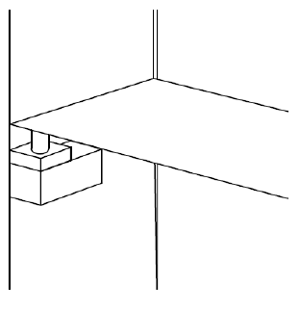
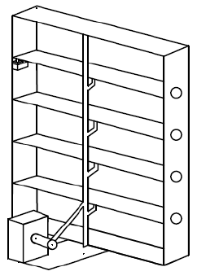

Result | Y/N
Is there adequate opening to supply combustion air for all boilers? | $oadia_result_1$
Is there an OADI on all moveable dampers used to supply outside air to boilers and a secondary interlock installed on a secondary opening? | $oadia_result_2$
If OADI exists, did it prevent boiler operation with damper(s) not at least 80% open? | $oadia_result_3$
Did secondary interlock prevent boiler operation? | $oadia_result_4$
Did audible alarm sound and annunciate properly when interlock activated? | $oadia_result_5$

Did the device fail or pass the 3 Question Criteria (section 1.3.1)? [$oadia_result_status$]
If boiler is to be operated with failed safety device, a properly approved ISM is required.
Describe safety device failure/remedy in Appendix F.

13. Outside Air Makeup Unit Interlock with Alarm [$oamula_result_status$]
(OAMUIA)

- Makeup air / ventilation unit(s) that provide combustion air supply to boiler(s) must be interlocked with boiler(s) to prevent boiler operation in the event the unit is not operational and stop boiler operation in the event the unit becomes disabled.
- The system must prove makeup unit operation via a differential pressure switch measuring the differential pressure across the unit fan. The DP switch must be plumbed across the fan with appropriate test ports and lock open only isolation valve shown below. The differential pressure switch must be set to activate the interlock at 80% or more of the minimum pressure difference measured across the fan during operation.
- To mitigate the impact of boiler outage due to a secondary device failure, facilities must install parallel interlocks on alternate air openings - provided the alternate air opening(s) are an equivalently sized combustion air opening. For example, a garage door fitted with a similar interlock switch to satisfy the required combustion air supply, to allow the boiler(s) to operate while the make-up unit is repaired.
- All interlocks and alarms must alarm locally and to the Building Management System for increased awareness and visibility.

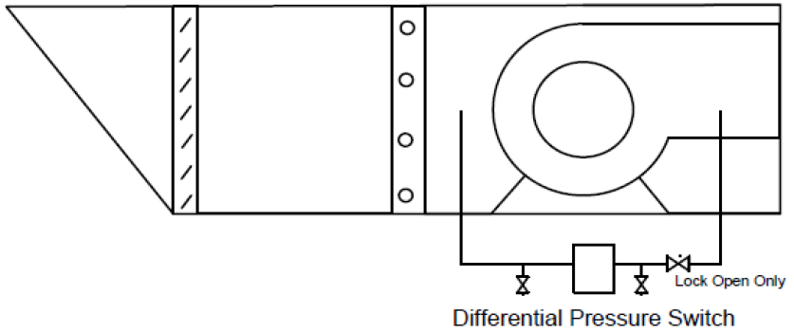

- Connect flex tubing / tee -bleed setup to high pressure test port closest to switch and high pressure side of monometer. Connect tubing from low pressure test port to low pressure side of manometer. Pinch / close off bleed line. Open test ports.
- With Make unit and boilers in operation determine the minimum differential pressure across the fan.
- With unit and boilers in operation close lockable only open isolation valve and slowly bleed pressure from switch until boiler trips offline. Record the activation pressure.
- With Makeup unit interlock switch isolated and open, close secondary outdoor air opening and verify boiler operation is prevented.

Result | Y/N | Pressure in wc
Correct installation with Lockable Only Open Valve in place? | $oamula_result_1$
What is the Minimum Pressure Difference across fan? |  | $oamula_result_2$
Did the OAMUIA activate at 80% or more of min pressure difference across fan? | $oamula_result_3$
Did OAMUIA activation prevent boiler operation? | $oamula_result_4$
Did secondary OAMUIA prevent boiler operation? | $oamula_result_5$
Did Alarm sound and annunciate properly when both interlocks activated? | $oamula_result_6$

Did the device fail or pass the 3 Question Criteria (section 1.3.1)? [$oamula_result_status$]
If boiler is to be operated with failed safety device, a properly approved ISM is required.
Describe safety device failure/remedy in Appendix F.

14. Emergency Stop/Panic Buttons [$espb_result_status$]
(ESPB)

- A ESPB is required at each egress point from the plant or boiler room and in the control room.
- Signage to identify the purpose of the ESPB is required.
- The ESPB is required to be protected from accidental activation.
- The ESPB is required to close the natural gas shutoff valve to the plant and de-energize all fuel oil pumps within 3 seconds of activation.
- All ESPB’s are required to be tested annually.

- Perform the following test for each of the required ESPB. (Perform test when a short steam outage will not deleteriously affect hospital operation.)
- Turn on fuel oil pumps.
- Fire one boiler on natural gas.
- Have an observer present at the natural gas shutoff valve to the plant and a second observer at the fuel oil pumps
- Activate the ESPB.
- Verify that the natural gas shut off valve to the plant closes within 3 seconds.
- Verify that the fuel oil pumps shut off within 3 seconds.

Result | Y/N
Are ESPB present at each egress point from plant or boiler room and in the control room? | $espb_result_1$
Is proper signage to identify the purpose of the ESPB present at the location of each ESPB? | $espb_result_2$
Are all ESPB protected from accidental activation? | $espb_result_3$
Did all ESPB shut off main gas valve to plant within 3 seconds? | $espb_result_6$
Did all ESPB shut off the fuel oil pumps within 3 seconds? | $espb_result_5$
Did all ESPB shut off the fuel propane within 3 seconds? | $espb_result_7$
Did all the required switches work correctly? | $espb_result_4$

Did the device fail or pass the 3 Question Criteria (section 1.3.1)? $espb_result_status$
If boiler is to be operated with failed safety device, a properly approved ISM is required.
Describe safety device failure/remedy in Appendix F.

15. High Fuel Gas Pressure Alarm on Main Gas Line [$hfgpamg_result_status$]
(HFGPAMG)

Item | Make | Range  (inwc/psi) | Switch  Setpoint  (inwc/psi) | Regulated Pressure  (inwc/psi)
HFGPAMG | $hfgpamg_make$ | $hfgpamg_range$ | $hfgpamg_sp$ | $hfgpamg_reg_pres$
Pressure Gauge | $hfgpamg_gauge_make$ | $hfgpamg_gauge_range$

- A high gas pressure alarm is required on the main gas line coming into the boiler plant. Switch must be located downstream of utility gas regulator and upstream of all boilers. Switch must activate an audible alarm and properly annunciate at a setpoint of 120% of regulated main gas pressure serving all boilers. A lockable only isolation valve and test port must be installed to facilitate testing.
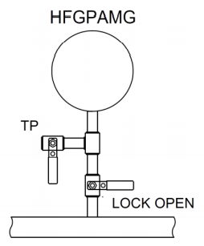

- Locate HFGPAMG and isolate switch by closing lockable valve.
- Connect pump/pressure gage setup to test port. Slowly pressurize the switch until alarm activates. Record pressure at which alarm activates.

Result | Y/N | Switch Trip Point
Correct location? Is LOOP Valve and test port in place? | $hfgpamg_result_1$
Did switch work correctly? Record Pressure | $hfgpamg_result_2$ | $hfgpamg_result_3$
Is switch trip point 120% or less of regulated pressure? | $hfgpamg_result_4$
Did alarm activate and annunciate properly? | $hfgpamg_result_5$

Did the device fail or pass the 3 Question Criteria (section 1.3.1)? [$hfgpamg_result_status$]
If boiler is to be operated with failed safety device, a properly approved ISM is required.
Describe safety device failure/remedy in Appendix F.

16. High Fuel Gas Pressure Alarm on Propane Line [$hfgpalp_result_status$]
(HFGPALP)

Item | Make | Range  (inwc/psi) | Switch  Setpoint  (inwc/psi) | Regulated Pressure  (inwc/psi)
HFGPALP | $hfgpalp_make$ | $hfgpalp_range$ | $hfgpalp_sp$ | $hfgpalp_reg_pres$
Pressure Gauge | $hfgpalp_gauge_make$ | $hfgpalp_gauge_range$

A high gas pressure alarm is required on the main gas line coming into the boiler plant. Switch must be located downstream of utility gas regulator and upstream of all boilers. Switch must activate an audible alarm and properly annunciate at a setpoint of 120% of regulated main gas pressure serving all boilers. A lockable only isolation valve and test port must be installed to facilitate testing.
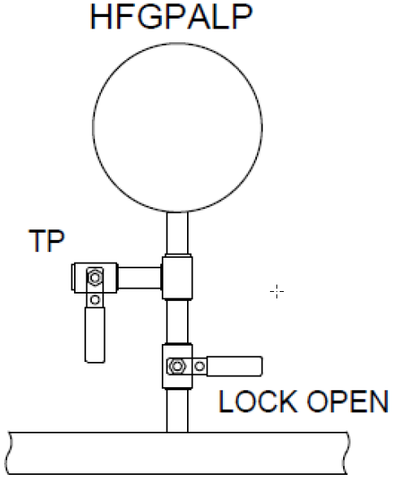

- Locate HFGPALP and isolate switch by closing lockable valve.
- Connect pump/pressure gage setup to test port. Slowly pressurize the switch until the alarm activates. Record pressure at which alarm activates.

Result | Y/N | Switch Trip Point
Correct location? Is LOOP Valve and test port in place? | $hfgpalp_result_1$
Did switch work correctly? Record Pressure | $hfgpalp_result_2$ | $hfgpalp_result_3$
Is switch trip point 120% or less of regulated pressure? | $hfgpalp_result_4$
Did alarm activate and annunciate properly? | $hfgpalp_result_5$

Did the device fail or pass the 3 Question Criteria (section 1.3.1)? [$hfgpalp_result_status$]
If boiler is to be operated with failed safety device, a properly approved ISM is required.
Describe safety device failure/remedy in Appendix F.

Appendix E: Checklist for General Plant Safety and Reliability

Most of the questions below are related to reliability. However, a decrease in reliability inevitably leads to increased safety risk.
The following questions my be answered base on actual experience and knowledge.
 | Result: | PASS/FAIL
1. | Is there a deaerator tank bypass? | $gpsr_result_1$
2. | Is there a condensate tank bypass? | $gpsr_result_2$
3. | Is there a softener bypass? | $gpsr_result_3$
4. | Is there auxiliary makeup to deaerator? | $gpsr_result_4$
5. | Is there an adequate supply of emergency water available for boilers? | $gpsr_result_5$
6. | Is there a high oil alarm on oil tanks? | $gpsr_result_6$
7. | Is there a high gas pressure alarm on main gas line entering boiler? | $gpsr_result_7$
8. | Is there an emergency kill switch (oil and gas) in office an all points of egress? | $gpsr_result_8$

Appendix F: Comments

Test | Comments:
1 | HWACT [$hwact_result_status$] - $hwact_result_comments$
2 | LWACT [$lwact_result_status$] -$lwact_result_comments$
3 | HWADT [$hwadt_result_status$] - $hwadt_result_comments$
4 | LWADT [$lwadt_result_status$] - $lwadt_result_comments$
5 | DAODS [$daods_result_status$] - $daods_result_comments$
6 | DASV [$dasv_result_status$] - $dasv_result_comments$
7 | SVFPRV [$svfprv_result_status$] - $svfprv_result_comments$
8 | SVFPRV (Other) [$svfprv2_result_status$] - $svfprv2_result_comments$
9 | LRVOPS [$lrvops_result_status$] - $lrvops_result_comments$
10 | COCGA [$cocga_result_status$] - $cocga_result_comments$
11 | CAPI [$capi_result_status$] - $capi_result_comments$
12 | OADIA [$oadia_result_status$] - $oadia_result_comments$
13 | OAMUIA [$oamuia_result_status$] - $oamuia_result_comments$
14 | ESPB [$espb_result_status$] - $espb_result_comments$
15 | HFGPAMG [$hfgpamg_result_status$] - $hfgpamg_result_comments$
16 | HFGPALP [$hfgpalp_result_status$] - $hfgpalp_result_comments$
 | General Notes: [$inspection_comments$]

