Nile Tilapia
Dorsal fin
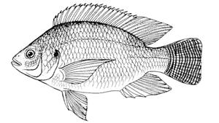
Body Height (BH)
Insertion of dorsal fin
Tail/Caudal fin
Caudal peduncle

Anal fin
Pelvic fin
Body Width (BW)
Pectoral fin
Standard Length (SL)

Total Length (TL)

Total Length (TL): measured between the front head extremity and end of caudal fin/tail
Standard Length (SL): measured between the front head extremity and the insertion of the tail fin
Body Height (BH): measured in front of the first ray of the dorsal fin
Body Width (BW), measured at the first ray of the dorsal fin

