9 June 2023

Conditioning candidate broodstock
- Duration: 4 weeks
- In the case of urgency, the minimum duration for conditioning is 2-3 weeks.
- Stocking density for conditioning.
- 10 fish/m3 for females (♀)
- 5 fish/m3 for males (♂)
- Feeding during conditioning: ad libitum twice a day (09:00 and 15:00).
- Add 3 gram of vitamin for every kilogram of feed
- Add 15 mL of squid oil for every kilogram of feed (1.5%).
- Cut upper lip of ♂, 2 weeks after conditioning (or 1 week before the mating start).

Mating list
- For each family, the mating list will give 3 ♂ choices and 3 ♀ choices (not all).
- For the first stocking for mating, use ♂ choice 1.
- The order of the mating list defines the order of the EBV value.

Setting up mating pairs
- Mating ratio is 1♂: 3♀.
- The family production needs to be concluded within 2-3 months.

Collection of eggs
- First check for eggs is conducted seven days after stocking broodstock.
- For the first egg collection, a successful spawning rate is approximately 10%.
- After the first check, do the checking every subsequent seven days.
- Subsequent spawning rate should be approximately in the range of 10-20%.
- Spawning will happen at its peak in 3 weeks’ time from the first set up of mating.
- During the 4th egg collection, if the spawning rate decrease, need to swap the ♂ choice to the next ♂ choice, if available. If not available, set up new mating pairs from the backup mating list.
- After the 4th week, swap the ♂ after every 2x egg collection to speed up the family production.
- Females that spawned were removed from the mating tank and put back into a designated conditioning tank at hatchery.

Incubation of eggs
- Fertilized eggs from each of the spawned ♀ are incubate separately (family cohort).
- The density for the incubation of egg per incubator jar is 4000 eggs/jar (density per L or water?)
- Remove dead eggs often, minimum of twice a day.
- Incubate fertilized eggs until hatching.
- Once hatch, remove the incubator jar and nurse the hatchlings in the aqua until yolk-sacs are completely absorbed.

Nursing of fry in egg incubator
- Swim-up fry refer to fry with yolk-sac completely absorbed and start to forage for food.
- Feed swim-up fry in the egg incubator for at least 3 days. Grind feed to fry size. Don’t feed too big the particle feed,
- Feed 4-5 times a day
- After the 3 days, transfer the swim up fry to their corresponding nursing tank. Remember to install hapa surrounding the hole on the overflow pipe to prevent escapees.

Nursing of fry in nursing tank
- Transfer the fry only if the number in the range of 150 - 200. If the fry if less than this, check for half-sibs. If no half-sibs, set up re-mating immediately.
- Water level for nursing tank:
- Week 1: When first stocking, keep water at 50% of the maximum water depth.
- Week 2: Increase water level to 75% of the maximum water depth.
- Week 3: Increase water level to maximum water depth.
- During water exchange, put the sieve net at the outlet pipe to collect any possible escapees.
- After a month in the nursing tank, need to reduce the density of fry to 200 fry for each nursing tank. If any family have <120 fry, check for any half-sibs at egg incubator. If none, set-up for re-mating immediately.
- Keep 80 leftover fry in the aqua at egg incubator section.
- After a month, check the number of fry in the nursing tank again. If the survival is okay, cull the leftover in the aqua.
- Nursing period is approximately 3 months for tank-based system from the transfer to nursing tank, until fry reach the fingerling size of 5 to 7 grams that are suitable for tagging.
- Feeding: ad libitum three times a day (09:00, 13:00 and 16:00).

Tagging
- All individuals in one family were tagged at the same time.
- Fingerlings are tagged at the size of 5 to 7 grams.
- For each family, 50 fingerlings are randomly chosen and tagged.
- Grade the fish using the fish grader for the selection of which fish to tag.
- Keep the leftover fish from tagging in an aqua at egg incubator section.
- At tagging, weight in grams, length, height, and thickness all in millimetres was recorded:
- Body weight using an electronic scale.
- Body length (standard and total) was measured at the maximum horizontal distance using a ruler.
- Body height was measured at the maximum vertical distance using a ruler.
- Body thickness was measured at the maximum thickness using a Vernier caliper.
- Take photos of both sides of a fish next to a ruler. The photos allow precise calculation of any desired measurements thereafter.
- After tagging, each family was stocked back into their tank for growing out.
- After 3 days, if there is no mortality of the tagged fish, cull the leftover fish in the aqua.

Growing out
- Stocking density for growing out is 50 tagged fish per family.
When we need to reduce to 30 fish?
- Feeding: ad libitum two times a day (09:00 and 15:00). 30% crude protein and 5% fat.
- Grow out period is 3 months from the tagging, until fish reach on average 250 grams.

Harvest, biometrics, data recording and archiving
- Biometric at harvest is done 3 months after the tagging.
- Stop feeding at least one day prior to harvesting.
- At harvest, weight in grams, body length, height and thickness all in millimeters was recorded:
- Body length (standard and total) was measured at the maximum horizontal distance, using a ruler
- Body height was measured at the maximum vertical distance, using a ruler
- Body thickness was measured at the maximum thickness, using a Vernier caliper with long jaws to accommodate the height (depth) of the fish.
- Take photos of both sides of a fish next to a ruler. The photos allow precise calculation of any desired measurements thereafter
- After biometric is done, fish are put back to their corresponding family grow-out tank

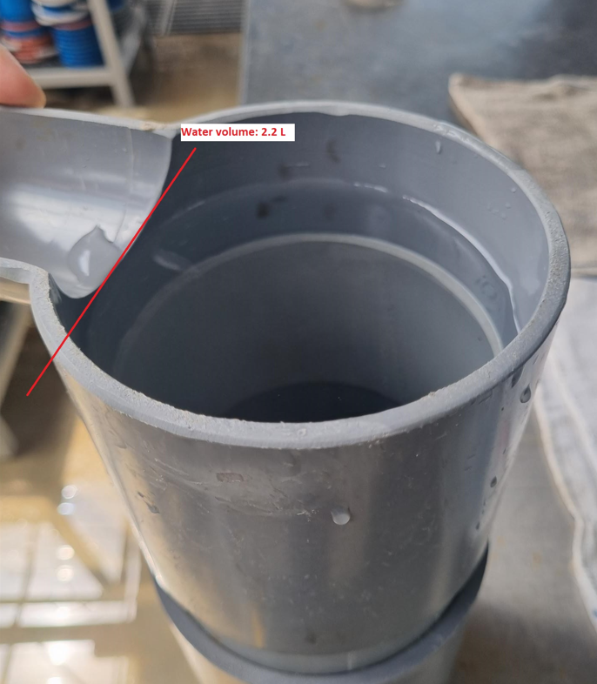
Volume of water: 2.2L

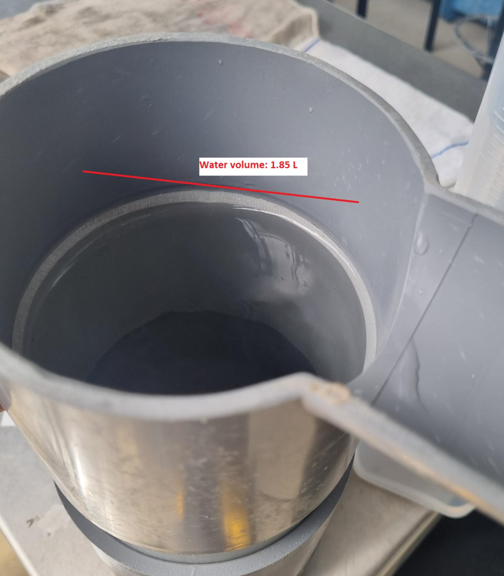
Volume of water: 1.85L

