Total Files Required
- frame.html (Run this file in browser)
- one.html
- two.html
- three.html
- a1.html
- a2.html
- a3.html
- a4.html
- form.html

frame.html- It divides the webpage in 2 rows and in second row part divides in two columns

Output of code is as below->

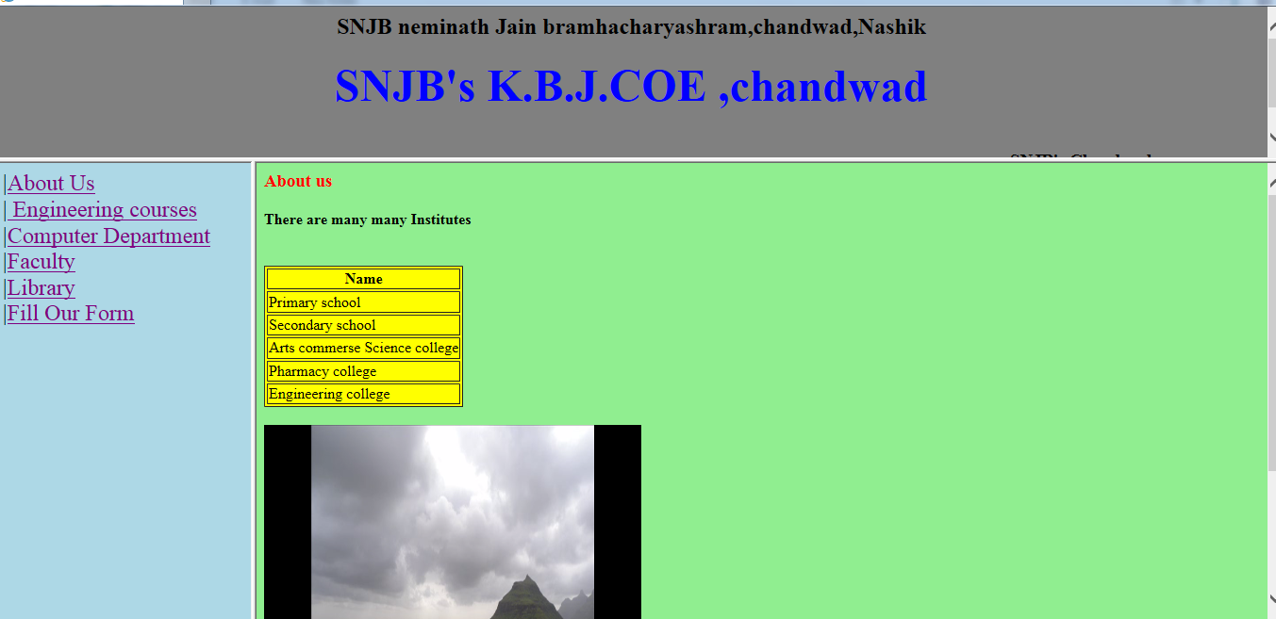

frame.html
<frameset rows="25%,75%">
<frame src="one.html">
<frameset cols="20%,80%">
<frame src="two.html">
<frame src="three.html" name="main">
</frameset>
</frameset>

one.html
<html>
<body bgcolor="grey">
<h2 align =center>SNJB neminath Jain bramhacharyashram,chandwad,Nashik</h2>
<h1 align =center><font color="blue" size=20>SNJB's K.B.J.COE ,chandwad</font></h1>
<marquee><h3>SNJB's Chandwad</h3></marquee>
</body>
</html>

two.html
<html>
<body>
<a href="image1.html" target="main">About Us</a><br>
<a href="a1.html" target="main"> Engineering courses </a><br>
<a href="a2.html" target="main">Computer Department</a><br>
<a href="a3.html" target="main">Faculty</a><br>
<a href="a4.html" target="main">Library</a><br>
<a href="form.html" target="main">Fill Our Form</a><br>
</font>
</body>
</html>

three.html
<html>
<body bgcolor="lightgreen">
<h3><font color ="red">About us</font></h3>
<h4> There are many many Institutes</h4>
<table border = "1" bgcolor = "yellow">
<tr> <th>Name </th> </tr>
<tr> <td>Primary school</td> </tr>
<tr> <td>Secondary school </td> </tr>
<tr> <td> Arts commerse Science college</td> </tr>
<tr> <td>Pharmacy college</td> </tr>
<tr> <td>Engineering college</td> </tr>
</table>
<br>
<Chandwad is surrounded by very cool and the beautiful nature .<br>
<imgsrc="1.png" alt="hostel Image" width="400" height="400"/>
</body>
</html>

a1.html
<html>
<body>
<h2><font color="red"> Engineering Courses</h2></font>
<h3>
<ol type="1" >
<li>Mechanical Department</li>
<li>ENTC</li>
<li>Computer</li>
<li>IT</li>
<li>MBA</li>
</ol>
</h3>
</body>
</html>

a2.html
<html>
<body>
<h3><font color="red">Computer Depatment</font></h3>
<h2>
Computer depatment having association
<br>
<marquee>SPACE</marquee>
Skill Progressive Association of Computer Engineering
</h2>
</body>
</html>

a3.html
<html>
<body bgcolor="lightyellow">
<h3><font color="red" >Faculties</font></h3>
<h4>Head of Department:Dr.M.R.Sanghavi</h4><br>
<h4>:Mrs.K.M.Sanghavi</h4><br>
<h4>:B.A.Khivsara</h4><br>
</body>
</html>

a4.html
<html>
<body>
<h3><font color ="red"></font></h3>
<h4>Library</h4>
<br>
<h3>The huge library is available in our college</h3>
</body>
</html>

form.html
<html>
<body>
<form>
<h1 align = Center style=“color:blue”> Admission Enquiry Form</h1>
<hr>
<table align =center border=1 bgcolor=lightblue>
<tr><td>Name</td>
<td><input type="text" name ="name" required></td></tr>

<tr><td>Mobile Number</td>
<td><input type="text" name="mobile" maxlength=10 required ></td></tr>

<tr><td>DOB </td>
<td><input type="date" name="dob" required></td></tr>

<tr><td>Email-id</td>
<td><input type="email" name ="email" required></td></tr>

<tr><td>Gender</td><td>
<input type="radio" name="G" value="Male"> M
<input type="radio" name="G" value="Female"> F
<input type="radio" name="G" value="other"> O
</td></tr>

<tr><td>Address</td>
<td>
<select name="address">
<option>nashik</option>
<option>pune</option>
<option>mumbai</option>
</select></td></tr>
<tr><td colspan=2 align=center>
<input type="submit" value="submit" ></td></tr>
</table>
</form>
</body>
</html>

