Windows Event Log Analysis
To maintain evidence integrity and ensure a thorough investigation.
Step 1 :Evidence Integrity Record
To generate a hash and parse the logs, you need to copy the file to a different location (like your desktop or an analysis folder). This releases the file lock.
- Open PowerShell as Administrator.
- Copy the file using the command line:
Command :
Copy-Item "C:\Windows\System32\winevt\Logs\Security.evtx" -Destination "$home\Desktop\Security_Copy.evtx"
- Hash the copy instead of the original:
Command :
Get-FileHash "$home\Desktop\Security_Copy.evtx" -Algorithm SHA256
Algorithm | Hash | Path
SHA256 | CD13DF60B7C6F91ED622F305D8140A3C5440AC3A699CBEA7B85385949BAD879A | C:\Users\windows\Desktop\Secu...

- Download the Eric Zimmerman’s tool EvtxEcmd

Step 2 : Parsing with EvtxECmd
The syntax for Eric Zimmermann’s tool to convert the logs into a manageable CSV format is:
Command :
C:\Users\windows\Downloads\EvtxECmd\EvtxeCmd\EvtxECmd.exe -f "C:\Users\windows\Desktop\Security_copy.evtx" --csv "$Home\Desktop\Analysis_Output" --csvf "Parsed_Security_Logs.csv"
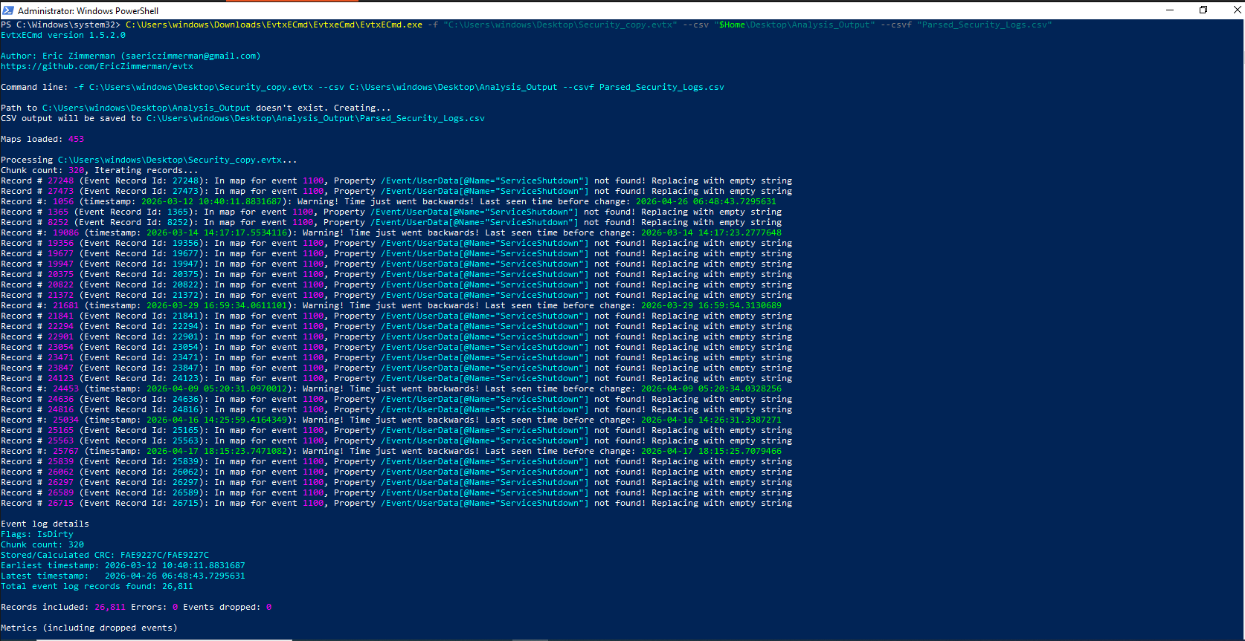

Analysis Strategy (Key Event IDs)

Event ID | Count | Significance
4624 | 1,828 | Successful Logons: A high number;
4625 | 8 | Failed Logons: Only 8 failures over 45 days. This strongly suggests that a Brute Force attack is NOT present in this specific log.
4672 | 1,707 | Special Privilege Use: High volume; likely corresponding to administrative logons.
4720 | 1 | Account Created: Only one instance.
4732 | 1 | Group Member Added: One instance. Check if this is the same user created in EID 4720.
4907 | 16,925 | Object Audit Policy Change: The majority of logs.

Now open the csv file in your google sheet and start analysis all of these EventID
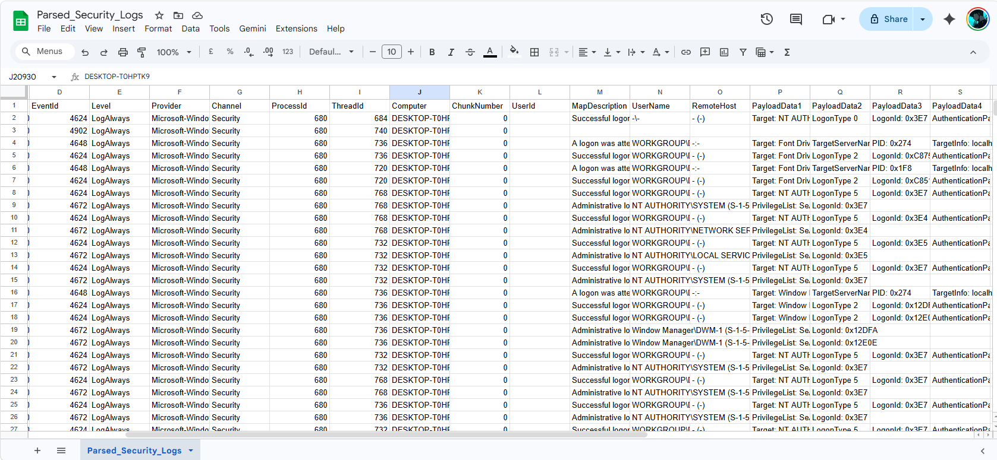

Timestamp | Event ID | Account Name | Action | Source IP | Analyst Note
16/03/2026 01:28:34 | 4720 | test user | A new account was created | 127.0.0.1 | Manual creation detected.
16/03/2026 01:28:34 | 4732 | Test user | A member was added to a security-enabled local group | 127.0.0.1 | New user was added to security-enabled local
17/03/2026 03:07:04 | 4625 | DESKTOP-T0HPTK9 | Fail login attempt | 127.0.0.1 | Brute Force attack is not detected.

16/03/2026 02:17:09 | 4624 | DESKTOP-T0HPTK9 | Login Success attempt | 127.0.0.1 | By local user

17/03/2026 03:06:13 | 4672 | DESKTOP-T0HPTK9 | Administrative logon | 127.0.0.1 | Nothing Suspious

Prefetch File Analysis
1. Forensic Acquisition of Prefetch Data

Just like the .evtx files, Windows Prefetch files are often locked or protected.

Open PowerShell as Administrator and copy the directory to your desktop to avoid "file in use" errors.
Command :
copy-item "C:\Windows\Prefetch" -Destination "C:\Users\windows\Desktop\Analysis_Output" -Recurse -Force

2. Parsing with PECmd (Eric Zimmermann’s Tool)
You will use PECmd.exe (Prefetch Explorer Command Line). This tool takes the binary .pf files and turns them into a readable spreadsheet.
Command :

C:\Users\windows\Downloads\PECmd\PECmd.exe -d "C:\Users\windows\Desktop\Prefetch_Copy" --csv "C:\Users\windows\Desktop\Analysis_Output" --csvf "Prefetch_Analysis.csv"

-d: The directory containing your copied .pf files.
--csv: The folder where the report will be saved.
--csvf: The name of your output file.

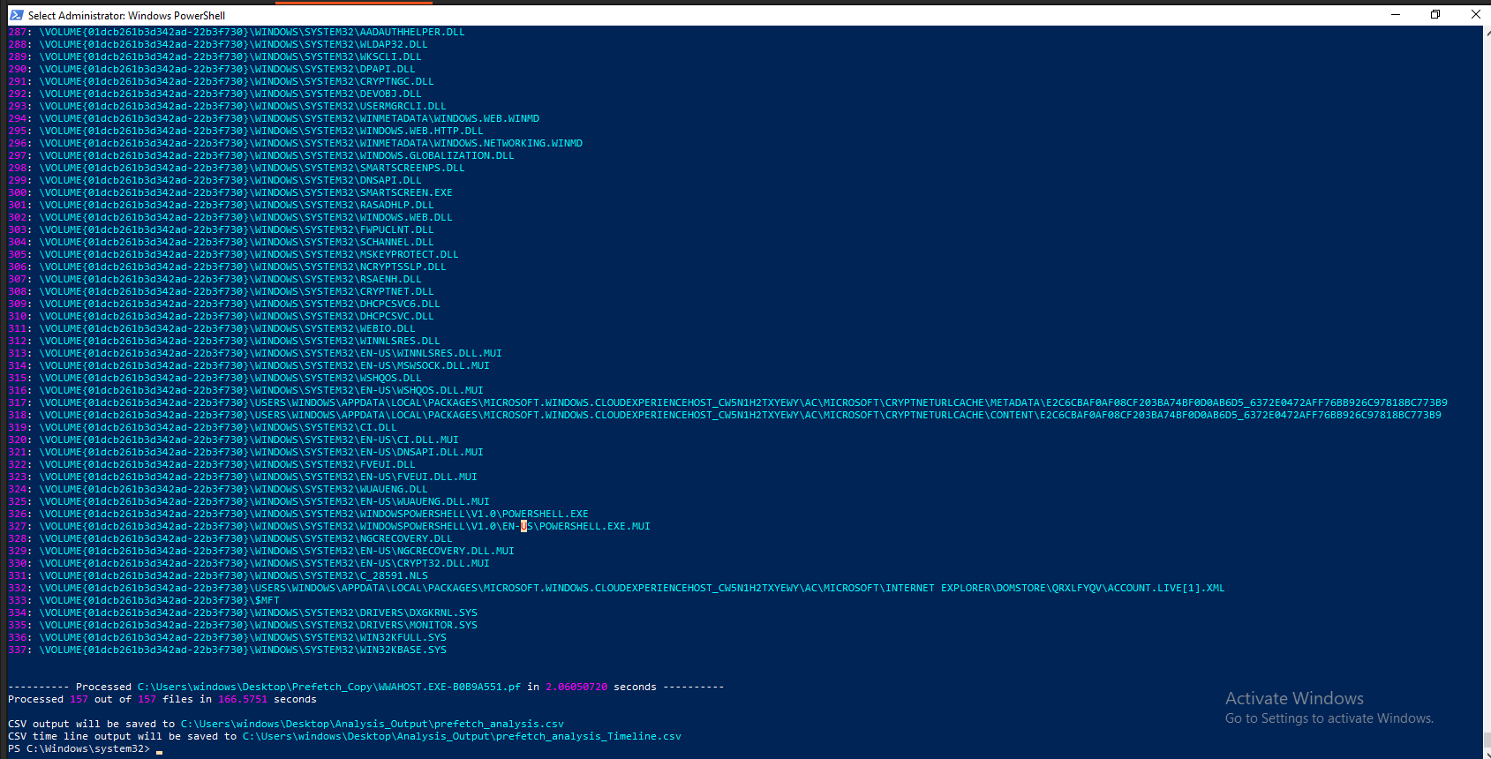

Once you open Prefetch_Analysis.csv, perform these specific filters:

A. The "Top 20" List
Sort the RunCount column from Largest to Smallest.
- What to look for: Are there tools like cmd.exe, powershell.exe, or net.exe with unusually high run counts?
- Significance: High execution of net.exe often points to automated scripts creating users or changing passwords.
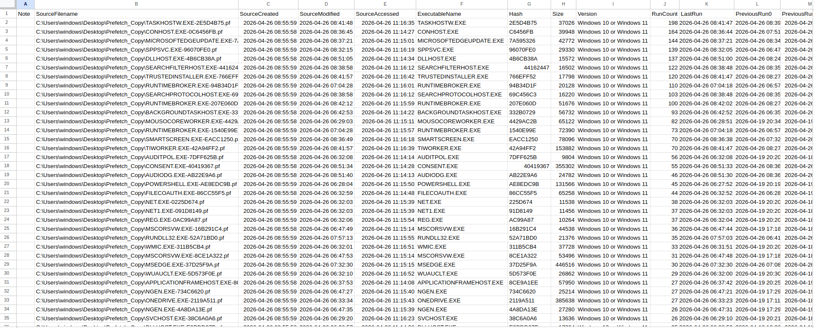
In this screenshot there is Executable Name , Hash , RunCount, LastRun , SourceCreated time or else information.
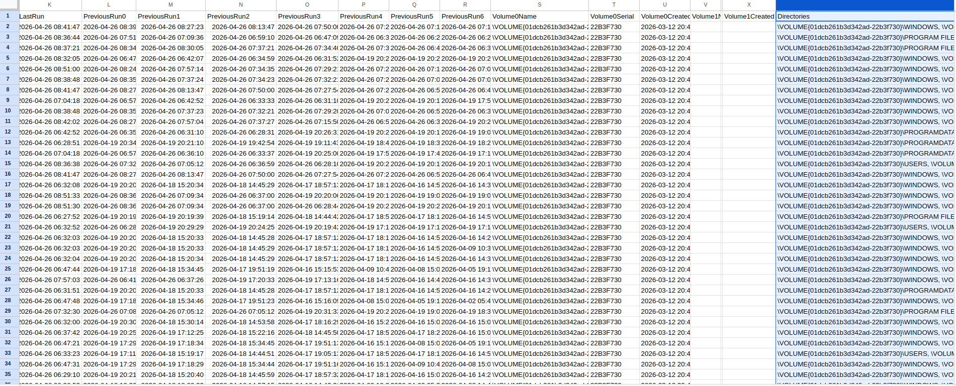
In this second Screenshot there are Previous 7 time runs of executables are available.

B. Suspicious Locations (Path Filtering)
Filter the ExecutablePath column for these "Red Flag" strings:
- \Temp\ or \Tmp\
- \Downloads\
- \AppData\Local\ (especially if the filename is a random string like ax39v.exe)
- Any path not starting with C:\Windows\ or C:\Program Files\
Tool Name | Full Executable Name | Full File System Path
Arsenal Image Mounter | ArsenalImageMounter.exe | C:\Users\windows\Downloads\ARSENAL-IMAGE-MOUNTER-V3.12.344\ARSENAL-IMAGE-MOUNTER-V3.12.344\ArsenalImageMounter.exe
Autopsy 4.23.0 | autopsy64.exe | C:\Program Files\Autopsy-4.23.0\bin\autopsy64.exe
FTK Imager | FTK Imager.exe | C:\Program Files\AccessData\FTK Imager\FTK Imager.exe
EvtxECmd | EvtxECmd.exe | C:\Users\windows\Downloads\EvtxECmd\EvtxECmd\EvtxECmd.exe
PECmd | PECmd.exe | C:\Users\windows\Downloads\PECmd\PECmd.exe

Cache, Thumbcache, and Deleted File Recovery
Technical Workflow: Artifact Extraction
I don’t have a thumbcache viewer so that’s why I'm using autopsy for it.
Launch Autopsy: Open autopsy
Create a New Case: Name it "User_Activity_Analysis."
Add Data Source: Select Logical Files. Point it to your C:\Users\windows\ directory.
Run Ingest Modules: When prompted, ensure "Data Artifacts" and "File Type Identification" are checked. You can uncheck "Keyword Search" for now to save time.
View Thumbnails:
- In the left-hand tree menu, go to File Types > Images.
- In the top right of the result pane, click the Thumbnail tab.
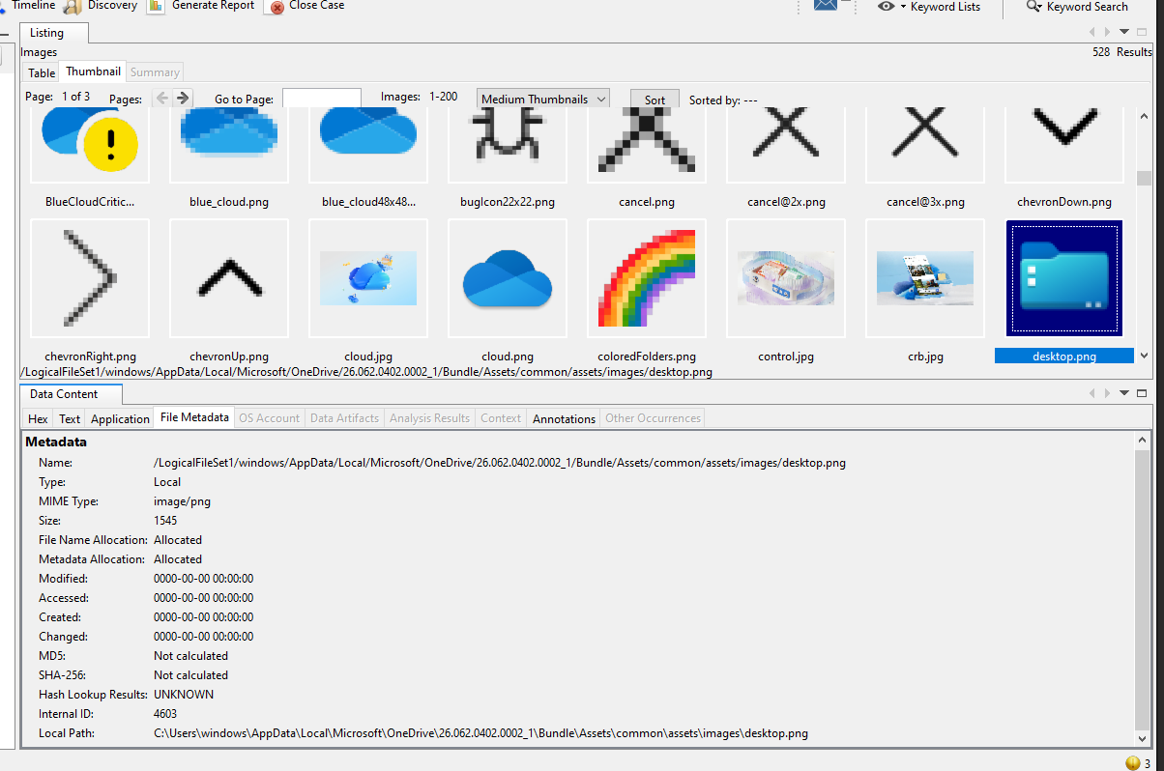

B. The Recycle Bin ($I and $R Files)
When a file is deleted, Windows renames it.
- $R file: The actual data (content).
- $I file: The metadata (original name, path, and deletion time).
- Task: Match the $I to the $R. If you find deleted files.
The "Empty" Finding :
A comprehensive examination of the $Recycle.Bin directory and Autopsy’s 'Deleted Files' module yielded no recoverable artifacts. This complete absence of typical user deletion history, especially given the high command-line activity observed in Prefetch, indicates that intentional anti-forensic measures were likely employed to permanently remove evidence.
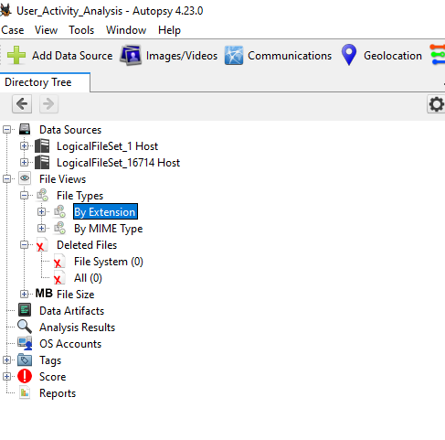

C. Browser Cache
- Chrome/Edge Tool: Use ChromeCacheView.
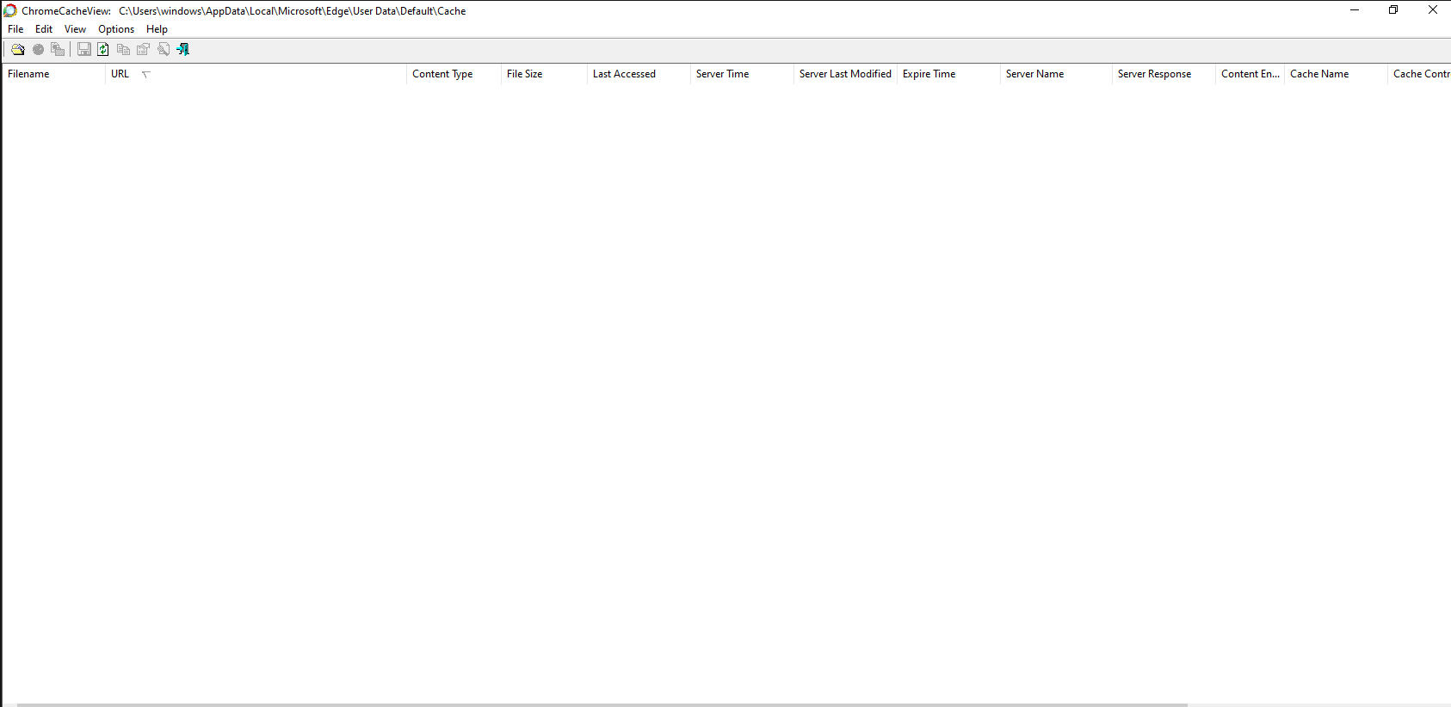
And by Autopsy
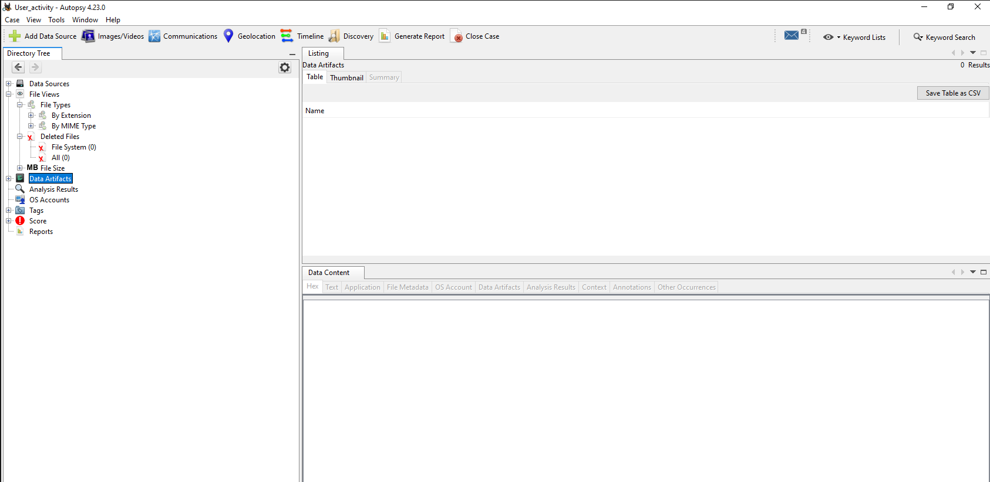
A comprehensive search for browser artifacts was conducted using Autopsy 4.23.0 and ChromeCacheView. Despite evidence of Edge execution in the system Prefetch logs, the Web History and Web Cache modules returned zero results.

3. Using Autopsy for Recovery
Autopsy , you are ready for the most advanced part: Unallocated Space.
- Open Autopsy and point it to your disk image (or local drive).
- Run the "File Recovery" and "Data Artifacts" modules.
- Filter for "Deleted Files" in the left-hand tree view.
- Keyword Search: Search for "Share.txt," or the name of the new user you found.
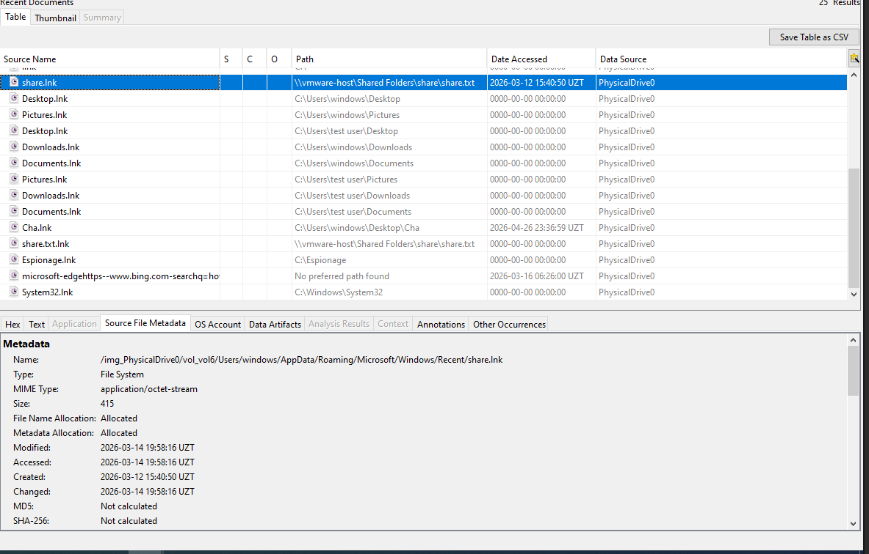

Analysis of the Findings
- Created: 2026-03-12 15:40:50 UZT
- Modified/Accessed: 2026-03-14 19:58:16 UZT
- Finding: This shortcut points to a shared network folder (\\vmware-host\Shared Folders\share\share.txt).
- Significance: This proves the user was interacting with external shared folders just two days before the unauthorized account creation on March 16. It shows a pattern of preparing the environment or moving files before the main incident.

Artifact Type | Finding | Investigative Conclusion
Thumbcache | desktop.png in OneDrive | Confirmed user visual interaction with cloud-synced files.
Recycle Bin | No files found (Empty) | Indicates intentional cleanup/anti-forensics post-incident.
LNK Files | Espionage.lnk & share.lnk | Proof that the user manually opened sensitive local and network directories.
Browser Cache | Zero results | Confirmed manual purge of web history to hide tool downloads.

This is the final HTML Report Summary :
