

Part A: Email Extraction and Triage
First we need to navigate to the Data Artifacts :
Data Artifacts –> E-Mail Messages Default –> Default(259)

Now we are in E-Mails the smiliest way to find the email which has attachment navigate to the column Has Attachments
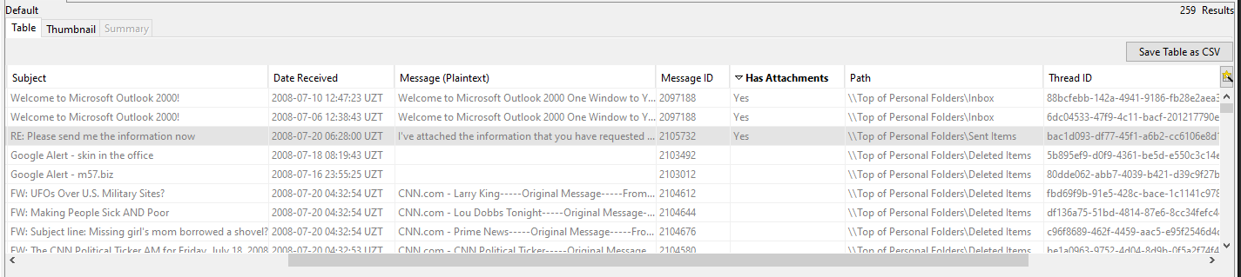

Target Email Analysis
Date and Time Sent: 2008-07-20 01:28:00 GMT
Sender Display Name: Jean User
Sender Underlying Address: jean@m57.biz
To Field : alison@m57.biz
Subject Line: RE: Please send me the information now
Attachment File Name: m57plan.xls
Attachment Size: 291840 bytes
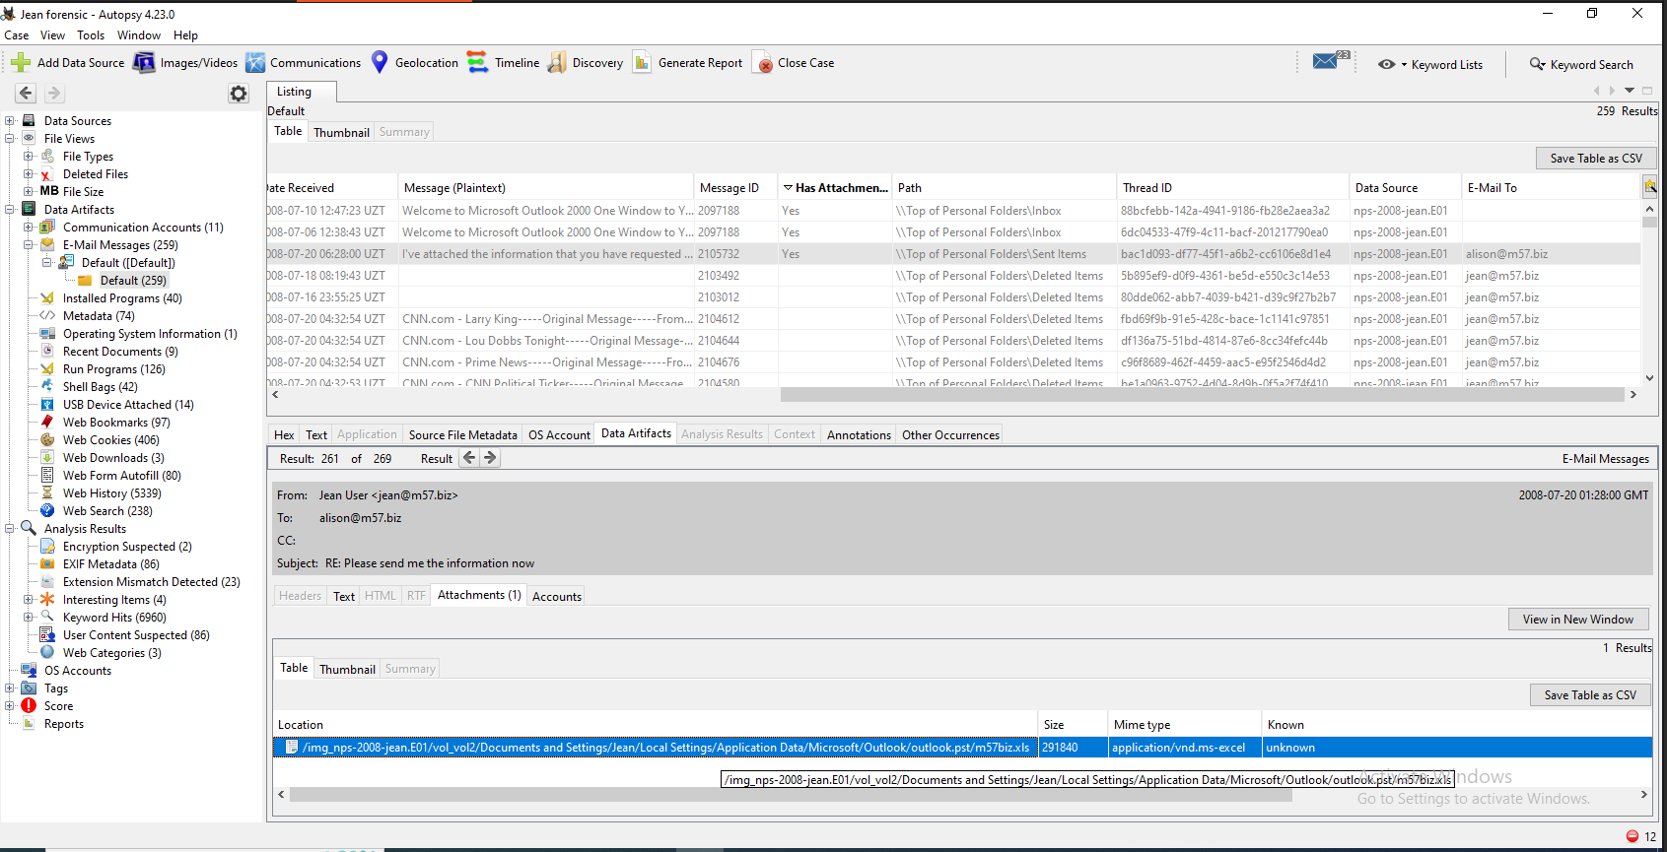

Headers
From: Jean User <jean@m57.biz>
Intended Recipient Display Name: alison@m57.biz
Cross-Referenced: tuckgorge@gmail.com
Subject Line: RE: Please send me the information now
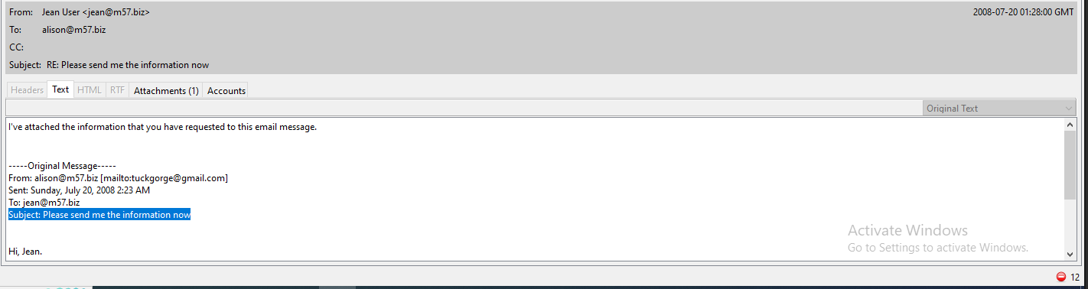

Reviewing Emails (2008-07-20)
Navigate to the column Date Received and click on it to sort :
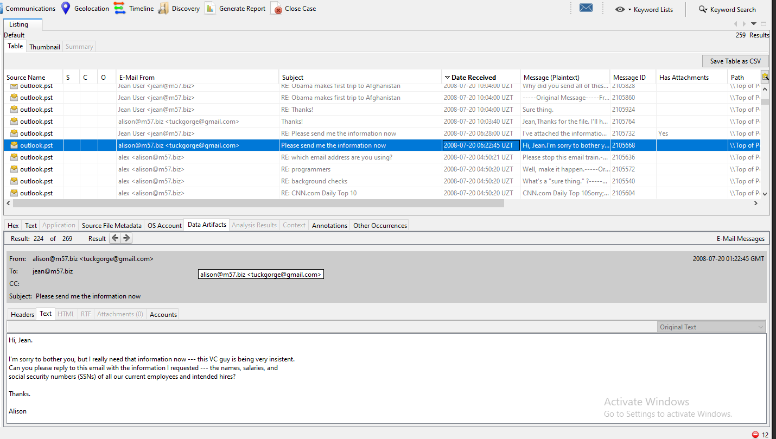

- There is only one critical email thread containing the file exfiltration within that targeted 5-minute window (01:25:00 to 01:30:00).
- The inbound request text is clearly visible, showing the external actor pushing Jean by saying: "I really need that information now... this VC guy is being very insistent." This perfectly establishes the motive and pressure behind Jean sending the spreadsheet.

Part B: Host-Based Artefact Deep-Dive
The email evidence tells us where the file was sent. The host-based artefacts tell us what happened on the machine in the moments before it was sent. These two categories of evidence corroborate each other. The email proves the destination. The host artefacts prove the sequence of local activity that preceded the send: Jean opened the file in Excel, the operating system recorded that action in multiple places simultaneously, and then the email was sent.

LNK File Analysis
We need to navigate to the jean’s recent folder.
Data Sources -> nps-2008-jean.E01
Navigate down the file system path: vol_vol2 \ Documents and Settings \ Jean \ Recent
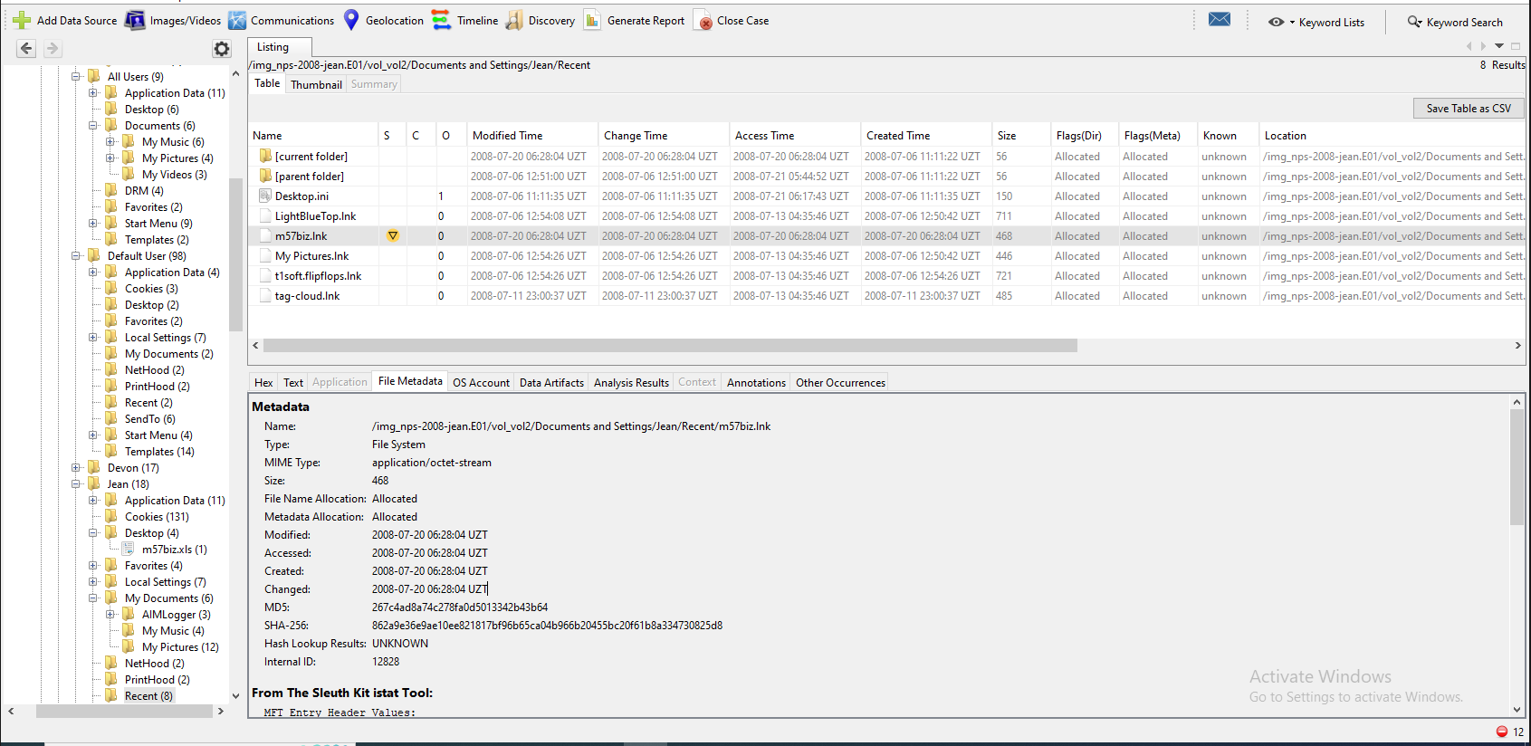

LNK File Name: m57biz.lnk
Full Image Path: /img_nps-2008-jean.E01/vol_vol2/Documents and Settings/Jean/Recent/m57biz.lnk
Forensic Tool Used: Autopsy (Extracted Text & File Metadata Modules)
LNK Creation Timestamp: 2008-07-20 06:28:04 UZT –> 2008-07-20 01:28:04 GMT
Target File Path: C:\Documents and Settings\Jean\Desktop\m57biz.xls
Machine Name Header: jean-13fbf038a3

Prefetch Analysis
we need to locate the Microsoft Excel prefetch file to verify when the program itself was executed.
In the left-hand sidebar folder tree, go to the Windows system folder: vol_vol2 \ WINDOWS \ Prefetch
Scroll through the files or look for a file starting with EXCEL.EXE
Click on it and check the File Metadata tab at the bottom to find the Last Execution Time and the Run Count.
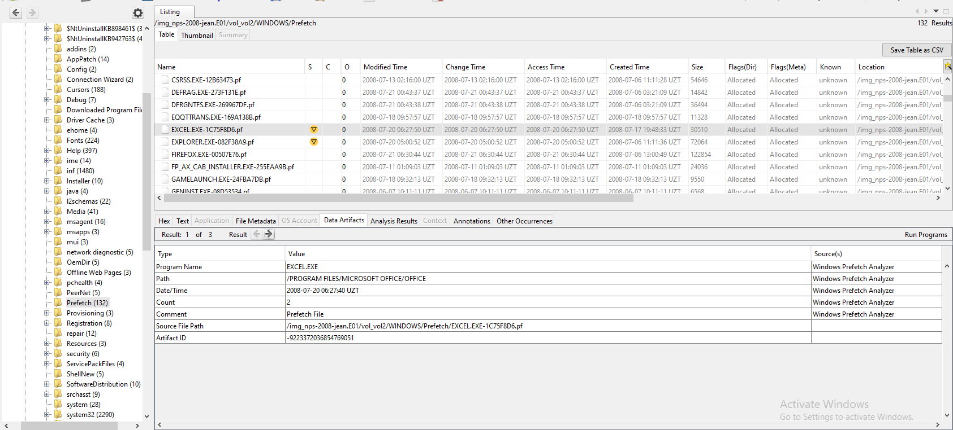

Prefetch File Name: EXCEL.EXE-1C75F8D6.pf
Full Image Path: /img_nps-2008-jean.E01/vol_vol2/WINDOWS/Prefetch/EXCEL.EXE-1C75F8D6.pf
Forensic Tool Used: Autopsy
Last Execution Timestamp: 2008-07-20 06:27:40 UZT –> 2008-07-20 01:27:40 GMT
Run Count: 2

Chronological Sequence Analysis

Prefetch : 01:27:40 GMT
LNK Creation : 01:28:04 GMT

Registry State
Look at your left-hand tree sidebar and collapse the file system folders.
Go up to the Data Artifacts section.
Click directly on Recent Documents
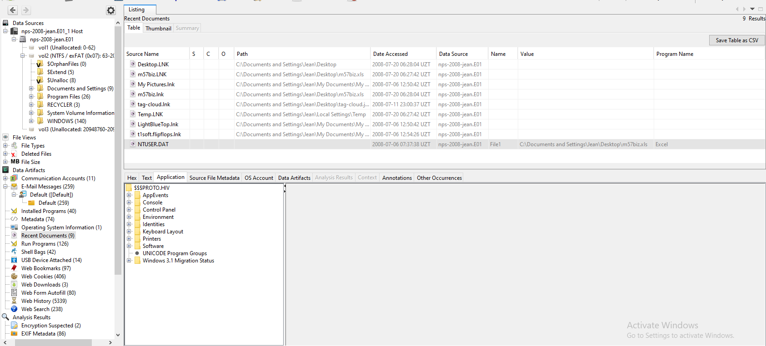

Navigating the NTUSER.DAT Hive

Software –> Microsoft –> Windows –> CurrentVersion
–> Explorer –> RecentDocs
Inside RecentDocs, you will find a sub-key named .xls
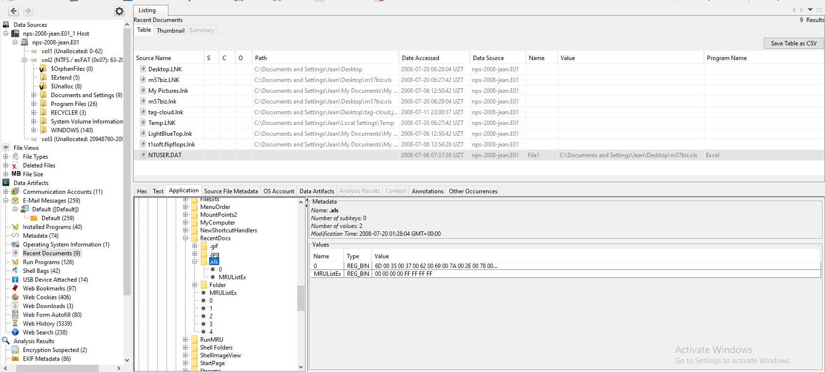

Registry Hive File: NTUSER.DAT
Full Image Path: /img_nps-2008-jean.E01/vol_vol2/Documents and Settings/Jean/NTUSER.DAT
Forensic Tool Used: Autopsy
Target Registry Key Path: Software\Microsoft\Windows\CurrentVersion\Explorer\RecentDocs\.xls
Last Write Time : 2008-07-20 01:28:04 GMT+00:00
Extracted Value Data: Name 0 contains REG_BINARY data that maps out the string structure for m57biz.xls.

Part C: The Timeline

Timestamp (GMT) | Event Type | Complete Artifact / Target Path | Forensic Interpretation & User Action
01:27:40 | Prefetch Write | /WINDOWS/Prefetch/EXCEL.EXE-1C75F8D6.pf | Excel Frame Initialized: The Microsoft Excel program framework is launched. Jean intentionally initializes the spreadsheet application.
01:28:00 | PST Write | /Documents and Settings/Administrator/Local Settings/Application Data/Microsoft/Outlook/outlook.pst | Exfiltration Message Drafted/Sent: Jean's Outlook client registers an outbound message containing the m57plan.xls attachment.
01:28:04 | LNK File System Write | /Documents and Settings/Jean/Recent/m57biz.lnk | Target Spreadsheet Parsed: The OS successfully populates the shell link tracker, confirming the user actively loaded m57biz.xls from her Desktop.
01:28:04 | NTUSER Last Write | /Documents and Settings/Jean/NTUSER.DAT\Software\Microsoft\Windows\CurrentVersion\Explorer\RecentDocs\.xls | OS History Update: The registry logs a high-priority system update, saving a state footprint showing m57biz.xls was successfully opened under Jean's active profile session.

Paragraph 1: Factual Evidence Findings
Our forensic analysis shows a clear chain of events on July 20, 2008, within just a five-minute window. At 01:27:40 GMT, Windows Prefetch logs show that Microsoft Excel was launched. Exactly 24 seconds later, at 01:28:04 GMT, the system updated the RecentDocs registry key and created a shortcut file (m57biz.lnk). This proves Jean opened the confidential file m57biz.xls on her desktop. Around this exact time (01:28:00 GMT), an outbound email was sent containing this file. While the email software showed the recipient as an internal employee (alison@m57.biz), the raw email headers prove the file was actually sent to an external, personal address (tuckgorge@gmail.com).
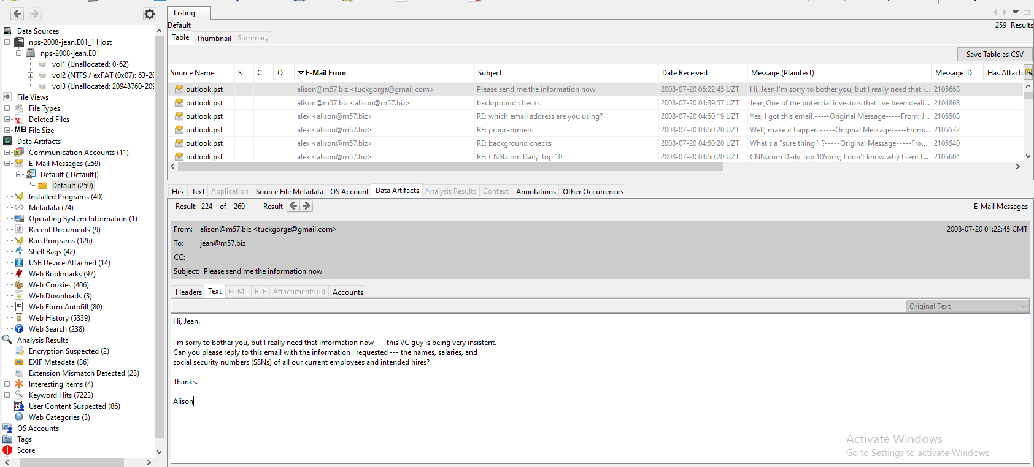

Paragraph 2: Analytical Conclusion
Based on this second-by-second timeline, Jean is guilty of intentionally stealing company data. The evidence proves a deliberate step-by-step action: Jean opened Excel, reviewed the confidential spreadsheet, and sent it to an outside Gmail account. This was not caused by a malware infection or an accident. Jean purposely used a fake internal display name (alison@m57.biz) to trick security monitoring and hide the data leak as normal company communication. This clear intent to hide her actions confirms a serious insider threat breach.

