02-Geo-Blocking-pfBlockerNG

Upgrading pfSense :
- On your Windows 10 VM, look at the top menu of your pfSense dashboard.
- Click on System, then click on Update.
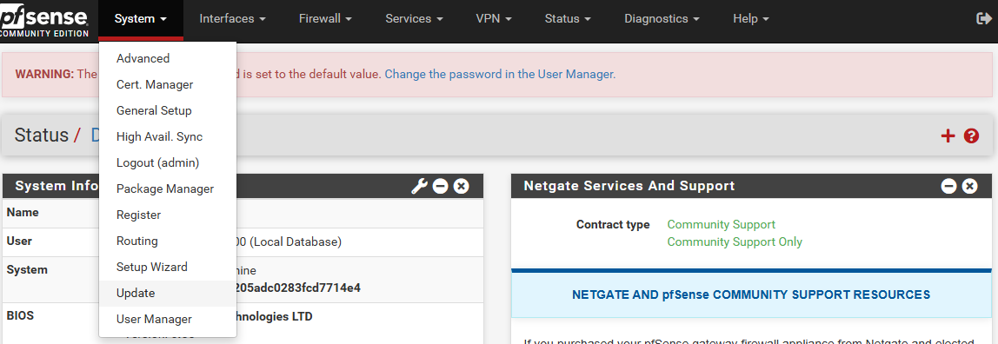
- Under the "System Update" tab, ensure the "Branch" dropdown is set to the latest stable version (usually "Current Stable Release").
- Click the Confirm or Update button to start the process.
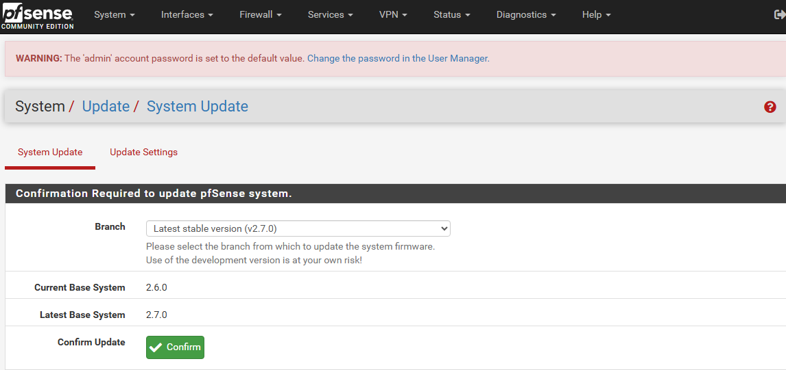
It will take your some time
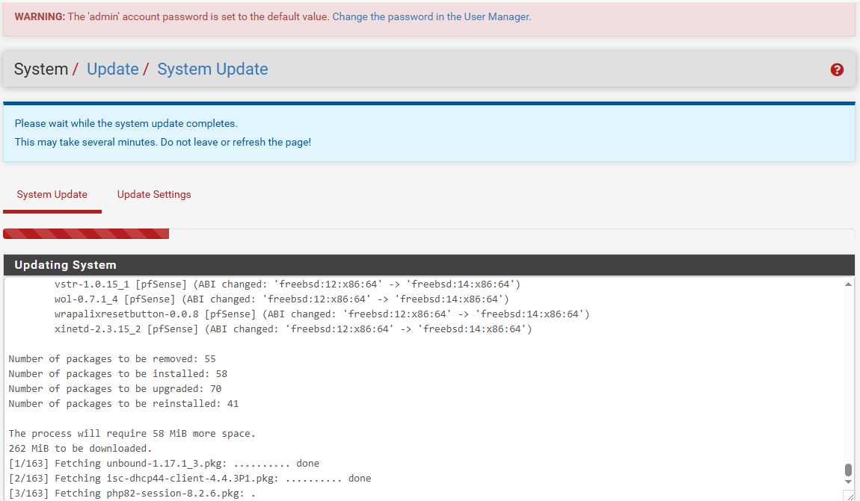
After the completion of System Update. Your pfSense will be automatically restarted then we started to install pfBlockerNG.

How to Install pfBlockerNG
- Open Microsoft Edge on your Windows 10 VM.
- Log into your pfSense dashboard by navigating to https://192.168.1.1.
- On the top menu bar, click on System and then select Package Manager.
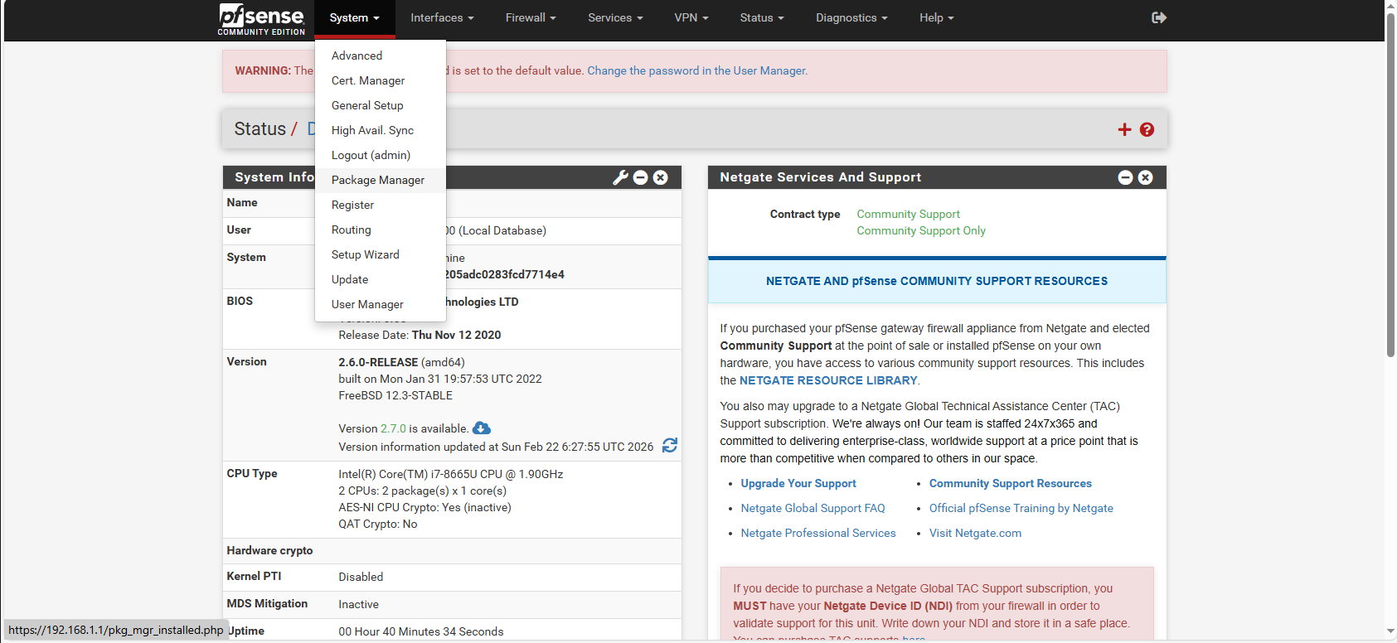
- Click on the Available Packages tab.
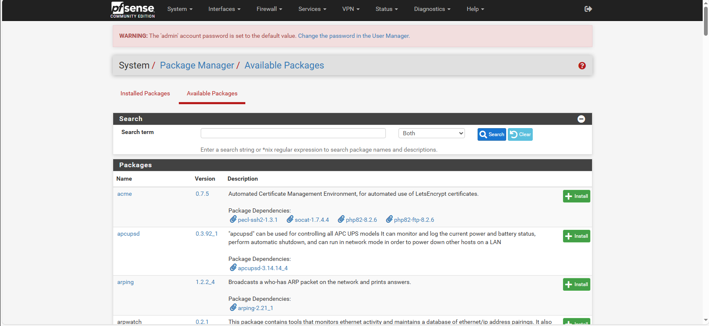
- In the "Search term" box, type exactly: pfBlockerNG
- Click the blue Search button.
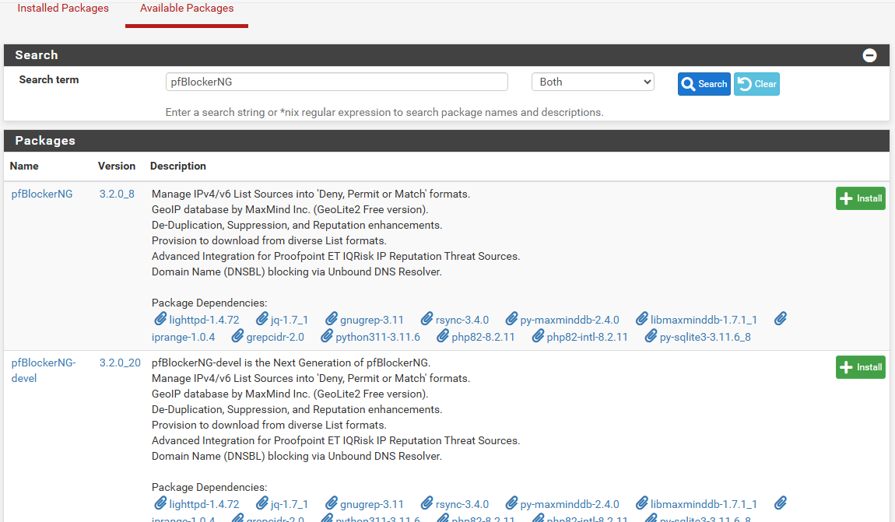

- You will see a package named pfBlockerNG (or pfBlockerNG-devel—either one is perfectly fine, but devel is usually the most up-to-date).
You should install pfBlockerNG-devel.
Here is the "why" behind this choice: In the software world, "devel" usually means a buggy, testing version. However, in the pfSense community, it is the exact opposite. The standard pfBlockerNG is actually the old, legacy version. pfBlockerNG-devel is the actively maintained, modern version that contains all the latest threat intelligence features and security patches.
- Click the green + Install button on the right side of the package name.
- On the next screen, click the green Confirm button.
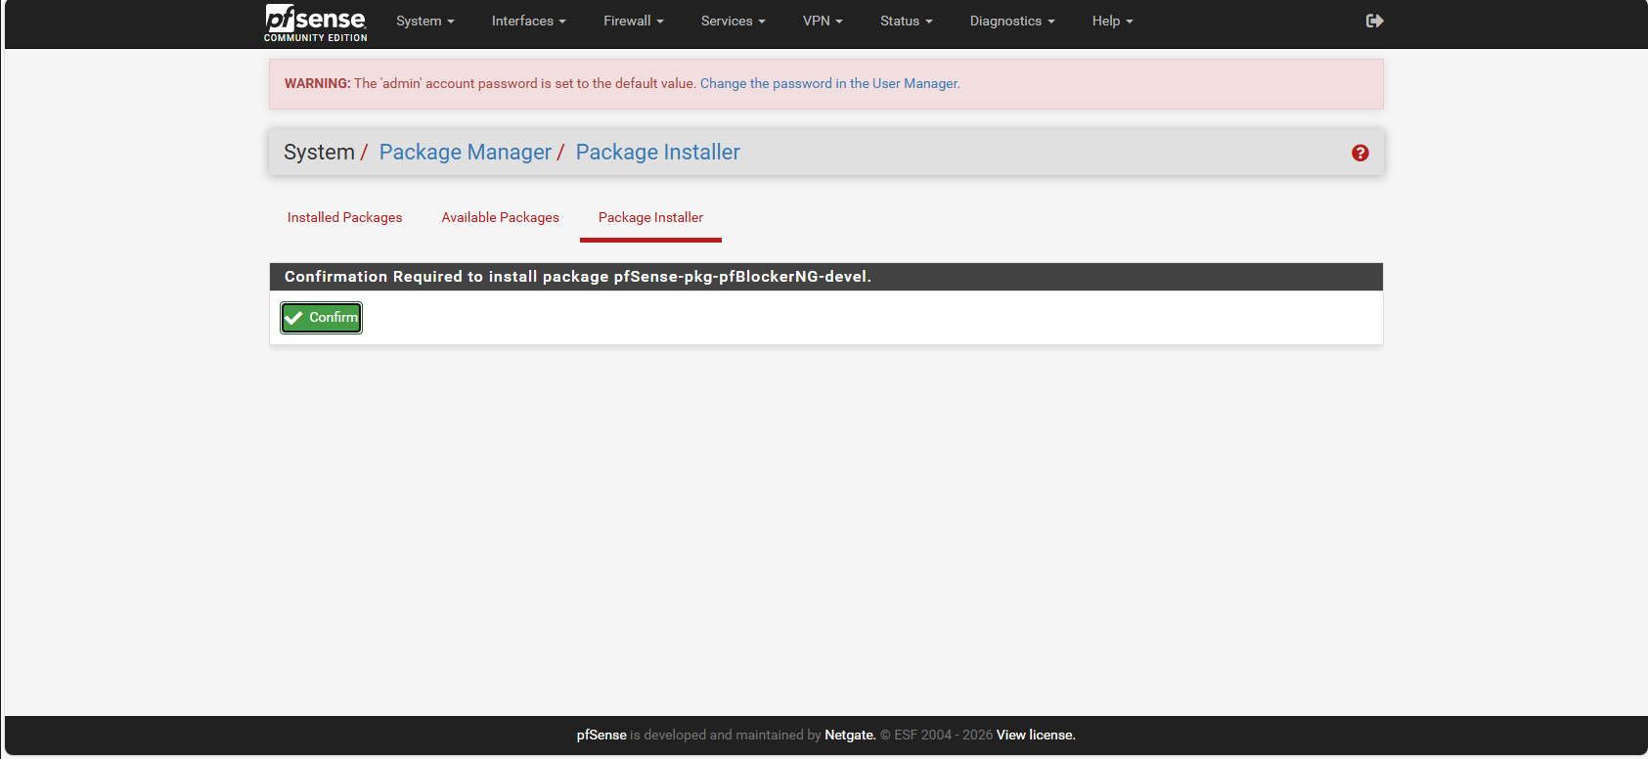
It will take some moments to be installed and ready
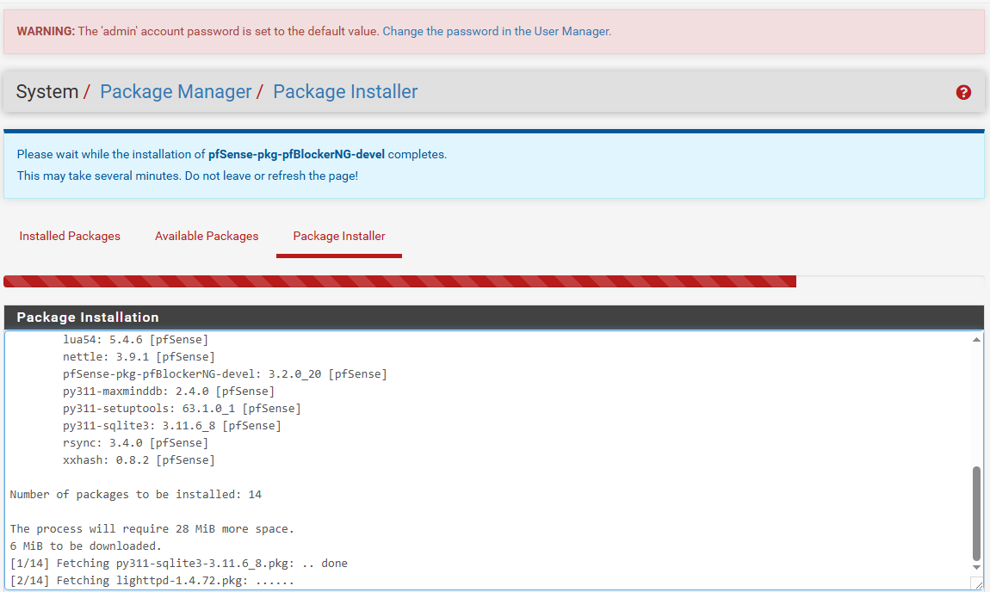
The following message will be displayed after installation has been complete

Getting the Global IP Map (MaxMind)
Right now, your firewall has the pfBlockerNG software, but it is completely "blind." It does not know which IP addresses belong to Russia, China, or any other country.
To give it its sight, we need to download a free "map" of the internet from a threat intelligence company called MaxMind.

Step 1: Get Your Free License Key
- On your Windows 10 VM, open Microsoft Edge and go to this website: https://www.maxmind.com/en/geolite2/signup
- Fill out the quick, free registration form (you can use your student email).
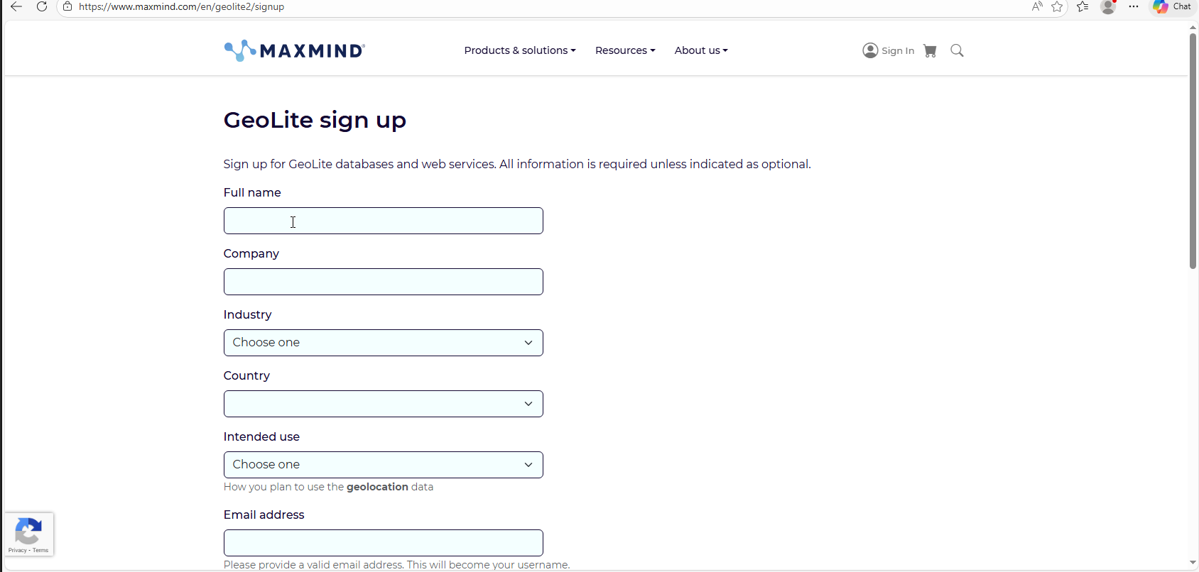
- Once you verify your email and log in to the MaxMind dashboard.
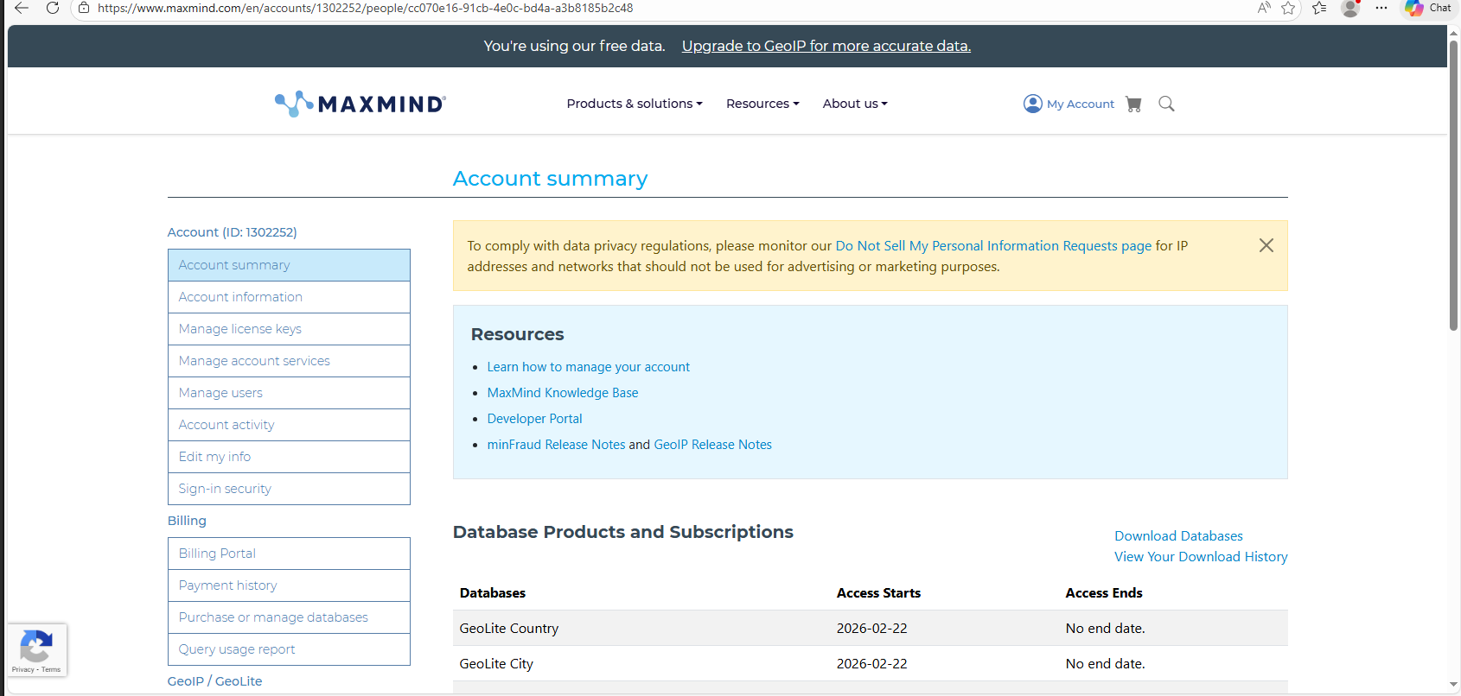
- Look at the right-side menu(My Account) and click on Manage License Keys.
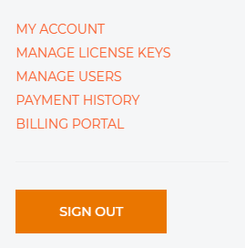
- Click the Generate new license key button.
- Give the key a description (like pfSense-Lab), answer No to the older version question, and click Confirm.

- Copy that License Key immediately! (They will only show it to you once).
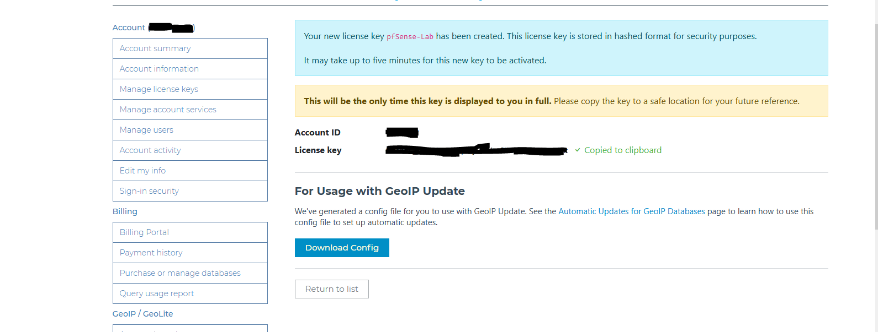
After copying the License Key save it to your secure place. After that click on Return to list.

Step 2: Connect the Map to pfSense
- Log into your pfSense WebGUI (https://192.168.1.1).
- At the top menu, click Firewall -> pfBlockerNG. (If a setup wizard pops up, you can simply click "Next" through the default options until it finishes).
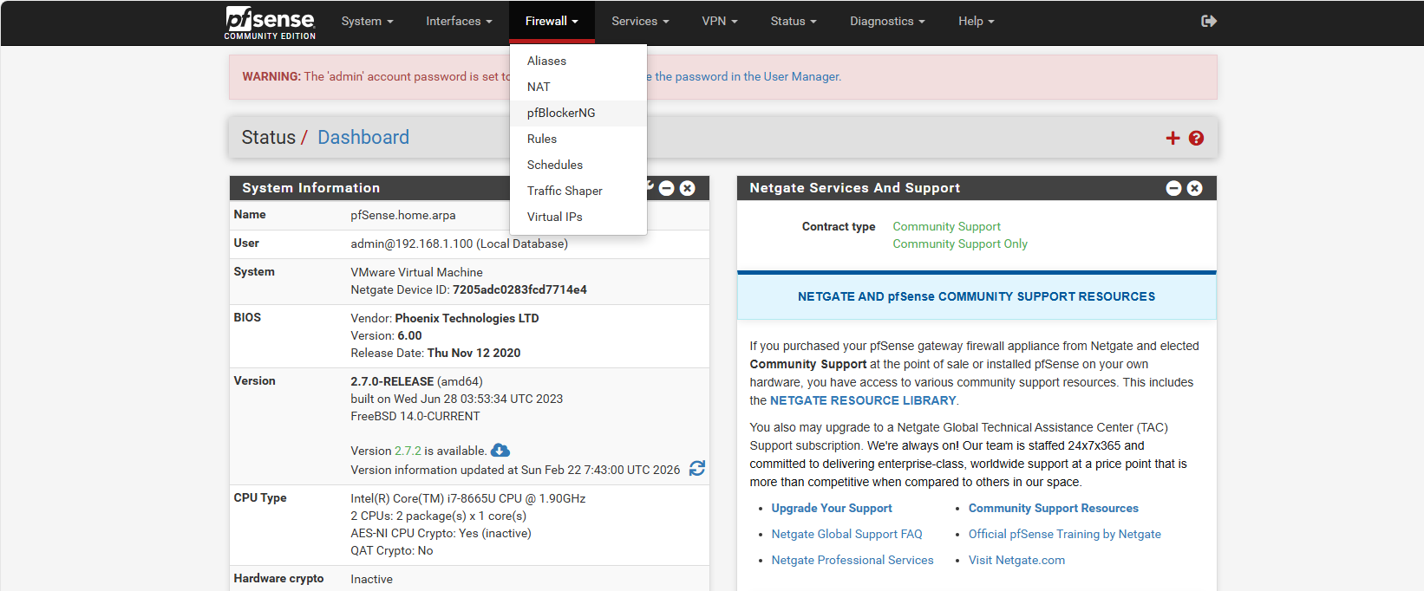
- On the main pfBlockerNG screen, click on the IP tab at the top.
- Scroll down until you see the MaxMind GeoIP Configuration section.
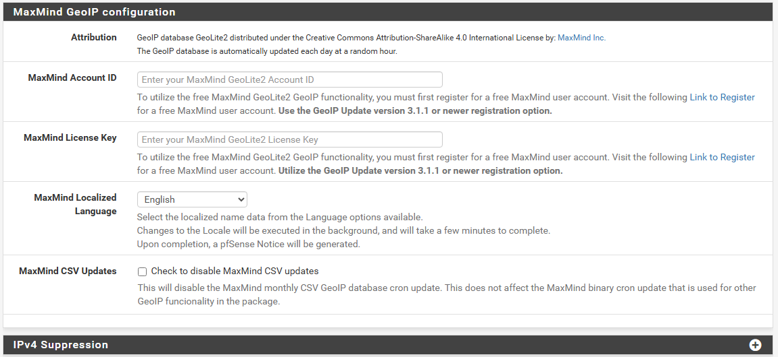
- Paste your new MaxMind License Key into the box.
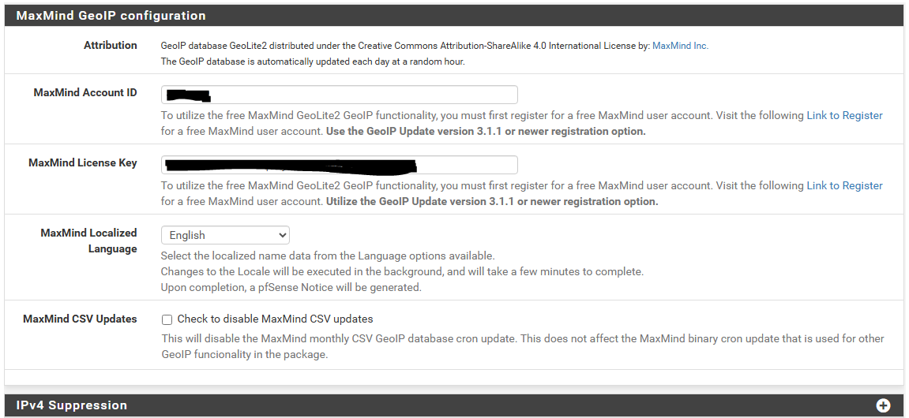
- Scroll to the very bottom and click Save.
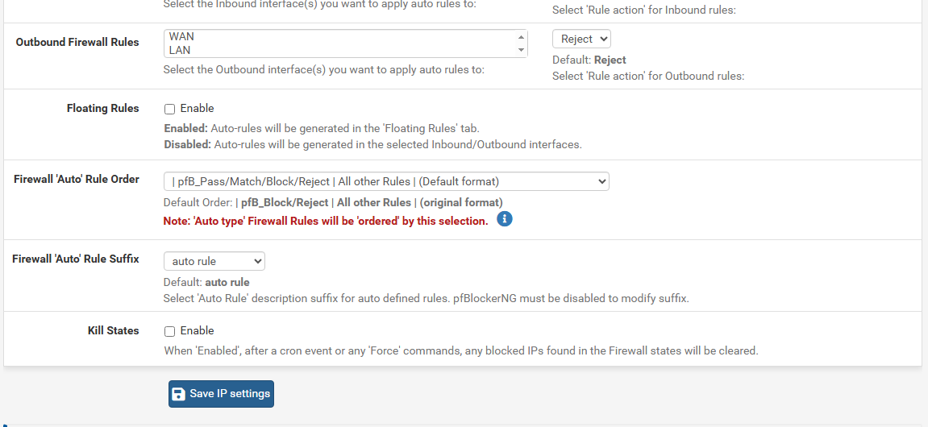
- After that go to the General and at the top and Enable pfBlockerNG.
- Scroll to the very bottom and click Save.
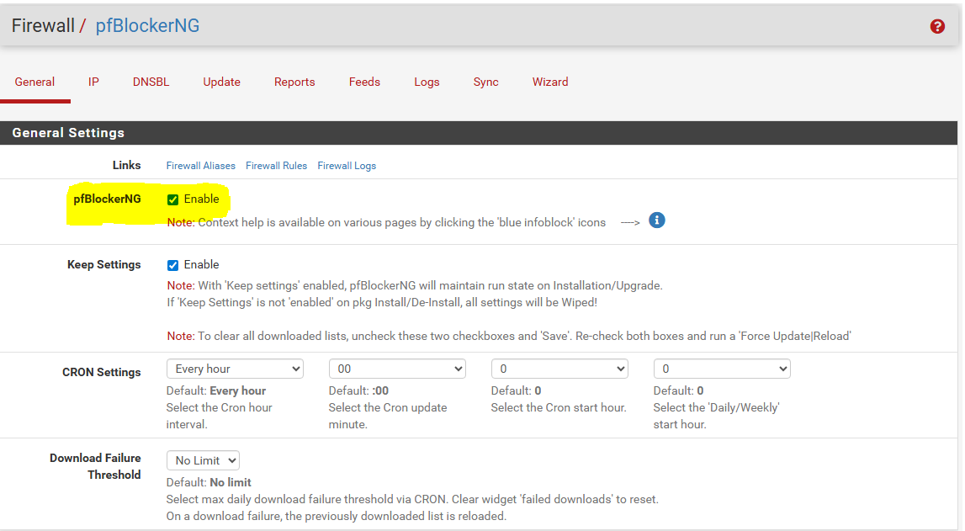

Step 3: Download the Database
- Go back to the top of the pfBlockerNG menu and click the Update tab.
- Select Run, and click the button to start the update.
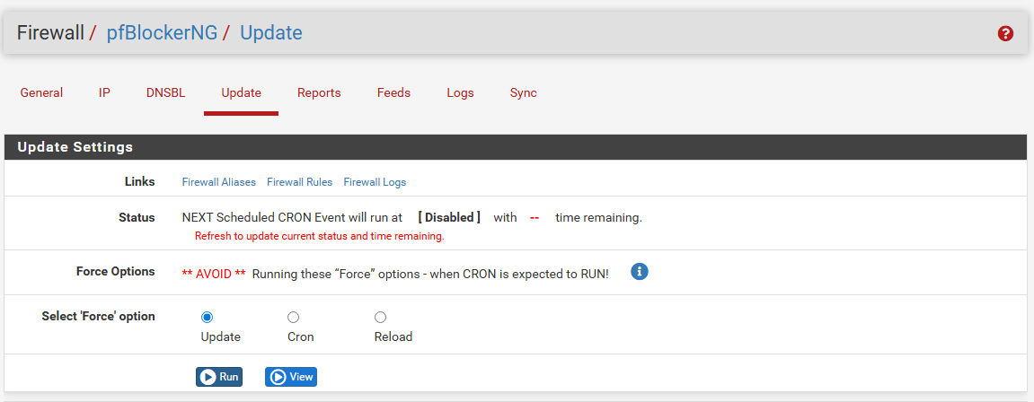
- A large log window will appear. Wait until the text stops moving and says "Update Process Ended."
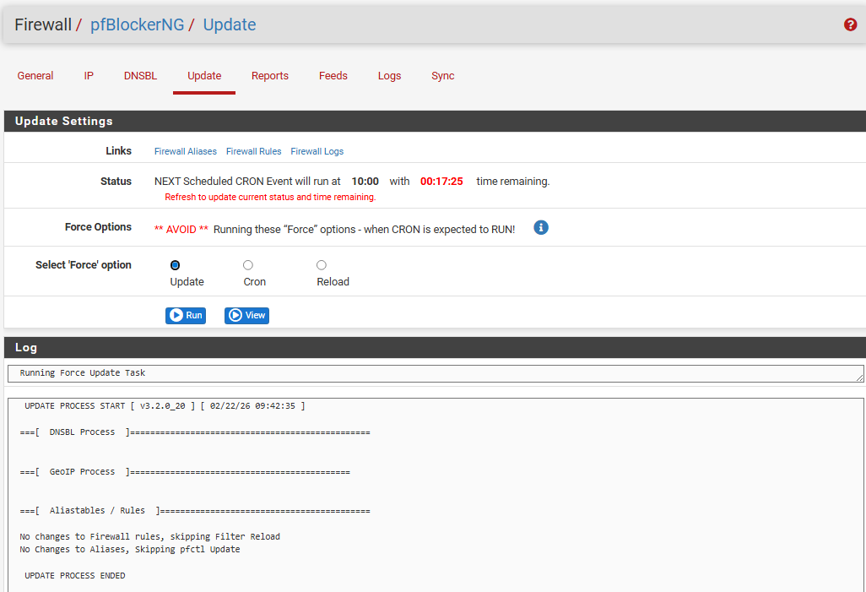

Blocking Russia and China (GeoIP)
Now that your firewall has the map, we need to give it the instructions to drop the traffic.
In enterprise SOC environments, analysts suffer from "alert fatigue" because they receive too many logs. Blocking high-risk countries like Russia and China immediately eliminates a massive amount of "noise.".

Step 1: Select the Target Countries
- On your pfSense top menu, go to Firewall -> pfBlockerNG.
- Click on the IP tab, and then click on the GeoIP sub-tab.
- You will see a list of continents and categories. Look for the row named Top Spammers.
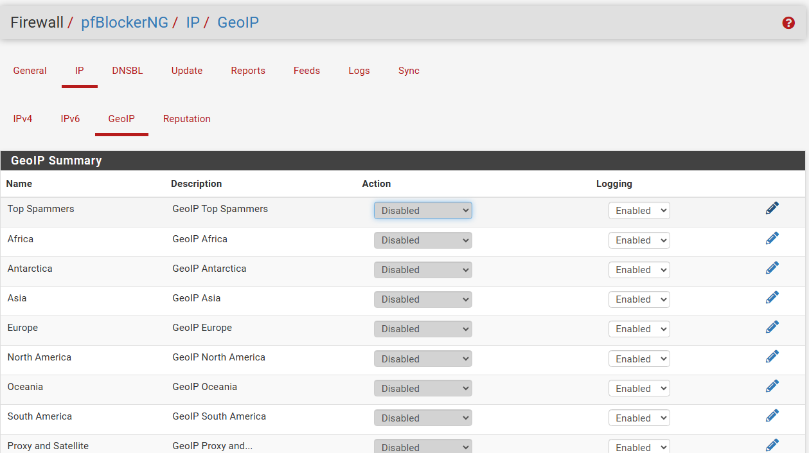
- Click the small pencil icon (Edit) next to "Top Spammers."
- You will see a large list of countries. Scroll through and click on China and Russia so they are highlighted.
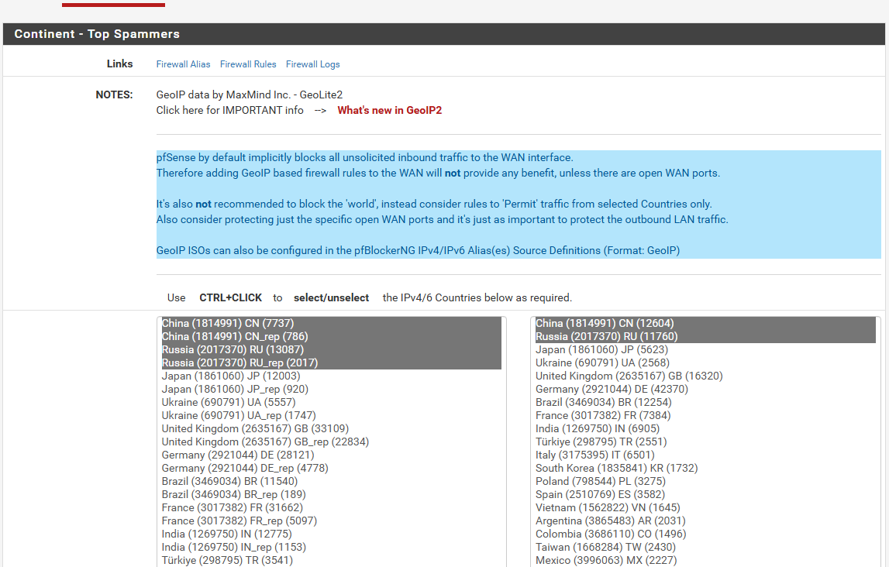

Step 2: Set the Firewall Action
- On that same page, scroll down to the List Action dropdown menu.
- Change the action from "Disabled" to Deny Both. (Explanation: "Deny Both" prevents hackers in those countries from coming IN, and prevents any malware on your network from calling OUT to them).
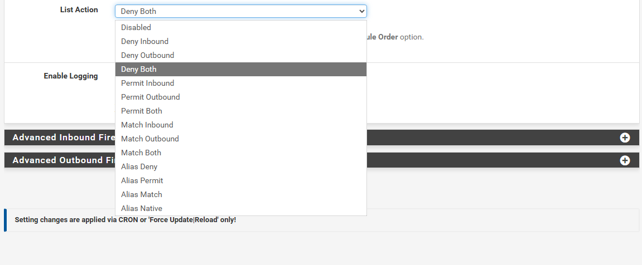
- Scroll to the very bottom and click Save
Step 3: Assigning the Interfaces
- On your pfSense menu, go back to Firewall -> pfBlockerNG.
- Click on the IP tab at the top.
- Scroll down until you find the section named IP Interface/Rules Configuration.
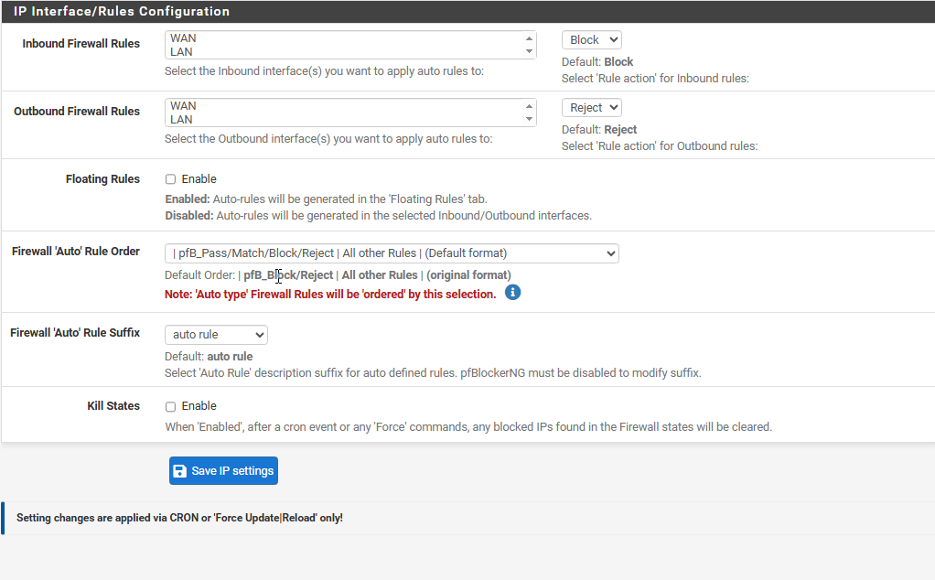

- Look at the Inbound Firewall Rules box.
- Click on WAN to highlight it. (This tells pfSense: "If a hacker from Russia or China tries to scan my public IP, drop the connection immediately").
- Look at the Outbound Firewall Rules box right below it.
- Click on LAN to highlight it. (This tells pfSense: "If a machine inside my lab gets infected with malware and tries to call home to a server in Russia or China, block it").
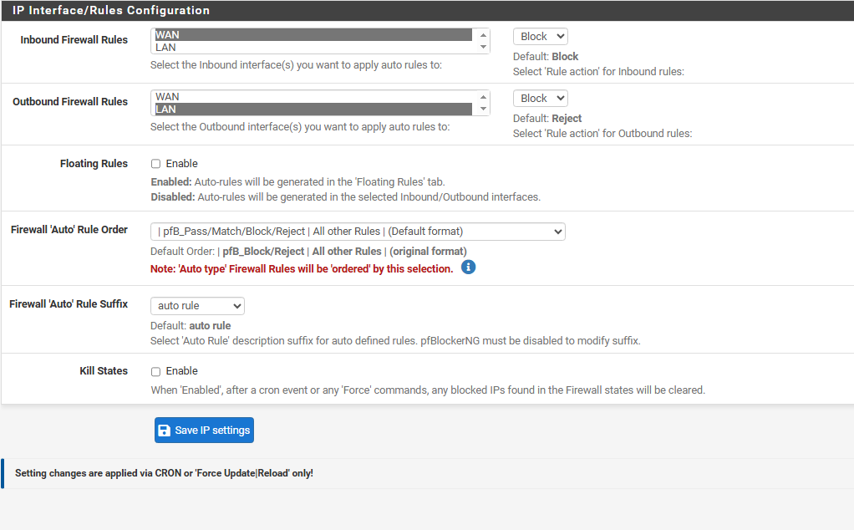
- Scroll to the very bottom of the page and click Save.

Step 4: Apply the Rule to the Firewall
Even though we saved the rule, pfSense won't enforce it until we reload the engine.
- Go to the Update tab at the top.
- Make sure Update is selected under the "Force" options.
- Click the blue Run button.
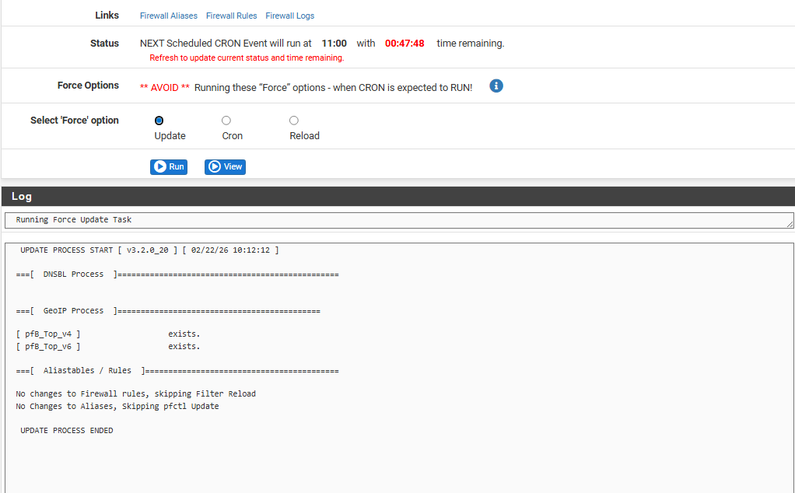
Trust, but Verify
The log says everything worked, but a professional Defensive Security analyst always verifies the configuration with their own eyes. We need to make sure pfSense actually placed the security guards on the doors.

Step 1: Check the Outside Door (WAN)
- On your pfSense top menu, go to Firewall -> Rules.
- Click on the WAN tab.
- Look at the list of rules. Do you see a new rule at the very top with a red "X" (Block) icon named something like pfB_Top_v4? (If you see this, it means traffic from Russia and China is instantly dropped before it even touches your network).
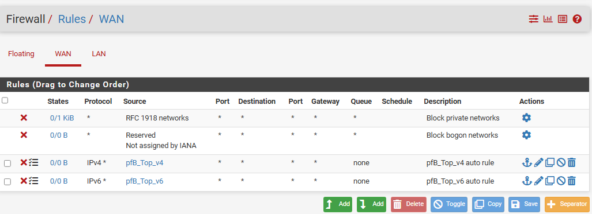

Step 2: Check the Inside Door (LAN)
- Now, click on the LAN tab right next to WAN.
- Look at the list of rules. Do you see a similar block/reject rule at the top here as well? (If you see this, it means if a machine inside your lab gets infected, it cannot call out to hackers in those countries).
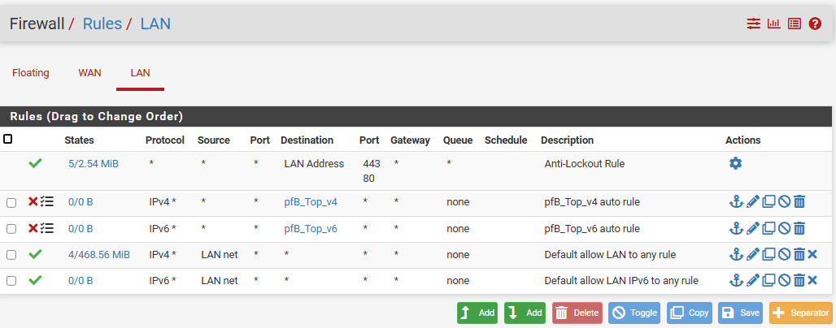
Successfully implemented inbound and outbound Geo-IP filtering using pfBlockerNG and the MaxMind database to drop traffic from top spamming countries.

