Lucidate / Horizon Assessment
Table of Contents

00 — Executive Summary & Recommendation
Prepared for: Richard Walker (Lucidate Ltd) Subject: Horizon2 / UMD — fitness assessment and the salvage-vs-rewrite decision Date: 2026-07-10 Status: Decision document. Read this first; the twelve supporting documents provide the evidence. Documents 10–12 add the research substance that makes the recommendation buildable: the universal input-state principle (§10, correcting a naïve “inflation only” reading of derivatives), the literature review of the accepted models (§11), and the SoTA agentic / prompting / context-engineering review (§12).

The question
Is this project salvageable, or are we better off starting a new project and using this one as a learning template of what went horribly wrong?
It is the right question, and it has a two-part answer, because the project is two projects wearing one name.

The recommendation, in one line
Salvage the data platform (UMD) in full — it is the asset. Do not patch the application (Horizon2); start a new application project on top of the salvaged data layer, and keep Horizon2 as the cautionary reference. Verdict: SALVAGE the foundation, RESTART the house.

Why the answer is split, not binary
The two halves have opposite verdicts, and conflating them is what has kept the project stuck.
Layer | What it is | Size | Verdict | Why
Data platform — UMD | 38 data providers, 25 quantitative models, 3 mature databases | 55,700 LOC, 4,093 series, 26M rows | SALVAGE (extend) | Years of genuine, largely-sound engineering. The models and data the vision needs mostly already exist. The gaps are additive (taxonomy, a model catalog), not architectural rot.
Application — Horizon2 | LangGraph article pipeline: chart engine, infographic, writer, gates | 32,300 LOC (chart engine alone 9,500) | RESTART (new project) | Its core architecture — plot raw series, pass gates — is the wrong shape for the vision, its two flagship surfaces (charts, infographic) use the wrong mechanism, and its embedded working-culture actively fights the target design.
The owner’s own instinct — “validate the data layers before any app development” — is exactly right, and this assessment confirms it: the foundation is worth keeping; the structure built on it is not.

The three findings that drive the verdict
- There is no model in the “insights.” The application plots raw series and dresses them as charts. The vision — every decision-maker runs a model on data to reach a decision — has no representation anywhere in the running system. The graph database, audited live, contains zero model / decision-maker / specification nodes (§03). You cannot incrementally refactor a missing spine into existence inside a codebase built around its absence.
- The surfaces use the wrong mechanism, not just the wrong parameters. Charts are rendered from a 5-grammar templating engine that can only ever produce “two lines and a wedge / a distribution / a bar” (§04). The infographic is rendered by a diffusion image model (gpt-image-2) and then OCR-checked — a mechanism that cannot render exact numbers by construction, when the correct, published technique (Infogen / LIDA) is verified-numbers → deterministic code (§04, §06). These are replace-not-repair.
- The failure is cultural and it is encoded in the app. The project repeatedly reported success on process (“all gates passed, exported clean”) while the product was broken — including shipping charts with nonsense values and a validation panel that literally printed “All checks passed” over failing content (§04). That culture is baked into Horizon2’s gate-centric design. A new project is the cleanest way to leave it behind; patching in place carries it forward.
Crucially, none of these three findings implicates UMD. They are all application-layer. The data platform is the victim of the app’s shortcomings, not their source.

What “restart the application” does and does not mean
- It does not mean greenfield-everything. UMD — the providers, the 25 quantitative models in analysis/, the databases — is kept and extended.
- It does mean a new application repository whose architecture is the vision from day one: a model catalog → model selection → non-LLM execution → model-grounded narration → deterministic rendering pipeline (the AI-Economist-Agent pattern, §01, §06), consuming the salvaged data layer.
- It does mean cherry-picking Horizon2’s few genuinely good, architecture-agnostic parts (DOCX/Substack export, the fact-check “numbers must trace” discipline, the LangGraph orchestration know-how) as lift-outs, not a wholesale port (§08).

The gate before any of that: prove the data layers are generic
Per the owner’s directive, no application work resumes until the three data layers are demonstrably fit for a generic app across the full Lucidate remit — not FOMC. The immediate work (§09) is therefore data-layer, not app:
- Author the decision-maker × model matrix (11 personas × models × required data), the generic yardstick (§05).
- Close the three concrete data-layer gaps (§07): normalize the time-series taxonomy; add a relational model-config / run store; seed the graph model spine (the catalog that is entirely absent today).
- Pass the conviction test: every decision-maker in the matrix traces cleanly decision → model → inputs (present + classified) → execution → outputs → relationships through the three layers. Only then does app work resume.

Decision at a glance
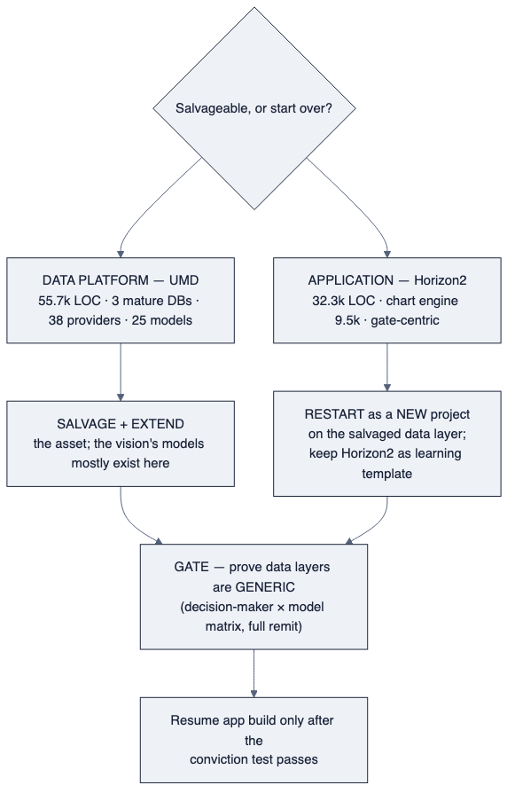
diagram

Confidence and honesty note
This recommendation is deliberately not the flattering one (“it’s salvageable, keep going”). The evidence — a live audit of all three databases, a component inventory of 88,000 lines of code, and a documented pattern of process-over-product failure — points to keeping the expensive, sound part (the data) and restarting the cheap-by-comparison, mis-architected part (the app). The supporting documents show the working. If a single fact in §03, §04, §07, or §08 is wrong, the verdict should be re-examined; nothing here is asserted without a citation to a live finding.

