Lucidate / Horizon Assessment
Table of Contents

02 — Current-State Architecture
This document describes what exists today, accurately and without euphemism, so the audit (§03) and post-mortem (§04) rest on a shared picture.

Two systems, one product
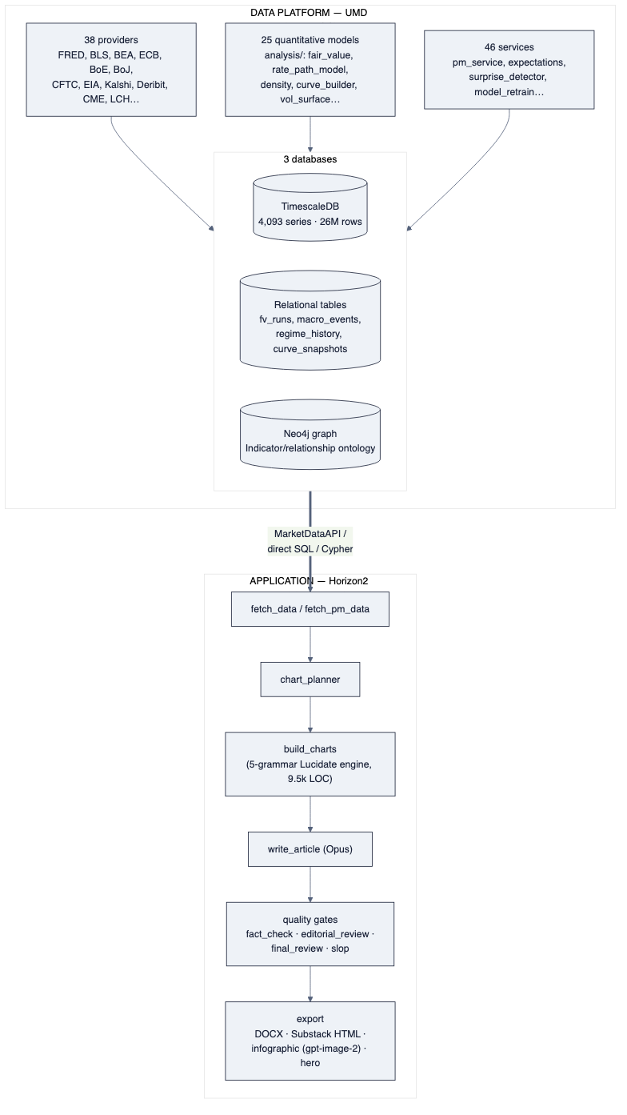
diagram

The application pipeline (Horizon2)
Horizon2 is a LangGraph state machine of 29 nodes producing one article per run. The spine, in order:
- select_event / resolve_data — resolve a template or free-text subject to a set of UMD series.
- fetch_data / fetch_pm_data — pull those series (direct SQL to TimescaleDB and MarketDataAPI), plus Kalshi prediction-market data.
- chart_planner — in subject mode, a Sonnet call picks which charts: 2–4 {chart_type, series, one-line title} intents from a 4-item vocabulary.
- build_charts — the Lucidate engine: for each intent a Sonnet tool-use call emits a typed LucidateChartSpec, which one of five deterministic grammar builders (G1 wedge, G2 atlas, G3 lattice, G4 layered, G4 stacked) renders via Plotly. ~9,500 LOC — the largest single subsystem.
- write_article — a single multimodal Opus call writes prose around the charts (the charts’ PNGs are now passed to the model).
- quality gates — fact_check, editorial_review, final_review, house-style and slop critics, with a revise-or-refuse loop and an “export-with-warnings” policy.
- export — DOCX, Substack HTML, a hero illustration and an infographic (both via the gpt-image-2 diffusion model), and a social card.

What the pipeline is, architecturally
It is a series-plotting and gate-checking pipeline. Its organising ideas are “select some series and a chart shape” and “pass a battery of text-based gates.” There is no model-execution stage and no representation of a decision-maker or their model anywhere in the 29 nodes. Insight, in the vision’s sense, has no home in this design.

The data platform (UMD)
UMD is a mature, multi-database market-data warehouse.
- Providers (13.4k LOC, 38 files): one BaseProvider subclass per source, auto-discovered, each declaring SeriesSpecs. Coverage spans official macro (FRED, BLS, BEA), every major central bank, IMF/OECD/World Bank, positioning (CFTC), commodities (EIA, USDA, FAO), rates curves (CME, LCH), options (Deribit, equity options), and prediction markets (Kalshi economics + perps).
- Analysis (11.6k LOC, 25 files): executable quantitative models — fair_value, spx_fair_value, rate_path_model, rate_divergence, density, kalshi_implied_distribution, gaussian_rate_kernel, curve_builder, vol_surface, historical_vol, and more. These are precisely the “implementation functions” the target architecture needs — they already run and produce numbers.
- Services (18.2k LOC, 46 files): orchestration, including pm_service (fair-value pipeline), expectations (market-implied surprise baseline), surprise_detector, and model_retrain.
- Three databases (detailed in §03):
  - TimescaleDB — the time-series store (observations, 4,093 series).
  - Relational tables (same instance) — model outputs and snapshots (fv_runs, divergence_signals, regime_history, curve_snapshots, spread_snapshots, macro_events, world_state_snapshots).
  - Neo4j — an economic-relationship graph (Indicator, TRANSMITS_TO, SENSITIVE_TO, CORRELATES_WITH, …).

What the data platform is, architecturally
A sound, extensible data layer with real models attached — but wired to serve the current app, not the vision. The models in analysis/ are called ad hoc by services; they are not catalogued, not bound to decision-makers, and their selection is hard-coded, not reasoned. The graph describes relationships between indicators, not models held by decision-makers. The raw material for the vision is here; the organising spine is not.

The seam between them
Horizon2 consumes UMD through MarketDataAPI, direct SQL, and Cypher — a clean, well-defined seam. This matters enormously for the recommendation (§08): because the two systems are decoupled at a real interface, the data platform can be kept and extended while the application is rebuilt against the same seam. The seam is the reason “salvage the data, restart the app” is a coherent, low-risk option rather than an all-or-nothing gamble.

