Lucidate / Horizon Assessment
Table of Contents

03 — Data-Layer Audit (live findings)
All figures below are from live queries run against the production databases on 2026-07-10, not from documentation. This is the evidence base for the “validate the data layers first” gate.

Summary verdict
Layer | Fit for a generic app? | Nature of the gap
Time-series (TimescaleDB) | Partially — broad but un-normalized | Data-quality (inconsistent taxonomy); coverage to be confirmed against the model matrix
Relational (same instance) | Partially — outputs yes, config no | Stores model outputs; has no model config store
Graph (Neo4j) | No — the spine is absent | Rich indicator ontology; zero model / decision-maker nodes

1. Time-series layer — TimescaleDB
Scale: 4,093 distinct series, 26,091,070 observations.
Breadth by source (top):
Source | Series |  | Source | Series
kalshi | 2,214 |  | fred | 105
kalshi_trades | 565 |  | yahoo | 92
cme | 346 |  | bls | 59
worldbank | 307 |  | sovereign_cds | 56
derived | 126 |  | oecd/ecb/eia/bea/… | ~250 combined
Breadth by asset class (as stored): macro 1,907 · prediction 1,096 · prediction_markets 255 · rates 219 · (blank) 126 · agriculture 118 · fx 107 · equities 70 · commodities 63 · credit 61 · interest-rates 61 · energy 60 · metals 45 · crypto 16 · yields 13 · equity 7 · …
The defect — an incoherent taxonomy. The asset_class field is not a controlled vocabulary. The same concept appears under multiple labels:
- rates vs interest-rates vs yields
- equities vs equity
- commodities vs commodity
- prediction vs prediction_markets
- 126 series with a blank asset class (the entire derived source)
A generic app that routes a decision-maker’s model to its inputs by domain cannot do so on this. This is a data-quality problem, not an architectural one — it is fixed by a canonical taxonomy plus a one-off normalization migration (§07), and it does not implicate the storage design.

2. Relational layer — tables in the same instance
The relational tables already capture model outputs and market snapshots:
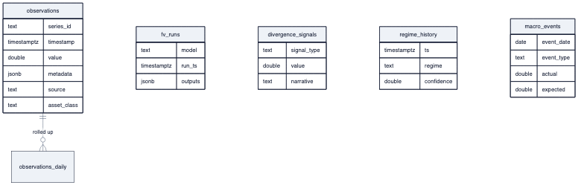
diagram
What is present: fv_runs (fair-value model runs), divergence_signals, regime_history, curve_snapshots, spread_snapshots, macro_events, world_state_snapshots, equity_fundamentals, kalshi_orderbook_snapshots, kalshi_perp_snapshots, sovereign_cds. This is genuinely useful — the platform already stores what models produced.
The defect — no model config. There is no store of model specifications: which model, its parameters, its input mapping, its assumptions, the decision it informs. That knowledge lives implicitly in analysis/ code and in YAML. fv_runs is a promising precedent (a generic model-run table), but it is fair-value-specific. Gap: a generic model_config + model_run + model_output_point schema (§07), a modest extension of a pattern that already exists.

3. Graph layer — Neo4j
Node labels (top): Indicator 603, RenderFeedback 501, Memory 414, DataSeries 262, Stock 113, DeribitExpiry 104, EditorialCriterion 90, ChartTemplate 85, KalshiEvent 74, FactSpec 60, ArticleType 38, EventType 37, … Theory 12, CentralBank 2.
Relationship types (top): RELEVANT_FOR 2,906, SUPPLIES 263, SENSITIVE_TO 192, USED_BY_MODEL 111, TRANSMITS_TO 21, RESPONDS_TO 44, CORRELATES_WITH 10, INFORMS 6, INFLUENCES 1, …
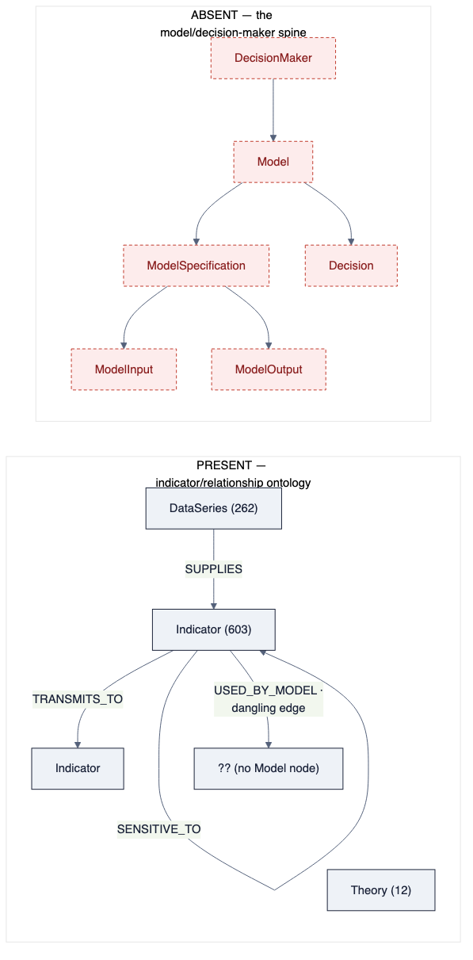
diagram
What is present: a genuinely rich indicator relationship graph — the economic substrate (transmission channels with lag/strength, sensitivities, correlations, lead-lag). This is valuable and reusable.
The defect — the model spine does not exist. A live query for any node whose label contains model, decision, persona, or equation returned nothing. There is a USED_BY_MODEL edge type (111 instances) and 12 Theory nodes — the intent to model was there — but no Model, ModelSpecification, ModelEquation, ModelInput, DecisionMaker, or Decision nodes. The entire catalog the vision runs on is absent from the graph.

What the audit proves for the recommendation
- The data platform holds the raw material — broad data, real models, relationship ontology.
- Its gaps are additive and bounded: normalize a taxonomy, add a config store, seed a model spine (§07). None require re-architecting UMD.
- The single largest gap — the missing model spine — is exactly the piece the application’s vision depends on, and its absence is why the app can only plot raw series. Fixing it is data-layer work that unblocks a new app; it is not app work.

