Lucidate / Horizon Assessment
Table of Contents

06 — Target Architecture
The target is the AI-Economist-Agent pattern (§01), specialised to Lucidate’s remit and consuming the salvaged UMD data layer. Its defining property: the LLM never authors a number. Numbers come from executing catalogued models; rendering is deterministic code; the LLM selects, designs, and narrates.

The engine
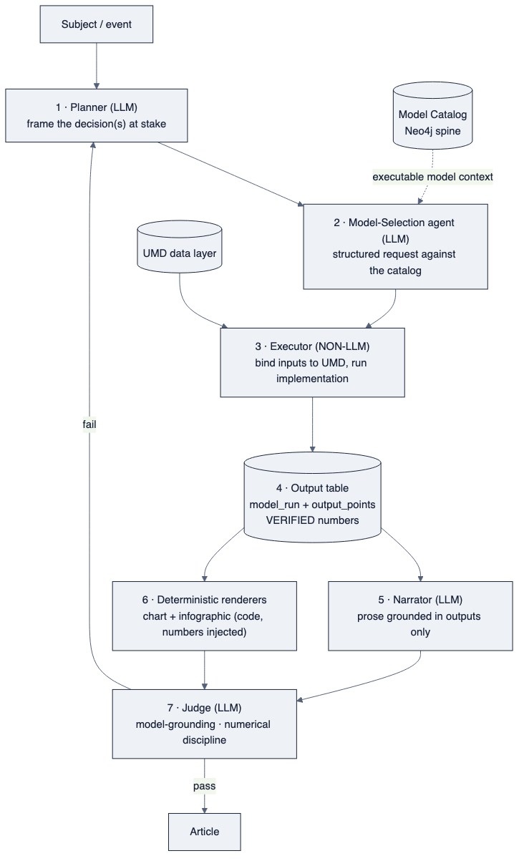
diagram
Seven roles, mapped to the paper and to existing assets:
- Planner — identifies the decision(s) and the decision-maker(s) (§05).
- Model-Selection agent — emits a structured request naming ModelSpecification node(s) from the catalog; never invents a model.
- Executor (non-LLM) — binds each ModelInput tuple {series, order, window} to the required §10 state (level, Δ, Δ², or context), runs the model’s implementation function (reusing UMD analysis/), and writes an output table.
- Output table — the single source of every number downstream; persisted as model_run + model_output_point.
- Narrator — writes prose grounded strictly in the output table.
- Deterministic renderers — chart and infographic produced by code with the verified numbers injected as literal text.
- Judge — scores model-grounding and numerical discipline; failure routes to revision. (This replaces the current gate battery’s role, but with the right definition of “done”: grounded and correct, not merely “passed”.)

Data-layer target schemas

Graph — the model spine (the piece absent today)
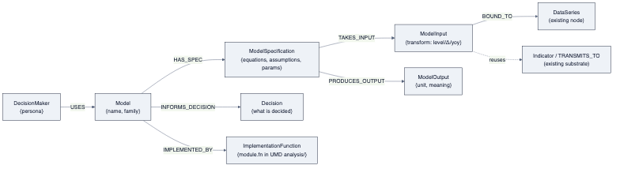
diagram
Seeded from YAML like templates (scripts/load_* pattern), run and verified (node/edge counts checked; three decision-makers spot-traced by Cypher).

Relational — model config + runs (generalize fv_runs)
- model_config(model_id, spec_json, params_json, input_map_json, decision, version)
- model_run(run_id, model_id, run_ts, inputs_snapshot, status)
- model_output_point(run_id, name, value, unit, source_computation)
Every rendered number and every prose figure references a model_output_point — the audit trail the Judge checks.

Time-series — canonical taxonomy
A controlled asset_class vocabulary (rates, inflation, labour, growth, housing, credit, fx, commodities, energy, metals, equities, crypto, prediction_markets), plus a one-off normalization migration that collapses the current duplicates and fills the blanks (§03, §07). Enables the Executor to bind model inputs by domain.

Deterministic rendering (both surfaces, one principle)
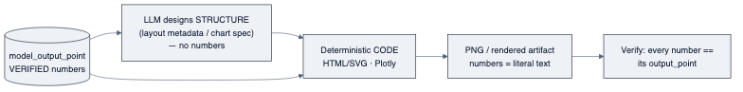
diagram
- Charts render a model’s output (implied vs actual vs market; the drivers), not raw series. The chart-mechanics work (axis semantics, real builders, editorial helpers) becomes the rendering substrate under the model outputs — necessary but subordinate.
- Infographic is produced by the Infogen/LIDA mechanism: verified numbers + LLM-designed layout → deterministic HTML/SVG (or Plotly) → PNG. No diffusion model. This is the litmus test, met by construction.

Why this architecture cannot repeat the failure
Each documented failure mode (§04) is designed out at the architectural level:
Failure mode (§04) | Designed-out by
Process reported as product | The Judge scores grounding & correctness, and “done” requires a human-viewed artifact (§09)
No model in the insight | Model execution is a mandatory pipeline stage; nothing renders without an output table
Wrong rendering mechanism | Deterministic code for all numeric artifacts; no diffusion, no LLM-authored numbers
Garbage data masked | Plausibility is a hard gate at input binding; the Executor refuses, never clips
FOMC default | The catalog is seeded across the full-remit matrix (§05); selection is generic
Architecture as avoidance | The first deliverable is one executed, rendered, looked-at artifact, not a system

