Lucidate / Horizon Assessment
Table of Contents

07 — Gap Analysis
This scores the three data layers against the union of requirements from the decision-maker × model matrix (§05), using the live audit (§03). Each gap is classified by nature — because the recommendation (§08) turns on whether the gaps are additive (fixable in place) or architectural (rot).

Gap map
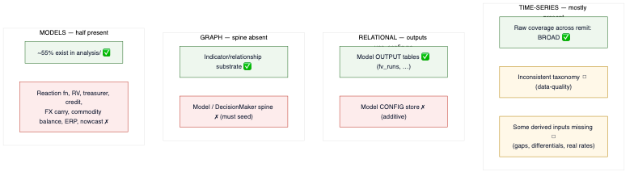
diagram

By layer

Time-series (TimescaleDB) — additive, low effort
Requirement (from §05 union) | Present? | Gap | Nature
Broad raw coverage across the full remit | ✅ 4,093 series | Confirm each matrix input has a series; a handful of derived inputs (output gap, real rates, differentials) to compute | Additive
A consistent asset_class taxonomy for routing | ✗ | rates/interest-rates/yields, blanks, dupes | Data-quality, one migration
Full input-state stack — level, Δ, Δ², context (§10) | ◻ | Δ/yoy exist ad hoc in code; no systematic, catalogued transform stack for every series | Additive
Verdict: normalize the taxonomy (one migration) + compute a short list of missing derived series. No storage re-architecture.

Relational — additive, low-medium effort
Requirement | Present? | Gap | Nature
Store model outputs / runs | ✅ fv_runs, divergence_signals, regime_history, snapshots | Generalize fv_runs to any model | Additive
Store model config (spec, params, input-map, decision) | ✗ | New model_config / model_run / model_output_point schema | Additive
Verdict: a small, well-precedented schema addition. The pattern already exists.

Graph (Neo4j) — additive but foundational
Requirement | Present? | Gap | Nature
Indicator / transmission substrate | ✅ 603 Indicator, TRANSMITS_TO, … | Reused as-is | —
DecisionMaker → Model → Spec → Input → Output → Decision spine | ✗ (zero nodes) | Seed the entire catalog | Additive (new nodes/edges on existing substrate); foundational for the vision
Verdict: the largest gap by importance, but still additive — it adds a subgraph on top of a sound substrate; it does not require re-modelling the graph.

Models (UMD analysis/) — half present
Present (✅ / ◻) | Missing (✗)
Curve fair value, rate path, rate divergence, vol surface, historical vol, Kalshi implied distribution, bias-correction, density, spx fair value, derived spreads, expectations, surprise detector | Reaction function, RV models, treasurer toolkit, structural credit/PD, FX carry/PPP, commodity supply-demand balance, equity risk premium, nowcasting
Verdict: the missing models are new analysis/ implementations + catalog entries — the same shape as the ~55% that already exist. This is data-platform work, not app work.

The critical read
Every gap above is additive — new series, a taxonomy migration, a config schema, catalog nodes, more analysis/ models. None is architectural rot in the data platform. The data layers are not fit today, but they become fit through bounded extension, not redesign. This is the empirical basis for salvaging the data platform (§08).
The single gap that is architectural — the absence of a model-execution spine — lives in the application, whose entire design presumes it away (§02, §04). That is the empirical basis for restarting the application (§08).

