Lucidate / Horizon Assessment
Table of Contents

08 — Salvage vs Rewrite (the decision)
This is the document the assessment exists to produce. It reaches the recommendation through a component inventory, three candidate paths, and a scored comparison — not a hunch.

Step 1 — Component inventory (reuse / refactor / discard)
Each component is classified against the target architecture (§06).

Data platform — UMD (55,700 LOC)
Component | LOC | Classification | Reason
38 providers | 13.4k | Reuse | Sound BaseProvider pattern; the data ingestion is the asset
25 analysis models | 11.6k | Reuse | The vision’s “implementation functions” already exist here
46 services | 18.2k | Reuse / refactor | pm_service, expectations, surprise_detector reused; orchestration lightly refactored
MarketDataAPI | 2.8k | Reuse | The clean seam the new app consumes
TimescaleDB + relational | — | Reuse + extend | Normalize taxonomy; add model-config store (§07)
Neo4j substrate | — | Reuse + extend | Keep indicator ontology; seed the model spine (§07)
UMD reuse rate: ~95%. The additions are extensions, not replacements.

Application — Horizon2 (32,300 LOC)
Component | LOC | Classification | Reason
Chart engine (build_charts, 5-grammar) | 9.5k | Discard | Wrong mechanism; structurally caps insight; renders raw series
Infographic (gpt-image-2 path) | ~1.5k | Discard | Diffusion model cannot render exact numbers
chart_planner | ~1k | Discard | Picks series+shape; no model reasoning
Quality gates | ~3k | Refactor / lift ideas | The “numbers must trace” discipline is worth keeping; the gate-culture is not
write_article + prompts | ~4.5k | Lift selectively | Prose craft & SoTA prompt patterns are reusable; the grounding target changes
Export (DOCX / Substack HTML) | ~2.7k | Reuse (lift-out) | Genuinely good, architecture-agnostic; portable to a new app
LangGraph orchestration | — | Reuse the know-how | The team’s LangGraph competence transfers; the specific graph does not
Horizon2 reuse rate: ~20–25%, and mostly as lift-outs (export, prompt craft, discipline) rather than a running spine. The two flagship surfaces (charts, infographic — ~11k LOC, ~35% of the app) are discards.
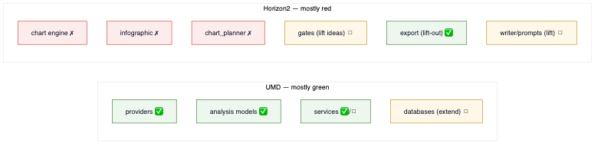
diagram

Step 2 — Three candidate paths
- Path A — Patch Horizon2 in place. Bolt a model engine, cross-section charts, and a code-based infographic onto the existing pipeline.
- Path B — New application project on the salvaged data layer. Keep and extend UMD; build a new app repo whose architecture is the model→data→insight engine from day one; lift out the few good Horizon2 parts (export, prompts, discipline).
- Path C — Full greenfield. Rebuild everything, including UMD.

Step 3 — Scored comparison
Scores 1 (poor) – 5 (excellent). Weight reflects owner priorities: fit to the vision and data-asset preservation dominate.
Criterion (weight) | A: Patch | B: New app / salvage data | C: Greenfield
Fit to model→data→insight vision (×3) | 2 | 5 | 5
Escapes the embedded gate-culture (×2) | 1 | 5 | 5
Preserves the data asset (×3) | 5 | 5 | 1
Effort / time to first quality artifact (×2) | 2 | 4 | 1
Risk (regression, half-migrated state) (×2) | 2 | 4 | 2
Leverages team’s existing know-how (×1) | 4 | 4 | 2
Weighted total (max 65) | 31 | 59 | 36
Path B wins decisively. Path A is dragged down by fighting an architecture and culture built around the vision’s absence — a half-migrated pipeline is the worst of both worlds. Path C throws away UMD, a 55.7k-LOC, three-database asset, for no architectural benefit over B.
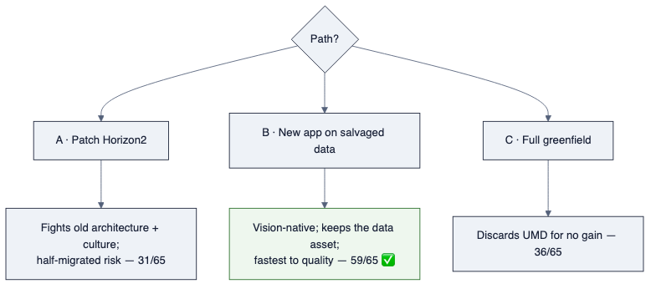
diagram

Step 4 — The recommendation
Salvage the data platform (UMD) in full and extend it; do not patch Horizon2 — stand up a new application project on the salvaged data layer, built as the model→data→insight engine from the first commit, and lift out only Horizon2’s few architecture-agnostic strengths (DOCX/Substack export, prompt craft, the numbers-must-trace discipline). Keep Horizon2 in the repo, read-only, as the documented “learning template of what went wrong.”

Why not “just salvage” (Path A)
The temptation is to keep the working pipeline and add the missing pieces. But the missing piece is the spine — model execution — and Horizon2’s every node presumes its absence. Retrofitting a spine into a body built without one is slower and riskier than a new body, and it carries the gate-centric culture (§04) forward intact. The dishonest_validation_panel is the warning: the culture is in the code.

Why not “rewrite everything” (Path C)
UMD is not the problem. It is 55.7k LOC of sound ingestion and real models, three mature databases, and 4,093 series — the exact foundation the vision needs, and the thing the owner rightly insisted we validate first. Rebuilding it would be the most expensive possible way to make no architectural progress.

The nuance that matters
This is not “the project failed, start over.” It is “the expensive, sound half succeeded and is kept; the mis-architected half is restarted.” The data platform is the asset; the application is the learning template. Naming them separately is the single most important output of this assessment.

What this decision unblocks
Nothing in the application is built until the data-layer conviction test (§09) passes — the taxonomy is clean, the model-config store exists, the graph spine is seeded, and every decision-maker in the matrix (§05) traces cleanly through the three layers. Only then does the new application’s first, single, looked-at quality artifact get built.

