Lucidate / Horizon Assessment
Table of Contents

10 — Model Input Representation: level, derivatives, and context
This document corrects a naïveté in the earlier drafts. They repeated the phrase “inflation and its rate of change” so often that they implied the derivative of a variable matters only for inflation. That is wrong, and building on it would invite disaster. The derivative principle is universal.

The principle
A professional never feeds a model a raw number. They feed it a state: the variable’s level and its motion. For every input, the questions are:
- Level — where is it? (housing starts at 1.35m)
- First derivative (velocity) — is it rising or falling, and how fast? (starts down 4% m/m)
- Second derivative (acceleration) — is the change itself speeding up or slowing? (the decline is decelerating — a possible turn)
- Context — how does this compare to trend, history, regime, and to what was expected? (starts in the 20th percentile of a decade; below consensus)
Housing starts falling is a different world from housing starts rising; rising-but-decelerating often signals an inflection a level-only reading misses entirely. The same is true of payrolls, ISM new orders, credit spreads, the curve, real yields, oil inventories, and every other input in the matrix (§05). A level alone is frequently insufficient; the model’s meaning lives in the motion.
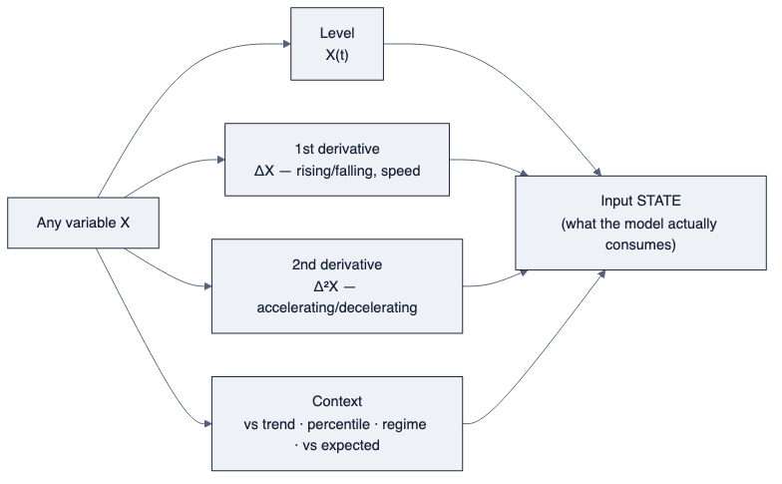
diagram

This is established practice, not a Horizon idea
The finance and macro literature formalises the derivative view:
- Momentum oscillators are literally derivatives. Technical oscillators are “second or third derivative functions” of a series; the McClellan Oscillator is the rate of change of the advance–decline line — acceleration of breadth. (leading indicators)
- Diffusion indices encode the first derivative across many series at once. ISM prints above/below 50 measure whether the breadth of activity is expanding or contracting — a first-derivative reading, not a level. ISM new orders is watched precisely because it leads (the derivative leads the level).
- Leading indicators are derivative constructs that “change before the broader economy does (commonly 3–12 months ahead)” (LEI) — you read them for direction and acceleration, not level.
- Whole models are built on momentum. The Atlanta Fed GDPNow nowcast aggregates the changes in 13 subcomponents (ISM, construction, vehicle sales, trade, employment, IP, housing starts, PPI/CPI) into a running estimate — a model whose inputs are fundamentally rates of change (GDPNow).
- Surprise indices (actual vs expected) are the “context vs expectations” axis made into a series — the same object the expectations layer already in UMD produces.

What this changes in the data-layer requirements
This is not a wording fix; it changes the specification of two layers.

Time-series layer — a derivative/transform stack per series
It is not enough to store levels. For every series the model matrix consumes, the layer must be able to produce, on demand and consistently:
Transform | Meaning | Example construct
level | X(t) | raw
Δ (mom/qoq/yoy) | first derivative | rate of change
Δ² | second derivative | acceleration / momentum-of-momentum
rolling context | vs its own history | z-score, percentile, vs trend
breadth / diffusion | first derivative across a group | %-of-components-rising
surprise | vs expected | actual − consensus / market-implied
Some of these exist ad hoc in UMD code (yoy, mom); none is systematically declared or stored as a first-class, catalogued transform. That is the gap (§07): a canonical transform stack, not scattered helpers.

Graph layer — ModelInput must declare which derivative and window
A model input is not “a series.” It is a tuple:
ModelInput = { series, order ∈ {level, Δ, Δ², context, diffusion, surprise},
window, transform_params }
The catalog must record, per model, which order and window of which series the model consumes — because the reaction function wants inflation’s level and its change, the momentum/nowcast models want changes and acceleration, and a valuation model wants a level in context. Encoding only “series → model” (as the dangling USED_BY_MODEL edge does today) is insufficient and would reproduce exactly the naïve reading this document corrects.

The corrected framing (to be applied throughout the set)
Wherever the earlier drafts said “inflation and its rate of change,” read the general rule:
Every model input is a state — level, first derivative, second derivative, and context — and the model catalog must declare which of these each model consumes. Inflation is one example among all variables, not the exception.
§05 (the matrix), §06 (target schema), and §07 (gap analysis) are to be read with this correction; the ModelInput tuple above is the concrete requirement it places on the graph and time-series layers.

