Lucidate / Horizon Assessment
Table of Contents

12 — SoTA Agentic Architecture, Prompting & Context Engineering
The earlier drafts asserted a seven-role pipeline (§06) without reviewing how, in 2026 practice, such agents are actually built, prompted, and kept reliable. This document supplies that review and maps it onto the model-grounded pipeline. The governing constraint throughout: the LLM selects, plans, and narrates; it never authors a number. Everything below is chosen to enforce that.

1. The agentic design patterns (and where each is used)
The 2026 literature has converged on a small vocabulary of patterns; production systems combine them rather than picking one.
Pattern | Mechanism | Where in our pipeline
Planning | Decompose the task before acting | Planner: frame the decision(s) and decision-maker(s) at stake
Routing | Classify intent → dispatch to a specialist | Route a subject to the relevant persona/model family; “misrouting → invalid narrative”
Tool Use / Context-Augmentation | LLM selects external tools/data; never computes internally | Model-Selection + Executor: numbers come from tools/DB, “never performs arithmetic internally”
Prompt-Chaining | Sequential subtasks passing structured data, with validation gates between | select → execute → validate → narrate; “insert validation gates so mistakes don’t cascade”
Parallelization | Independent subtasks concurrently; voting/consensus | run several candidate models / independent checks; majority-vote on a number’s provenance
Orchestrator-Workers | Central LLM decomposes and delegates; workers retrieve, never author | orchestrate which workers fetch which model outputs
Reflection | Self-critique and revise before returning | narrator reviews prose against the output table before emitting
Evaluator-Optimizer | A separate judge scores against explicit criteria; generator revises | the Judge (below) — “makes quality measurable rather than vibes-based”
Design philosophy (explicit in the sources): start simple; add agentic structure only when a simpler solution falls short. The pipeline should be the minimum set of these patterns that enforces number-grounding — not a maximal multi-agent sprawl.
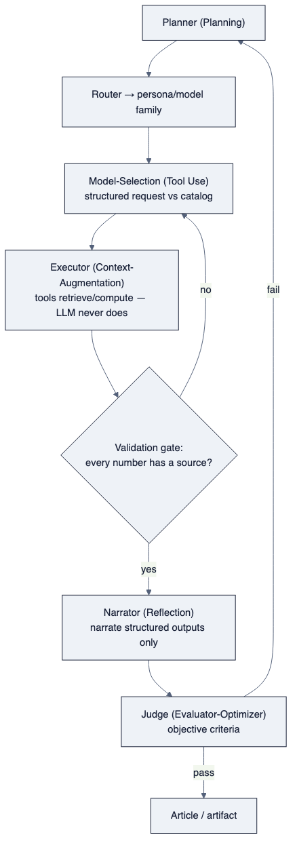
diagram

2. Structured output — the mechanism that forbids invented numbers
Between every stage, data passes as a schema, not prose. The canonical number-carrying object:
{ "name": "reaction_function_implied_rate",
"value": 3.9, "unit": "%",
"source": "model_run:MR-2026-07-10-taylor99",
"source_computation": "taylor1999(pi=4.17, dpi=+0.3, gap=-0.4, rstar=0.9)",
"as_of": "2026-07-10" }
Because the narrator receives only these objects (and the model’s asserts / interpretation text from §11), it can explain the number but has nothing to invent from. This is the Infogen/LIDA principle (§01) at the data-flow level: “pass only retrieved/computed fields to the narrative LLM, not raw documents — this constrains the LLM to narrating selections, not generating numbers.”

3. The Judge (Evaluator-Optimizer) — measurable quality, not vibes
A separate agent scores each artifact against explicit, objective criteria (adapted from the AI-Economist-Agent judge, §01):
- Model grounding — every quantitative claim traces to a model_run / model_output_point. Naming a model without an executed run scores zero.
- Numerical discipline — no number appears without provenance metadata; the narrative never contradicts the output table.
- Interpretation vs computation — the prose distinguishes the model’s interpretation (qualitative) from its computed figures (quantitative).
- Derivative correctness (§10) — where a model consumes a rate of change or acceleration, the prose reflects direction and speed, not just level.
- Audit — the artifact exposes enough to trace every claim to its source.
Failure routes to revision (Reflection). “Poorly designed stopping criteria trap systems in suboptimal states” — so the gate is source-verification passing, not a turn count, and — per §04 — the ultimate acceptance is a human looking at the artifact, with the Judge as an aid, never the definition of done.

4. Context engineering — the discipline that makes it reliable
“Most agent failures aren’t model failures; they’re context failures.” The 2026 practice:
- Memory tiers. Working (the live window), short-term (this run’s tool results), long-term (cross-run: editorial preferences, prior calibration, model provenance) — with a compaction step that condenses old turns into summaries.
- Index-then-load, not dump. Naïve RAG loads ~35k tokens of which “only ~6% is relevant — the rest pollutes the window and degrades performance.” Instead, show the agent a compact index (model names, inputs, token cost) and let it load on demand. Every token in the window must have a reason to be there.
- Retrieval modes matched to the store: classical RAG for the literature (ArXiv model curation), structured queries for the catalog and data (Cypher against Neo4j, SQL against the model store), file reads, and just-in-time retrieval by identifier.
- Knowledge-graph memory — a direct fit. State-of-the-art memory systems (A-MEM’s Zettelkasten of linked notes; Zep/Graphiti’s temporal knowledge graph where nodes are entities and edges carry timestamps) are exactly the shape of the model spine we must build anyway (§06). Lucidate already runs Neo4j — the model catalog is the agent’s long-term structured memory. This is a strategic alignment: the graph that stores the models is also the retrieval substrate that keeps the agents grounded.
- “Bad retrieval is one of the largest sources of hallucinated answers” — so retrieval quality (the right model spec, the right series, the right derivative order) is a first-class reliability concern, not plumbing.
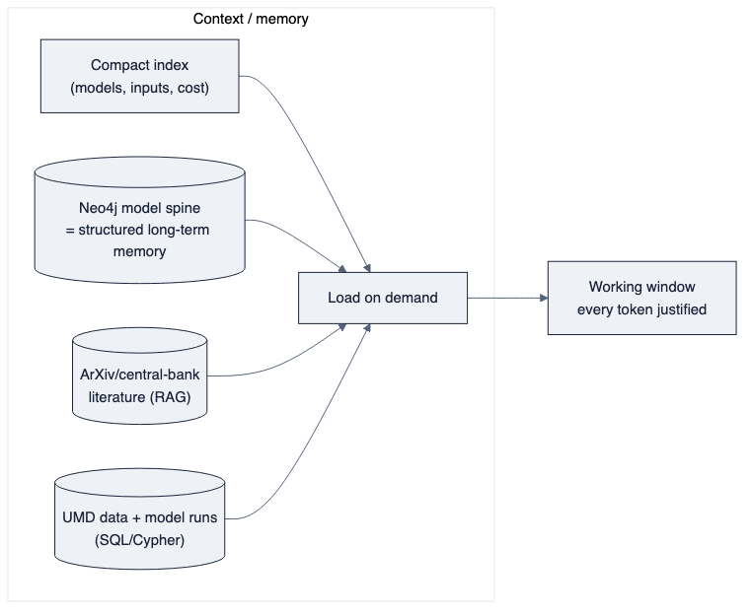
diagram

5. Prompting discipline (model-grounded narration)
The narrator’s system prompt, following the AI-Economist-Agent’s proven conditioning:
- Supply: the selected ModelSpecification (form, asserts, interpretation), the model_run id, and the model_output_point table.
- Instruct: “Link every quantitative claim to a model output. Distinguish the model’s economic interpretation from its computed numbers. Do not state that a model was run unless a run id is provided. Where a model consumes a rate of change or acceleration, describe direction and speed, not level alone.”
- Forbid: authoring any figure; recomputing arithmetic; describing a chart feature not present.
Their controlled result is the target: moving the output “from a fluent narrative to a traceable economic analysis.” That single sentence is the difference between Horizon2’s prose and the product.

6. What this review adds to the recommendation
- The target architecture (§06) is not hand-waving: it is the mainstream 2026 agentic pattern set (Planning + Routing + Tool-Use + Prompt-Chaining + Evaluator-Optimizer + Reflection) specialised to number-grounding.
- Context engineering is where reliability is won or lost, and Lucidate’s existing Neo4j is a genuine head-start — the model spine doubles as the agents’ structured long-term memory.
- None of this can be prompted into existence until the model catalog (§11) and the derivative-aware inputs (§10) exist in the data layers. This is the final confirmation of the sequencing (§09): data layers first, agents second — the agents are only as grounded as the catalog and data they retrieve from.
Sources: Agentic design patterns 2026 (SitePoint) · HF: design patterns for agentic workflows · Context engineering (Sourcegraph) · Context engineering & memory (Weaviate) · AI Economist Agent, arXiv 2606.20041 · Infogen, arXiv 2507.20046

