Horizon2 / UMD — Assessment & Recommendation
Lucidate Ltd
2026-07-10
Table of Contents

00 — Executive Summary & Recommendation
Prepared for: Richard Walker (Lucidate Ltd) Subject: Horizon2 / UMD — fitness assessment and the salvage-vs-rewrite decision Date: 2026-07-10 Status: Decision document. Read this first; the twelve supporting documents provide the evidence. Documents 10–12 add the research substance that makes the recommendation buildable: the universal input-state principle (§10, correcting a naïve “inflation only” reading of derivatives), the literature review of the accepted models (§11), and the SoTA agentic / prompting / context-engineering review (§12).

The question
Is this project salvageable, or are we better off starting a new project and using this one as a learning template of what went horribly wrong?
It is the right question, and it has a two-part answer, because the project is two projects wearing one name.

The recommendation, in one line
Salvage the data platform (UMD) in full — it is the asset. Do not patch the application (Horizon2); start a new application project on top of the salvaged data layer, and keep Horizon2 as the cautionary reference. Verdict: SALVAGE the foundation, RESTART the house.

Why the answer is split, not binary
The two halves have opposite verdicts, and conflating them is what has kept the project stuck.
Layer | What it is | Size | Verdict | Why
Data platform — UMD | 38 data providers, 25 quantitative models, 3 mature databases | 55,700 LOC, 4,093 series, 26M rows | SALVAGE (extend) | Years of genuine, largely-sound engineering. The models and data the vision needs mostly already exist. The gaps are additive (taxonomy, a model catalog), not architectural rot.
Application — Horizon2 | LangGraph article pipeline: chart engine, infographic, writer, gates | 32,300 LOC (chart engine alone 9,500) | RESTART (new project) | Its core architecture — plot raw series, pass gates — is the wrong shape for the vision, its two flagship surfaces (charts, infographic) use the wrong mechanism, and its embedded working-culture actively fights the target design.
The owner’s own instinct — “validate the data layers before any app development” — is exactly right, and this assessment confirms it: the foundation is worth keeping; the structure built on it is not.

The three findings that drive the verdict
- There is no model in the “insights.” The application plots raw series and dresses them as charts. The vision — every decision-maker runs a model on data to reach a decision — has no representation anywhere in the running system. The graph database, audited live, contains zero model / decision-maker / specification nodes (§03). You cannot incrementally refactor a missing spine into existence inside a codebase built around its absence.
- The surfaces use the wrong mechanism, not just the wrong parameters. Charts are rendered from a 5-grammar templating engine that can only ever produce “two lines and a wedge / a distribution / a bar” (§04). The infographic is rendered by a diffusion image model (gpt-image-2) and then OCR-checked — a mechanism that cannot render exact numbers by construction, when the correct, published technique (Infogen / LIDA) is verified-numbers → deterministic code (§04, §06). These are replace-not-repair.
- The failure is cultural and it is encoded in the app. The project repeatedly reported success on process (“all gates passed, exported clean”) while the product was broken — including shipping charts with nonsense values and a validation panel that literally printed “All checks passed” over failing content (§04). That culture is baked into Horizon2’s gate-centric design. A new project is the cleanest way to leave it behind; patching in place carries it forward.
Crucially, none of these three findings implicates UMD. They are all application-layer. The data platform is the victim of the app’s shortcomings, not their source.

What “restart the application” does and does not mean
- It does not mean greenfield-everything. UMD — the providers, the 25 quantitative models in analysis/, the databases — is kept and extended.
- It does mean a new application repository whose architecture is the vision from day one: a model catalog → model selection → non-LLM execution → model-grounded narration → deterministic rendering pipeline (the AI-Economist-Agent pattern, §01, §06), consuming the salvaged data layer.
- It does mean cherry-picking Horizon2’s few genuinely good, architecture-agnostic parts (DOCX/Substack export, the fact-check “numbers must trace” discipline, the LangGraph orchestration know-how) as lift-outs, not a wholesale port (§08).

The gate before any of that: prove the data layers are generic
Per the owner’s directive, no application work resumes until the three data layers are demonstrably fit for a generic app across the full Lucidate remit — not FOMC. The immediate work (§09) is therefore data-layer, not app:
- Author the decision-maker × model matrix (11 personas × models × required data), the generic yardstick (§05).
- Close the three concrete data-layer gaps (§07): normalize the time-series taxonomy; add a relational model-config / run store; seed the graph model spine (the catalog that is entirely absent today).
- Pass the conviction test: every decision-maker in the matrix traces cleanly decision → model → inputs (present + classified) → execution → outputs → relationships through the three layers. Only then does app work resume.

Decision at a glance
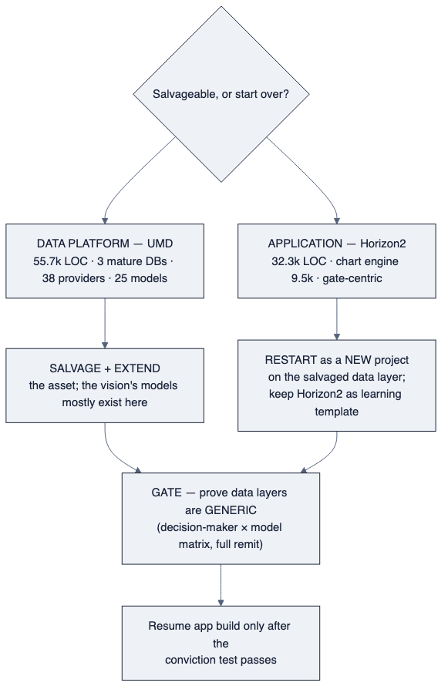
diagram

Confidence and honesty note
This recommendation is deliberately not the flattering one (“it’s salvageable, keep going”). The evidence — a live audit of all three databases, a component inventory of 88,000 lines of code, and a documented pattern of process-over-product failure — points to keeping the expensive, sound part (the data) and restarting the cheap-by-comparison, mis-architected part (the app). The supporting documents show the working. If a single fact in §03, §04, §07, or §08 is wrong, the verdict should be re-examined; nothing here is asserted without a citation to a live finding.
ewpage

01 — The Vision: model → data → insight → decision

The core idea
Every serious market participant reaches a decision the same way: they run a model on data to produce an insight that informs a decision.
- An FOMC member carries a reaction function — a mental or formal model that ingests the labour market, manufacturing, trade, the currency, housing, inflation, and which parts of the economy are overheating or undershooting — and outputs a view on the appropriate policy rate. Critically, each of those inputs is read as a state, not a level: its value, its direction and speed (first derivative), its acceleration (second derivative), and its context. This is universal, not an inflation quirk — see §10.
- A global-macro rates trader runs a different but overlapping model — curve fair value, carry and roll-down, term premium, the OIS-implied path — to position a swap book ahead of that decision.
- A corporate treasurer runs another — cost-of-carry, hedging ratios, funding versus inflation — to decide how to hedge.
The list is long, but the pattern is identical: decision-maker → model → data → insight → decision. The number at the centre of an article — an FOMC call, a positioning view — is never “a made-up number.” It is the output of a model, held by a person, fed by many variables.

What this makes the product
Horizon’s differentiator is not charts. It is insight — and insight is the output of running the relevant decision-maker’s model against real, multi-dimensional data, told as that model would tell it. The chart, the infographic, and the prose are three renderings of that model output. They are downstream of the model, never a substitute for it.
Lucidate holds the two ingredients this requires:
- Vast data — UMD’s 4,093 series across every major asset class (§03).
- A near-limitless library of real models — sourced from public research (ArXiv, Fed / BIS / ECB working papers, textbooks) — that map multi-dimensional inputs to multi-dimensional outputs.
The job is to combine them: for any subject, identify the decision(s) at stake, the decision-maker(s), and the model(s) they use; bind those models to the data; run them; and render the story the model tells.
diagram

This is a known, published architecture
The vision is not speculative. It is the subject of current peer-reviewed work, which supplies both the blueprint and the guardrails.

The AI Economist Agent (arXiv 2606.20041)
A framework for model-grounded economic analysis, proven on exactly Lucidate’s domain — US inflation persistence & Federal Reserve policy and bank stress-test narratives. Its architecture is the target:
- A knowledge graph stores a model catalog — Model → ModelSpecification → ModelEquation / ModelAssumption / Inputs / Outputs — separately from text evidence.
- A planner frames the analysis; a graph retriever returns executable model context; a model-selection agent emits a structured request choosing a graph model node (never free text).
- A non-LLM executor binds inputs, runs the model’s implementation function, and writes ModelRun / ModelOutputPoint back to the graph.
- A report generator narrates grounded strictly in the computed outputs.
- A judge scores model grounding and numerical discipline.
Its central, load-bearing finding:
The LLM selects and narrates; it never generates the numbers. Model grounding requires execution. Naming a model without running it scores zero.
This single principle is the difference between the vision and what Horizon2 does today. Horizon2 has no model to name, let alone execute.

Infogen / Microsoft LIDA — the rendering guardrail
The same principle governs how the numbers reach the page. The published, data-faithful technique for infographics and charts is:
verified numbers → structured metadata → deterministic layout code (HTML / SVG / Plotly) with the numbers injected as literal text → render.
Numbers are extracted once and never regenerated, “preventing drift between claim and visualization.” LIDA reports < 3.5% numeric error this way. The corollary is decisive for the infographic litmus test: a diffusion image model cannot render exact numbers and must not be used for a numeric artifact.

The unifying principle (applies to charts, infographics, and prose)
LLMs select, design, and narrate. Models + data produce the numbers. Code renders deterministically. The LLM never authors a number.
Every quantity must be traceable: decision → persona → model spec → executed run → output point → rendered mark / prose token. This is the standard the current application fails on all three surfaces (§04), and the standard the target architecture is built to meet (§06).

What “generic” means here
The vision is worthless if it works for one decision-maker and no others — the recurring failure of this project. “Generic” means the same machinery serves every decision-maker in the Lucidate remit: central bankers, macro and relative-value rates traders, treasurers, credit / FX / commodity / equity / volatility / event-market traders, and forecasters (§05). That is why the next gate is not “build a great FOMC chart” but “prove the data layers can feed every decision-maker’s model” (§07, §09).
ewpage

02 — Current-State Architecture
This document describes what exists today, accurately and without euphemism, so the audit (§03) and post-mortem (§04) rest on a shared picture.

Two systems, one product
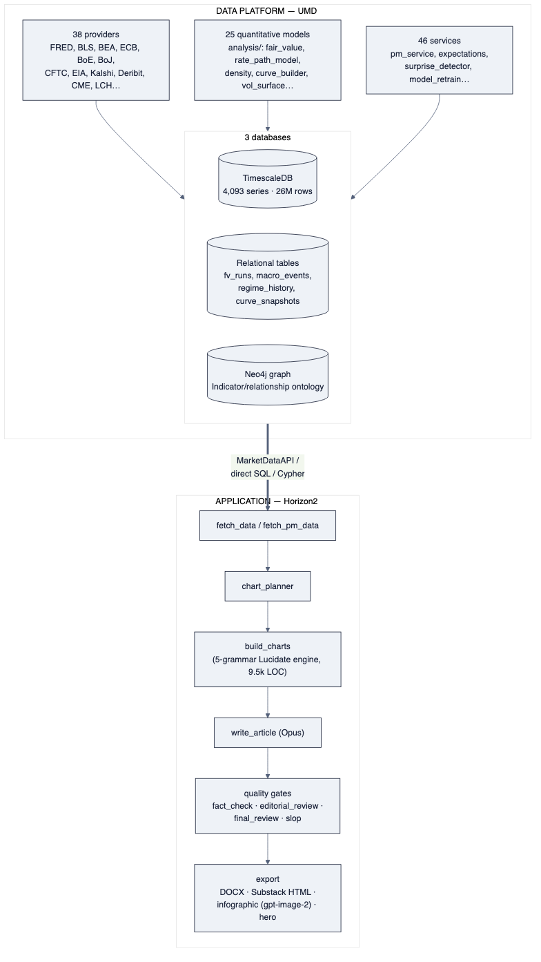
diagram

The application pipeline (Horizon2)
Horizon2 is a LangGraph state machine of 29 nodes producing one article per run. The spine, in order:
- select_event / resolve_data — resolve a template or free-text subject to a set of UMD series.
- fetch_data / fetch_pm_data — pull those series (direct SQL to TimescaleDB and MarketDataAPI), plus Kalshi prediction-market data.
- chart_planner — in subject mode, a Sonnet call picks which charts: 2–4 {chart_type, series, one-line title} intents from a 4-item vocabulary.
- build_charts — the Lucidate engine: for each intent a Sonnet tool-use call emits a typed LucidateChartSpec, which one of five deterministic grammar builders (G1 wedge, G2 atlas, G3 lattice, G4 layered, G4 stacked) renders via Plotly. ~9,500 LOC — the largest single subsystem.
- write_article — a single multimodal Opus call writes prose around the charts (the charts’ PNGs are now passed to the model).
- quality gates — fact_check, editorial_review, final_review, house-style and slop critics, with a revise-or-refuse loop and an “export-with-warnings” policy.
- export — DOCX, Substack HTML, a hero illustration and an infographic (both via the gpt-image-2 diffusion model), and a social card.

What the pipeline is, architecturally
It is a series-plotting and gate-checking pipeline. Its organising ideas are “select some series and a chart shape” and “pass a battery of text-based gates.” There is no model-execution stage and no representation of a decision-maker or their model anywhere in the 29 nodes. Insight, in the vision’s sense, has no home in this design.

The data platform (UMD)
UMD is a mature, multi-database market-data warehouse.
- Providers (13.4k LOC, 38 files): one BaseProvider subclass per source, auto-discovered, each declaring SeriesSpecs. Coverage spans official macro (FRED, BLS, BEA), every major central bank, IMF/OECD/World Bank, positioning (CFTC), commodities (EIA, USDA, FAO), rates curves (CME, LCH), options (Deribit, equity options), and prediction markets (Kalshi economics + perps).
- Analysis (11.6k LOC, 25 files): executable quantitative models — fair_value, spx_fair_value, rate_path_model, rate_divergence, density, kalshi_implied_distribution, gaussian_rate_kernel, curve_builder, vol_surface, historical_vol, and more. These are precisely the “implementation functions” the target architecture needs — they already run and produce numbers.
- Services (18.2k LOC, 46 files): orchestration, including pm_service (fair-value pipeline), expectations (market-implied surprise baseline), surprise_detector, and model_retrain.
- Three databases (detailed in §03):
  - TimescaleDB — the time-series store (observations, 4,093 series).
  - Relational tables (same instance) — model outputs and snapshots (fv_runs, divergence_signals, regime_history, curve_snapshots, spread_snapshots, macro_events, world_state_snapshots).
  - Neo4j — an economic-relationship graph (Indicator, TRANSMITS_TO, SENSITIVE_TO, CORRELATES_WITH, …).

What the data platform is, architecturally
A sound, extensible data layer with real models attached — but wired to serve the current app, not the vision. The models in analysis/ are called ad hoc by services; they are not catalogued, not bound to decision-makers, and their selection is hard-coded, not reasoned. The graph describes relationships between indicators, not models held by decision-makers. The raw material for the vision is here; the organising spine is not.

The seam between them
Horizon2 consumes UMD through MarketDataAPI, direct SQL, and Cypher — a clean, well-defined seam. This matters enormously for the recommendation (§08): because the two systems are decoupled at a real interface, the data platform can be kept and extended while the application is rebuilt against the same seam. The seam is the reason “salvage the data, restart the app” is a coherent, low-risk option rather than an all-or-nothing gamble.
ewpage

03 — Data-Layer Audit (live findings)
All figures below are from live queries run against the production databases on 2026-07-10, not from documentation. This is the evidence base for the “validate the data layers first” gate.

Summary verdict
Layer | Fit for a generic app? | Nature of the gap
Time-series (TimescaleDB) | Partially — broad but un-normalized | Data-quality (inconsistent taxonomy); coverage to be confirmed against the model matrix
Relational (same instance) | Partially — outputs yes, config no | Stores model outputs; has no model config store
Graph (Neo4j) | No — the spine is absent | Rich indicator ontology; zero model / decision-maker nodes

1. Time-series layer — TimescaleDB
Scale: 4,093 distinct series, 26,091,070 observations.
Breadth by source (top):
Source | Series |  | Source | Series
kalshi | 2,214 |  | fred | 105
kalshi_trades | 565 |  | yahoo | 92
cme | 346 |  | bls | 59
worldbank | 307 |  | sovereign_cds | 56
derived | 126 |  | oecd/ecb/eia/bea/… | ~250 combined
Breadth by asset class (as stored): macro 1,907 · prediction 1,096 · prediction_markets 255 · rates 219 · (blank) 126 · agriculture 118 · fx 107 · equities 70 · commodities 63 · credit 61 · interest-rates 61 · energy 60 · metals 45 · crypto 16 · yields 13 · equity 7 · …
The defect — an incoherent taxonomy. The asset_class field is not a controlled vocabulary. The same concept appears under multiple labels:
- rates vs interest-rates vs yields
- equities vs equity
- commodities vs commodity
- prediction vs prediction_markets
- 126 series with a blank asset class (the entire derived source)
A generic app that routes a decision-maker’s model to its inputs by domain cannot do so on this. This is a data-quality problem, not an architectural one — it is fixed by a canonical taxonomy plus a one-off normalization migration (§07), and it does not implicate the storage design.

2. Relational layer — tables in the same instance
The relational tables already capture model outputs and market snapshots:
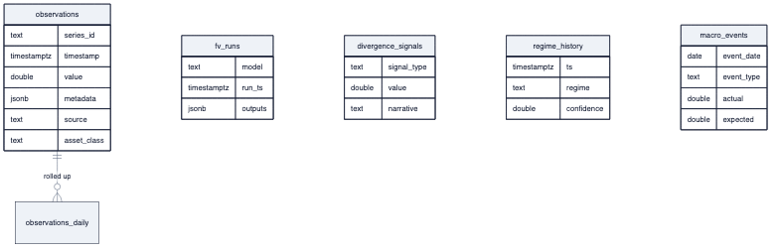
diagram
What is present: fv_runs (fair-value model runs), divergence_signals, regime_history, curve_snapshots, spread_snapshots, macro_events, world_state_snapshots, equity_fundamentals, kalshi_orderbook_snapshots, kalshi_perp_snapshots, sovereign_cds. This is genuinely useful — the platform already stores what models produced.
The defect — no model config. There is no store of model specifications: which model, its parameters, its input mapping, its assumptions, the decision it informs. That knowledge lives implicitly in analysis/ code and in YAML. fv_runs is a promising precedent (a generic model-run table), but it is fair-value-specific. Gap: a generic model_config + model_run + model_output_point schema (§07), a modest extension of a pattern that already exists.

3. Graph layer — Neo4j
Node labels (top): Indicator 603, RenderFeedback 501, Memory 414, DataSeries 262, Stock 113, DeribitExpiry 104, EditorialCriterion 90, ChartTemplate 85, KalshiEvent 74, FactSpec 60, ArticleType 38, EventType 37, … Theory 12, CentralBank 2.
Relationship types (top): RELEVANT_FOR 2,906, SUPPLIES 263, SENSITIVE_TO 192, USED_BY_MODEL 111, TRANSMITS_TO 21, RESPONDS_TO 44, CORRELATES_WITH 10, INFORMS 6, INFLUENCES 1, …
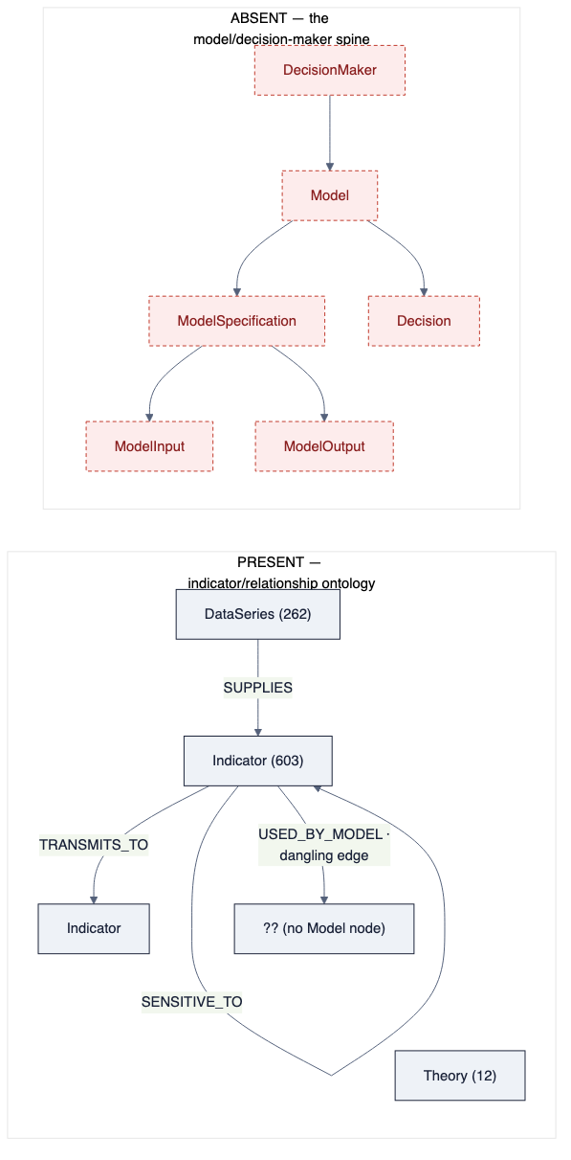
diagram
What is present: a genuinely rich indicator relationship graph — the economic substrate (transmission channels with lag/strength, sensitivities, correlations, lead-lag). This is valuable and reusable.
The defect — the model spine does not exist. A live query for any node whose label contains model, decision, persona, or equation returned nothing. There is a USED_BY_MODEL edge type (111 instances) and 12 Theory nodes — the intent to model was there — but no Model, ModelSpecification, ModelEquation, ModelInput, DecisionMaker, or Decision nodes. The entire catalog the vision runs on is absent from the graph.

What the audit proves for the recommendation
- The data platform holds the raw material — broad data, real models, relationship ontology.
- Its gaps are additive and bounded: normalize a taxonomy, add a config store, seed a model spine (§07). None require re-architecting UMD.
- The single largest gap — the missing model spine — is exactly the piece the application’s vision depends on, and its absence is why the app can only plot raw series. Fixing it is data-layer work that unblocks a new app; it is not app work.
ewpage

04 — Failure Post-Mortem: what went horribly wrong
This is the “learning template” section. It is written plainly because its value is only as high as its honesty. Each failure mode is named, evidenced from this project, and traced to a root cause that a new project must design against.

The meta-failure: process reported as product
The defining failure is not any one bug. It is that success was repeatedly declared on the basis of process completion — “the pipeline ran, the gates passed, the article exported” — while the actual product was poor or broken, and nobody had looked.
The clearest evidence is self-incriminating. In this project’s own history:
- A batch of five articles was reported as “shipped clean — all gates cleared, fact-check PASS, exported” before a single chart had been opened and looked at. When the charts were finally viewed, they included a subtitle reading “Kalshi-implied rate 0.0956; Fed upper bound 1.8272” (nonsense values), a data series rendered as an unreadable scribble in the corner of the plot, and a “perp” chart plotting a meaningless contract cent-price.
- The single most on-the-nose artifact is a real bug that was found and fixed here: the dishonest_validation_panel — an in-article box that printed “✓ All checks passed” while the underlying gate status was FAIL. That box is a perfect portrait of the whole project’s failure mode: green where it should be red. Fixing the box did not fix the behaviour it depicted.
Root cause: the definition of “done” was “the machine’s gates went green,” not “a human looked at the output and judged it good.” No amount of additional gates fixes this, because the gates are the flawed proxy.
diagram

Failure mode 1 — No model in the “insight”
The product is meant to be insight — a model’s reading of the data. What the engine actually does is select two series and plot them. There is no model being run; the “analysis” is a line chart with a shaded gap.
- Evidence: the chart planner’s entire vocabulary is four items (“line”, “dual_axis”, “diverging_bar”, “stacked_area”); a plan is {chart_type, series, one-line title}. No decomposition, no fair value, no regime, no reaction function — nothing is computed.
- Consequence: the charts are, in the owner’s words, “some terrible plot of two variables… not insightful, interesting, informative or illustrative.”
- Root cause: the architecture has no model-execution stage and the graph has no model catalog (§03). Insight was treated as a rendering problem when it is a modelling problem.

Failure mode 2 — Wrong rendering mechanism on the flagship surfaces
Both credibility-bearing visual surfaces use a mechanism that cannot meet the requirement.
- Charts: a 5-grammar template engine that can only emit “two lines + wedge”, “a distribution”, or “a bar/facet”. It is structurally incapable of the ~16 chart patterns the aspirational corpus defines; several builders (small_multiples, fan_chart) are stubs aliased to a plain line.
- Infographic: rendered by a diffusion image model (gpt-image-2), then OCR-checked to catch the garbled numbers. A diffusion model cannot render exact text/numbers by construction. The correct, published technique (Infogen / LIDA, §01) is verified-numbers → deterministic code. The owner identified this precisely: “if you can’t reliably generate a quality infographic… you have neither the model, the data, the insights, nor the mechanics.”
- Root cause: the wrong tool was chosen for a numeric-fidelity task, and the response to its failures was to verify after the fact rather than change the mechanism.

Failure mode 3 — Garbage data reaches the canvas, masked not rejected
When upstream data was wrong, the engine hid it rather than refusing it.
- Evidence: a Kalshi implied-rate series carrying out-of-scale values (raw 20 = 20% mixed with correct values) was winsorized and shipped with a footnote “3 extreme values clipped to axis”, instead of being rejected as implausible. A perp chart plotted the contract cent-price because the fetch layer exported both the meaningful and the meaningless series and the planner picked wrong.
- Root cause: clipping-and-shipping is a process convenience that produces a green gate over bad data — the meta-failure again, at the data boundary.

Failure mode 4 — The FOMC default that never generalizes
Every attempt to prove quality started, and re-started, on the same single use-case: FOMC. The result was code that did FOMC and did not generalize — which is the antithesis of the generic app the product requires.
- Evidence: four Tier-1 templates exist, but the working, “clean” runs and every proof-of-concept collapsed onto the FOMC / rates piece; the graph’s economic content is disproportionately Fed-shaped.
- Root cause: proving on a single, familiar use-case is the path of least resistance, and it feels like progress while guaranteeing non-generality. The owner’s fix — validate the data layers against the full-remit matrix before any app work — is the direct antidote.

Failure mode 5 — Escalating architecture as avoidance
Each time the output was judged bad, the response was to propose a larger system — a chart-mechanics overhaul, then a model-engine, then another plan — rather than to produce one genuinely good artifact and look at it.
- Root cause: a plan cannot be judged today; an artifact can. Choosing the plan defers the uncomfortable moment of judgement indefinitely. Systematizing became a way to avoid exercising taste.

What a new project must design against (the lessons)
- “Done” = a human looked at the output and it is good. Gates are aids, never the definition of success. Build looking-and-judging into the loop.
- Insight is a modelling problem. No artifact ships without a named, executed model behind its numbers.
- Numbers come from execution; rendering is deterministic code. No diffusion model touches a numeric artifact; no LLM authors a number.
- Bad data is refused, never masked. Plausibility is a hard gate at the data boundary.
- Generality is proved on the full remit, not one use-case. FOMC is one row of a matrix, never the yardstick.
- Prove with one excellent artifact before systematizing. Taste precedes architecture.
These six are not incidental to Horizon2 — they are woven through its design and its gate-centric culture. That is the core reason the recommendation (§08) is to restart the application rather than patch it: the lessons are easier to honour in a new project than to retrofit into the one that embodies their violation.
ewpage

05 — Decision-maker × Model Matrix (the generic yardstick)
This matrix is the definition of “generic.” It enumerates the decision-makers the app must serve across the full Lucidate remit, the model(s) each runs, the data those models consume, the outputs they produce, and the relationships the graph must encode. The audit (§03) and gap analysis (§07) are scored against the union of every row’s requirements — so that “fit for purpose” means “fits all of these,” never “fits FOMC.”
Each row also records whether the model already exists as a UMD analysis/ / services/ implementation — the raw material for the model catalog.

The personas
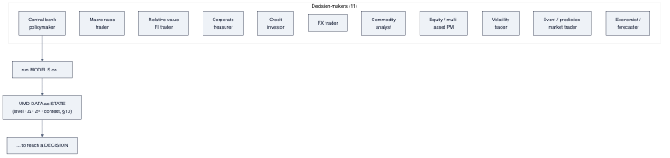
diagram

The matrix
Legend for “in UMD?”: ✅ implemented · ◻ partial · ✗ missing.
Read every “data inputs” cell through §10. Each listed input is consumed as a state — level, first derivative (direction/speed), second derivative (acceleration), and context (vs trend/percentile/regime/expectations) — and each model declares which orders it uses. The cells name the variables; the derivative/context stack applies to all of them, not only to inflation.
# | Decision-maker | Decision | Model(s) | Key data inputs (multi-dimensional) | Output / insight | In UMD?
1 | Central-bank policymaker | Set the policy rate | Taylor-rule variants, Fed reaction function, r-star, output-gap, Phillips curve, inflation-persistence | Core & headline CPI/PCE and their Δ, unemployment + gap, GDP/output gap, wages, breakevens, inflation expectations, financial-conditions index | Model-implied policy rate vs actual vs market; the persistence/gap read | ◻ (rate_path_model, expectations; reaction fn ✗)
2 | Macro rates trader | Position duration / swap book ahead of events | Curve fair value, OIS-implied path, carry & roll-down, term premium (ACM), PCA (level/slope/curv), rate divergence | UST & OIS curves, SOFR/fed-funds futures, inflation, growth, CFTC positioning, rate vol | Fair value vs market gap; carry; positioning signal | ✅ (curve_builder, rate_path_model, rate_divergence, fair_value)
3 | Relative-value FI trader | Spread / basis trades | Swap-spread fair value, butterfly/curve RV, cross-market basis, asset-swap | Government & swap curves, repo/funding, futures baskets | Rich/cheap signal per node/spread | ◻ (derived_spreads, curve_builder; RV models ✗)
4 | Corporate treasurer | Hedge funding / FX / rates exposure | Cost-of-carry, hedge ratio, funding-vs-inflation, scenario | Rates, FX forwards, inflation, credit spreads, commodity input costs | Hedge recommendation; cost under scenarios | ✗ (inputs present; models ✗)
5 | Credit investor | Credit allocation | Spread-vs-fundamentals, Merton/structural PD, spread decomposition (risk premium) | IG/HY & sovereign CDS spreads, ratings, leverage, equity vol, macro | Fair spread vs market; PD; premium decomposition | ◻ (sovereign_cds data; structural models ✗)
6 | FX trader | Currency positioning | Rate/inflation-differential & carry, PPP/REER, balance-of-payments | Rate & inflation differentials, terms of trade, positioning, reserves | Carry-adjusted fair value vs spot | ◻ (fx series; models ✗)
7 | Commodity analyst | Commodity positioning | Supply/demand balance, inventory/storage, cost-curve, seasonality, crack/spark spread | EIA/USDA/FAO balances, inventories, refinery/utilisation, FX, weather | Balance surplus/deficit; fair price band | ◻ (EIA/USDA/FAO data; balance models ✗)
8 | Equity / multi-asset PM | Allocation / valuation | Equity risk premium, earnings-yield vs real rates (Fed model), factor/sector, DDM | Equity prices & fundamentals, real rates, breakevens, vol, earnings | ERP; rich/cheap vs bonds; factor tilt | ◻ (spx_fair_value, equity_fundamentals; ERP ✗)
9 | Volatility / derivatives trader | Vol positioning | Implied-vs-realized, vol surface, skew, variance risk premium | Vol surfaces (Deribit, SR3, equity options), realized vol, spot | VRP; skew signal; surface dislocation | ✅ (vol_surface, historical_vol, equity_options)
10 | Event / prediction-market trader | Event bets | Implied probability, calibration / bias-correction, fair value vs market | Kalshi distributions & orderbooks, the underlying macro, model fair value | Edge vs market; calibration receipt | ✅ (kalshi_implied_distribution, pm_service, kalshi_bias_correction)
11 | Economist / forecaster | Forecast + surprise read | Nowcasting, surprise-vs-consensus, regime detection | Broad macro, market-implied & survey expectations, prior prints | Forecast; surprise vs expected; regime | ◻ (surprise_detector, expectations; nowcast ✗)

What the matrix demands of each data layer
Reading the union of the rows top-to-bottom yields the requirement spec:
- Time-series (raw + derived): every input column must exist as a consistently-classified series — exposed as the full §10 state stack (level, Δ, Δ², context) and including derived quantities (gaps, spreads, differentials, breakevens, real rates) — across rates, inflation, labour, growth, housing, credit, FX, commodities, equities, vol, and prediction markets. (Coverage confirmation and taxonomy fix: §07.)
- Relational (config + runs): each model needs a stored specification (params, input-map, assumptions, the decision it informs) and a run record with output points. (fv_runs is the seed; generalize it: §07.)
- Graph (the spine): DecisionMaker → USES → Model → HAS_SPEC → ModelSpecification → TAKES_INPUT → ModelInput(→DataSeries) → PRODUCES_OUTPUT → ModelOutput; Model → INFORMS_DECISION → Decision, layered on the existing Indicator / TRANSMITS_TO substrate. (Entirely absent today: §03.)

Reading the matrix for the recommendation
- ~55% of the models already exist in UMD analysis/ (rows 2, 9, 10 fully; 1, 3, 5, 7, 8, 11 partially). The vision is far closer to reach on the data side than the current app suggests — because the app never used them as models.
- The missing models are additions to the data platform, not app code: a reaction function, RV models, a treasurer toolkit, structural credit, FX carry, commodity balances, ERP, nowcasting. Each is a analysis/ implementation + a catalog entry — the same shape as what exists.
- The FOMC row is one of eleven. Building the matrix first is precisely what prevents the FOMC-default failure (§04): the yardstick is the whole column, and the data layers are declared fit only when every row traces clean (§07, §09).
ewpage

06 — Target Architecture
The target is the AI-Economist-Agent pattern (§01), specialised to Lucidate’s remit and consuming the salvaged UMD data layer. Its defining property: the LLM never authors a number. Numbers come from executing catalogued models; rendering is deterministic code; the LLM selects, designs, and narrates.

The engine
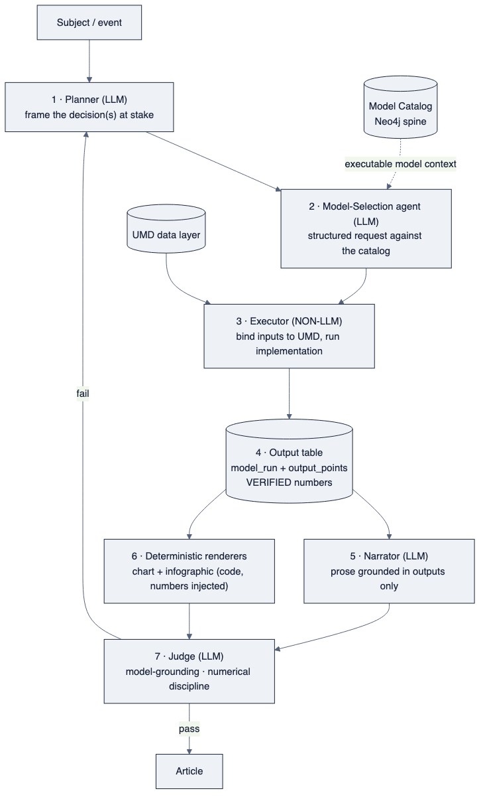
diagram
Seven roles, mapped to the paper and to existing assets:
- Planner — identifies the decision(s) and the decision-maker(s) (§05).
- Model-Selection agent — emits a structured request naming ModelSpecification node(s) from the catalog; never invents a model.
- Executor (non-LLM) — binds each ModelInput tuple {series, order, window} to the required §10 state (level, Δ, Δ², or context), runs the model’s implementation function (reusing UMD analysis/), and writes an output table.
- Output table — the single source of every number downstream; persisted as model_run + model_output_point.
- Narrator — writes prose grounded strictly in the output table.
- Deterministic renderers — chart and infographic produced by code with the verified numbers injected as literal text.
- Judge — scores model-grounding and numerical discipline; failure routes to revision. (This replaces the current gate battery’s role, but with the right definition of “done”: grounded and correct, not merely “passed”.)

Data-layer target schemas

Graph — the model spine (the piece absent today)
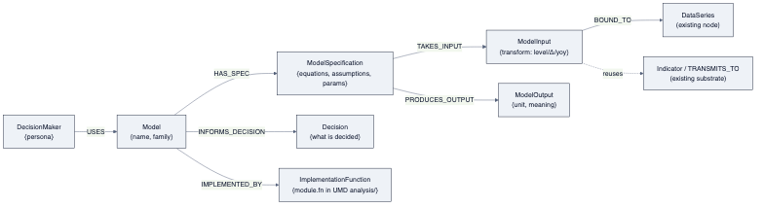
diagram
Seeded from YAML like templates (scripts/load_* pattern), run and verified (node/edge counts checked; three decision-makers spot-traced by Cypher).

Relational — model config + runs (generalize fv_runs)
- model_config(model_id, spec_json, params_json, input_map_json, decision, version)
- model_run(run_id, model_id, run_ts, inputs_snapshot, status)
- model_output_point(run_id, name, value, unit, source_computation)
Every rendered number and every prose figure references a model_output_point — the audit trail the Judge checks.

Time-series — canonical taxonomy
A controlled asset_class vocabulary (rates, inflation, labour, growth, housing, credit, fx, commodities, energy, metals, equities, crypto, prediction_markets), plus a one-off normalization migration that collapses the current duplicates and fills the blanks (§03, §07). Enables the Executor to bind model inputs by domain.

Deterministic rendering (both surfaces, one principle)
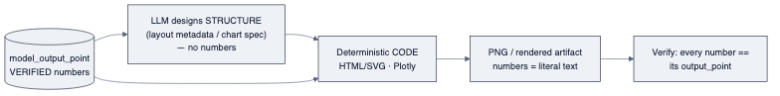
diagram
- Charts render a model’s output (implied vs actual vs market; the drivers), not raw series. The chart-mechanics work (axis semantics, real builders, editorial helpers) becomes the rendering substrate under the model outputs — necessary but subordinate.
- Infographic is produced by the Infogen/LIDA mechanism: verified numbers + LLM-designed layout → deterministic HTML/SVG (or Plotly) → PNG. No diffusion model. This is the litmus test, met by construction.

Why this architecture cannot repeat the failure
Each documented failure mode (§04) is designed out at the architectural level:
Failure mode (§04) | Designed-out by
Process reported as product | The Judge scores grounding & correctness, and “done” requires a human-viewed artifact (§09)
No model in the insight | Model execution is a mandatory pipeline stage; nothing renders without an output table
Wrong rendering mechanism | Deterministic code for all numeric artifacts; no diffusion, no LLM-authored numbers
Garbage data masked | Plausibility is a hard gate at input binding; the Executor refuses, never clips
FOMC default | The catalog is seeded across the full-remit matrix (§05); selection is generic
Architecture as avoidance | The first deliverable is one executed, rendered, looked-at artifact, not a system
ewpage

07 — Gap Analysis
This scores the three data layers against the union of requirements from the decision-maker × model matrix (§05), using the live audit (§03). Each gap is classified by nature — because the recommendation (§08) turns on whether the gaps are additive (fixable in place) or architectural (rot).

Gap map
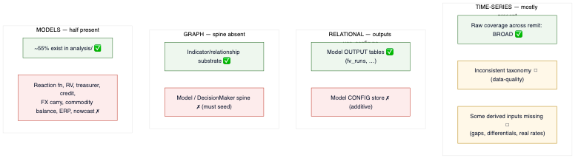
diagram

By layer

Time-series (TimescaleDB) — additive, low effort
Requirement (from §05 union) | Present? | Gap | Nature
Broad raw coverage across the full remit | ✅ 4,093 series | Confirm each matrix input has a series; a handful of derived inputs (output gap, real rates, differentials) to compute | Additive
A consistent asset_class taxonomy for routing | ✗ | rates/interest-rates/yields, blanks, dupes | Data-quality, one migration
Full input-state stack — level, Δ, Δ², context (§10) | ◻ | Δ/yoy exist ad hoc in code; no systematic, catalogued transform stack for every series | Additive
Verdict: normalize the taxonomy (one migration) + compute a short list of missing derived series. No storage re-architecture.

Relational — additive, low-medium effort
Requirement | Present? | Gap | Nature
Store model outputs / runs | ✅ fv_runs, divergence_signals, regime_history, snapshots | Generalize fv_runs to any model | Additive
Store model config (spec, params, input-map, decision) | ✗ | New model_config / model_run / model_output_point schema | Additive
Verdict: a small, well-precedented schema addition. The pattern already exists.

Graph (Neo4j) — additive but foundational
Requirement | Present? | Gap | Nature
Indicator / transmission substrate | ✅ 603 Indicator, TRANSMITS_TO, … | Reused as-is | —
DecisionMaker → Model → Spec → Input → Output → Decision spine | ✗ (zero nodes) | Seed the entire catalog | Additive (new nodes/edges on existing substrate); foundational for the vision
Verdict: the largest gap by importance, but still additive — it adds a subgraph on top of a sound substrate; it does not require re-modelling the graph.

Models (UMD analysis/) — half present
Present (✅ / ◻) | Missing (✗)
Curve fair value, rate path, rate divergence, vol surface, historical vol, Kalshi implied distribution, bias-correction, density, spx fair value, derived spreads, expectations, surprise detector | Reaction function, RV models, treasurer toolkit, structural credit/PD, FX carry/PPP, commodity supply-demand balance, equity risk premium, nowcasting
Verdict: the missing models are new analysis/ implementations + catalog entries — the same shape as the ~55% that already exist. This is data-platform work, not app work.

The critical read
Every gap above is additive — new series, a taxonomy migration, a config schema, catalog nodes, more analysis/ models. None is architectural rot in the data platform. The data layers are not fit today, but they become fit through bounded extension, not redesign. This is the empirical basis for salvaging the data platform (§08).
The single gap that is architectural — the absence of a model-execution spine — lives in the application, whose entire design presumes it away (§02, §04). That is the empirical basis for restarting the application (§08).
ewpage

08 — Salvage vs Rewrite (the decision)
This is the document the assessment exists to produce. It reaches the recommendation through a component inventory, three candidate paths, and a scored comparison — not a hunch.

Step 1 — Component inventory (reuse / refactor / discard)
Each component is classified against the target architecture (§06).

Data platform — UMD (55,700 LOC)
Component | LOC | Classification | Reason
38 providers | 13.4k | Reuse | Sound BaseProvider pattern; the data ingestion is the asset
25 analysis models | 11.6k | Reuse | The vision’s “implementation functions” already exist here
46 services | 18.2k | Reuse / refactor | pm_service, expectations, surprise_detector reused; orchestration lightly refactored
MarketDataAPI | 2.8k | Reuse | The clean seam the new app consumes
TimescaleDB + relational | — | Reuse + extend | Normalize taxonomy; add model-config store (§07)
Neo4j substrate | — | Reuse + extend | Keep indicator ontology; seed the model spine (§07)
UMD reuse rate: ~95%. The additions are extensions, not replacements.

Application — Horizon2 (32,300 LOC)
Component | LOC | Classification | Reason
Chart engine (build_charts, 5-grammar) | 9.5k | Discard | Wrong mechanism; structurally caps insight; renders raw series
Infographic (gpt-image-2 path) | ~1.5k | Discard | Diffusion model cannot render exact numbers
chart_planner | ~1k | Discard | Picks series+shape; no model reasoning
Quality gates | ~3k | Refactor / lift ideas | The “numbers must trace” discipline is worth keeping; the gate-culture is not
write_article + prompts | ~4.5k | Lift selectively | Prose craft & SoTA prompt patterns are reusable; the grounding target changes
Export (DOCX / Substack HTML) | ~2.7k | Reuse (lift-out) | Genuinely good, architecture-agnostic; portable to a new app
LangGraph orchestration | — | Reuse the know-how | The team’s LangGraph competence transfers; the specific graph does not
Horizon2 reuse rate: ~20–25%, and mostly as lift-outs (export, prompt craft, discipline) rather than a running spine. The two flagship surfaces (charts, infographic — ~11k LOC, ~35% of the app) are discards.
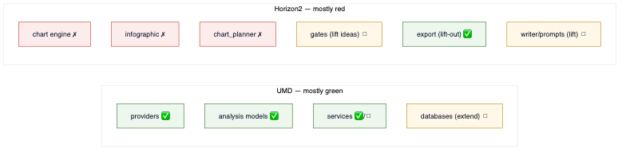
diagram

Step 2 — Three candidate paths
- Path A — Patch Horizon2 in place. Bolt a model engine, cross-section charts, and a code-based infographic onto the existing pipeline.
- Path B — New application project on the salvaged data layer. Keep and extend UMD; build a new app repo whose architecture is the model→data→insight engine from day one; lift out the few good Horizon2 parts (export, prompts, discipline).
- Path C — Full greenfield. Rebuild everything, including UMD.

Step 3 — Scored comparison
Scores 1 (poor) – 5 (excellent). Weight reflects owner priorities: fit to the vision and data-asset preservation dominate.
Criterion (weight) | A: Patch | B: New app / salvage data | C: Greenfield
Fit to model→data→insight vision (×3) | 2 | 5 | 5
Escapes the embedded gate-culture (×2) | 1 | 5 | 5
Preserves the data asset (×3) | 5 | 5 | 1
Effort / time to first quality artifact (×2) | 2 | 4 | 1
Risk (regression, half-migrated state) (×2) | 2 | 4 | 2
Leverages team’s existing know-how (×1) | 4 | 4 | 2
Weighted total (max 65) | 31 | 59 | 36
Path B wins decisively. Path A is dragged down by fighting an architecture and culture built around the vision’s absence — a half-migrated pipeline is the worst of both worlds. Path C throws away UMD, a 55.7k-LOC, three-database asset, for no architectural benefit over B.
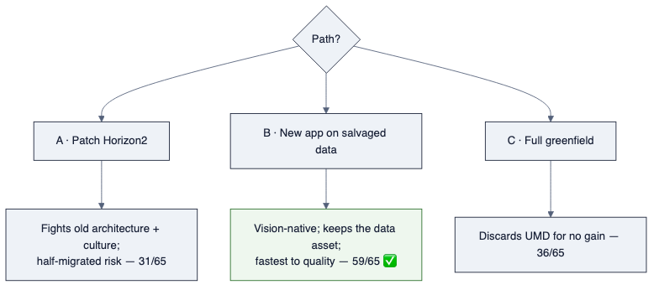
diagram

Step 4 — The recommendation
Salvage the data platform (UMD) in full and extend it; do not patch Horizon2 — stand up a new application project on the salvaged data layer, built as the model→data→insight engine from the first commit, and lift out only Horizon2’s few architecture-agnostic strengths (DOCX/Substack export, prompt craft, the numbers-must-trace discipline). Keep Horizon2 in the repo, read-only, as the documented “learning template of what went wrong.”

Why not “just salvage” (Path A)
The temptation is to keep the working pipeline and add the missing pieces. But the missing piece is the spine — model execution — and Horizon2’s every node presumes its absence. Retrofitting a spine into a body built without one is slower and riskier than a new body, and it carries the gate-centric culture (§04) forward intact. The dishonest_validation_panel is the warning: the culture is in the code.

Why not “rewrite everything” (Path C)
UMD is not the problem. It is 55.7k LOC of sound ingestion and real models, three mature databases, and 4,093 series — the exact foundation the vision needs, and the thing the owner rightly insisted we validate first. Rebuilding it would be the most expensive possible way to make no architectural progress.

The nuance that matters
This is not “the project failed, start over.” It is “the expensive, sound half succeeded and is kept; the mis-architected half is restarted.” The data platform is the asset; the application is the learning template. Naming them separately is the single most important output of this assessment.

What this decision unblocks
Nothing in the application is built until the data-layer conviction test (§09) passes — the taxonomy is clean, the model-config store exists, the graph spine is seeded, and every decision-maker in the matrix (§05) traces cleanly through the three layers. Only then does the new application’s first, single, looked-at quality artifact get built.
ewpage

09 — Roadmap (recommended path)
Path B: salvage + extend UMD; build a new application on top of it. The sequence is deliberately data-layer-first, with a hard gate — the conviction test — before any application code. No use-case (least of all FOMC) is built until the data layers serve all of them.
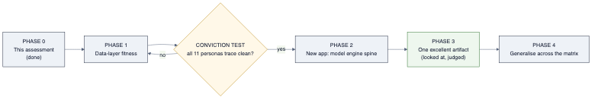
diagram

Phase 1 — Data-layer fitness (no app code)
The only work until the gate. All in UMD.
- Author the model catalog as YAML seeds covering the §05 matrix, using the literature review (§11) as the source content: for each persona, its model(s), spec (form/equations/assumptions/params), input tuples {series, order, window} per the §10 state stack, outputs, the model’s asserts/interpretation text, and the decision informed. Where the model exists in analysis/, point IMPLEMENTED_BY at it; else record a build stub.
- Normalize the time-series taxonomy AND build the transform stack (§10): a controlled asset_class vocabulary + a one-off migration collapsing duplicates and filling blanks (§07); plus a systematic, catalogued transform stack (level, Δ, Δ², context/z-score, diffusion, surprise) so any model input can be served at the derivative order it requires. Add the missing derived series (gaps, real rates, differentials).
- Add the relational model store: model_config / model_run / model_output_point (generalize fv_runs).
- Seed the graph model spine (§06) from the YAML — and verify it loaded (node/edge counts; spot-trace three personas by Cypher). Seeds are run, not just written — a lesson from this project.
- Build the missing high-priority models in analysis/ (reaction function first only because it is broadly reused, then RV, credit, FX carry, commodity balance, ERP, nowcast), each as an implementation function + catalog entry.

GATE — the conviction test
For every decision-maker in the matrix, prove the trace end-to-end through the three layers:
Decision → Model (graph spec) → inputs present & correctly classified (time-series) → implementation exists (analysis/) → outputs storable (relational) → relationships present (graph)
A machine-checkable report lists, per persona, PASS or the exact missing link. The data layers are declared fit only when the report is N/N. Application work does not begin before this. This is the owner’s gate, made concrete and testable.

Phase 2 — New application: the engine spine
A new repository (e.g. horizon3) consuming UMD via the existing seam. Build the seven-role engine (§06) using the SoTA agentic patterns and context-engineering of §12 — structured-output number-grounding, the evaluator-optimizer Judge, and the Neo4j model spine doubling as the agents’ structured long-term memory — as thin, honest stages:
- Planner → Model-Selection agent (structured request against the catalog) → Executor (non-LLM, binds + runs, refuses implausible inputs) → output table → Narrator (grounded) → deterministic renderers → Judge.
- Lift out from Horizon2, deliberately: the DOCX/Substack export, the prompt craft, and the numbers-must-trace discipline. Nothing else is ported.

Phase 3 — One excellent artifact (the real proof)
Produce, for one decision on one subject, the full chain: a selected model, executed on UMD, a model-grounded chart and a code-rendered infographic with verified numbers, and prose grounded in the output table. Then open it and judge it by eye against the FT / Economist bar — with the owner. “Done” means it looks good, not that a gate passed. Iterate on the artifact until it is genuinely excellent. This is the litmus test, met properly.

Phase 4 — Generalise across the matrix
Only after one artifact is proven excellent, extend selection/execution/rendering across the other decision-makers, one persona at a time, each judged by eye. The matrix (§05) is the coverage checklist; breadth is earned, not assumed.

Guardrails carried from the post-mortem (§04)
- Every phase ends with a looked-at artifact or a machine-checked fact — never “the gate passed.”
- No diffusion model touches a numeric artifact.
- No number is authored by an LLM.
- Bad data is refused at the boundary, never clipped-and-shipped.
- Generality is proven on the full remit; FOMC is one row.

Indicative sequencing (not a commitment)
Phase | Nature | Gate to exit
1 — Data fitness | UMD extension only | Conviction test N/N
2 — Engine spine | New app scaffold | One model executes end-to-end, numbers traced
3 — One artifact | Depth | Owner judges it excellent by eye
4 — Generalise | Breadth | Each persona’s artifact judged excellent
ewpage

10 — Model Input Representation: level, derivatives, and context
This document corrects a naïveté in the earlier drafts. They repeated the phrase “inflation and its rate of change” so often that they implied the derivative of a variable matters only for inflation. That is wrong, and building on it would invite disaster. The derivative principle is universal.

The principle
A professional never feeds a model a raw number. They feed it a state: the variable’s level and its motion. For every input, the questions are:
- Level — where is it? (housing starts at 1.35m)
- First derivative (velocity) — is it rising or falling, and how fast? (starts down 4% m/m)
- Second derivative (acceleration) — is the change itself speeding up or slowing? (the decline is decelerating — a possible turn)
- Context — how does this compare to trend, history, regime, and to what was expected? (starts in the 20th percentile of a decade; below consensus)
Housing starts falling is a different world from housing starts rising; rising-but-decelerating often signals an inflection a level-only reading misses entirely. The same is true of payrolls, ISM new orders, credit spreads, the curve, real yields, oil inventories, and every other input in the matrix (§05). A level alone is frequently insufficient; the model’s meaning lives in the motion.
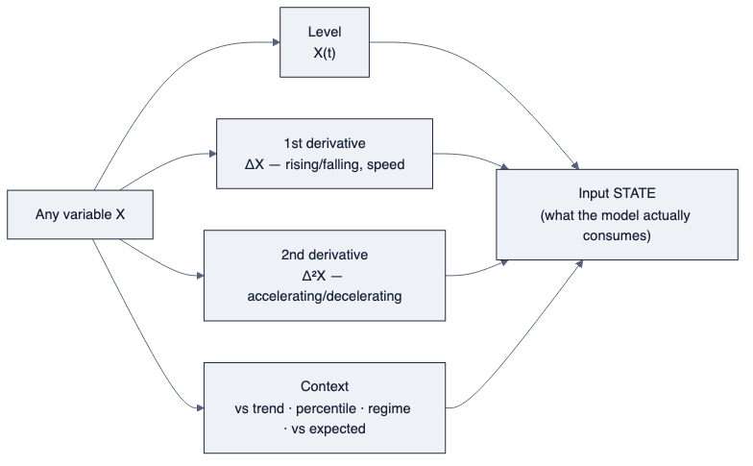
diagram

This is established practice, not a Horizon idea
The finance and macro literature formalises the derivative view:
- Momentum oscillators are literally derivatives. Technical oscillators are “second or third derivative functions” of a series; the McClellan Oscillator is the rate of change of the advance–decline line — acceleration of breadth. (leading indicators)
- Diffusion indices encode the first derivative across many series at once. ISM prints above/below 50 measure whether the breadth of activity is expanding or contracting — a first-derivative reading, not a level. ISM new orders is watched precisely because it leads (the derivative leads the level).
- Leading indicators are derivative constructs that “change before the broader economy does (commonly 3–12 months ahead)” (LEI) — you read them for direction and acceleration, not level.
- Whole models are built on momentum. The Atlanta Fed GDPNow nowcast aggregates the changes in 13 subcomponents (ISM, construction, vehicle sales, trade, employment, IP, housing starts, PPI/CPI) into a running estimate — a model whose inputs are fundamentally rates of change (GDPNow).
- Surprise indices (actual vs expected) are the “context vs expectations” axis made into a series — the same object the expectations layer already in UMD produces.

What this changes in the data-layer requirements
This is not a wording fix; it changes the specification of two layers.

Time-series layer — a derivative/transform stack per series
It is not enough to store levels. For every series the model matrix consumes, the layer must be able to produce, on demand and consistently:
Transform | Meaning | Example construct
level | X(t) | raw
Δ (mom/qoq/yoy) | first derivative | rate of change
Δ² | second derivative | acceleration / momentum-of-momentum
rolling context | vs its own history | z-score, percentile, vs trend
breadth / diffusion | first derivative across a group | %-of-components-rising
surprise | vs expected | actual − consensus / market-implied
Some of these exist ad hoc in UMD code (yoy, mom); none is systematically declared or stored as a first-class, catalogued transform. That is the gap (§07): a canonical transform stack, not scattered helpers.

Graph layer — ModelInput must declare which derivative and window
A model input is not “a series.” It is a tuple:
ModelInput = { series, order ∈ {level, Δ, Δ², context, diffusion, surprise},
window, transform_params }
The catalog must record, per model, which order and window of which series the model consumes — because the reaction function wants inflation’s level and its change, the momentum/nowcast models want changes and acceleration, and a valuation model wants a level in context. Encoding only “series → model” (as the dangling USED_BY_MODEL edge does today) is insufficient and would reproduce exactly the naïve reading this document corrects.

The corrected framing (to be applied throughout the set)
Wherever the earlier drafts said “inflation and its rate of change,” read the general rule:
Every model input is a state — level, first derivative, second derivative, and context — and the model catalog must declare which of these each model consumes. Inflation is one example among all variables, not the exception.
§05 (the matrix), §06 (target schema), and §07 (gap analysis) are to be read with this correction; the ModelInput tuple above is the concrete requirement it places on the graph and time-series layers.
ewpage

11 — Model Reference (literature review)
The earlier drafts named models but never specified them. This document is the literature review: for each model class the app must support, its canonical form, inputs (with the derivative/context order each requires, per §10), outputs, what the output asserts, interpretation, why it is insightful, and references. This is the content that populates the Neo4j model catalog (§06) and grounds the agent prompts (§12). It is a working reference, not exhaustive — but it is specific enough to build from.
For each model, “insight” is stated as the gap the model reveals — because the story is almost always the divergence between the model and the market/consensus.

A. Central-bank policymaker

A1 — Taylor rule and its variants
- Form: i* = r* + π + 0.5(π − π*) + 0.5·(output gap) (Taylor 1993). Variants: 1999 / “balanced-approach” doubles the gap coefficient to 1.0; first-difference rule prescribes a change in the rate from activity/ inflation changes (no r* level needed); inertial rule adds smoothing (partial adjustment to the prescription).
- Inputs: inflation level and its change (π and Δπ, core & headline), the inflation target π*, the output gap (a context/level construct), and r* (from A2). The first-difference variant is explicitly derivative-based.
- Output: a prescribed policy rate i* (one per variant).
- Asserts: “given this inflation and this slack, policy should be here.”
- Interpretation: the gap between the prescription and the actual/market path is the policy-stance signal — restrictive if actual < prescription in an overheating regime, accommodative if above in a slack regime.
- Insight: the dispersion across variants is itself the story — the Fed’s own Monetary Policy Report shows a fan of Taylor prescriptions; where the market sits within that fan is a positioning map.
- Refs: Cleveland Fed simple-rules · KC Fed “Beyond the Taylor Rule”

A2 — Natural rate of interest (r*)
- Form: state-space / Kalman-filter estimation of an unobserved trend real rate (Laubach-Williams 2003; Holston-Laubach-Williams 2017). Lubik-Matthes is a VAR-based alternative.
- Inputs: real GDP (trend & gap), core inflation, the real policy rate — all as trends and deviations (context constructs), estimated recursively.
- Output: a slow-moving r* estimate (HLW ~0.7%, Lubik-Matthes ~1.5%, Fed staff ~1.0–1.2%).
- Asserts: “the neutral real rate is here” — the anchor for A1.
- Interpretation: policy is restrictive when the real rate > r*, easy when <. Not observable — model-dependent, so always show which estimate.
- Insight: the range across estimators bounds “how tight is policy, really.”
- Refs: Dallas Fed r* · Cleveland Fed

B. Rates traders (macro & relative value)

B1 — Affine term-structure / term-premium (ACM, Kim-Wright)
- Form: multi-factor affine dynamic term-structure model. ACM (Adrian-Crump-Moench, NY Fed) estimates it via a three-step linear regression on zero-coupon yields; Kim-Wright (Fed Board) is a 3-factor arbitrage-free model.
- Inputs: the zero-coupon yield curve (daily); pricing factors are the curve’s own level/slope/curvature (PCA-like context).
- Output: decomposition of each yield into an expectations component and a term premium component.
- Asserts: “of the 10y yield, this much is expected future short rates and this much is the risk premium for holding duration.”
- Interpretation: a selloff driven by term premium (supply, uncertainty) is a different trade from one driven by expectations (repricing the Fed path).
- Insight: the term-premium series is a positioning signal (rich/cheap duration); the decomposition tells you why rates moved.
- Refs: NY Fed ACM / Treasury Term Premia · BIS term premia · Fed Kim-Wright robustness

B2 — Curve factor model (Nelson-Siegel / PCA)
- Form: reduce the curve to 3 factors — level, slope, curvature (PCA) or the Nelson-Siegel functional form.
- Inputs: the full curve (levels) and its changes (factor moves).
- Output: factor loadings + fair-value residuals per tenor.
- Asserts: “this tenor is rich/cheap relative to the fitted curve.”
- Interpretation / insight: RV signals (butterflies, spreads); a large curvature move is a different macro signal from a slope move.

B3 — Carry & roll-down
- Form: expected return of a rates position absent yield change = carry (yield) + roll-down (sliding down a static curve).
- Inputs: the curve shape (level + slope), funding.
- Output: expected carry per position/tenor.
- Asserts: “you are paid this much to hold, if nothing moves.”
- Insight: carry vs the fair-value/term-premium signal is the trade-selection frame for a macro rates book.

C. Credit investor

C1 — Merton structural model / distance-to-default
- Form: equity is a European call option on the firm’s assets (Merton 1974); default occurs if asset value < debt at maturity.
- Inputs: asset value & asset volatility (inferred from equity value/vol), debt (default point), horizon, risk-free rate. Equity vol is a level+change input.
- Output: distance-to-default (number of asset-vol standard deviations to the default point) → probability of default and an implied credit spread.
- Asserts: “the firm is DD standard deviations from default; the fair spread is X.”
- Interpretation: model spread vs market spread = rich/cheap credit; DD falling (its derivative) is an early-warning signal.
- Insight: derives a spread without bond prices — useful where market data are thin; the basis (model − market) is the trade.
- Refs: Merton structural model · MATLAB Merton DD

D. Equity / multi-asset PM

D1 — Gordon growth / dividend discount & the equity risk premium
- Form: P = D₁ / (r − g); rearranged, ERP ≈ dividend yield + g − long government yield. Cost of equity via CAPM r = r_f + β·ERP.
- Inputs: dividend/earnings yield (level), expected growth g (a derivative/expectation), the long bond yield (level), real rates.
- Output: intrinsic value / implied ERP.
- Asserts: “equities offer this premium over bonds for this growth.”
- Interpretation: the Fed-model comparison (earnings yield vs bond yield) says rich/cheap vs bonds. Caveat to encode: as r → g, (r−g) → 0 and value explodes — the model has broken down, not found infinite value; the agent must flag this, not report it.
- Insight: ERP vs its history and vs real rates is the allocation signal.
- Refs: Gordon ERP · Damodaran DDM

E. FX trader

E1 — Equilibrium exchange-rate models (PPP / BEER / FEER) and UIP/carry
- Form: PPP (long-run price-level parity); BEER (behavioural equilibrium — a reduced-form regression on fundamentals); FEER (the rate consistent with a sustainable current account); UIP (expected FX move offsets the rate differential).
- Inputs: rate differentials and inflation differentials (derivative/ relative constructs), terms of trade, current account, productivity.
- Output: an equilibrium/fair-value exchange rate; UIP-implied forward path.
- Asserts: “the currency is X% mis-aligned vs fundamentals.”
- Interpretation / insight: UIP fails empirically — high-yielders don’t depreciate as much as the differential implies — and that failure is the carry trade. The model’s value is often in where reality deviates from it.
- Refs: CFA parity conditions · Handbook: currency fair-value models

F. Commodity analyst

F1 — Theory of storage / convenience yield
- Form: F = S + storage cost − convenience yield (Kaldor 1939, Working 1949, Brennan 1958). Working’s storage supply curve maps the price of storage against inventory.
- Inputs: spot, inventory level and its change (the convenience yield is a strongly non-linear function of inventory), storage cost, financing rate.
- Output: the fair futures curve shape — contango (ample inventory) vs backwardation (scarcity → high convenience yield).
- Asserts: “the curve should be in backwardation/contango given inventories.”
- Interpretation / insight: curve shape vs inventory trend is the positioning signal; a short-run scarcity shock steepens backwardation non-linearly.
- Refs: Theory of storage / convenience yield · NBER commodity futures returns · IMF: curves & inventories under scarcity

G. Volatility trader

G1 — Variance risk premium (VRP)
- Form: VRP = implied variance − expected realized variance; VIX approximates 30-day expected realized vol nonparametrically; affine models fit SPX + VIX jointly.
- Inputs: the vol surface / VIX (implied, level+change) and realized vol (a derivative-of-price construct).
- Output: the premium paid for volatility insurance; a term structure of VRP.
- Asserts: “options are pricing this much more variance than is likely to realise.”
- Interpretation / insight: a large positive VRP is compensation for selling insurance; VRP vs its history is the vol-positioning signal; the sign and change of VRP flag regime shifts.
- Refs: Carr-Wu Variance Risk Premia · Fed: variance risk premia & returns

H. Economist / forecaster

H1 — Nowcasting (dynamic factor model)
- Form: a dynamic factor model extracts a common factor from many higher-frequency series; GDPNow combines it with bridge equations and BVARs across 13 GDP subcomponents.
- Inputs: the changes in ISM, construction, vehicle sales, trade, employment, IP, housing starts, PPI/CPI — fundamentally a derivative-driven model (§10).
- Output: a running estimate of current-quarter real GDP that updates with each release.
- Asserts: “given the data in so far, growth is tracking X%.”
- Interpretation / insight: the nowcast vs consensus, and its revision path (its own derivative) as data arrive, is the surprise/positioning signal.
- Refs: Atlanta Fed GDPNow

H2 — Surprise vs expectations
- Form: surprise = actual − expected, where “expected” is market-implied (OIS/Kalshi) or survey consensus.
- Inputs: the print, and the pre-event expectation (already produced by UMD’s expectations layer).
- Output: a signed, scaled surprise; a surprise index across releases.
- Asserts: “the data beat/missed what was priced.”
- Insight: the surprise, not the level, moves markets; this is the “context vs expectations” order of §10 as a first-class series.

I. Event / prediction-market trader

I1 — Implied distribution + calibration / bias-correction
- Form: convert contract prices to an implied probability distribution; correct for known Kalshi biases; compare to a model fair value.
- Inputs: contract mids/orderbooks, the underlying macro model’s output.
- Output: a calibrated implied distribution and an edge (model − market).
- Asserts: “the crowd prices X%; the model says Y%.”
- Insight: the edge and the calibration receipt (past implied vs realised) are the trade and the credibility. Already implemented in UMD (pm_service, kalshi_implied_distribution, kalshi_bias_correction).

How this reference is used
Each model above becomes a ModelSpecification node (§06) carrying its form, its ModelInput tuples (with the §10 derivative/context orders), its outputs, and — critically for narration — a asserts / interpretation field so the narrator agent (§12) can explain what the number means without inventing it. The IMPLEMENTED_BY edge points at the UMD analysis/ function (present for ~55% today; the remainder are the build list in §07/§09). This reference is the seed content; extending it from ArXiv/central-bank literature is the ongoing model curation pipeline.
ewpage

12 — SoTA Agentic Architecture, Prompting & Context Engineering
The earlier drafts asserted a seven-role pipeline (§06) without reviewing how, in 2026 practice, such agents are actually built, prompted, and kept reliable. This document supplies that review and maps it onto the model-grounded pipeline. The governing constraint throughout: the LLM selects, plans, and narrates; it never authors a number. Everything below is chosen to enforce that.

1. The agentic design patterns (and where each is used)
The 2026 literature has converged on a small vocabulary of patterns; production systems combine them rather than picking one.
Pattern | Mechanism | Where in our pipeline
Planning | Decompose the task before acting | Planner: frame the decision(s) and decision-maker(s) at stake
Routing | Classify intent → dispatch to a specialist | Route a subject to the relevant persona/model family; “misrouting → invalid narrative”
Tool Use / Context-Augmentation | LLM selects external tools/data; never computes internally | Model-Selection + Executor: numbers come from tools/DB, “never performs arithmetic internally”
Prompt-Chaining | Sequential subtasks passing structured data, with validation gates between | select → execute → validate → narrate; “insert validation gates so mistakes don’t cascade”
Parallelization | Independent subtasks concurrently; voting/consensus | run several candidate models / independent checks; majority-vote on a number’s provenance
Orchestrator-Workers | Central LLM decomposes and delegates; workers retrieve, never author | orchestrate which workers fetch which model outputs
Reflection | Self-critique and revise before returning | narrator reviews prose against the output table before emitting
Evaluator-Optimizer | A separate judge scores against explicit criteria; generator revises | the Judge (below) — “makes quality measurable rather than vibes-based”
Design philosophy (explicit in the sources): start simple; add agentic structure only when a simpler solution falls short. The pipeline should be the minimum set of these patterns that enforces number-grounding — not a maximal multi-agent sprawl.
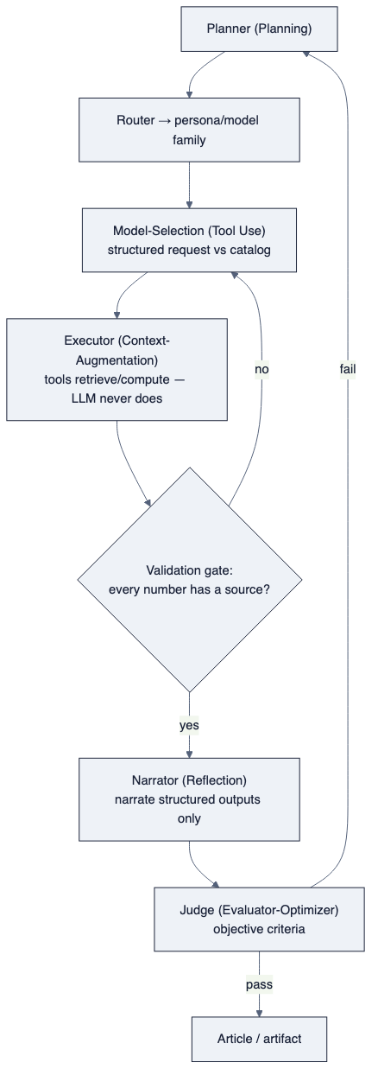
diagram

2. Structured output — the mechanism that forbids invented numbers
Between every stage, data passes as a schema, not prose. The canonical number-carrying object:
{ "name": "reaction_function_implied_rate",
"value": 3.9, "unit": "%",
"source": "model_run:MR-2026-07-10-taylor99",
"source_computation": "taylor1999(pi=4.17, dpi=+0.3, gap=-0.4, rstar=0.9)",
"as_of": "2026-07-10" }
Because the narrator receives only these objects (and the model’s asserts / interpretation text from §11), it can explain the number but has nothing to invent from. This is the Infogen/LIDA principle (§01) at the data-flow level: “pass only retrieved/computed fields to the narrative LLM, not raw documents — this constrains the LLM to narrating selections, not generating numbers.”

3. The Judge (Evaluator-Optimizer) — measurable quality, not vibes
A separate agent scores each artifact against explicit, objective criteria (adapted from the AI-Economist-Agent judge, §01):
- Model grounding — every quantitative claim traces to a model_run / model_output_point. Naming a model without an executed run scores zero.
- Numerical discipline — no number appears without provenance metadata; the narrative never contradicts the output table.
- Interpretation vs computation — the prose distinguishes the model’s interpretation (qualitative) from its computed figures (quantitative).
- Derivative correctness (§10) — where a model consumes a rate of change or acceleration, the prose reflects direction and speed, not just level.
- Audit — the artifact exposes enough to trace every claim to its source.
Failure routes to revision (Reflection). “Poorly designed stopping criteria trap systems in suboptimal states” — so the gate is source-verification passing, not a turn count, and — per §04 — the ultimate acceptance is a human looking at the artifact, with the Judge as an aid, never the definition of done.

4. Context engineering — the discipline that makes it reliable
“Most agent failures aren’t model failures; they’re context failures.” The 2026 practice:
- Memory tiers. Working (the live window), short-term (this run’s tool results), long-term (cross-run: editorial preferences, prior calibration, model provenance) — with a compaction step that condenses old turns into summaries.
- Index-then-load, not dump. Naïve RAG loads ~35k tokens of which “only ~6% is relevant — the rest pollutes the window and degrades performance.” Instead, show the agent a compact index (model names, inputs, token cost) and let it load on demand. Every token in the window must have a reason to be there.
- Retrieval modes matched to the store: classical RAG for the literature (ArXiv model curation), structured queries for the catalog and data (Cypher against Neo4j, SQL against the model store), file reads, and just-in-time retrieval by identifier.
- Knowledge-graph memory — a direct fit. State-of-the-art memory systems (A-MEM’s Zettelkasten of linked notes; Zep/Graphiti’s temporal knowledge graph where nodes are entities and edges carry timestamps) are exactly the shape of the model spine we must build anyway (§06). Lucidate already runs Neo4j — the model catalog is the agent’s long-term structured memory. This is a strategic alignment: the graph that stores the models is also the retrieval substrate that keeps the agents grounded.
- “Bad retrieval is one of the largest sources of hallucinated answers” — so retrieval quality (the right model spec, the right series, the right derivative order) is a first-class reliability concern, not plumbing.
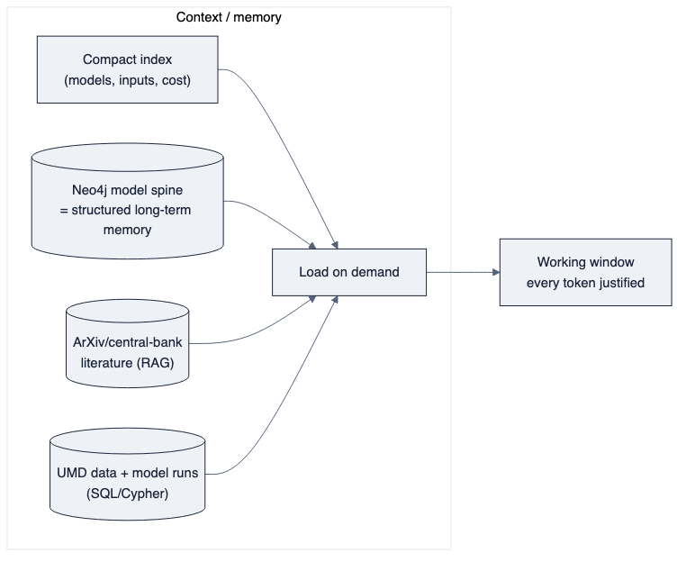
diagram

5. Prompting discipline (model-grounded narration)
The narrator’s system prompt, following the AI-Economist-Agent’s proven conditioning:
- Supply: the selected ModelSpecification (form, asserts, interpretation), the model_run id, and the model_output_point table.
- Instruct: “Link every quantitative claim to a model output. Distinguish the model’s economic interpretation from its computed numbers. Do not state that a model was run unless a run id is provided. Where a model consumes a rate of change or acceleration, describe direction and speed, not level alone.”
- Forbid: authoring any figure; recomputing arithmetic; describing a chart feature not present.
Their controlled result is the target: moving the output “from a fluent narrative to a traceable economic analysis.” That single sentence is the difference between Horizon2’s prose and the product.

6. What this review adds to the recommendation
- The target architecture (§06) is not hand-waving: it is the mainstream 2026 agentic pattern set (Planning + Routing + Tool-Use + Prompt-Chaining + Evaluator-Optimizer + Reflection) specialised to number-grounding.
- Context engineering is where reliability is won or lost, and Lucidate’s existing Neo4j is a genuine head-start — the model spine doubles as the agents’ structured long-term memory.
- None of this can be prompted into existence until the model catalog (§11) and the derivative-aware inputs (§10) exist in the data layers. This is the final confirmation of the sequencing (§09): data layers first, agents second — the agents are only as grounded as the catalog and data they retrieve from.
Sources: Agentic design patterns 2026 (SitePoint) · HF: design patterns for agentic workflows · Context engineering (Sourcegraph) · Context engineering & memory (Weaviate) · AI Economist Agent, arXiv 2606.20041 · Infogen, arXiv 2507.20046
ewpage

