**THE STATE UNIVERSITY OF ZANZIBAR**

**DEPARTMENT OF COMPUTER SCIENCE AND INFORMATION TECHNOLOGY**

**MINI PROJECT REPORT**

|  |  |  |
| --- | --- | --- |
| **SNO** | **STUDENT FULL NAMES** | **REGISTRATION NUMBER** |
| **1** | **SALAMA THANI AWESU** | BITAM/5/17/259/TZ |

|  |  |  |
| --- | --- | --- |
| PROJECT TITLE | ONLINE SUPERMARKET | |
| BRIEF PROBLEM STATEMENT | People, they don’t have any information about the Supermarket. They don’t know which kind of product that found and how much it cost . | |
| CURRENT SITUATION | People goes to supermarket without knowing that the product is available at that supermarket and how much it cost. After reaching at that supermarket and asking, they get to know that the product that they need is not available at there and it obtained at another supermarket. It really brings discomfort. | |
| RELATED PROJECTS |  | |
| HOW THE PROPOSED SYSTEM WILL SOLVE THE PROBLEM | * People will get to know the information about the supermarket * They will be able to know which product or goods that supermarket have and how much it cost. * They will get chance to make an order of the product that they require for easy way. * It will reduce the ques from the supermarket. | |
| MAIN AIM AND SPECIFIC OBJECTIVES | **Main aim** is to create computerized system that will make easy way of getting information from the supermarket and making order for the product to the customer.  **Specific objectives:-**   * It will provide information for the customer * It will give them a chance to make order for the customer . | |
| ANTICIPATED ARTIFACT | * System: that will enable the user to get more information * Project documentation: that will make the other person who wants to modify it, to modify it smoothly and easily. | |
| GANTT CHART |  | |
| RESOURCE REQUIREMENT | HARDWARE   * Personal computer (RAM 2GB, PROCESOR AT LEAST DUAL CORE, HARD DISC AT LEAST A 10 GB free spaces) * Printer(For printing invoice and report) | |
| SOFTWARE   * + PDO   + HTML 5   + MYSQL   + APPACHE SERVER   + Bootstrap   + Notepad ++ | |
| SUPERVISOR SIGNATURE |  | DATE: |

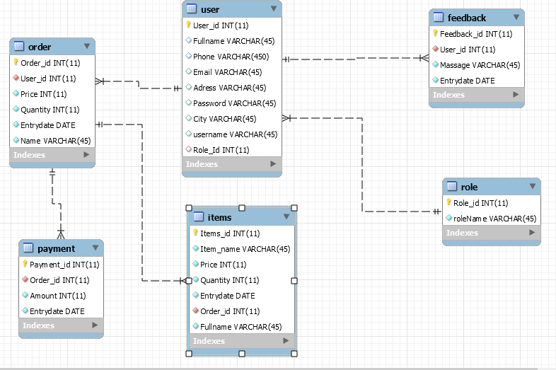

This is a login form where by the user of the system can enter his/her username and password so as to interact with the system .they use the same form to login but every one have their own layout (interface) due to the use of section to make some security.

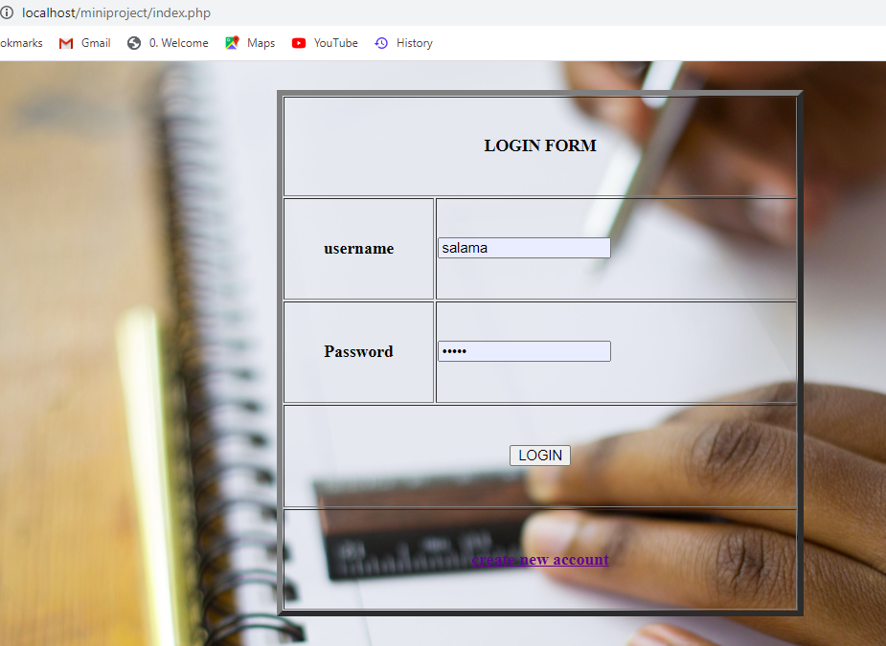

This is interface for customer and shopkeeper once he/she login it seem layout like this

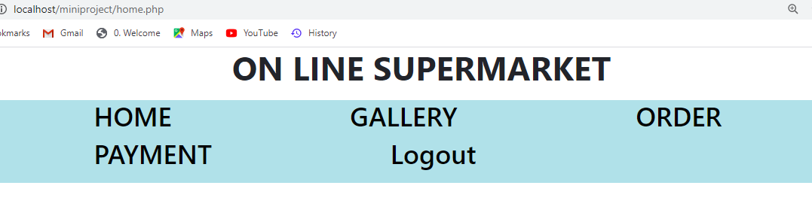

This is interface for administrator once he/she login to the system he seem layout like this and he is also can able to perform function like to view shopkeeper,tp add shopkeeper ,edit and delete.

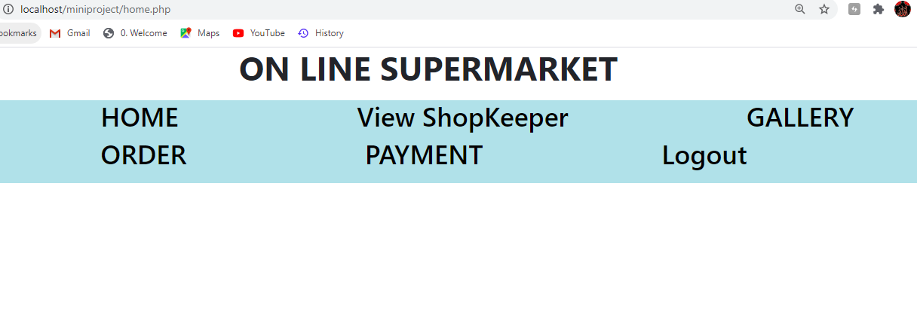

This is a page that display the product that found in supermarket

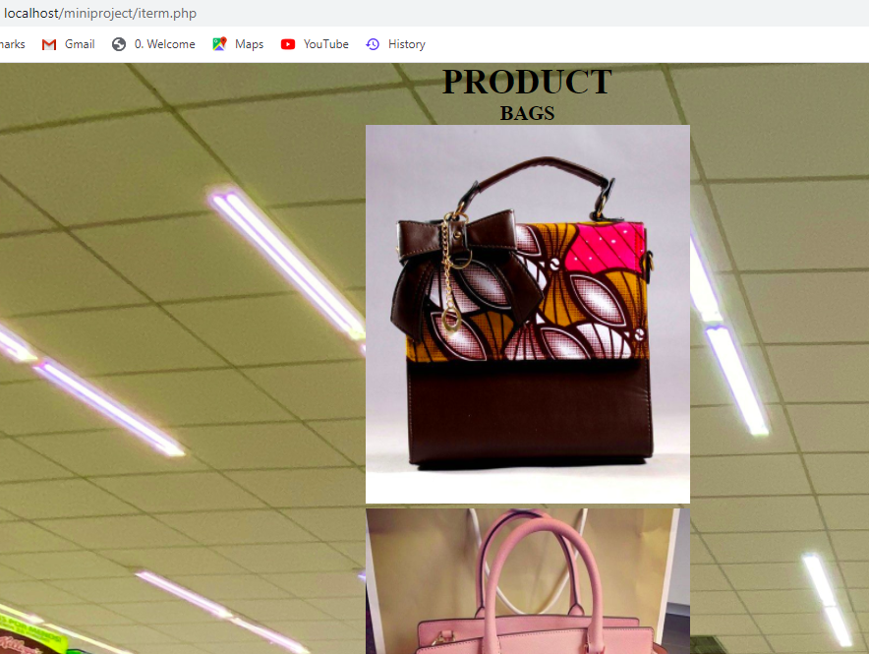

This is special form for ordering product in market in this form you can make the product type that you want ,quantity of product, price of the item and the you can choose the date that you make order.

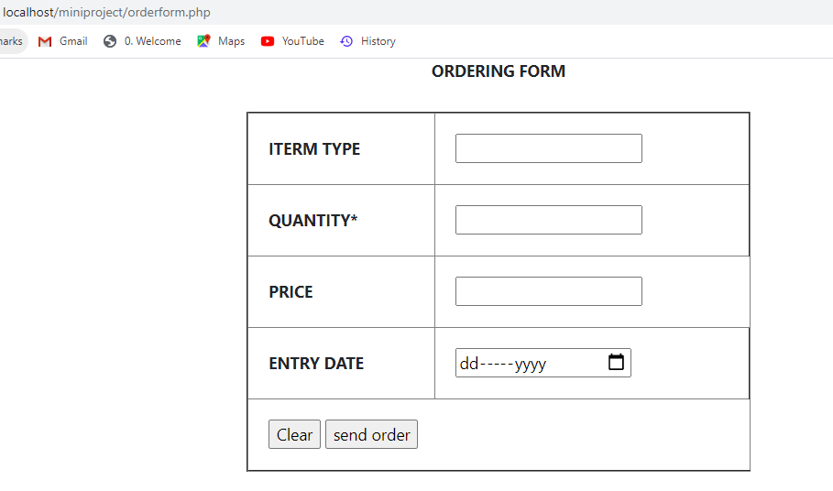

Also this is form for registering a new user and shopkeeper so as to iner to the system

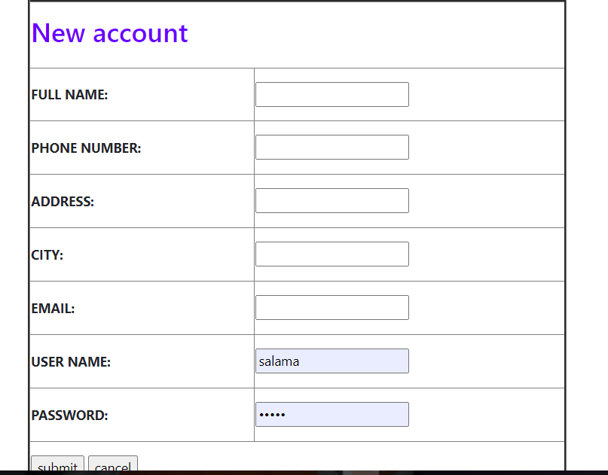

<https://github.com/mrssalama/webtechnology.git>