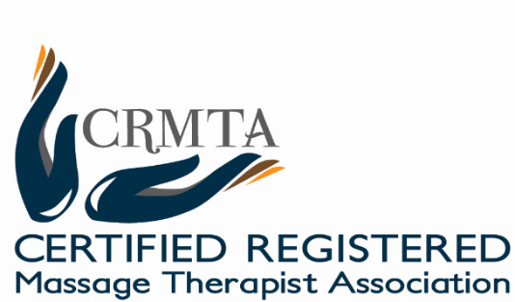

**2017 CRMTA Conference Scholarship**

*In support of therapist development and training*

|  |  |
| --- | --- |
| CRMTA Conference, May 26 - 28  The Conference supports continuous learning and innovative educational opportunities for massage therapists and students. This year we will sponsor students enrolled in a full-time post-secondary massage program to attend the CRMTA Conference.  Who is Eligible?  Full-time students who:   1. Are enrolled in a full-time massage therapy program. Students must include which post-secondary institution and massage program(s) they are enrolled in. 2. Are committed to lifelong learning. 3. Willing to write a summary report and share their ideas and experiences with CRMTA, our sponsors and members. 4. Must be a first time applicant. | What is included?  The scholarship will pay 100% of regular conference registration. All travel and accommodation expenses are the responsibility of the applicant. Gala dinner tickets are available at a reduced rate in advance.  How do you Apply?  Application is available at www.crmtaab.com All requests for funding support must be received by May 5, 2017. Funds will be paid by our sponsors on your behalf directly to the CRMTA.  What is the Selection Process?  Space is limited to 10 participants, and will be offered on a first come, first served to eligible applicants. The conference committee will review the applications and choose the successful candidates. |

**Student Scholarship Registration Form**

CRMTA Conference - May 26 – 28, 2017

Name: _______________________________________________________________________________

Mailing Address: _______________________________________________________________________

Phone: ____________________________________ E-mail: __________________________________

Please answer the questions below AND submit a letter of recommendation/reference with your completed application. *(Note: the scholarship is open to current massage therapy students only.)*

1. I am a student enrolled in a full-time post-secondary tourism program Yes No
2. I am able to attend the full conference Yes No
3. What is your intended graduation date? ___________________________
4. What do you hope to gain from attending this learning event?
5. Do you belong to any related associations? Yes No

If so, which one(s)?

1. How would you be willing to share your ideas and experiences from attending this learning event?

|  |  |
| --- | --- |
| Deadline for applying  May 5, 2017 | Please send completed application to:  CRMTA  Attn: Awards Committee  E: [crmtaconference@crmtaab.com](mailto:crmtaconference@crmtaab.com) www.crmtaab.com |