Table of Contents
- DocNexus Architecture & Logic Flows
- 1. Functional Layout (Block Design)
- 2. Low Level Architecture (Class Design)
- 3. Detailed Logic Flows
- A. Application Startup (Deep Dive)
- B. Document Rendering Pipeline
- C. Export Request Flow
- D. Extension Management Flow
- 4. Versioning Architecture
- The Source of Truth
- The Propagation Flow
- 5. Module Breakdown
- docnexus.core
- docnexus.features
- docnexus.plugins

DocNexus Architecture & Logic Flows
This document provides a deep dive into the internal architecture, versioning logic, and data rendering flows of DocNexus v1.2.0+.

1. Functional Layout (Block Design)
The application consists of three primary functional blocks: the Input Processor, the Core Kernel, and the Output Generators.
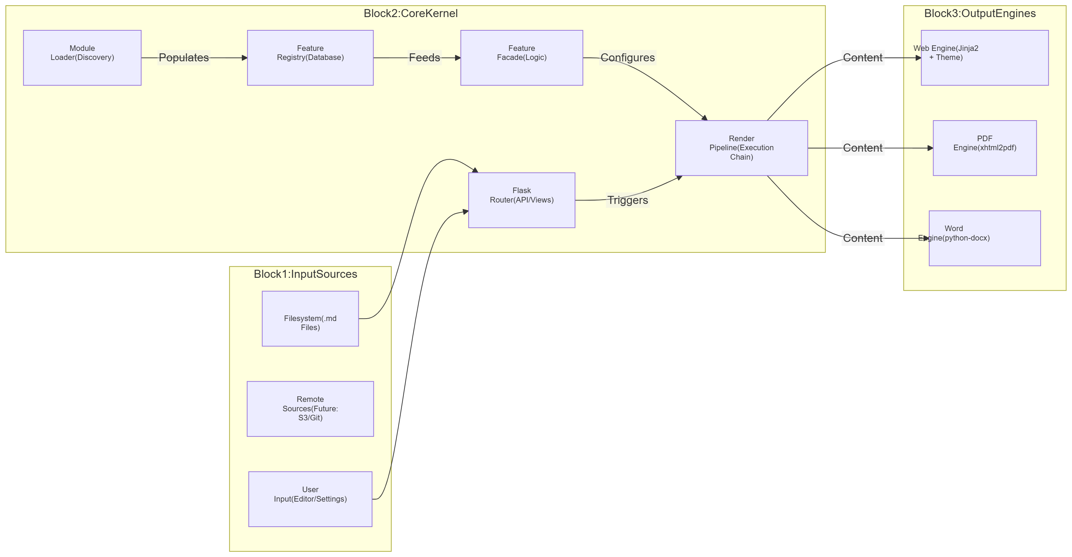

2. Low Level Architecture (Class Design)
The system relies on a strictly typed (checked at runtime) relationship between the Manager, Registry, and Features.
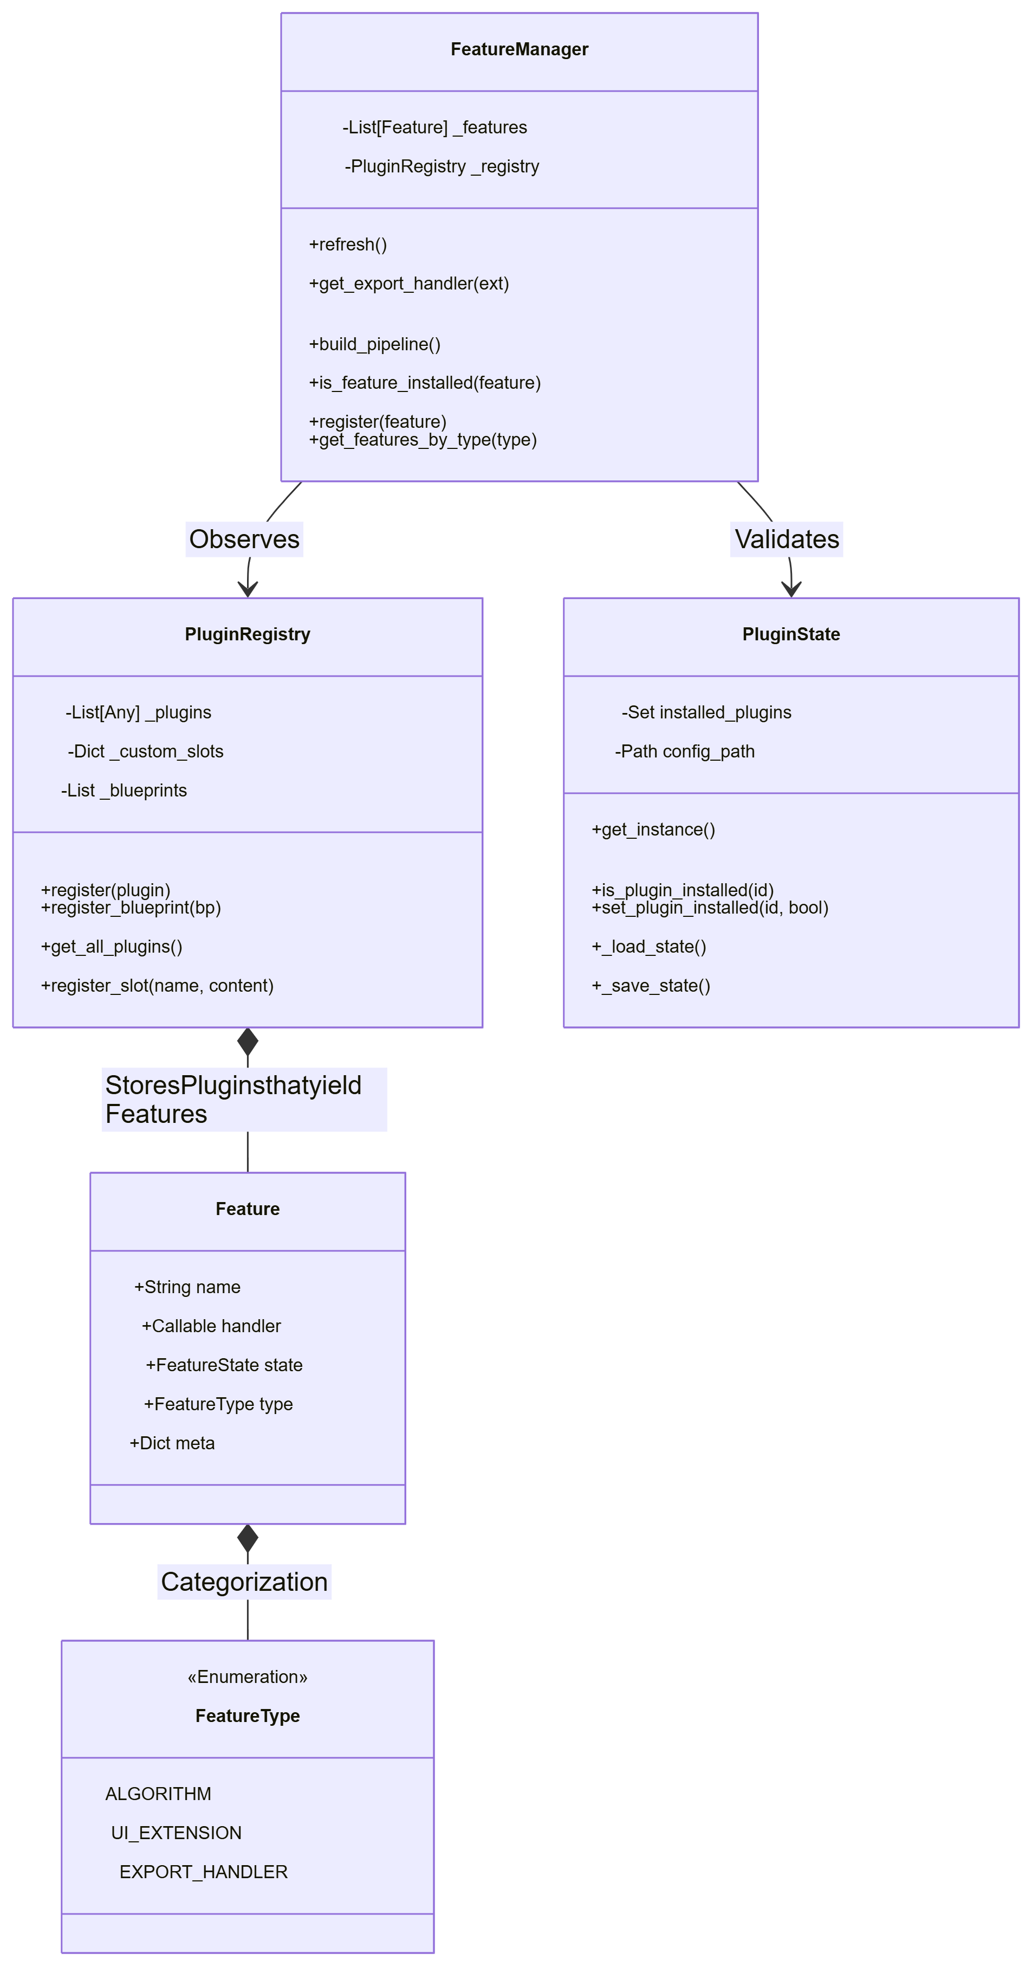

3. Detailed Logic Flows

A. Application Startup (Deep Dive)
How the application initializes, handling both frozen (PyInstaller) and source environments.
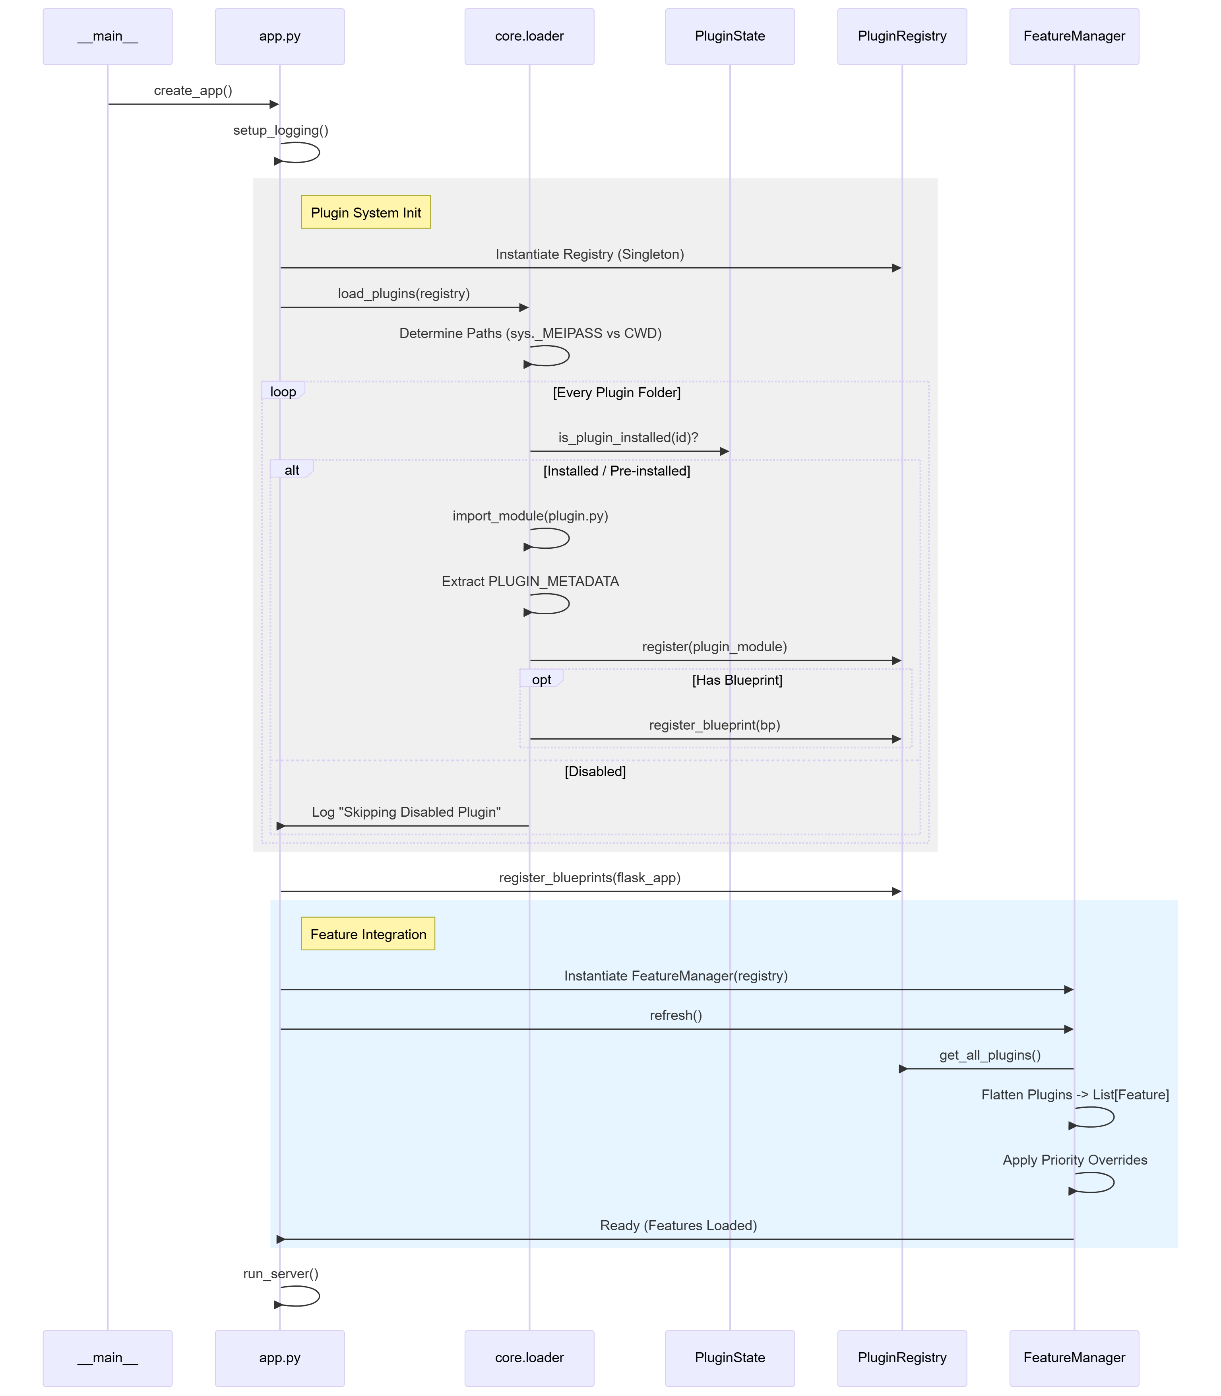

B. Document Rendering Pipeline
The core loop: transforming Markdown source into the HTML viewed by the user.
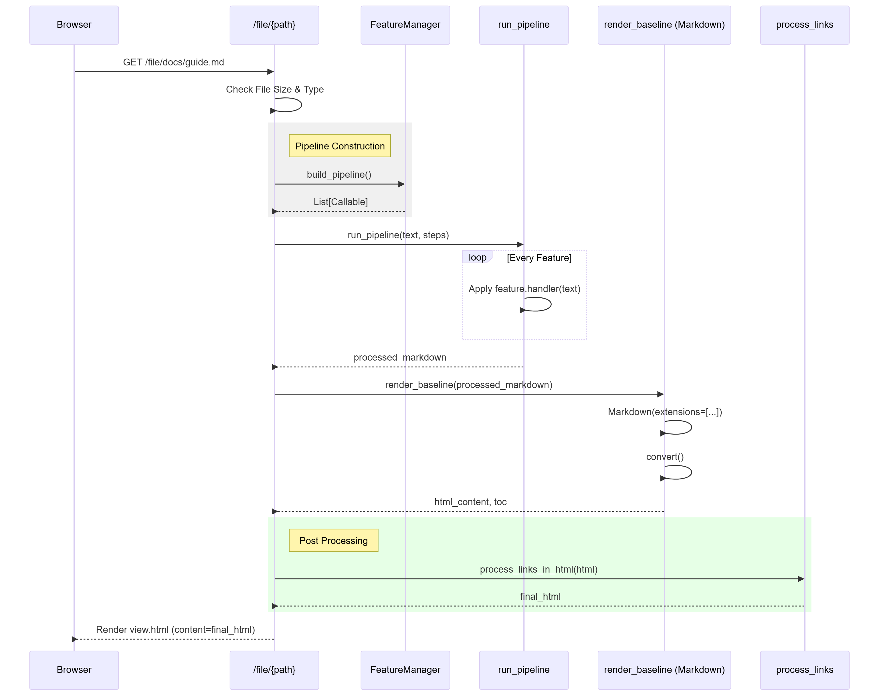

C. Export Request Flow
The user clicks "Export to PDF". The system must locate the correct handler, ensure it's allowed, and execute it safe-mode.
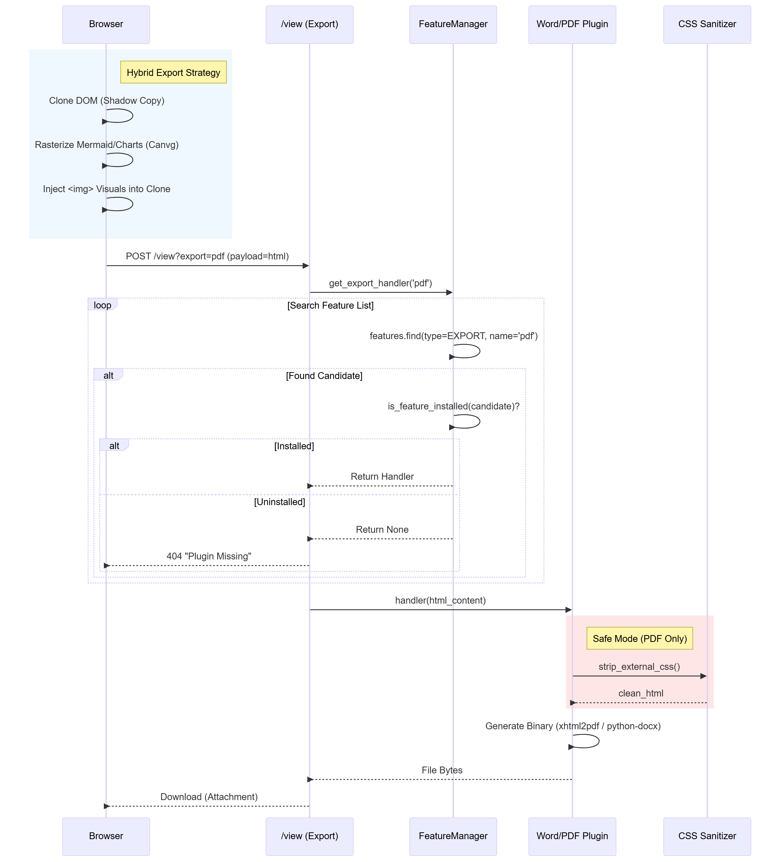

D. Extension Management Flow
User installs an extension via the Marketplace UI.
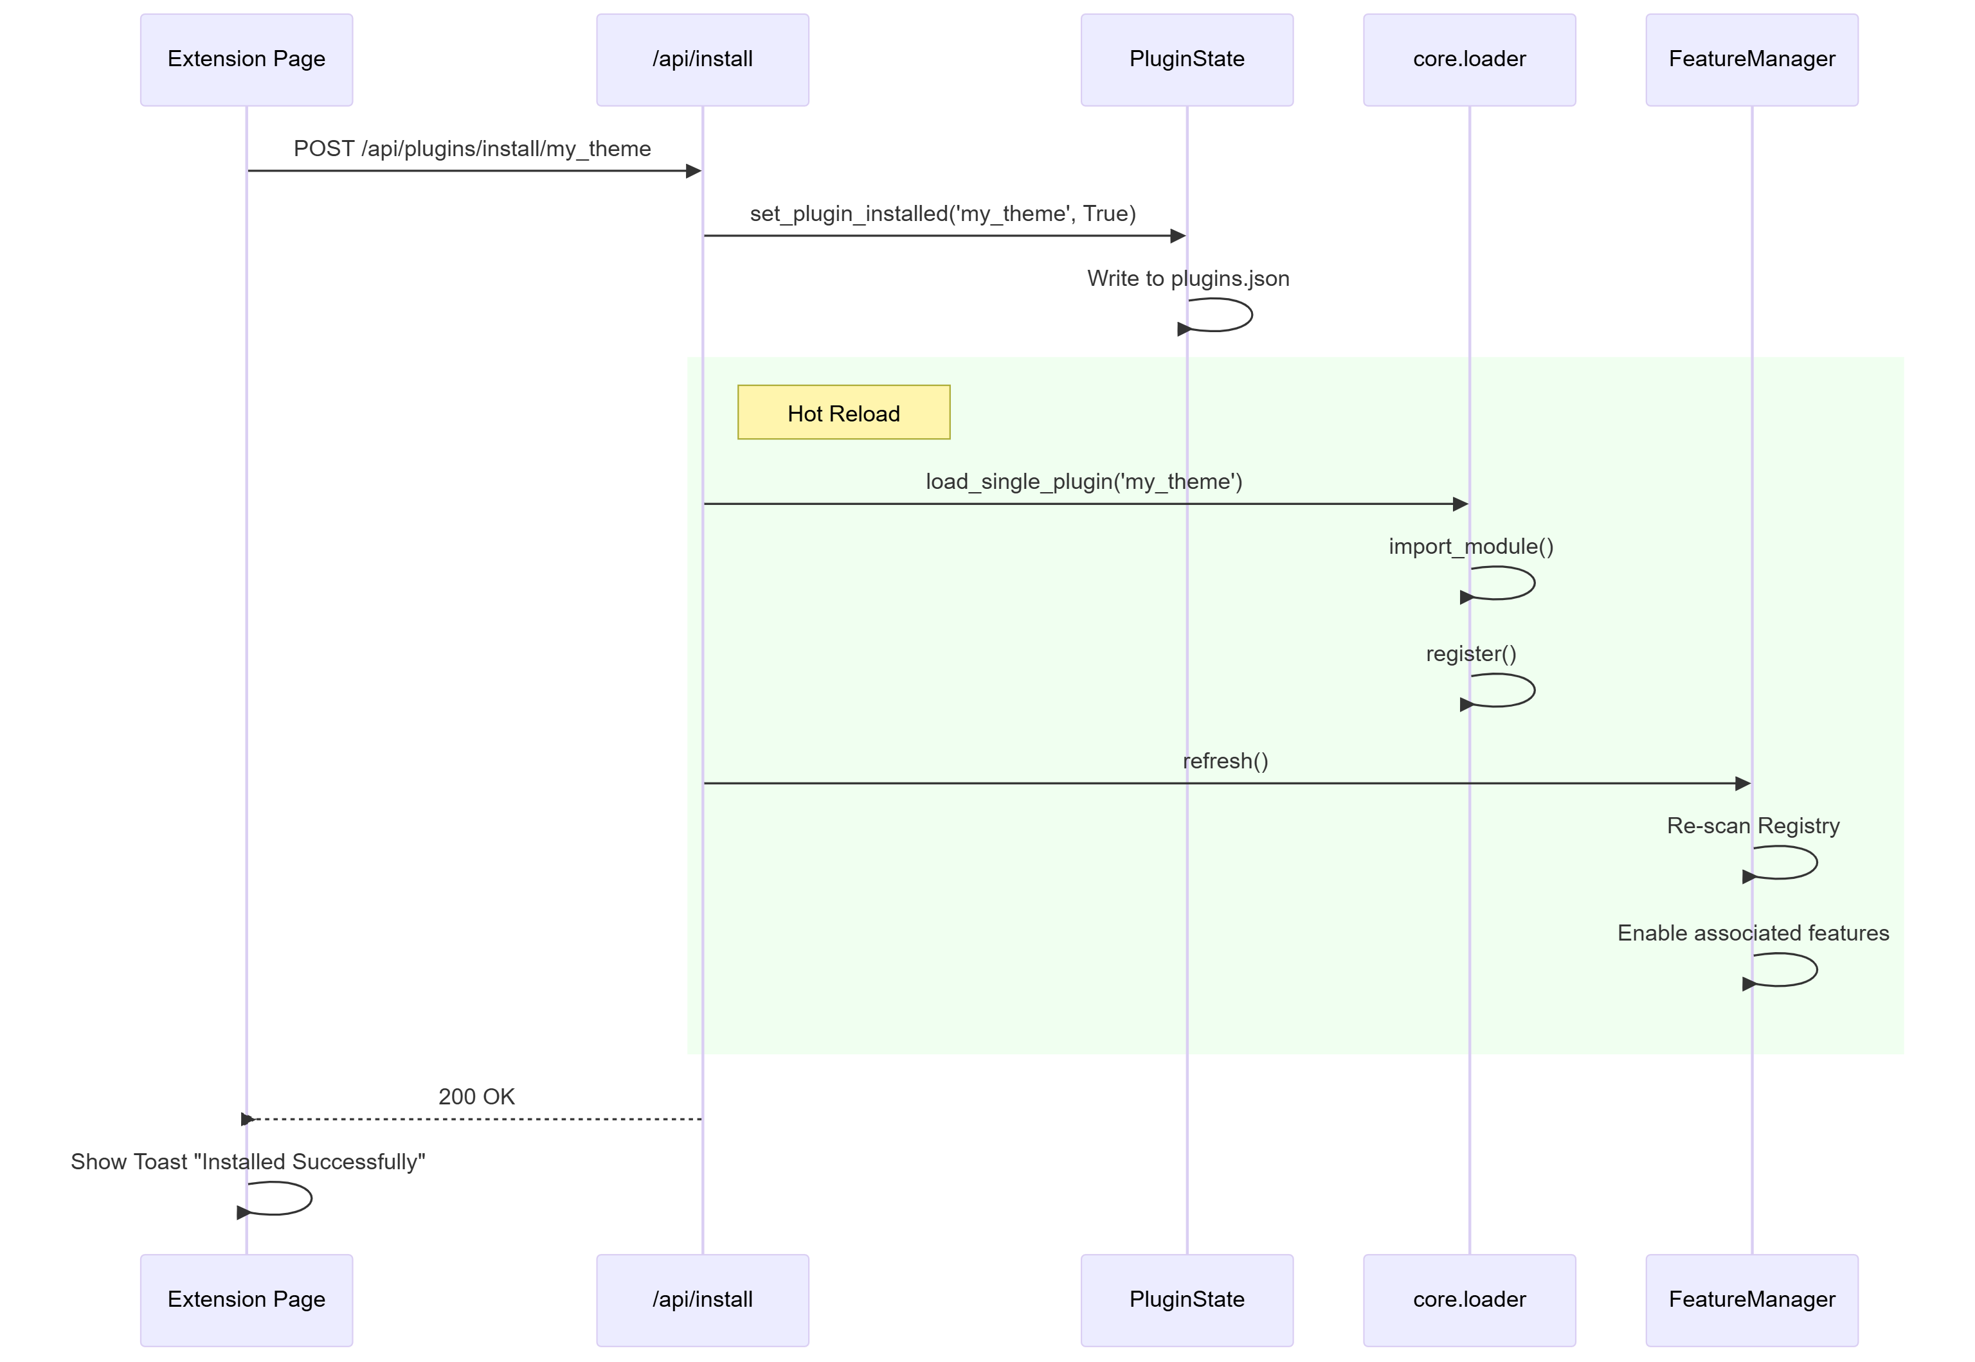

4. Versioning Architecture
We adhere to a Single Source of Truth (SSOT) robust versioning strategy.

The Source of Truth
- File: docnexus/version_info.py
- Content: __version__ = '1.2.x'
- Role: This is the only place the version number is hardcoded.
- Sync: The root VERSION file is automatically updated from this source during build.

The Propagation Flow
- Package Init: docnexus/__init__.py imports __version__ from version_info.py.
- Runtime App: docnexus/app.py imports docnexus.version_info to populate the VERSION constant.
- Build System: scripts/build.py reads version_info.py directly from the filesystem to name the executable (e.g., DocNexus_v1.2.0.exe).
- User Interface: app.py injects version into the global Jinja2 template context.

5. Module Breakdown

docnexus.core
The engine room.
* renderer.py: Orchestrates the markdown-to-html conversion.
* loader.py: Handles plugin discovery, dependency injection, and loading in both Dev and Frozen environments.
* state.py: Manages the persistence of plugin states (Enabled/Disabled) via plugins.json.

docnexus.features
The "Plugin" system for core features.
* Registry: Singleton managing active features.
* FeatureManager: The global access point (FEATURES) acting as a facade.
* Standard: Baseline features (TOC, Headers).
* Smart: Advanced AI/Regex features.

docnexus.plugins
User-installable extensions isolated in their own packages.
* Bundled: Essential plugins (Word Export, Auth) shipped with the exe.
* Dev: Optional/Premium plugins.

