**A**

**PROJECT REPORT**

**on**

**RESULT MANAGEMENT SYSTEM**

# Project report submitted in partial fulfilment of the Requirements of the Degree of

**MASTER IN COMPUTER APPLICATION**

# SUBMITTED TO



**GODAVARI INSTITUTE OF MANAGEMENT AND RESEARCH, JALGAON**

**AFFILATED TO**

**KAVAYITRI BAHINABAI CHAUDHARI NORTH MAHARASTRA UNIVARSITY, JALGAON**

**Guidance of**

**Prof.Charushila Chaudhari**

**Submitted by**

**Neha Ravsaheb Patil**

**&**

**Yogeshwari Vilas Sonawane**

# Batch(2022-2023)

***Certificate***

This is to certify that the content of this field project **“Result Management System” by Neha Ravsaheb Patil & Yogeshwari Vilas Sonawane** is the bonafied work of their submitted to the **Godavari Institute of Management and Research, Jalgaon** . For consideration in the partial fulfilment of the degree of Master Of Computer Application under the Kavayitri Bahinabai Chaudhari, North Maharashtra University,Jalgaon.

This work done by their is original & satisfactory.

**Project Guide (Director)**

Prof.Charushila Chaudhari Dr.Prashant S.Warke

# Acknowledgement

I have Pleasure in successful completion on this field work/project report titled “Result Management System” for academic year 2023-2024.

I would like to take this opportunity to express my sincere thanks and deep gratitude

To **Dr.Prashant Warke** Director of GIMR, Jalgaon.For his constent encouragement and inspiration though out the course and for having given me opportunity to undertake this project.

I am extremely delighted to express my deep hearted regards to my project guide **Prof.Charushila Chaudhari.** She has spent her precious time to direct this academic undertakings without her guidance and valuable suggestions, this work would not been completed.

I also pay my sincere thanks to all those who have directly or indirectly helped me in completion of my project till preparation of this report.

Place:JALGAON Name: Neha Ravsaheb Patil &

Yogeshwari Vilas Sonawane

Date: Sign:

## INDEX

|  |  |  |
| --- | --- | --- |
| **Sr.no** | **Description** | **Page no.** |
| 1. | Introduction | 5 |
| 2. | Objective of Project | 7 |
| 3. | Technology use for Project | 8 |
| 4. | Phase of Development | 9 |
| 5. | Hardware and Software Requirements | 11 |
| 6. | Data and Flow Diagram | 12 |
| 7. | Entity-Relationship Diagram | 14 |
| 8. | Use case Diagram | 16 |
| 9. | Database Design | 17 |
| 10. | Input Screen | 18 |
| 11. | Testing of Project | 22 |
| 12. | Future scope of Project | 24 |
| 13. | Conclusion | 25 |
| 14. | Reference | 26 |

**Chapter -1**

### Introduction

A Result Management System is a software application that is designed to manage the results of students in an educational institution. This system provides an automated approach to manage student grades, attendance, and other related information.

A Result Management System (RMS) is a web-based application that helps schools, colleges, and universities manage their examination results. The system stores and manages student data, exam results, and other related information. It automates the process of entering and processing results and generates reports that can be used for various purposes.

A result management system is a software application that is used to automate the process of managing and maintaining student results. The system allows educational institutions to easily store, manage, and analyze student performance data. This project report provides a brief overview of the result management system, including its features, benefits, and implementation.

Student profile management: The system allows for the creation and management of student profiles, including personal information, attendance, and grades.

Teacher profile management: The system allows for the creation and management of teacher profiles, including personal information, subject taught, and class assigned.

To complete project of college fest website HTML, CSS and bootstrap for front end designing along with server side scripting language PHP is used. MySQL is used for database.

**Chapter-2**

### Objective of Project

* To provide an automated approach to manage student results.
* To improve the efficiency and accuracy of the result management process.
* To provide easy access to student results for both students and teachers.
* To provide a platform for students to monitor their performance and progress.
* To provide a platform for teachers to monitor student progress and identify areas for improvement.
* To reduce the workload of teachers in managing and calculating student results.
* The main objective of this project is to develop a web-based RMS that can efficiently manage student data and exam results.
* The system should be able to:
* Store student data, including personal information, academic history, and exam results.
* Allow authorized users to enter and edit results.
* Generate reports, such as individual student reports, class reports, and school/college reports.
* Provide secure access to the system and protect student data.

**Chapter-3**

### Technology use for Project

HTML (Hypertext Mark-up Language)

* HTML is the standard mark-up language for creating Web pages
* HTML describes the structure of a Web page
* HTML consists of a series of elements
* HTML elements tell the browser how to display the content

PHP

* PHP stands for PHP: Hypertext Pre-processor - PHP is a server-side scripting language.
* PHP scripts are executed on the server
* MySQL
* MYSQL is a data base server
* MYSQL is ideal for both small and large applications
* MYSQL compiles on a number of platforms
* MYSQL is free to download and use

CSS

* Cascading Style Sheets(CSS)
* Simple mechanism
* Easy for adding style (e.g., fonts, colours, spacing)to Web documents

**Chapter-4**

### Phases of development

**There are some Software Process Models these are listed below—**

- Waterfall model.

#### Waterfall Model

The waterfall model is probably the oldest and the best-known model as far as software development process models is concerned. The role of the waterfall model in software engineering is as important as its role in software testing. Of course, over the years, there are a number of other software process models which have been designed and implemented, but what is true is that a lot of them are based (in some way or the other)on the fundamental principle of the waterfall model.

**Waterfall Model in details.**

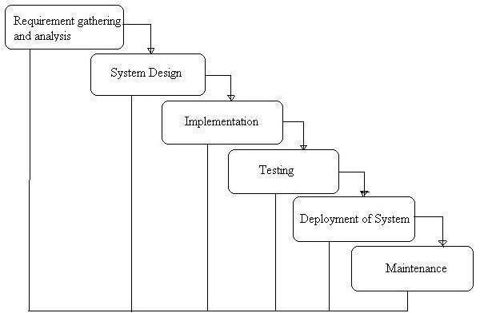

**Fig.WaterfallModel**

#### Advantages of Waterfall Model

* Simple and easy to understand and use.
* Easy to manage due to the rigidity of the model – each phase has specific deliverables and a review process.
* Phases are processed and completed on eat time.
* Works well for smaller projects where requirements are very well understood.

#### Disadvantages of Waterfall Model

* Once an application in the testing stage, it is very difficult to go back and change something that was

not well-thought out in the concept stage.

* No working software is produced until ate during the life cycle.
* High amounts of risk and uncertainty. Not a good model for complex and object-oriented projects.

**Chapter-5**

### Hardware and Software Requirement

**Hardware Requirement:-**

* Operating system: windows
* Processor : intel CORE i3
* RAM :1Gb
* Hard Drive: 50 Gb

**Software Requirement:-**

* Frontend- HTML, CSS, bootstrap
* Backend- XAMPP server 2021, Apache server, SQL server v3.3.0
* Database- MySQL
* Web browser- Google Chrome

**Chapter-6**

### Data and Flow Diagram

#### Data Flow Diagram

Data flow diagram (DFD) represents the flows of data between different processes in a business. It is a graphical technique that depicts information flow and the transforms that are applied as data move form input to output.

#### Representation of Components

DFDs only involve four symbols. They are:

* Process
* Data Object
* Data Store
* External entity

#### Process

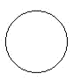

Transform of incoming data flow(s) to outgoing flow(s).



**Data Flow**

Movement of data in the system.

#### Data store



Data repositories for data that are not moving. It may be as simple as a buffer or a queue or as sophisticated as a relational database.

**0th Level DFD:**

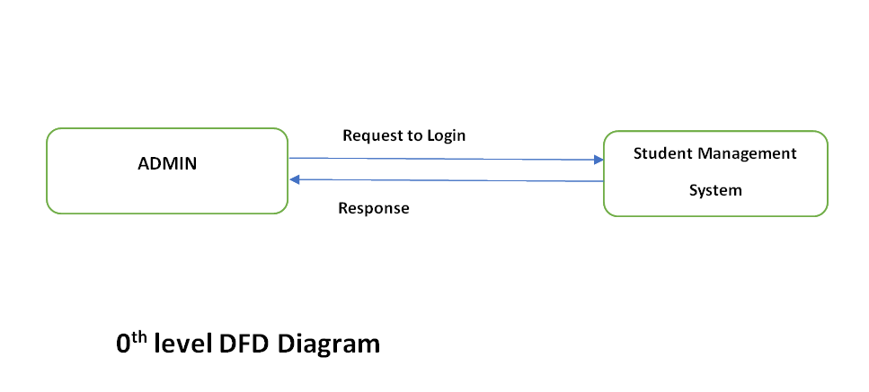

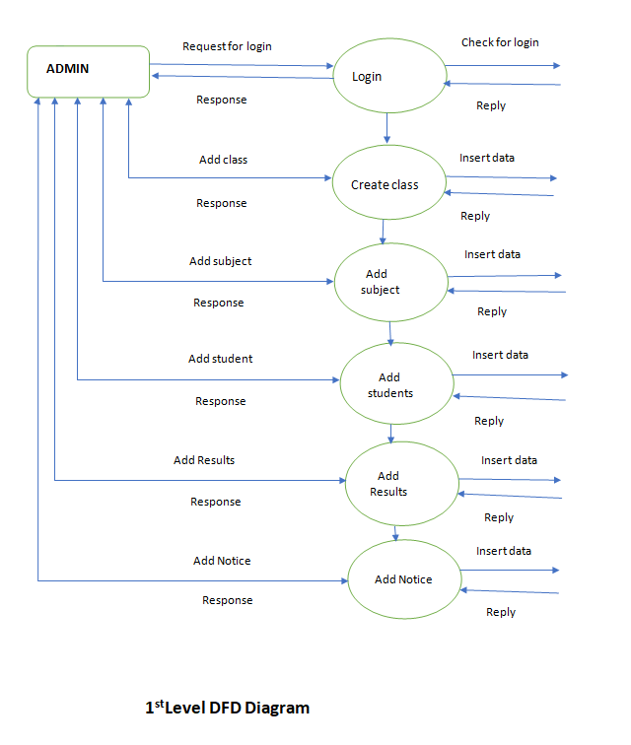

**Chapter-7**



### Entity-Relationship Diagram

The Entity Relationship Diagram (Model) is based on perception of a real world that consists of a collection of basic objects called as Entity and relationships among these objects. Entities in database are described as set of attributes.

1. A **Relationship** is an association among several **Entities.**
2. The set of **Entities** of the same type are called as **Entity Set.**
3. The set of Relationships of same type are called as **Relationship Set.**

A graphical model of the data needed by the system, including think about which information is stored and the relationship among them, produced in structured analysis and information engineering.

The relational approaches to system development places a great deal of emphasis on data storage requirements include the data entities, their attributes and the relationship among the data entities. The model used to define the data storage requirements is called the Entity Relationship Diagram.

#### Components of ERD:-

1.  Entity

2.

Attributes

3.

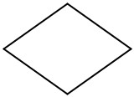Relationship

#### E-R Diagram:-

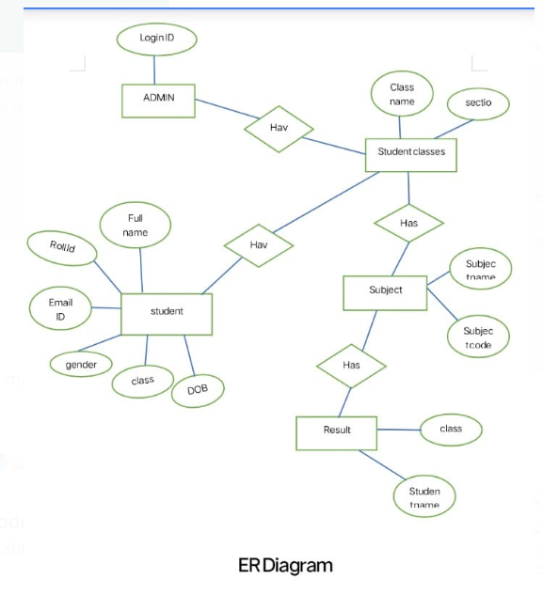

**Chapter-8**

### Use case Diagram

**Use case Diagram:**

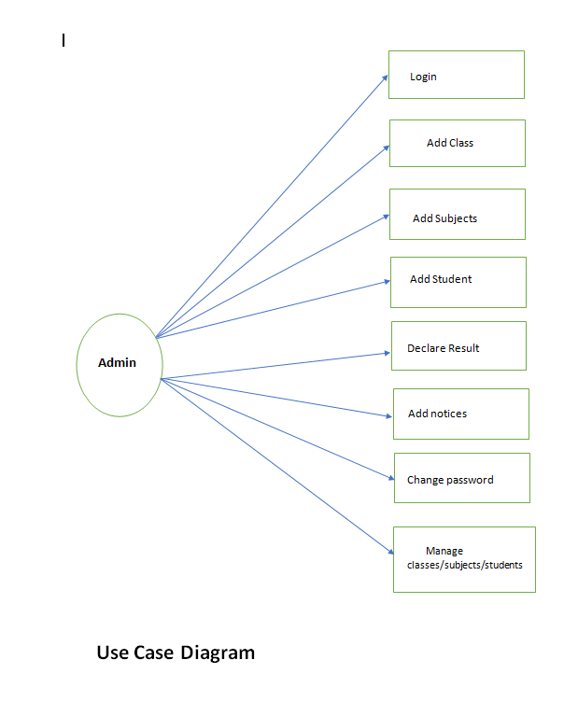

**Chapter-9**

### Database Design

#### Files and Database:-

We have organized one database **Doctor Appointment System** for system design. It can be accessed directly or sequentially by registered. The database determines files, record, fields, and characters. It can be easily controlled and updated. This database and its table and component are described by using flow diagram that is given in the below……….

**Student Result Database :-**

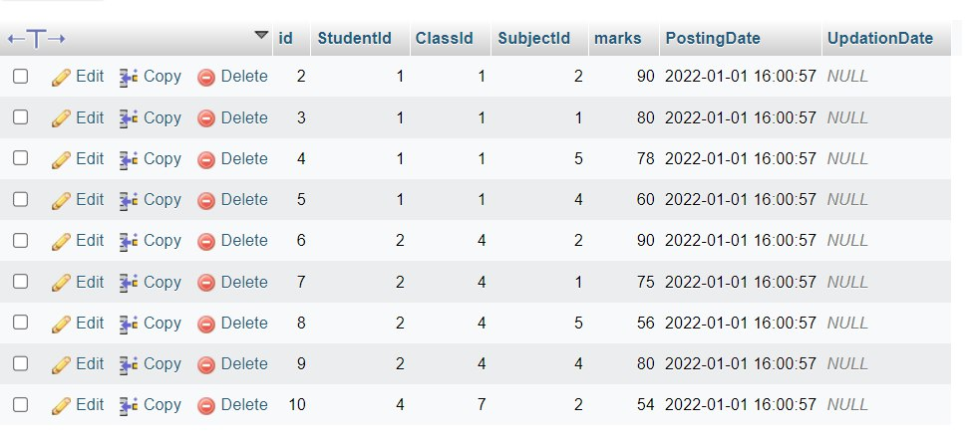

**Student Database:-**

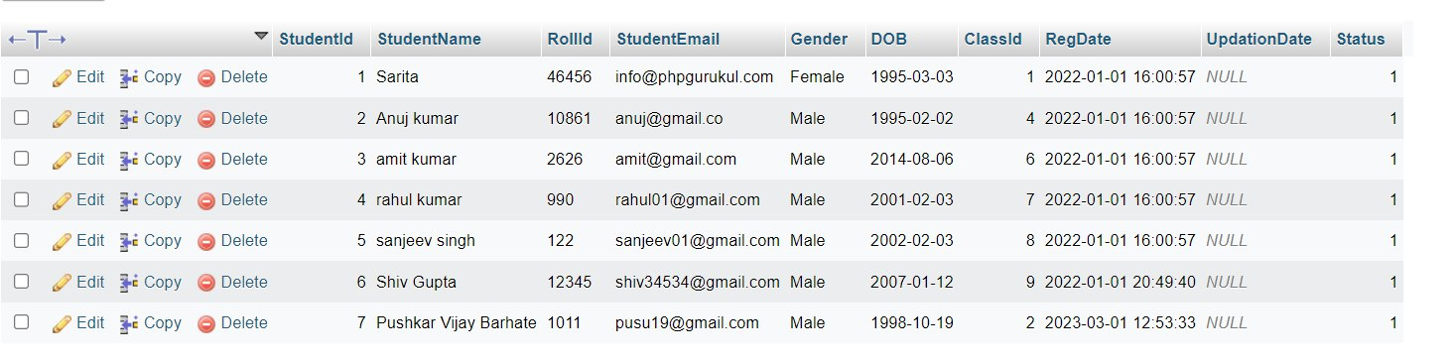

**Subject Combination Database:-**

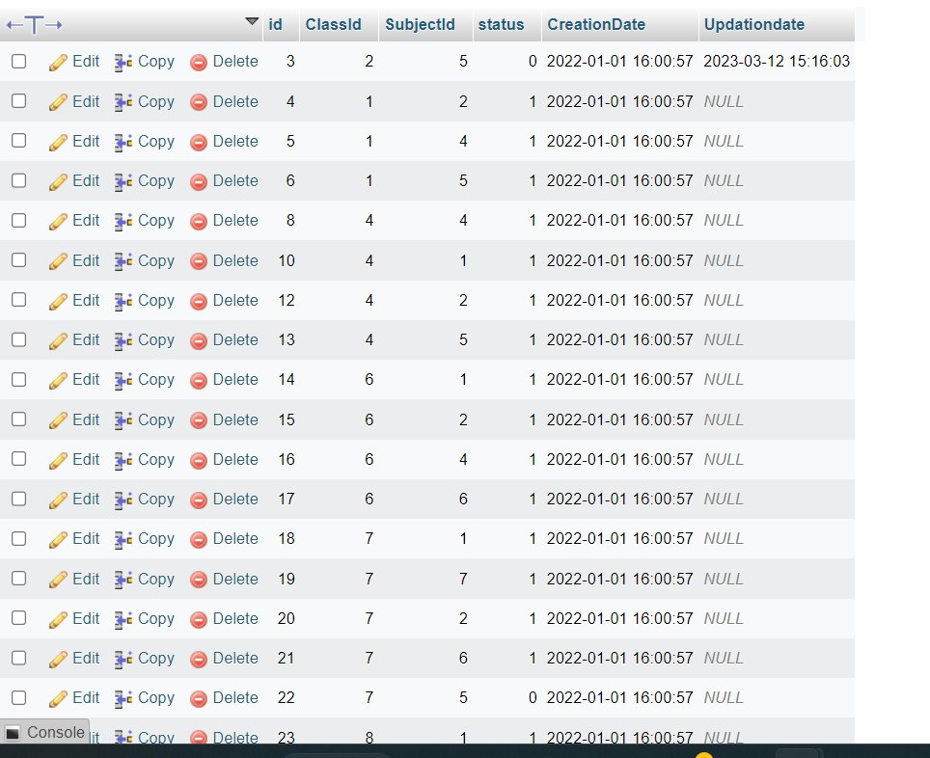

**Subject Database:-**

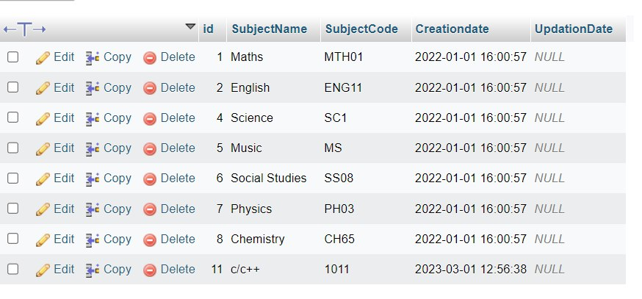

**Classes Database:-**

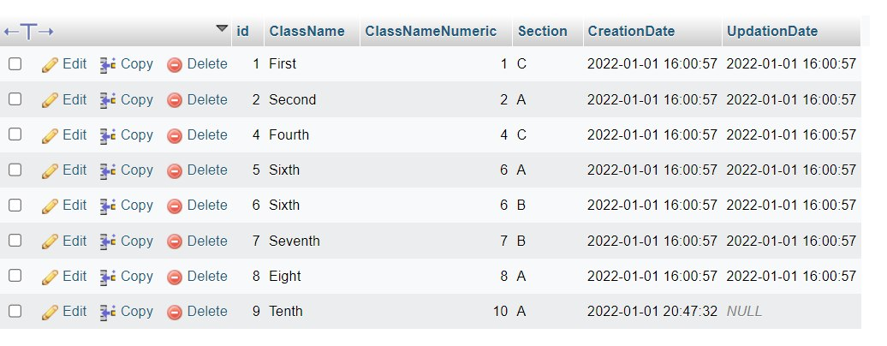

**Chapter-10**

### Input Screen

**Home Page:**

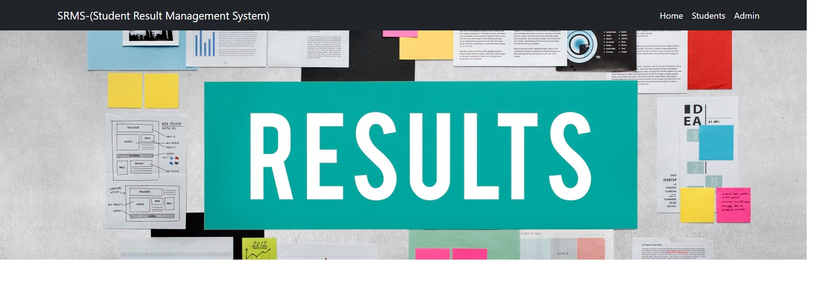

**Student Admission:**

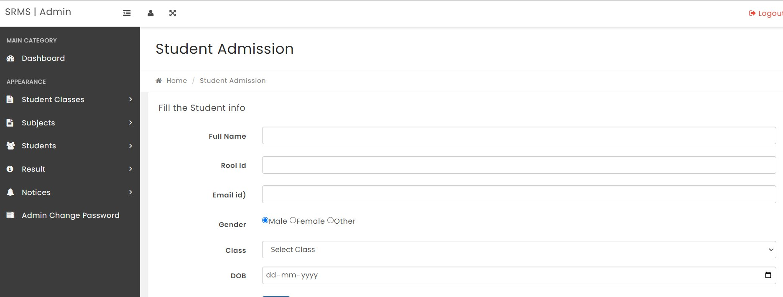

**Manage Students:**

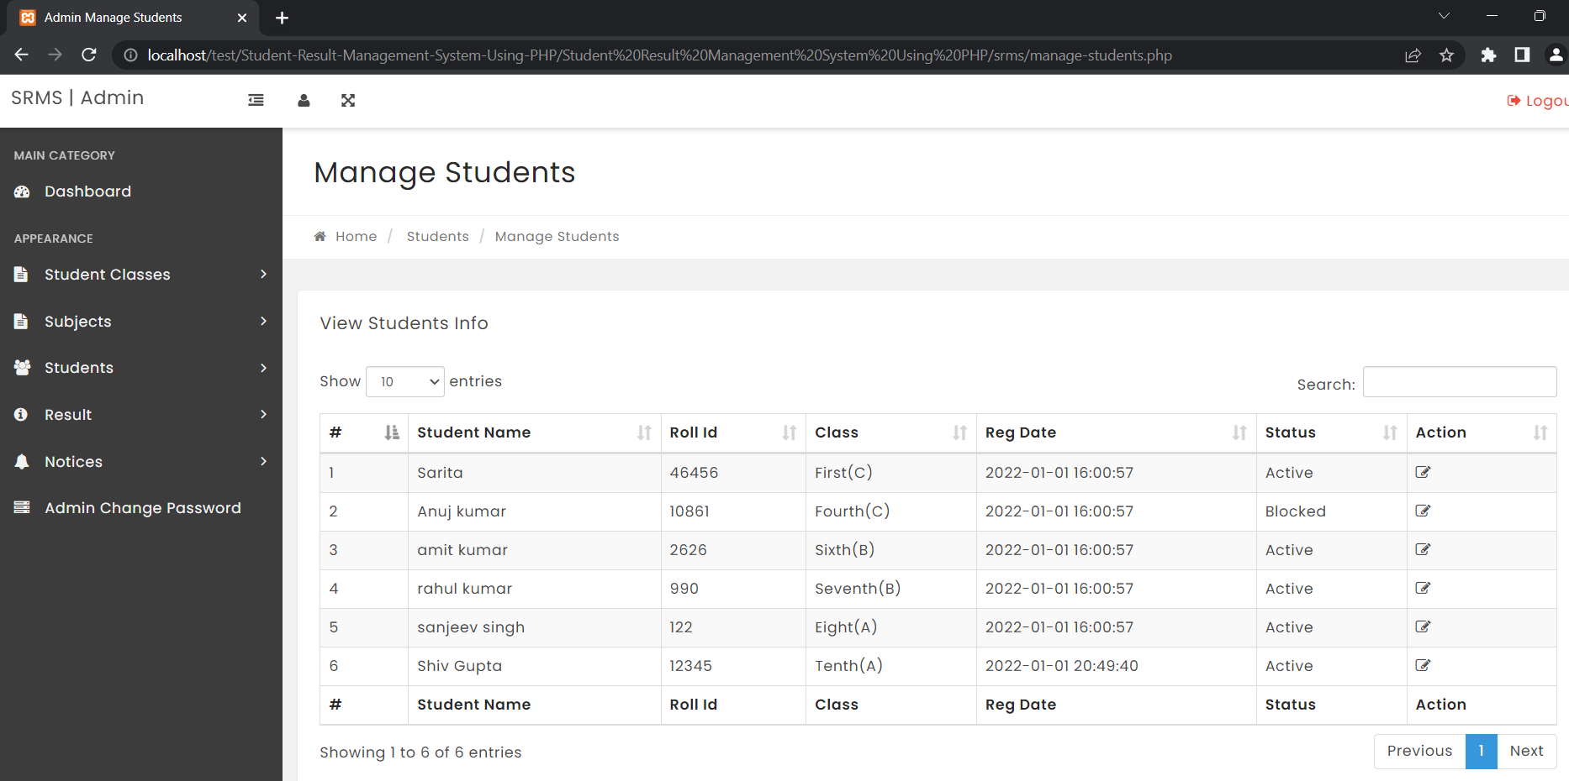

**Subject Creation:**

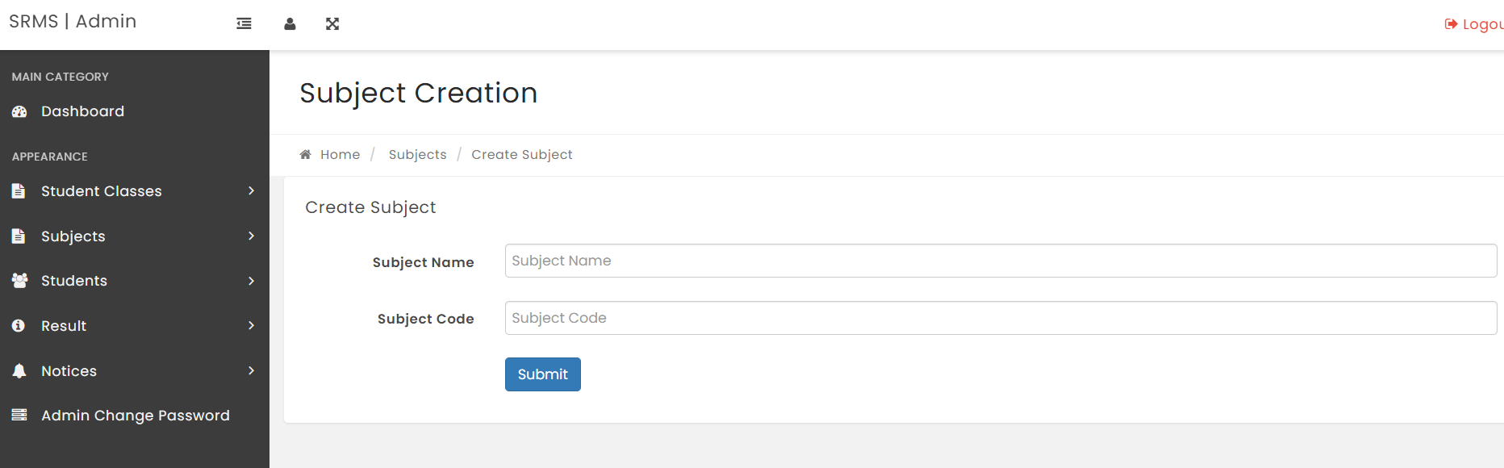

**Manage Subjects:**

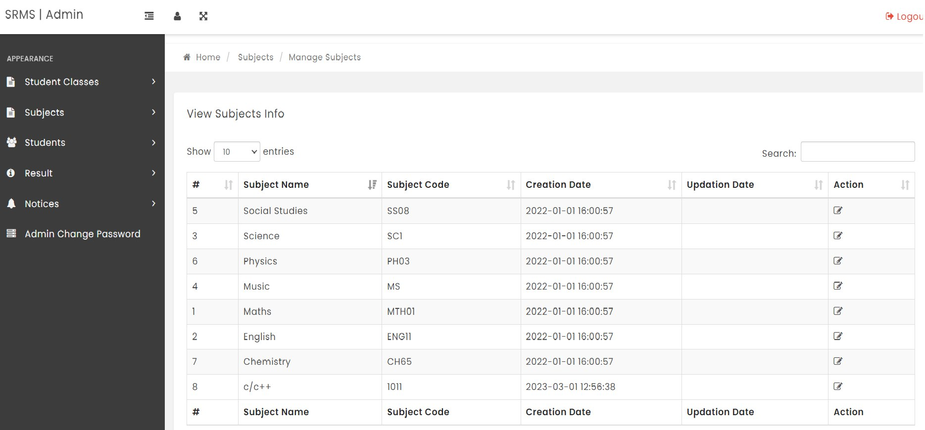

**Manage Results:**

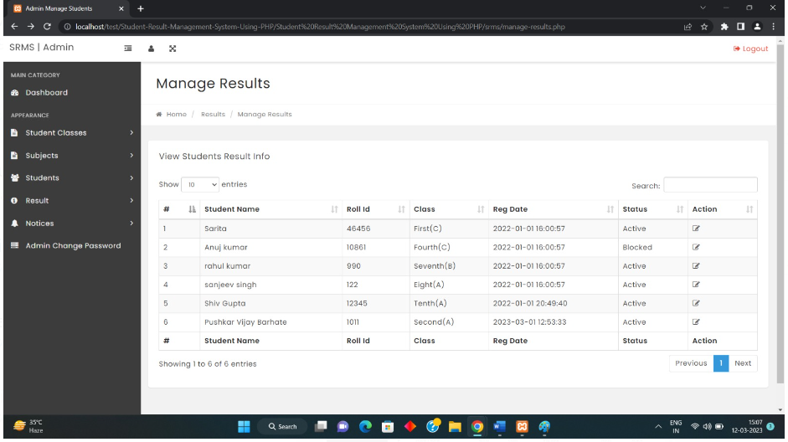

**Result Information:**

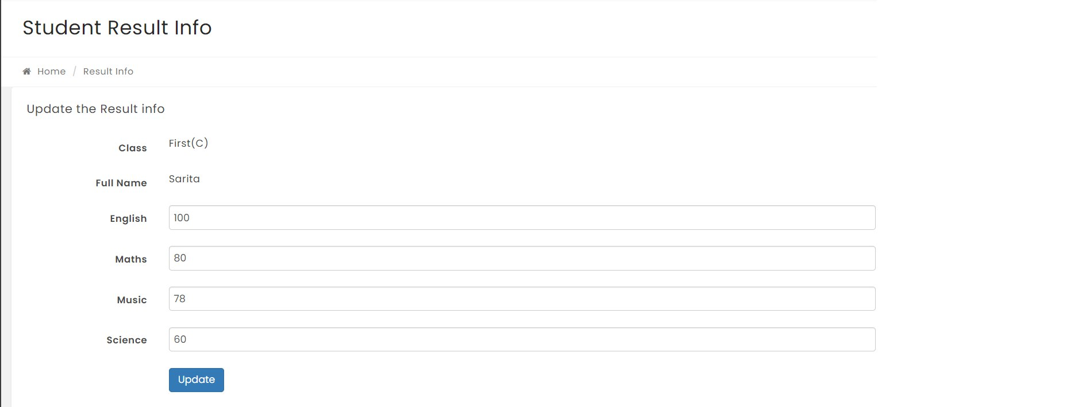

**Add Subject Combination:**

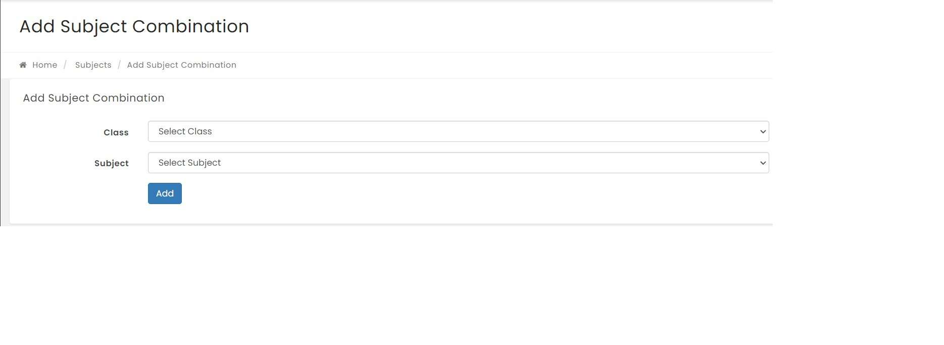

**Subject Combination Info:**

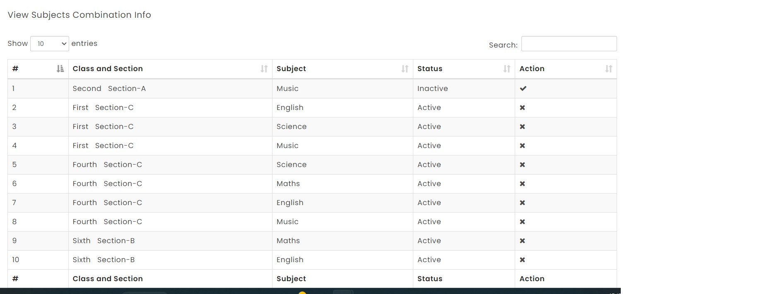

**Create Student Class:**

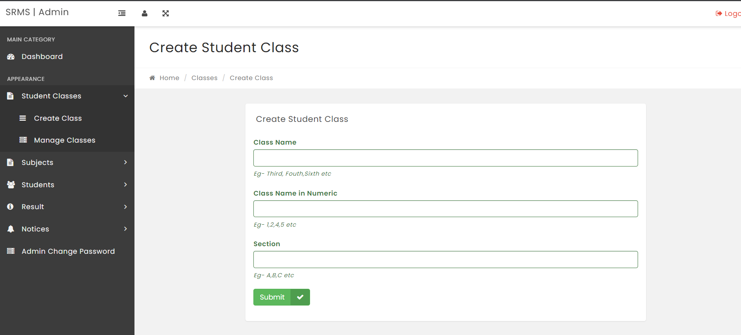

**Manage Classes:**

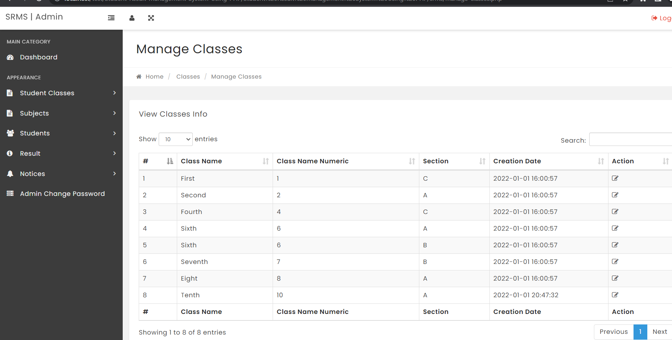

**Declare Result:**

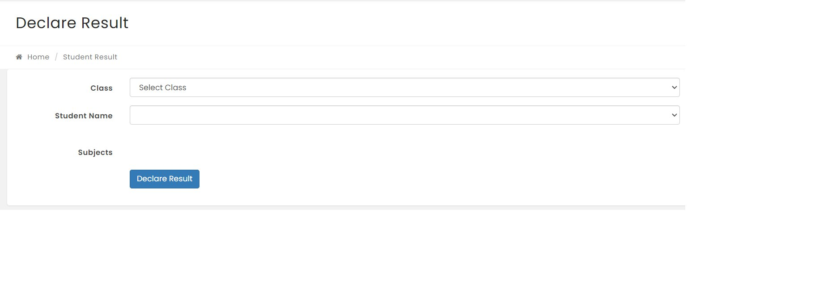

Change Password:

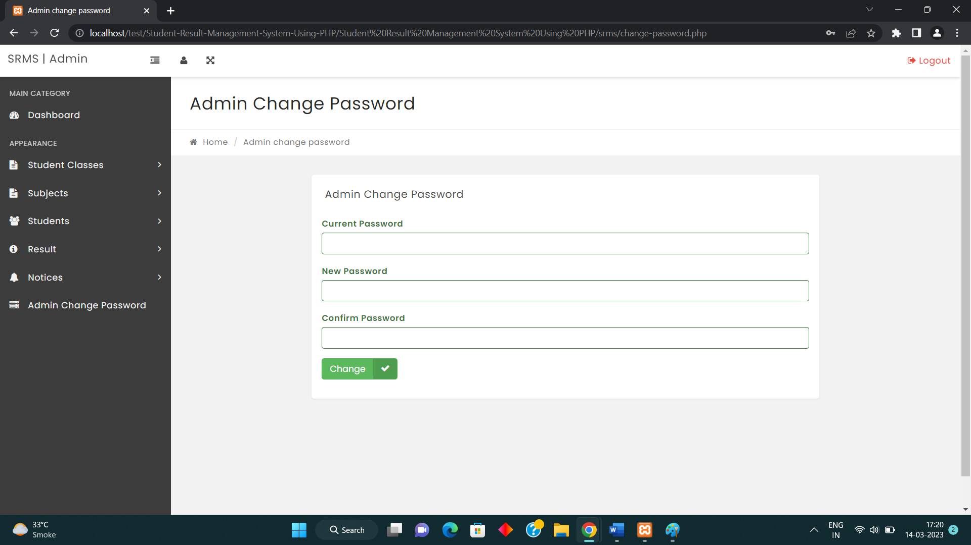

Dashboard:

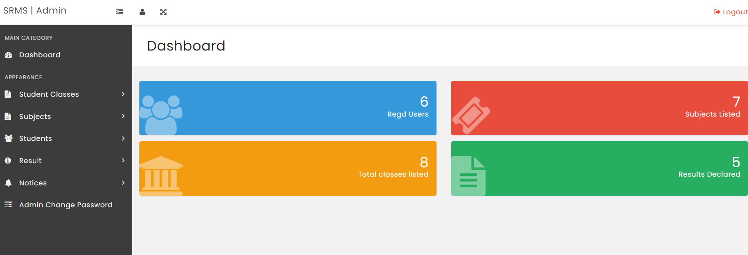

**Chapter-11**

### Testing of Project

Testing is important form the point of view of accurate functioning of the project. There are many testing measures and tools available to test a project. Basic tools used to test this project are:

1. Black-Box Testing.
2. White-Box Testing
3. GUI Testing
4. Black-Box Testing:-

It is a method of software testing that tests the functionality of an application as opposed to its internal structure so workings. Specific knowledge of the application’s code / internal structure and programming knowledge in general is not required. The tester is only aware of what the software is supposed to do, but not how i.e. when he enters a certain input, he gets a certain output; without being aware of how the outputs was produced. Test cases are built around specifications and requirements, i.e., what the application is supposed to do. It uses external descriptions of the software, including specifications, requirements, and designs to derive test cases. These tests can be functional or non-functional, though usually functional. The test designer selects valid and invalid inputs and determines the correct output. There is no knowledge of the test object’s internal structure.

This method of test can be applied to all levels of software testing: Unit, Integration, System and Acceptance. It typically comprises most if not all testing at higher levels, but canal so do min ate unit testing as well.

**The Advantages of this type of testing includes:**

* + The test is unbiased because the designer and the tester are independent of each other.
  + The tester does not need knowledge of any specific programming languages.
  + The test is done from the point of view of the user, not the designer
  + The test can be read if the software designer has already run as testing every possible input stream i sun realistic because it would take an inordinate amount of time; therefore, many program paths will go untested.

1. White-box Testing:-

White-box testing of software is predicted on close

Examination of procedural detail. Logical paths through the software are tested by providing test cases that exercise specific sets of conditions and loops.

1. Graphical user interface Testing:-

It is the process of testing a product’s graphical user interface to ensure it meets its written specifications. This is normally done through the use of a variety of test cases. GUI testing checks only the user friendliness.

**Chapter-12**

### Future Scope of Project

In a nutshell, it can be summarized that the future scope of the project circles around maintaining information regarding:

* We can add printer in future.
* We can give more advance software for Student Result Management System.
* including more facilities.
* We will host the platform on online servers to make it accessible worldwide.
* Integrate multiple load balancers to distribute the loads of the system.

Create the master and slave database structure to reduce the overload of the database queries Implement the backup mechanism for taking backup of codebase and database on regular basis on different servers

The above mentioned points are the enhancements which can be done to increase the applicability and usage of this project Here we can maintain the records of Student and Result. Also, as it can be seen that now-a-days the players are versatile, le so there is a scope for introducing a method to maintain the Student Result Management System. Enhancements can be done to maintain all the Student Result. Subject Class Semester

We have left all the options open so that if there is any other future requirement in the system by the user for the enhancement of the system then it is possible to implement them in the last we would like to thanks all the persons involved in the development of the system directly or indirectly. We hope that the project will serve its purpose for which it is develop there by underlining success of process.

**Chapter-13**

### Conclusion

This system is developed by using HTML, CSS as front-end tool and PHP as back end tool. The system is developed after studying the requirements and necessities of the system. Large data can be securely stored and accessed through SQL Server database using queries. As the system is created in a userfriendly manner with appropriate message guiding the user, even a person with some computer knowledge will be able to use the system.

Our project is only a humble venture to satisfy the needs to manage their project work. Several user friendly coding have also adopted. This package shall prove to be a powerful package in satisfying all the requirements of the school. The objective of software planning is to provide a frame work that enables the manger to make reasonable estimates made within a limited time frame at the beginning of the software project and should be updated regularly as the project progresses.

The key features of the project:

* A description of the background and context of the project and its relation to work already done in the area.
* Made statement of the aims and objectives of the project.
* The description of Purpose, Scope, and applicability.
* We define the problem on which we are working in the project.
* We describe the requirement Specifications of the system and the actions that can be done on these things.
* We understand the problem domain and produce a model of the system, which
* describes operations that can be performed on the system.
* We included features and operations in detail, including screen layouts.
* We designed user interface and security issues related to system.

**Chapter-14**

**Reference**

The completion of this project would not have been possible without the assistance of the following.

**Books for Reference:**

* WroxPublication,“SQL Server 2005”:SQL Queries.
* Rajib Mall, “Fundamentals of Software Engineering”:ERD,DFD
* Ivan Bayross, Sharanam Shah, “PHP for Beginners”:PHP concepts.
* Silberschatz ,KorthandSudarshan,“Database System Concept”:Database Connections.

**Website for Reference:** [https://www.tutorialspoint.com](https://www.tutorialspoint.com/)

1. Feasibility Study.
2. Dataflow Diagram.
3. Entity-Relationship Diagram.
4. Testing. [www.w3schools.com](http://www.w3schools.com/)
5. PHP.
6. HTML and CSS.
7. Bootstrap. [www.stackoverflow.com](http://www.stackoverflow.com/)[www.php.net](http://www.php.net/)[www.javaTpoint.com](http://www.javatpoint.com/)[www.getbootstrap.com](http://www.getbootstrap.com/)[www.google.com](http://www.google.com/)