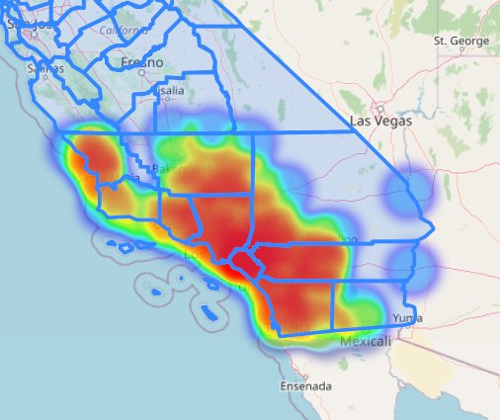

**Approximate house price finder**

The price of a property depends on many indicators, some of them are: location, size, amenities, access to facilities and many more. In this Jupyter Notebook you can see how I managed to find an average price of a house in a given address.

In the following Jupyter Notebook links you can see the code and interactive visualizations.

Please Note: Some cell outputs are lengthy. Please scroll down to continue.

* This link will use my repository in Github and will generate the project:

<https://nbviewer.org/github/mrt5010v/Approximate-house-price-finder---with-Folium/blob/main/Approximate%20house%20price%20finder.ipynb>

If you want to test the code and modify the Jupyter Notebook you might want to try the Binder compiler from the header options from the link above.

