** HealthLink**

[**healthlink5.netlify.app**](https://healthlink5.netlify.app)

**Team “Ctrl C Ctrl V”**

* Pramatha Rao
* Nainika Agrawal
* Vriddhi Agrawal
* R. Ricky Roger

**Problem Statement**The challenge at hand is to design and develop an advanced tele-health platform that redefines the landscape of remote medical consultations. This platform should cater to the vision of enabling individuals, regardless of their location, to access timely medical assistance seamlessly. The focus is on creating an integrated system that employs chat, audio calls, and video calls to connect patients with the right level of medical expertise based on the severity of their case

**Tech Stack**

We are using the Svelte, OpenAI ChatGPT 3.5, Firebase Firestore, Firebase Auth, Jitsi Meet as our tech Stack.

* Svelte - Svelte is a free and open-source front-end component framework and language.
* OpenAI - ChatGPT is a large language model-based chatbot developed by OpenAI, enables users to refine and steer a conversation towards a desired length, format, style, level of detail, and language.
* Firebase – Firebase, a set of backend cloud computing services and application development platforms provided by Google. It hosts databases, services, authentication, and integration for a variety of applications.
* Jitsi Meet - Jitsi Meet offers free, secure and open-source video conferencing.

**Technical Architecture**

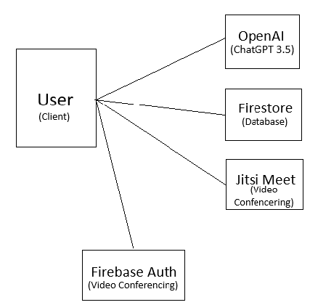

**Challenges we ran into**As this was our first hackathon, we initially had to learn a few new concepts and languages. We decided to go for Svelte instead of React or Angular, as it had a smaller learning curve as compared to the latter, and used a similar syntax to that of Vanilla JS.

Firebase provided easy to use API’s for handling Authentication, and Database management, hence we decided to stick with them. Now since it was not feasible for us, to make our own LLM model to perform chat conversations, from scratch, we decided to use ChatGPT 3.5 Turbo provided by OpenAI.

Later on, we had to work upon the Severity routing part, and luckily ChatGPT now introduced, the Function Calling where, ChatGPT now gives JSON Outputs, and hence predictable responses.

To ensure security and privacy of user data, we have implemented robust Firebase Security rules, to prevent un-authorized access, to sensitive user information.   
We also

To offer one-to-one meetings between the doctors and patients, we tried to initially find an Open Source software, to help do the Video communications. Luckily we stumbled upon Jitsi Meet, and we ended up, using one of their Contributor servers, to take care of hosting.

For future scopes, we can always transition from OpenAI to Azure Cloud, to help scale the service. We can also host the Jitsi Instance ourselves on the cloud, to prevent reliance on external community contributor servers.   
Note: OpenAI recently lowered the No. of requests per minute, to 3, for the free tier in which the public deployment is running in.

**Future Scope**

* We can add additional services such as Scheduling of Doctor Appointments.
* We also plan to add a blog section, and self-help videos to further enhance the experience of our visitors.
* Implement End-To-End Encryption on our user conversation with the doctors, which could be done using Private-Public key cryptography.
* To ensure sustainability of the platform, we can add a subscription based model to further incentivize our doctors, help better our services, and cover operational costs.