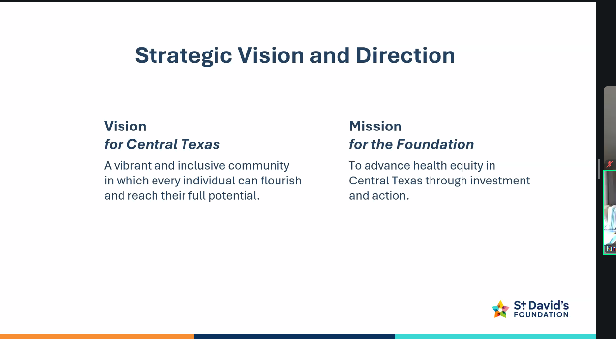
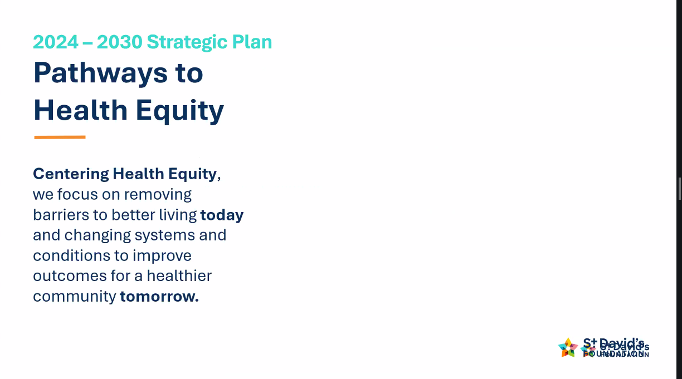
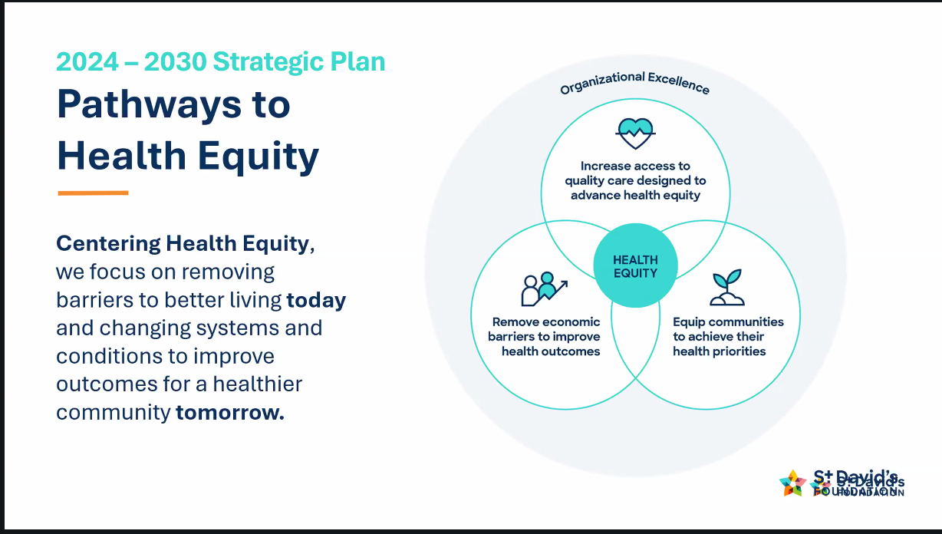
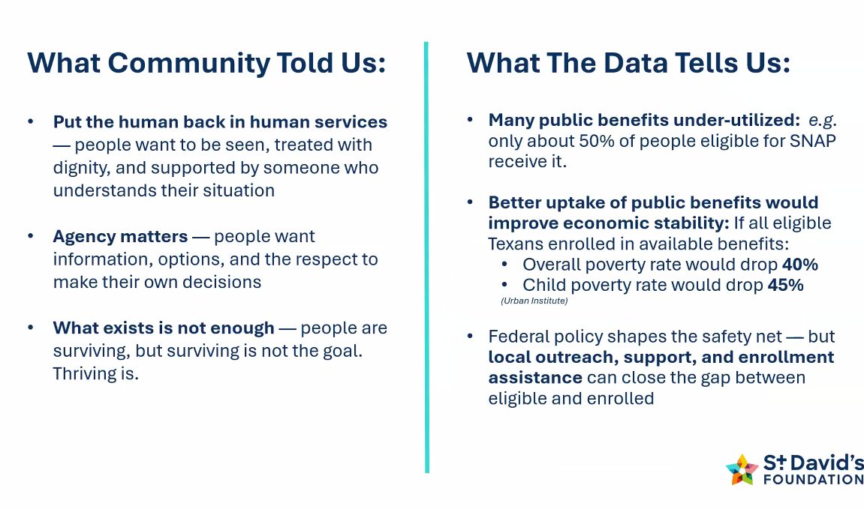
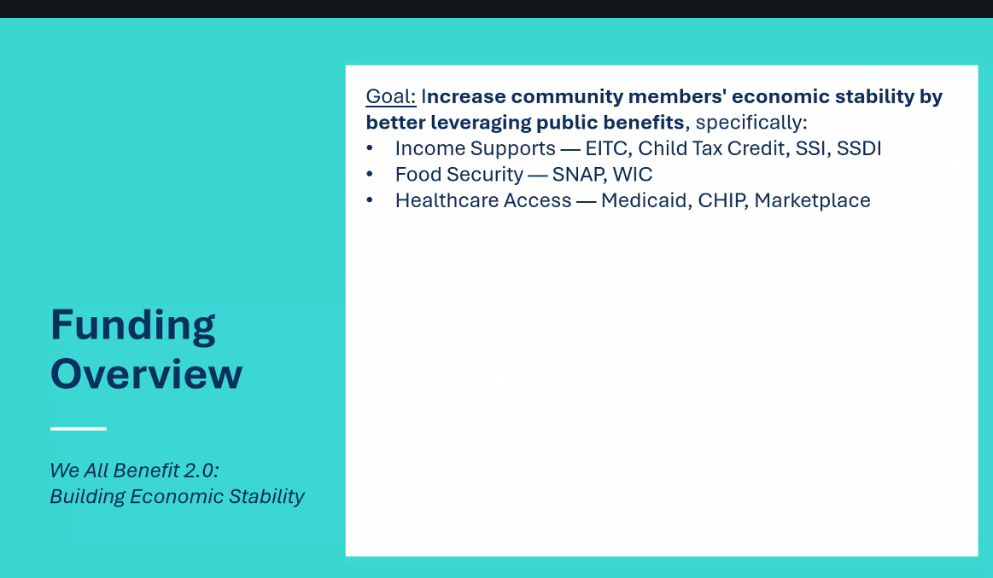
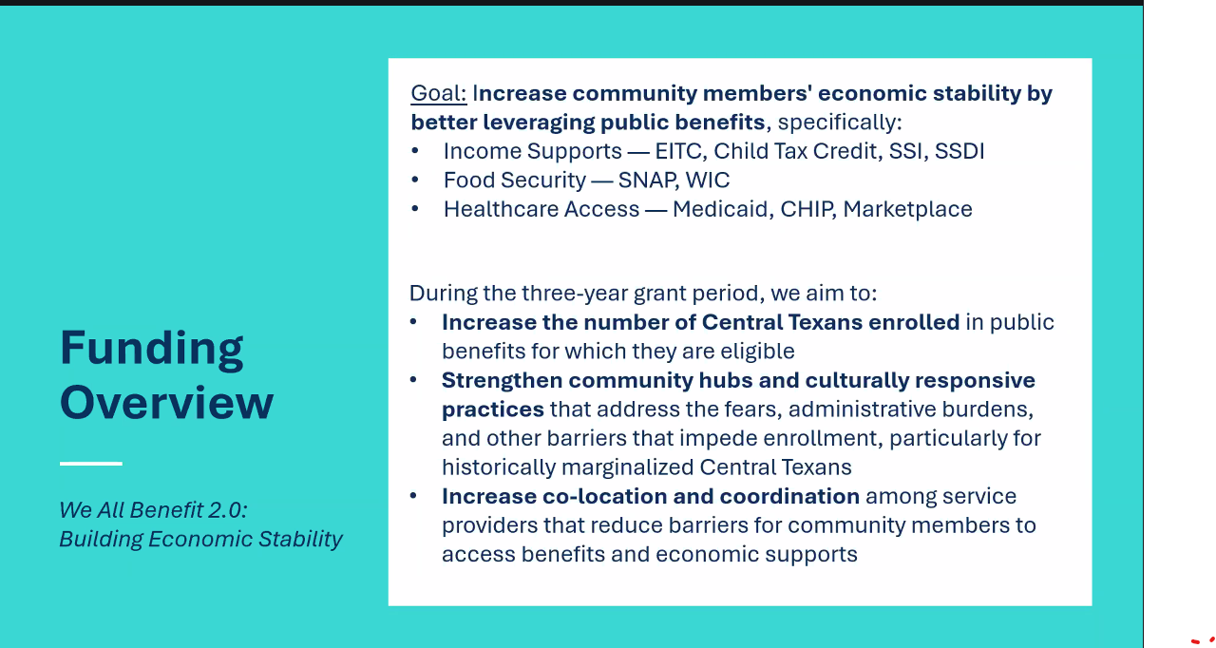
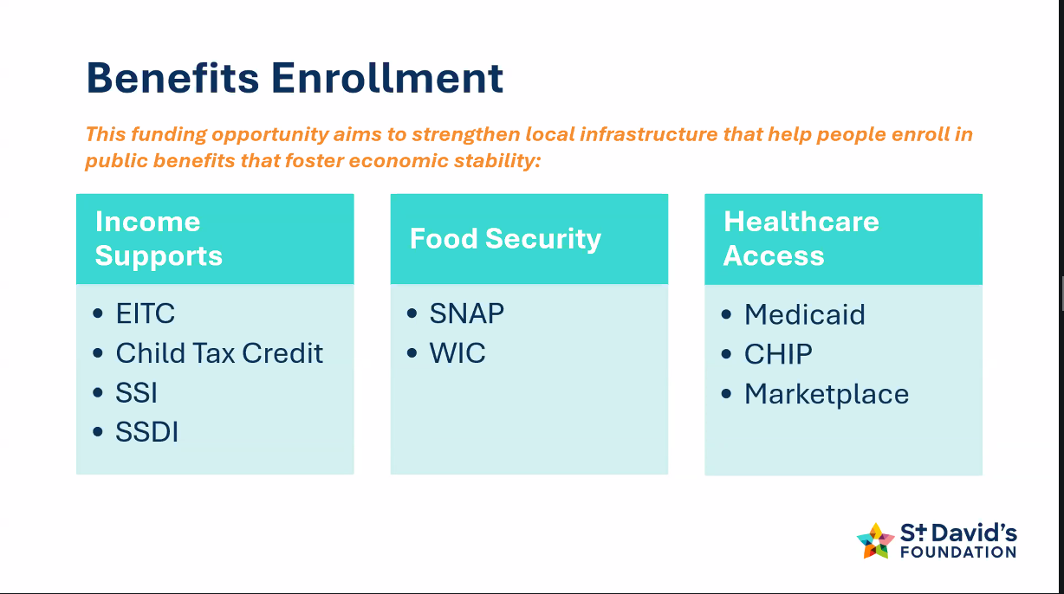
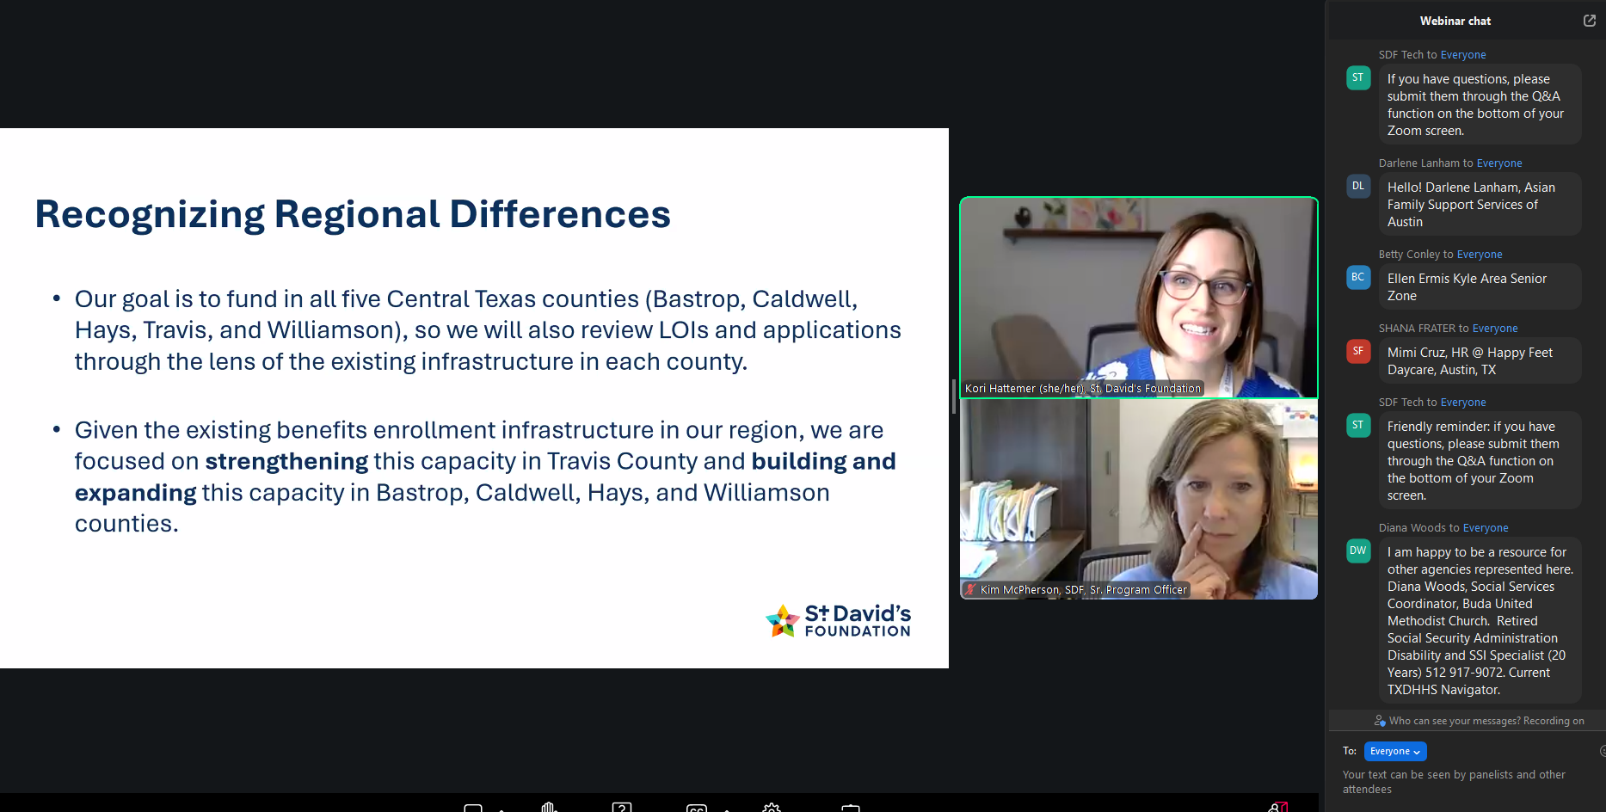
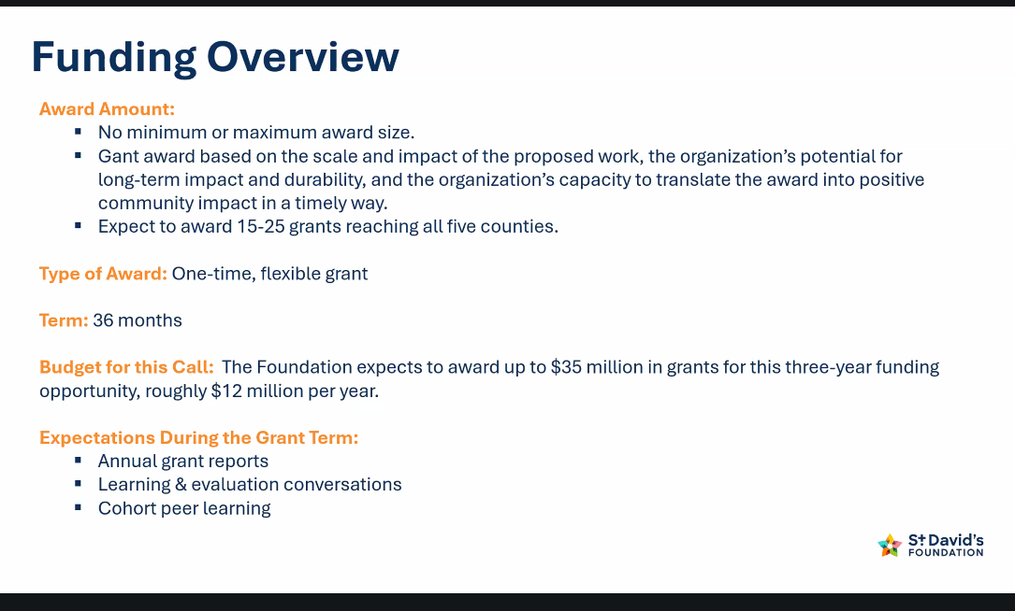
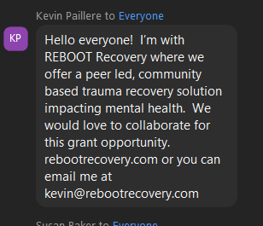
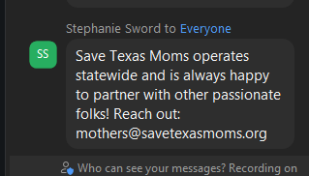
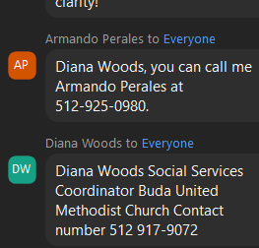
JoLynne Williams 11:11 AM
Are food pantries in Williamson County specifically covered in this grant?
SDF Tech 11:16 AM
Yes, if it includes benefits enrollment or there is a plan to integrate benefits enrollment to the work. You can find the rest of our eligibility criteria here: https://stdavidsfoundation.org/how-we-work/grantmaking/funding-opportunities/we-all-benefit-2-building-economic-stability/#FAQ
Jessica Ostiguin 11:13 AM
Will there be a focus to support Out Stationed Eligibility Workers for organizations through HHS?
SDF Tech would like to answer this question live.
Andrea Brauer 11:14 AM
Does connection to workforce support count for income support?
SDF Tech would like to answer this question live.
Alok 11:15 AM
What aout people with disabilities? Direct language access or multi-lingual support - would that count?
SDF Tech would like to answer this question live.
Cassie Newman 11:15 AM
Will collaborative proposals be any more competitive?
SDF Tech would like to answer this question live.
Diana Woods 11:16 AM
Will slides be emailed out after presentation?
Kevin Paillere 11:16 AM
Outside of enrolling community members into CHIP, Medicaid or Marketplace insurance, would providing services (mental health) qualify for this cycle?
SDF Tech would like to answer this question live.
Stephanie Russell 11:17 AM
Would you be able to touch on how this opportunity differs from the next opportunity that you'll be offering in June, particularly in regards to organizations that address health care access?
SDF Tech would like to answer this question live.
Anonymous attendee 11:17 AM
Is this grant limited to federal health programs only? Specifically asking if enrollment efforts for MAP (Medical Access Program) for Travis County would be eligible for consideration?
St. David's Foundation would like to answer this question live.
Monique Hatch 11:18 AM
Will we have access to this recording?
SDF Tech 11:19 AM
Yes! We will make the recording available on our website.
Michelle Gustafson 11:19 AM
I saw that an applicant can submit more than 1 LOI. Could we apply independently AND as part of a collaborative? If so, could both applications be approved?
SDF Tech would like to answer this question live.
Kat Ruiz 11:19 AM
if applying collaboratively, do all organizations need to be 501c3?
SDF Tech would like to answer this question live.
Matthew Gonzales 11:19 AM
How does St. David's define "collaborative" in Hays County the Health Department serves as the host agency for the "Healthy Hays Coalition". The coalition is not a recognized 501(c)3, but a group that has routine meetings through its work group. Would this be eligible as a collaborative?
SDF Tech would like to answer this question live.
Anonymous attendee 11:20 AM
What percentage of this funding will go toward new projects/organizations vs existing funded projects?
David Clauss 11:20 AM
Will you only award the amount requested in an application, or could you award smaller amount that was requested?
SDF Tech 11:27 AM
If the project is competitive and is selected under this funding opportunity, and funding needed to be decreased, that would be a conversation we would have at that point in time. For now, the focus is on explaining the project that you believe aligns with the goal of this call.
Angie Zuniga 11:20 AM
Can applicants apply both individually and as a part of a collaboratively and potentially receive funding through both?
SDF Tech would like to answer this question live.
Meredith Morrow 11:21 AM
Confirming that this grant is primarily to help residents in our region access economic stability programs (SNAP, CHIP, etc.) rather than providing direct financilal support?
SDF Tech 11:24 AM
That is correct! You can find more in-depth FAQ here: https://stdavidsfoundation.org/how-we-work/grantmaking/funding-opportunities/we-all-benefit-2-building-economic-stability/#FAQ
Alicia Fischweicher 11:22 AM
how many participants to you anticipate moving from LOI to application?
Amanda Hill 11:22 AM
Approximately how many ogranizations that submit an LOI will be invited to submit a full application?
David Johnson 11:26 AM
Is there a limit to the level of collaboration (incl. number of orgs) that the Foundation will consider?
SDF Tech would like to answer this question live.
Amanda Doenges 11:27 AM
can you restate the HHSC committee that is prefered to be a part of?
SDF Tech 11:29 AM
Many of the public benefits included in this call are managed by HHSC and accessed through the HHSC benefits application.
Through the Community Partner Program, HHSC partners with organizations across the state to help community members complete HHSC benefits applications, providing training and varying levels of access to submitted applications to support community members through the process.
Organizations that participate in the Community Partner Program are able to provide more extensive support through the application process—particularly those with a Level 3 status—which is an important component of providing effective and efficient enrollment support to community members eligible for these benefits. You can find more information here: https://stdavidsfoundation.org/how-we-work/grantmaking/funding-opportunities/we-all-benefit-2-building-economic-stability/#FAQ
Grace Holland 11:28 AM
for orgs who may play the role of connecting families to benefits enrollment experts, how are you wanting to see the evidence of impact there?
SDF Tech 11:37 AM
In this phase of the application process, it's important to demonstrate that your proposed porject is client-driven, holistic, and effective.
Luis Caballero 11:28 AM
What is the total funding available for this opportunity per year?
SDF Tech 11:29 AM
The Foundation expects to award up to $35 million in grants for this three-year funding opportunity, roughly $12 million per year. We expect to award 15-25 grants reaching all five counties. There is not a minimum or maximum award size.
Jessica Ostiguin 11:28 AM
when will the actual application open in the portal?
SDF Tech 11:30 AM
It is currently open!
Benn Chang 11:29 AM
Texas Ramp Project question: We provide free wheelchair ramps to low-income older adults and people with disabilities identified by local health care providers. we do not have a benefits enrollment plan in our program. am I correct we would not be eligible for this funding opportunity?
SDF Tech 11:32 AM
Thank you so much for the work you do! Unfortunately, that is correct -- since the goal of this call is to maximize public benefits, a core component is to have a benefits enrollment plan. If you help connect your clients with SSI or SSDI enrollment support, that would be an example of how that project would be more in line with the objectives of this call.
Diana Woods 11:30 AM
Very difficult to see. Able to enlarge?
Kevin Fincher 11:30 AM
Do organizations we are collaborating with need to be part of the HHSC Community Partner Program or just the lead applicant?
Anonymous attendee 11:31 AM
Can you clarify if MAP qualifies?
SDF Tech 11:34 AM
MAP enrollment alone would not qualify, a combination of MAP enrollment CHIP/Medicaid, SNAP would!
Meredith Morrow 11:32 AM
Will an application that serves counties outside of Travis County be more competitive?
Michelle Gustafson 11:32 AM
Is there a preference for new benefits enrollments versus renewals?
SDF Tech would like to answer this question live.
Michelle Gustafson 11:33 AM
Should the request amount be a 1-year number or a 3-year number?
Should we submit a 1-year or 3-year budget?
Does the budget need to be the same year over year?
Grace Holland 11:33 AM
In other words, can you speak to outcomes you are expecting to see?
SDF Tech 11:38 AM
his funding opportunity is designed to increase community members’ financial stability by better leveraging available public benefits. Specific and shorter-term outcomes we hope to achieve by the end of the three-year grant period, include:
Increased enrollment in public benefits among eligible populations that lead to increased financial stability through client-driven, holistic, and effective service delivery.
Stronger community hubs with culturally responsive practices that address fears, administrative burdens, and other barriers that impede enrollment, particularly for historically marginalized populations.
Increased co-location and coordination among service providers, reducing fragmentation and barriers for community members seeking support.
Laureen Born 11:34 AM
How about including the Workforce Commission program for subsidized childcare payments?
Rebecca Knowles 11:34 AM
In addition to the program focus on benefit enrollment, would grantees be allowed to use part of the funds for service delivery, programs, or capital to build capacity and sustainable service access?

For context, our service focus is community health.
SDF Tech would like to answer this question live.
Caro Fenno 11:35 AM
Would you consider supporting our networking within this ecosystem by sharing the list of organizations who submit LOIs so that we can review and connect for future grant collaborations? Thank you!
SDF Tech would like to answer this question live.
Anonymous attendee 11:35 AM
Is there priority given to smaller organizations, or it moreso based on the scoring of the LOI?
Audrey Vivar 11:36 AM
If we are helping kinship caregivers who are caring for children navigating the foster care system - to file for SNAP & Medicaid but ALSO to become state licensed foster families to access even more government assistance (e.g. access monthly foster care stipends, reimbursement, free/subsidized childcare, afterschool programs, and more). Would this RFP have to focus just on the SNAP & Medicaid OR the entire process in which we support?
Lesly Johnson 11:36 AM
Does the term flexible funding indicate thie funidng is unrestricted
Allison Myers 11:36 AM
Could you please say more about the flexible funding - will funds be restricted to the enrollment related expenses / supports that specifically will increase benefit enrollment?
SDF Tech 11:43 AM
This is flexible funding, meaning grantees have significant discretion in how funds are used to achieve the proposed work. Unlike restricted funding that specifies exact uses, flexible funding allows you to adapt your approach as you learn what works best for the communities you serve. You can read more here: https://stdavidsfoundation.org/how-we-work/grantmaking/funding-opportunities/we-all-benefit-2-building-economic-stability/#FAQ
Sabrina Sha 11:37 AM
How are you considering non-state/federal benefits? For example, we help our clients navigate local benefits such as MAP in Travis County!
This question has been answered live
SDF Tech 11:40 AM
For the We All Benefit 2.0 funding opportunity, core economic stability services include three categories: Income Supports, Food Security, and Healthcare Access. This call is focused on the following public benefits:
Income Supports
Earned Income Tax Credit (EITC) – a refundable tax credit that households can claim by filing a tax return. During the 2025 filing season, eligible households who earn less than $68,675/year could receive up to $8,046 in EITC.
Child Tax Credit (CTC) – a refundable tax credit that eligible households with children under age 17 can claim by filing a tax return, up to $2,200 per child.
Supplemental Security Income (SSI) – monthly benefits to people with limited income and resources who are blind, age 65 or older, or with a qualifying disability.
Social Security Disability Insurance (SSDI) – monthly benefits to individuals who are unable to work due to severe, long-term, or terminal disability.
Food Security
SNAP (Supplemental Nutrition Assistance Program) – monthly benefits provided
Anonymous attendee 11:37 AM
Beyond direct public benefits enrollment, how much weight does the rubric give to holistic economic stability supports, like food access, food as medicine, and income-generating opportunities through workforce development and incubator programs.
This question has been answered live
christine murphy 11:39 AM
How do you define “historically marginalized groups”?
SDF Tech 11:41 AM
Historically marginalized communities are populations that have faced systemic barriers to accessing resources and opportunities due to discrimination and inequitable policies. These communities often face compounded barriers when trying to access public benefits based on their race, ethnicity, income level, immigration status, language, geography, sexual orientation, gender, or other factors. You can read more here: https://stdavidsfoundation.org/how-we-work/grantmaking/funding-opportunities/we-all-benefit-2-building-economic-stability/#FAQ
Anonymous attendee 11:39 AM
If you are providing health care, specifically free pediatric care, would we also need to route into CHIP/Medicaid or other services if you are the health care solution?
Laura Carter 11:41 AM
May an organization use some of the funds for immediate basic needs while clients are waiting for enrollment in public services?
SDF Tech would like to answer this question live.
Anonymous attendee 11:42 AM
Is the portal registration needed to send in the LOI?
Anonymous attendee 11:44 AM
With healthcare access on medicaid does conencting clients to mental health care for medicaid count? Is the healthcare scope expanded to mental health care non profits?
This question has been answered live
Anonymous attendee 11:46 AM
Does this opportunity support Medicaid for elderly who have dual enrollments? They have both Medicaid and Medicare?
SDF Tech 11:52 AM
Yes! You can read more about the benefits enrollment we are looking to fund here: https://stdavidsfoundation.org/how-we-work/grantmaking/funding-opportunities/we-all-benefit-2-building-economic-stability/#FAQ
Dr Denise Gobert 11:46 AM
Greeting everyone. We at Texas State Univeristy (campuses) are based in both Hays and Williamson counties. Please let me know if you are interested in collaborating with an academic institute. dgobert@txstate.edu :-)
Sarah McQueen 11:50 AM
Is there any opportunity for orgs whose work focuses on strengthening enrollment systems, or is it limited to client facing services?
This question has been answered live
Terry Flood (You) 11:51 AM
Is there a lane for providing services for transitioning people dmv, abuse, and fostercare/families, traficking. These groups typically get enrolled automatically into some programs, but may have trouble navigating, and have trouble with guardians, and court orders etc. Access?
Anonymous attendee 11:52 AM
What does reporting on the grant look like?
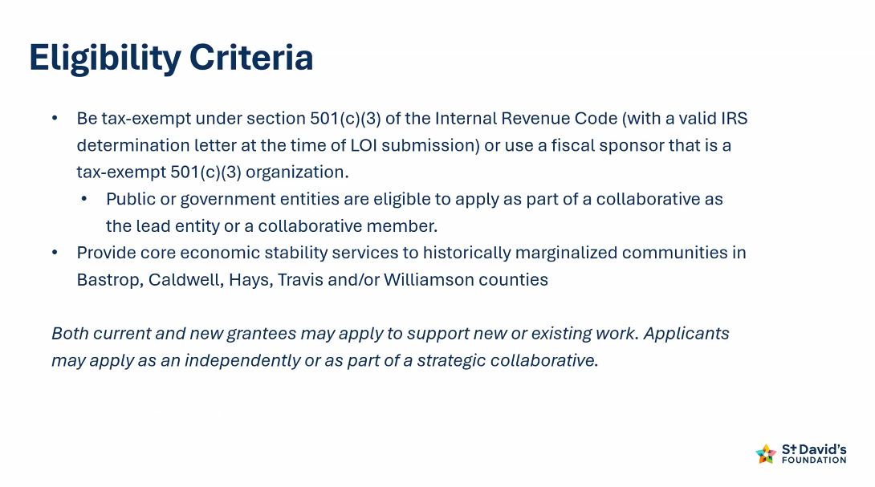
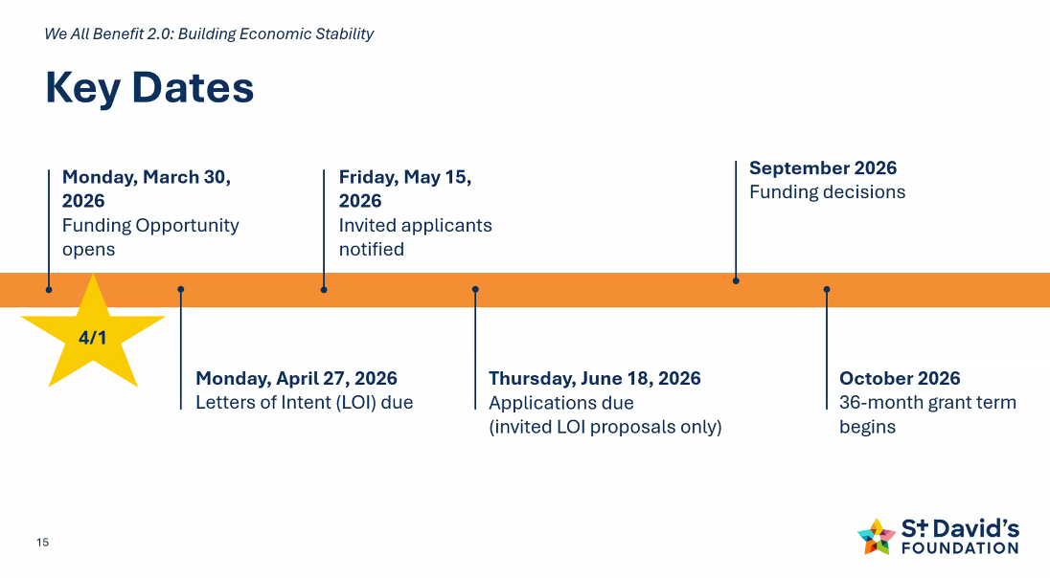
. 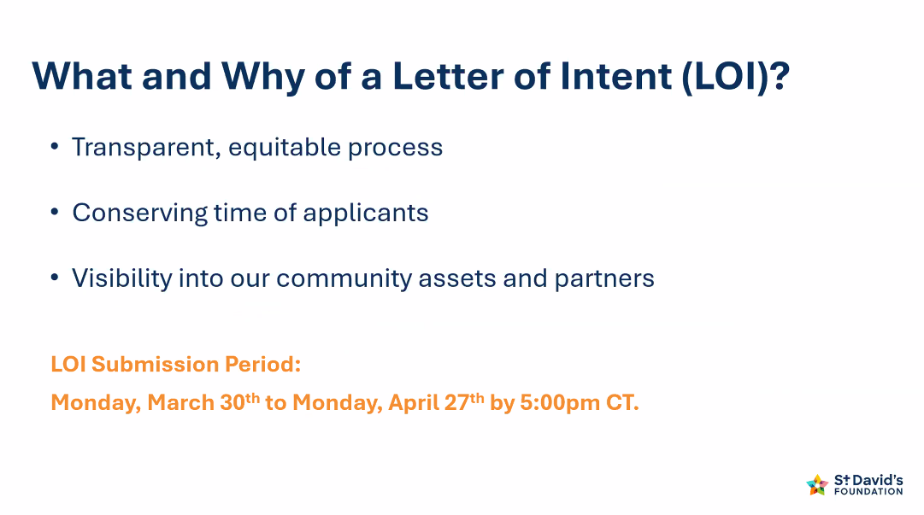
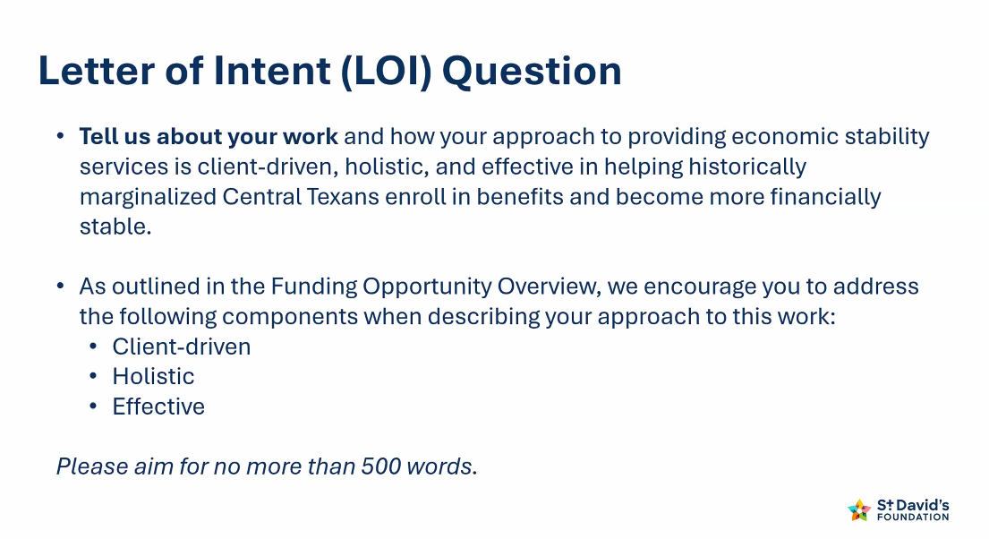
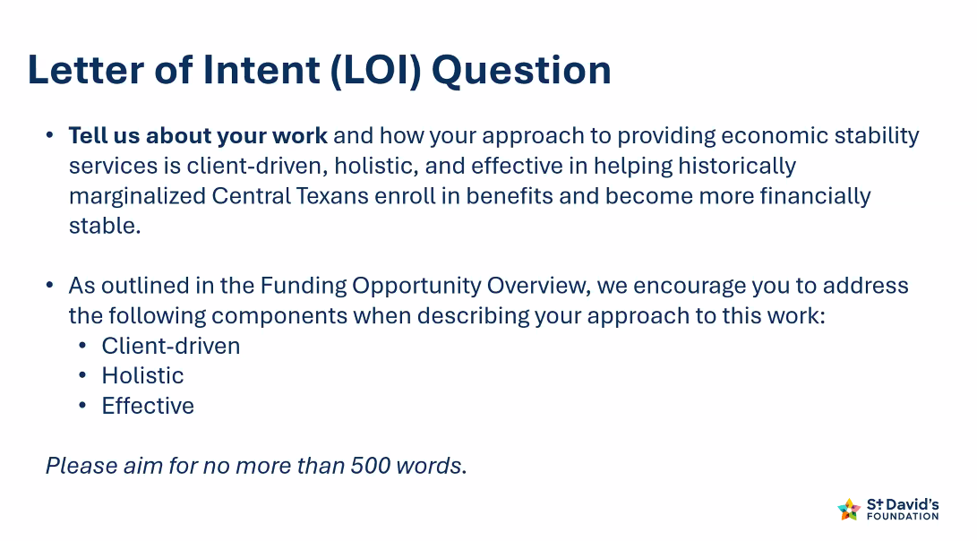

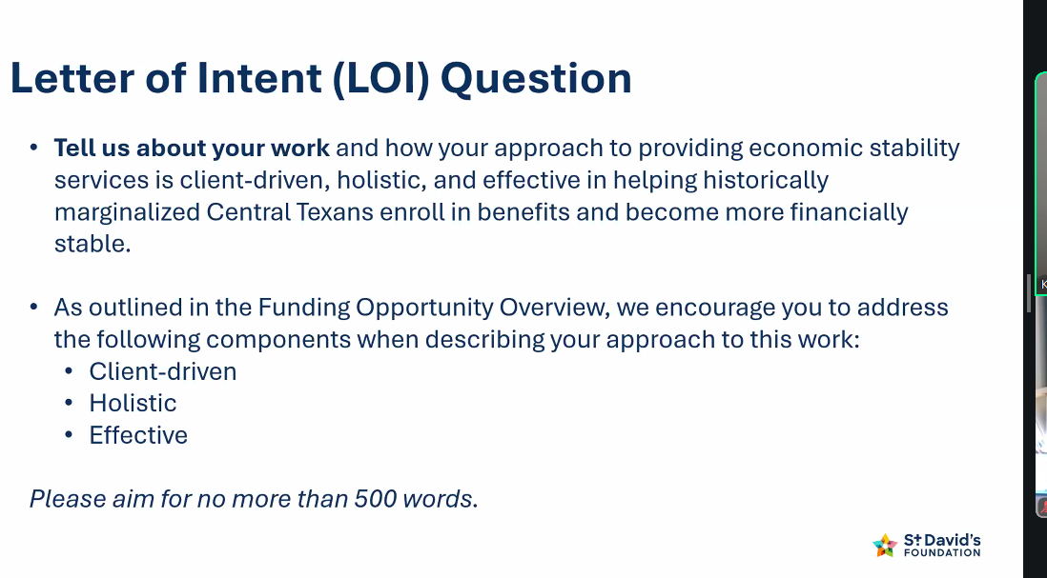

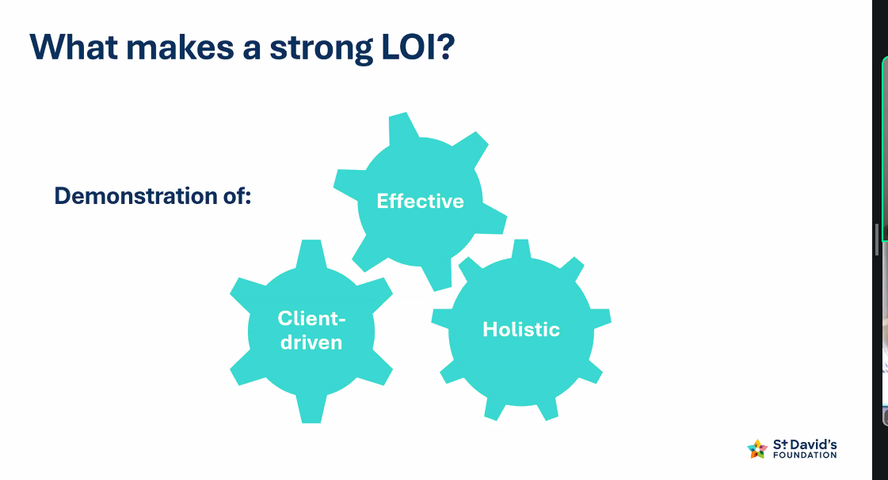
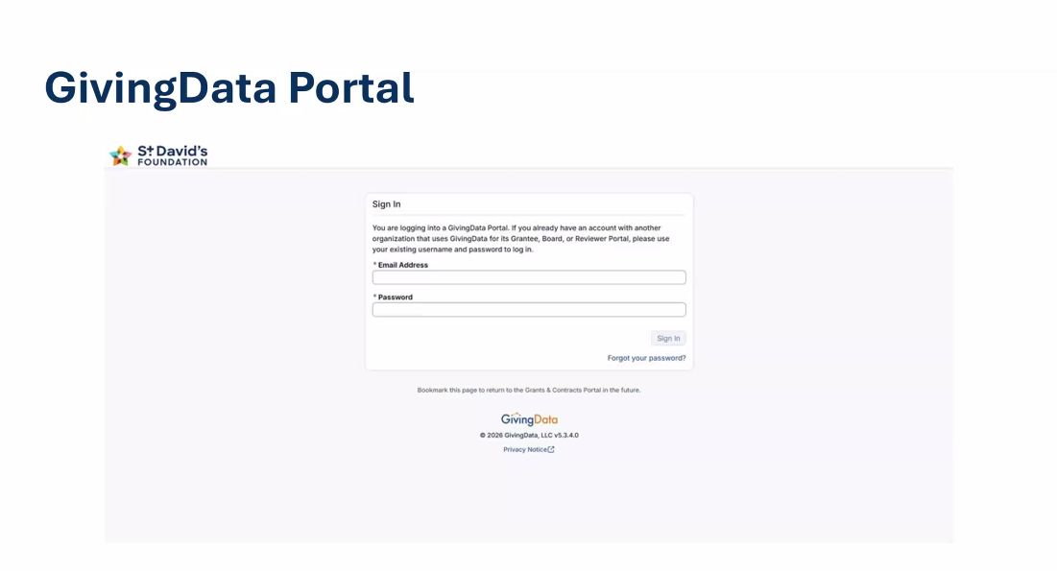
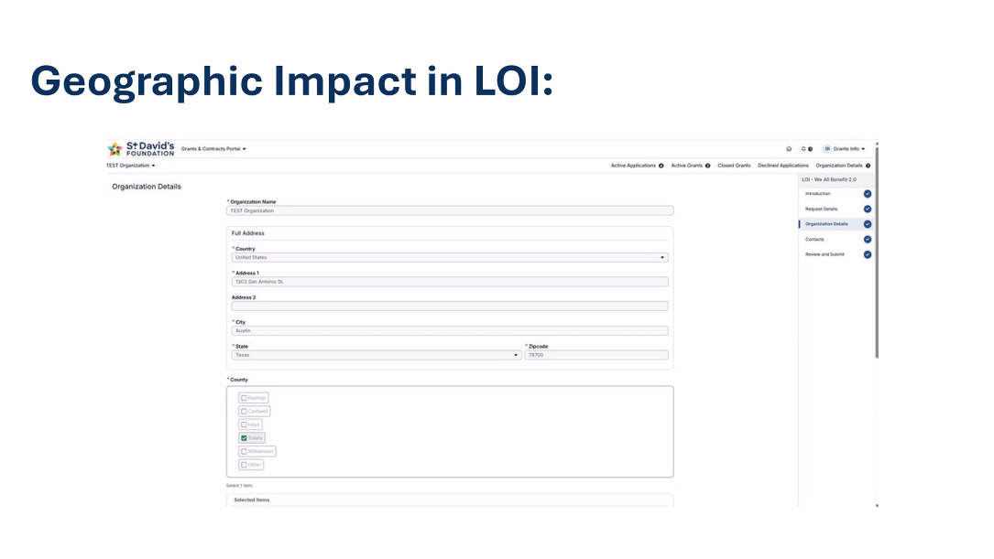
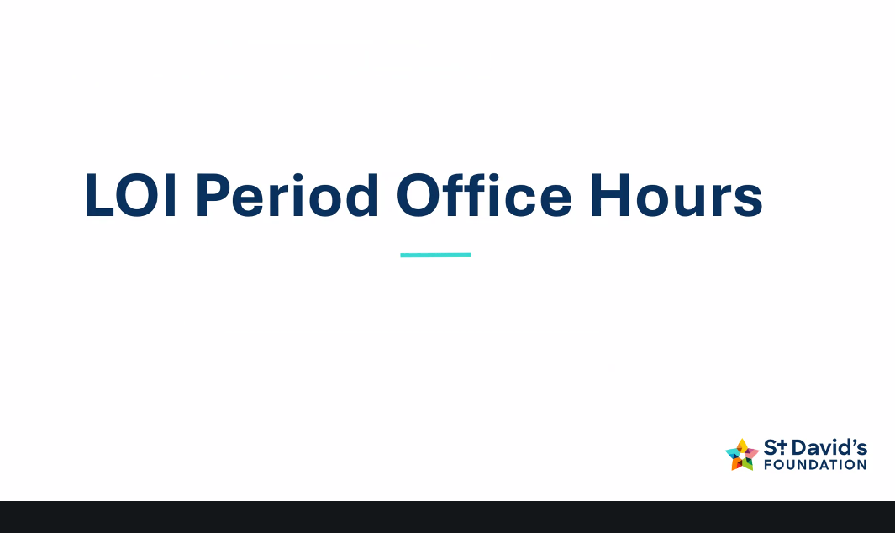

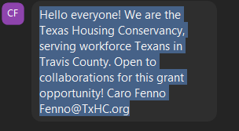
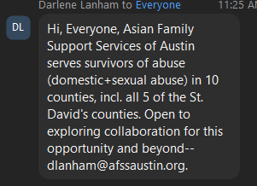
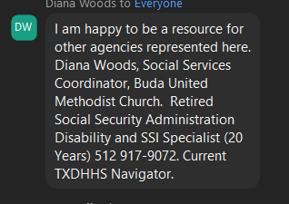

Skip to main content
Download Otter for your meeting notes
+5
Login
We All Benefit 2.0: Building Economic Stability LOI Phase Informational Webinar
Jennipha RicksToday at 11:01 am
20 screenshots
So let's record,
recording in progress.
All
right. My name is Claire frankenfield. I'm a program associate here at St David's foundation. Before we dive in, we want to take a moment to acknowledge everyone on this call, whether you're a volunteer or a program director and executive director, a board member, a staff member or civil servant, the passion and compassion that you bring to Central Texas communities makes a real difference. We don't take that for granted here at St David's foundation. So thank you. Thank you. Thank you for the work that you do and continue to do at your organizations and for the communities that you serve. We also want to name something that we think everyone on this call is feeling. This is a hard moment for the sector.
Demand for services is up, the funding landscape is stretched, and organizations that are doing some of the most important work in our communities are being asked to do a lot more with a lot less. And what that means for all of us, funders and organizations alike, is that we have to think differently about how we work and how we fund and how we show up for communities together. So that's a part of what we want to talk about today, not just this specific funding opportunity, but the bigger context that it sits in. And with that, I want to hand things over to Corey and Kim, who will be facilitating our time together today. Corey and Kim take it away.
Thanks so much. Claire, hi everybody. My name is Corey hadamer, and I'm a Program Officer here at the Foundation, which means that my work includes supporting our grantees and supporting our grant making processes. I just want to echo Claire's gratitude and acknowledgement of the moment we're in and the vital ways that everyone on this call is showing up for our community. I see you and deeply value the work that you do every day.
Great. Thanks, Corey and Hello everybody. I'm Kim McPherson, Senior Program Officer with the St David's Foundation, and my role is really to help steer the Foundation's work around economic stability, which is where this call sits.
And
just like Claire and Corey, I want to echo both our gratitude for you taking the time to learn about this funding call. But regardless of whether this call is the right fit for your organization, just want to thank you for the work that you for the work that you do on behalf of the of Central Texas. So appreciate it next slide.
And so our promise to you is that by the end of the day, we really hope that we have helped you understand a little bit more about this funding opportunity, particularly what we're trying to achieve, and why who this is and isn't a good fit for and then what applying looks like, what's the timeline, how you go and get additional questions and answers to your questions.
But
before we get into all those details, we wanted to ground this a little bit more into the foundation strategic vision. And so next slide here, you can see our vision and direction for our new strategic plan, which I think many of you on this call have probably had time to engage with, but for those of you that haven't, we've set aside a mission to advance health equity in Central Texas, and our vision is that Central Texas is a vibrant and inclusive community where every individual can reach their full potential next slide.
So
our strategic plan, which is called Pathways to health equity, really leans into the fact that we all know, which is that healthcare or health is way more than medical care.
It's influenced by where you live, what you eat, whether you feel safe, and the degree to which you feel agency to control the things that are really important to you.
And
so in other words, our strategic plan is really trying to lean into the fact that health, wealth and community agency are all highly interdependent, and our strategic plan reflects this. And you can see in the graphic there that all of our work is driving to health equity, but we've named three very specific pathways to get to that health equity destination, and those are clinical care, economic stability and community agency, and this funding opportunity sits right in that economic stability goal and pathway Next slide.
So wanted to kind of pull back now that you have that strategic vision and explain a little bit about our thinking as we were developing this call in alignment with a strategic plan. And the call really reflects two things. It reflects what we heard from community in the past couple of years and what data is telling us about the state of the social safety net. So first, what we heard from community, we did a project in 2024 called the Community Voices project. You can find it on our website. It has really rich information from our community members about what they are experiencing, what their dreams are, and how services are showing up for them, and some of the most salient points really influenced how this call was shaped and designed, and you can read those on the screen, and I'm just going to pause for you to do that.
But they're really powerful about putting human back in Human Services, the importance of agency and people's desire not just to survive, but to thrive.
The additional piece that informed this call was sort of, was the data piece. What do we know from actual data? And what we know is that we have a really, really important social safety net that is not working for everybody.
We know that we've got a lot of people who are eligible for benefits but who aren't enrolled, so the safety net cannot work for them. Specifically, we know about half of the people who are eligible for SNAP aren't receiving it, and about 20% of the people eligible for the Earned Income Tax Credit aren't claiming it.
So our belief started that if we want to create economic stability for our community. We've got to start with the public benefits infrastructure, as imperfect as it may be, and so sorry I'm seeing that there's an echo. We're going to do our best and try to work with it. So we're starting with the public benefit infrastructure, recognizing that many people who are eligible aren't enrolled. So our goal in this call is to really close that participation gap, so that anyone who can benefit from public benefits and wants to be enrolled can get enrolled. And so we believe that there's a real power to closing that participation gap. There's a link in the in our funding call that you may have seen. There's a report by Urban Institute called state of the safety net, and it found that if everybody who is eligible for public benefits in Texas was participating, our poverty rate would drop by about 40% so we're really leaning into the public benefits as not the only way to increase public or economic stability, but a critical first step.
And so what we know about the public benefit system is it's definitely shaped by federal policy, but the quality of local administration and assistance is also really important. We have limited influence over federal policy, but we do believe with these grants that will make through this, we can really influence and improve the role of public of local administration and assistance. And so that's the goal of this call.
And last week, one of our community members, veronda Durden, was getting an award, and she said something that really stuck with me, so I want to share it with y'all. She said, systems matter, but how they show up for families matters even more, and so that's really the spirit that's informing this call. We know we have a public system that we want to fully leverage and maximize, but we know that the quality of that help and how friendly and consumer centered it is really matters as well.
That is the why of the call. And then next slide. Now
I'm
going to hand it over to Corey to talk a little bit more about some of the details. Great. Thanks, Kim, so let's dig into the details of this funding opportunity and what it looks like. So our goal with this funding is to increase community members economic stability by better leveraging public benefits, specifically income supports, including the Earned Income Tax Credit, Child Tax Credit, SSI and SSDI, food security, including SNAP and WIC and health care access, including Medicaid, CHIP and Marketplace coverage. These programs exist to help people, but existing and being accessible are two very different things. Enrollment is complicated, and staying enrolled can be just as hard as getting enrolled, plus recent federal policy changes have made all of that harder. The work of public benefits navigators has never been more difficult, and it's never been more necessary. A key lesson from our we all benefit 1.0 grantees who have been working over the past 18 months to enroll more people in health insurance benefits is that while the path to public benefits has narrowed, it has not closed. What makes the difference is personalized, trusted support from someone who knows how to navigate the
system and who the community trusts. So through this three year funding opportunity, we hope to increase the number of central Texans enrolled in public benefits they're eligible for, strengthen community hubs and culturally responsive practices that address the fears administrative burdens and other barriers that get in the way, especially for historically marginalized central Texans who have faced systemic barriers because of race, ethnicity, income, immigration status, language, geography, sexual orientation, gender and other factors. And we also really want to increase the Co Location and coordination among service providers that reduce the barriers for community members, so it's easier for people to get the help that they need.
So
let's take a minute and talk about these specific benefits. So as I mentioned on the previous slide, the three buckets our income supports, food security and healthcare access. I want to know don't need to help community members enroll in all of these benefits to be eligible for this call, but you do need to help them access at least one of these to be eligible for this call, and your application will be stronger if you help with multiple so let's talk a little bit about what that can look like in practice, knowing there are a lot of different ways to do this work. So looking at income supports, many organizations across the country participate in the VITA program to offer free tax preparation in their communities, and that's a great way to help more people claim the earned income tax credit and Child Tax Credit, which are refundable credits that put more real money back in people's pockets. We love to see more of that work across our five county service area. And another example within affordable housing communities, we know that many case managers conduct benefit screening and enrollment, including for SSI and SSDI, maybe to help residents who aren't able to work access, income and health coverage, thinking about food security. Maybe you're in a food pantry, and with this funding, you want to hire or train someone to help clients apply for SNAP or perhaps many of the families you serve are uninsured. You could use this funding to hire a benefits navigator or partner with an organization that has that expertise so the families you serve can get connected to health coverage through Medicaid, CHIP or the marketplace at an organization that they already know and already trust. So these are the kinds of models we want to fund through this call. I also want to note that if awarded, you can use this funding to support and complement benefits enrollment, such as providing emergency food or direct cash for someone while they're waiting for SNAP or maybe paying for transportation for people to travel to their appointments. We're looking for models that include Benefits Enrollment for one of these benefits, but also serve people in a holistic and client driven way.
So
I'm going to note the regional differences. We serve a five county area, and so we want to fund this work in all five counties we serve. That includes Bastrop, Caldwell, Hayes, Travis and Williamson counties. We also recognize that benefits, enrollment infrastructure looks really different across these five counties. So notably, Travis County has much more existing benefits enrollment capacity. So we're focused there on strengthening that capacity. And our other four counties fast drop, Caldwell, Hayes and Williamson, that infrastructure is a little bit thinner. So we're thinking about ways that we can build and expand capacity for benefits enrollment through this call. That means, if you're based on one of those counties and aren't yet doing benefits enrollment, that's okay, but you do need a plan to add benefits enrollment in some capacity, and your application should speak to how your current experience providing different safety net services really will help you leverage that kind of expertise and connection to your community to build enrollment capacity, whether That's internally or through a strategic partnership. When we review LOI, we won't just be looking at individual organizations. We're going to be looking at the context of each county, so looking at what's already there, what's missing, and where this funding can make the biggest difference, and helping community members increase their financial stability through effective benefits, enrollment and holistic support.
Thanks.
Corey, so I'm going to give you just a very high level sort of the scope and size of the funding opportunity. As you can see, there's no minimum reward size. We've got $35 million to spread over three years, and so what that is, is about 12 million a year, and we expect to fund about 20 ish grants in this funding opportunity. It's a one time flexible award. And let me just break down some of those words, because they may not mean much to you. One time means that we do not, at this point expect to reissue this call. So as you're thinking about submitting an LOI or potentially a full application for the call, really think about, if you're starting new services, how you would continue to fund those ongoing expenses after the grant term is done. So one time, just really think about that. And flexible is super exciting. It means that we really trust you. If you're funded, we want you to get to the impact that we're intending, and you have lots of discretion about how to get that we're not going to be getting in the weeds of this dollar here, that dollar there. You've got flexibility to achieve your impact in terms of expectations. These are the typical ones. There'll be regular grant reporting, or grant reporting is relatively simple, and then we do really want to lean into the learning piece of this. We're hoping that the cohort selected for this can inform our learning going forward in terms of the type of actions and future investments we make. We also are really hoping that that cohort will facilitate learning across the cohort members, so that people doing one type of benefit can really share what they've learned with others next slide,
and
then eligibility? We know this tends to be the biggest question that's asked, so we've tried to break it down, and I'm just going to acknowledge that some of these eligibility pieces are a little bit nuanced. The first couple are pretty straightforward. To be eligible for this, you have to either be a 501, c3, or using a fiscal sponsor that is public entities local governments, can apply only if they are part of a collaborative. They cannot apply individually on their own, but if part of a larger collaborative, they're eligible. Work has to be done with historically marginalized communities in one of our five counties, Bastrop, Caldwell, Hayes, Travis or Williamson, if you're not operating in one of those five. This is not the call for you.
The other pieces that you really need to be doing core services that support economic stability in a prompt way. So what we're really looking for is that the work that you are doing can promptly translate into economic stability for our local community members. So that's the basics of the eligibility criteria. A couple other things that come up are questions like, well, I currently have a grant. Can I apply? The answer is, yes. I've never gotten a grant. Do I need to have some special thing to get one? No, if you've never gotten a grant, you can still apply. Another thing that's important to recognize is this work is about both maintaining important services that are already happening and building and strengthening work so you can be applying for new work that you have not yet launched, or work that is already happening that's eligibility. And then, oh, the other thing is, you know, Corey will talk more about this, but we've really opened this up so that you can apply as an individual organization or as a collaborative. We'll talk more about what makes a good collaborative, but know that both of those pathways are open
to you, next to key dates. So we I realize many of you on this call probably haven't even had a chance to review all of the funding materials, because they just got dropped on Monday. So here we are two days later, as you will hear more of our application process is a two step process, LOI, first, if your LOI is selected, then full application. The most important thing that I hope you walk away from today with is LOI. ZR, do on April 27 I'm sorry we can't accept late ones, but So April 27 is the LOI date. That's about four weeks away. So we hope that that gives you plenty of time to start thinking about whether this is a good fit, whether or not you want to apply as a collaborative and if so, who that might be with.
And then the last thing I'll say is just kind to yourself, like, don't wait to the last minute. Go ahead and get familiar with what you need to do and plan on submitting a day ahead, if you can. Just so any last minute glitches don't cause all of your hard work to be for naught.
Okay,
so let's dive in a little bit to the LOI, letter of intent, which is the first step in this process. We made a deliberate choice to make this an open call, rather than inviting specific organizations. We do know many of the organizations doing this work, but we don't know all of them, and an open call helps us, helps us make sure that the door is open for any organization aligned with the call goals. It also gives us more visibility into our community assets and partners, but we know that applying takes time and writing a full proposal is a significant investment, so we don't want organizations spending weeks on something before we've had a chance to signal whether there's alignment. And that's what the LOI is for. It's a lighter touch first step where you share your high level idea, who you are, what you're proposing, and why it fits this call. We're not asking for a work plan or a budget at this stage. So once you know what you want to propose submitting the LOI should be a relatively brief process, and then LOI that strongly aligned with this call will be invited to submit a full proposal. And we'll host a second webinar on May 20 for organizations who are invited to submit a full application, to talk a little bit more in depth about what that specific process looks like two practical notes about the LOI. First, you can submit multiple LOI if each one represents a distinct program or project. We're not looking for variations on the same work repackaged a separate submissions. It needs to be distinct. And second, multiple programs within a single organization can submit an LOI. Again, if the work is genuinely distinct. So as Kim mentioned, the LOI is open now, and the deadline, deadline to submit is Monday, April 27 at 5pm Central Time. Like him said, We cannot accept late submission. So please make sure your LOI is in by then and don't wait to apply.
Okay,
let's go to the next slide and talk a little bit about kind of once you get into the LOI, what are we looking for? This is the question and the LOI, or the prompt and the LOI, as you see, the LOI really is a wide screen. That's on purpose. We're not making final funding decisions at this stage. When we're reviewing LOI, we're trying to answer two questions. One, Does this meet the eligibility criteria, and two, does this align with the goals that we have for this funding opportunity? I also want to note that advancing past the LOI stage doesn't mean that you're getting funding, or it's not a guarantee of funding. It means you've cleared that initial bar,
even though this is a relatively light lift. We hope. We do want you to think carefully before you submit an LOI and really ask yourself, honestly, does this opportunity align with your mission, the strengths of your organization and what your community needs? Right now, the LOI and full application materials are already posted on our website, so you can take a look at those and start to plan out. Okay, if we're a good fit, do we have the time to invest in this? Does it feel like a good fit for us and worth that investment of time? I also wanted to re emphasize something that Kim said, that this doesn't have to be new work. We expect that many of these proposals are going to be about nurturing or growing or refining something that already exists. You don't need to invent something to be competitive for this funding. I also want to reiterate what Kim said about this thing one time funding, there's no guarantee that this exact opportunity will be available again in the future, and we don't say that to create any sort of pressure, but we do want to be transparent about what you'd be taking on. So please think carefully before using this funding to incur significant new expenses that will continue beyond the three year term of this grant.
So
in terms of how we evaluate LOI, we're really focused on this one central question. Does your approach have the potential to help historically marginalized central Texans enroll in benefits and become more financially stable? We'll be looking at this potential impact through three lenses. Is the approach, client driven, holistic and effective, and we'll dive in a little bit more on the next slide about what that looks like.
Okay, so what makes a strong LOI? Let's walk through what we mean by each of these terms and what we mean by demonstrate since, as you noted in the fine print on the last slide, we're asking that you keep this to about 500 words.
So client driven for us means that your services are built around the people you serve, and not the other way around. Does your staff speak the languages of the communities that you work with? Do you understand the specific concerns that people may have about enrolling in public benefits, maybe fears about immigration status, past experience with government agencies, with distrust in systems that is completely earned. Also our clients treated with dignity and given honest information so they can make decisions based on what's best for their own lives. Holistic for us means that you understand that benefits enrollment does not exist in a silo, and you're really thinking about the whole person. You connect clients to other resources they need, and ideally not just through flyers, but through warm handoffs and real relationships with other safety net partners.

For an example, an organization helping someone enroll in SNAP hopefully also provides food or emergency rent assistance while benefits are pending, if that's something that clients need.
And then effective, when we say effective in this context, we mean that you have the expertise and the track record to actually help people enroll in benefits so your staff are trained on benefits, and you have real data that shows how you've been helping folks enroll in benefits, and how, specifically for organizations in Travis County, we're going to be looking at whether or not you're part of the HHSC community partner program, ideally as a level three partner, as an important signal, but not a disqualifier, especially if you're focused on SNAP and Medicaid that are administered through HHSC. And then when we say demonstrate, we mean show us. Don't just tell us. It's easy to write that your approach is client driven or it's culturally responsive, but we're looking for the evidence, enrollment numbers, a story that illustrates what your model looks like in practice, or maybe a specific way that you've adapted your work based on community feedback. We're not looking for buzzwords. We're looking for organizations that can demonstrate their potential for impact.
Now I'll turn it back over to Kim to talk about the rest of the process.
Okay,
you've seen this timeline before the LOI, as we've said, Do April 27
and then the other piece to say is that you will be notified by May 15 if your LOI is selected to move on to the full application status. I just want to highlight that date, because if you haven't heard from us, reach out. We don't want to your approval to move to full application to be lost in your spam filter, which has happened sometimes. So those are two dates to know. The other thing to sort of recognize here is that we've really tried to gear what we're telling you now to be about the LOI process. If you are selected, we'll do another webinar that dives much more deeply into the full application, and we'll also be making some office hours available for that. So just know LOI is the focus here. That is due on April 27 you'll be notified on May 15.
Next
slide, okay, so the giving data portal. So here is the deal, the only way we can accept your request for grants is through the giving data port. Giving data portal, I am a person who does not love portals. The word password gives me high so if you are like me, I feel you and I am sorry, but this is the only way we can accept applications. I will also say that if you run into any trouble with the portal, our staff are amazing. They deal with me. There is nothing you can throw at them that they cannot help you with. So if you're new to the St David's foundation and haven't used our portal before. Take a little bit of time up front to get familiar with it. Make sure you can access it. You've got all the right passwords. Reach out again. Don't create stress for yourself.
And then next slide.
Thank you. So this is an important one. Corey and I think have both said earlier that what we're really trying to do on this call is to make sure that we are improving the Benefits Enrollment infrastructure across our whole region, and that means that we really want to improve it in each county by locally driven work. And so we really need your help on this, because when we are looking at the LOI that come in, we're going to be looking at them with a geographic lens, and so you're going to be asked a question about what geography benefits from your proposed work.
It will be immensely helpful to us if you're specific in that, what we've noticed is there's a pattern where people, very correctly, say, Gosh, my work affects people from all kinds of counties. I'm going to check regional for this particular call. We really want to be specific about where the vast benefit of your work is occurring. So if most of the people who benefit from your work live in Hays County, even though some may be from Travis, some may be from Caldwell. Please put hates. If you really are distributing your work equally among all five counties, that's really the only time you should be selecting regional and again, this is just to help us. There's no penalty. If you get it wrong, we'll reach out if something doesn't look right. But our goal really is to make sure that we are funding in every single county, recognizing that the county infrastructure looks different, as Corey said. So you can help us do this by being as specific as possible on this question and next slide.
So we are introducing something that we've done in the past. We're calling them office hours. And I'll be honest, we're super excited about it, because some of the funnest parts of our job are talking to people like you about what you're seeing, what you're trying to build, what challenges you are encountering. So the office hours are really meant to help you answer a couple things. Is this, am I eligible for this? Is this a good fit for my organization? And we're going to be as clear as we can be in these we're not going to be
giving information that you can't find on our website through reading the call and associated links. But we also get that sometimes just reading something doesn't make it come alive. So if talking to a real human being is helpful to you and answering those questions or making the office hours available.
Get automatic meeting notes
Sign up for freeLog in
Stop Notetaker
38:20

