


CITY OF SAN ANTONIO

EARLY LEARNING LANDSCAPE

Report
A Comprehensive Report on Early Learning and Community Voices

January 2025
Authors:
Melissa M. Jozwiak, PhD Hatice Z. Inan, PhD





Disclaimer: The contents of this report are final. Print layout subject to change. The views expressed in this publication do not necessarily reflect the views or policies of the City of San Antonio or Texas A&M University San Antonio.

Acknowledgement: The development of this report would not have been possible without the help of the City of San Antonio staff who assisted us in connecting with essential personnel and constituent groups. Additionally, the larger early childhood community used their coaching and support networks to encourage broad participation. Finally, we are grateful to the community members and early childhood advocates who helped us connect with the families and staff. Their introductions to neighbors, childcare providers, and professional contacts ensured that this study captures voices from across our community.

Prepared by:
Texas A&M University – San Antonio 2
For:
The City of San Antonio



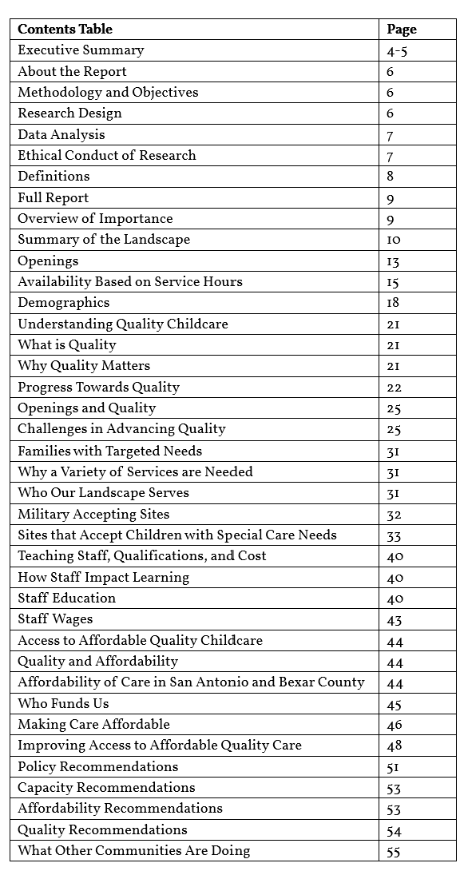
Table of Contents

3


Executive Summary
The current landscape of early education services in Bexar County and San Antonio can be characterized as developing. There are many highlights to be celebrated and much work to be done. As one of the 10 largest cities in the United States, San Antonio faces a significant challenge in ensuring its residents have access to high quality, affordable childcare for the 132,355 children under the age of five residing in Bexar County.

Bexar County currently has a maximum allocation of 87,217 early learning seats for children under the age of five in externally evaluated and regulated Early Learning Sites. However, survey data reveals that these providers are only operating at 70% of their maximum capacity. The result is an adjusted early learning seat capacity of 61,052 seats for Bexar County. For over 71,000 families in Bexar County, this means their choices are limited to exiting the workforce or relying on family members, friends, neighbors, or non-regulated sites to care for their children under five.

The gap between what agencies such as the Texas Health and Human Services Child Care Licensing agency reported as licensed childcare center capacity and what the sites themselves have reported as capacity can be caused by a number of factors. This research identifies the reasons for the lower capacity include a commitment to offering quality care that requires smaller group sizes, difficulty in finding qualified staff, restrictive regulatory standards, and financial barriers.

Study participants reported that their programs had openings available to families. However, 55% of these openings are for preschool age children, 28% for toddlers, and only 17% for infants. Families seeking high-quality sites face a greater challenge when compared to families open to a site developing in quality. Only 3% of all seats are open are at high-quality sites.

Families with infants, children requiring special care, and military families all face limited options for childcare. Families needing non-traditional care hours encounter the greatest challenge, as 93% of sites operate between 6:00 a.m. and 6:59 p.m. Less than 1% of sites offer overnight or weekend hours.

San Antonio has made important advancements in the quality of care available within the community. Currently 62% of sites participating in the Texas Rising Star program are rated at the highest level of quality (4-Star).

4


Unfortunately, only 29% of Licensed Centers, Registered Child-Care Homes, and Licensed Child-Care Homes participate in the Texas Rising Star [TRS], Quality Improvement Rating System [QRIS]. For programs aiming to improve their quality, hiring staff with at least a Child Development Associate [CDA] credential is the most challenging barrier, regardless of program demographics. The research shows that only 37% of infant staff have specialized training (CDA credential or college coursework) to prepare them for working with children.

Quality Improvement Rating System [QRIS]. For programs aiming to improve their quality, hiring staff with at least a Child Development Associate [CDA] credential is the most challenging barrier, regardless of program demographics. The research shows that only 37% of infant staff have specialized training (CDA credential or college coursework) to prepare them for working with children.

The desire to improve quality is further complicated by budgetary limitations that suppress staff salaries, especially for those working in non-governmentally funded programs. On average, staff in these programs earn $1.94 less per hour with infant staff earning an average wage between $12.90 and $15.34 per hour. Preschool staff typically earn more per hour with an average range between $13.92 and $17.11 per hour.

Early Learning Sites are striving to balance the cost of quality while providing affordable care. Many sites offer discounts for families with children who have special care needs, military families, and employees. Additionally, they provide discounted or free tuition through externally funded programs, such as Texas Workforce Commission Child Care Scholarships or Military Child Care in Your Neighborhood. Despite these efforts, the cost of care remains high. Infant tuition can reach up to $2,200 per month, with an average ranging between $861 and
$1,126 per month, depending on quality.

Taken together, this research highlights the need for the City of San Antonio and Bexar County to carefully consider policy advancements in the following three areas:

Capacity: Expand high-quality infant care options and increase funding to help facilities meet quality standards.

Quality: Improve educator compensation and establish professional development pathways to enhance access to professional degrees.
Affordability: Advocate for increased state, federal, and local subsidies to reduce financial burdens on families. Additionally, develop a public website that allows families to view and compare childcare pricing alongside information about subsidies they may be eligible to apply for. 5

About the Report
This report provides a comprehensive analysis of the early childhood education landscape in Bexar County and San Antonio, Texas. It aims to identify key challenges and opportunities related to childcare access, quality, affordability, and workforce development. The findings are based on a mixed-methods approach, incorporating:
- Quantitative data from surveys distributed to childcare providers.
- Qualitative insights from 75 focus group interviews with parents/guardians, caregivers/teachers, administrators/owners, and community stakeholders.

By combining data and lived experiences, the report offers actionable recommendations to support children, families, and early childhood professionals in achieving high-quality educational outcomes.

Methodology and Objectives:
This mixed-methods study provides a detailed, evidence-based understanding of San Antonio's early learning landscape, enabling targeted recommendations for policy and program improvements.

Objective 1: Provide a baseline assessment of the availability of affordable, high-quality early learning and care in San Antonio and Bexar County.
Objective 2: Estimate the gap between licensed capacity and actual availability of seats by age category, cost, quality rating, special needs status, geographic location, and provider type.
Objective 3: Examine the current level of staffing and what effects, if any, staffing shortages have on the availability of affordable, high-quality early learning and care in San Antonio and Bexar County.

Research Design:
- Qualitative Data Collection: A total of 75 in-depth interviews were conducted with 41 owners/administrators, childcare providers/teachers, and/or parents/guardians. These interviews captured diverse perspectives on challenges such as staffing, capacity constraints, and affordability. Onsite, semi-structured, open-ended questions were used to explore nuanced responses, allowing for a comprehensive understanding of participants’ experiences and viewpoints.
- Quantitative Data Collection: Surveys were distributed to all Texas Health and Human Services Child Care Licensing [CCL] childcare entities in Bexar County. Additionally, all public, private, and charter schools serving children prior to kindergarten entry were invited to complete the survey. Survey reliability was established through a test-retest Intraclass Correlation Coefficient [ICC].
- Quantitative-Qualitative Integration: Interview findings were analyzed alongside existing quantitative data to complement the other and provide a more comprehensive understanding.
- Triangulation of the Data: The inclusion of voices from all three key stakeholder groups—namely, childcare administrators/owners, parents/guardians, and caregivers/teachers—provided a comprehensive perspective. These stakeholders represented diverse types of early learning settings, including public and private schools, programs serving military families, and facilities accommodating children with special needs. Caregivers and teachers with varying educational backgrounds and experiences were also included, further strengthening the triangulation of the data. Interviews were conducted across a wide range of ZIP codes within Bexar County to ensure representation from different areas of the city. Additionally, findings were cross-verified with quantitative data and relevant literature to ensure accuracy and reliability.
- Quantitative-Survey responses: 214 viable responses were used.
- Qualitative-Interviews: Total 41 Individuals-75 Interviews were conducted. 6

Focus Group Participant Distribution

Administrators | Teachers | Parents
Charter Schools: 2x2 Licensed:  Center: 6x2 Before/After and School Age: 3x2 Licensed Homes: 1x3 Listed Homes: 1x3 Registered Homes: 4x3 PreK4SA: 2x2  Private:  Faith Based: 2x2 For Profit: 2x2 Head Start: 2x2 | Clock Hours Only: 3  Child Development Associate Certificate: 2  Associate’s Degree: 1  Bachelor's Degree: 2 | No Childcare: 2  Licensed Childcare: 1  Licensed After/Before School: 2 Typically Developing Child: 1 Child with Special Needs: 1 Licensed Family Home: 2 Military Parent with Infant: 1 Military Parent with Toddler and Preschooler: 1
Data Analysis:

- Quantitative: Quantitative data analysis was conducted using IBM-SPSS software. Data was cleaned and sorted removing any duplicate responses and those with a completion percentage below 20%. The resulting 214 responses were analyzed using descriptive statistics. Survey respondents accounted for 27% of the total number of providers and 34% of the reported seats in Bexar County by the Department of Health and Human Servies as a Licensed Center, Licensed Child-Care Home, or a Registered Child-Care Home.

- Qualitative: For thematic analysis, interview transcripts were reviewed, coded, and categorized into themes based on the research questions. Common themes included staffing shortages, financial challenges, accessibility gaps, and quality enhancement strategies. For cross-comparison, emerging themes were compared across participant groups to identify discrepancies and shared challenges, offering a layered understanding of the issues.

Ethical Conduct of Research:

- Participant confidentiality was maintained throughout the study.

- Informed consent was obtained, and surveys/interviews were conducted in a manner respectful of participants' time and comfort.

7

Definitions

Developing Quality- A site that has not been evaluated for quality, is not nationally accredited, or is rated below a Texas Rising Star “4-Star” rating. It is important to note that sites designated as “Developing Quality” may provide excellent care and demonstrate behaviors and practices that are indicative of high-quality.
However, because confirmation of that quality has not occurred, or they are advancing towards the highest level
of quality, they are designated as “Developing Quality.”
Early Learning Site [ELS] refers to schools, centers, or homes that provide early learning and care for young children from birth to school age.

Government Funded- In this research, sites classified as Government-Funded included sites receiving Head Start, Early Head Start, EHSCCP, Texas Education Agency [TEA], or local government funding (e.g. PreK 4 SA).

High Quality- A site that has reached the highest level of quality possible based on the Texas Rising Star system (4-STAR) or National Accreditation standards.
Infant-Serving- Refers to sites that provide care and early learning services specifically for infants, typically defined as children from birth to 12 months of age. These sites may offer specialized environments, equipment, and staff trained to address the unique developmental and caregiving needs of this age group. To be classified as “Infant-Serving,” a site must have reported at least one infant attending or be listed on the CCL database as serving infant-aged children.
Military-Serving- Refers to sites that reported having military families currently attending the program, offered military discounts, prioritized enrollment based on military status, or accepted military funding.
Non-Government Funded- In this research, non-government funded [NGF] programs are those who do not receive Head Start, Early Head Start, EHSCCP, TEA, or local government funding (e.g. PreK 4 SA). They may receive funding from a sponsor agency who is not a government entity. Sites enrolling Texas Workforce Commission CCS funded families are not excluded from this category due to the source of this scholarship.
Seat- Refers to a single opening at a site that a child may be enrolled in. When children attend less than full-time. A single seat may be filled by two children however, the seat is still only counted once as no more than one child may fill it at any given time.
Site- Sites refer to schools, centers, or homes that provide early learning and care for young children ages birth to school age. Early childhood sites are sites that offer care to children prior to school entry. Also referred to as an Early Learning Site (ELS) when serving children prior to school entry.
Special Care Needs- Texas Department of Health and Human Services defines special care needs as “a chronic physical, developmental, behavioral, or emotional condition or a disability that requires assistance beyond what is typically needed by a child of the same age. This includes help with tasks within the typical developmental range, such as gross or fine motor skills, learning, talking, communicating, comprehension, emotional regulation, self-help, social skills, emotional well-being, seeing, hearing, and breathing. It may also refer to limitations caused by an injury, illness, or allergy.”
Special Needs-Serving- Refers to sites that reported accepting or providing care and early learning services for children with special care needs, including physical, cognitive, emotional, or developmental disabilities.
8


9

Overview of Importance:
FULL REPORT
THE CITY OF SAN ANTONIO EARLY LEARNING LANDSCAPE
Understanding Capacity and Access to Early Learning Sites in San Antonio, TX A Comprehensive Report on Early Learning and Community Voices
According to the 2023 American Communities Survey[i], Bexar County is home to over 132,355 children under the age of 5. Access to reliable childcare is essential for parents or guardians to seek external employment or pursue educational studies. Employers are dependent on a reliable supply of employees. Without sufficient access to childcare, potential employees who are of the childbearing age are limited in their ability to participate in the workforce; thereby, limiting the economic growth of the community.

Before the pandemic, the stability of the workforce for much of Texas and Bexar County was compromised by the presence of childcare shortages. The resulting childcare deserts represented areas wherein a zip code had more than 30 children under the age of 5 and no childcare availability[ii]- or so few providers — that there are more than three times as many children than licensed childcare slots[iii].

In 2019, Bexar County and predominantly south Bexar County had high numbers of childcare deserts. These deserts grew by 50% across the state from August 2020 to August 2021[iv] negatively impacting economic growth of the area. The determination of a childcare desert is based on U.S. Census data for the region compared to maximum licensed capacity for a childcare facility. As these maps are drawn based on a childcare provider’s maximum licensed capacity, not the number of actual seats available at any given time, these maps underestimate the severity of the problem. Health and safety protocols, a commitment to quality, as well as staffing shortages have forced many childcare facilities to operate on a much smaller scale, thereby contributing to the underestimation of this problem. Additionally, the maps reflect potential enrollment openings as a single unit without consideration of service times. The availability of services for families who need childcare during non-traditional hours or on a flexible basis are not fully represented in these models.

To fully understand access, quality, and affordability, this research examines the enrollment capacity available to the San Antonio and Bexar County communities at a given point in time, as well as the scope of services, service times, and enrollment patterns. For families in Texas and Bexar County, where childcare deserts have grown in the recent years, lack of available care options makes finding childcare extremely challenging, thereby making employment difficult. When a family finds care, cost and quality challenges remain significant barriers that complicate participation in the workforce or education systems. This research provides essential information on access, quality, and affordability as a conduit for change.

Summary of the Landscape:
To understand the current state of the early learning landscape in Bexar County and San Antonio, data from the Texas Department of Health and Human Services, National Head Start Office, and the Texas Education Agency [TEA] was used to calculate "agency-reported capacity” for 2024. When combined, Bexar County providers are estimated to have the potential to serve over 90,000 children, from birth to school-age, in Texas Health and Human Services Child Care Licensing- Licensed Centers, Registered Child-Care Homes, Licensed Child-Care Homes, Listed Family Homes, or public school buildings, including after-school programs. When after-school only programs are removed, there are less than 89,000 available seats for children from birth to kindergarten. Meaning, there is a care option for 66% of the children in Bexar County under the age of five.

Regulated Early Learning Sites [ELS] in Texas typically include sites that are regulated by the TEA if the site is operated in a public school buildings (including charter schools) or the Texas Department of Health and Human Services Child Care Licensing [CCL]. In communities such as San Antonio, where federal military bases are located, Federal Department of Defense [DOD] oversight may apply. Programs funded under Federal Head Start and locally sponsored programs (e.g., PreK 4 SA) typically[v] fall under the jurisdiction of these two agencies depending on the ownership, operation, and physical location of the program.

TEA TAPR reports identify 19,207 Bexar County children being served in early education classrooms in the Spring of 2024[vi]. Administration for Children & Families Head Start, Early Head Start and Early Head Start Child Care Partnership Services Snapshots including Spring 2024 reported 7569 seats allocated to Bexar County agencies. Department of Family Protective Services Licensed Childcare Centers (68010), Licensed Child-Care Homes (657), Registered Child-Care Homes (2026), and Listed Child-Care Homes (189) comprise the remaining capacity for San Antonio and Bexar County. To determine the number of regulated early childhood seats in Bexar County, licensed centers serving only children who are school age (2802) and listed family homes were removed (189). The figure below shows that the majority of seats for children in Bexar County are at non-governmentally funded CCL centers or homes.


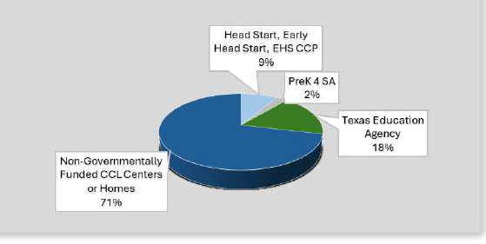
10
Distribution of Early Learning Seats by Provider Type

This figure shows how the number of reported seats are distributed when primary funding type is used to organize the data.

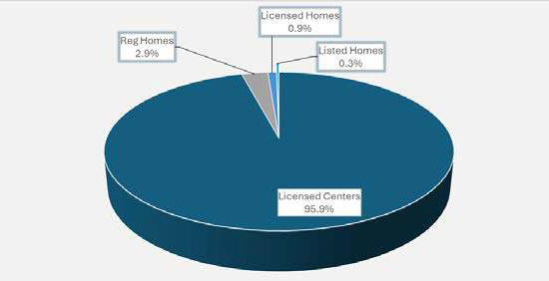
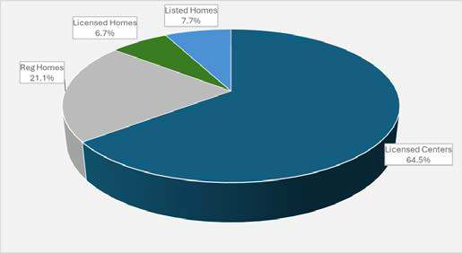
When sites under the jurisdiction of the Texas Health and Human Services Child Care Licensing are considered, Licensed Centers comprise the largest percentage of ELS and hold the largest number of seats for children.
Distribution of CCL Sites by Type Distribution of CCL Seats by Type

This figure shows the difference between the provider types when distributed by the number of Department of Family and Protective Services sites versus the number of seats each site is permitted to fill

To better understand the data that is reported by TEA, Texas Department of Family and Protective Services, National Head Start Office, data from the landscape study is shared below. Taken together, they provide an increasingly accurate understanding of the true current state of the early learning landscape in Bexar County.

The inclusion of the landscape data is essential because not all sites included in the maximum capacity are operating at their agency-reported capacity. The lower operating capacities result from a mix of circumstances and challenges. These include the need or desire to maintain higher standards for quality care. For example, the National Association for the Education of Young children Accreditation Standards require smaller group sizes than CCL licensed capacity permits. Some experience difficulty recruiting families and are not able operate at their full capacity. Additionally, staffing shortages, and financial costs serve as the reasons others do not operate at their agency-reported capacity.

Recognizing that not all service providers operate at the agency-reported maximum capacity, this study examined the gap between the maximum capacity as determined by the licensing or regulatory agency (agency-reported capacity) and the capacity the provider determines as their highest operating capacity (site-reported capacity). This is not equal to current enrollment. Current enrollment was a separate measure. Site-reported capacity is the maximum number of children a site was willing to serve at that point in time. The impact of sites electing to operate at a lower capacity is significant.

When the agency-reported capacity is compared to site-reported capacity, the early learning landscape changes. Specifically, site-reported operating capacity for children birth to preschool is 69.7% lower than the agency-reported capacity. For survey respondents this removes over 6,800 seats from Bexar County’s capacity. When generalized across all providers, this represents over 25,000 fewer seats in Bexar County than currently expected and makes childcare available to only 46% of children under the age of 5. While some families select family, friend, or neighbor care for their child, survey data reveals over 71,000 children under the age of 5 do
not have a regulated care option available to them. 11


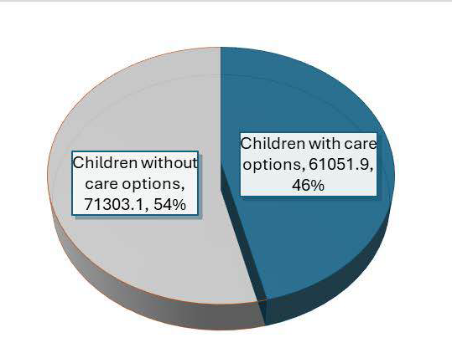
Qualitative data provides essential insight into why sites are opting for a lower capacity. Some providers choose to remain small to prioritize quality, while others face transportation and mobility issues. Providers also report parents’ unrealistic expectations for niche program models. For others, the decision to operate below capacity is based on demand. Some sites indicated they struggle to fill their licensed capacity due to restrictive licensing standards, licensing restrictions on the number of children based on specific age, staffing shortages, financial barriers, administrative barriers to programs, location, post-COVID issues, and parental misconceptions. They also indicated competition with public pre-K programs, uneven marketing efforts, and a declining birth rate as contributing to experiencing lower demand.
Care Coverage
This figure shows how reported availability of care applies to children under five in Bexar County.

From Providers:

Why They Are Not Operating at Capacity

“I like the small group that I have right now because, I mean the more children you have then you know, you want to provide quality time with them.”

"We've actually closed down the classroom recently because we have no children for that age group. […] the age group from three to five is what we have a hard time keeping.”

“At this time, we are operating below capacity right now. We're probably running between 75% and 80% capacity at this point. And one of the reasons why was prior to the last couple of months, we had problems finding qualified teachers that were able to work into our program. And because we didn't have enough teachers, we voluntarily took away some of our capacity or reduced our capacity until we were able to get those teachers in play.”
Families have observed the challenges providers face in finding sufficient and qualified staff that are necessary for them to operate at a higher capacity. Families share these insights. 12

From Parents:
Why They Are Not Operating at Capacity
"There is really high turnover within the teachers. You know, these people aren't compensated very highly. I get it. Child care is hard for anyone to afford even people with money. So um you can't pay those people a lot but that's, I don't know, just the culture sometimes of the employees. You can tell that they're not that into it or that they're not, you know, passionate about being there with the kids and that hurts. And then they seem to turn over pretty quick because they're not highly compensated and it's just a job."
"As an ESL parent, I struggle with language barriers when finding and assessing childcare options." (translated from a language other than Spanish to English – a parent who could not find a school for her toddler)
Importantly, staff shortages were a significant reason why programs were not operating at capacity. Teacher availability and teacher turnover both contribute to the staffing challenge. This teacher shares the complexity of the challenges they face to remain in the classroom serving children and why some leave.
From Teachers:
Why They Are Not Operating at Capacity
"Sometimes teachers might just need a break, you know, because sometimes you can get overwhelmed. Sometimes or you know or you just, a lot things going on in your work, in your life, at home, school, work, you know, trying to be a wife, a student, and work at your job. I think those might be the reasons why we’re short of staff sometimes or sometimes things just come up, you know, and like [what happened] with my husband, [it] was unexpected, you know, I didn't expect that would happen and I would have to leave my job."
Openings:
To fully understand the capacity of the early learning landscape, survey participants recorded the site-reported capacity, current enrollment, and current openings. The number of available openings varied by provider type and demographic qualities of the provider. The majority of openings are for preschool-age children and exist at centers with developing quality. Survey respondents reported a maximum of 3476 openings when age-group specific openings were aggregated. However, this data represents a limitation in the study as providers can fill one opening by at least three different age groups, thus resulting in a potential overestimation of openings. Further, the seemingly high number of openings can be misleading because it represents the city as a whole and does not reflect the geographic location of the openings. Limitations withstanding, those reported openings account for no more than 15% of the maximum capacity of the survey participants.

For those 3476 potential openings, when the quality of those openings is considered, the number decreases exponentially. Only 23% of all openings are at high-quality sites and 14% at non-governmentally funded high-quality sites, making it difficult for families to find high-quality early education and care for their child. When this information is generalized to all ELS in Bexar County, the capacity profile appears as follows.
13


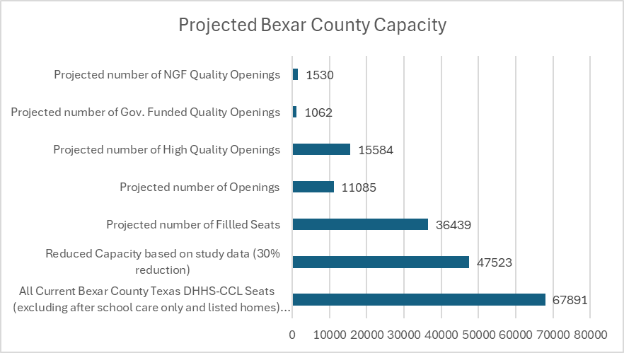

Survey data for age-specific openings indicated that there are 593 openings county-wide for infants while toddlers and preschoolers have 982 and 1901, respectively.

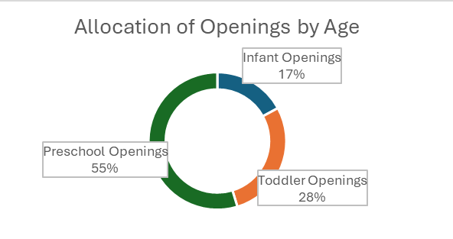

The quantitative data is consistent with the qualitative data shared by focus group participants. Issues like the cost of infant care, lower infant to teacher ratios, and competition with governmentally funded preschool programs all contributed to this imbalance. 14


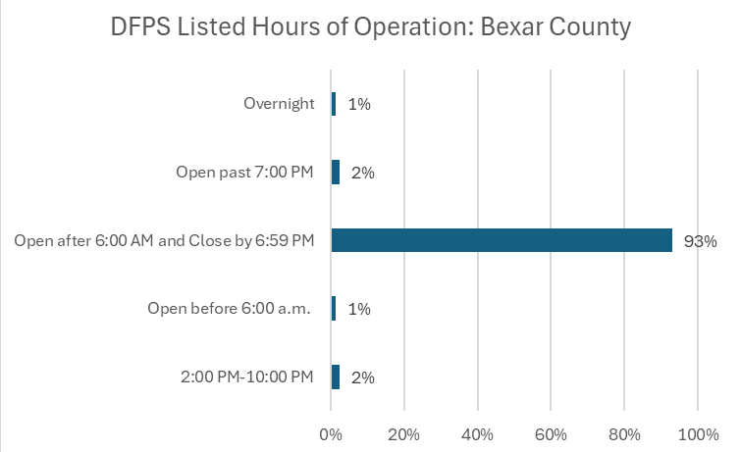
15

Why Most Openings are for Preschool-Age Children
From Providers:
“It's very difficult to recruit families that are in that four to five age range because […] one is they qualify for pre-k so they would rather have a free education than pay private pay. The second reason is that they're currently happy with their childcare and they're not looking to switch. So, I have a lot of families. I have currently about eight families on my wait list, but I can’t take them because, and I won't be able to take them, because their children are only two.”
"Unfortunately, we lose a lot of children to free public school." “The waiting list was for the baby room, the small infant room."
From Parents:
"We've talked about, you know, what's best for us. Is it better to stay home and try and make ends meet with one income until the child reaches school age [...] or do we, you know, work and try to find a way to make the tuition fit into our budget?”

A full discussion of how quality impacts enrollment and openings is included in the next section.

Availability Based on Service Hours:
The hours providers offer care to families are overwhelmingly limited to traditional working hours. Survey response showed only 3% of those surveyed offered weekend hours. Those responding included one licensed center with a capacity of less than 50 and five home-based providers indicated they provide service hours on Saturday or Sunday. Over 95% of respondents indicated their operating hours fell between 6:00 a.m. and 6:30 p.m. leaving families with non-traditional care needs largely without resources.

Survey data is consistent with Texas Health and Human Services Child Care Licensing data that identifies the majority of early childhood serving[vii] sites operate during traditional hours. State-level data shows a maximum of 9 sites have operating hours that include overnight hours. Two sites are home-based care providers. The seven center-based sites serve a maximum of 442 children and include two elementary sites, one of which is also designated as a Head Start program. It is important to note, that while these 9 sites are permitted by the Texas Health and Human Services Child Care Licensing to be open during those hours, they may or may not offer services to families during those times.

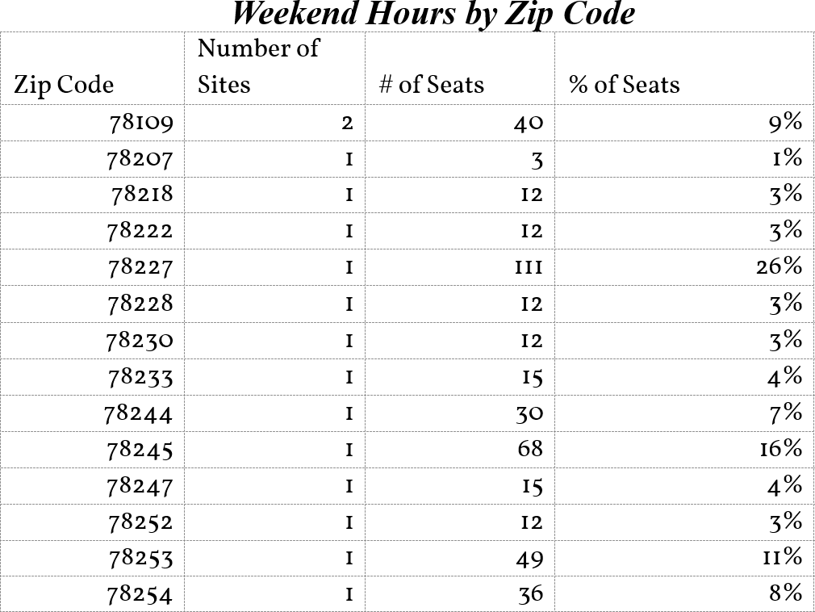
Data from the Texas Health and Human Services Child Care Licensing shows almost all operate Monday through Friday with less than 1% of sites listed as able offer care hours on the weekend. This table shows the locations of the sites able to offer weekend hours and the maximum number of openings permitted at those sites, regardless of if the site operates at that full capacity on the weekend.

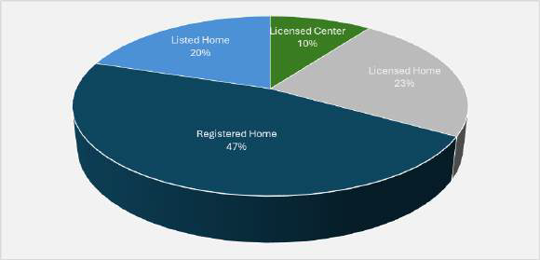
Those openings are provided by the following types of providers as shown in the graphic below.
Weekend Hours by Provider Type

This figure shows the percentages of providers that indicated they offered weekend hours.

Offering care outside of the traditional workday is challenging. Some providers work to expand the services they offer to best meet the needs of the family, but limitations remain.

Why Care is Limited to Traditional Hours
From Providers:
"The challenge is a lot of our parents work past 6:30 and that is something again that I and the assistant and the director is also speaking into in getting additional care to help our family to help our kids and our families so that we'd be able to provide that extended care.”

“Well, we offer extended day. It's after school is out and school ends at 2:50 and then they transition into extended day. Extended day is offered for any of those families that are working or if they're in school. So, once they provide the documentation that supports that they're in school or if they're working a certain schedule, we will accommodate the after-school care up until six o'clock. And that's given as part of our service so there's not an extra cost for that. It is determined on, it's based off of what their needs are for their work or school…. Not weekends, we're closed on weekends but it's after six well it's up until six o'clock so after six o'clock we don't have services that's when our program ends at six o'clock and then we’re off on the weekends. There's no, we're
closed for the weekend.” 16


We do not provide services on the weekend […] because we do not have the personnel to come in
Others recognize the challenges of offering care in the evening, overnight, or on the weekend and the toll it places on staff. Staff-related challenges remain a key factor in formulating a solution to expanding services beyond the traditional days and hours.

Why Care is Limited to Traditional Hours
From Providers:
"I don’t do after-school care because I can’t go and pick them up."

“Staffing for us, especially with the after-school extended aid program, a lot of staff will sign on […] they want to work but then they find out that it’s non-traditional hours and so because I think the landscape right now doesn't really consider like five o'clock, six o'clock traditional school, you know, their expectations are a little different. And so, we have a lot of turnover with staff.”

" I have calls from the military once in a while for the weekends and it's I love to do it but it's kind of hard for me […]. Because of the fact that I work from Monday to Friday and the weekend is the only time I get to spend with my kids, you know, my grandkids."

“We do not provide services on the weekend […] because we do not have the personnel to come in and be able to do that that is a challenge especially because if we don’t have that many children that that needs that services in the weekend and then if we have only one or two then it's not worth it because we still have to pay electricity pay everything to be used in that weekend that especially the AC that we turn it off in the weekend because there's no one here.”

From Teachers:
“Last year, we didn't have our afterschool [program] fully staffed. So as teachers during the day we all had to take at least once a week to step after school which meant we had days going from 7:30 to 6 o'clock at least once a week if not more. […] That's not fun, you know. It's like did it, I love the kids that are there, but that,
that made it difficult too was having those long days.” (This teacher left this school)
17

Demographics:
In the introduction to this section, overarching categories of early learning providers were described, including, sites that are regulated by the Texas Health and Human Services Child Care Licensing [CCL] or funded under the City of San Antonio, TEA, Federal Department of Defense [DOD], Federal Head Start, Early Head Start, and Early Head Start Child Care Partnerships [EHSCCP]. These broad groupings fail to fully express the differences in care options available to families in San Antonio and Bexar County.

Recognizing that families have unique care needs due to their career and life circumstances. Families may have preferences based on value systems (e.g. faith-based care, home providers), income-based needs, or career-necessitated care qualities (e.g. hours of service, employer-sponsored support). As such, a healthy early learning landscapes must provide a wide array of services families can select from based on their needs. Table 3 shows the demographic profile for Bexar County reflects survey respondent’s qualities and care types.

In the sections that follow, these demographic differences will be used to better understand access to high quality affordable care and identify sub-groups where improvements are needed. The demographics are an aggregate for all respondents. When respondents operating within the City of San Antonio are compared to those operating outside of San Antonio (e.g. Bexar County, incorporated cities), respondents show a similar distribution of demographics. One difference between city and non-city respondents was a lower concentration of Registered Homes and Non-Government Funded sites. Importantly, this did not impact the overall percent of high-quality non-government funded sites.

Differences in provider demographics result in a more robust pool of services for families. For example, home-based providers account for 70% of the sites offering weekend care options. Communities that prioritize a single care model over a diversified model risk failing to meet the needs of all families.

One the differences in provider types is the classification of the site owner as a for-profit or not-for-profit (e.g. IRS 501 c3) entity. The cost of operating a childcare facility has recently gained media attention as the cost of childcare is financially crip p ling for many families. Owners who are operating the site with the need to run a profitable business face different challenges than those who are non-profit.


For-profit/non-profit is but one demographic consideration that must be used when examining the current landscape of early learning in San Antonio. However, careful examination of demographic differences expands what we know about the broad system of early care options available to families in San Antonio, what challenges they face based on those demographic factors, and importantly what families need and want from their providers. Insight from focus group participants, is shared after the table as an example of the challenges.

18

Demographic Profile of Survey Respondents
19

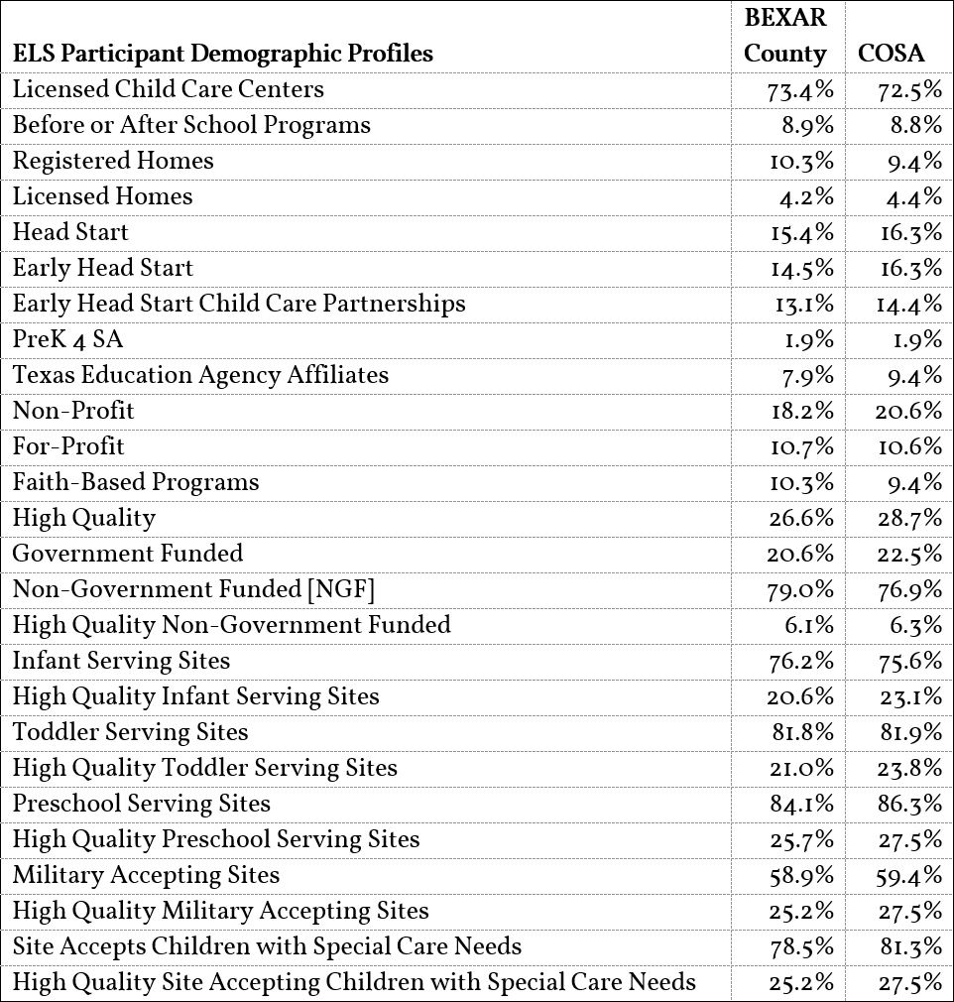

From a Non-Profit Provider
"We actually used to have one specific person who was what we would consider an executive director. [… ] we have our teachers, our admin of course, and then our director. We would have an assistant director but we are also run by a board so our executive director was our grant writer so he used to just focus on getting grants-focus on proposals […] because we are a non-profit organization."
From a Faith-Based Provider

"To have more grants to be able to provide for our staff- to be able to provide for our staff better pay or even benefits. […] I had a wonderful kinder teacher that we lost this school year. We had [them] for five years, but we lost [them] for this school year to Head Start because they have insurance. They paid a lot more- a lot-- a lot--- she's getting a good salary but she has 401k, she has medical insurance, and she's a single parent that is able to provide for her daughter. Her daughter still comes here. Ah, imagine that mommy's teaching the three-year-olds and her three-year-old daughter is here […] she's choosing to pay for her education here because she wants the faith-base [program].”

From Parents/Guardians:
"It's located in a really inconvenient place- when my son went to that Head Start. It was like on the south side of San Antonio, and I work here in Stone Oak- that's just where my job is. And my husband worked for the organization so he did drop off and pick up but like if my husband for whatever reason couldn't [drop off or pick up] then I’m having to drive ages to go get him. For him to be in this high quality affordable child care situation I'm having to go from one side of the city to the other just to pick them up and then do that back to get home, uh!"

"It's very hard to see diverse teachers. I think which is very important for me as I'm coming from different kind of cultural background. It's very important for me to see someone coming from different cultures and having some diverse experiences. So, I cannot see this in schools in my district that's a kind of sign of the quality for me."

"I look at safety when I'm looking for who my child is going to be [with], where we're located, what's around, and then a lot of their safety policies put in place, making sure that they have their fire drills, security around, and then looking at and the quality of the center they're accredited, what standards they hold themselves to,
and their teachers in the classrooms for the children." 20

Understanding Quality Childcare

What is Quality:

Quality care refers to early education services that combine structural quality, such as teacher-to-child ratios, class sizes, and teacher qualifications, with process quality, including teacher-child interactions, classroom management, and instructional methods[viii]. For the purpose of this study, high-quality sites are sites where the quality level has been evaluated and determined by a regulatory agency to be reflective of best practices in early education. Specifically, high-quality is defined in this study as being a Texas Rising Star 4-Star site, a Texas Health and Human Services Child Care Licensing ELS holding National Accreditation, or a Head Start, Early Head Start or TEA site. Most children in Bexar County are being cared for at sites that do not meet this metric. While many of these sites may be providing care that includes indicators of quality, the standards for quality listed above provide verification of performance by an external regulatory agency assessing that the academic, health and life benefits that are associated with quality are likely to be extended to the children in these groups.

Recognizing that not everyone defines quality in the same way, we share the different ways focus-group participants defined quality. Quality indicators included accreditation or evaluation at the national and state level, (National Association for the Education of Young Children Accreditation, Texas Rising Star, Classroom Assessment Scoring System- CLASS). The presence of indicators such as Science, Technology, Engineering, and Mathematics [STEM] curriculum, professional training, flexibility, developmentally appropriate practices, nature-based and Reggio Emilia-inspired programs, outdoor play-based programs, and progressive early childhood practices. Additionally, parents who return with a sibling, healthy grownups, teachers with diverse backgrounds, and safety (including concreate representations of safety such as unbroken materials and sanitized school) were all reported by participants as indicators of quality.

Why Quality Matters:
The link between quality of care and children’s overall developmental gains[ix] is well established. Higher quality care results in increased learning, increased safety, and increased life outcomes. Studies by economists including James Heckman[x] prove that investments in quality early education result in significant economic benefit to the community thought the economic contributions the individual makes and the cost-savings communities receive when remediation services are not needed.

High quality early education and care for young children improves physical, cognitive, social-emotional, and language development and can result in enhanced school readiness. Early education and care can be viewed as an investment and studies show a positive return on this investment.[xi] For example, children attending State Pre-K/Head Start classrooms demonstrated an average gain of 4 months beyond their chronological age in various developmental areas, including cognitive and language skills. These gains underscore the importance of teacher-child interaction quality, which plays a crucial role in fostering children’s higher-
order thinking, creativity, and overall academic progress.[xii] 21

Recognizing the connection between quality and developmental and economic gains, many funding agencies have linked access to funding when ELS have confirmed quality. Agencies and programs such as the Texas Workforce Commission, Head Start, Military Child Care in Your Neighborhood and others restrict funding to sites with confirmed quality.

Progress Towards Quality:
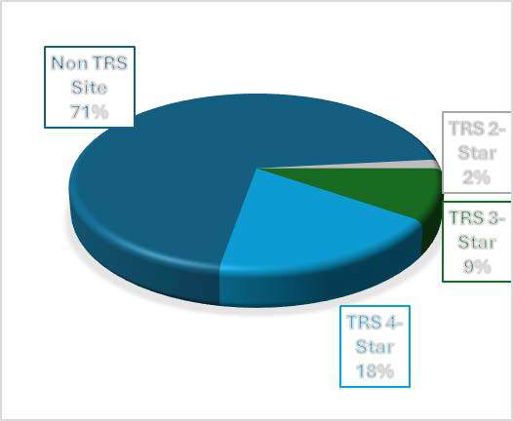
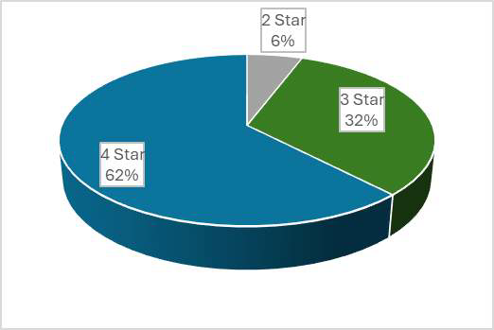
The Texas Workforce Commission reports that Texas began working on a Quality Improvement Rating System [QRIS] in the 1980s[xiii]. The system was designed to evaluate sites receiving Child Care Subsidies/Scholarships [CCS]. Since then, it has been expanded beyond to encourage childcare providers, state-wide, to use the tool as a way to improve the quality of their site. In Bexar County, there are 250 Texas Rising Star providers. The 2, 3, and 4-Star levels of those providers are shown below. Bexar County has 14 2-Star, 81 3-Star, and 155 4-Star sites. While the correlation between participation and star rating is beyond the scope of this report, the high percentage of participants who have achieved a 4-Star rating is notable.
TRS Participating Sites
All Bexar County CCL Sites

Texas Rising Star Participants by Number and Percent

Unfortunately, less than 30% of all CCL sites are participating. Given the high percentage of participants who reach the high-quality 4-Star level, and link between Star Level and access to select funding sources, encouraging more sites to participate in quality improvement programs such as Texas Rising Star or National Accreditation should be prioritized. High participation in quality improvement programs can yield both human and economic gains such as those documented in Heckman’s work. Additionally, they can make the site eligible for additional funding that would strengthen the economic stability of the program.

26.6 % of Early Learning Sites who responded to the survey were high-quality sites. The majority of those sites were governmentally funded sites. When the number of children they serve is considered, most of seats available to families are non-determined quality. The graphic below shows how the available seats are distributed. For those high-quality seats, the majority are governmentally funded seats. childcare.
22

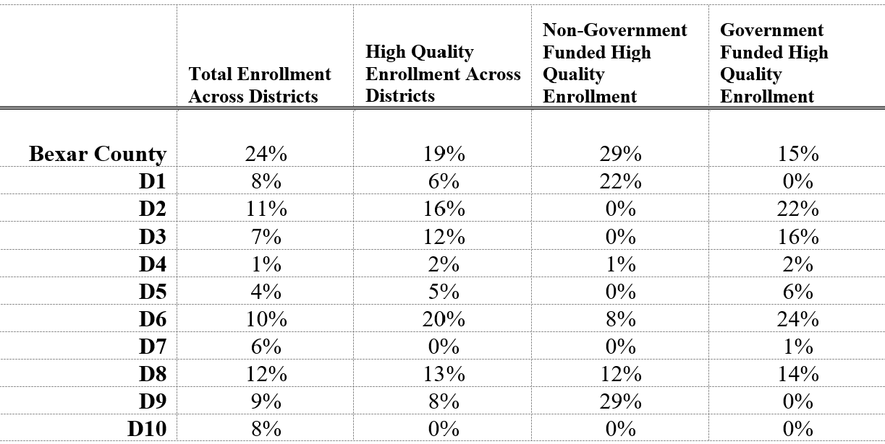
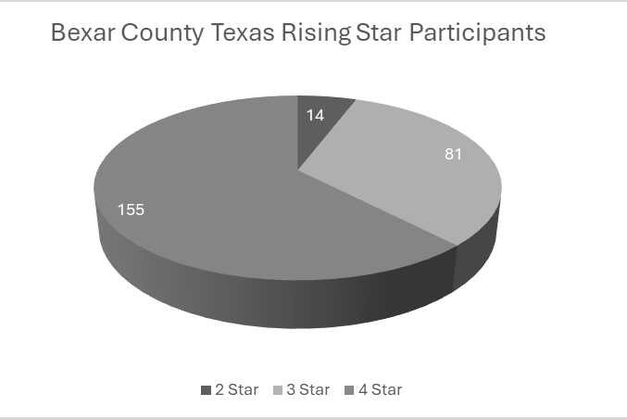

At the City Council District level, the ways government-funded and non-government funded high quality seats are distributed varied.
23

While there are City Council Districts where no survey respondents were non-governmentally funded high quality sites, high quality sites may exist in that district. Currently, Texas Workforce Commission reports 250 Bexar-County sites participating in the TRS program. Of those, the majority (n~155 or 62%) are Texas Rising Star 4-Star.


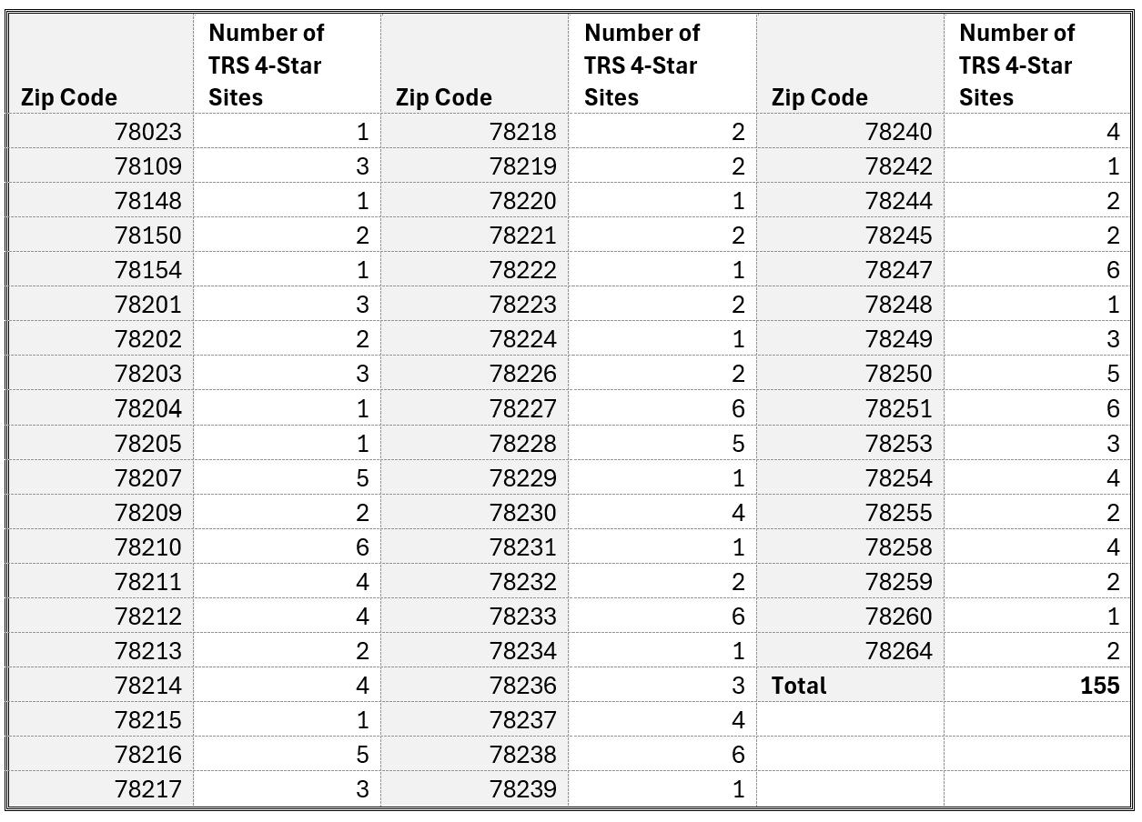
While the number of Texas Rising Star sites that have achieved the highest rating is to be celebrated, the data also highlights the progress yet to be made. Those 4-Star sites represented above only comprise 18% of the total number of sites reported by the HHS-CCL. Making 82% (n~599) of our licensed childcare centers, licensed child-care homes, and registered child-care homes developing quality. This data is consistent with the survey responses which reported 26% high-quality as indicated by either TRS 4-Star or National Accreditation, with National Accreditation accounting for the slightly higher percentage. The following table shows the zip codes where the 4-Star sites are located.

The age of the child being served also significantly impacts the availability of quality care. In the section below, the impact of the children’s ages on access and quality are considered.

24

Openings and Quality:

The impact of quality on availability of childcare is not only evident in the number of seats being filled but also in the number of available openings to families. Respondents reported that a maximum of 15% of their capacity is currently unfilled. When quality is considered, less than 3% of current capacity is open to families who want quality care for their child. If families don’t qualify for government-funded programs, only 1.8% of the capacity is currently open for their enrollment.

Availability is impacted by the quality rating of the provider the ages of children being served and the geographic area where the sites reside. Survey respondents show, no one City of San Antonio Council district has more than 150 quality openings, regardless of age, with most openings being concentrated in four of the ten districts as shown below.
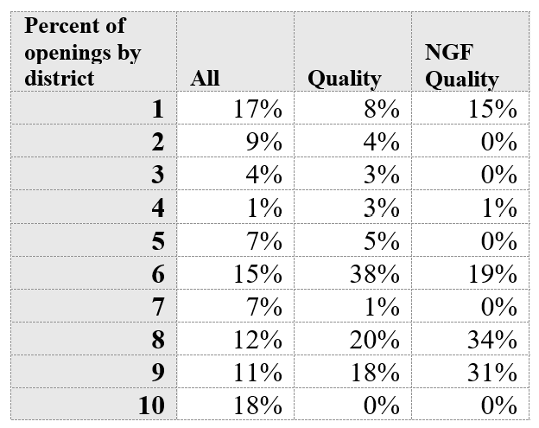
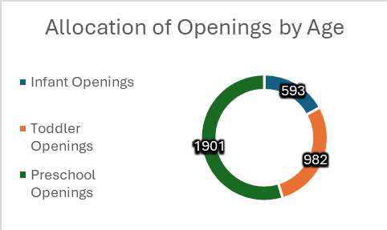
Challenges to Advancing Quality:

To advance the number of high-quality sites, study data can be used to understand how individuals define quality, the reasons sites do not pursue quality initiatives and what challenges they face if they wish to improve the quality of their site. Qualitative data from focus-groups revealed the existing barriers to achieving higher quality ratings include:

- ·Insufficient funding,
- ·Inadequate staff training opportunities,
- ·Lack of awareness about QRIS,
- ·Mentorship inconsistencies for staff,
- ·Limited training for parents on the importance of play-based learning, and Developmentally Appropriate Practice.

Providers emphasize the need for long-term investments in “advanced” professional development and community partnerships. Concerns regarding the difficulty of forming partnerships (when required by funding or support agencies) were noted. Further, they need support/mentorship/materials delivered on time. Below, providers, parents, and staff talk about the importance of quality and the challenges pursuing quality presents.
25

Quality is Important but Not Easy
From Providers:
“Bigger doesn't make for better! It could harm, potentially harm the quality of the program. […] you have to continue to look at what is the best practice for young children, what is the research telling us young children need, how are we growing and evolving within our practice to meet those needs of the young children- again a very Reggio philosophy. […] We are the only NAEYC accredited program in our immediate area, or the only full day NAEYC accredited program in our area. We try to follow the NAEYC ratios, not the child care licensing. [For staff] to give them that quality, higher-level training, I have to send them out of state to different conferences so that they're getting more of the progressive kinds of early childhood practices.”

“Well, just because they're not on Texas Rising Star does not mean that they're not providing quality care. There's a lot of programs that are out here. There's a lot of home providers that are out here that are providing quality care. […] I knew nothing about Texas Rising Star. So, when I go to a training and you suddenly fill out a survey and they're asking you, are you in Texas Rising Star? Well, I don't even know what it is. I've never even heard of it. It's on the paper, but are they sudden, there? […] It hasn't been to just recently that all of a sudden, they started bringing you in for more information on Texas Rising Star because it’s like, okay, I'm going on [operating] 24 years. Where were you when I first started? If Texas Rising Star has been around for a very long time, where were you when I first started? How come you didn't give me information or spread out more information about your program? […] now all of a sudden you know they're pushing it and like I said I never knew anything about the program, it hasn't been but probably less, what maybe like the last five years, that I just barely found out about the program. [Before that] I didn't know anything about it.”

“In public charter schools like ours, we must have a partner to apply for pre-K3 YO programs because we cannot serve pre-K3 YO students independently. This is because, for pre-K3 YO, you are required to have a partner under the Texas Workforce Commission. Public schools operate under the Texas Education Agency, which means we cannot run such programs alone if we would like to [receive] eligible subsidy funds and other related grants. Independent school districts (ISDs) have different regulations. Texas Rising Star accreditation is not appealing to ISDs due to the extensive paperwork involved. It is also not attractive for Child Development Centers (CDCs) because they cannot charge fees and prefer to serve children at their own facilities. Operating in their own facilities means less paperwork and fewer staffing requirements. If CDCs were to serve children in a school setting, they would need to appoint a site director and invest heavily to ensure the facility aligns with guidelines. Their own facilities, however, are already inspected and approved, and they already have site directors in place. When we decided to start this program, we reached out to over 30 Texas Rising Star-accredited entities. None of them accepted until this partner came on board. It has been challenging to convince them because they see us as competitors to their programs. It is difficult to reassure them that we are not competing—we genuinely want to host their programs here. We have invited them to bring their programs to our facility, but reaching a mutual understanding remains a significant challenge.”

“We do our quality. We have quality reports. We do a quality report every quarter and one of our corporate office directors, they come down. We meet, we talk for, a few hours- we talk about the things that our school is going through. Like if we have anything financially. […] a lot of things that Texas Rising Star asked for it does not align with Montessori. So for example, like the labeling and having stuff everywhere, having artwork out on the board, having everything at eye level, have everything like in English and Spanish, and
doing charts, and all that. We don't do that in Montessori.” 26

“I was on Texas Rising Star for 20 years. When I first started, the first 10 years, when I was living at the other place, they were very nice, they did a lot of stuff for, not just for the children, but for the providers. They awarded us and they did a banquet for us, you know, for the providers and then they would give us money for our toys, for the daycares, which was great. And then the following five years, it changed for the worse, I think. What they did is anybody that was back with the first 10 years, they took them off what they had. Like I had a four [star rating] for the longest and they took my four [star] away. I had to restart all over as a beginner for Texas Rising Star. […] So I did it and they gave me back my score because I had to redo it. And then the next five years, which includes now, they had gotten worse. I didn't like what they were doing because they were doing paperwork. They wanted you to do paperwork and demanding we need it now. And I said, I can't do it now because I'm doing the daycare. I have kids to have to attend to. You're just going to have to wait whenever I can send you the paper. […] I try to put up with them. But then I said, you know what, I can't handle this. […] finally decided that I'm just gonna drop it so I've been out already a year- I dropped it!"

From Parents/Guardians:
"I'm even thinking of like, I've looked at Pre-K 4 SA and to qualify for that, it's like you have to be, you know, a veteran or in the military or English has to be your second language or, you know, low income, you know, you're utilizing things like maybe like WIC or Snap or whatever. Like there's certain things for that. But if you don't meet that criteria, then you can't go there. And I've heard amazing things about Pre-K 4 SA. But it's like my family doesn't meet that criteria.”

"You enforcing that ratio then that's really going to impact those child care centers because then all those child care centers have to hire more people but then they're likely going to have to increase tuition which you know so it's like child care centers might close so like well I can't afford to hire more people or they might increase tuition so then families are like, I can't afford to send my kid.”

From Teachers:

“I have a friend who teaches in Austin, and she teaches pre-k. And we talk and I know one thing she definitely likes hearing about my program here. She definitely is like ‘Oh! I wish we had that in Austin,’ because the idea of like the things that we do here that are just developmentally appropriate, I think, make a huge difference because it's like we're meeting the kids where they're at. We’re not putting an unreasonable expectation on them […]. I just think it's wonderful which is why I'm here.”
27


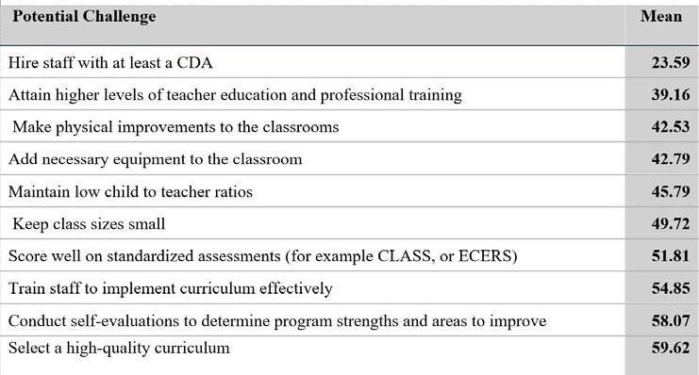
Challenges to Quality Improvement
Quantitative data shows that staffing issues and physical improvements are the most difficult challenges to overcome, and curriculum and self-evaluation are the easiest to overcome. The mean score for each challenge is shown below. Responses were recorded on a scale ranging from 1-100. Low scores represent more difficult activities. The score ranges were: 0-20 Extremely Difficult, 21-40 Somewhat Difficult, 41-60 indicated the activity was Neither Easy nor Difficult, 61-80 indicated Somewhat Easy, and scores 81+ indicate the activity is Extremely Easy to accomplish.

When scores were separated by demographic groups as shown below, all demographic groups identified staff earning a Child Development Associate Credential and Professional Learning as one of their top three greatest challenges to improving quality. Quality improvement efforts must include strategies to support staff professional learning at higher levels and the attainment of credentials. Color coding in the table below indicates easier (green) and more difficult (rose color) accomplishments.

 | All | Quality | Non-Quality | Military Accepting | Licensed Centers | Licensed Centers NGF | Gov. Funded | Homes
Hire CDA Staff | 21 | 17 | 24 | 19 | 21 | 20 | 20 | 27
Low Teacher Ratio | 42 | 33 | 48 | 38 | 44 | 47 | 30 | 39
Small Classes | 45 | 34 | 53 | 41 | 46 | 48 | 32 | 56
Physical Improvements | 37 | 34 | 40 | 37 | 40 | 43 | 23 | 36
Add Equipment | 41 | 43 | 41 | 43 | 42 | 42 | 42 | 37
Self-Evaluation | 56 | 53 | 58 | 57 | 58 | 60 | 49 | 52
Higher Teacher Professional Learning | 36 | 30 | 38 | 32 | 37 | 39 | 21 | 36
Score Well on Assessments | 47 | 41 | 51 | 44 | 49 | 51 | 35 | 52
High Quality Curriculum | 58 | 58 | 57 | 58 | 61 | 61 | 54 | 43 | 28
Train Staff to implement correctly | 49 | 43 | 54 | 48 | 53 | 56 | 35 | 42

From Providers:

Quality


“Well, our facility actually is licensed and we also NAEYC accredited. So, with that in mind, we operate above because we're wanting to make sure that we cover and are in compliance with NAEYC guidelines as well as licensing guidelines.”
29

“Well actually we are further along than the Texas Rising Star we actually support a lot of other programs that are trying to get to Texas Rising Star so we actually are NAEYC accredited which is a step above as well as we're licensed and all facilities have to be licensed but we're NAEYC accredited as well.”

“So, we don't participate in the QRIS program because we're actually at a level that's higher than that. So if we were in a child development center, we would definitely participate in that. We also help our program that works with our shared services, where we work with other child care facilities and day homes. We actually help them work on this rating system, and we help them get to that TRS in the TRS system. So we're higher than that. We actually [have] all NAEYC accredited program, and all of our programs have actually reached NAEYC accreditation and actually did recertification even for the second time. So we are above that, but we do help our shared services [partners], which we have quite a few programs that we actually help them in this system, and we help them to reach that rating on that rating scale.”

“And sometimes I, one thing I've heard even currently in this role is that parents will ask, what are they learning? What are you doing? And like, like he just said that even play at this age, that's learning. They are learning.”

“I think I'd like to improve more on my curriculum […] even though I've had a lot of training curriculum is just so big and so enormous and there's just so much out there that that I'd like to improve more on that. So I try to always try to take as much training as I can on that okay actually.”

"I mean it's a good program [Texas Rising Star] uh except that […] there was just issues, I guess back when during COVID I had a mentor and I never got to meet her. And then when I did want her to come and give me support, she would make appointments, and then she wouldn't show up."

“Who is QRIS? I don't know who that is.”



From Parents/Guardians:

Quality

"For me, the most important thing was methodology, kind of like the structure of care. You know, what would they be doing and kind of like the culture of care, like the philosophy of the school." "I noticed that a lot of the daycare centers, there's not much room to play outside. That probably doesn't feel good for parents who, for affordability reasons, have to send their kids to those places. You know, that's such a bummer. I wish there was some kind of regulation, like there had to be a certain amount of outdoor space or something and time spent outside regardless of the circumstances." (parent at nature/Reggio school)

"I look at safety when I'm looking for who my child is going to be, where we're located, what's around, and then a lot of their safety policies put in place, making sure that they have their fire drills, security around, and then looking at and the quality of the center they're accredited what standards they hold themselves to and their teachers in the classrooms for the children.”

“I don't know last year or I mean not last year but the time that we got it right last time, we got, like, incentives for passing, you know, Texas Rising Star, and then, and it's kind of nice to know that this center is one of those, because, like, as a parent myself, that's something that a lot of parents look into like is this is this center um you know a Texas Rising Star you know four stars or you know you look into that you know
kind of like google reviews you look into it and you're like okay is this good.” 30

Families with Targeted Needs

Why a Variety of Services are Needed:

While developmental norms have been widely recognized and used for the basis of educational approaches, variations in children’s development are both necessary and expected. Variations in development result from growth patterns where children have strengths in one domain over another. They also result from genetic sequencing and environmental factors. Differences in development are to be expected[xiv] and require differences in early education services.


Further, life and career circumstances may require families to need unique services. Preferential elements based on value systems (e.g. faith-based care, home providers), income-based needs, or career-necessitated care qualities (e.g. hours of service, employer-sponsored support) all influence what families look for when seeking out childcare for their family. As such, a healthy early learning landscape responds to the leading needs and preferences in a community.

Who Our Landscape Serves:

When San Antonio’s early learning landscape is examined, we find that:

- Less than 80% of Texas Health and Human Services Child Care Licensing ELS identify that they accept children with special care needs.
- Less than 60% of those who accept children with special care needs are also counted as military accepting based on their enrollment or funding model.
- Less than 20% are non-profit.
- Approximately 10% are faith based.

Focus group participants identified that they face difficulties in serving special populations due to the complexity of military subsidies and uneven resources for children with special needs. They search online for ideas or collaborate with nearby providers. Providers frequently collaborate informally with peers or external therapists but cite insufficient training for working with children on the autism spectrum or those with disabilities. Awareness of military-specific childcare subsidies remains low, with centers struggling to navigate paperwork and meet program criteria. Military families face accessibility challenges tied to income-level qualifications and limited regional options
31


Military Accepting Sites:
32

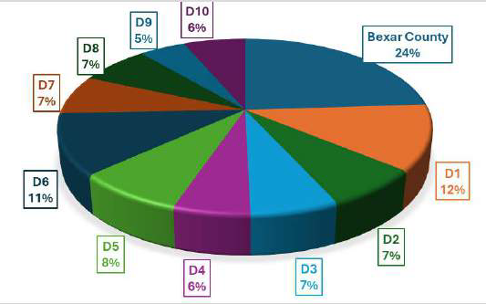
Survey data indicates that Military Accepting sites account for less than 60% of the survey respondent sites. Only 25% of the Military Accepting sites meet the standard for High Quality. The distribution of Military Accepting sites across the 10 City Council Districts is fairly balanced with each city council district hosting between 5-12 of the sites. Bexar County hosts the largest percentage with 24% of the sites falling outside of the City of San Antonio limits. No Department of Defense operated sites are included in this data as participation in the survey was voluntary and this demographic indicator for Department of Defense Operated was not identified in the data.
Percent of Early Learning Sites who Reported being Military Accepting
Despite the Military Child Care in Your Neighborhood (MCCYN) program being available to service members in San Antonio, Early Learning Sites don’t know about MCCYN and must verify the quality of care they provide.
Thus, building awareness and focusing on quality will improve the number of sites who can serve military families. The sites who provide care for military families and military families, themselves, share important insight into the challenges they face and what motivates them to serve others.

From Providers:
“We love to have military and also we provide 10% discount for military families that's something that we do, and we also provide 10% discount for first responders families.”
“There aren't many CCA providers in the area. You have to become a provider and accept that that criteria.
[…]I have been a CCA provider for eight years already. […]whoever cannot afford for a child to attend here-that's getting CCA-- they have to be on the waiting list for the learning center on base. […] that center is always full. […] so they have to be on that waiting list they have to live at least 25 miles away from the base.”

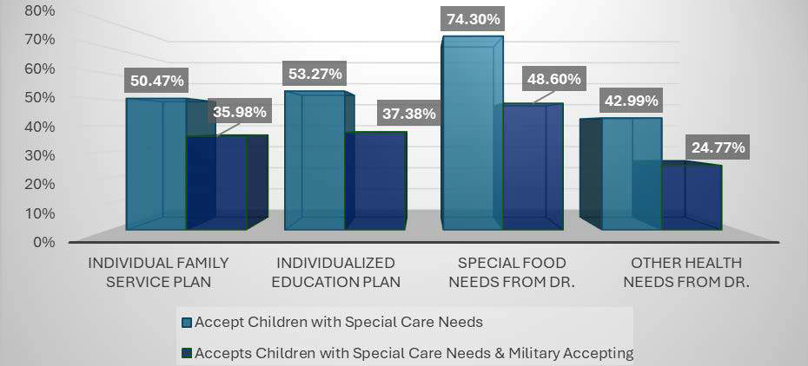
Sites that Accept Children with Special Care Needs:
33

Similar to the distribution of military-accepting sites, ELS that accept children with special care needs span all 10 districts and Bexar County.
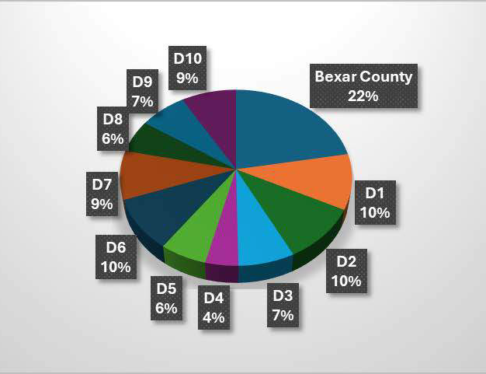
Percent of Bexar County Early Learning Sites Accepting Children with Special Needs

This figure shows how the sites are distributed across City Council Districts and Bexar County
Seventy-eight percent of respondents are affiliated with sites that serve children with special care needs. The type of care needs they accept and the number of children enrolled with those needs varies from site to site. Most sites identify they are able to enroll a child with a special care need related to food or diet, followed by children who have an Individualized Education Plan (IEP) and Individualized Family Service Plan (IFSP). The fewest number of sites enroll children with special care needs that are health or medical needs, requested by a doctor, but not covered by an IFSP or IEP

From Providers:

Few Options

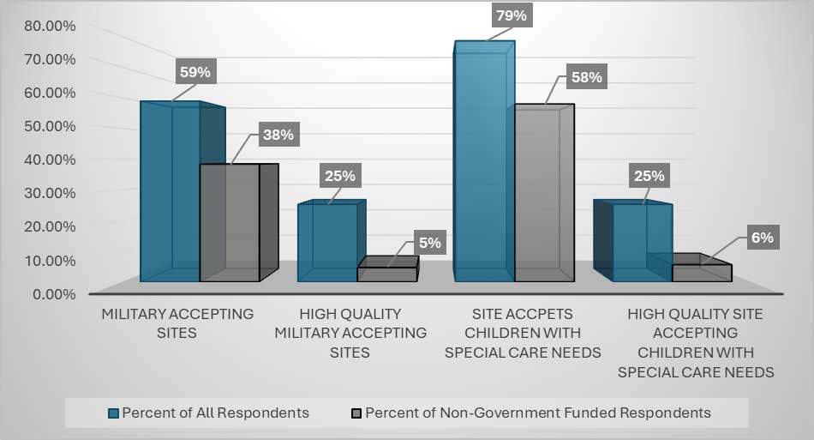
“Affordability and accessibility are the biggest things, but the accessibility that's the biggest challenge is for families with special needs kids. There are not a lot of options out there and, as you may know, it costs more. Lower staff child ratios, access to program being able to mainstream the kids is huge for us and we try to work with families and try to help them be successful but sometimes our environments are not that [well] equipped.”

It is more challenging for military families who have children with special needs to find an ELS that accepts military clients and children with special care needs. San Antonio’s high presence of medical and military services may result in San Antonio being selected by military personnel as a Compassionate Care assignment [xv, xvi]. The potential for this to occur is the catalyst behind the comparison below.

Comparing Early Learning Sites
All Respondents vs. Non-Government Respondents

34

Children with Special Care Needs

From Providers:
"We do have a couple children who get tube fed so their nurses are here all day we allow for any kind of therapists or overseers are always welcome into the center of course […] always welcome in the center and we have a special location just for them to have […] to meet [for] their sessions with their children that they have."

"We have one that is non-verbal. […] I just research online for ideas and we've been adding like pictures so and he tries to talk but through his throat the vocal he doesn't move his mouth sees but through pictures he can tell us what he wants or what his needs are so that's the new thing we're adding for him […] He was taking speech therapy and then once he turned three they dropped him and we did speak to the parent and the parent was between jobs so they were between insurance then she finally got insurance and right now she's waiting for the referral for a referral to get him."
"I want to learn how to work more with children with special needs, you know, that's... I really want to work with kids with autism spectrum and different disabilities.” (teacher)
"I was a Champs trainer of trainers, you know, I had a lot of good training on behavior which I implemented in my classroom. I don't think the issue is training. The issue is support- like there's one, you know, one person, I can’t do everything, I can't. You have to wear so many hats as a teacher. I think the most important thing isn't more training, it's more help in the schools like more people who are going to devote time to mental health. You have to pull the kids out into classrooms and do one-on-one therapy or group therapy with kids. (teacher who left)

From Families:

"Until he’s diagnosed, you have to wait, you have to pay.”
35



Why They Are Not Able to Support Military Parents
From Providers:
“No, no, that's the first time I hear about that [The Military Child Care in Your Neighborhood – Plus Program].” “Parents prefer not to send kids outside of the base there because their home is also over there, but it is really great when students come because […] there's a period they are getting used to work[ing] with the other students in the campus. And, because there is a transition period for them, I can understand there's a fear there's anger maybe and they come [from outside] of city, out of country […] that's huge stress on the child and parent, but [the] child has more stress. […] Think about it, you have a lot of friends one day and then another day they're all gone, you don't know why you are moving out, you have [a] life over there, you think about three four or five years of [life] and you will not see them any longer and this creates a depression on them [the students] that's a challenge.”
"I help her [a military mom] a lot because, like I said, she lives on the other side of town, and she works right here at this base right here. […] so she's very happy that she found me because she said I can come and feed her on my lunch hour, you know, and she breastfeeds her.”
"Well actually based on where we're located, we're not actually getting a lot of interest from military families because we're not super close to any of the bases besides Bullis and I don’t I don't even personally know anybody that works at Bullis because it's a training campus."
“I offer assistance for military families and CCS, and I do offer CCS I'm part of that but I don't get any inquiries."
“The second issue that we began to face is a lot of places don't want to take the military subsidies because there's a lot of paperwork that's created for them.”
“We also did the street sign permission for us to promote or to advertise our school. So that's the one that is for CCS and military program that we receive. We are enrolled in those programs, so we are able to receive those type of students or students are based on those programs. Unfortunately, some of our street signs were taken out the first time that we put it. The city gave us permission to have [them and by the] weekend, there are some intersections that our street signs were taken away, they disappeared, they were thrown on the street.”
36

From Military Parents:

Why They Are Not Getting What They Need

“We first found out I was pregnant and we were considering child care options. He thought you know we could go to the CDC on base- that's available-- but if anybody knows anything about CDCs they have kind of kind of a structure of how like importance almost of who gets accepted in more quickly so we weren't really very high on that [list]. So there was a very long wait list for us and also I hadn't heard great things about the CDC. So we were looking for options closer to us. […] The good thing about CDC's is the cost is based on your rank and your income. […] It's been more affordable than off-base daycare, I guess I should say, because it probably was still very expensive."

“We kept up getting bumped down the list, because my understanding is they prioritize people who were either dual military or people who were single parents. […] I understand that- I think that’s noble and that makes a lot of sense to me. However, I feel that like as a spouse, I'm already making a lot of sacrifices in terms of my career, and my career trajectory has already been thrown off multiple times. I should be in a higher position and earning a lot more money than I am. However, because of how disruptive my spouse's [military] career is to mine, I've had to make concessions and you know and kind of make sacrifices and I don't think that that's always seen or appreciated.”


37

To better understand the experience of military families finding care, we share this vignette from the conversation between the researcher and the spouse of a military service member. Factors like quality, cost and complexity are all evident in their exchange.

A Conversation

Researcher: What factors do you prioritize the most when choosing a child care center for your child?

Parent: The first thing that we looked for was safety. We were very concerned about a place that we felt would take care of our child in a way that we felt comfortable so that was the first thing. The second thing we looked into what's cost. We wanted to make sure that we didn't leave our child someplace that would set us back financially as we're planning for both the short-term and the long-term. The other factors that were included were the cleanliness of the center and we also try to make sure that we found places that were somewhat convenient to us in terms of our location.

Researcher: Could you share your experiences in searching for a suitable child care center for your child? And, what challenges did you face?

Parent: So navigating the system for the military was a bit complicated. We were under the impression that if we signed up with sufficient time that we would be okay when it came to child care. So we actually signed up, I think as soon as we found out that we were pregnant so maybe like 10 to 9 months-- well I mean that's an exaggeration but probably close to eight months before the child was born anticipating that my spouse would have some leave to spend time with our child before we would need the daycare. So, we figured we'd have 10 to 12 months before we would actually use it. So we thought that that would be plenty of time.

We actually went ahead and waited, didn't look at any off-post options because we had no information and we were under the impression that, you know, a year of anticipation would be more than enough time. It turned out that it wasn't. So, after our child was born was when we realized that we needed to find child care because it became evident to evident to us that we were not going to get into the on post daycare and that proved to be a challenge for multiple reason. The first is a lot of daycare centers or child care centers near us actually were either packed or they couldn't guarantee a space, which is very difficult because it's hard to plan when you know you have a deadline. […]The second issue that we began to face is a lot of places don't want to take the military subsidies because there's a lot of paperwork that's created for them. So, they would just rather not deal with the amount of paperwork, especially because the system seems to be convoluted on both ends. I had a hard time understanding how the system worked after doing plenty of research and had to gain outside assistance just to make heads or tails of it. Also, the other thing is that a lot of the places that took the subsidy, a lot of the places that I spoke to, they weren't even sure how each worked. [Sometimes] they would tell us that they did take them, but then they didn't necessarily qualify because of some of the restrictions that are placed by the military. so that created a different challenge and it also kind of forced us to look outside of our neighborhood because the centers that were available to us in my immediate vicinity didn't meet some of the other requirements that we were looking for such as like cleanliness for our child.

38


39
Researcher: Do you mean toilet training?

Parent: No, no, no, there's a difference when you walk into a center [and] you can tell that they sanitize everything, and everything's clean. […] Not every center kind of gave us that that feeling it just there's some centers we felt a little uncomfortable just leaving our child- other centers it didn't look like it was the necessarily the most sanitized place.

Researcher: I see, I see! Thank you! How has the availability or lack of availability of child care impacted your family life and career decisions?

Parent: First and foremost, in terms of me specifically, well let me back up… One of the biggest challenges that we were facing, like I said, there wasn't any suitable daycare options near us that actually took the military subsidy We found the daycare center that we really liked, and it was where we wanted to send our child. However, because they didn't take the subsidy, it actually made it a lot more expensive. And, it became a question of whether or not it was, not that whether the center was worth it because the center is [worth it], but whether or not we should spend the extra money to make sure that our child was in a good situation. They just offered amenities such as immersion, like language, which we felt were very important to us because we had concerns that because of how often the military has moved us and because we were separated from our families. We had concerns whether our daughter would be able to adapt to our culture and be able to speak the language of our ancestors so that's something that became a bit of an issue is that they weren't able- due to the military requirements-- to take the subsidy. In addition to that, the other challenges that we faced, […] what I ended up doing was working one job and I actually ended up leaving that job to take a different job because the second job would provide me with access to a day center a child care center that did take the military subsidy. But that is a sacrifice that I had to make because I had to take a position that I wasn't necessarily looking for and then I also had to change my working style to make sure that I can find suitable child care for my child.

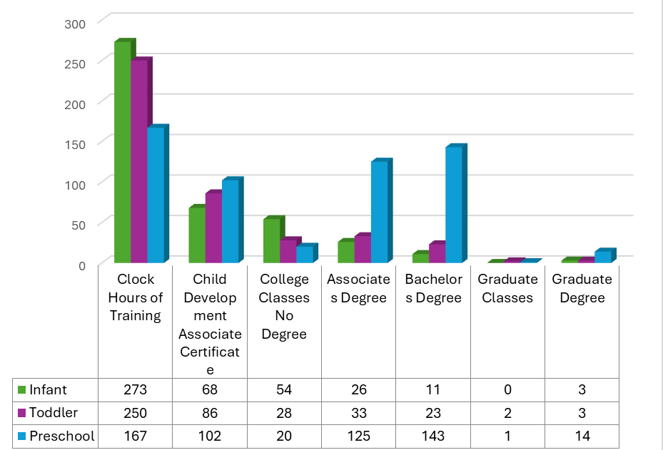
Teaching Staff, Qualifications, and Cost

How Staff Impact Learning:
Research has proven that teachers with expertise in working with young children are foundational to children’s wellbeing[xvii]. There is a direct link between caregiver’s education and the quality of care they provide.
Caregivers with higher education levels have demonstrated better classroom quality, teacher-child interactions, and improved developmental and life outcomes for the children in their care[xviii].

Staff Education:
With a large percentage of preschool education occurring in TEA, Head Start, and PreK 4 SA programs that have a higher education standard than Texas Health and Human Services Child Care Licensing Minimum Standards requires, preschool educator qualifications are far higher than those of infant and toddler caregivers. Infant and toddler caregivers overwhelmingly rely on clock hours of training with no degree attainment.
Further, they receive the lowest compensation. These two factors combined produce instability in the employment sector for those caring for our youngest residents.

The following graphic shows the differences in teacher education levels.

Staff Educational Qualifications

This figure shows the differences between respondents when grouped by age they work with and level of educational attainment they achieved. The total number of professionals reported at each attainment level is provided. 40

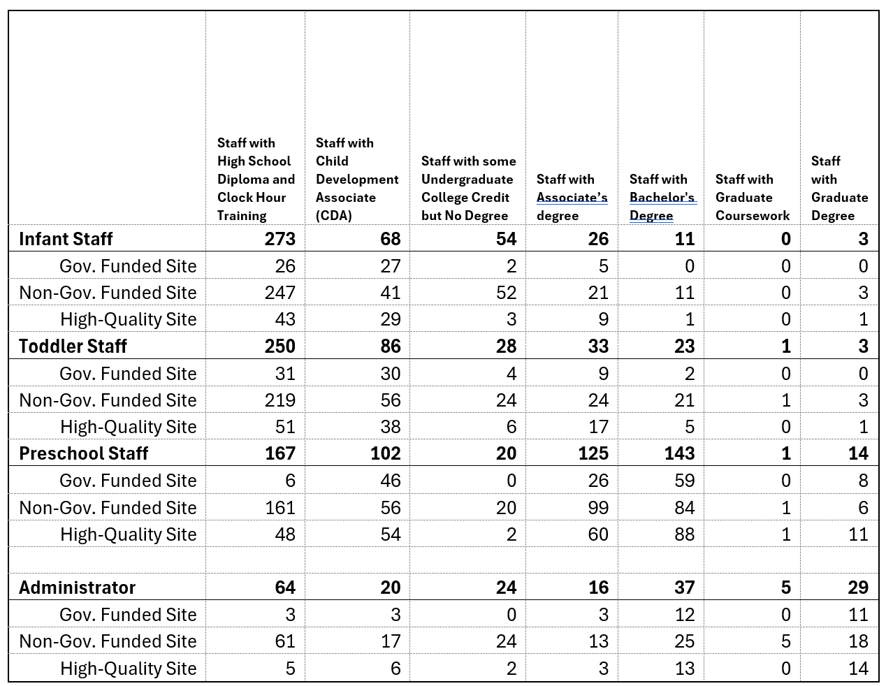

To provide a more detailed understanding of the profile of staff based on quality and government funding status, the following table is provided.

41

The following graphics are provided to show educational variation in age-specific staff. Infant and toddler staff profiles look similar with a clear majority having a high school diploma and clock-hour training. Preschool staff have a varied profile with many staff falling into each educational category.

When asked if their staff record their professional credentials and training in the Texas Early Childhood Professional Development System [TECPDS], data shows that not all participate. Twenty-six percent of sites reported not using the system at all. Thirty-three percent reported all teachers using the system. The majority, 41% have some teachers using the system but not all.

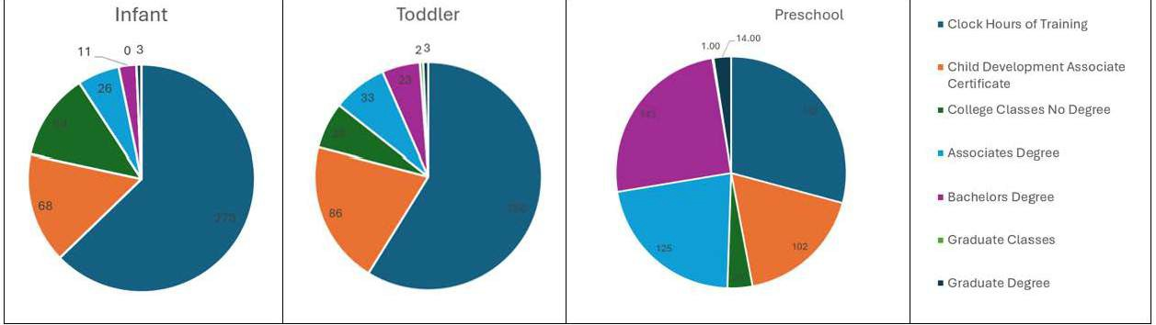
The diverse educational profile of preschool staff, showing significantly higher levels of bachelor’s degree attainment may result from the number of Head Start classrooms located in buildings with TEA oversight.

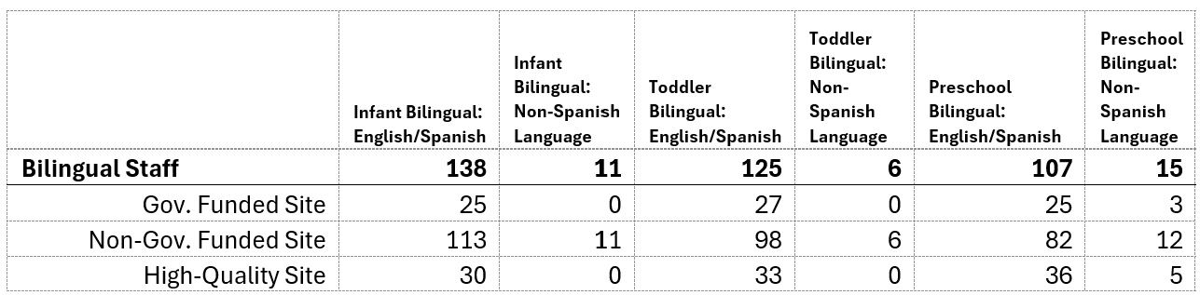
Some families who participated in focus-group interviews indicated that they wanted care options that maintained family languages or exposed their child to different languages. The table below shows the number of respondents who reported bilingual staff (English/Spanish and other languages)

Parents want quality care for their child. They recognize that education and training are directly linked to the type of quality education they want for their child. When we consider: a.) what staff educational qualifications are, b.) what parents want for their child, and c.) the challenges staff training and education presents in quality improvement efforts, quality becomes the key area that must be addressed before the early learning landscape is stabilized. 42

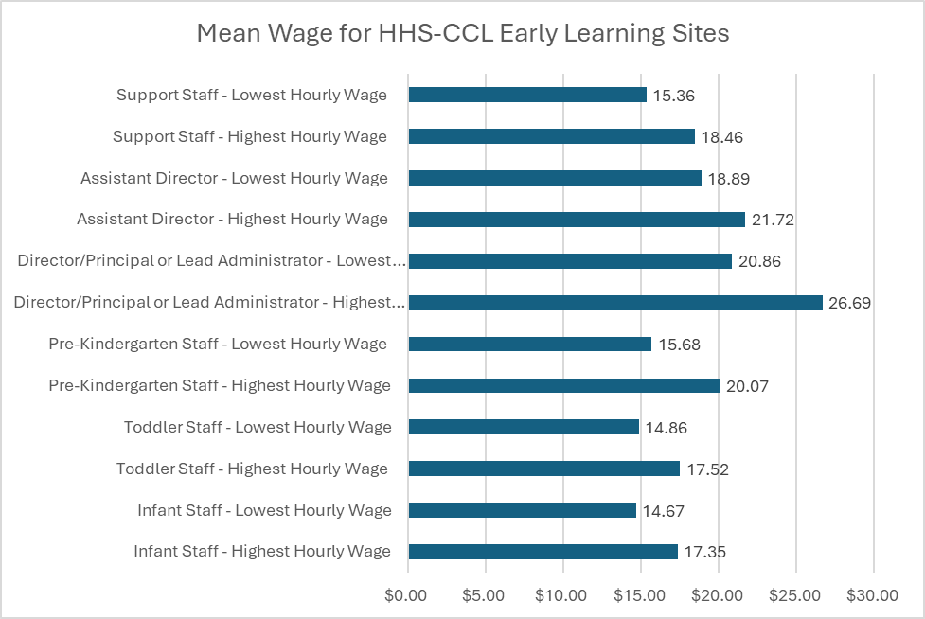
From Parents/Guardians:
“My daughter's teacher which is also the owner, has a master's in education. The teachers at my son's school, he goes to a Montessori school, all the teachers have a Montessori certification that they've gone through- a certain level of training / education to be able to utilize that curriculum. Versus, a child care center where they're, I don’t know, getting someone who is very young and who doesn't have a lot of experience.”
“When you can't, I think, pay competitively, then you might not necessarily get the quality of staff that you
might need when it comes to the importance of something like early childhood education.”
"I don’t like a lack of flexibility in the classroom programs." (parent at nature/Reggio school)

Staff Wages:
While the wages of child care providers continue to be low, the average hourly rate for infant caregivers is lower than toddler and preschool staff. When government-funded programs like Head Start or Early Head Start are removed from the survey responses, wages drop an average of $ 1.94 per hour with preschool staff and infant staff experiencing the greatest impact [xix]

43

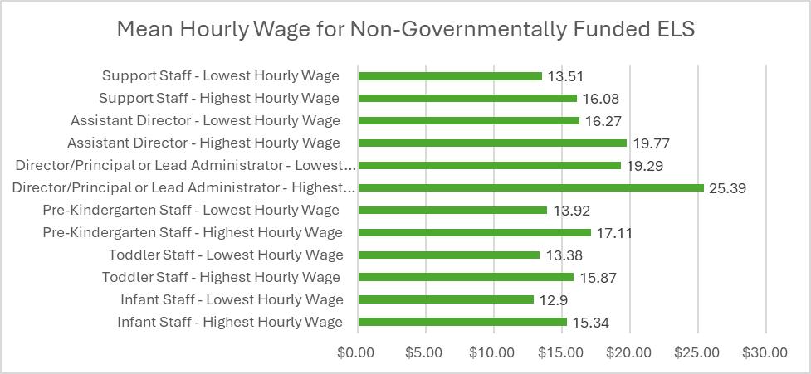
Access to Affordable Quality Childcare
Quality and Affordability:
The current state of childcare affordability has received intense scrutiny when it was reported that many families pay more for childcare than tuition at an in-state college[xx]. Further, waitlists for childcare scholarships are often long and families wait months to years to receive funding.

Quality early care costs more than care that meets minimum standards. The Texas Health and Human Services Commission issues Minimum Standards for Child Care Centers as a baseline for safety. They should not be interpreted as the standard for quality. Thus, Texas Rising Star and National Accreditation standards can be utilized to understand the differences between minimum standards and quality. Specifically, quality requires lower staff-child ratios, higher staff training and education, and well-equipped classrooms. All of these quality factors add additional cost to the operating budget.

Affordability of Care in San Antonio and Bexar County:
The primary source of funding for HHS-CCL ELS is family paid tuition at a set rate. Only 16% of sites provide a sliding scale that adjusts for income. And, while 71% of sites accept TWC CCS funding, only 32% are recognized as meeting the standard for high-quality set in this study.

Focus group participants cite affordability as a pressing issue, with subsidized programs often tangled in bureaucracy and families struggling to afford higher-quality care. Cost differences between subsidized and non-subsidized care are significant, but bureaucratic delays in subsidy programs like CCMS/CCS frustrate families and providers alike. Many families find high-quality childcare unaffordable, forcing tough decisions about employment or reliance on lower-quality options. Inflation and rising operational costs exacerbate affordability issues, creating a tension between maintaining tuition levels and providing competitive wages for staff. Dual-income families face challenges balancing work and childcare costs, while employers often lack
flexibility. 44

From Providers:
“Ok! I say, one of the things we really work hard at is making sure our staffing is full, that we have every position staffed. When every position is staffed, then it operates like a well oil machine. When it's not, that makes it a little bit difficult. So we try to make sure also that our staff are, they actually receive trainings that are needed to keep them up to standards as far as knowing the latest research. We also make sure that our staff understand fully early childhood. And so we'll continue to have the staff, the trainings that are needed to make sure that our staff understand fully what they are expected to know. And then also making sure that the staff is fully, each center is fully staffed. I could see us only continuing to grow in the next 10 years. We have a wait list of over 2,000 this year, which is the largest wait list we've ever overhead over 2,000. And so it's good and bad. The good part is that people are understanding what they get when they come to XX. The bad part is we don't know if we're going to get to all those families. That's the bad part. But one thing now that we serve three-year-olds, three and four-year-olds, we have the capability of keeping those families for two years. That's awesome for us. We love that because we really give them a strong foundation before they go off to the school.”

Who Funds Us:
The number of funding sources for sites varies; however, families represent the most frequent financial source cited in the responses. Seventy-five percent of all respondents rely on family tuition. For high-quality ELS that percentage drops significantly due to the impact of federally funded programs such as Head Start, Early Head Start, and PreK 4 SA where all (or almost all) tuition costs are subsidized by the funding agency for qualifying children.
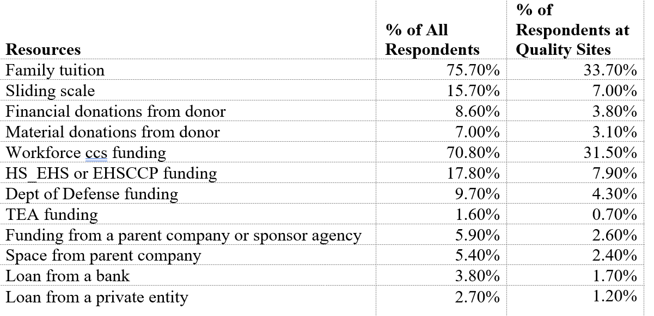

High quality sites are more likely to receive CCS funding and are eligible to receive MCCYN [xxi] clients. However, they are less likely to offer a sliding scale or payment plans for families .
45

Making Care Affordable
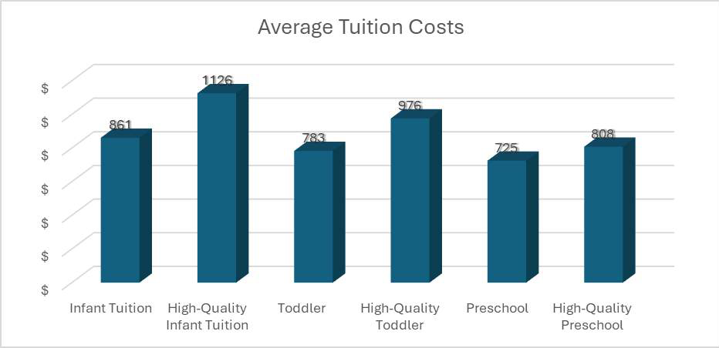
Even when families are offered discounts or scholarships, the cost of care may remain beyond the reach of many families. If a resident earns the 2023 median wage for San Antonio — $62,917 — over 30% of their take-home wage would go to paying for quality childcare for one child [xxii]

To help make care affordable, some sites offer discounts for families based on income. These include sliding scale tuition where the cost of the tuition is based on the family income. Families with lower incomes pay less. The cost of providing care to these families remains constant but the site assumes more of the financial liability for families with lower incomes than families with higher incomes. Other discounts included discounts for families with children who have special care needs, military families, and employees. Discounted or free tuition can also result from an external funding source including Workforce Child Care Scholarships, Military Child Care in Your Neighborhood Coverage, and private scholarships. The percentage of sites who offer these discounts is shown below. Recognizing the impact quality has on cost, the figures are show with all respondents next to respondents who are identified as high-quality.

46

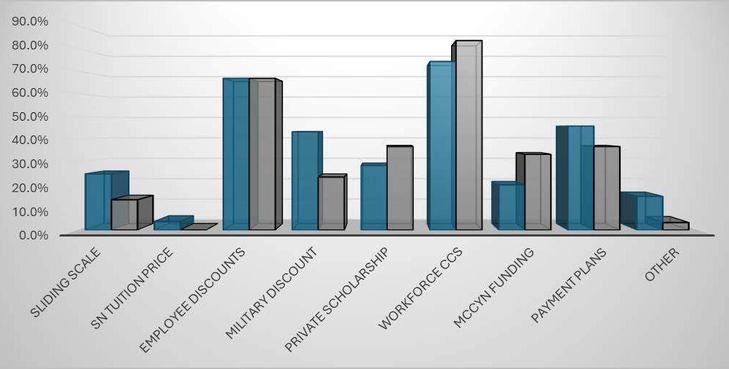
Child Care Licensing Respondent's Reported Discounts

This figure shows what percentage of respondents reported to offer the type of discount listed

From Providers:
“Inflation is killing everybody right now our expenses have gone up about 40 percent over the last three years where our tuition has only gone up about 20% of that so we are in the process of going through and absorbing a lot of the inflationary costs for our customers. […] but if the inflation continues to move in the direction it is moving a lot of families need more help. We're just finding a lot of our customers that we thought we’re gonna be with us for a long time [have] one of the parents are quitting to stay at home especially if they have more than one child "

"So last year, we changed to a flat rate of tuition fees for our private pay or CCS or CPS. So with CCS, which is Child Care Services, they determine the rate for us. So they pay the difference, and then the parents just pay whatever is left over, which can be from five dollars a month to ten twenty dollars whatever that they go by off of their family's income and then of course CPS children who are currently on CPS their services are paid in full.”

From Parents:
“There's ones that are more affordable and then you're kind of questioning the cleanliness, the safety, the development of your children. “

"Childcare costs $1,200 per month, which is too high for us. That’s why I couldn’t send my child to daycare before age 3.”
47

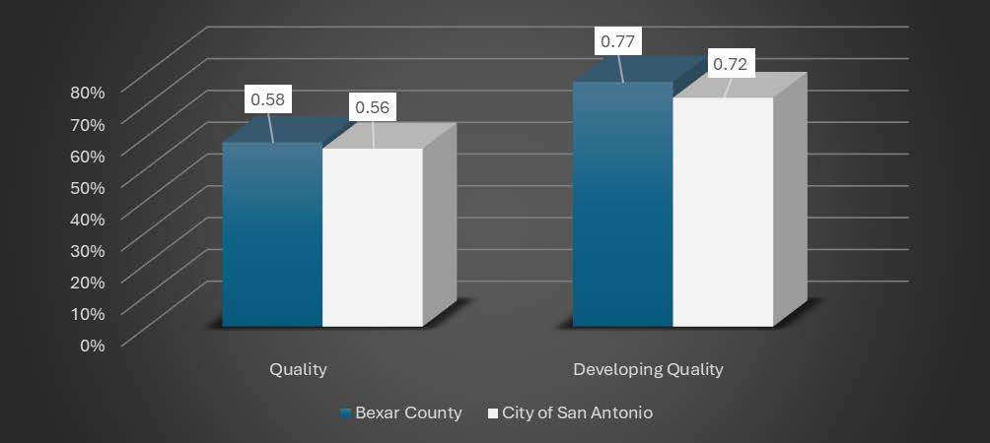
Improving Access to Affordable Quality Care:
Throughout this report the current state of access, quality and affordability have been examined. The data shows that increased access to affordable care is needed. This section will examine some of the factors ELS cite as hindering improvements in capacity and access. Then, in the final section we offer ways we can improve current services and expand to meet demand.

The majority of sites in Bexar County and San Antonio are interested in expanding their capacity. However, sites that have met the standard of high-quality show a lower interest in expanding capacity. This may result from the challenges associated with quality indicators such as low teacher-child ratios and class sizes.

Respondent’s Interest in Expansion

This figure shows what percent of high-quality respondents are interested in expanding their enrollment capacity. Interest is distributed between respondents that are high-quality and those who are developing quality.

48


As providers consider expanding their capacity to provide greater access to families, the data shows that staff shortages remain a critical barrier to expanding childcare capacity. Providers struggle to attract and retain qualified staff due to low wages, limited benefits, and demanding workloads.
49

Recognizing the importance of quality, the challenges expanding capacity presents for high-quality sites versus those developing their quality are shown below, beginning with those most challenging.

High Quality Sites: Challenges to Expansion

- Finding Qualified Staff
- Finding Available Staff 3. Revenue
- Families to fill the openings
- Offering hours families need
- Physical Space
- Knowledge off how to expand 8. Regulations

Developing quality sites prioritize their challenges differently
- Revenue
- Finding Qualified Staff
- Finding Available Staff
- Families to fill the openings
- Physical Space
- Knowledge off how to expand
- Regulations
- Offering hours families need

Providers face different challenges when they want to expand. Some are based on staffing, some on knowledge, but the providers below cite physical and economic barriers that work against their expanding. They highlight the role the public works infrastructure plays in supporting expansion.



Why they cannot expand capacity
From Providers (Home care and Private school):
“The septic tank is rated for three people which makes zero sense to me! So, what we did was submit water usage records for six months and what they found was we were using less water with the three daycare kids. […] we had eight people living in the home full-time plus the three daycare kids and we were using less water than the rating for three people, […] but because it [septic tank] says it's rated for three people they can't approve a change of occupancy based on the septic being rated for three people so that is where we got stuck and that is where we still are and I am very frustrated with it." (Listed home care provider trying to be registered to have more children)

"Yes, so I am a licensed home. I serve children ages 2 to 5. Our capacity is 12. We're licensed for 12. […] I would love to expand my facility, but financially, it's really difficult. I've looked into various ways, acquiring property, buying an existing home, and converting this home. And there are so many constraints besides financial. For example, when I looked into converting this home, there's many constraints citywide. There's also constraints for licensing." (Licensed home care provider)

“I'm currently at my limit. I'm on a septic tank […] and that only allows so many so much growth. […] And, I can’t get another septic tank because I don't have this space. SAWS is coming out here with the new development-- like all the houses, there's going to be a gas station across here, and when they come in they're not going to be on septic tank they're going to be on SAWS plumbing and sewage. So when they do that then we can tap into that and then I can have more kids so and I say within the next 10 years I hope my plan is to grow at least another maybe 40 children.” (Private school provider)
50


POLICY RECOMMENDATIONS

Capacity
Expand high-quality infant care options and increase funding for facilities to meet quality standards

Throughout the preceding pages, the current state of the early learning landscape, as well as, the challenges and opportunities have been explored. Policy recommendations to promote increased access to high-quality affordable care for young children birth to school age include strategies that are easily implemented as well as more complex strategies that will require inter-agency coordination. The recommendations fall into three domains: Capacity, Quality, & Affordability. They correspond to the areas discussed throughout the report.

Quality
Improve educator compensation and establish professional development pathways that enhance access to professional degrees.
Affordability
Advocate for increased state and federal subsidies to reduce financial burdens for families and develop a public website that allows families to view and compare the pricing of childcare institutions alongside the subsidies they may be eligible to apply for.

51

52

- Expand high-quality infant and toddler care options.
Capacity Recommendations
- Implement an annual enrollment reporting processes for Texas Health and Human Service CCL providers.
- Streamline licensing regulations to enable facilities to grow more easily.
- Repurpose unused buildings (e.g., abandoned schools) into childcare facilities.
- Offer funding for infrastructure improvements to meet licensing requirements.
- Develop employer-supported childcare centers near workplaces to reduce commute times for parents.
- Increase capacity for infant care by offering funding for facilities to meet lower child-to-teacher ratios.
- Pilot programs for evening and weekend childcare services, especially in areas with high military populations.
- Create flexible, mobile-friendly childcare options such as drop-in care or part-time enrollment for families in transitional periods.
- Utilize public-private-charter partnerships to expand childcare offerings in underserved areas.
- Develop centralized databases for families to search childcare options by price, zip code, availability, and quality ratings.
- Monitor birth rate trends to adjust capacity based on demographic changes.
- Partner with local schools or community centers to co-host after-school and summer care programs.
- Expand existing CCA providers to increase capacity for infant and toddler care.
- Prioritize CCS scholarships for child care staff to expand capacity.

- Advocate for increased local, state, and federal funding for subsidy programs to meet demand.
Affordability Recommendations
- Reduce bureaucratic delays in childcare subsidy programs like CCMS/CCS.
- Create sliding scale tuition models to support middle-income families and provide professional mentoring on use of sliding scales and mixed funding models.
- Advocate for expanded state and federal tax credits to offset childcare expenses for families.
- Offer subsidies or stipends for employees needing childcare, particularly in industries with irregular hours.
- Provide targeted grants or stipends to home providers for training, resources, and facility upgrades.
- Create public-private and employer-based partnerships to reduce the cost of childcare for families.
- Incentivize direct partnerships between companies and childcare centers to offer discounted rates for employees.
- Launch awareness campaigns about subsidy programs like CCS, United Way, Military Child Care in Your Neighborhood Plus Program.
- Pilot community-based transportation programs targeting high-need childcare areas.
- Offer financial incentives such as grants or tax breaks to providers who operate in underserved areas or childcare deserts.
- Explore partnerships with nonprofits or corporations to subsidize costs for middle-income families.
- Advocate for military-specific discounts or streamlined processes for childcare subsidies.
- Provide financial consulting for sites wanting to diversify their funding model.

53

- Improve compensation and benefits for early childhood educators to attract and retain qualified staff.
Quality Recommendations
- Maintain funding to programs demonstrating a positive impact on quality to ensure sustainability.
- Improve Health and Human Services CCL provider and licensing staff usage of TECPEDS.
- Incentivize training and certifications for educators through partnerships with local colleges and universities.
- Provide advanced trainings and implement professional development pipelines to keep staff updated on early childhood best practices including the importance of play, Reggio Emilia approach, and nature-based education.
- Fund in-house or partnership-based mental health professionals for children and educators.
- Create centralized, on-demand professional development platforms for educators that reduce reliance on clock-hour training and make advanced degrees attainable.
- Foster community partnerships for schools that are having difficulty in finding partners to achieve Texas Rising Star accreditation.
- Expand access to pre-accreditation grants or loans to support providers aiming for accreditation.
- Offer financial incentives for centers achieving higher quality standards.
- Enhance peer networking and create centralized networks for sharing best practices.
- Facilitate monthly regional forums for directors and educators that target findings from this report and other issues they identify.
- Develop a "navigator" role to assist providers with accreditation and grant processes.
- Support providers in implementing high-quality curriculum and staff training.
- Provide resources and workshops for parents to understand quality standards.
- Promote variability among staffing by recruiting educators with differing educational qualifications, experiences, and skills (including cultural competence and languages spoken).
- Reduce staff burnout through shorter shifts, mental health support, flexible scheduling, reasonable ratio of children with special needs.
- Provide long-term incentives such as milestone bonuses for educators5. 4
- Develop partnerships with local universities and high schools to recruit future educators.

What Other Communities Are Doing
The following links include what other communities are doing in response to the need for access to high quality affordable early learning supports.
States Are Taking Action To Address the Child Care Crisis - Center for American Progress
Improving Access to Child Care and Preschool by Expanding Parental Options - FREOPP
More Families Accessed High-Quality Child Care after Changes to the State’s Subsidy Program | Urban Institute
The Early Childhood Policy Network


55

- https://data.census.gov/table/ACSST1Y2023.S0101?q=Bexar%20County
- https://childcaredeserts.org/2018/#:~:text=A%20child%20care%20desert%20is,as%20licensed%20child%20care%20 slots.&text=In%20the%20United%20States%2C%2051,in%20a%20child%20care%20desert.
- https://childrenatrisk.org/child-care-desert-analysis-2024/#:~:text=Child%20Care%20Deserts%20in%20Texas&text=A%20zip%20code%20is%20deemed,Child%20Care%20De sert%20map%20here.
- Children at Risk, 2021
- If a program is located on a Native American Reservation, the tribe’s governing council may supersede these agencies. Additionally, local governance may apply.
- Student Information (TAPR) Region 20
- Early childhood serving includes any licensed center, registered home or licensed child-care home that does not exclusively serve “school-age” children. Programs that serve preschool and school age programs are included even when only operating as after-school programs.
[vii] Early childhood education and care quality and associations with child outcomes: A meta-analysis
Examining concept development classroom interaction quality and children's developmental progress in state pre-
K/head start programs using pre-K CLASS and LAP-3 – ScienceDirect
[ix]
Early childhood education and care quality and associations with child outcomes: A meta-analysis Quality Early Education and Child Care From Birth to Kindergarten
Quality Matters in Early Childhood Education and Care
- https://heckmanequation.org/resource/invest-in-early-childhood-development-reduce-deficits-strengthen-the-economy/
- Quality Early Education and Child Care From Birth to Kindergarten
Early childhood education and care quality and associations with child outcomes: A meta-analysis

- Early childhood education and care quality and associations with child outcomes: A meta-analysis
Examining concept development classroom interaction quality and children's developmental progress in state pre-K/head start programs using pre-K CLASS and LAP-3 – ScienceDirect

- History of Texas Rising Start https://texasrisingstar.org/about-trs/
- Thelen, E. (1995). Motor development: A new synthesis. American Psychologist, 50(2), 79-95
- https://www.hrc.army.mil/content/Enlisted%20Compassionate%20Actions
- https://www.afpc.af.mil/Exceptional-Family-Member-Program/
[xvii The relationship between teacher qualification and the quality of the early childhood education and care environment.
- The relationship between teacher qualification and the quality of the early childhood education and care environment.
- This calculation uses the mean salary for the highest salary category
- Child Care Costs Outpace College Tuition 56
- Military Child Care in Your Neighborhood
[xxii] https://www.census.gov/quickfacts/fact/table/sanantoniocitytexas/

Contact Information:

Dr. Sarah Baray
Sarah.Baray@sanantonio.gov
Dr. Melissa M. Jozwiak
Melissa.Jozwiak@tamusa.edu 210-784-2512




The views expressed in this publication do not necessarily reflect the views or policies of the City of San Antonio or Texas A&M University San Antonio.

57

