|  |  |  |  |  |  |
| --- | --- | --- | --- | --- | --- |
| Array Size | Bubble Sort  O(n^2) | Insertion Sort  O(n^2) | Selection Sort  O(n^2) | Shell Sort 1  O(n^3/2) | Quick Sort  O(n^2) |
| 1 | 0 | 0 | 0 | 0 | 0 |
| 2 | 0 | 0 | 0 | 0 | 0 |
| 4 | 0 | 0 | 0 | 0 | 0 |
| 8 | 0 | 0 | 0 | 0 | 0 |
| 16 | 0 | 0 | 0 | 0 | 0 |
| 32 | 0 | 0 | 0 | 0 | 0 |
| 64 | 0 | 0 | 0 | 0 | 0 |
| 128 | 0 | 0 | 0 | 0 | 0 |
| 256 | 0.015625 | 0 | 0 | 0 | 0 |
| 512 | 0 | 0 | 0.015625 | 0 | 0 |
| 1024 | 0.015625 | 0.015625 | 0.015625 | 0.015625 | 0 |
| 2048 | 0.140625 | 0.0625 | 0.109375 | 0 | 0 |
| 4096 | 0.65625 | 0.25 | 0.234375 | 0.015625 | 0 |
| 8192 | 2.07812 | 1.07812 | 1.5625 | 0.03125 | 0 |
| 16834 | 10.6719 | 3.6875 | 4.26562 | 0.078125 | 0 |
| 32768 | 37.3906 | 16.9062 | 21.25 | 0.265625 | 0.03125 |
| 65536 | 157.234 | 54.6094 | 90.7344 | 0.875 | 0.078125 |

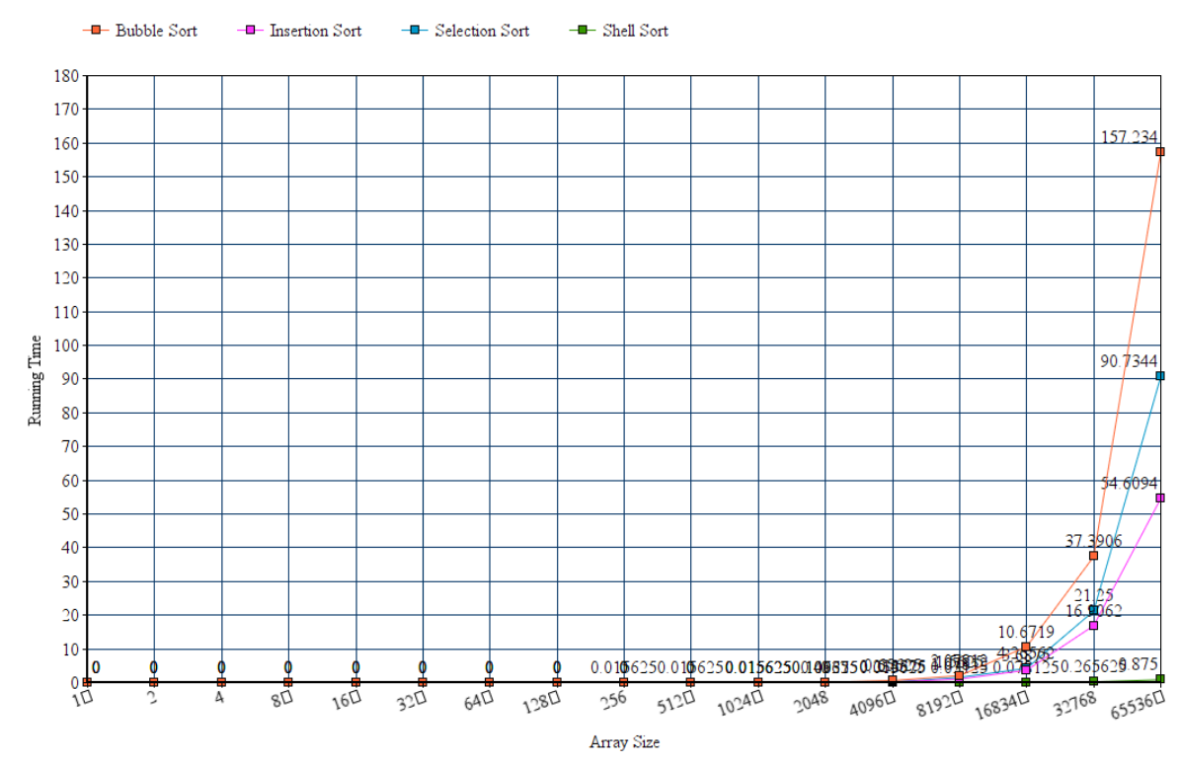https://www.onlinecharttool.com/graph/image/blank?antifreeze=1510125397The more inefficient the Big-Oh, the longer the running time is as the number of elements get substantially bigger.