Controllable Image Synthesis With Attribute-Decomposed GAN
In this paper author is enhancing existing ADGAN algorithm with ADGAN++ to synthesize images. Synthesizing images means generating new images by keeping some content from source image. GAN algorithm used to generate new images from given images and in propose paper author modifying existing ADGAN to generate new model called ADGAN++. In paper author saying propose ADGAN++ algorithm can be utilized to generate STYLE images by giving source image and target image as style pose and then ADGAN++ will generate new images by combing both images.
ADGAN++ can be used to generate new images from POSE also and can be used to EDIT source image with the target image. It can used to generate synthesize images from CELEB faces where single source image will be input to algorithm and then new multiple images will be generated by keeping some similarity from the source image.
Author evaluating propose algorithm performance using SSIM formula, SSIM refers to structural similarity between original and generated images so the higher the similarity the better is the algorithm.
To generate pose, scene, style and face images author utilize different datasets and training algorithm on all those dataset is not possible so we trained ADGAN++ on CELEB faces dataset to generate new face images.
Propose Attribute-Decomposed GAN (ADGAN) and its enhanced version (ADGAN++) for controllable image synthesis, which can produce realistic images with desired attributes provided in various source inputs. The core ideas of the proposed ADGAN and ADGAN++ are both to embed component attributes into the latent space as independent codes and thus achieve flexible and continuous control of attributes via mixing and interpolation operations in explicit style representations. The major difference between them is that ADGAN processes all component attributes simultaneously while ADGAN++ utilizes a serial encoding strategy. More specifically, ADGAN consists of two encoding pathways with style block connections and is capable of decomposing the original hard mapping into multiple more accessible subtasks. In the source pathway, component layouts are extracted via a semantic parser and the segmented components are fed into a shared global texture encoder to obtain decomposed latent codes. This strategy allows for the synthesis of more realistic output images and the automatic separation of un-annotated component attributes. Although the original ADGAN works in a delicate and efficient manner, intrinsically it fails to handle the semantic image synthesizing task when the number of attribute categories is huge. To address this problem, ADGAN++ employs the serial encoding of different component attributes to synthesize each part of the target real-world image, and adopts several residual blocks with segmentation guided instance normalization to assemble the synthesized component images and refine the original synthesis result.
To implement this project we have designed following modules
- Upload CelebMask Faces Dataset: using this module will upload dataset to application
- Generate & Load AD-GAN++ Model: this module will take train and test images from dataset folder as input and then generate and load model
- Generate Synthesize Faces: using this module will upload face image and then application will generate new faces.
SCREEN SHOTS
To run project double click on ‘run.bat’ file to get below screen
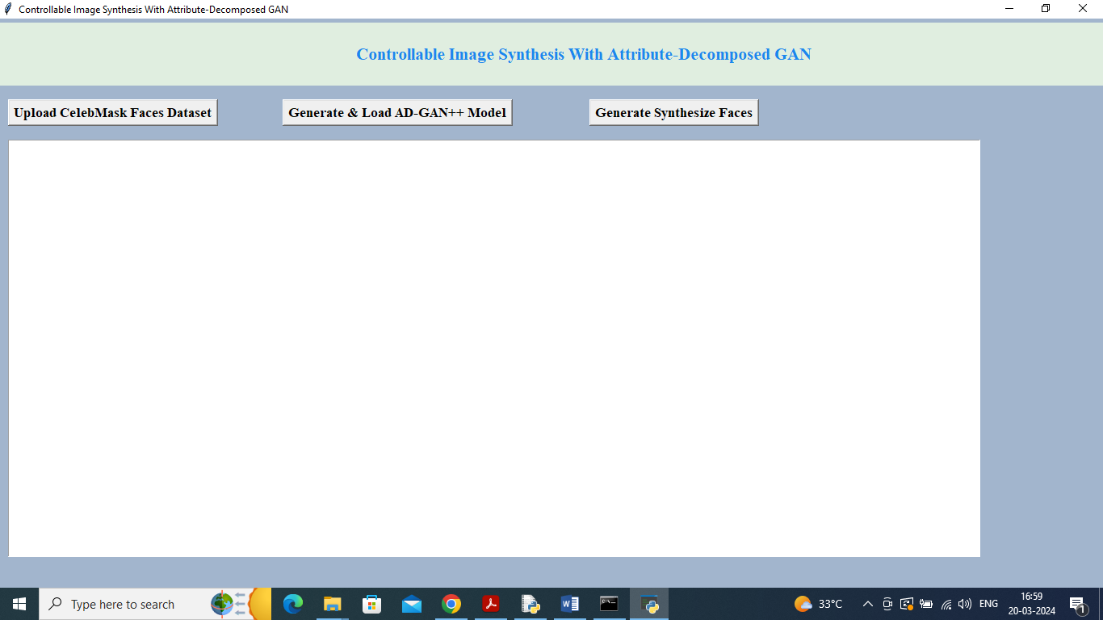
In above screen click on ‘Upload CelebMask Faces Dataset’ button to upload dataset and get below page
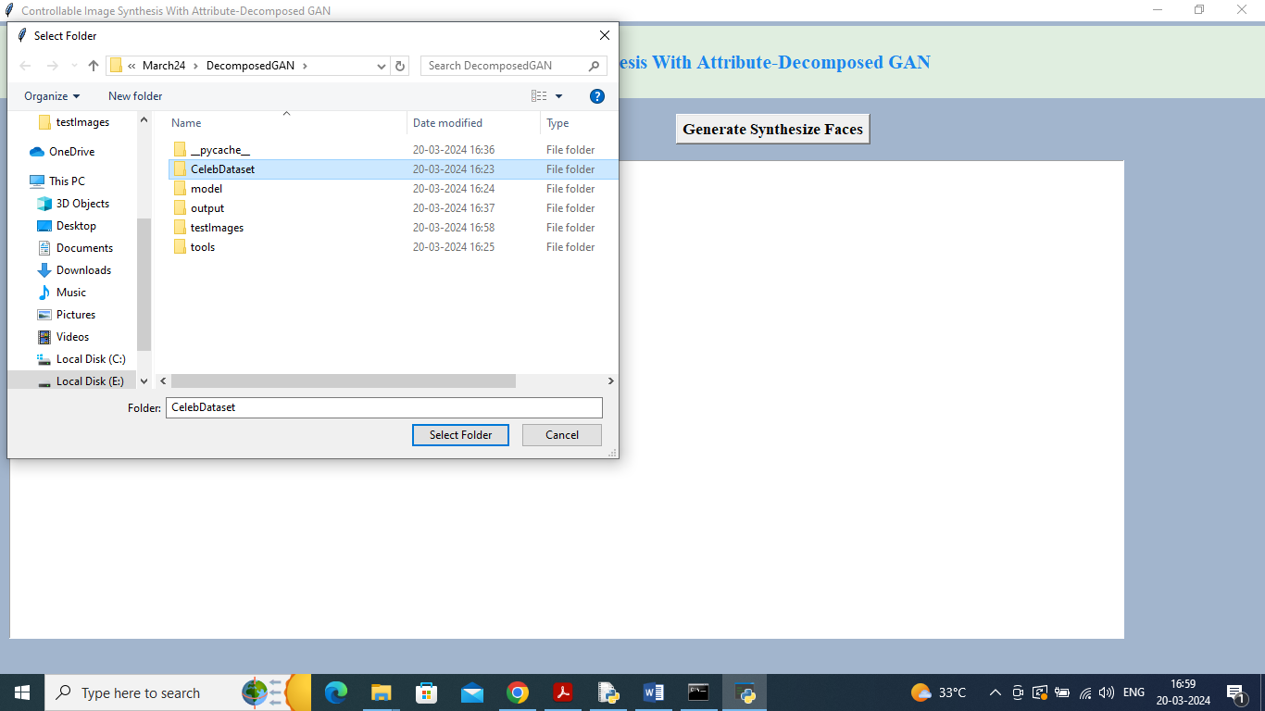
In above screen selecting and uploading ‘Celeb Faces Dataset’ and then click on ‘Select Folder’ button to load dataset and get below page
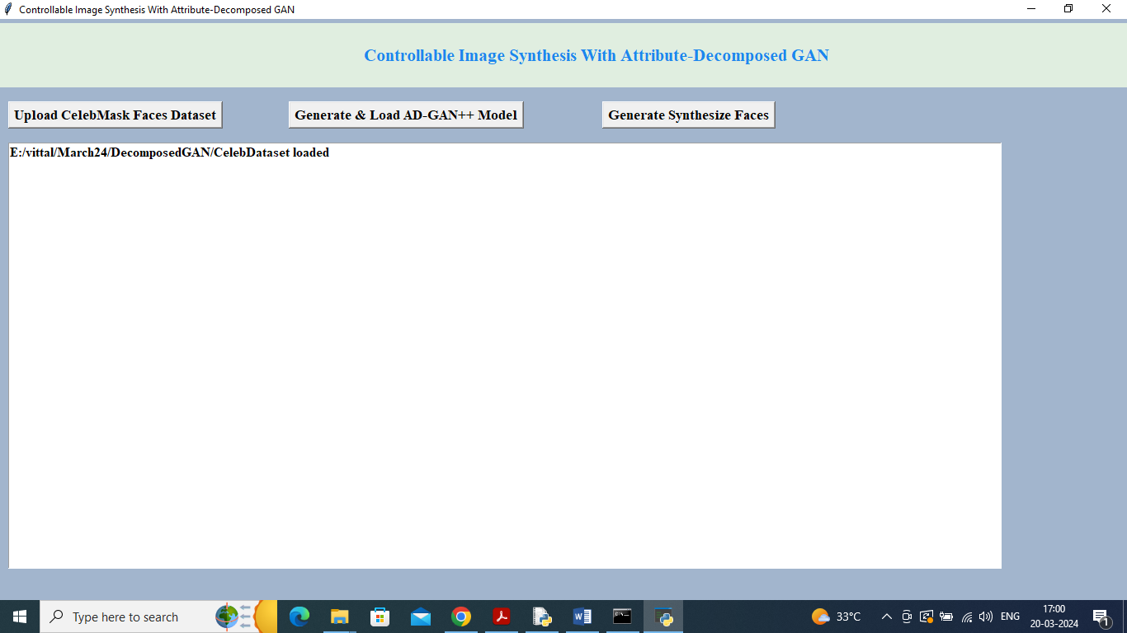
In above screen dataset loaded and now click on ‘Generate & Load AD-GAN++ Model’ button to load model and get below output
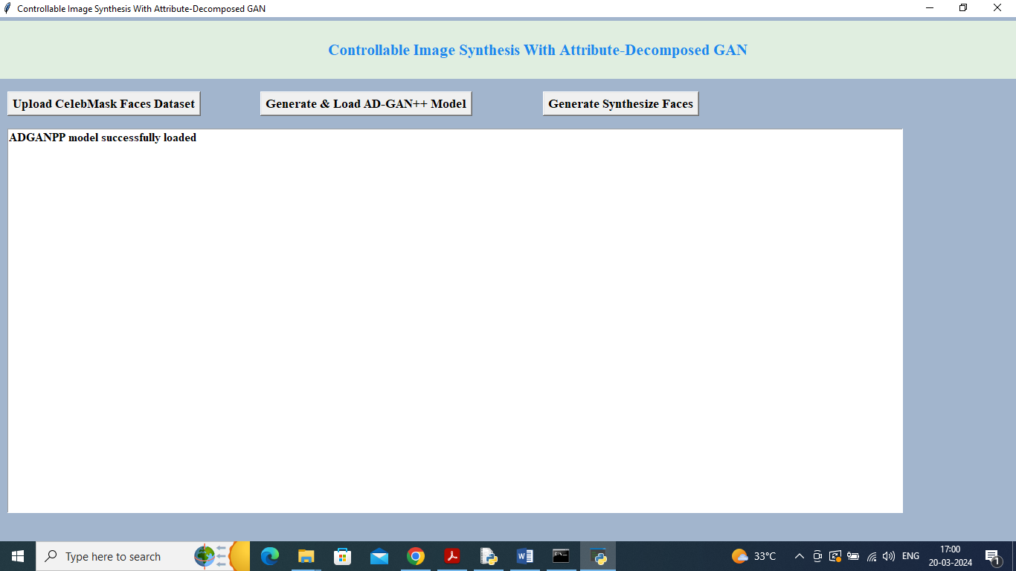
In above screen ADGAN++ model loaded and now click on ‘Generate Synthesize Faces’ button to upload test image
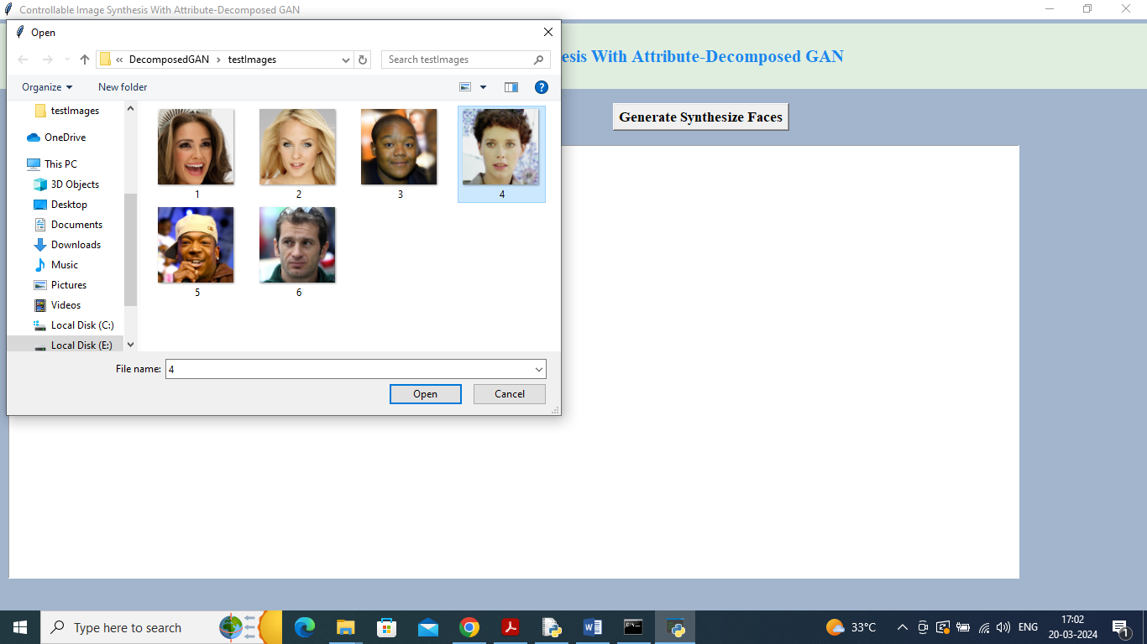
In above screen selecting and uploading ‘4.jpg’ file and then click on ‘Open’ button to get below page
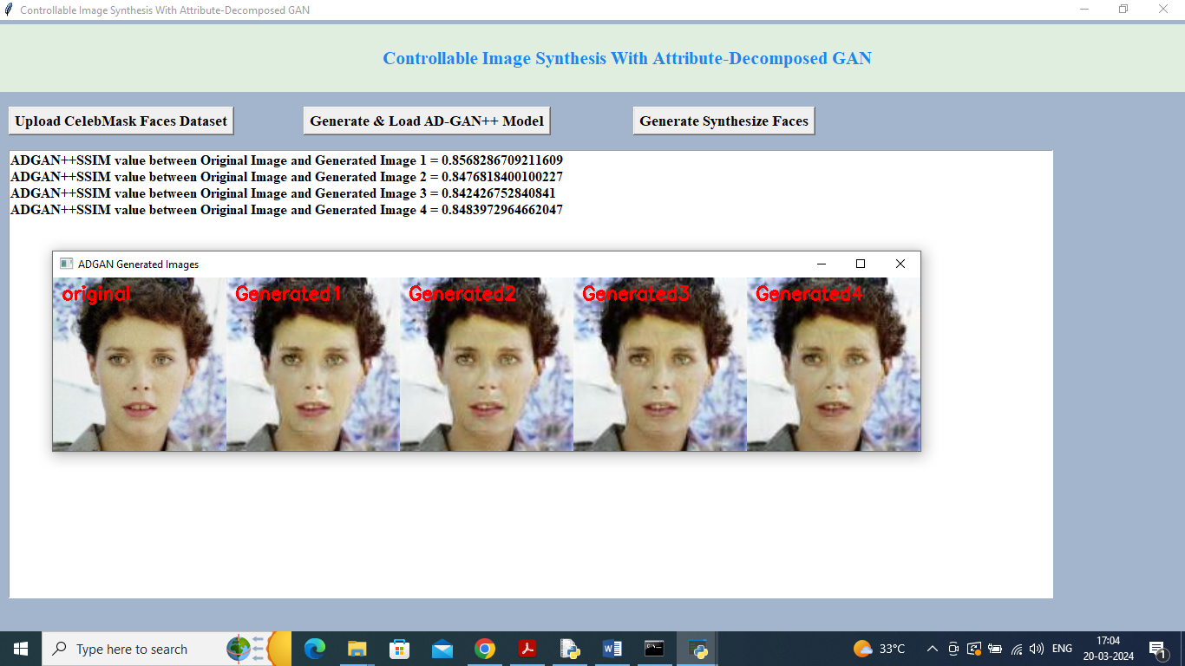
In above screen first image is the original uploaded image and remaining 4 are the generated images and can see some changes in the generated images and in text area can see SSIM similarity percentage between original and generated images. Similarly you can upload and test other images
In below screen can see output of other images
