**FPT Aptech**

--- o0o ---

**PROJECT REPORT**

**<TechBlog>**

Batch: T1804E

Semester: 2

Group: Group3

Nguyễn Tiến Thịnh

Phạm Thành Đạt

Nguyễn Quang Thành

**Hanoi - 04/2019**

**Table of Contents**

1. Problem Definition 3

i. Introduction 3

ii. Implementation Environment 3

User Stories 4

1.2 User type 1 (Example: Admin) 4

i. Story 1 4

ii. Story 2 4

iii. Story 3 4

iv. … 4

1.3 User type 2 (Example: Staff) 4

i. Story 1 4

ii. Story 2 4

iii. … 4

1.4 User type 3 (Example: Customer) 4

i. Story 1 4

ii. Story 2 4

iii. Story 3 4

iv. … 4

1.5 … 4

1.6 … 4

1.7 ... 4

1.8 ... 4

2. Database 5

2.1 DB Relationship Diagram 5

2.2 Table 1 (Example: Account) 5

2.3 Table 2 (Example: Caegory) 6

2.4 Table 3 (Example: Product) 6

2.5 … 6

2.6 … 6

2.7 ... 6

2.8 ... 6

3. UI\UX 7

3.1 GUI 1 (Example: Login Form) 7

3.2 GUI 2 (Example: Address Book Form) 7

3.3 GUI 3 8

3.4 … 8

3.5 … 9

3.6 … 9

3.7 ... 9

3.8 ... 9

3.9 ... 9

3.10 ... 9

3.11 ... 9

4. Summary 10

# Problem Definition

### Introduction

….

### Implementation Environment

….

# User Stories

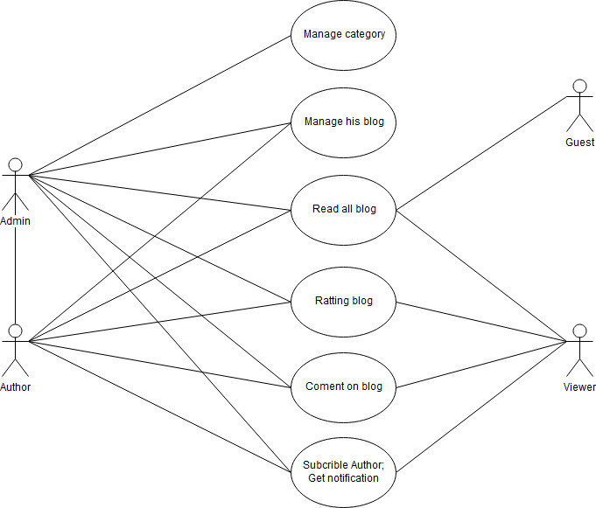

## User type 1 (Example: Admin)

### Story 1

### Story 2

### Story 3

### …

## User type 2 (Example: Staff)

### Story 1

### Story 2

### …

## User type 3 (Example: Customer)

### Story 1

### Story 2

### Story 3

### …

# Database

## DB Relationship Diagram

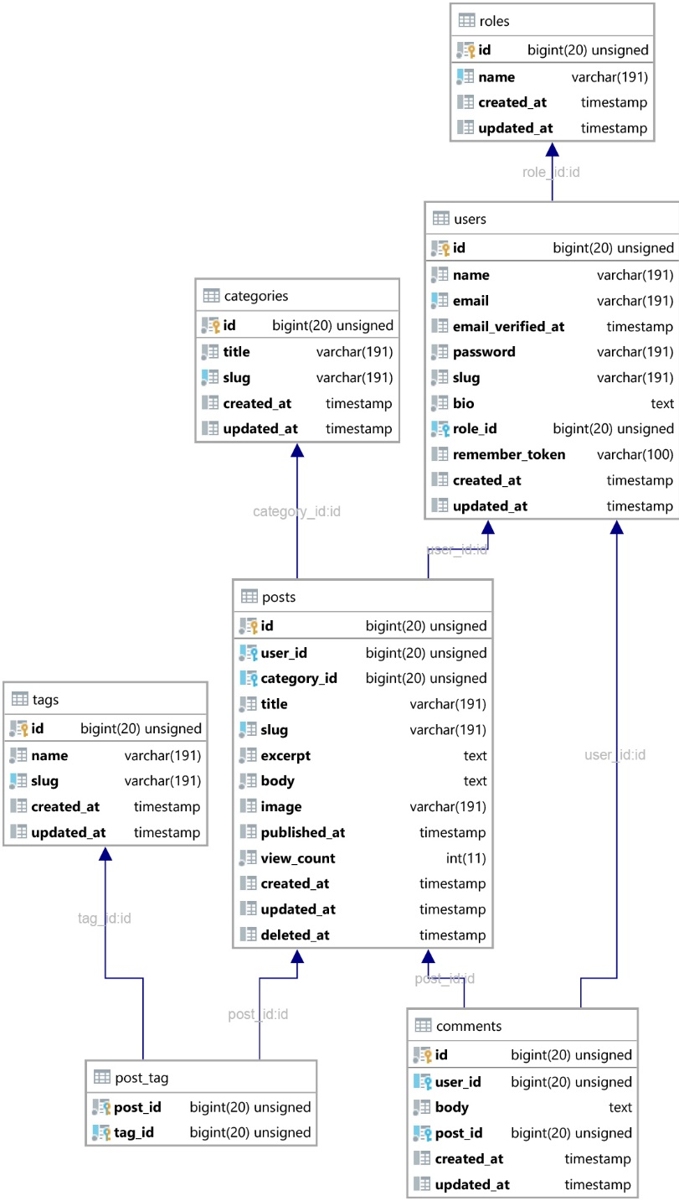

## Table 1 (Example: Account)

|  |  |  |  |
| --- | --- | --- | --- |
| **Column Name** | **Data Type** | **Constraint** | **Description** |
|  |  |  |  |
|  |  |  |  |
|  |  |  |  |

Example:

|  |  |  |  |
| --- | --- | --- | --- |
| **Column Name** | **Data Type** | **Constraint** | **Description** |
| AccountID | int | PK | Primary key of the table |
| Username | varchar(30) | Unique | User name, to identify a account |
| Password | varchar(40) | Not null |  |
| LastLogin | Datetime |  | This is the time that the user last logged into the system. |
| Status | char(1) | Default(‘D’) | Status of the account (Disable, Active, …) |

## Table 2 (Example: Caegory)

## Table 3 (Example: Product)

## …

## …

## ...

## ...

# UI\UX

## GUI 1 (Login Form)

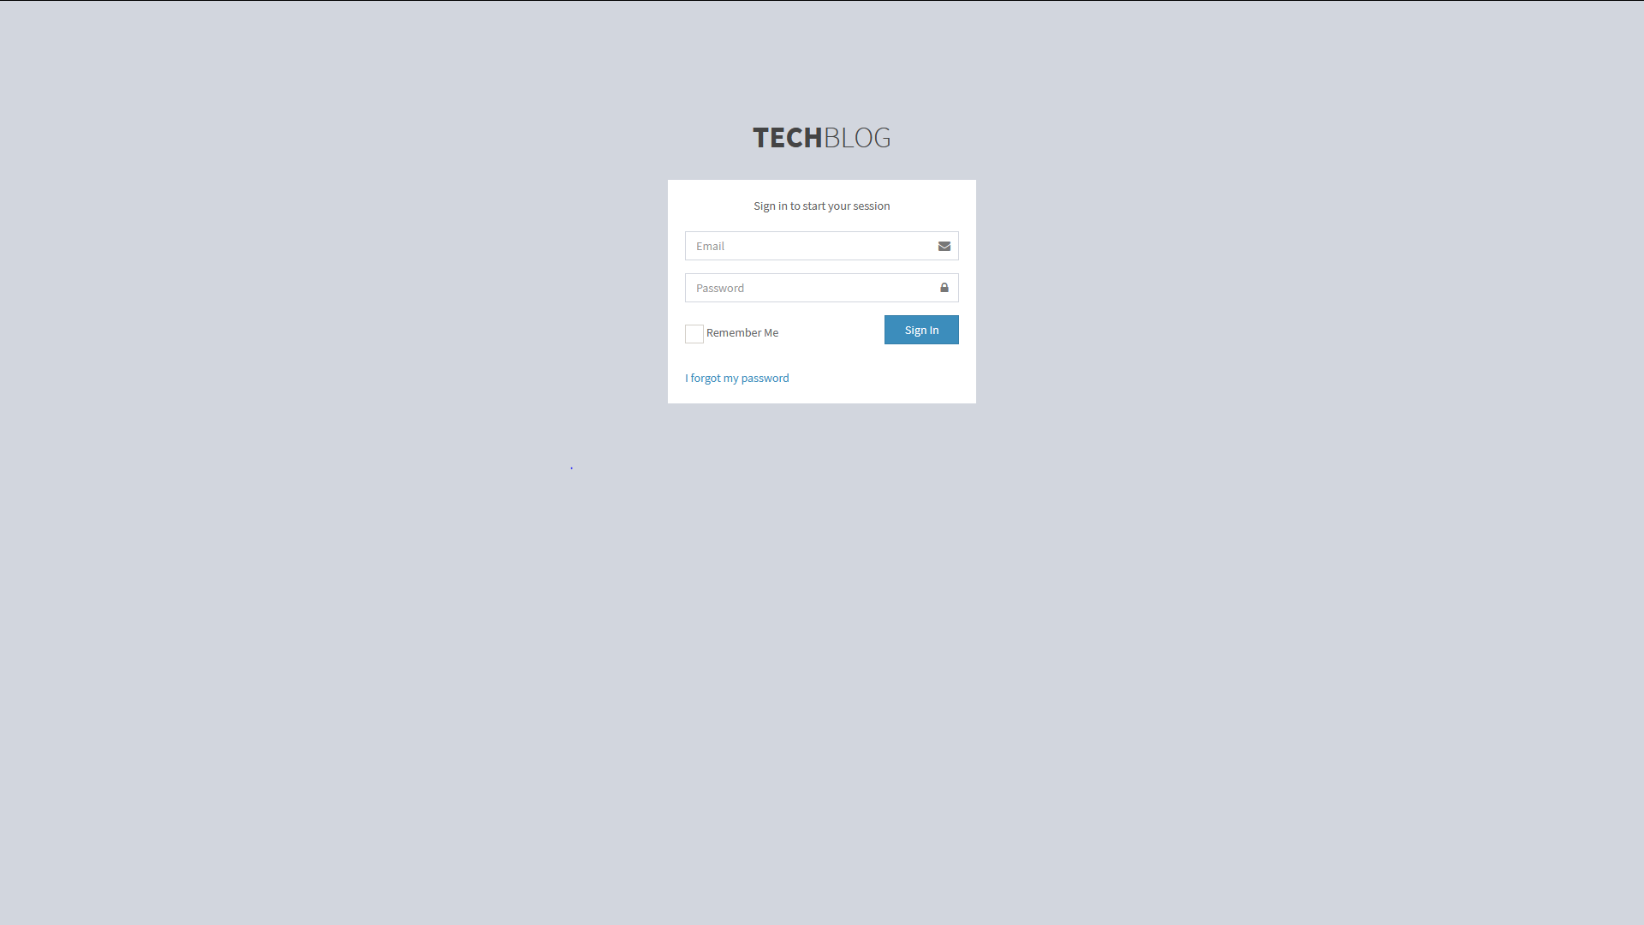

## GUI 2 (Dashboard)

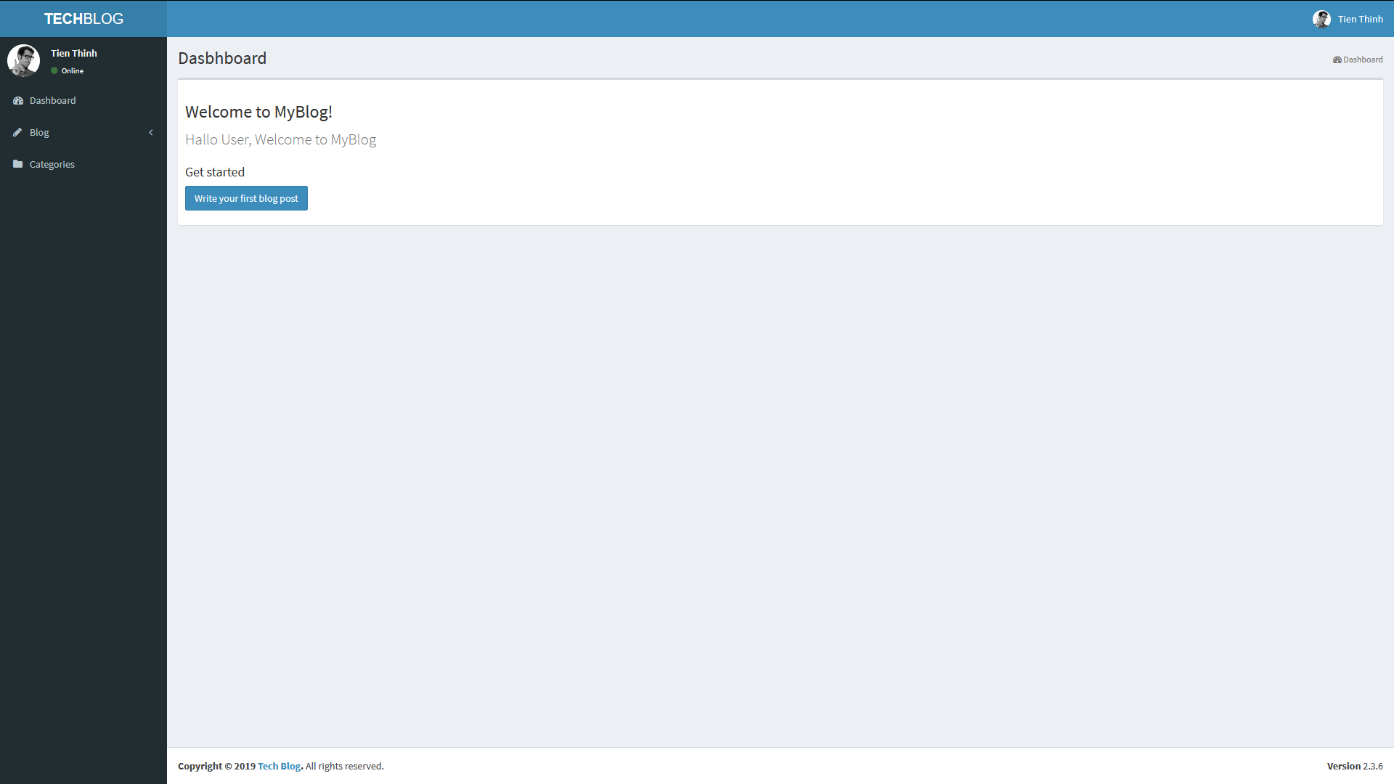

## GUI 3

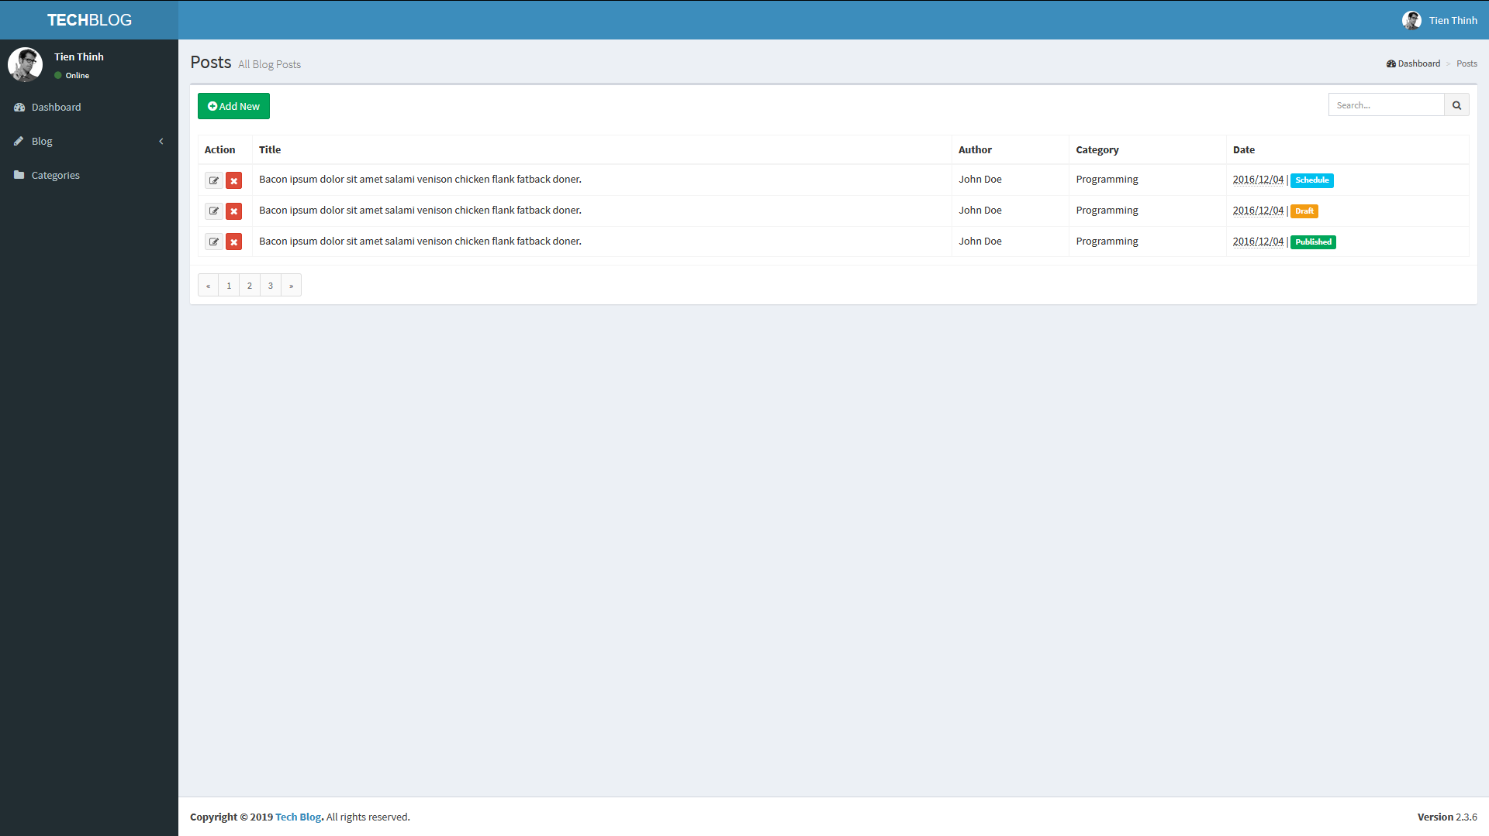

## …

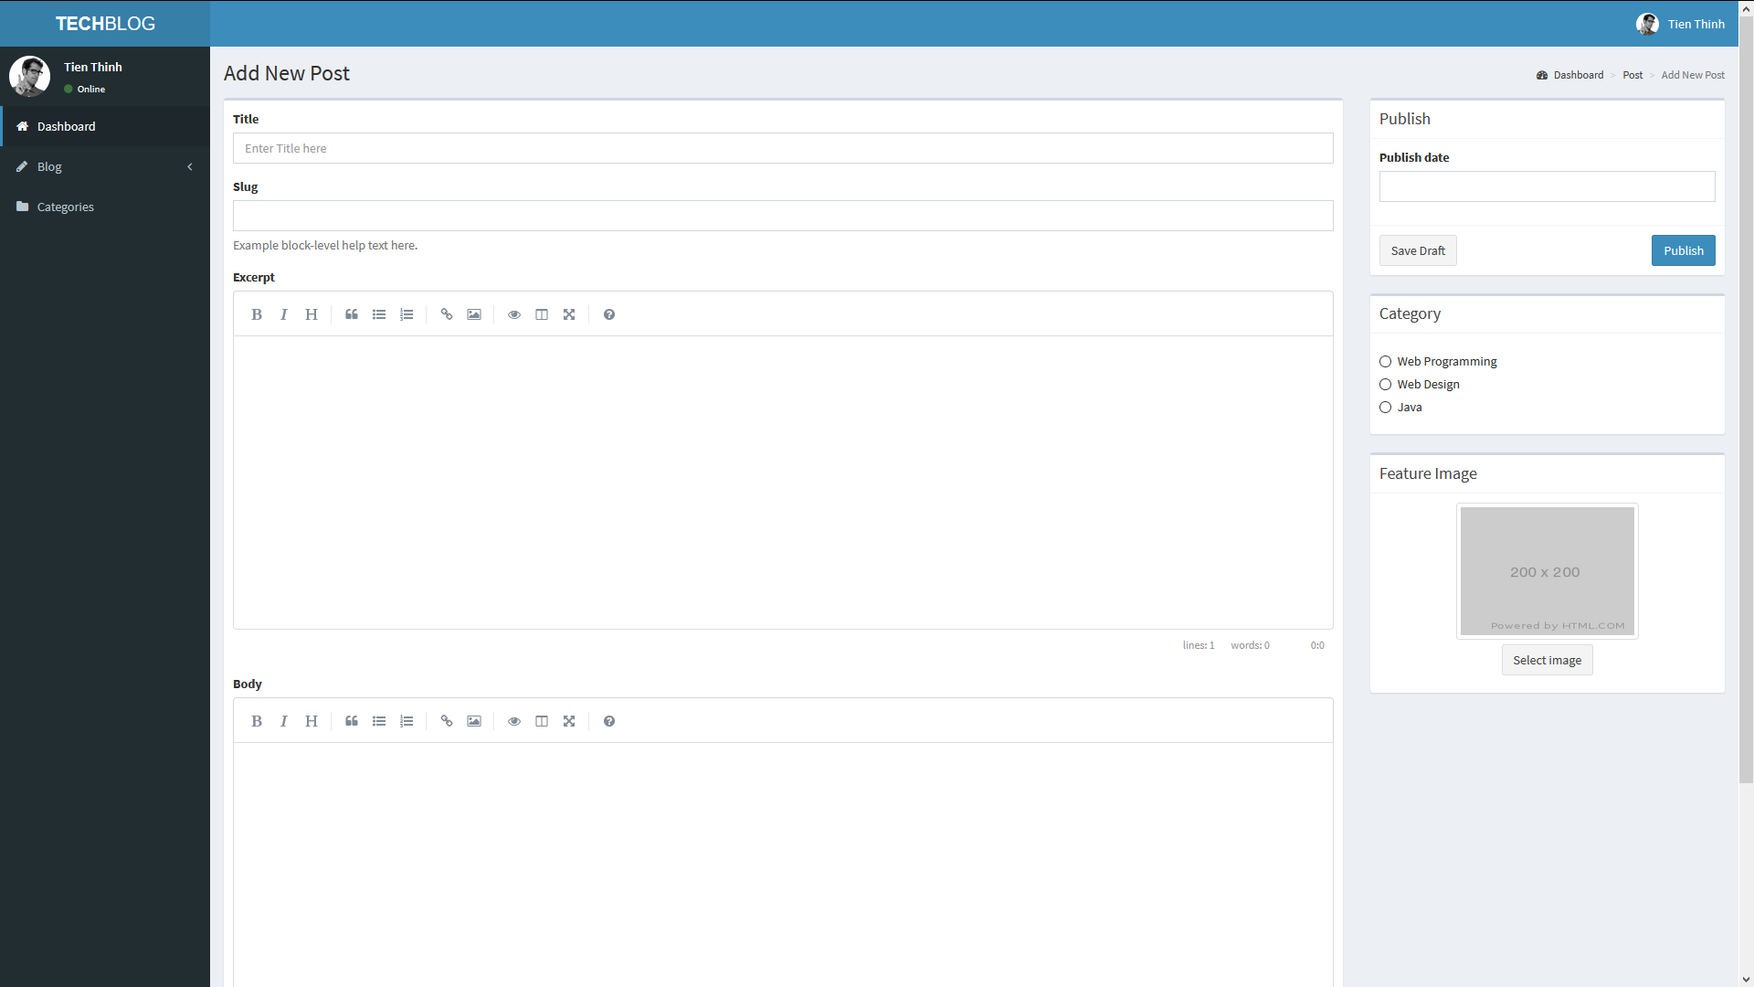

## …

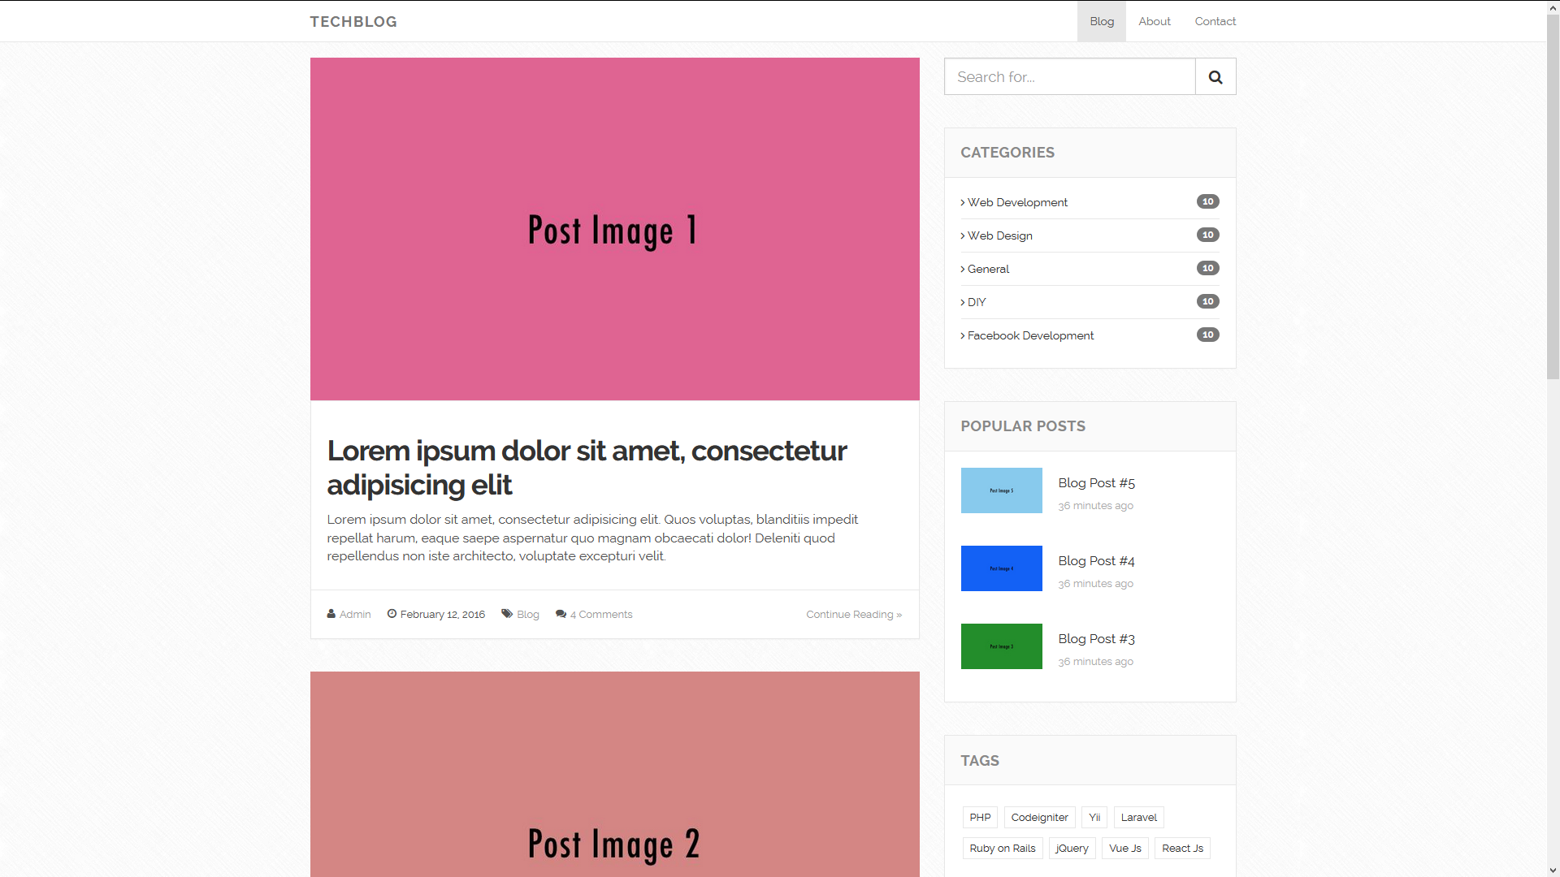

## …

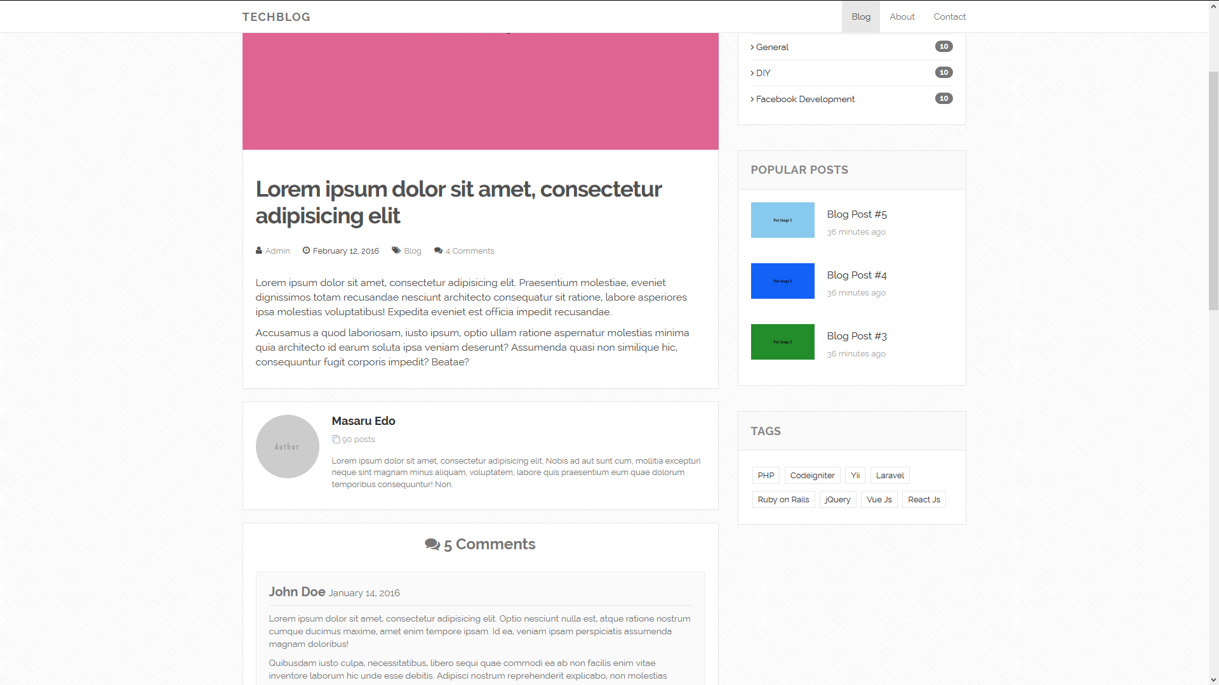

## ...

## ...

## ...

## ...

## ...

# Summary