You should be able to get by with creating a Standard team site:
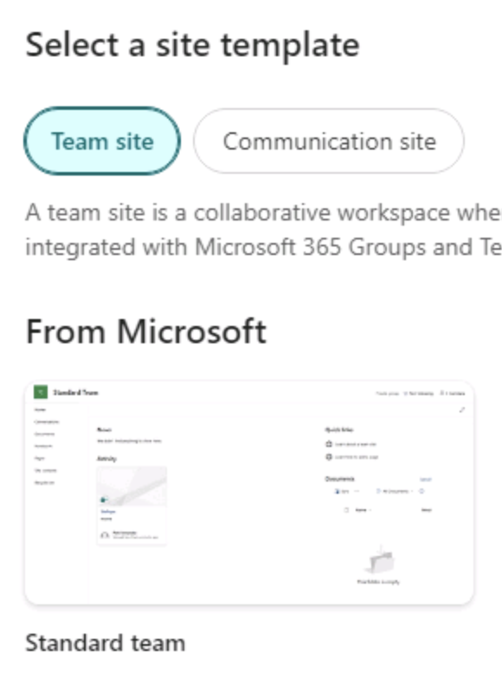

For the cktraining site, you should also add a subsite at the “sales" URL:
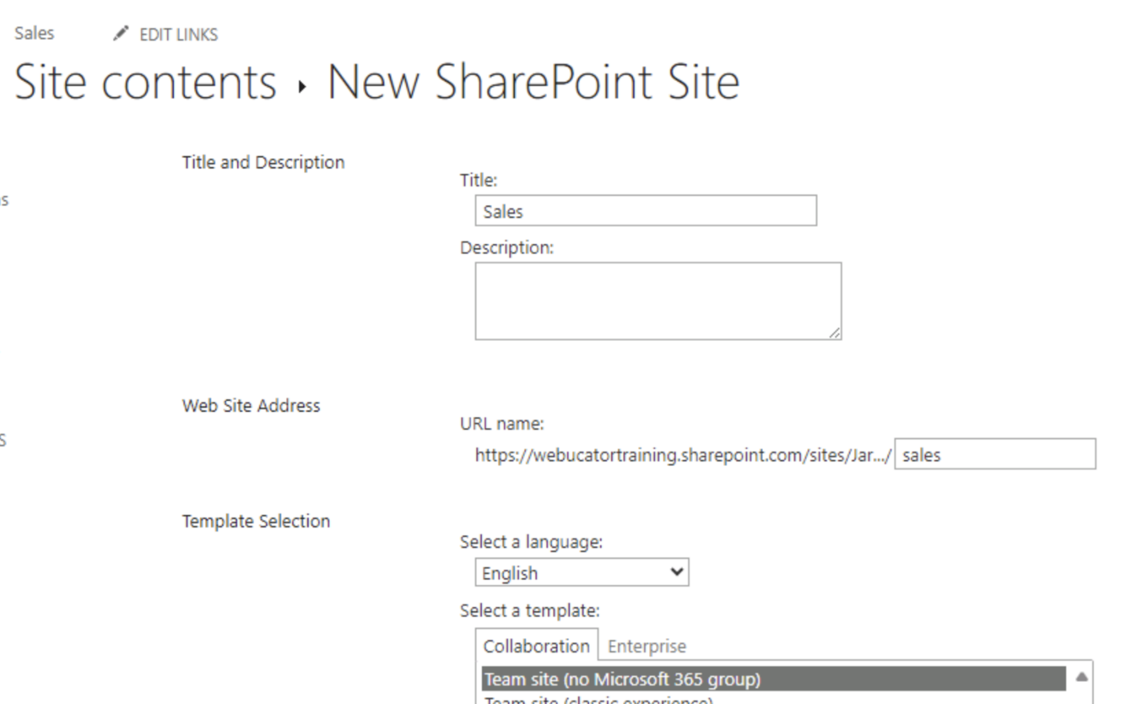

Thanks,
Jared
Penny acct missing
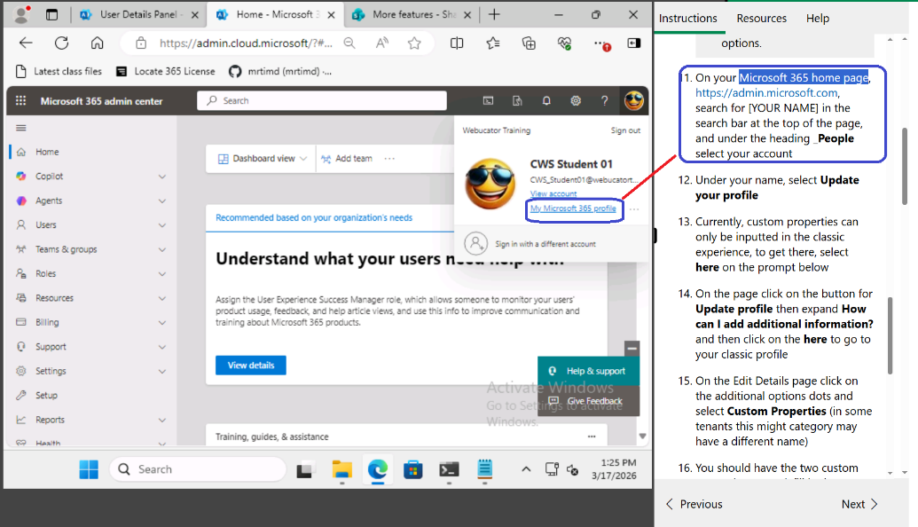
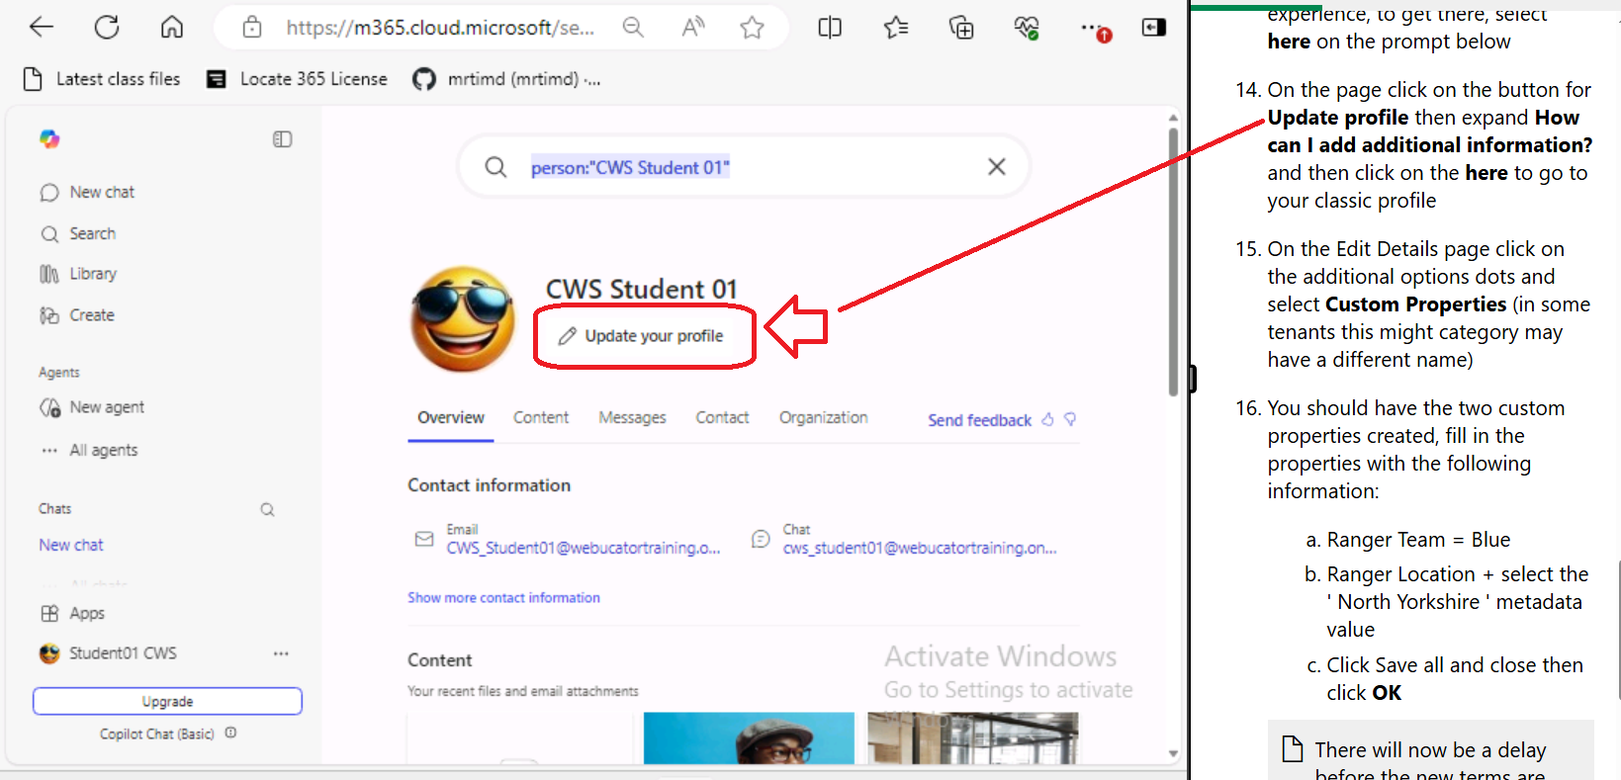
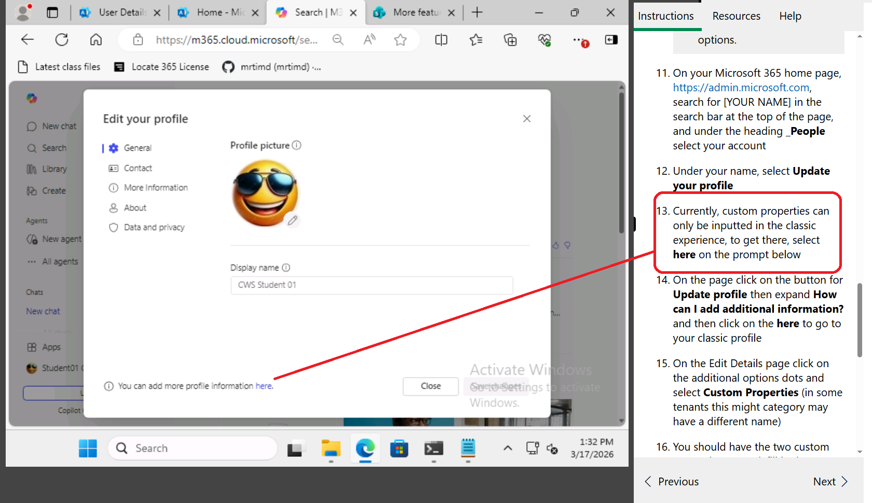
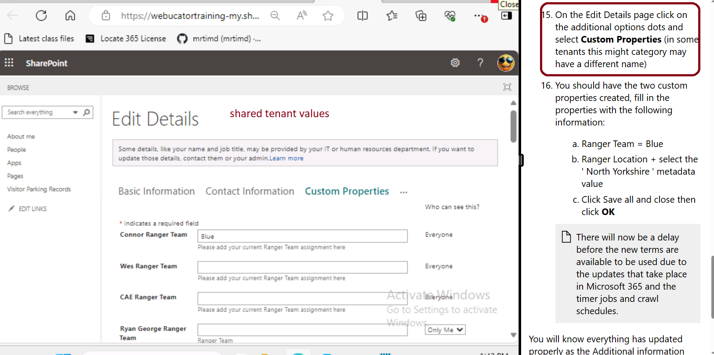
Lab F - missing items
Exercise 2: Search across associated hub sites
Create Contracts Doc Lib in cktraining/sales sub site to use later
- add document titled Contract alpha financials (used Exercise 3: Create an audience targeted search web part)
Where is
Marketing on the top left nav, as it's linked through a hub association
Exercise 3: Create an audience targeted search web part
setup audience
