Highly Energy‐Efficient Current   
Control for Vehicle Drives

Tobias Schmidt

TH Köln

Cologne, Germany

Tobias.Schmidt@th-koeln.de

*Abstract*—This paper presents three optimized pulse width modulation (PWM) methods based on the space vector modulation. These are intended to minimize losses in drive control and thus make the vehicle drive more efficient. For this purpose, discontinuous space vector modulation, synchronous pulse width modulation and an optimized modulation are used. Discontinuous space vector modulation minimizes switching losses in the inverter. Synchronous pulse width modulation and optimized modulation reduce the current ripple in the motor and the losses that occur there in the form of heat. The interaction of these three methods results in a highly energy-efficient vehicle drive. The implementation of the methods is performed with the help of the Matlab/Simulink software.

Keywords—Current control; Vehicle drives; Minimum losses; Optimized pulse width modulation; Matlab/Simulink

# Introduction

The control of electric vehicle drives is becoming more and more important today, as it is increasingly important for the vehicle industry. The problem today is that the range of electric vehicles is very small due to the energy density of the battery and the high weight of the vehicle caused by the battery. Therefore, this paper presents a method for highly energy-efficient control to minimize the losses in a vehicle drive. The minimization of losses results in two advantages that increase the range of a vehicle. On the one hand, less energy is needed for the same range. On the other hand the weight of the engine is reduced if the heat losses are reduced, which again means more range. Because less losses means less heat and therefore a smaller cooling unit is necessary.

Another problem is to minimize both the switching losses in the inverter and the heat losses in the motor at the same time. If the drive has a high switching frequency, the losses in the motor are low but higher in the inverter. Conversely, if the switching frequency is low, the switching losses are low but the current ripple is large and the losses in the motor increase. For the current ripple applies:

$∆i\sim \frac{1}{f_{s}}$ (1)

Fig. 1 shows the structure of a current control for a drive system. In most cases, a standard PI controller is used for the current controller, whose output signal, the control signal, is a voltage setpoint $U^{*}$. This setpoint is then realized on time average by the inverter using a corresponding modulation method. The modulation method, which is examined in more detail in this paper, generates the switching states $u_{k}$ of the inverter. The permanent magnet synchronous motor is driven by the inverter and the current is measured in each phase in order to determine the control deviation from the setpoint and the actual value [5].

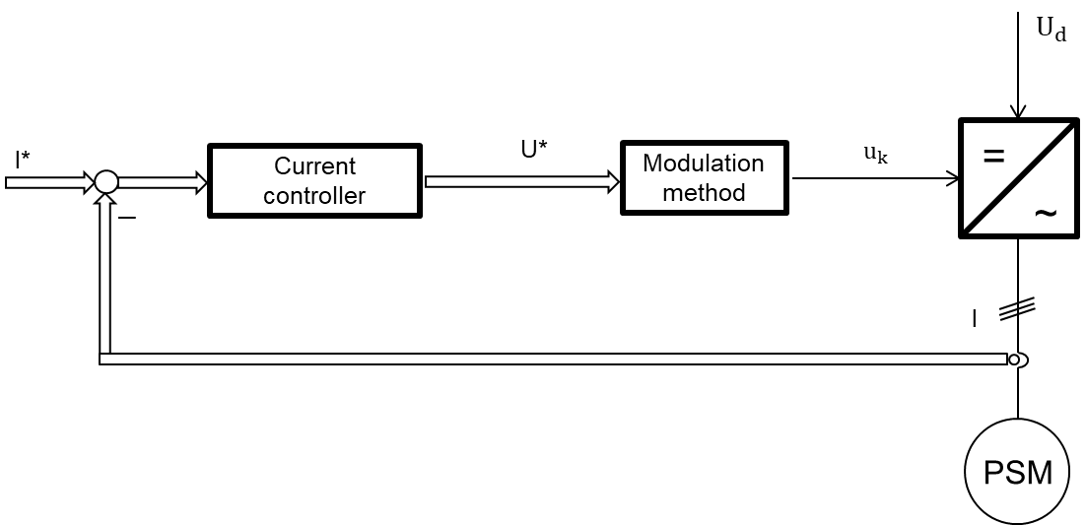

Fig. 1. Structure of a drive system.

# Space Vector Modulation (SVM)

Today, space vector modulation is one of the most important modulation methods for calculating switching states for a three-phase drive inverter. The inverter circuit shown in Fig. 2 has eight possible switching states. Each of these switching states has an associated space vector as shown in Fig. 3 ( $-1$ is equivalent to switch on $-U_{dc}$, $+1$ is equivalent to switch on ${+U}_{dc}$). Thus there are eight space vectors $U_{0}$ to $U_{7}$ of which six are active voltage vectors and two are the so-called zero voltage vectors $U_{0} / U_{7}$.

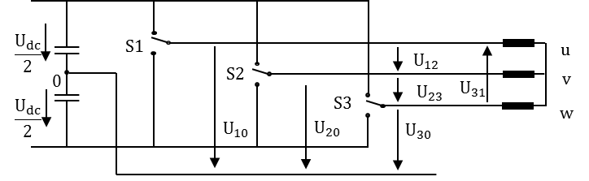

Fig. 2. Three phase converter circuit.

The three desired sinusoidal input voltages are represented by one space vector. If this space vector rotates with constant angular velocity and constant amplitude in the plane, an ideal three-phase sine wave is generated. This space vector is also the setpoint space vector $U^{*}$. With space vector modulation, the sampled setpoint voltage vector is now simulated with the aid of the eight space vectors, thus generating a rotating space vector [1].

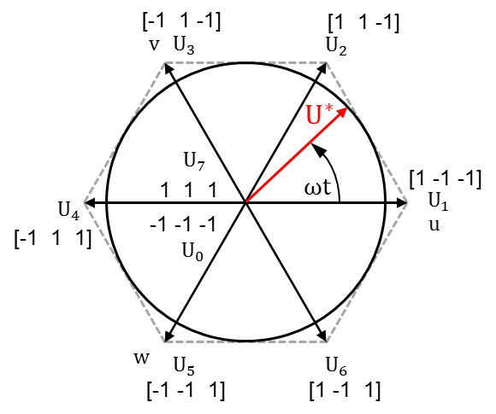

Fig. 3. Space vector display in plane.

To create a space vector within a sector, the two corresponding active voltage vectors and at least one zero voltage vector are necessary. The duty cycle of each vector can be easily calculated by transforming the plane. In [2] the duty cycles for sector I, for example, can be calculated as follows:

$t_{a}=u_{α}-{\frac{\sqrt{3}}{3}u}_{β}$ (2)

$t_{b}=u_{β}+{\frac{\sqrt{3}}{3}u}_{β}$ (3)

$t_{0}=t_{s}-t_{a}-t_{b}$ (4)

Where $t_{s}$ is the sampling time and $u_{α}$  and $u_{β}$   are the Clarke transformed three-phase voltages. The duty cycle of the first active voltage vector can be calculated according to (2), that of the second according to (3) and that of the zero voltage vector according to (4). Similar equations can be used to calculate the duty cycles for the remaining sectors.

# Optimized Methods

In the following, the three optimized modulations discussed in this paper are presented. The method of modulation is described and its advantages compared to standard methods.

## Discontinuous Space Vector Modultaion

The discontinuous space vector modulation is a variation of the standard or continuous space vector modulation. The exemplary switching sequence for sector I in Fig. 4(a) is called continuous because all switches are switched on one after the other and then switched off again in reverse order. This results in a switching sequence similar to a carrier-based sine-triangle-modulation. In order to simulate the setpoint voltage vector, six switching operations are required. The switching sequence including the duty cycle of the individual space vectors in Fig: 4(a) can be represented as follows according to (2), (3) and (4):

$U_{0}\left({t_{0}}/4\right)→ U_{1}\left({t_{a}}/2\right)→ U_{2}\left({t_{b}}/2\right)→$ (5)

$$U_{7}\left({t_{0}}/2\right)→ U_{2}\left({t_{b}}/2\right)→ U_{1}\left({t_{a}}/2\right)→U_{0}\left({t_{0}}/4\right)$$

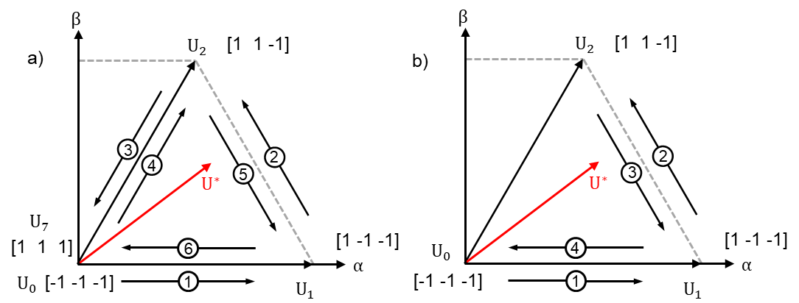

Fig. 4. Switching sequence. (a) continous, (b) discontinous.

However, this same setpoint voltage vector from Fig. 4(a) can also be simulated with a different switching sequence of the space vectors as shown in Fig. 4(b). But now, in comparison to before, only four switching operations are required. In addition, it can be seen that the switch is not switched at all in phase w in this sector. The same applies to sector II, because this switch is not switched here either. Thus the switch of the phase w is not switched for 120°. The same applies for the switch of phase u in sector III and IV and for the switch of phase v in sector V and VI. In this case, the switching sequence including the duty cycle of the space vectors looks as follows according to (2), (3) and (4):

$U_{0}\left({t_{0}}/2\right)→ U_{1}\left({t_{a}}/2\right)→$ (6)

$U_{2}\left(t_{b}\right)→U_{1}\left({t_{a}}/2\right)→U_{0}\left({t_{0}}/2\right)$

Due to the discontinuous space vector modulation, the switching frequency in the inverter and thus also the switching losses have been reduced by about a third. The disadvantage of discontinuous space vector modulation is that the subharmonic oscillations and thus the current ripple in the motor current increase, which in turn leads to increased losses in the motor. It is now again possible to increase the switching frequency of the discontinuous modulation so that it corresponds to the average switching frequency of the continuous modulation. This results in the same switching losses in the inverter again, but the voltage quality improves and the current ripple decreases. In any case, loss minimization is achieved by discontinuous space vector modulation [1].

## Synchronous Pulse Width Modulation

Synchronous pulse width modulation involves generating a synchronous triangular carrier signal. The carrier signal is to be synchronized to the reference signal so that an integer frequency ratio $m_{f}$ between PWM frequency or carrier frequency $f_{c}$ and fundamental frequency $f_{1}$ is obtained. The fundamental frequency $f_{1}$ refers to the output voltage of the inverter, which is also proportional to the motor speed. Therefore the frequency ratio $m_{f}$ is:

$m_{f}=\frac{f_{c}}{f_{1}}$ (7)

Since $m_{f}$ is a fixed integer value and the carrier frequency should be synchronous to the fundamental frequency, the triangular carrier signal no longer has a constant frequency [3].

To generate such a synchronous triangle signal, either the motor speed and the number of pole pairs of the motor or, more simply, the commutation angle is required, Fig. 5.

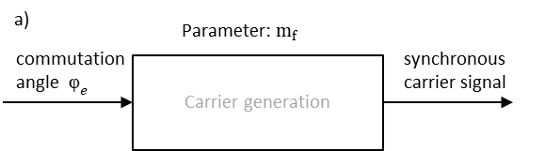

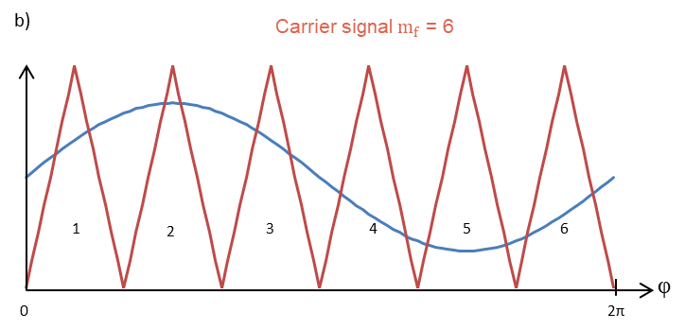

Fig. 5. Generation of a synchronous carrier signal with the commutation angle e. (a) block diagram, (b) synchronous carrier signal.

The synchronous pulse width modulation ensures that no subharmonic oscillations occur and so losses are minimized, especially in high power applications with frequency ratios smaller than 15 ( $m_{f}$ < 15) [3]. Furthermore, by selecting an odd and by three divisible frequency ratios, a half-oscillation symmetric and in all three phases identical voltage form can be generated [1].

In addition, the synchronous triangle signal can be used to sample the voltages ${ u}_{α}$  and $u_{β}$  or later to sample the current. Sampling always takes place at the corners of the carrier signal. In this case, it cannot happen that too few samples are taken at high frequencies and the output signal loses its quality. But this signal can also be used for current measurement for current control. If sampling is always performed at the reversal points of the triangle signal, the current ripple caused by the PWM can be suppressed [3].

## Optimized Modulation

The duration for generating a setpoint voltage vector was previously considered constant. Thus each switching sequence of a simulated space vector has the same duration $T_{0}$. The duty cycle is again calculated from (2), (3) and (4). In the further course, the time duration for a subcycle is always considered. A subcycle corresponds to the time sequence of three consecutive switching state vectors. Therefore, one pulse is exactly equivalent to two subcycles.

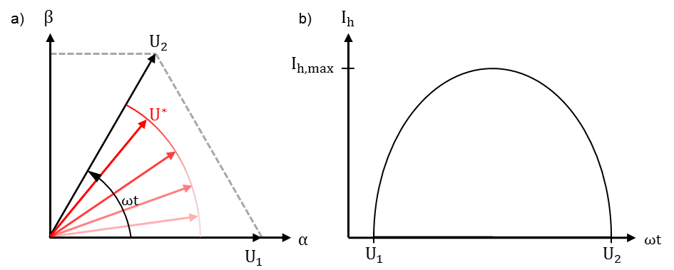

Fig. 6. Harmonic current. (a) subcycles in sector I, (b) harmonic current as function of angle for sector I.

The harmonic current resulting from this standard space vector modulation method with constant subcycle duration is shown in Fig. 6. As shown in Figure 6(b), the harmonic current is greatest exactly in the middle between the active voltage vectors U1 and U2 [4].

With the newly introduced optimized modulation, the harmonic current in Figure 6(b) is minimized by considering the duration $T_{0}$ of a subcycle as variable rather than constant $T_{0}→ T_{k}$. To minimize the harmonic current between two active voltage vectors, the duration of a subcycle to generate a space vector is reduced. However, in order to still have the desired average number of subcycles within a fundamental period, the duration in the proximity of an active voltage vector must be increased.

A possibility optimal subcycle duration depending on the phase angle of the setpoint voltage vector is shown in Fig. 7. [4].

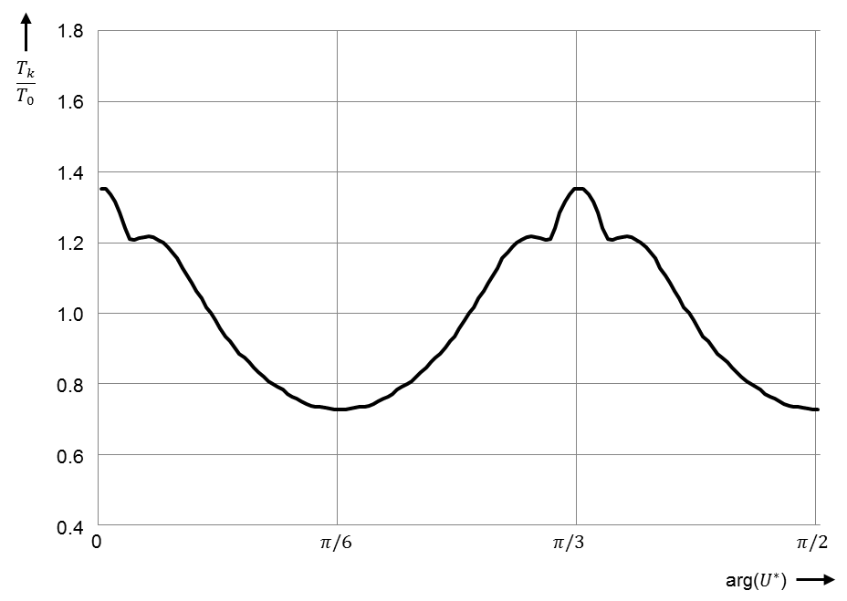

Fig. 7. Continuous functions $T_{k}/T_{0}$ versus fundamental phase angle.

Here it can be seen that the duration of a subcycle between two active voltage vectors is the longest and the shortest near an active voltage vector. The curve in Fig. 7 is repeated after a phase angle of $π/3$ and is therefore also valid for the other sectors II to VI.

The switching sequence for an optimal modulation with variable subcycle duration $T_{k}$ is shown in Fig. 8(b). In comparison, a switching sequence of a continuous space vector modulation can be seen next to it. Before the optimization in Fig. 8(a), the same subcycle duration $T_{0}$ is always visible. After optimization, a variable subcycle duration with shorter and longer times than $T_{0}$ can be recognized.

The optimized modulation reduces the harmonic current and thus the losses in the motor. In addition, the switching frequency changes within a sector, but in such a way that the average switching frequency in the inverter remains constant.

Fig. 8. Switched waveforms. (a) before optimization, (b) after optimization.

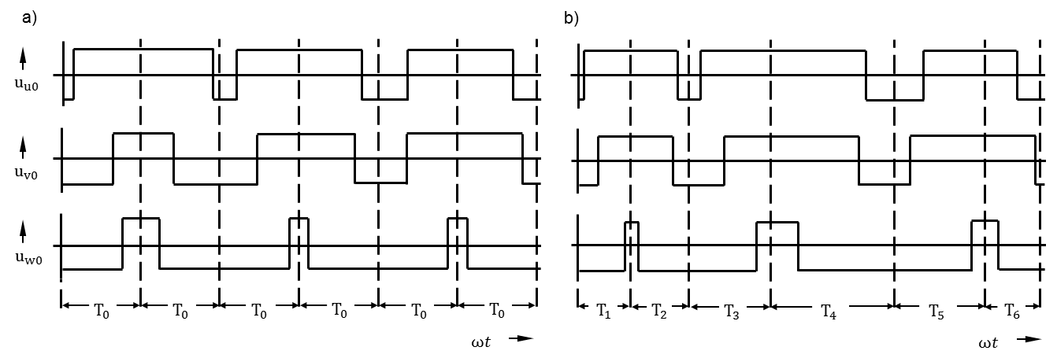

# Implementation of the Models

In this part the implementation of the previously described modulation methods in Matlab/Simulink is presented. First, the three modulation methods were created in a separate model and then assembled into one large model.

## Discontinuous Space Vector Modultaion

The block diagram for discontinuous space vector modulation is shown in Fig. 9. In the first block “Space vector transformation”, the three sinusoidal setpoint voltages are transformed by a Clarke transformation into the plane, so that the voltages $u_{α}$ and $u_{β}$ arise. In addition, as described in Section III A, the plane is transformed there to simplify the calculation of the duty cycle. Then the voltages $u_{α}$ and $u_{β,m}$ (Modulated $u_{β}$) are sampled, which is still realized in this model with constant time intervals.

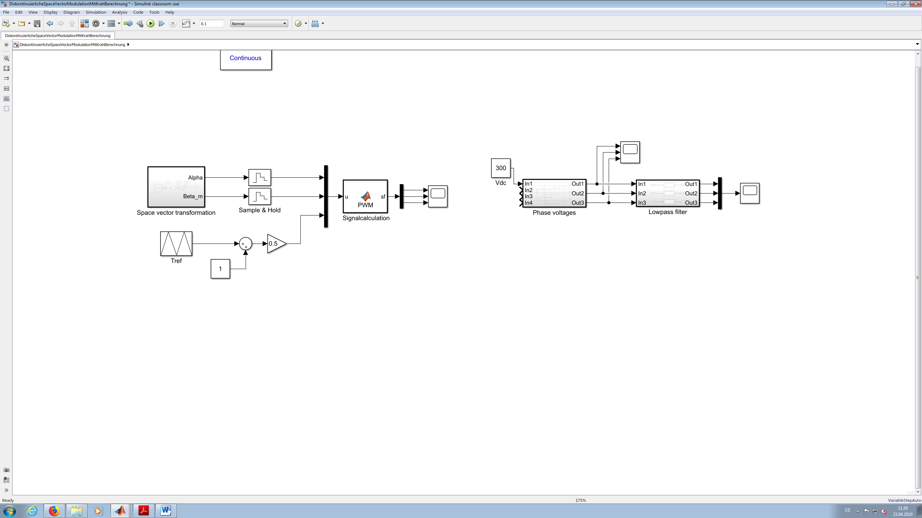

Fig. 9. Block diagram discontinous space vector modulation.

The blocks below generate a triangular reference signal with a fixed frequency and amplitude from zero to one. This reference signal is required to output the switching states for the calculated duty cycle. The sampled voltages $u_{α}$ and $u_{β}$ and the reference signal are then used in the "Signalcalculation" block to calculate the switching sequences for the inverter for the three phases u, v and w.

In this block, the sector and thus the appropriate calculation for the duty cycle of the space vectors according to (2), (3) and (4) is determined on the basis of $u_{α}$ and $u_{β}$. Using the duty cycles, three levels for phases u, v and w can be determined so that a comparison with the reference signal produces the desired switching sequence with the correct time intervals according to (6). One level is set in such a way that this phase   
  
  
  
is not switched at all. An example for the signal calculation in sector I is shown in the following code section.

%Decision tree for the sectors

if alpha>=0

if beta>=0

if alpha>=beta_m

% sector I

ta = alpha – beta_m;

tb = beta + beta_m;

t0 = (ts-ta-tb);

%Determination of the levels

x1=((1/(ts/2))*(t0/2));

x2=((1/(ts/2))*((t0/2)+(ta/2)));

x3=10;

%Comparison level to reference signal

if y>x1 %y=triangular signal

sa=1;

else

sa=0;

end

if y>x2

sb=1;

else

sb=0;

end

if y>x3

sc=1;

else

sc=0;

end

The output signals sa, sb and sc from this last block are then the finished switching sequences to control the three switches in the inverter in Fig. 2.

## Synchronous Pulse Width Modulation

The block diagram for synchronous pulse width modulation is shown in Fig. 10. Input signal is the commutation angle $φ_{e}$ of the motor. In addition, a frequency can be specified in this model at which the frequency ratio is to change. This can be useful to reduce the frequency ratio at higher speeds and to reduce the switching operations. For example in Fig. 10, at a frequency of 150 Hz, the frequency ratio $m_{f}$ is reduced from thirteen to nine. In the block "Determination $C_{x}$" the constant $C_{x}$ is calculated, which is added to the angle when changing the frequency ratio to prevent a jump in the triangle signal.

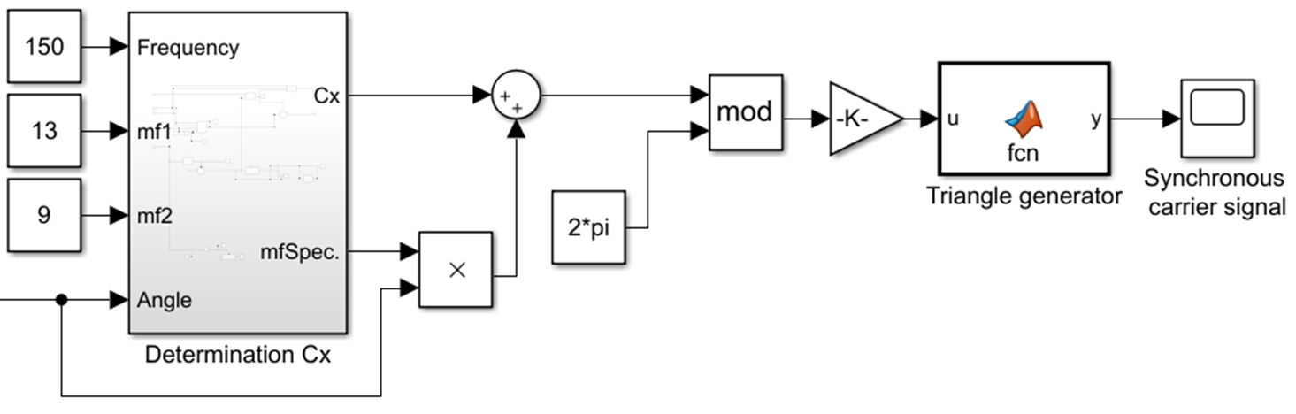

Fig. 10. Block diagram synchronous pulse width modulation.

This signal is used to perform modulo operation with $2π$ to produce a synchronous sawtooth signal with amplitude of 0 to $2π$. The sawtooth signal is then normalized to amplitude of 0 to 1 and converted into a triangular signal in the "Triangle generator" block. The output signal is then the synchronous carrier signal which can be used for space vector modulation.

## Optimized Modulation

The block diagram for optimized modulation is shown in Fig. 11. The structure is very similar to that of the discontinuous space vector modulation in Figure 10. The model has remained almost the same, only the generation of the triangular reference signal has changed. In addition, two further input parameters have been added. Firstly, the number of subcycles per period of the fundamental frequency can now be specified. On the other hand, the modulation index for PWM can be set by shifting the triangle signal in the vertical direction.

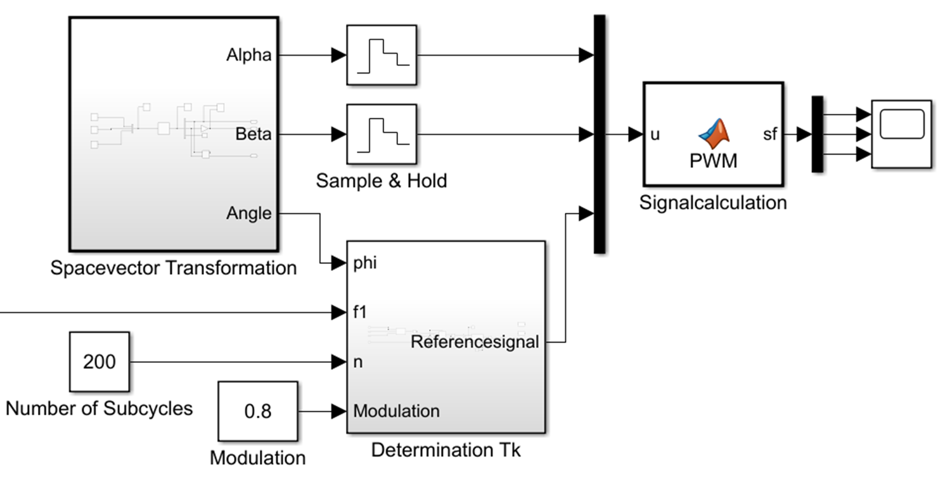

Fig. 11. Block diagram optimized modulation.

Since the duty cycle of a space vector depends on the frequency of the reference signal and variable subcycle duration is necessary for the optimized modulation, the reference signal must also have a variable frequency and not a fixed frequency as previously. For this reason, the subcycle duration is calculated in the block "Determination $T_{k}$" as a function of the angle according to Fig. 7 and a triangular reference signal is generated. The reference signal therefore has high frequencies if the setpoint voltage vector is between two active voltage vectors and low frequencies if it is close to an active voltage vector. In order to continue to have a synchronous reference signal, the number of subcycles and the fundamental frequency $f_{1}$ are also required for the calculation. With this new reference signal with variable frequency, the switching sequence can be calculated again as described in section A. This results in a switching sequence as shown in Fig. 8(b).

##### Conclusion

All three modulation methods are implemented in one model in Matlab/Simulink. This model performs the calculation of the switching states $u_{k}$ for the inverter from the setpoint voltage vector $U^{*}$ in the "Modulation method" block in Fig. 1. Thereby a switching sequence is generated with the presented methods, which results in minimum losses in the inverter and in the motor. The discontinuous space vector modulation minimizes the switching losses in the inverter by reducing the number of switching operations. The synchronous pulse width modulation and the optimized method minimize in two different ways the current distortion in the motor current and thus the heat losses in the motor. On the one hand, synchronous pulse width modulation ensures a synchronous carrier signal through a fixed frequency ratio $m_{f}$ and thus minimizes the harmonic current. The optimized method, on the other hand, varies the subcycle duration $T_{k}$ to generate a space vector according to a given curve, and thus minimizes the harmonic current. In this model, different parameters can now be set to achieve the optimal operating point. Both the modulation index of the PWM and the number of subcycles can be set. The frequency ratio $m_{f}$ of the synchronous pulse width modulation is included in the number of subcycles.

##### References

1. S. Bernet, “Selbstgeführte Stromrichter am Gleichspannungs-zwischenkreis” Technische Universität Dresden, Dresden, Germany, Springer Vieweg, 2012.
2. J.O. Krah, J. Holtz, “High-Performance Current Regulation and Efficient PWM Implementation for Low-Inductance Servo Motors” IEEE Transactions on industry applications, vol. 35, no. 5, September / October 1999.
3. J.O. Krah, M. Höltgen, J. Pieper, C. Klarenbach, “Natural-sampled, quasi-continuous and synchronous pulse width modulator enables field oriented control for high speed drives” PCIM Europe 2017, 16 – 18 May 2017, Nuremberg, Germany.
4. J. Holtz, B. Beyer, „Optimal Pulsewidth Modulation for AC Servos and Low-Cost Industrial Drives”, IEEE Transactions on industry applications, vol. 30, no. 4, July, August, 1994.
5. D. Schröder, “Elektrische Antriebe - Regelung von Antriebssystemen“ 4. Auflage, Springer Verlag, München, Deutschland, 2015.
6. Y. Ma, “Realizing Space Vector Modulation in MATLAB/Simulink and PSCAD” IEEE, 2013 North American Power Symposium (NAPS), November 2013.
7. A. Iqbal, A. Lamine, I. Ashraf, “Matlab/Simulink Model of Space Vector PWM for Three-phase Voltage Source Inverter” IEEE, Aligarh Muslim University, India, June 2007.
8. F. Jenni, D. Wüest, “Steuerverfahren für selbstgeführte Stromrichter” Hochschulverlag AG an der ETH Zürich, 1995.