Bing Custom Search API v7 Findings

The Good

**Speed**

The Search response is much faster than our current Extron search. It also takes the burden off of us to host a bandwidth-heavy process.

**Simplicity**

The Custom Search portal (*although restrictive feeling, See Drawbacks: 1,2,7*) is easy to understand and get started with creating a configuration. The API is also easy to work with and allows for fluid AJAX.  
<https://www.customsearch.ai>

**Pagination**

Opens our searches up for new improvements such as “Google-like” pagination. Allowing our users to go 10+ pages deep in results.

**Basic “Typo” handling**

It handles misspellings well. So far, I can see it’s more advanced than just a basic Levenshtein distance compute.

**PDF Indexing**

The Crawlers will index PDF content and make them available for search. This synergizes with other Extron projects like Online Knowledgebase.

Technical Drawbacks

1. Specifying a new search definition for sections of the site that go past 2 levels deep is not supported. (I.e. if I wanted a new search concentration of just “User Manuals” that is 3 levels deep as shown below)  
   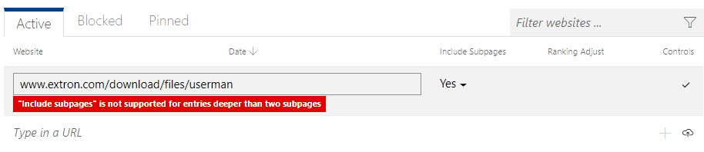
2. Search definitions only work at a “Folder level”. We cannot specify for the definition to be of a specific file (aspx) then find all dynamic pages that the file generates.
3. No customization of snippet text. What Bing gives you is what you get. You can further edit down. But you can’t get more or specify a different focus for snippets. The Crawlers work in mysterious ways.
4. No Result match score returned from API. Would be nice to know if a result is not very “Matchy”. If we search a bad keyword and Bing produces some results, we have no way of knowing if those results are: Weak vs. Strong.
5. Limited to 50 results per API call. This works ok if we’re ok with a generic search with standard pagination. However, if we want to make our search fancier and pre-load hundreds of results and further filter down to deliver custom views, it is not possible past 50 line items.
6. Thumbnails: Bing CS will only support OpenGraph image to define a thumbnail or page preview. We have not set up OpenGraph in any of our existing pages.   
   <http://ogp.me/>
7. On the issue of Filtering results (Blocking, Pinning, Improving Rank) the Custom Search Portal is a bit cumbersome to work with. There are no macro tools, or ways to edit in batch. (It feels like single-item line by line edits, clicking Up-and-Down arrows on each line item)  
   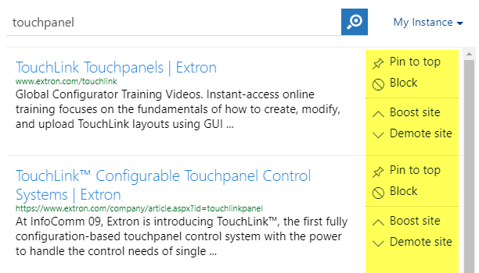
8. Bing Autosuggest does not work in tandem with Custom Search. The Autosuggest API is generic and meant to be used in conjunction with Bing Web Search API which has the scope of the entire Web (Like a generic Bing search). There is no way to limit the Autosuggest responses to your custom domains/subsites/webpages.  
   <https://stackoverflow.com/questions/48063945/can-i-use-bing-autosuggest-with-custom-search>

Potential “Deal-breakers”

**Inability to handle translated pages that are produced dynamically.**

Bing does not provide us with any option to create searches using custom parameters and cookie values.

What this implies is that we cannot crawl product pages with a value set of Lang=5 to index all the Spanish pages. (There are possible work-arounds, but involve us changing our infrastructure to appease the Bing bots)

Foreign languages must be already static pages with no dynamic parameters. PDF’s are fine. For example, a quick search using a language filtration of ‘JP’ produces only Brochure results since Bing was able to pick up the static content in Japanese.

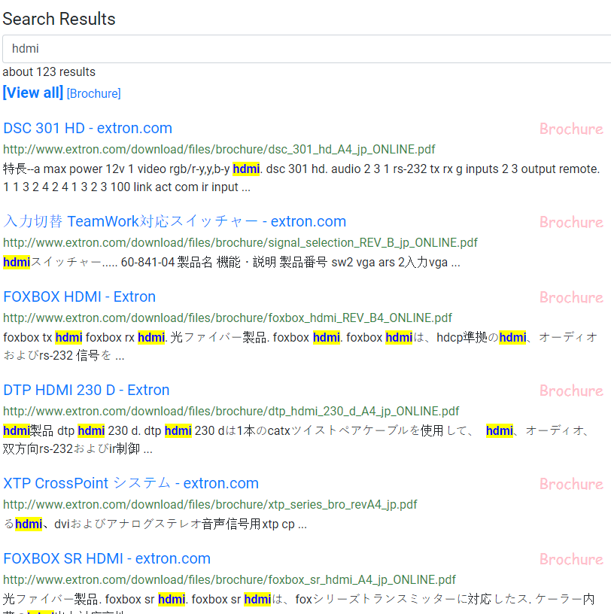

**Limited Return Objects from the API**

One thing that I noticed we do on our current Extron search is we will show pill icons for “New”. I was not able to customize a way for Bing to handle this.

The JSON that Bing returns is not very extendable. We are given a rule-book via the reference sheet. We can pull a few more pieces of data, such as Thumbnail, and some simple Metatag data like ‘Keywords’. But not much more after that.  
