CECS 424

Assignment 4

Total: 40 Points

Trevor Anderson - 014373123

General Instruction

• I recommend that you can type your answers by using LATEX.

• Submit your work via BeachBoard (Not email or in class).

1. (15 points) Write a POSIX standard regular expression to capture the hexadecimal floating-point values. A hexadecimal floating-point value begins with 0x or 0X, may contain the digits 0–9 and a/A–f/F, and has an optional fractional portion (beginning with a dot) and a mandatory exponent (beginning with P or p). There may be digits to the left of the dot, the right of the dot, or both, and the exponent itself is given in decimal (contains only the digits 0-9), with an optional leading + or - sign. A hexadecimal floating-point value may end with an optional F or f (indicating “float”-single precision) or L or l (indicating “long”-double precision). You can verify your answer using an online regex testers such as <https://regex101.com/>.

[0x|0X] ([\d|a-fA-F]*[(\d|a-fA-F)\.|\.(\d|a-fA-F)][\d|a-fA-F]*)[p|P][+-]?[\d]*[fF|lL]

2. (a) (5 points) Transform the regular expression letter (letter | digit) ∗ to a NFA.

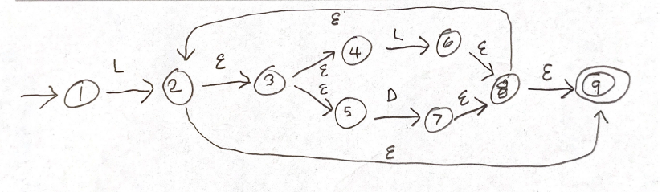

(b) (5 points) Create an equivalent DFA.

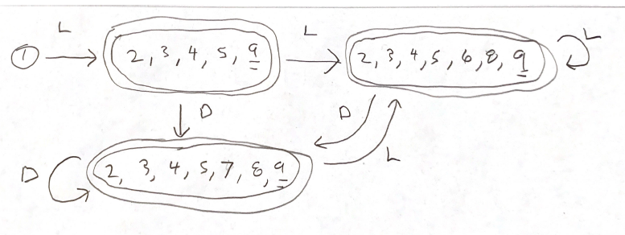

(c) (5 points) Minimize the DFA.

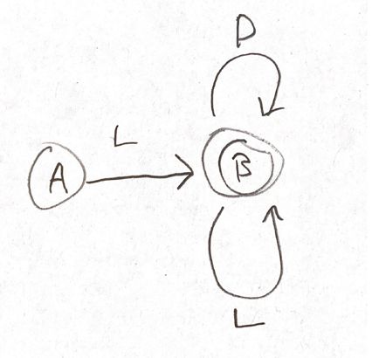

3. (10 points) Show the left-most parse tree for the string a b a a.

**Terminal symbols: {a, b}**

**S -> A M**

**M -> S | ε**

**A -> a E | b A A**

**E -> a B | b A | ε**

**B -> b E | a B B**

