AI-Based Smart Transport Fleet & Shipment Management System
A Mini Project Report Submitted in the partial fulfillment of the requirements for the award of the degree of

BACHELOR OF TECHNOLOGY

In
DEPARTMENT OF COMPUTER SCIENCE ENGINNERING
Or
DEPARTMENT OF COMPUTER SCIENCE AND INFORMATION TECHNOLOGY
By
P. Hasitha Sai Keerthana – 2420090107(Team Lead)
L. Suvarchala Mrudani – 2420030591
C. Suma Priya Varma – 2420030337

Under the Esteemed Guidance of

K.Venkateshwari





K L (Deemed to be) University
DEPARTMENT OF COMPUTER SCIENCE ENGINEERING
Or
DEPARTMENT OF COMPUTER SCIENCE AND INFORMATION TECHNOLOGY

DECLARATION

The Mini Project Report entitled “AI-Based Smart Transport Fleet & Shipment Management System“is a record of Bonafide work of P. Hasitha Sai Keerthana – 2420090107, L. Suvarchala Mrudani – 2420030591, C. Suma Priya– 2420030337. submitted in partial fulfillment for the award of B. Tech in Computer Science and Engineering (or) Computer Science and Information Technology to the K L University. The results embodied in this report have not been copied from any other departments/University/Institute.

P. Hasitha Sai Keerthana – 2420090107
L. Suvarchala Mrudani – 2420030591
C. Suma Priya Varma – 2420030337

K L (Deemed to be) University
DEPARTMENT OF COMPUTER SCIENCE ENGINEERING
Or
DEPARTMENT OF COMPUTER SCIENCE AND INFORMATION TECHNOLOGY
CERTIFICATE

This is certify that the mini project based report entitled “AI-Based Smart Transport Fleet & Shipment Management System” is a bonafide work done and submitted by P. Hasitha Sai Keerthana – 2420090107, L. Suvarchala Mrudani – 2420030591, C. Suma Priya– 2420030337. in partial fulfillment of the requirements for the award of the degree of BACHELOR OF TECHNOLOGY in Department of Computer Science Engineering, K L (Deemed to be University), during the academic year 2026-2027.

Signature of the Course Co-ordinator Signature of HOD

ACKNOWLEDGEMENT

The success in this project would not have been possible but for the timely help and guidance rendered by many people. Our wish to express my sincere thanks to all those who has assisted us in one way or the other for the completion of my project.

Our greatest appreciation to my guide, Name of the SOA faculty of respective section, Department of Computer Science which cannot be expressed in words for his/her tremendous support, encouragement and guidance for this project.

We express our gratitude to Dr. P.Venkateshwar Sir (CSE)/Dr. Kaja Shareef Sir (CSIT), Head of the Department for Computer Science Engineering/ Department for Computer Science and Information Technology for providing us with adequate facilities, ways and means by which we are able to complete this project-based Lab.

We thank all the members of teaching and non-teaching staff members, and also who have assisted me directly or indirectly for successful completion of this project. Finally, I sincerely thank my parents, friends and classmates for their kind help and cooperation during my work.

P. Hasitha Sai Keerthana – 2420090107
L. Suvarchala Mrudani – 2420030591
C. Suma Priya Varma – 2420030337

TABLE OF CONTENTS

S.No. | Contents | Page no.
1. | Abstract
2. | Introduction
3. | Literature survey
4. | Problem Statement and Objectives
5. | Hardware and Software requirements
6. | Implementation
7. | Results & Discussion
8. | Conclusion & Future Scope
9. | References

- ABSTRACT

SmartFleet is an AI-Based Smart Transport Fleet and Shipment Management System developed to simplify transportation operations, improve fleet utilization, and provide transparent shipment tracking. Traditional transportation management often involves manual vehicle allocation, inefficient route planning, limited shipment visibility, and communication gaps between customers, drivers, and fleet managers. SmartFleet addresses these challenges through a centralized web-based application.
The system provides three primary roles: Customer, Driver, and Manager. Customers can register, log in, create transportation requests, and track shipment progress. Managers can manage transport requests, assign available drivers and vehicles, monitor fleet operations, and access operational analytics. Drivers can view assigned requests, start trips, and mark shipments as delivered. The application uses React, Vite, and TypeScript for the frontend, with Node.js, Express, TypeScript, and SQLite supporting backend services and persistent data storage. JWT-based authentication supports secure access to role-specific functionality.
The system incorporates Dijkstra's algorithm for shortest-path computation and Leaflet with OpenStreetMap for interactive map visualization. OSRM can provide road-network routing, while Groq-powered AI assists users with transportation-related queries. The application also supports shipment status updates and notifications. SmartFleet aims to improve operational coordination, reduce manual effort, and enhance visibility throughout the transportation lifecycle.
Team Name: SmartFleet Team
Team Logo (if any):
Team Members:
  - P. Hasitha Sai Keerthana– Role: Frontend Developer – 2420090107
  - L. Suvarchala Mrudani – Role: AI-Integration and Data Acquisition– 2420030591
  - C. Suma Priya Varma – Role: Backend Developer– 2420030337

- INTRODUCTION

2.1 Background
Transportation and logistics management play an important role in the movement of goods between individuals, businesses, warehouses, and commercial locations. Transportation services include household shifting, parcel delivery, construction-material transport, warehouse distribution, and commercial goods movement. Managing these activities efficiently requires proper coordination between customers, drivers, vehicles, and transport managers.
Traditional fleet management methods may depend on phone calls, manual records, spreadsheets, and disconnected tracking systems. These approaches can lead to delays in assigning vehicles, difficulty monitoring shipments, inefficient route selection, and a lack of centralized information. As transportation demand increases, these limitations can affect service quality and operational efficiency.
SmartFleet is designed as a centralized web application that integrates transport request management, fleet allocation, shipment tracking, route planning, and AI-assisted support into a single platform.
2.2 Motivation
The primary motivation behind SmartFleet is to make transportation management more organized, accessible, and transparent. Customers need a convenient way to request transportation and monitor their shipments. Drivers require clear assignment and trip-management information, while managers need a centralized interface to coordinate resources and monitor operational activities.
By combining web technologies, mapping services, route algorithms, and AI assistance, SmartFleet aims to reduce manual coordination and improve the overall transportation workflow.
2.3 Scope of the Project
The system covers the following activities:
- Customer registration, login, and transport request creation.
- Management of transportation requests and shipment statuses.
- Driver and vehicle management.
- Assignment of available drivers and vehicles by managers.
- Trip initiation and completion by assigned drivers.
- Interactive route visualization using Leaflet and OpenStreetMap.
- Shortest-path computation using Dijkstra's algorithm.
- AI-assisted transportation queries through the Groq API.
- Role-based access control and shipment notifications.
- Persistent storage of application records using SQLite.
The project focuses on a web-based transportation management solution. Advanced live GPS tracking, predictive arrival-time estimation, and large-scale multi-vehicle optimization can be extended in future versions.
2.4 Organization of the Report
This report presents the literature survey, problem statement, objectives, hardware and software requirements, implementation details, results and discussion, conclusion, future scope, and references used during the development of SmartFleet.

- LITERATURE SURVEY

3.1 Existing Systems

3.1.1 Onfleet — Delivery Management System
Onfleet provides delivery management capabilities, including dispatching, driver coordination, delivery tracking, and route optimization. Its routing features consider factors such as delivery locations, driver schedules, capacity, and delivery time windows. These capabilities demonstrate how automated planning can improve last-mile delivery operations. SmartFleet adopts the broader concepts of driver assignment, shipment tracking, and route planning in an academic web application. [1]
Website: https://onfleet.com/

3.1.2 Bringg — Last-Mile Delivery Platform
Bringg provides a platform for coordinating delivery planning, routing, dispatching, and driver management. It focuses on connecting operational workflows with customer delivery experiences. Its modular approach illustrates the importance of integrating different transportation activities within one system. SmartFleet follows a similar centralized approach while providing customer, driver, and manager interfaces. [2]
Website: https://www.bringg.com/platform

3.1.3 project44 — Supply Chain Visibility
project44 provides shipment visibility across transportation modes, including parcel, truckload, air, and other freight movements. Its platform supports shipment status monitoring, tracking information, predictive arrival estimates, and operational analytics. This demonstrates the importance of accessible shipment information throughout the transportation lifecycle. SmartFleet implements shipment status management and role-specific tracking features. [3]
Website: https://www.project44.com/platform/visibility/

3.1.4 OptimoRoute — Route Planning and Optimization
OptimoRoute is a route-planning platform intended to help transportation and delivery operations organize stops and delivery schedules. Route planning systems can assist in reducing unnecessary travel and improving resource utilization. Such systems illustrate the value of computational route planning in logistics. SmartFleet incorporates Dijkstra's algorithm for shortest-path computation and uses mapping services for route visualization.
Website: https://optimoroute.com/

3.1.5 Samsara — Fleet Management and Vehicle Tracking
Samsara provides fleet-management solutions involving vehicle visibility, operational monitoring, safety, and fleet data. These features demonstrate how centralized information can help organizations understand fleet activity and improve coordination. SmartFleet similarly provides a centralized interface for vehicle records, driver assignments, shipment progress, and managerial monitoring.
Website: https://www.samsara.com/

3.1.6 Blue Dart — Courier and Express Logistics
Blue Dart is an express logistics and courier service provider that offers shipment booking and tracking services. Its customer-facing tracking facilities illustrate the importance of providing shipment references and status visibility. SmartFleet applies the same general principle by allowing customers to create transportation requests and follow their shipment progress. SmartFleet is an academic transport-management application rather than a courier company's operational network.
Website: https://www.bluedart.com/

3.1.7 Leaflet — Interactive Mapping Library
Leaflet is an open-source JavaScript library used to create interactive maps for web applications. It supports map markers, zooming, panning, and polylines, making it suitable for displaying locations and transportation routes. SmartFleet uses Leaflet to present map-based information through an interactive frontend. OpenStreetMap provides the map-data source used by the application.
Website: https://leafletjs.com/

3.1.8 OpenStreetMap — Open Map Data
OpenStreetMap is a collaborative project that provides geographic map data. Its data can support mapping applications, including road maps and location visualization, subject to the applicable usage policies and attribution requirements. SmartFleet uses OpenStreetMap-based mapping to visualize transport locations and routes without relying on a paid Google Maps API key. Production deployments must follow the relevant tile-service usage policies.
Website: https://www.openstreetmap.org/

3.1.9 OSRM — Open Source Routing Machine
The Open Source Routing Machine (OSRM) provides routing services based on road-network data. It can calculate routes between geographic coordinates and return route geometry for display on maps. SmartFleet can use OSRM to obtain road-based routes for visualization, while Dijkstra's algorithm supports shortest-path computation within the application's route-planning logic. The two serve related but distinct purposes.
Website: https://project-osrm.org/

3.1.10 Groq — AI Inference API
Groq provides an API for generating responses from supported language models. It allows applications to submit conversational messages and receive AI-generated responses. SmartFleet integrates Groq through the backend to provide transportation-related assistance, while keeping API credentials outside the frontend. The assistant can help users understand general logistics concepts and system workflows, subject to the application's configured context and access controls. [4]
Website: https://console.groq.com/docs/api-reference

3.2 Research Gap
Existing transportation platforms demonstrate the value of delivery coordination, route planning, shipment visibility, and AI-supported operations. However, some solutions are commercial platforms intended for large organizations and may include features beyond the requirements of a student mini project.
SmartFleet brings selected concepts together in a single academic application with three role-based interfaces, persistent shipment records, vehicle and driver assignment, interactive maps, shortest-path computation, notifications, and AI assistance. The objective is to demonstrate an integrated and extensible transport-management workflow using accessible web technologies.

- Problem Statement and Objectives

Problem Statement:
Manual transportation management can lead to inefficient resource allocation, limited shipment visibility, and difficulties coordinating customers, drivers, vehicles, and managers.

Problem Description:
A centralized system is required to manage transport requests, allocate available drivers and vehicles, monitor shipment progress, visualize routes, and provide convenient assistance to users. The system should reduce manual coordination while maintaining accurate records and role-based access.

Objectives:
The primary objectives of SmartFleet are:
- To develop a centralized web-based transportation management system.
- To provide secure registration and login for customers and drivers, with controlled manager access.
- To enable customers to create transportation requests and view shipment statuses.
- To allow managers to assign drivers and vehicles to transport requests.
- To enable drivers to view assignments, start trips, and complete deliveries.
- To maintain shipment, vehicle, driver, and trip records in a persistent database.
- To visualize transportation locations and routes using Leaflet and OpenStreetMap.
- To implement shortest-path computation using Dijkstra's algorithm.
- To integrate AI-powered transportation assistance through the Groq API.
- To provide shipment notifications and operational information to relevant users.
- To improve coordination, visibility, and usability across the transportation workflow.
.
4.4 Proposed Solution
SmartFleet provides a role-based application that connects customers, drivers, and managers through a common backend. Customers submit requests, managers allocate resources, and drivers update trip progress. The backend maintains the relevant records in SQLite and exposes API endpoints to the frontend. Mapping and routing components support geographical visualization, while Groq provides AI-assisted interaction.
4.5 Main Modules
- Authentication Module: Handles account registration, login, password security, JWT authentication, and role-based access.
- Customer Module: Allows customers to create transport requests and monitor their own shipments.
- Manager Module: Supports request management, resource assignment, vehicle administration, and operational analytics.
- Driver Module: Displays assigned jobs and supports trip-start and trip-completion actions.
- Fleet Module: Maintains vehicle details and availability.
- Route Module: Computes shortest paths and displays geographical routes.
- AI Assistant Module: Provides transportation-related responses through the Groq API.
- Notification Module: Communicates relevant shipment and trip updates.
- Database Module: Stores user, shipment, vehicle, trip, and related records.

- HARDWARE AND SOFTWARE REQUIREMENTS
Hardware Requirements:
The following are recommended development requirements, not measured minimums.
- Processor: Intel Core i3 or equivalent processor; Intel Core i5 or equivalent recommended.
- RAM: 4 GB minimum; 8 GB or more recommended.
- Storage: At least 2 GB of free space for source files, dependencies, and development tools, excluding additional storage for project data.
- Display: Standard monitor or laptop display supporting a modern web browser.
- Network: Internet connection for accessing external mapping tiles, routing services, and the Groq API.

Software Requirements:
- Operating System: Windows 10/11, Linux, or macOS.
- Frontend: React, Vite, TypeScript, HTML, CSS, and JavaScript.
- Backend: Node.js, Express.js, and TypeScript.
- Database: SQLite.
- Authentication: JSON Web Tokens (JWT) and secure password hashing.
- Mapping: Leaflet and OpenStreetMap.
- Routing: Dijkstra's algorithm and OSRM-based road routing, where configured.
- AI Integration: Groq API and the groq-sdk package.
- Development Environment: Visual Studio Code.
- Version Control: Git and GitHub.
- Testing: The project's configured backend test framework and build tools.
- Browser: Google Chrome, Microsoft Edge, Mozilla Firefox, or another modern browser.

- IMPLEMENTATION
- Frontend: React, TypeScript, HTML, CSS
- Backend: Node.js, Express.js, TypeScript
- API Integration: REST APIs, Groq AI API, Leaflet and OpenStreetMap

1. Frontend (HTML, CSS, JavaScript):
- src/main.tsx – Main entry point of the React application.
- src/App.tsx – Main application component and routing.
- src/components/ – Reusable UI components and interface elements.
- src/pages/ – Login, registration, dashboard, and shipment management pages.
- src/services/ – API integration and communication with the backend.
- src/ – CSS files and other frontend assets.
- package.json – Frontend dependencies and scripts.
2. Backend (JAVA):
- backend/src/server.ts – Backend server initialization and configuration.
- backend/src/routes/ – API routes for authentication, users, shipments, drivers, and vehicles.
- backend/src/controllers/ – Handles incoming requests and application logic.
- backend/src/middleware/ – Authentication, JWT verification, and role-based access control.
- backend/src/ – Database operations and supporting service files.
- backend/smartfleet.db – SQLite database for storing application data.
- backend/package.json – Backend dependencies and scripts.

- RESULTS & DISCUSSION
- The project demonstrates how a centralized web application can connect customers, managers, and drivers through a common workflow. Persistent storage supports the management of application records, while authentication and authorization help protect role-specific information. 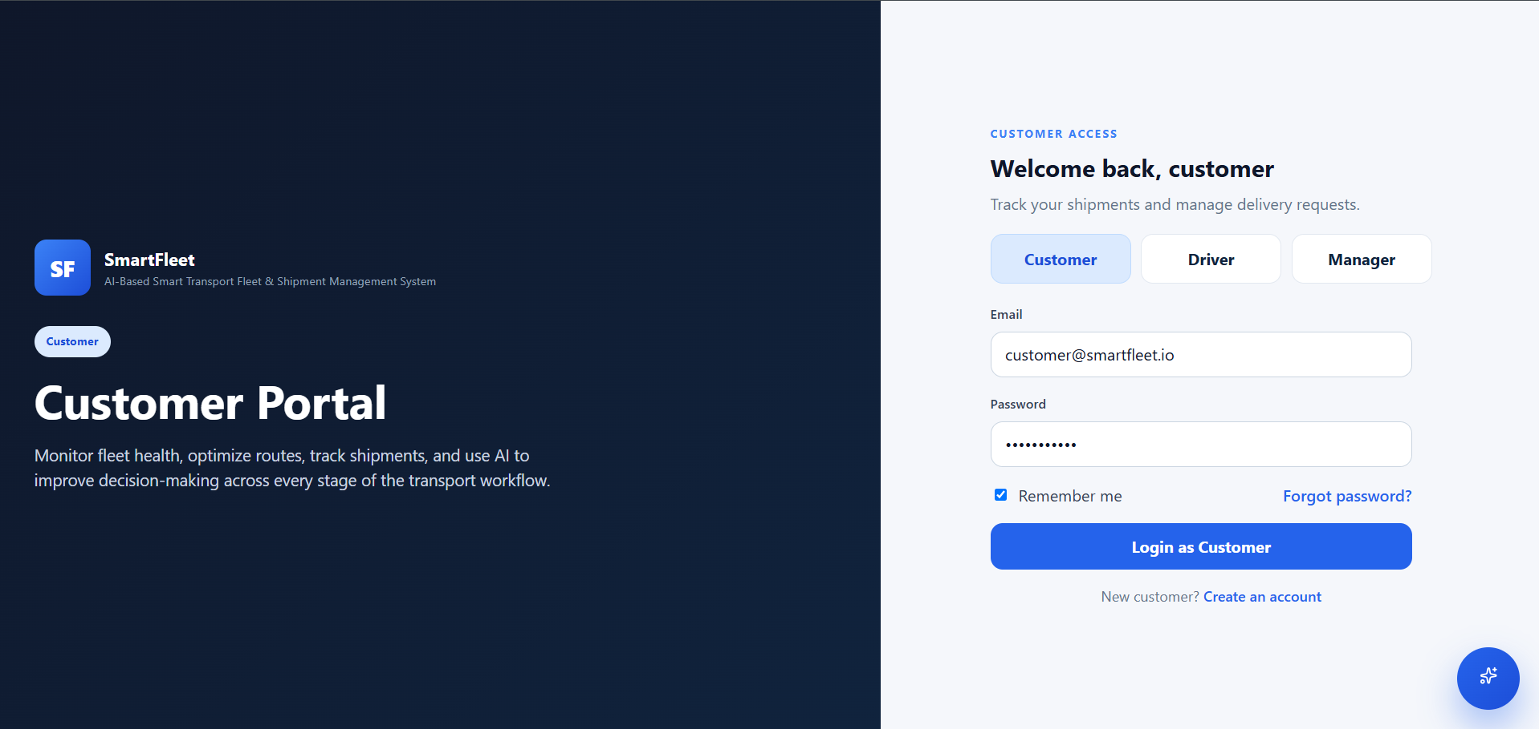
- The integration of mapping and route-planning components demonstrates the use of geographical data and graph algorithms in transportation applications. The AI assistant provides an additional interface for logistics-related questions. The overall design can be extended to support more advanced dispatching, live vehicle telemetry, and operational forecasting.
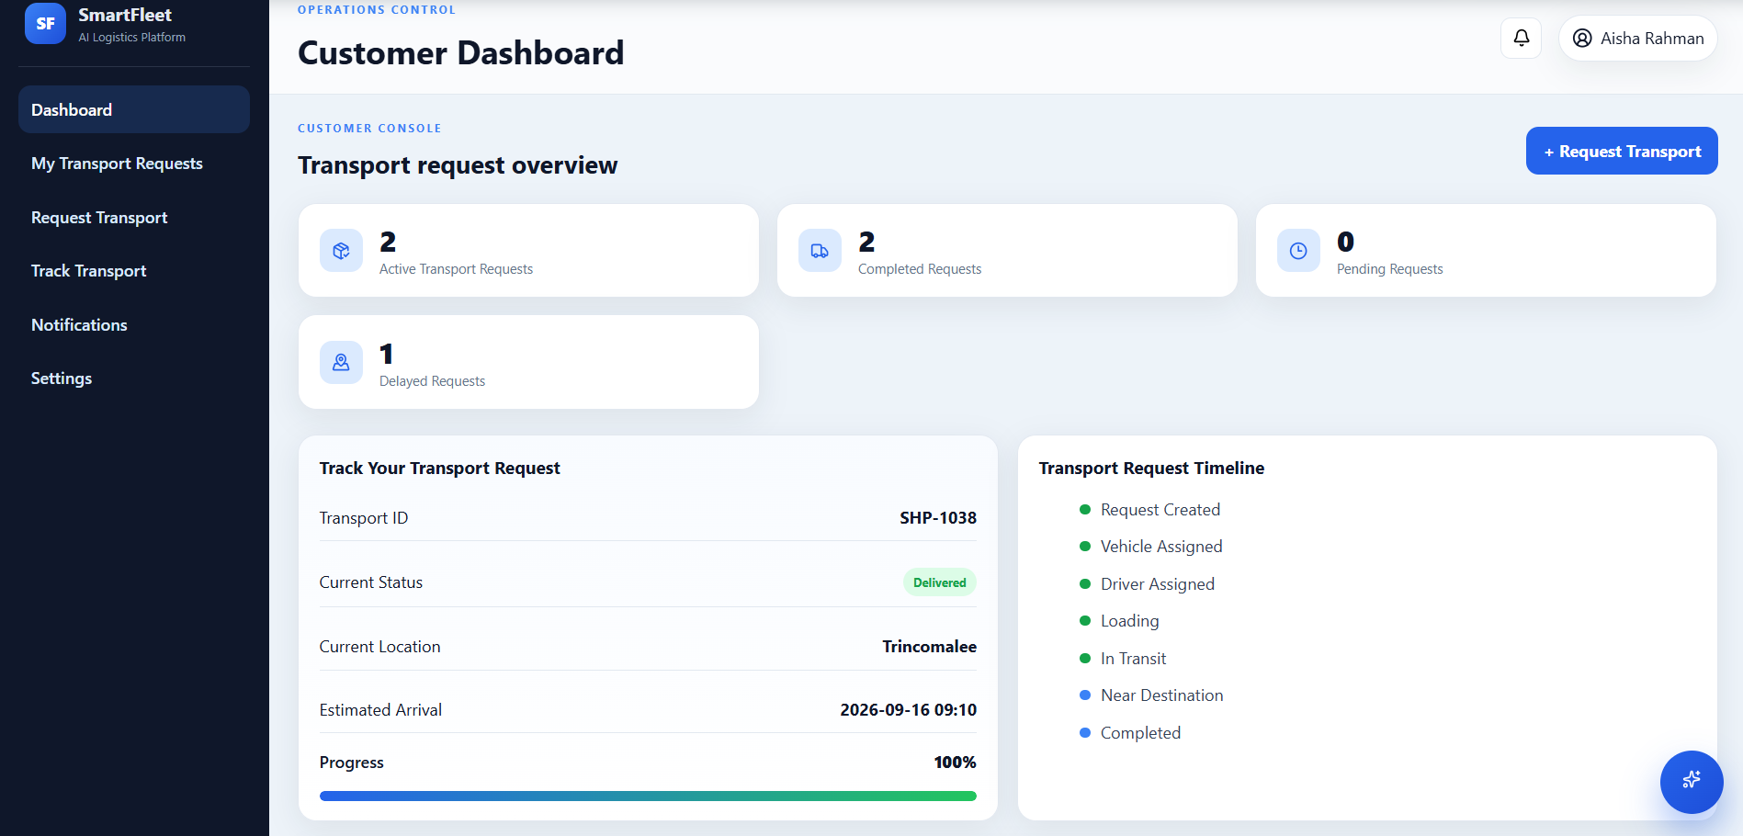
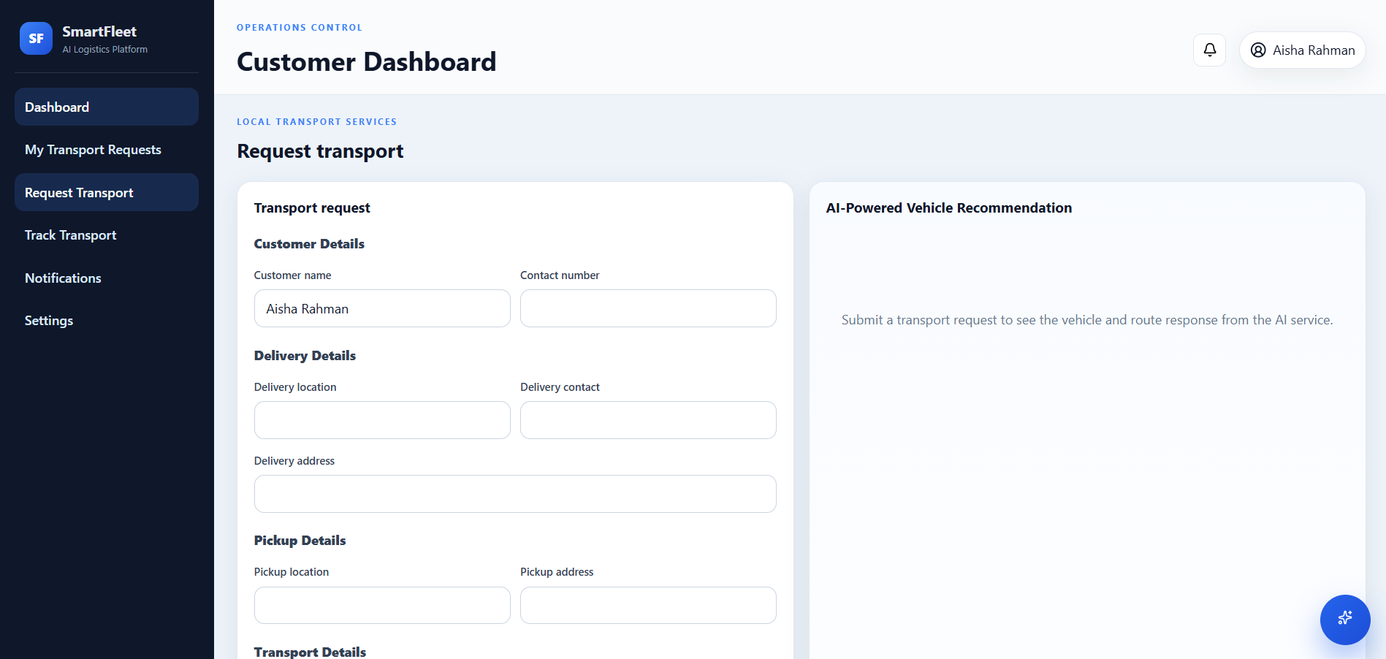

- CONCLUSION & FUTURE SCOPE
8.1 Conclusion
SmartFleet is a web-based AI-assisted transportation management system developed to organize transport requests, fleet allocation, shipment tracking, and trip operations. The system provides role-specific functionality for customers, drivers, and managers, helping coordinate activities throughout the transportation lifecycle.
The application combines React, Vite, TypeScript, Express, and SQLite to provide a structured client-server architecture. JWT-based authentication supports protected access, while shipment and trip workflows maintain operational status information. Leaflet and OpenStreetMap support interactive map visualization, Dijkstra's algorithm provides shortest-path computation, and OSRM can supply road-based routing information. The Groq API adds AI-assisted transportation support.
The project demonstrates the practical integration of web development, database management, routing algorithms, mapping services, and AI APIs in a logistics application. SmartFleet provides a foundation for further development into a more advanced and scalable fleet-management platform. Final performance and reliability claims should be based on the actual tests and observations recorded during project evaluation.
8.2 Future Scope
The system can be enhanced in several ways.
Short-Term Enhancements
- Improve form validation and user feedback.
- Add more detailed shipment history and audit logs.
- Improve dashboard filtering, sorting, and reporting.
- Strengthen automated tests for authentication, assignments, and trip transitions.
- Improve error handling for database and external-service failures.
Medium-Term Enhancements
- Integrate GPS devices or mobile-device location services for live vehicle tracking.
- Add estimated arrival-time calculations using route distance, travel time, and traffic information where available.
- Extend route optimization to consider vehicle capacity, delivery windows, driver schedules, and multiple stops.
- Introduce email or SMS notifications through an appropriate provider.
- Add reports on vehicle utilization, delivery performance, and fleet availability.
- Support proof of delivery through photographs, signatures, or delivery confirmation records.
Long-Term Enhancements
- Develop a mobile application for drivers and customers.
- Explore machine-learning models for delivery-delay prediction and demand forecasting.
- Introduce advanced dispatch recommendations based on historical operational data.
- Support larger fleets and distributed deployments through a more scalable infrastructure.
- Integrate external enterprise resource planning, warehouse management, and logistics systems.
- Improve accessibility, localization, and usability for different categories of transportation users.
These enhancements would extend SmartFleet beyond its current academic scope and support more advanced transportation management scenarios.

- REFERENCES

- 1. Onfleet, “Last Mile Delivery Software and Route Management.” Available at: https://onfleet.com/
- Bringg, “Delivery Management Platform.” Available at: https://www.bringg.com/platform
- project44, “Supply Chain Visibility Platform.” Available at: https://www.project44.com/platform/visibility/
- Groq, “API Reference Documentation.” Available at: https://console.groq.com/docs/api-reference
- OptimoRoute, “Route Planning and Optimization.” Available at: https://optimoroute.com/
- Samsara, “Fleet Management Solutions.” Available at: https://www.samsara.com/
- Blue Dart, “Courier and Express Logistics Services.” Available at: https://www.bluedart.com/
- Leaflet, “Leaflet JavaScript Mapping Library Documentation.” Available at: https://leafletjs.com/
- OpenStreetMap Foundation, “OpenStreetMap.” Available at: https://www.openstreetmap.org/
- Project OSRM, “Open Source Routing Machine.” Available at: https://project-osrm.org/

