AI-Based Smart Transport Fleet Management System Using Service-Oriented Architecture
L. Suvarchala Mrudani  Dept. of Computer Science and Engineering  KL University (Deemed to be University)  Hyderabad, India  Roll No. 2420030591 | P. Hasitha Sai Keerthana  Dept. of Computer Science and Information Technology  KL University (Deemed to be University)  Hyderabad, India  Roll No. 2420090107 | C. Suma Priya Varma  Dept. of Computer Science and Engineering  KL University (Deemed to be University)  Hyderabad, India  Roll No. 2420030337

Abstract — Conventional fleet management systems rely largely on manual, reactive decision-making, which leads to unexpected vehicle breakdowns, poor fleet utilization, high fuel consumption, and inefficient trip planning. Vehicles, drivers, trips, fuel, and maintenance are usually managed in isolation, which limits integrated decision support. This paper presents the design of an AI-Based Smart Transport Fleet Management System that combines a Service-Oriented Architecture (SOA) with machine learning to make fleet operations proactive. The proposed framework decomposes fleet functions into independent microservices (vehicle, driver, trip, route, maintenance, fuel, location, notification, user, and analytics) exposed through a secure API gateway, and couples them with an AI/ML layer for predictive maintenance, fuel-consumption prediction, route and travel-time estimation, anomaly detection, and AI-assisted vehicle allocation. Vehicle and route recommendations are produced by jointly considering vehicle availability, condition, fuel efficiency, maintenance risk, and trip requirements. The system is planned for implementation with React.js, Spring Boot, Spring Cloud, Python FastAPI, scikit-learn, and PostgreSQL over a ten-week, ten-phase schedule. We review related work, identify the gap left by existing approaches, describe the layered architecture, and outline the feasibility analysis and evaluation plan. The paper reports the design stage of the project; experimental results will follow implementation.
Keywords — fleet management, service-oriented architecture, microservices, predictive maintenance, fuel consumption prediction, vehicle allocation, route prediction, machine learning

I. INTRODUCTION
Fleet management covers the coordinated control of vehicles, drivers, trips, routes, fuel, and maintenance in transport operations. Its main cost drivers are vehicle downtime, fuel consumption, and under-used vehicles. Most existing fleet systems concentrate on vehicle tracking, trip scheduling, and record keeping, and the decisions built on them remain largely manual and reactive: maintenance is performed after a fault appears, and vehicles are assigned without a joint view of their condition, fuel efficiency, and risk of failure.
Machine learning (ML) offers a way to move from reactive to proactive operation. Vehicle operating data can be used to predict maintenance needs and support reliability [1], and fuel consumption can be estimated from features such as speed, acceleration, and road gradient [3]. Optimization models can also assign vehicles and drivers to planned trips at lower operating cost [2]. However, these capabilities are generally studied in isolation, and few solutions integrate them in one scalable platform.
This paper proposes an AI-Based Smart Transport Fleet Management System built on a Service-Oriented Architecture (SOA). Independent services for vehicles, drivers, trips, routes, maintenance, fuel, and AI communicate through APIs behind a gateway, so each service can be developed, deployed, and scaled on its own. The main contributions are: (1) an integrated view of vehicle, driver, trip, route, fuel, and maintenance data; (2) an AI/ML layer for predictive maintenance, fuel-consumption prediction, route and travel-time prediction, and anomaly detection; (3) AI-assisted vehicle and route recommendation; and (4) a modular SOA design with a feasibility analysis and a ten-week implementation plan.
The rest of the paper is organized as follows. Section II reviews related work and the research gap. Section III states the problem and objectives. Section IV presents the proposed architecture. Section V covers implementation and feasibility, Section VI the expected outcomes and evaluation plan, and Section VII concludes.
II. RELATED WORK
A. Predictive Maintenance
Theissler et al. survey ML-based predictive maintenance in the automotive industry, covering supervised and deep-learning approaches [1]. They conclude that vehicle operating data can anticipate maintenance needs, but that sufficient labelled data, the combination of multiple data sources, and interpretability remain open challenges. Giannoulidis and Gounaris address fleet predictive maintenance without labels, using unsupervised streaming anomaly detection with proximity-based, statistical, and transformer methods that model the context in which each vehicle operates [4]. Early detection of failures remains difficult, and wider data and real-world validation are needed. The same group describes a cloud-native fleet management system with a multi-layered architecture in which in-vehicle edge devices feed predictive maintenance and analytics [5].
B. Vehicle and Driver Assignment
Monnerat et al. model joint vehicle and driver assignment as a Generalized Assignment Problem and solve it with mathematical optimization and a genetic-algorithm-based matheuristic [2]. Joint assignment can reduce the operating cost of planned trips, but larger instances become computationally demanding, so heuristic approaches are required for scalability.
C. Fuel-Consumption Prediction
Ko compares linear regression, k-nearest neighbors, decision tree, random forest, and gradient boosting for predicting vehicle fuel consumption from vehicle speed, acceleration, and road gradient [3]. Prediction quality depends on driving and road conditions, and broader real-world datasets would improve applicability. Table I summarizes the surveyed work.
TABLE I
Summary of Surveyed Literature
Ref. | Methodology | Limitation / Future Work
[1] | ML-based predictive maintenance; supervised and deep-learning approaches | Needs labelled data; multi-source data fusion and interpretability remain open
[2] | Generalized Assignment Problem; optimization and genetic-algorithm matheuristic | Large instances are computationally hard; heuristics needed for scalability
[3] | Linear regression, KNN, decision tree, random forest, gradient boosting | Depends on driving and road conditions; broader datasets needed
[4] | Unsupervised streaming anomaly detection (proximity-based, statistical, transformer) | Early failure detection is hard; wider data and real-world validation needed

D. Research Gap
Existing approaches mainly address vehicle tracking, trip scheduling, and record management. Maintenance is generally performed after faults or breakdowns occur, vehicle allocation may not jointly consider availability, condition, fuel efficiency, and maintenance risk, and fuel monitoring and route planning are often handled independently. Monolithic implementations further make scaling, integration, and maintenance difficult. The gap is therefore an integrated fleet-management system that combines AI/ML prediction, predictive maintenance, fuel prediction, vehicle allocation, route and travel-time prediction, and an SOA.
III. PROBLEM STATEMENT AND OBJECTIVES
A. Problem Statement
Traditional fleet systems depend on manual decision-making and reactive management. Unexpected breakdowns cause downtime and raise maintenance cost; inefficient vehicle allocation leaves available vehicles under-utilized; high and unpredictable fuel consumption increases operating cost; and poor route and trip planning lengthens travel time and wastes fuel. Because vehicles, drivers, trips, fuel, and maintenance are managed separately, integrated decision-making is limited. An AI-powered, SOA-based system that predicts risks and recommends efficient fleet decisions proactively is needed.
B. Objectives
The objectives of this work are: (1) to improve fleet-management efficiency by integrating vehicle, driver, trip, route, fuel, and maintenance information in a unified intelligent system; (2) to apply ML to predictive maintenance, fuel-consumption prediction, vehicle allocation, and travel-time/route prediction; (3) to provide AI-assisted recommendations for the most suitable vehicle and route based on vehicle condition, availability, fuel efficiency, maintenance risk, and trip requirements; (4) to develop an SOA-based modular architecture in which vehicle, driver, trip, maintenance, route, and AI services communicate through APIs and can be developed, deployed, and scaled independently; (5) to reduce unexpected breakdowns, fuel consumption, operational cost, and downtime through predictive, data-driven decisions; and (6) to improve fleet utilization and transportation efficiency through proactive planning and intelligent optimization.
IV. PROPOSED SYSTEM ARCHITECTURE
A. Layered Overview
The system follows the layered SOA shown in Fig. 1. The client layer offers a web dashboard for administrators, mobile applications for managers and drivers, and a trip-request interface for customers. All requests pass through an API gateway that performs authentication, authorization, routing, rate limiting, and load balancing. Behind the gateway, a service layer of microservices implements the fleet functions, while an AI/ML layer supplies predictions and recommendations. Each service persists its data in its own database in the data layer, and the infrastructure layer provides the application server, service discovery, security, and REST APIs. External services for maps and traffic, weather, e-mail/SMS, and payment are reached from the service layer.
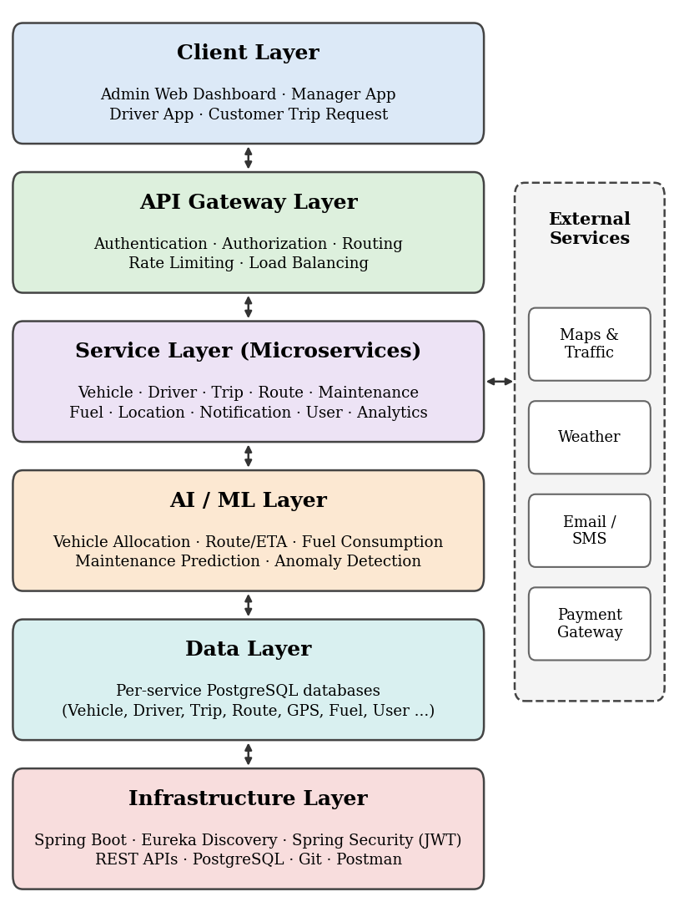
Fig. 1. Layered architecture of the proposed AI-based fleet management system.
B. Service Layer
The service layer consists of ten independent microservices (Table II). Each exposes a REST API and can be scaled separately, which realizes the SOA objective of independent development and deployment.
TABLE II
Microservices and Responsibilities
Service | Main responsibilities
Vehicle | Registration, details, status, tracking
Driver | Registration, license and documents, performance, availability
Trip | Creation, scheduling, status, history
Route | Route planning, distance and time estimation, traffic information, dynamic re-routing
Maintenance | Maintenance records, service scheduling, reminders, spare parts
Fuel | Transactions, consumption, mileage tracking, efficiency reports
Location | Real-time tracking, location history, geo-fencing, idle-time monitoring
Notification | Alerts, reminders, system notifications, e-mail/SMS/push
User | User and role management, permissions, authentication
Report & Analytics | Report generation, dashboards, KPI monitoring, data visualization

C. AI/ML Layer
The AI/ML layer contains five modules (Table III) implemented as Python services. Tree-ensemble models are planned for the prediction tasks because the surveyed work shows that random forest and gradient boosting are suitable for fuel-consumption prediction [3]; an isolation-based detector is planned for unlabelled anomaly detection, in line with the unsupervised approach of [4].
TABLE III
AI/ML Modules
Module | Planned model | Purpose
Vehicle allocation | ML ranking / optimization | Select the best vehicle for a trip using availability, condition, and fuel efficiency
Route / ETA prediction | Random Forest / XGBoost | Predict travel time, ETA, and optimal route from traffic, weather, and history
Fuel consumption | Random Forest / XGBoost / regression | Predict per-trip fuel usage from trip features and driving
Maintenance prediction | Random Forest / XGBoost / classification | Predict vehicle failure or service need to reduce downtime
Anomaly detection | Isolation Forest | Detect abnormal vehicle behavior or unusual events in real time

D. Decision and Recommendation Workflow
The workflow has five stages. (1) Fleet data integration collects vehicle, driver, trip, fuel, and maintenance data through the services. (2) AI/ML prediction estimates maintenance risk, fuel consumption, and travel time. (3) Vehicle and route evaluation scores candidates on availability, condition, fuel efficiency, maintenance risk, and trip requirements. (4) Smart recommendation returns the best vehicle and the optimal route for the trip to the fleet manager. (5) Optimized fleet operations follow, with the aim of reduced downtime, lower fuel consumption, improved vehicle utilization, and lower operating cost.
E. Novelty
The novelty of the proposal lies in combining, within one SOA, six elements that are usually treated separately: AI-based vehicle allocation; predictive fleet intelligence for maintenance, fuel, travel time, and route efficiency; integrated SOA-based fleet optimization; intelligent route and travel-time prediction; integrated decision-making over vehicle, driver, trip, maintenance, fuel, and route information; and a modular architecture of independently deployable services.
V. IMPLEMENTATION AND FEASIBILITY
A. Technology Stack
The microservices are built with Spring Boot, with Spring Cloud (Eureka service discovery and gateway) for registration and routing and Spring Security with JWT for authentication. The AI/ML services are written in Python using FastAPI and scikit-learn. PostgreSQL stores the service data, React.js provides the front end, and REST APIs connect all components. External APIs (maps, weather, SMS) supply route, traffic, and notification data.
B. Feasibility Analysis
Technical: the system relies on established technologies (React.js, Spring Boot, FastAPI, scikit-learn, PostgreSQL, Spring Cloud, REST), which support scalable service-based development. Operational: separate services for vehicles, drivers, trips, routes, maintenance, fuel, location, notifications, users, and analytics enable efficient fleet operations through one platform. Economic: the use of open-source technologies and modular services reduces development and maintenance cost and lets individual services scale independently. Schedule: the work is divided into ten phases covering requirement analysis, SOA service development, AI/ML integration, database integration, testing, and deployment.
C. Project Timeline
Fig. 2 shows the ten-week plan. Phases 1–3 cover requirements, literature survey, dataset preparation, and SOA/API-gateway design; phases 4–5 develop the core and supporting services; phases 6–7 develop the ML models and the allocation and recommendation logic; and phases 8–10 cover database and external-API integration, front-end integration and performance testing, and security, deployment, and final evaluation.
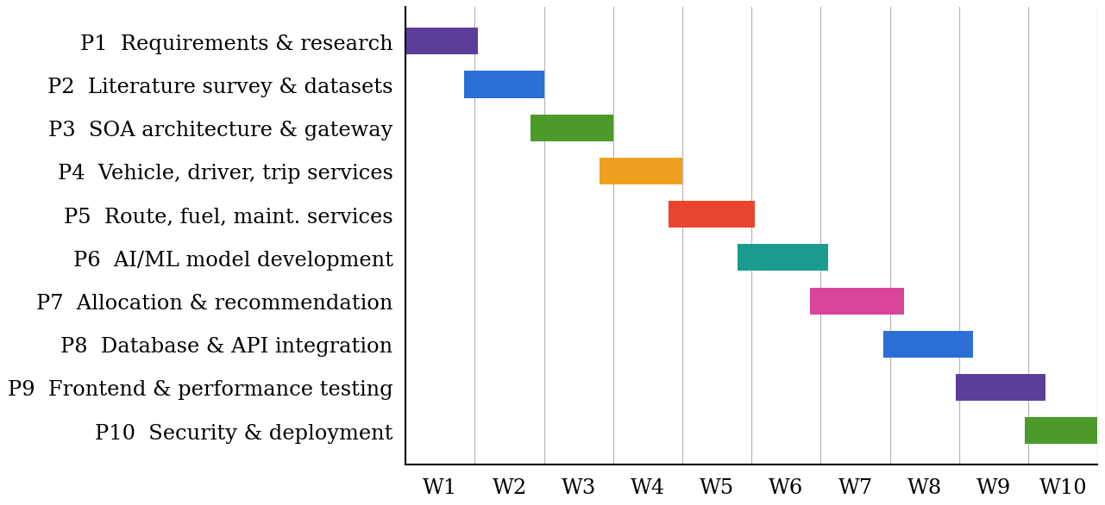
Fig. 2. Ten-phase, ten-week project timeline.
VI. EXPECTED OUTCOMES AND EVALUATION PLAN
The project is at the design stage, so no experimental results are reported here. Table IV contrasts existing practice with the proposed system, and the outcomes expected from the objectives are reduced unexpected breakdowns, lower fuel consumption and operating cost, less downtime, better fleet utilization, and improved transportation efficiency.
TABLE IV
Existing Systems Versus Proposed System
Aspect | Existing systems | Proposed system
Decisions | Manual and reactive | Data-driven and proactive
Maintenance | After faults or breakdowns | Predicted by ML models
Allocation | Does not jointly weigh availability, condition, fuel, and risk | AI-ranked recommendation using all factors
Fuel and route | Handled independently | Integrated fuel and travel-time prediction
Architecture | Monolithic; hard to scale | SOA microservices behind an API gateway

After implementation, the ML modules will be evaluated on held-out data: regression error (MAE, RMSE) for fuel consumption and travel time, and precision, recall, and F1-score for maintenance prediction and anomaly detection. Vehicle allocation will be compared with a manual baseline, and the platform will be assessed through API response time and behavior under load during the performance-testing phase.
VII. CONCLUSION AND FUTURE WORK
This paper presented the design of an AI-Based Smart Transport Fleet Management System that integrates predictive maintenance, fuel and travel-time prediction, anomaly detection, and AI-assisted vehicle allocation within a service-oriented architecture. By moving from isolated, reactive tools to independent services with a shared intelligence layer, the framework targets fewer breakdowns, lower fuel use, better utilization, and more scalable operation.
Future work includes implementing the ten microservices and the AI/ML services, preparing datasets and training the models, integrating the external APIs and the front end, and validating the system with real-world fleet data. The surveyed literature also points to open issues that will need attention: sufficient labelled data, interpretability of predictions, and scalability of assignment for large fleets [1], [2], [4].
ACKNOWLEDGMENT
The authors thank Ketineni Venkateswari, Assistant Professor, Department of Computer Science and Engineering, KLH CSE Bowrampet Campus, for her guidance throughout this project.
REFERENCES
[1] A. Theissler, J. Pérez-Velázquez, M. Kettelgerdes, and G. Elger, “Predictive maintenance enabled by machine learning: Use cases and challenges in the automotive industry,” Reliab. Eng. Syst. Saf., vol. 215, Art. no. 107864, 2021, doi: 10.1016/j.ress.2021.107864.
[2] F. Monnerat, J. Dias, and M. J. Alves, “Fleet management: A vehicle and driver assignment model,” Eur. J. Oper. Res., vol. 278, no. 1, pp. 64–75, Oct. 2019, doi: 10.1016/j.ejor.2019.03.021.
[3] K. Ko, “Machine learning methods to predict vehicle fuel consumption,” J. Korea Soc. Comput. Inf., vol. 27, no. 9, 2022, doi: 10.9708/jksci.2022.27.09.013.
[4] A. Giannoulidis and A. Gounaris, “A context-aware unsupervised predictive maintenance solution for fleet management,” J. Intell. Inf. Syst., vol. 60, no. 2, pp. 521–547, 2023, doi: 10.1007/s10844-022-00744-2.
[5] A. Giannoulidis, A.-V. Michailidou, T. Toliopoulos, I. Constantinou, and A. Gounaris, “Predictive maintenance in a fleet management system: The Navarchos case,” in Proc. CAiSE Forum, 2024, pp. 111–119.

