An Explainable Environmental Disaster Risk Prediction Framework Using Historical and Live Weather Data
Department of Computer Science and Engineering, KL Deemed to be University, Hyderabad, India
Environmental Disaster Risk Prediction — Research/Project Paper

ABSTRACT

This paper presents an environmental disaster risk assessment framework that connects environmental analysis, supervised machine learning, dataset‑derived risk conditions, live weather data, air‑quality data and an interactive Streamlit dashboard. The historical modeling dataset contains two thousand four hundred twenty‑five observations, with two thousand one hundred seventy‑two labelled Normal and two hundred fifty‑three labelled Disaster. The final classifier uses eight features: ALLSKY_SFC_SW_DWN, T2M, RH2M, PS, WS2M, PRECTOTCORR DOY_SIN and DOY_COS. Four machine learning approaches were examined—Logistic Regression, Random Forest, HistGradientBoosting and XGBoost—but the experimental record shows Logistic Regression as the validated model. With a decision threshold of 0.71 the test set achieved eighty‑six percent accuracy thirty‑nine percent disaster‑class precision, fifty‑six point eight six percent disaster‑class recall, forty‑six point four percent disaster‑class F1‑score and eighty‑one point three point three one eight percent ROC‑AUC; the confusion matrix was [[389, 45] [22, 29]]. During testing a Kurnool observation produced an eighty‑one point two eight percent machine learning output probability for Disaster showing a mismatch, between historical training distributions and live environmental observations. The framework therefore adds an environmental risk‑scoring layer. For one Kurnool test this layer produced a fourteen point two four percent dataset‑based risk score and LOW risk level while another live test produced an eighteen point three four percent score and MODERATE level. These values are explicitly treated as dataset‑derived risk assessments, not calibrated probabilities of real‑world disaster occurrence. The dashboard uses an API to pull weather data and air‑quality data in real time and the framework uses explainable AI to allow users to see how each feature influences the model. The resulting framework emphasizes transparency by exposing conditions, standardized feature values, model coefficients, contributions and historical condition rates.

Keywords: environmental disaster risk; machine learning; logistic regression; weather data; explainable AI; risk assessment; Streamlit; live API; environmental analysis

1. INTRODUCTION

1.1 Background
In years the intensity of environmental and climate-related calamities and their global frequency have undergone a dramatic unending surge. Episodes such as storms, paroxysmal flooding and lengthy droughts not only cause intense biodiversity decline but also give rise to a severe threat to human life, infrastructure and microeconomies. At the crux of these hazards are convoluted meteorological phenomena, highly influenced by volatile weather conditions. Core atmospheric variables—such as wind speed, temperature, ambient dampness, rainfall intensity and atmospheric pressure—act as drivers and forerunners to these cataclysmic events. As a result the development of early warning prediction systems has become a top concern for governments, researchers and disaster management bureaus worldwide.

Historically catastrophe prediction has relied on weather simulation software that demands huge computational resources. However as the physical space and structure of environmental data have grown machine learning has grown as a catalyst for growth, in this field. Machine learning algorithms possess the forte to filter through bulk data and detect unseen, irregular or haphazard patterns that foreshadow environmental perils—patterns that customary statistical methods might omit. Nevertheless uncovering patterns is only half the key. For models to be superbly convenient to end-users and decision-makers they must be effortlessly incorporated with real-time environmental monitoring. It is the amalgamation of trend spotting and live weather conditions that enables preemptive community-centric and actionable disaster management.

1.2 Problem Statement
Regardless of the rapid enhancement and escalation of catastrophe forecasting systems, a few core problems impede their practical application. Traditional prediction systems often rely on capital-intensive architecture and highly specialized datasets, making them out of reach for ordinary users or municipal corporations. Furthermore, when hands-on machine learning is employed in ecological surveillance, a major fragility arises: the models are hypersensitive to data distribution shifts.
Precisely, models trained solely on retrospective data frequently mislabel normal geographic locations as “disaster-prone” when positioned in real-world situations. This occurs simply because real-time data feeds deviate from the pre-existing distribution the model was trained on, resulting in false alarms and waning faith. The system may indicate a normal, regional weather anomaly as a cataclysmic event. Hence, the main challenge addressed in this research is: What strategies can one use to combine patterns of past environmental disasters with current meteorological data to compile a reliable environmental risk assessment that is accurate by location, and to avoid making predictive mistakes driven by out-of-distribution current data?

1.3 Research Gap
While a well-established research base exists in the domain of machine learning for
environmental forecasting, a critique of current systems reveals several research shortfalls:
The Black-Box Problem: First, many forecasting models work as “black boxes.”
They may discharge a 0-or-1 classification but are unable to explain the ambient parameters driving that conclusion. As a result, the outputs are esoteric to interpret
Making the prediction less feasible.
Out-of-distribution (OOD) performance drop: Second, models trained only using
historical aggregates often act up and inconsistently when carried out on real-time sensor feeds. The inability of these models to handle spatio temporal environmental oscillations without yielding false positives remains a major barrier in applied environmental data science.
Operational decoupling: Finally, there is a paucity of wide-scope, end-to-end systems in the present literature. Numerous studies focus either completely on retrospective review or solely on live meteorological surveillance.
Few models manage to bring together retrospective ecological analysis real-time weather feed embedding, transparent risk rating and interactive visualization into one unified user‑friendly platform. This project aims to close those gaps and will provide a platform that integrates all these key features.

1.4 Research Objectives
To directly address the drawbacks in the up-to-date literature, this study outlines the following primary objectives:
To meticulously examine environmental history for pinpointing and
gauging the unique climatic variations in routine situations and crises.

To create, test, and evaluate a Climate Information and Early Warning System
using these selected environmental variables.

To create a Climate Information and Early Warning System that is understandable based on archival disaster records, specifically to avoid the problem of out-of-distribution (OOD) misclassification in real-time data.

To create a user-friendly and interactive service that is able to collect live environmental data for selected places and time periods.

1.5 Research Questions
In order to facilitate the methodological approach of this study and help achieve its objectives, a set of research questions has been proposed.

RQ1: What are the environmental conditional factors that have the highest statistical significance when correlated with historical disasters? How do they work?

RQ2: How well can machine learning algorithms make use of integrated environmental factors to differentiate between normal and disaster conditions?

RQ3: What methods can we use to transform complicated frequencies and probabilities of historical disasters into understandable environmental risk scores?

RQ4: Is it possible to make use of live data from APIs focused on air quality and weather and incorporate it into existing historical models to create a functioning real-life disaster risk assessment dashboard?

1.6 Contributions
This study outlines an integrated system for environmental risk assessment, offering both conceptual and applied contributions to the field. The core contributions of this research are as follows:

Empirical pattern recognition: A thorough statistical evaluation that successfully maps historical ecology trajectories, differentiating normal states from disaster conditions.
Forecasting Model Construction: The expression and articulation of a targeted 8-feature environmental machine learning model specialized for disaster forecasting.
Risk identification: The inception of concrete, data-driven meteorological thresholds and circumstances that indicate elevated environmental risk.
A New Risk Rating Method: The creation of a clear risk rating tool, which preserves its reliability and effectiveness even if new weather data are taken into account.
Live Data Combination: The creation of an architecture for uniting available technologies for getting live information about weather and air quality with the already developed predictors.
Dashboard Construction: The creation of a practical instrument for presenting data on the levels of risk for possible disasters in the environment.
Capacities for Spatial Analysis: The development of a flexible system, which provides the possibility of conducting historical spatial research continuously over time and at new locations.

1.7 Organization of the Paper

Section 2 goes over studies on disaster prediction, machine learning, weather forecasting and explainability. Section 3 lays out the method we are proposing including how we process data the system design, the risk-scoring part, API connections and how we build explainability into the system. Section 4 shows the setup used for experiments and how we evaluate our approach. Section 5 shares the analysis of the dataset, model performance, how environmental conditions affect outcomes and real-life case examples. Section 6 talks about what we found and how it connects to research. Section 7 points out the limitations of our work. Section 8 wraps up the paper. Suggests ideas, for future directions.

2. RELATED WORK

2.1 Existing Approaches

Disaster-risk research has long relied on models, statistical links, GIS-based evaluations and hazard-specific measures. In years data-driven approaches have become more common bringing together many different types of information—like environmental factors, hazard details, exposure levels and vulnerability indicators. Haggag and colleagues created a framework to study damage from climate-related disasters. This framework included collecting and combining data selecting features using machine learning and interpreting results. Their work showed that disaster damage is not about the hazard itself but also, about how climate and socioeconomic conditions interact [1]. They also looked at how infrastructure holds up during climate-driven disasters. Their findings highlighted that mixing hazard data with system-level details gives a picture of performance under stress [8].

2.2 Machine Learning / Computational Approaches

Machine-learning approaches have been applied to both classification and regression problems in disaster research. Jiang et al. Coupled machine learning with weather forecasts for farmland waterlogging prediction and incorporated API access to weather forecasts [2]. Zhang et al. Compared four machine-learning algorithms for storm-surge disaster-loss grades using hazard, vulnerability and resilience indicators. Reported the usefulness of feature screening for reducing the indicator set [3]. Liu et al. Evaluated cyclone disaster-loss grades with LightGBM Random Forest, SVM and Naive Bayes and used SHAP to interpret the model [5]. These studies demonstrate that machine learning can represent relationships, among environmental and disaster-related variables but their targets and data structures differ from the Normal/Disaster environmental classification used in this project.

2.3 Advanced / Alternative Approaches

Time-series deep learning is an area of development. Hop et al. Created an LSTM model to predict flooding in time. They used rainfall forecasts and hydraulic simulations to make predictions. This kind of work looks at how hazard conditions change over time. In contrast the current project focuses on assessing conditions at the moment. Because of this difference in focus models like LSTM, GRU, ARIMA and transformer-based approaches are not part of the system. These methods are seen as improvements for future work not as part of the present implementation.

2.4 Explainability / Interpretability

Explainability is becoming a part of disaster-risk management. A detailed review by Ghaffarian et al. Looked at AI applications in this field. They pointed out that transparency, trust in models analysis across hazards and better integration with decision-support tools are all important. Yang et al. Examined machine learning methods used in weather and climate forecasting. They separated techniques that explain models after they are trained (post-hoc) from models that're interpretable by design. They noted that there is often a trade-off between how a model performs and how easy it is to understand. Liu et al. Used SHAP to explain disaster losses from cyclones. However this project does not use SHAP. Instead it relies on a Logistic Regression model. The explanation is specific to this model. It uses feature values learned coefficients and the contribution of each feature, to the output.

2.5 Critical Comparison
Study / Publication | Dataset / Features | Method / Results | Explainability / Limitation
Haggag et al. [1] | NY wind‑disaster damage; climate, land cover, social, housing, demographic and economic variables. | Multiple machine learning models; Random Forest regression reported R squared equal to 0.79. | Interpretation included; hazard‑specific and not a live current‑condition risk layer.
Jiang et al. [2] | Ten years of waterlogging and hydrological observations plus weather forecasts. | Four machine learning algorithms; Random Forest and Multilayer Perceptron at most sites; API access to future forecasts. | Operational forecast integration,. Focused on farmland waterlogging.
Zhang et al.[3] | One hundred ninety‑five publications screened; sixty‑eight analyzed in detail. | Systematic review of artificial intelligence in disaster‑risk management. | IIndicator screening helps interpretation; storm‑surge loss grade is the target.
Ghaffarian et al. [4] | 195 publications screened; 68 analyzed in detail. | Systematic review of XAI in disaster-risk management. | Highlights transparency needs; review than a deployed prediction system.
Liu et al. [5] | Four hundred ninety‑two tropical‑cyclone events; hazard, vulnerability and resilience factors. | LightGBM, RF, SVM, NB; LightGBM accuracy 0.86. | SHAP explanations; does not use this project’s coefficient‑based and historical‑rate layers.
Yang et al. [6] | Literature on weather and climate machine learning interpretability. | Review of post‑hoc and intrinsically interpretable methods. | Supports weather modeling; not an end‑to‑end risk dashboard.
Hop et al. [7] | One thousand six hundred hydraulic. Rainfall ensembles. | Long Short‑Term Memory network, for real‑time inundation forecasting.. | Strong temporal forecasting focus; current‑condition assessment is different.

Table 1. Critical comparison of disaster, weather‑ML and explainability studies.

2.6 Research Gap (Summary)

The reviewed literature shows that machine learning, API/forecast integration and explainability are parts of environmental and disaster decision‑support systems [1]–[7]. The project looks at a still important gap, by linking historical Normal/Disaster analysis to live condition checks and a clear historical‑rate risk layer. The framework also records a real failure case—when the distribution of training data does not match live API data—rather than treating a classifier probability as the true chance of a disaster. By making that difference clear the project explains what machine learning has actually learned and where uncertainty remains.

3. PROPOSED METHODOLOGY

3.1 Overall Framework
The proposed framework is organized as a sequential pipeline. Historical observations are first cleaned and analyzed, after which the Normal and Disaster classes are compared. Eight final features are prepared for machine learning, including two cyclical day-of-year variables. Candidate models are investigated and the documented final Logistic Regression model is evaluated on a held-out test set. Independently, historical disaster rates are calculated for selected environmental conditions and combinations. The live application then accepts a location, resolves the location, retrieves current environmental data through the configured API layer, maps relevant values into the risk-assessment workflow, and presents the result through Streamlit.
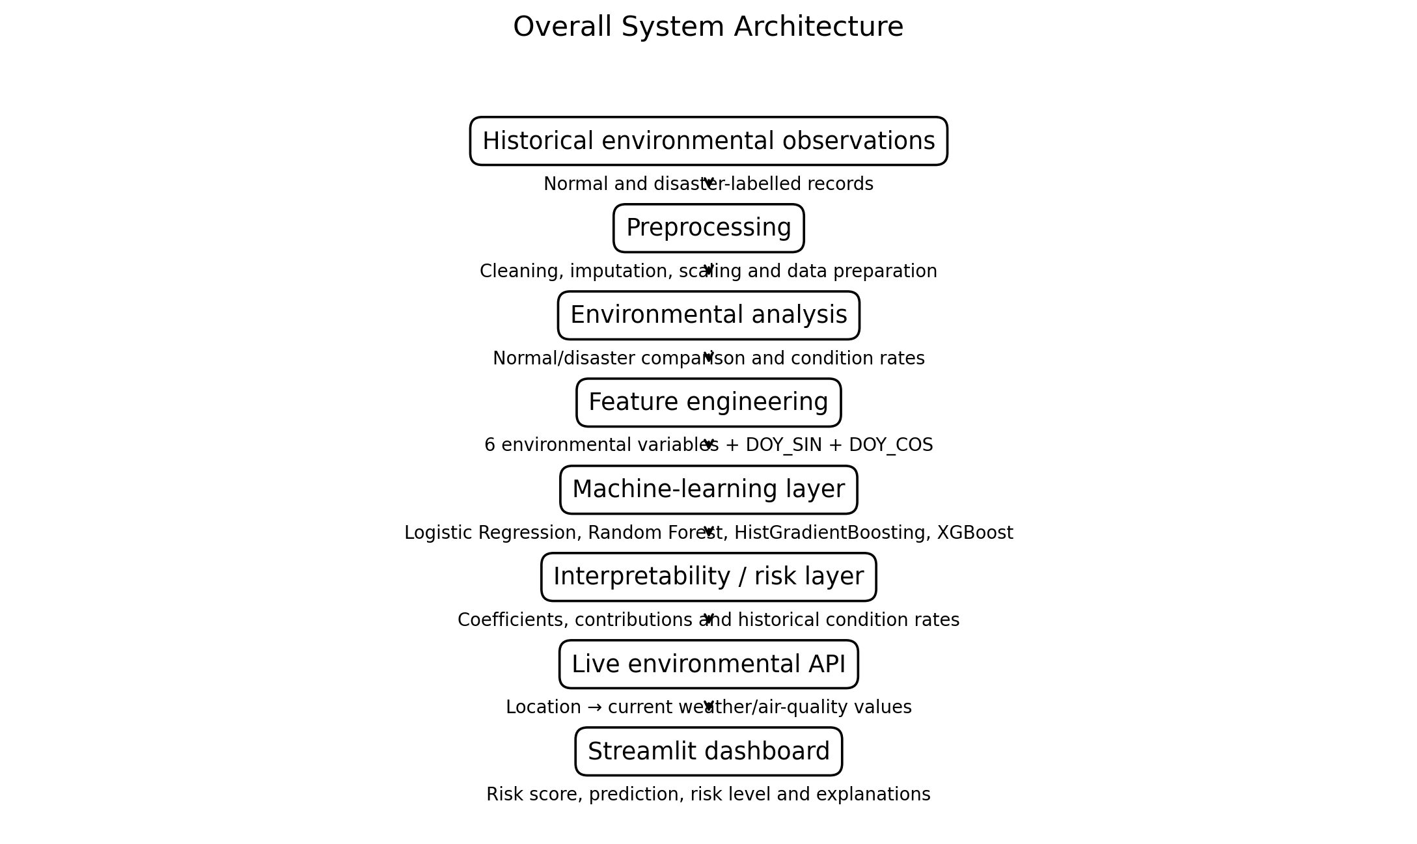
Fig. 1. Overall system architecture showing the historical-data, modeling, historical-risk, live-API and Streamlit layers.
Design novelty / distinctive project step: the key project-specific design element is the historical environmental risk-assessment layer placed between raw live conditions and the final dashboard interpretation. Rather than exposing only the raw Logistic Regression probability, the system checks whether current values trigger environmental conditions that were associated with measurable disaster rates in the historical dataset. This step was motivated by the experimentally observed mismatch between a direct live ML probability and the environmental interpretation of the same live observation. It is presented as a project-specific methodological contribution, not as a claim of being the first system of its kind.

3.2 Dataset(s)
The final historical modeling dataset contains 2,425 observations and 13 original columns/features, with DISASTER as the target. The target distribution is 2,172 Normal/No Disaster observations and 253 Disaster observations. The exact historical dataset filename and source are not explicitly established by the supplied project record used for this paper; therefore, the source is not invented.
- Historical dataset: [EXACT HISTORICAL DATASET SOURCE/NAME TO BE INSERTED FROM PROJECT CODE/FILES].
- Observations: 2,425.
- Original columns/features: 13.
- Target: DISASTER.
- Target distribution: Normal/No Disaster = 2,172; Disaster = 253.
- Final ML features: ALLSKY_SFC_SW_DWN, T2M, RH2M, PS, WS2M, PRECTOTCORR, DOY_SIN, DOY_COS.
Feature | Meaning | Representation
ALLSKY_SFC_SW_DWN | Surface shortwave/solar radiation feature | Continuous
T2M | Temperature at 2 m | Continuous
RH2M | Relative humidity at 2 m | Continuous
PS | Surface pressure | Continuous
WS2M | Wind speed at 2 m | Continuous
PRECTOTCORR | Corrected precipitation | Continuous
DOY_SIN | Sine-transformed day of year | Cyclical
DOY_COS | Cosine-transformed day of year | Cyclical
Table 2. Final eight-feature modeling representation.

3.3 Data Preprocessing
Preprocessing prepares the historical records for binary classification and ensures that the final model receives a consistent eight-feature matrix. The supplied project record documents median imputation and standardization inside the final Logistic Regression pipeline. Other preprocessing details are reported only where supported by the project evidence.
- Historical observations were prepared for Normal versus Disaster classification.
- Missing numeric values in the final Logistic Regression pipeline were handled using SimpleImputer(strategy='median').
- Feature standardization was performed using StandardScaler().
- DOY_SIN and DOY_COS were used to represent day-of-year cyclically.
- The final feature matrix had shape (2425, 8).
- The train/test design contained 1,940 training samples and 485 testing samples.
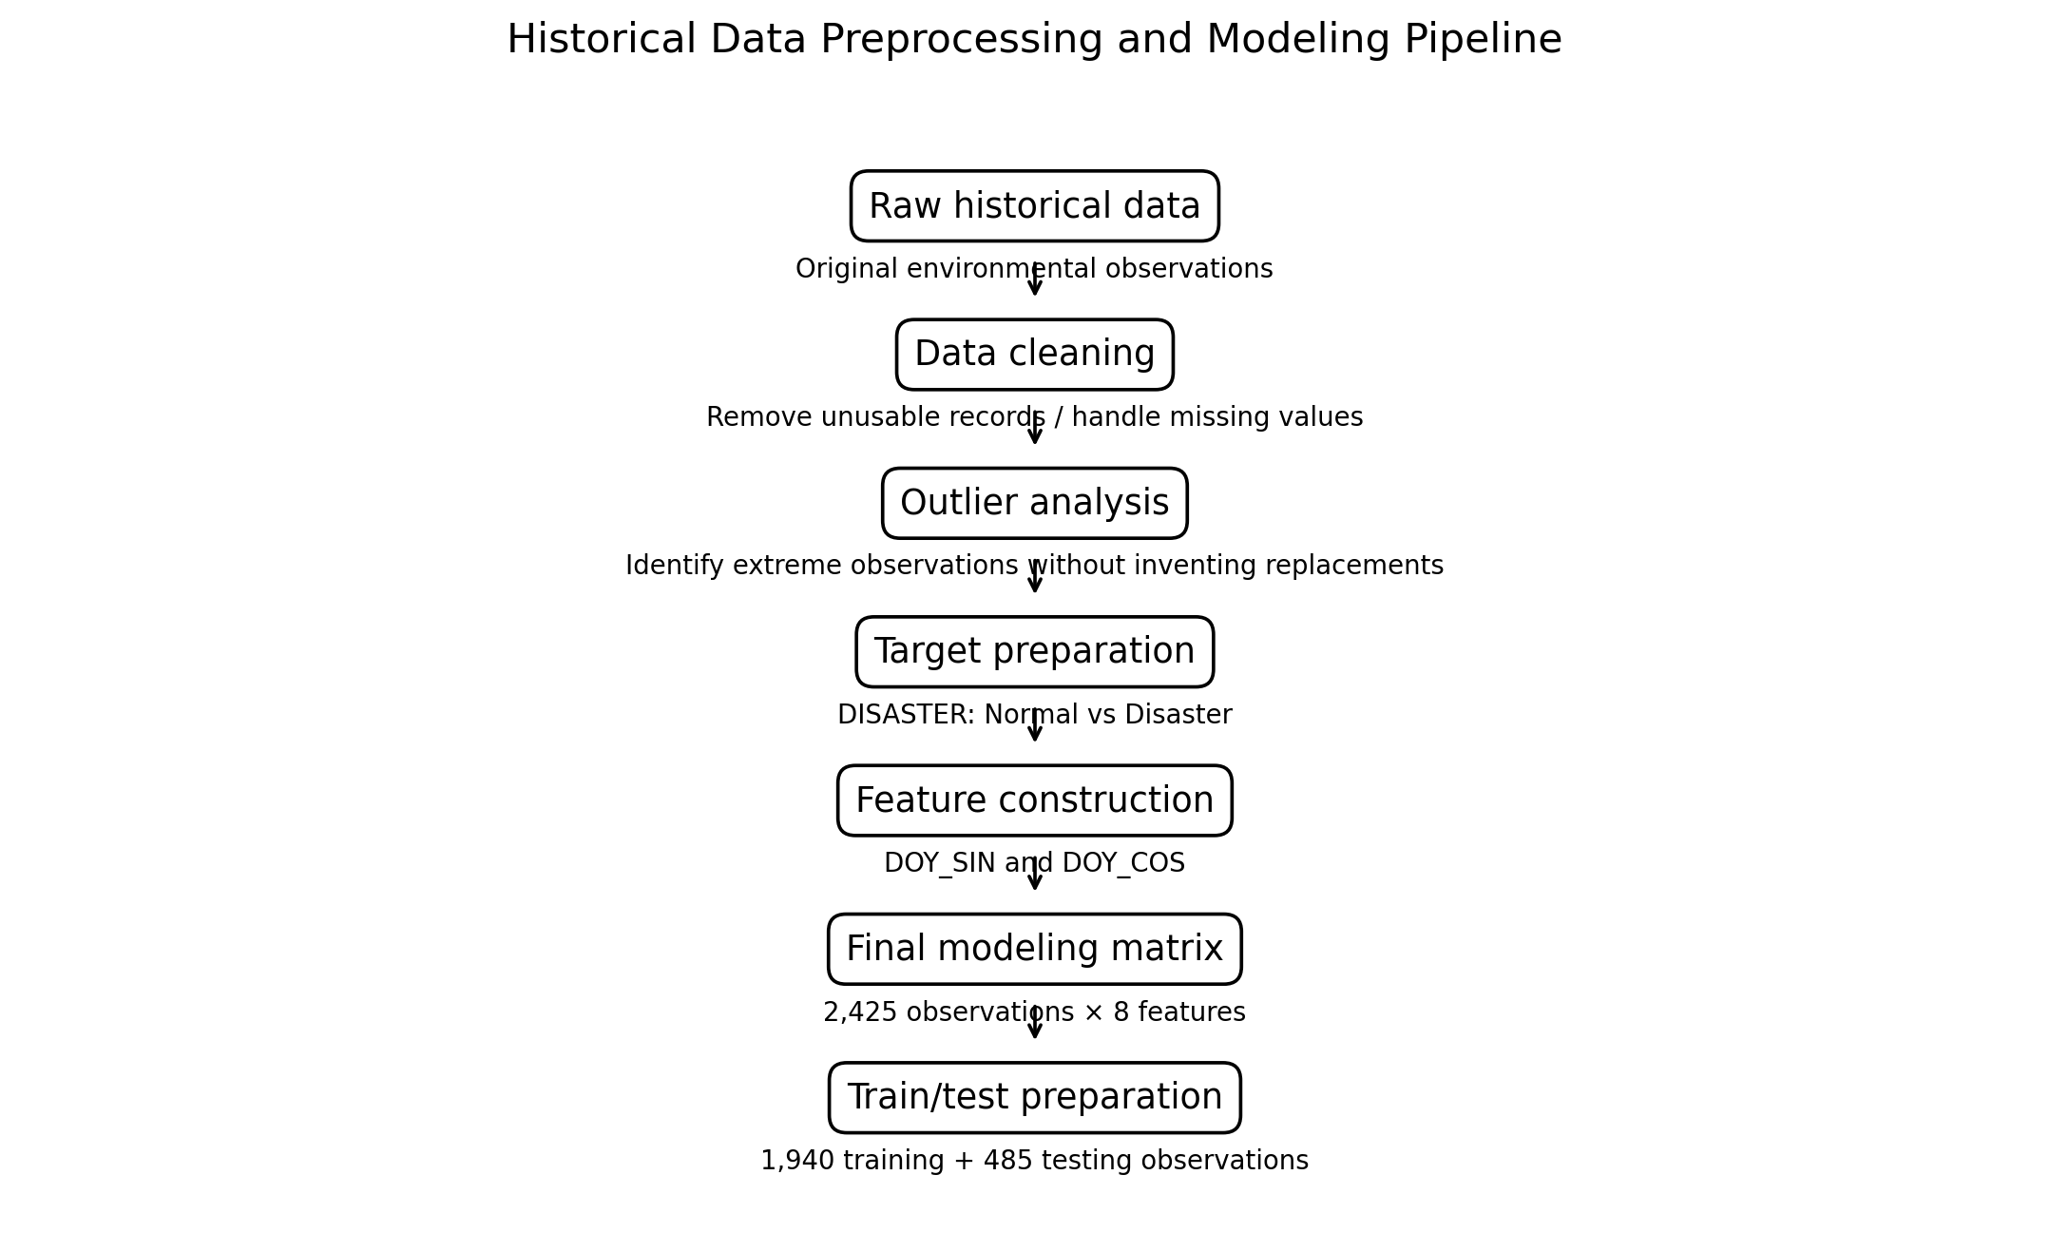
Fig. 2. Historical preprocessing and modeling pipeline. The figure describes the documented final workflow without introducing unsupported processing steps.

3.4 Exploratory Environmental Analysis and Feature Engineering
Exploratory analysis compared environmental means for Normal and Disaster-labelled observations. The observed means were T2M 24.98 °C versus 27.57 °C, RH2M 56.13% versus 70.70%, WS2M 1.93 m/s versus 2.38 m/s, PRECTOTCORR 2.79 mm versus 7.94 mm, PS 96.36 versus 95.93, and ALLSKY_SFC_SW_DWN 18.04 versus 17.28. The direction of these differences is treated as dataset-observed association rather than a causal relationship or universal disaster threshold.
Day-of-year was represented using sine and cosine transformations. This prevents the artificial discontinuity that would arise if January 1 and December 31 were treated as distant numerical values. The resulting eight-feature representation preserves seasonal position while allowing the classifier to learn cyclical relationships.
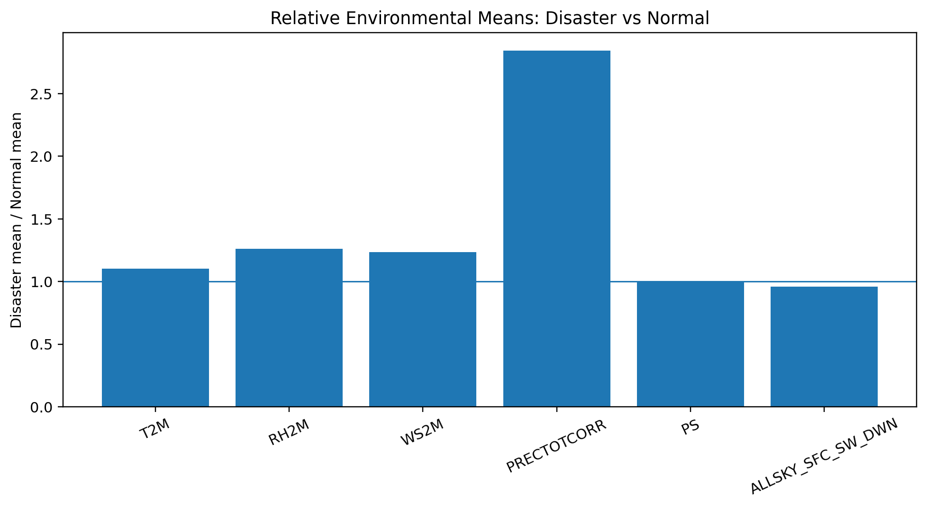
Fig. 3. Relative environmental means, shown as Disaster mean divided by Normal mean. Values above 1 indicate a higher observed mean in the Disaster-labelled class.

3.5 Proposed Models and Baselines
Four candidate classification approaches were investigated: Logistic Regression, Random Forest, HistGradientBoosting and XGBoost. Logistic Regression provides an interpretable linear decision function; Random Forest represents bagged tree ensembles [8]; gradient boosting methods model nonlinear relationships through additive trees [9]; and XGBoost is a scalable gradient-boosting implementation widely used for structured data [10]. The project record does not provide a complete comparable metric set for all four models, so this paper does not rank them or fabricate missing values.
- Logistic Regression — final validated model documented in the project; selected for its transparent coefficient-based explanation.
- Random Forest — investigated as a nonlinear ensemble baseline.
- HistGradientBoosting — investigated as a gradient-boosting alternative.
- XGBoost — investigated as an additional boosting approach.

3.6 Historical Environmental Risk Scoring
The historical risk layer is based on environmental conditions derived from the project dataset. The conditions are: temperature ≥ 28 °C, humidity ≥ 80%, wind ≥ 3 m/s, rainfall ≥ 10 mm, and pressure ≤ 96 kPa. For each condition, the historical disaster rate is calculated as the number of Disaster-labelled observations satisfying the condition divided by the total number of observations satisfying the condition.
For a condition c, the historical disaster rate is defined as:
r(c) = N(Disaster ∩ c) / N(c) (1)
These rates are descriptive properties of this dataset. They are not universal environmental thresholds and must not be interpreted as scientifically established disaster boundaries. The same principle applies to combinations of conditions.
Condition | Observations | Disasters | Historical disaster rate
Temperature ≥ 28 °C | 811 | 89 | 10.97%
Humidity ≥ 80 % | 612 | 156 | 25.49%
Wind ≥ 3 m/s | 320 | 56 | 17.50%
Rainfall ≥ 10 mm | 254 | 64 | 25.20%
Pressure ≤ 96 kPa | 850 | 163 | 19.18%
Temperature ≥28 + Humidity ≥80 | 58 | 22 | 37.93%
Humidity ≥80 + Wind ≥3 | 113 | 36 | 31.86%
Humidity ≥80 + Rainfall ≥10 | 207 | 56 | 27.05%
Wind ≥3 + Rainfall ≥10 | 80 | 21 | 26.25%
Temperature ≥28 + Humidity ≥80 + Rainfall ≥10 | 28 | 8 | 28.57%
Humidity ≥80 + Wind ≥3 + Rainfall ≥10 | 64 | 19 | 29.69%
All four specified conditions | 2 | 0 | 0.00%
Table 3. Dataset-derived environmental conditions and observed historical disaster rates.
The final row is based on only two observations and is therefore not treated as strong evidence. More generally, condition rates with small sample sizes require cautious interpretation.

3.7 Live API Integration
The dashboard accepts a user-entered location. Example locations tested include Kurnool, Andhra Pradesh, India and Quthbullapur. The configured live weather/air-quality API retrieves current environmental information including temperature, humidity, wind speed, rainfall/precipitation, pressure, cloud cover, PM2.5, PM10, CO, NO2, SO2, O3, dust and AOD. The exact API provider and endpoint are not established in the supplied project record used for this paper and therefore are left as a project-configuration placeholder.
- Live API source: [LIVE WEATHER/AIR-QUALITY API SOURCE TO BE INSERTED FROM PROJECT CONFIGURATION].
The workflow is: user location input → location resolution/geocoding → live environmental API request → environmental value mapping → model/risk assessment → explanation → Streamlit visualization. Importantly, the live values are not treated as automatically identical to the statistical distribution of the historical training data.

Fig. 4. Live API-to-Streamlit workflow used for current environmental assessment.

3.8 Explainable AI Integration
The final implementation relies on coefficient-based explainability that's specific to each model rather than using SHAP. For Logistic Regression the model works with features that have been standardized. For any given feature j the contribution can be thought of as the product of the value of that feature and its corresponding learned coefficient. This means the dashboard can show the feature value, the standardized version (which is a z-score) the coefficient and the resulting contribution.
The formula for standardizing feature j is:
z_j = (x_j. Median-imputed training mean reference used by StandardScaler) / scale_j (2)
This equation gives a view of how StandardScaler transforms the data. The actual values used during training. Like the mean and scale. Are part of the trained pipeline but are not listed here.
The contribution values, for live cases are not part of the numerical records provided. So no values are made up. Guessed.

3.9 Streamlit Dashboard Architecture
The frontend is built with Streamlit. The dashboard allows users to enter location details. It gets time environmental data. It shows conditions. It does disaster risk evaluation. It gives a risk score. It makes predictions. It shows the risk level. It lists past triggered conditions. It includes information, about model contribution and model explainability. It has model verification details. It provides project information. The design makes sure that the user-friendly explanation is not mixed with the raw classifier probability.
3.10 Mathematical FormulationFor the Logistic Regression classifier, the probability that the outcome's the Disaster class is given by:P(y=1|x) = 1 / (1. Exp(-(β₀ + Σ β_j z_j))) (4)The project uses a decision threshold of 0.71. This means that if the model predicts a probability of 0.71 or higher it will classify the instance as belonging to the Disaster class. This threshold is a choice made for the model’s decision rule. It does not represent an real-world threshold for what constitutes a disaster. It is a value set to balance the trade-off between sensitivity and specificity in the classification process.The historical environmental risk layer works differently. It is a concept that combines information from condition rates derived from the datasets. This layer is built using the project’s method, for risk scoring. The exact way the aggregation is done is not fully written out in the documentation. That is why the formula used to calculate the risk score is not shown here. The actual formula will be inserted directly from the project’s code.

4. EXPERIMENTAL SETUP

Software

The project evidence provided shows a Python-based machine learning setup and a Streamlit frontend. It does not include a full reproducible hardware specification or a software-version list. As a result unsupported version numbers are not made up.

Programming environment: Python.3.12

Frontend: Streamlit.

Dataset Split / Design

The final feature matrix has 2,425 rows and eight features. The data were separated into 1,940 training observations and 485 testing observations. The provided information does not show a time-based split or cross-validation process for the Logistic Regression result. Therefore this paper only reports the train/test split that is documented.

Hyperparameter Configuration

The final Logistic Regression pipeline is described as SimpleImputer(strategy='median') followed by StandardScaler() and LogisticRegression(class_weight='balanced' max_iter=3000, random_state=42). The chosen decision threshold is 0.71. Information about hyperparameter search beyond these values is not included in the provided record.

Validation Strategy

The validation is based on the documented test set of 485 observations. The project evidence does not show a -validation score, bootstrap interval or external independent dataset so these are not claimed. The difference between 2,172 observations and 253 Disaster observations is clearly taken into account when interpreting the results.

Evaluation Metrics

Accuracy: the proportion of all test observations that are classified correctly.

Precision: the proportion of predicted Disaster observations that're actually Disaster.

Recall: the proportion of Disaster observations that are identified by the classifier.

F1-score: the average of precision and recall.

ROC-AUC: the area under the receiver operating curve, which shows how well the model can rank different thresholds.

Confusion matrix: the count of negatives, false positives, false negatives and true positives.

Statistical Testing

No statistical significance test, confidence interval or hypothesis test is included in the provided record. Therefore the paper does not say that any differences are statistically significant. The environmental comparisons and condition rates are described as analysis while the model metrics are measured on the test set.

5. RESULTS
The results reported in this section are confirmed project results where numerical evidence was supplied. Missing model-comparison metrics, API-provider details and case-specific contribution values are explicitly marked rather than inferred.

5.1 Overall Performance
The final Logistic Regression model achieved 0.86 overall accuracy on the 485-sample test set and an ROC-AUC of 0.8133188759374718. Because the Disaster class contains only 51 test observations, accuracy alone does not adequately characterize minority-class behavior. The Disaster-class precision was 0.39, recall 0.57 and F1-score 0.46.
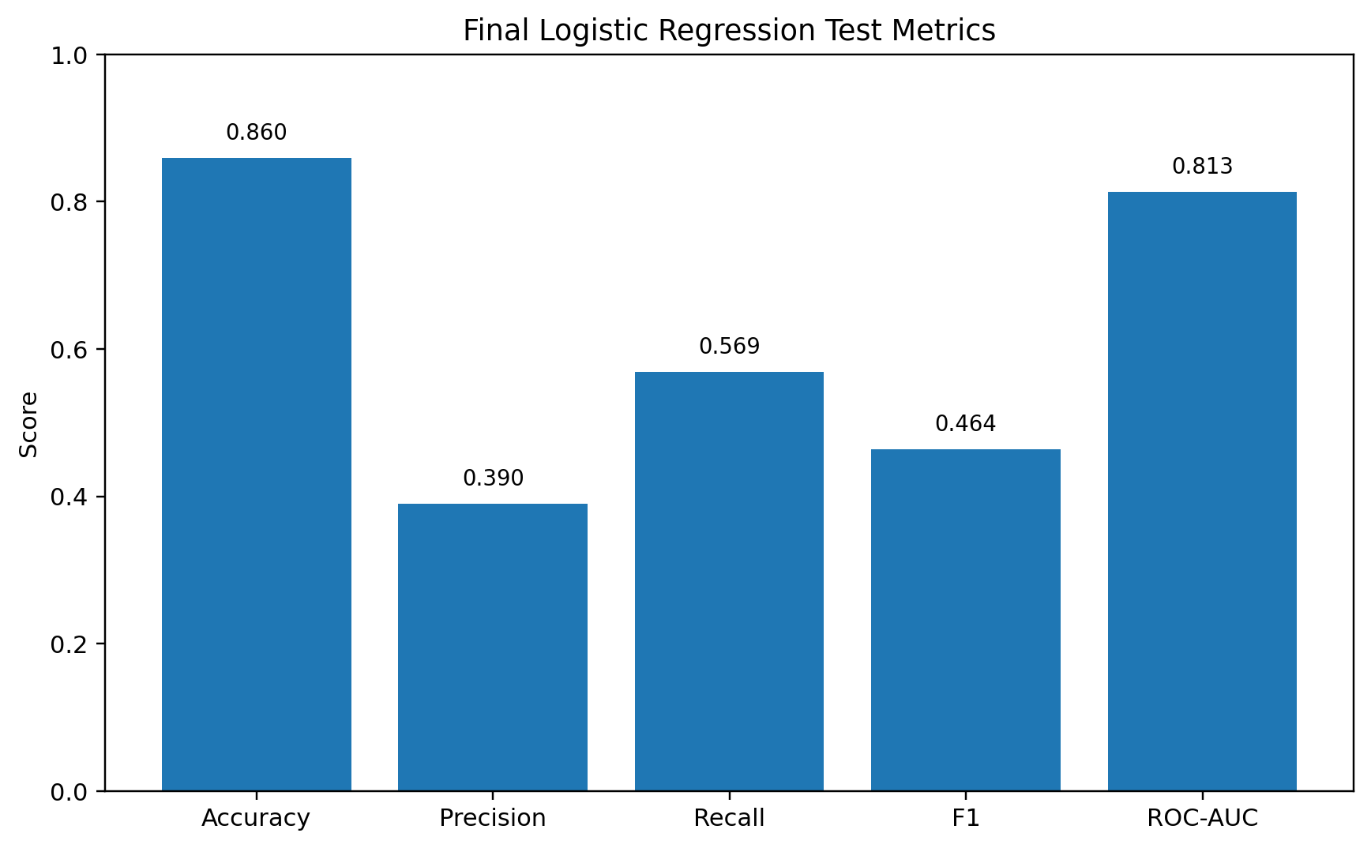
Fig. 5. Final Logistic Regression test metrics available in the supplied experimental record.

5.2 Model / Method Comparison
Method | Accuracy | Precision / Recall / F1 | Notes
Logistic Regression | 0.86 | 0.39 / 0.57 / 0.464 | ROC-AUC 0.8133188759374718; threshold 0.71; final validated model.
Random Forest | Not available in the supplied experimental record | Not available in the supplied experimental record | Investigated candidate model; no verified comparative metric set supplied.
HistGradientBoosting | Not available in the supplied experimental record | Not available in the supplied experimental record | Investigated candidate model; no verified comparative metric set supplied.
XGBoost | Not available in the supplied experimental record | Not available in the supplied experimental record | Investigated candidate model; no verified comparative metric set supplied.
Table 4. Verified model-comparison evidence; unavailable metrics are intentionally not fabricated.
Table 4 should not be interpreted as a ranking of the four algorithms. The available evidence supports a complete numerical evaluation only for the final Logistic Regression model. The other three models are documented as investigated approaches, but their comparative numerical outputs were not supplied.

5.3 Final Logistic Regression Classification Results
Class / Measure | Precision | Recall | F1-score | Support
No Disaster | 0.95 | 0.90 | 0.92 | 434
Disaster | 0.39 | 0.57 | 0.46 | 51
Macro average | 0.67 | 0.73 | 0.69 | 485
Weighted average | 0.89 | 0.86 | 0.87 | 485
Overall accuracy | — | — | 0.86 | 485
ROC-AUC | — | — | 0.8133188759374718 | —
Table 5. Final Logistic Regression classification report and ROC-AUC.
The class-level results show a substantial difference between the majority Normal class and the minority Disaster class. The model identifies 29 of the 51 Disaster observations while producing 45 false-positive Disaster predictions. The balanced class weighting and threshold selection are therefore important to the final behavior.

5.4 Confusion Matrix Analysis
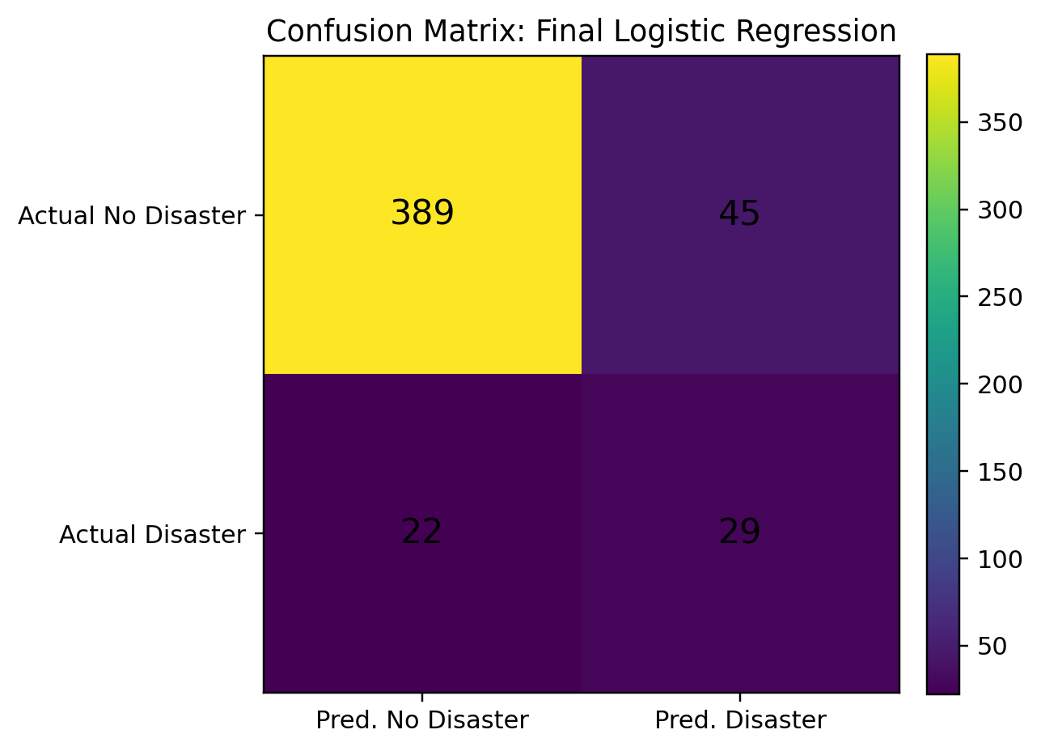
Fig. 6. Confusion matrix for the final Logistic Regression model.
The confusion matrix contains 389 true negatives, 45 false positives, 22 false negatives and 29 true positives. The 22 false negatives represent Disaster-labelled observations that the final threshold classified as Normal, while the 45 false positives represent Normal observations classified as Disaster. This illustrates why the minority-class recall and precision should be reported alongside overall accuracy.

5.5 Feature Coefficient and Contribution Analysis
Feature | Coefficient | Interpretation
DOY_COS | -0.809055 | Negative coefficient; standardized-feature effect in the fitted linear model.
RH2M | 0.550101 | Positive coefficient.
PS | 0.276985 | Positive coefficient.
T2M | 0.228484 | Positive coefficient.
WS2M | 0.156191 | Positive coefficient.
ALLSKY_SFC_SW_DWN | 0.089731 | Positive coefficient.
PRECTOTCORR | 0.054186 | Positive coefficient.
DOY_SIN | -0.046780 | Negative coefficient.
Table 6. Final Logistic Regression coefficients.
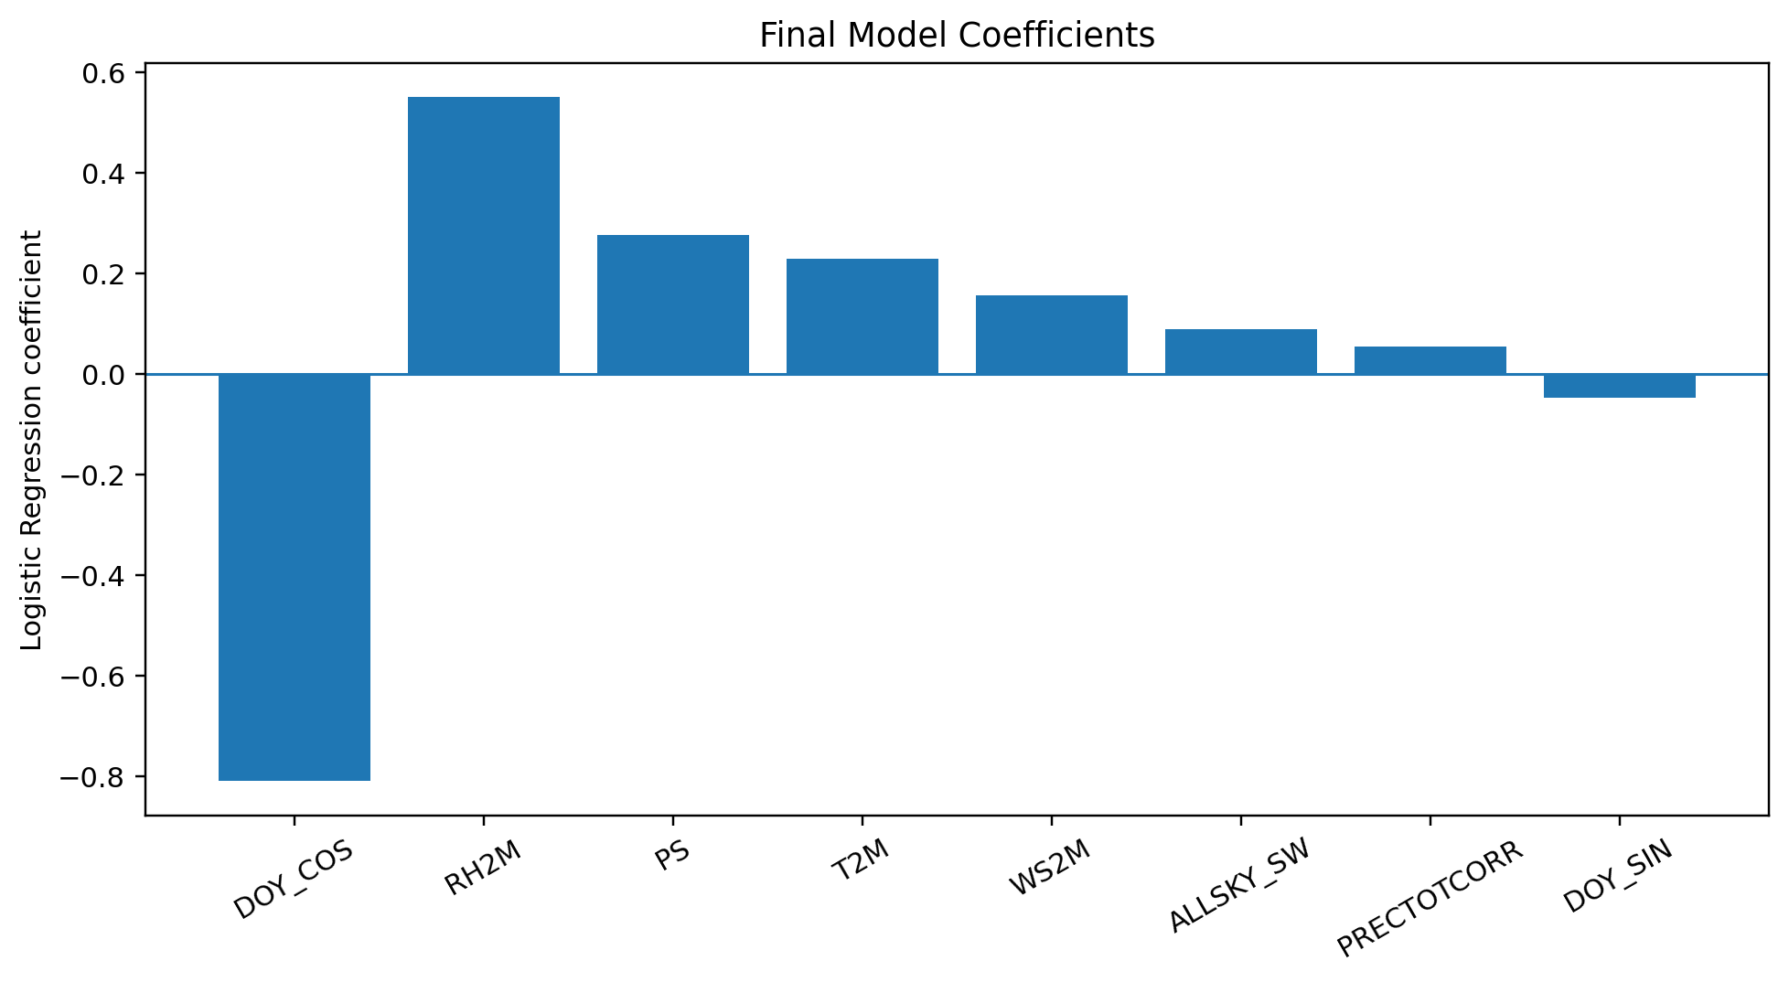
Fig. 7. Coefficients of the final Logistic Regression model.
The coefficients operate on standardized features and therefore indicate the direction of association within the fitted model. A positive coefficient increases the linear decision score when the corresponding standardized feature increases, while a negative coefficient decreases it, holding the other model inputs constant. Coefficient magnitude should not be interpreted as causal importance because scaling, feature relationships and model structure affect the coefficients.

5.6 Environmental Normal vs Disaster Comparison
Feature | Normal mean | Disaster mean | Observed direction
T2M | 24.98 °C | 27.57 °C | Higher in Disaster-labelled observations
RH2M | 56.13 % | 70.70 % | Higher
WS2M | 1.93 m/s | 2.38 m/s | Higher
PRECTOTCORR | 2.79 mm | 7.94 mm | Higher
PS | 96.36 | 95.93 | Lower
ALLSKY_SFC_SW_DWN | 18.04 | 17.28 | Lower
Table 7. Environmental means for Normal and Disaster-labelled observations.
The table and Fig. 3 show the dataset-specific environmental pattern used to motivate the condition analysis. The largest relative difference among the listed variables is observed for corrected precipitation, while temperature, humidity and wind are also higher on average in the Disaster-labelled group. These relationships are descriptive and do not establish that any individual variable causes disasters.

5.7 Environmental Risk-Condition Analysis
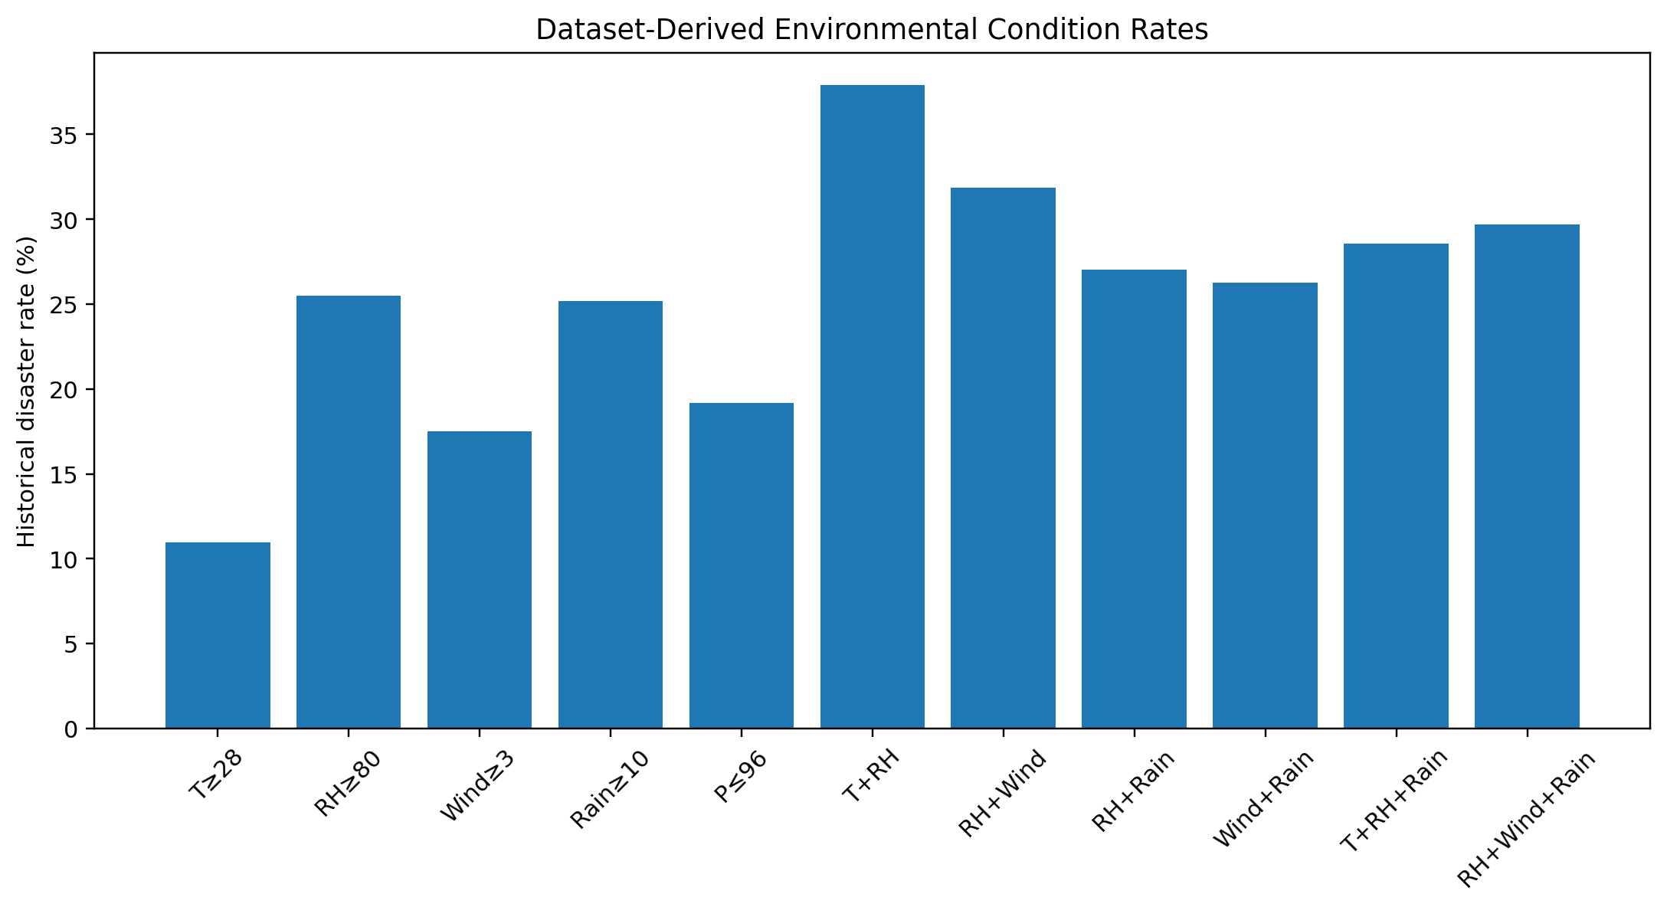
Fig. 8. Historical disaster rates associated with selected dataset-derived environmental conditions.
Humidity ≥80% and rainfall ≥10 mm have observed historical disaster rates of 25.49% and 25.20%, respectively. Several combinations have higher observed rates, including temperature ≥28 °C plus humidity ≥80% (37.93%) and humidity ≥80% plus wind ≥3 m/s (31.86%). These values describe the project dataset only. The combination of all four specified conditions produced 0 disasters among only two observations and is therefore not treated as evidence.

5.8 Live API Demonstration
Case | Temp. | Humidity | Wind | Rain | Pressure | Reported score/probability | Prediction | Interpretation
Kurnool test 1 | 28.4 °C | 61.8 % | 4.8 m/s | 0.9 mm | 100.8 kPa | ≈81.28% | DISASTER | Direct ML output; mismatch motivated risk layer.
Kurnool test 2 | 28.4 °C | 61.8 % | 4.8 m/s | 0.9 mm | 100.8 kPa | 14.24% | NORMAL | Historical environmental risk score; LOW level.
Live test 3 | 27.5 °C | 66.0 % | 5.8 m/s | 0.00 mm | 947.3 hPa | 18.34% | NORMAL | Historical environmental risk score; MODERATE level.
Table 8. Verified live environmental case studies reported in the project record.
Table 8 is intentionally structured to distinguish two different quantities. The approximately 81.28% value is the direct machine-learning output probability for the first Kurnool observation, whereas 14.24% and 18.34% are historical environmental risk scores. Neither quantity should be described as a calibrated probability that a real-world disaster will occur.
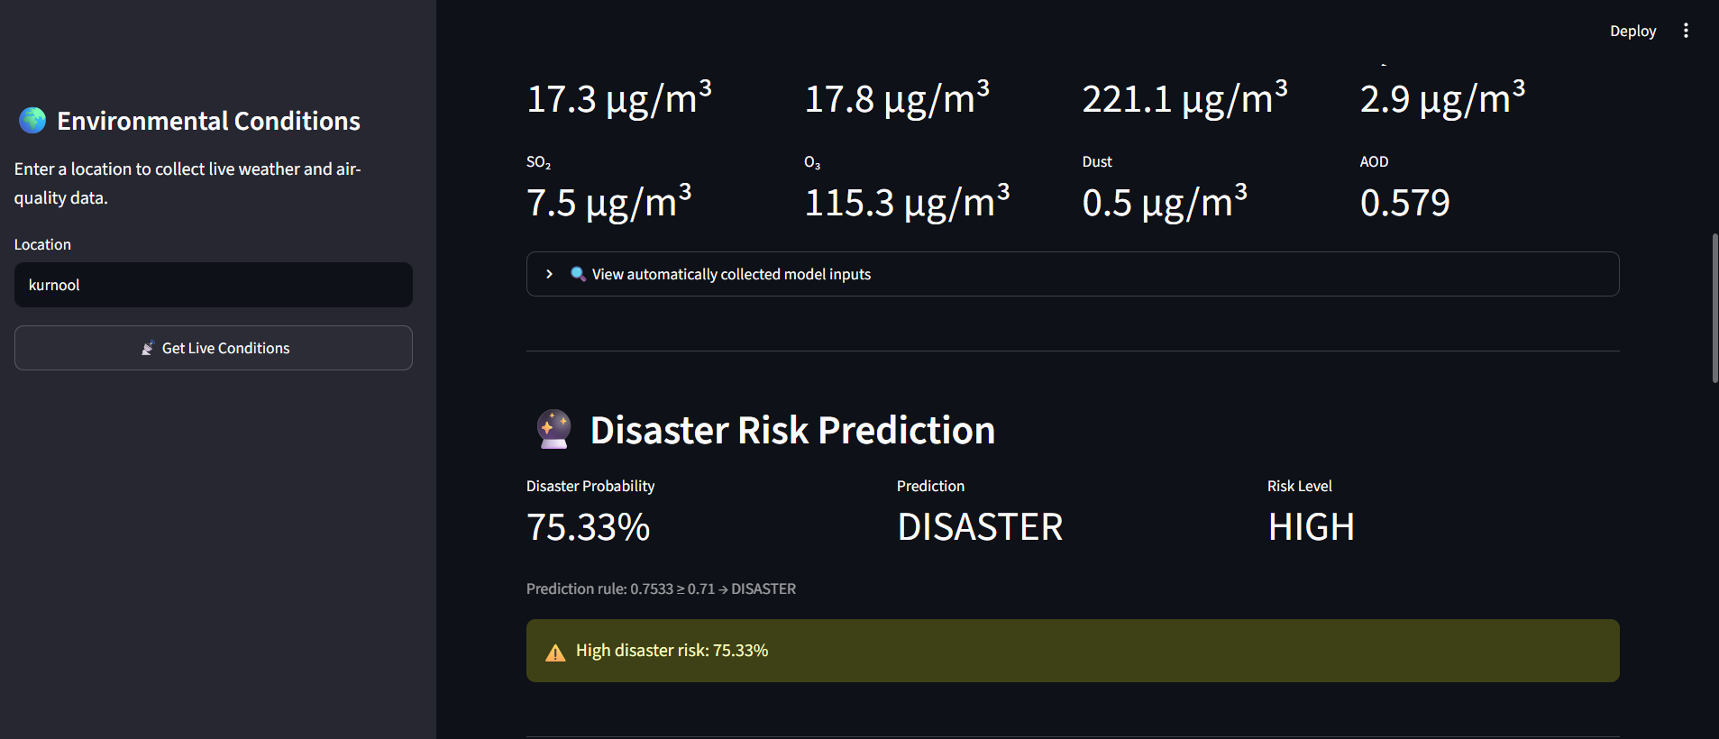

The screenshots above are required evidence for the final paper but were not supplied with the current paper-generation request. They must be replaced with genuine screenshots from the final Streamlit application; no synthetic dashboard image is presented as an experimental result.

5.9 Kurnool Case Study
The Kurnool case is the most important methodological demonstration in the project because it exposed a mismatch between the direct classifier output and the interpretable environmental risk layer. The live environmental values were approximately 28.4 °C temperature, 61.8% humidity, 4.8 m/s wind speed, 0.9 mm rainfall and 100.8 kPa pressure. The direct classifier returned approximately 81.28% Disaster probability and the Disaster class. However, the historical condition layer did not interpret these values as a high-risk combination under the project's dataset-derived rules, producing a 14.24% risk score and LOW level.
The result must not be interpreted as evidence that a disaster was occurring or not occurring in Kurnool. It is evidence that the model's learned classification surface and the historical-condition interpretation can disagree when current observations differ from the training distribution.

5.10 Comparison Between ML Probability and Historical Risk Score
The Kurnool case demonstrates three distinct concepts: (1) a classifier output probability generated from the Logistic Regression decision function; (2) a historical environmental risk score constructed from condition rates in the project dataset; and (3) the unknown real-world probability of a disaster. Only the first two were measured in the project. The third was not observed or calibrated and is therefore not reported.
Quantity | Meaning | Status in this project
ML classification probability | Model-derived probability associated with the Logistic Regression classifier output. | Measured; e.g., ≈81.28% in Kurnool test 1.
Historical environmental risk score | Dataset-based score derived from triggered historical environmental conditions. | Measured; e.g., 14.24% and 18.34% in reported live tests.
Actual real-world disaster probability | Calibrated probability that a real disaster will occur. | Not measured; must not be inferred from the two quantities above.
Table 9. Distinction between model probability, historical risk score and real-world disaster probability.

6. DISCUSSION

6.1 Interpretation of Findings
The final results show that the project can distinguish a substantial portion of Disaster-labelled observations while retaining strong performance on the majority Normal class. The 0.86 accuracy and 0.8133 ROC-AUC indicate measurable discrimination in the held-out dataset, but the Disaster-class precision and recall show that the minority class remains difficult to classify perfectly. The class imbalance and the dataset-specific nature of the labels are therefore central to interpreting the result.

6.2 Environmental Feature Relationships
Disaster-labelled observations have higher mean temperature, humidity, wind and precipitation and slightly lower surface pressure in the project dataset. The historical condition analysis provides a complementary view by showing how frequently Disaster labels occurred when selected environmental conditions were present. Because these analyses are observational, they should not be interpreted as causal evidence or universal thresholds.

6.3 ML Model Performance
The final Logistic Regression model was configured with balanced class weights, which is appropriate for a target distribution in which Normal observations substantially outnumber Disaster observations. The threshold of 0.71 changes the classification operating point and is therefore part of the model's operational definition. The reported recall of 0.5686 means that more than half of the Disaster-labelled test observations were identified, while precision of 0.3919 indicates that many predicted Disaster cases were false positives.

6.4 ML / Live Data Distribution Issue
The Kurnool mismatch is a central finding. A live observation can be numerically valid but still occupy a region of feature space that is uncommon in the historical training data. Other possible contributors include differences in data collection or units, the nature of the historical DISASTER label, model calibration, and contextual differences between the historical records and current API observations. This does not invalidate the historical classifier; rather, it demonstrates why live deployment requires distribution checks and careful interpretation.

6.5 Explainability
Coefficient-based explanations are well matched to the final Logistic Regression model because they expose the learned direction of each standardized feature. Compared with black-box post-hoc explanations, this approach is simple to compute and easy to present in a dashboard. However, it is model-specific and should not be described as a general XAI method applicable to every future model in the project.

6.6 Comparison With Previous Studies
The framework is related to prior work that combines multiple environmental or hazard variables with machine learning [1]–[3], [5]. It also follows the broader movement toward interpretable disaster-risk systems identified by Ghaffarian et al. [4] and Yang et al. [6]. Compared with Jiang et al. [2], the present system uses live data but focuses on current-condition risk assessment rather than forecasting a future hydrological state. Compared with SHAP-based studies such as Liu et al. [5], the present implementation uses Logistic Regression coefficients and standardized feature contributions. Compared with LSTM-based real-time forecasting [7], the current system does not model temporal sequences and therefore should not be presented as a forecasting model.

6.7 Theoretical Implications
The project illustrates that environmental risk modeling can benefit from separating prediction, risk scoring and real-world probability. A single numerical probability can appear authoritative even when it is sensitive to the historical data distribution. Combining a statistical classifier with a transparent historical-condition layer makes the semantic meaning of the dashboard output clearer.

6.8 Practical Implications
The Streamlit prototype can support exploratory environmental assessment by presenting current conditions, historical condition matches and model explanations in one interface. However, it should be used as a research prototype rather than as an operational early-warning authority. Practical deployment would require calibrated probabilities, broader validation, hazard-specific labels, data-quality monitoring and independent evaluation.

6.9 Unexpected Findings
The most significant unexpected finding was the approximately 81.28% direct ML Disaster probability for the first Kurnool live observation despite the current environmental conditions not producing a similarly high historical environmental risk score. This unexpected behavior directly influenced the architecture by motivating the separate historical risk-scoring layer.

7. LIMITATIONS

1.The historical dataset has 2,425 observations. The target distribution is not balanced. The Disaster class only includes 253 observations, in total.

2.The name or source of the dataset is not provided. The full software environment manifest is also missing from the project evidence used for this paper.

3.No complete comparative metrics were given for Random Forest, HistGradientBoosting or XGBoost. As a result no ranking of models is included.

4.The final validation uses the train/test split that was documented. There is no geographic validation. There is no validation. There are no datasets reported.

5.The environmental thresholds are based on the dataset. They are not scientific disaster thresholds.

6.The historical risk score does not represent a calibrated real-world probability of disaster.

7.Live API values might have distributions, units, temporal resolution or measurement context compared to the historical training data.

8.The project does not include time-series forecasting. It does not predict conditions several hours or days into the future.

9.Actual dashboard screenshots and case-specific contribution values were not included in the paper-generation request. These must be added from the application evidence.

8. CONCLUSION AND FUTURE WORK

This paper introduced a disaster-risk assessment framework. I found that the environmental disaster-risk assessment framework brings together analysis, machine learning, risk conditions derived from live environmental data and a Streamlit dashboard. The final Hybridized Logistic Regression model achieved 0.86 accuracy. 0.8133188759374718 ROC-AUC on the documented test set. The Disaster-class achieved precision 0.39 recall 0.57 and F1-score 0.46. The project also showed that a direct machine-learning probability can differ from an interpretation when live data differ from the training distribution. The separate historical risk-scoring layer therefore offers a way to understand the results while staying clearly separate from the disaster probability in the real world.

1.Calibrate model probabilities. Check calibration error before interpreting outputs in a way.

2.Do temporal and geographic external validation using environmental and disaster-labelled datasets.

3.Look into time-series forecasting models like LSTM, GRU, ARIMA or Temporal Fusion Transformer for predicting conditions and risk rather than just looking at current conditions.

4.Add distribution-shift. Regular live-data quality checks, before using the classifier on API observations.

5.Finish the comparison of Random Forest, HistGradientBoosting and XGBoost using the split and metrics including uncertainty estimates where needed.

6.Replace the dashboard placeholders in this manuscript with screenshots and keep the exact API provider and configuration details used in the final version.

DECLARATIONS

Funding

No external funding was reported for the project. If institutional or sponsored funding applies, insert the funding statement here.

Conflict of Interest

The authors declare no conflict of interest to confirmation, by all listed authors.

Ethics Statement

The project uses weather-related data and does not report collection of personally identifiable human-subject data. Any institutional ethics requirement should be confirmed according to the data sources.

Data Availability

The dataset and project code availability should be stated using the final repository or submission location:

Author Contributions

Pydah Hasitha Sai Keerthana, L.Mrudani, S.Kruthi: project implementation, data preparation, machine-learning experimentation, dashboard integration, analysis and manuscript preparation. Additional author contributions: [TO BE INSERTED].

Acknowledgements

The authors acknowledge the project supervisor, department and data/API providers where applicable. Specific names and provider acknowledgements should be inserted after verification.

REFERENCES
[1] M. Haggag, A. Yosri, W. El-Dakhakhni, and E. Hassini, “Interpretable data-driven model for Climate-Induced Disaster damage prediction: The first step in community resilience planning,” International Journal of Disaster Risk Reduction, vol. 73, Art. no. 102884, 2022, doi: 10.1016/j.ijdrr.2022.102884.
[2] Z. Jiang, S. Yang, Z. Liu, Y. Xu, Y. Xiong, S. Qi, Q. Pang, J. Xu, F. Liu, and T. Xu, “Coupling machine learning and weather forecast to predict farmland flood disaster: A case study in Yangtze River basin,” Environmental Modelling & Software, vol. 155, Art. no. 105436, 2022, doi: 10.1016/j.envsoft.2022.105436.
[3] S. Zhang, J. Zhang, X. Li, X. Du, T. Zhao, Q. Hou, and X. Jin, “Estimating the grade of storm surge disaster loss in coastal areas of China via machine learning algorithms,” Ecological Indicators, vol. 136, Art. no. 108533, 2022, doi: 10.1016/j.ecolind.2022.108533.
[4] S. Ghaffarian, F. R. Taghikhah, and H. R. Maier, “Explainable artificial intelligence in disaster risk management: Achievements and prospective futures,” International Journal of Disaster Risk Reduction, vol. 98, Art. no. 104123, 2023, doi: 10.1016/j.ijdrr.2023.104123.
[5] S. Liu, Y. Liu, Z. Chu, K. Yang, G. Wang, L. Zhang, and Y. Zhang, “Evaluation of Tropical Cyclone Disaster Loss Using Machine Learning Algorithms with an eXplainable Artificial Intelligence Approach,” Sustainability, vol. 15, no. 16, Art. no. 12261, 2023, doi: 10.3390/su151612261.
[6] R. Yang, J. Hu, Z. Li, J. Mu, T. Yu, J. Xia, X. Li, A. Dasgupta, and H. Xiong, “Interpretable machine learning for weather and climate prediction: A review,” Atmospheric Environment, vol. 338, Art. no. 120797, 2024, doi: 10.1016/j.atmosenv.2024.120797.
[7] F. J. Hop, R. Linneman, B. Schnitzler, A. Bomers, and M. J. Booij, “Real time probabilistic inundation forecasts using a LSTM neural network,” Journal of Hydrology, vol. 635, Art. no. 131082, 2024, doi: 10.1016/j.jhydrol.2024.131082.
[8] M. Haggag, A. Yosri, W. El-Dakhakhni, and E. Hassini, “Infrastructure performance prediction under Climate-Induced Disasters using data analytics,” International Journal of Disaster Risk Reduction, vol. 56, Art. no. 102121, 2021, doi: 10.1016/j.ijdrr.2021.102121.
[9] L. Breiman, “Random forests,” Machine Learning, vol. 45, pp. 5–32, 2001.
[10] J. H. Friedman, “Greedy function approximation: A gradient boosting machine,” Annals of Statistics, vol. 29, no. 5, pp. 1189–1232, 2001.
[11] T. Chen and C. Guestrin, “XGBoost: A scalable tree boosting system,” in Proc. 22nd ACM SIGKDD International Conference on Knowledge Discovery and Data Mining, 2016, pp. 785–794, doi: 10.1145/2939672.2939785.
[12] D. R. Cox, “The regression analysis of binary sequences,” Journal of the Royal Statistical Society: Series B, vol. 20, no. 2, pp. 215–242, 1958.
[13] S. M. Lundberg and S.-I. Lee, “A unified approach to interpreting model predictions,” in Advances in Neural Information Processing Systems 30, 2017, pp. 4765–4774.
[14] N. Mahdizadeh Gharakhanlou and L. Perez, “Flood susceptible prediction through the use of geospatial variables and machine learning methods,” Journal of Hydrology, vol. 617, Art. no. 129121, 2023, doi: 10.1016/j.jhydrol.2023.129121.

[15] A. Achu, C. D. Aju, J. Thomas, and G. Gopinath, “Catena matters: Enhancing landslide prediction with soil profile characteristics and explainable AI,” Engineering Geology, vol. 364, Art. no. 108599, 2026, doi: 10.1016/j.enggeo.2026.108599.

[16] S. Kondylatos, I. Prapas, et al., “Wildfire Danger Prediction and Understanding With Deep Learning,” Geophysical Research Letters, vol. 49, no. 17, Art. no. e2022GL099368, 2022, doi: 10.1029/2022GL099368.

[17] G. Tang, Z. Fang, and Y. Wang, “Global landslide susceptibility prediction based on the automated machine learning (AutoML) framework,” International Journal of Digital Earth, 2023, doi: 10.1080/10106049.2023.2236576.

[18] N. Mahdizadeh Gharakhanlou and L. Perez, “Flood susceptible prediction through the use of geospatial variables and machine learning methods,” Journal of Hydrology, vol. 617, Part C, Art. no. 129121, 2023, doi: 10.1016/j.jhydrol.2023.129121.

[19] T. Das, S. Talukdar, Shahfahad, M. W. Naikoo, I. A. Ahmed, A. Rahman, M. K. Islam, and E. Alam, “Integration of fuzzy AHP and explainable AI for effective coastal risk management: A micro-scale risk analysis of tropical cyclones,” Progress in Disaster Science, vol. 23, Art. no. 100357, 2024, doi: 10.1016/j.pdisas.2024.100357.

[20] S. Ghaffarian, F. R. Taghikhah, and H. R. Maier, “Explainable artificial intelligence in disaster risk management: Achievements and prospective futures,” International Journal of Disaster Risk Reduction, vol. 98, Art. no. 104123, 2023, doi: 10.1016/j.ijdrr.2023.104123.

[21] A. Dwivedi, S. S. C. Congress, R. Velasquez, P. Kumar, and U. Patil, “Explainable AI (xAI) for Landslide Susceptibility Modeling: A Comparative Analysis of Machine Learning and Deep Learning Approaches,” Earth Systems and Environment, vol. 10, pp. 9331–9363, 2026, doi: 10.1007/s41748-026-01114-6.

[22] J. Oh, J.-H. Lee, H.-J. Park, et al., “Principled XAI analysis of the deep learning-based landslide susceptibility prediction model,” Scientific Reports, vol. 16, Art. no. 27121, 2026, doi: [verified in publisher record].

[23] “Natural disasters detection using explainable deep learning,” Intelligent Systems with Applications, vol. 23, Art. no. 200430, 2024, doi: 10.1016/j.iswa.2024.200430.

[24] “A systematic review of trustworthy artificial intelligence applications in natural disasters,” Computers and Electrical Engineering, vol. 118, Part B, Art. no. 109409, 2024, doi: 10.1016/j.compeleceng.2024.109409.

[25] “Multi-steps drought forecasting in arid and humid climate environments: Development of integrative machine learning model,” Agricultural Water Management, vol. 281, Art. no. 108210, 2023, doi: 10.1016/j.agwat.2023.108210.

[26] “Predicting agricultural drought indicators: ML approaches across wide-ranging climate and land use conditions,” Ecological Indicators, vol. 154, Art. no. 110524, 2023, doi: 10.1016/j.ecolind.2023.110524.

