1. **Experiment number1- Based pc communication**

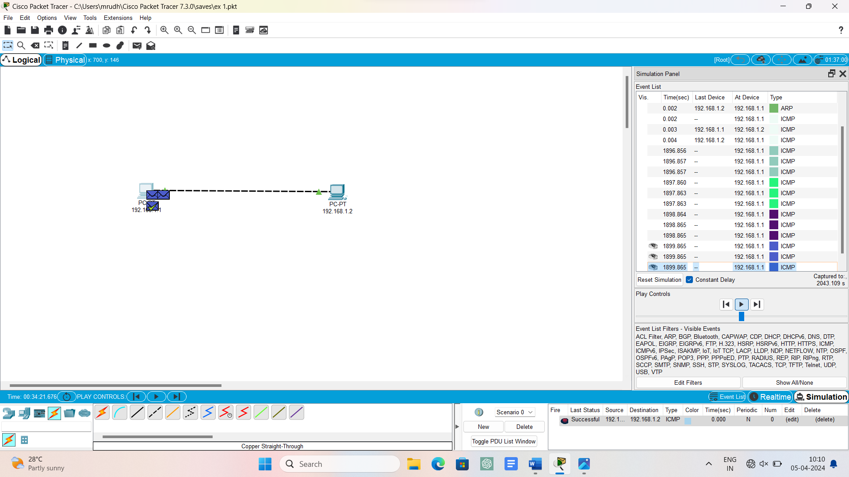

1. **Experiment number2 – star topology**

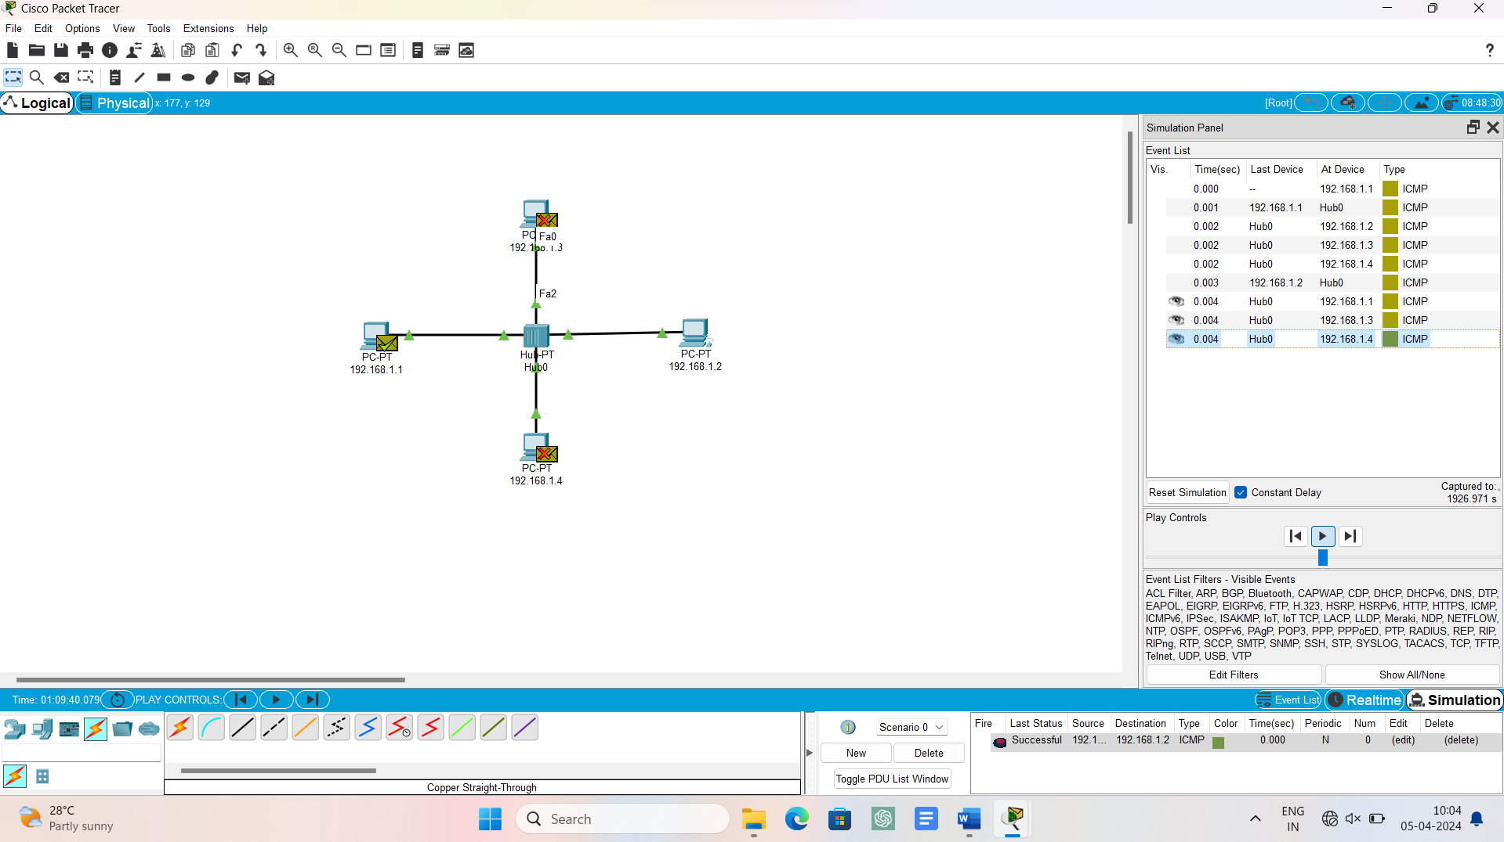

1. **Experiment number3 – bus topology**

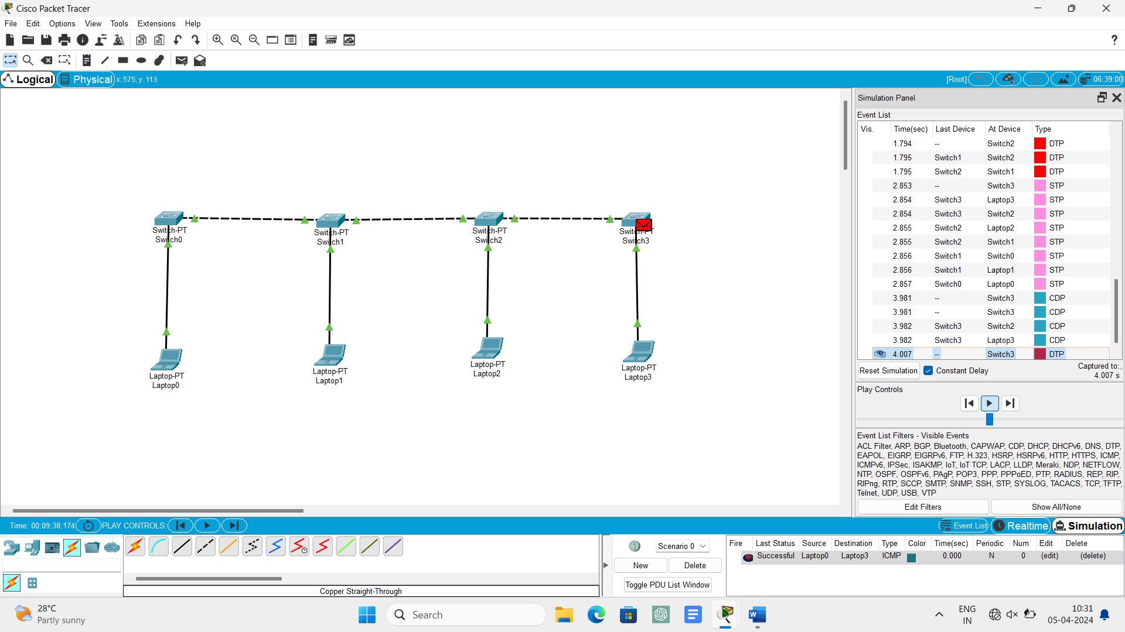

1. **Experiment number4 – ring topology**

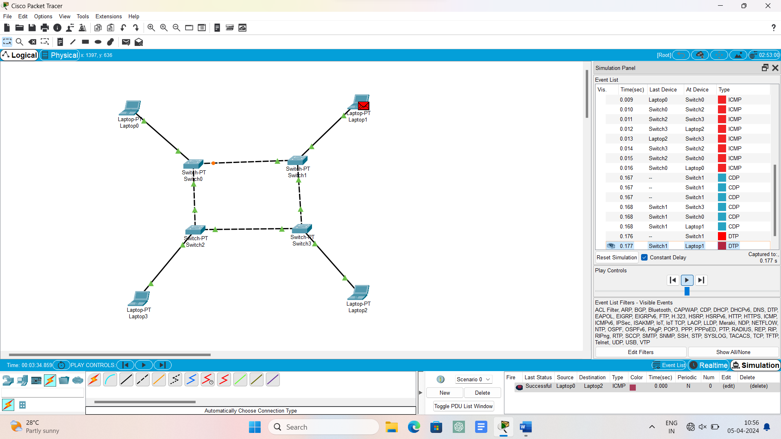

1. **Experiment number5 – mesh topology**

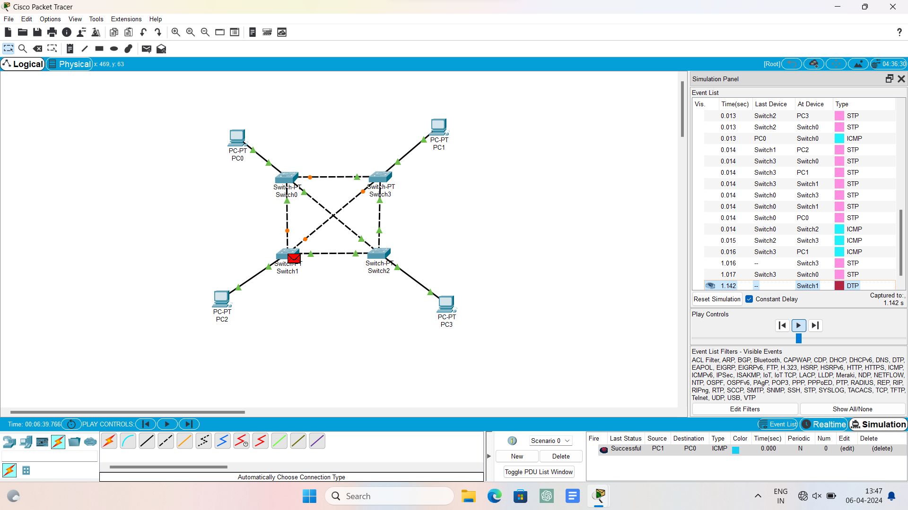

1. **Experiment number6 – tree topology**

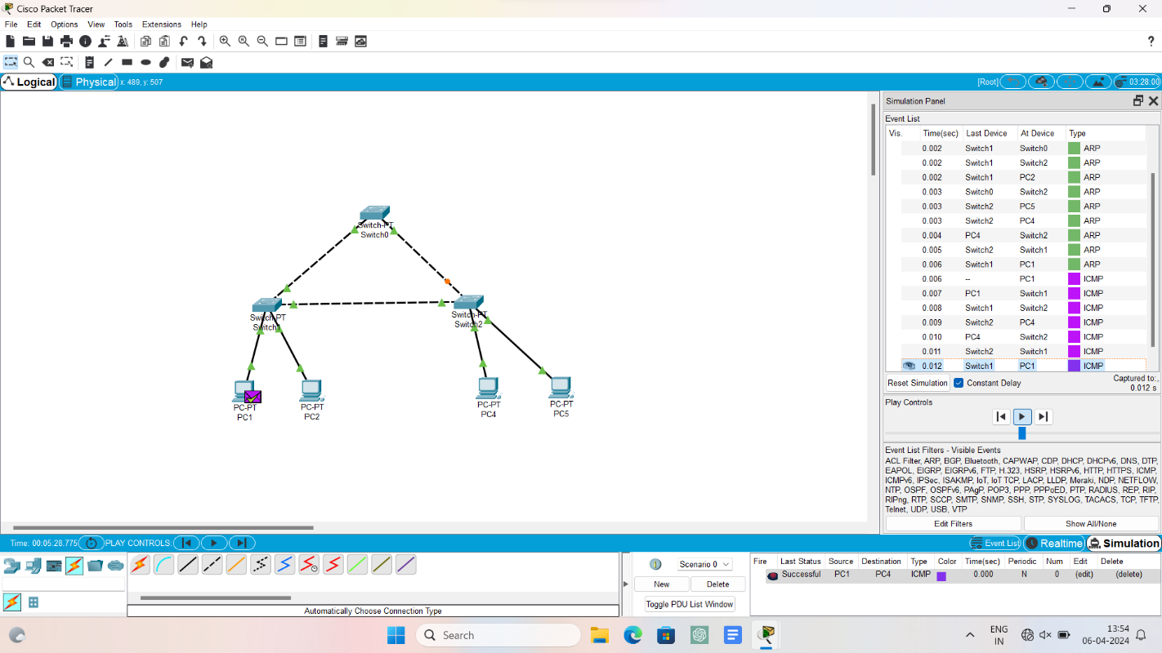

1. **Experiment number7 – hybrid topology**

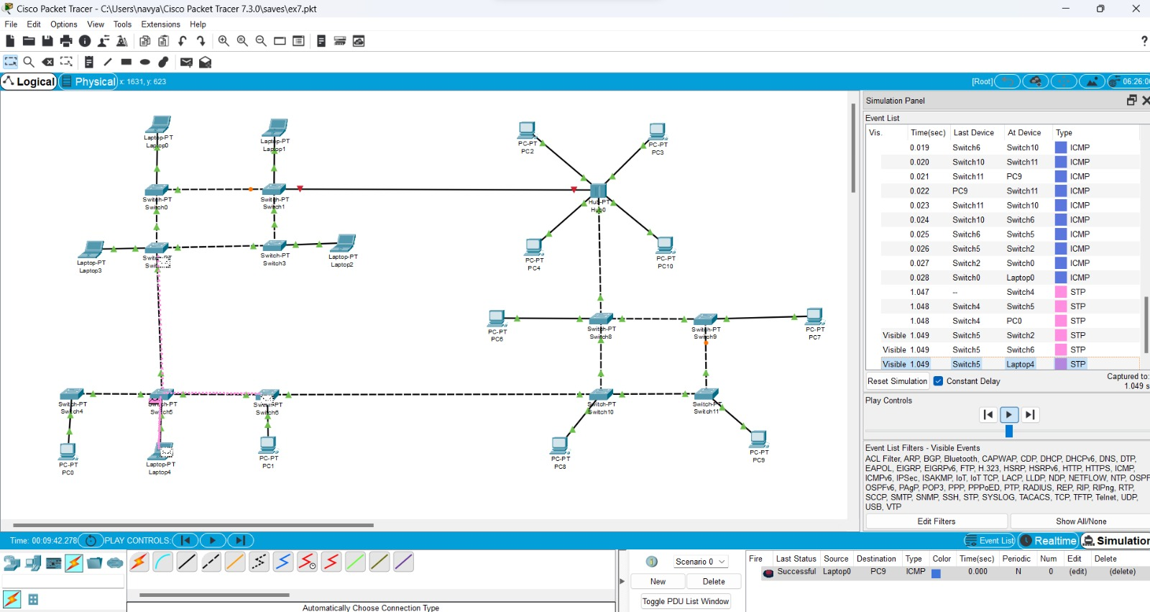

1. **Experiment number8 – CSMA**

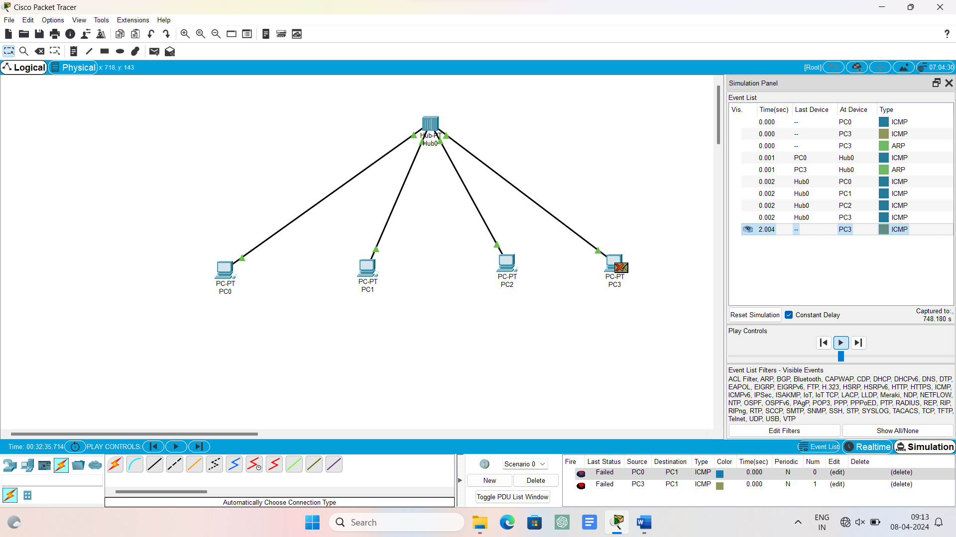

1. **Experiment number9 – ARP**

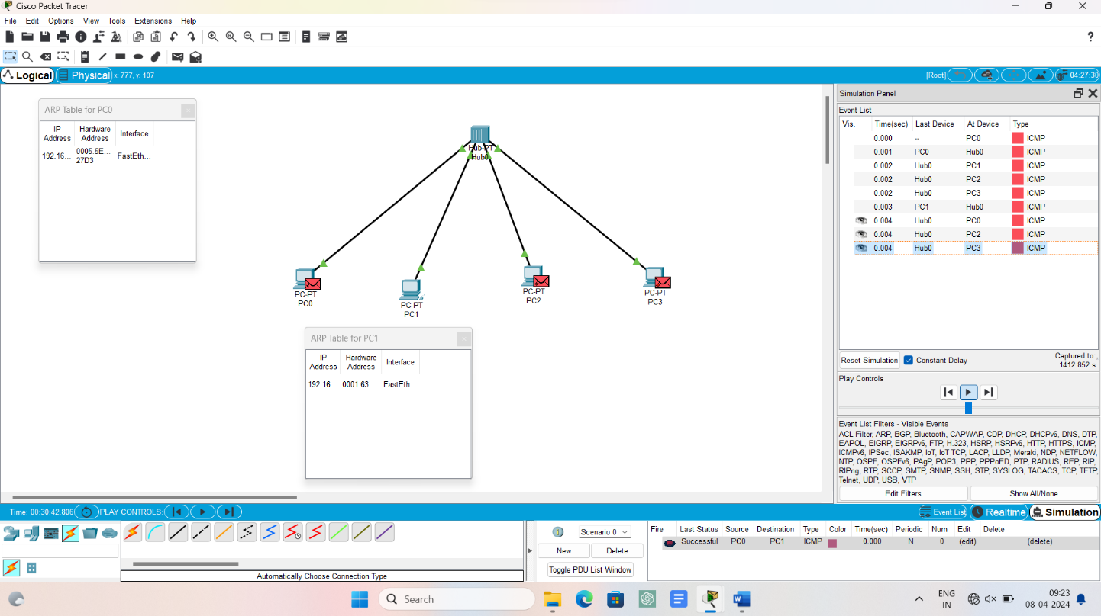

1. **Experiment number10 – LLDP**

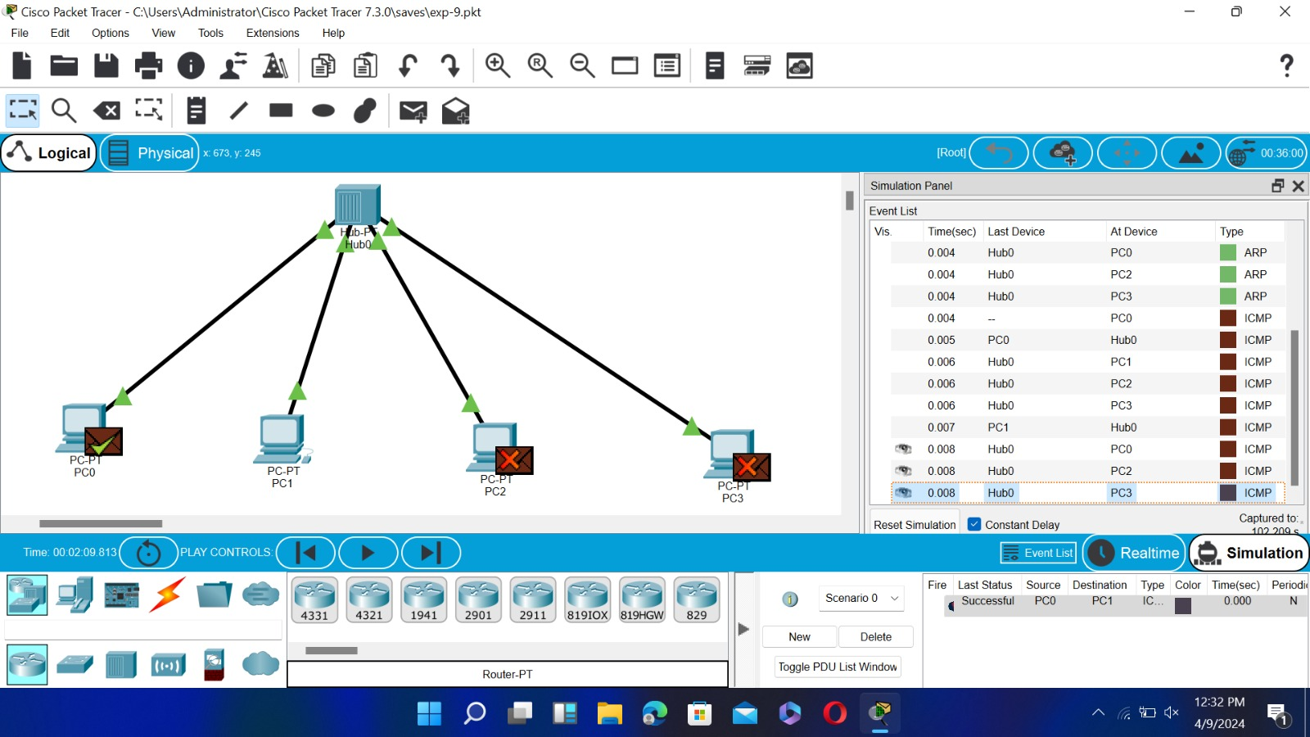

1. **Experiment number11 – firewall topology**

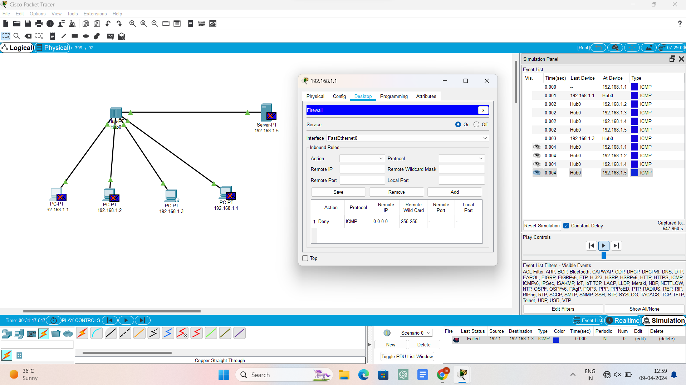

1. **Experiment number12 – message transfer**

