A Comprehensive Survey On Advanced Technologies For Enhancing Efficiency In Ocean Energy Harvesting

# Mrudu Bhashini CR

*Student,* *Department* *of* *Electronics* *and* *Communication Engineering* *SRM* *Institute* *of* *Science* *and*

*Technology,* *Ramapuram* Chennai, India [mr4808@srmist.edu.in](mailto:mr4808@srmist.edu.in)

# Tanisha Pavithrakumar

*Student, Department of Electronics and Communication Engineering SRM Institute of Science and*

*Technology,* *Ramapuram* Chennai, India [tp3929@srmist.edu.in](mailto:tp3929@srmist.edu.in)

# Roshini F

*Student,* *Department* *of* *Electronics* *and* *Communication Engineering* *SRM* *Institute* *of* *Science* *and*

*Technology,* *Ramapuram* Chennai, India [rl0084@srmist.edu.in](mailto:rl0084@srmist.edu.in)

# Christeena Joseph

*Associate* *Professor,* *Department* *of* *Electronics* *and* *Communication* *Engineering*

*SRM* *Institute* *of* *Science* *and* *Technology,* *Ramapuram* Chennai, India [christeena003@gmail.com](mailto:christeena003@gmail.com)

# Veda Varshini B

*Student,* *Department* *of* *Electronics* *and* *Communication*  *Engineering* *SRM* *Institute* *of* *Science* *and*

*Technology, Ramapuram Chennai, India* [vb8355@srmist.edu.in](mailto:vb8355@srmist.edu.in)

***Abstract*—** **The optimal utilization of ocean energy is a key pathway toward sustainability and a zero-carbon future. With oceans covering 71% of Earth’s surface, tidal currents, waves, and thermal gradients represent vast yet underused renewable energy sources, aligning with UN Sustainable Development Goal 7 (*Clean and Affordable Energy*). Despite challenges such as variability, device efficiency, and large-scale integration, recent advancements in IoT, AI, and nanoelectronics are enabling transformative solutions. IoT supports real-time monitoring, AI enhances predictive analytics and control, and nanoelectronics innovations—including piezoelectric, triboelectric, electromagnetic, dielectric elastomer, hydro voltaic, and hybrid nanogenerators—offer scalable, cost-effective energy harvesting. This paper surveys existing techniques, explores their enhancement through emerging technologies, and highlights pathways toward sustainable, intelligent, and autonomous ocean energy systems for the global**

**renewable energy market.** A graph of a number of years



Fig. 1. Research on Ocean Energy over the last 20 years

Fig 1 shows the cumulative increase in the documents that has published papers on Ocean Energy over the last 20 years and as we are able to observe it is increasing linearly as we years are moving forward. The following photos shows the graph that is plotted between the amount of citations these papers have received across various domains .

***Keywords—*** ***Sustainable Energy, Efficiency, Nano electronics, Digital Twin, Ocean Energy***

I.INTRODUCTION

[6][7] The usage of ocean energy is a crucial pathway for a sustainable and zero-carbon future. Oceans that cover 71% of the Earth’s surface provides surface, waves, tidal currents that makes up underexploited Renewable Energy resources that contributes to the UN Sustainable Development goal 7 (Affordable and clean Energy). Due to the gravitational pull of the moon and sun the rise and fall of the tides in the ocean are generated. This Ocean Energy Harvesting is not only used in electricity generation but also supports offshore industries and reducing carbon emissions. However, the large-scale implementation has many complications like variability of resources, efficiency of devices, and integration into existing power grids. In order to overcome these barriers, researchers have increasingly turned to evolving technologies such as the Internet of Things (IoT), artificial intelligence (AI), and nanoelectronics. For instance, Khan (2022) demonstrated an IoT-enabled tidal energy transducer using Arduino, Wi-Fi, and sensor networks, capable of generating >4 W at 5 V and 75 RPM with real-time monitoring. Han et al. (2020) proposed a decentralized Internet of Underwater Things (IoUT) framework, leveraging multiagent reinforcement learning and Branch and Bound optimization to enhance throughput and fairness. Similarly, Syed and Goggins (2023, 2024) applied AI-driven structural health monitoring to tidal turbines, integrating explainable AI and supervised learning for predictive maintenance and improved reliability, with operational targets approaching EUR 100/MWh.

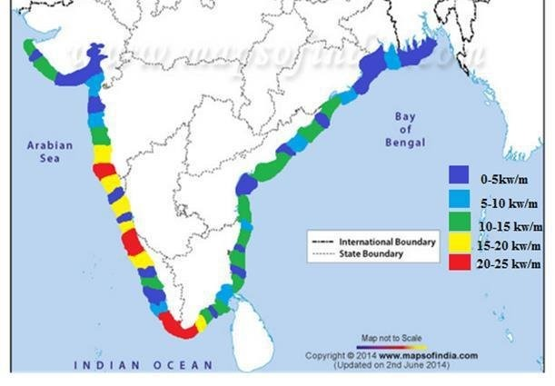[2][8][16] A country-based survey would involve potential and current state of various ocean energy technologies (wave, tidal, OTEC, etc.) in different nations. After consideration of various factors like wave height, tidal range, and water depth, the suitability of different locations within each country for energy harvesting is analyzed. Tidal barrage technologies can be utilized by countries (e.g., France, UK, Canada) with significant tidal range differences along their coast. The tidal stream technologies can be deployed in certain areas where tidal kinetic energy is high. With the growing population of India, its energy needs are also rapidly increasing and is calculated to reach around 4000 TWh by 2030. with a long coastline stretching across the massive 7500 km (about 4660.28 mi) across the seven states and its 336 islands, India has enormous potential for ocean energy harvesting. The waves recorded over the years are as high as 11m to 8m, with an average of 6.77 and 5.23m this, makes it highly suitable for these projects. The Ministry of New and Renewable Energy (MNRE) has identified considerable ocean energy potential across the Arabian Sea, Indian Ocean, Bay of Bengal, as well as the Lakshadweep and Andaman & Nicobar Islands. Additionally, the Sundarbans and the Gangetic delta region in West Bengal present vast prospects for harnessing ocean-based renewable resources.

Fig. 3 Wave Energy potential along the Indian coastline

Fig 3 shows the wave energy potential of the areas along the coastline and it is marked in different colors as well for easy verification.

[7][9][10] By Including AI in Ocean Energy Harvesting is helping in addressing the key challenges like variability, efficiency, and reliability. By using predictive AI model, we can get accurate forecasting of tides using historical and real time data. Overall, these applications demonstrate how AI can enhance Ocean Energy Harvesting by making it more reliable, efficient, and economically feasible, thereby supporting the transition towards the global sustainability targets. By leveraging IoUT networks and multiagent learning, AI is enabling decentralized and autonomous operation of ocean energy systems. This transformation not just reduces code of electricity but enhances market competitiveness and drives sustainable approaches that go hand in hand with energy extraction with marine environmental protection.

II.LITERATURE SURVEY

[9][10] To address the issues of low energy density and non-stationary ocean wave conditions, the study proposes a novel AI powered reliable real-time wave height prediction model using LSTM-DE model architecture coupled with STD scaling for post-hoc uncertainty calibration to guarantee high predictive accuracy and model reliability for safe and efficient operation.

[3][5][13][14][15] To crack the enabling techniques to bridge the gap, the article is calling upon research specifically using deep learning tasks to intermittently execute EH-IoT devices also make reliable progress which allows deep learning to dynamically balance between analysis precision and computation overhead to cope with changing energy input. These capabilities are achieved by efficient and precise runtime energy input prediction. This article also cites that research domain will unlock many new IoT application in future, thus making IoT more intelligent and environment friendly.

[13][14][15] Unlike traditional embedded systems design that depends and works on constant power supply, Intermittent computing can work without a constant power supply, that is, it stops and saves the progress when the power supply is not given which makes it ideal to combine with IoT.

[11][12] The difference in energy density between wave crests and troughs are primarily used in regular waves. A positive net energy can be taken by increased harvesting during crest phase and simultaneously reducing it in the trough phase. the interaction between waves and OWSC (ocean wave surge converter) can be calculated even through 2D simulations simplify wave diffraction and lead to small reductions in the computer CWR (Capture Width Ratio). This allows the Deep Reinforcement Learning to learn policies accurately. this training strategy remains effective even under wave height variation. Its performance deteriorates when the wave period changes. Thus, this study shows that the optimization effect becomes more pronounced with longer wave periods.

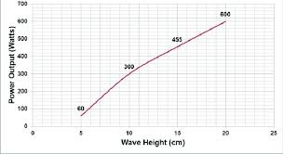

Fig**. 4.** Wave height vs Power Output Graph

Fig 4 is showing the output that is observed when the wave height is increased and it is plotted against the power output that is received as well.

As we can see the graph is increasing linearly .

Fig. 5. Position of the wave energy converter system in the sea.

Fig 5 shows the position of the wave energy converter system that is placed in the sea and also it is showing the various levels of wave power that is being extracted in different places of the sea .

III.METHODS

**Intermittent Computing in Energy Harvesting System:**

One of the main problems with tidal energy is that the energy source is not constant and can never be predicted. This method aims to tolerate power failure and resume work when energy returns. The devices are made into smaller parts and finds the perfect order to execute the tasks efficiently even when the power goes out. Scientists are currently researching battery less WIFI / LoRa sensors and special software to help devices to keep them on track.

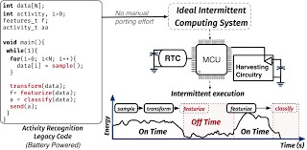

Fig. 6. Intermittent Computing in Ocean Energy Harvesting

Fig 6 shows the architecture of intermittent computing that is used in Ocean Energy Harvesting .

**Nanotechnology in energy harvesting:**

According to recent research nanogenerators uses movement/heat/light into electricity. This method uses small materials with certain properties that help to capture and use energy. Piezoelectric harvesters use vibrations and turn them into electricity i.e. they become independent of battery sources. they can be very useful in electricity generation at remote places.

**Triboelectric Nanogenerators:**

TENGs effectively convert mechanical energy into electrical energy through the principles of triboelectrification and electrostatic induction.

They offer several advantages for energy harvesting, including cost-effectiveness, simplistic structure, compact size, rapid response speed, lightweight design, ease of manufacturing, wide material selection, and environmental friendliness. Primarily, due to their high energy conversion efficiency and elevated power density, they can harvest power under low frequency conditions. They come in various designs like spring assistance which convert low frequency wave motion to high frequency vibration, biomimetic like flower shaped which harvest kinetic energy from water waves with six degrees of freedom or duck-shaped which efficiently harvest energy from random and low frequency water waves.

Recent advancements include thin film blue energy collectors have been developed to mitigate shielding effects against water such as those with external cylindrical electrode, and conversion of vortex energy to electrical energy achieving maximum output voltage in a resonant state through novel design.

Fig. 7. Design and characteristics of triboelectric nanogenerators.

Fig 7 shows the design and characteristics of triboelectric nanogenerators that are used in the conversion of mechanical energy to electrical energy through the principles of triboelectrification and electrostatic induction .

**Hydro voltaic generators:**

The generators propel water through its nanochannels through the process of evaporation, converting ambient heat to electricity.

These are environment friendly and include biomimetic interfacial evaporation-driven generators inspired by lotus plants, flexible two-mode electric nanogenerators for dynamically changing aqueous solutions and ion selective hydrogel films.

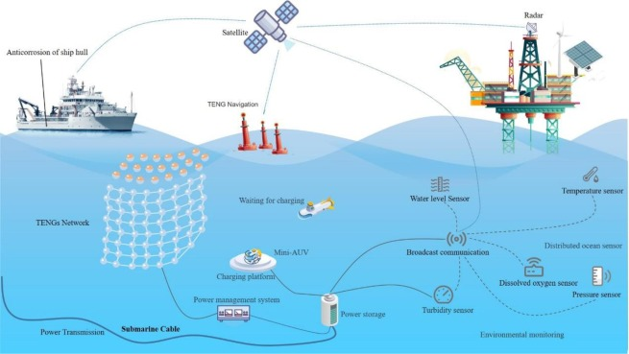

Fig. 8. Triboelectric Nanogenerators in Ocean Energy Harvesting

Fig 8 shows the flow chart on how the triboelectric nanogenerators are used in Ocean Energy Harvesting .

**AI- Powered Digital Twin of the Ocean for Wave Energy Prediction:**

With existing records of the ocean data like wave height, pressure, the Long Short-Term memory is trained to predict the upcoming wave's condition. The prediction is made more precise by combining multiple Long Short-Term Memory. The Validation of the results is done by comparing the results with the real-time data from Oscillating Water Column (OWC) system present in Jeju, South Korea.  
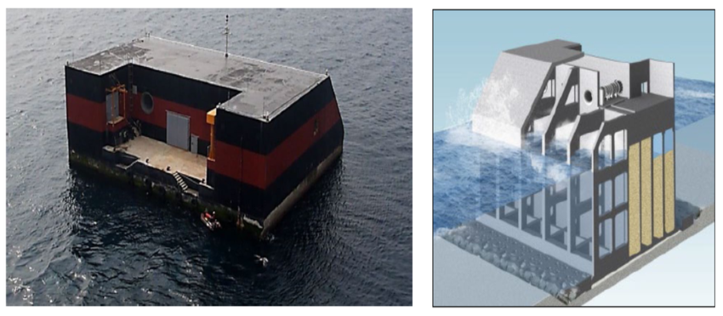

Fig. 9. Oscillating Water Column system, Jeju South Korea

Fig 9 shows the validation system used to get the results that was used for comparing the real time data .

**IoT & AI for Real-Time WEC Optimization:**

This solution has a sensor connected to its prototype, that detects motion due to waves, and the readings are then converted to work with AI by a cloud system. Now, the AI model predicts the characteristics of upcoming wave and provides suitable action directly to WEC (Wave Energy Converter) hardware for the purpose of adaptation.

Fig. 10 [On the potential of ocean energy technologies to contribute to future sustainability](https://link.springer.com/article/10.1007/s43621-025-01676-x).

Fig 10 explains the potential of ocean energy technologies to contribute to future sustainability , the data is shown across various countries and also between various sustainable energies . The data is precented in terms of percentages .

IV.CONCLUSION

Ocean Energy Harvesting is a form of clean energy which utilizes methods of extracting energy from tides, waves and temperature difference, Since it is a sustainable energy source it is encouraged to harness this efficiently and help our world progress better. Through this survey we have analyzed/studied the different methods of ocean energy harvesting through comparison of different parameters such as efficiency ,voltage , energy and power density etc. The key advantages of this survey would include evidence based insights through the help of various existing documentations, This collected data is a reliable source of information as it is based on years of progress monitoring. When it comes to drawbacks, the sustainability of triboelectric energy harvesters remains a concern, the practical application of piezoelectric harvesters is still limited, and the bulky design of electromagnetic harvesters hinders their optimal performance. Nevertheless, due to the vast potential of ocean energy resources, the development of wave energy harvesting technologies continues to progress rapidly.

|  |  |  |  |  |  |  |
| --- | --- | --- | --- | --- | --- | --- |
| Technology | Output Voltage | Output Power | Energy Density | Power Density | Efficiency | Special Features |
| PENG Piezoelectric Nanogenerators | 2.6 V (±1.3 V); up to 36.93 V | 29.7 µW (<2 Hz); 5 mW; 16.72 mW | 2.11 W/m² | – | Enhanced via up-conversion & magnetic augmentation | Frequency up-conversion, magnetic augmentation, vortex flow |
| EMG Electromagnetic Generators | 7.2 V (open-circuit) | 520 mW (ultra-low freq); 120 mW; 80.87 mW | – | 0.3 W; 3453.8 kg/m³; 0.36 mW/cm³ | – | Halbach array, tunable stiffness |
| TENG Triboelectric Nanogenerators | 60 V | 10 mW (rolling ball) | >100 W/m³; 5.38 W/m³ | 5.38 W/m³; >100 W/m³ | – | Rolling ball, spherical arrays |
| DEG Dielectric Elastomer Generators | – | 0.87–3.8 W | 140 mJ/g | – | 18% | Wave-cycle harvesting |
| Hydrovoltaic | 0.16–0.72 V | 0.048 µW | – | 45.6 µW/cm² | – | Nanomaterial-water interaction |
| Hybrid | – | 21.95 mW | 5.73 W/m³ to 100s W/m³ | 5.73 W/m³ to 100s W/m³ | – | Multi-mechanism integration |

V. REFERENCES

[1] Reikard G. Integrating wave energy into the power grid: simulation and forecasting. Ocean Eng 2013;73:168–78.

[2] Factors to Promote Ocean Energy in India,” *Energy Policy*, vol. 156, no. C, 2021.

[3] A. J. Williams, M. F. Torquato, I. M. Cameron, A. A. Fahmy, and J. Sienz, “Survey of energy harvesting technologies for wireless sensor networks,” IEEE Access, vol. 9, pp. 77493–77510, 2021.

[4] W. Yang, J. Peng, Q. Chen, S. Zhao, R. Zhuo, Y. Luo, and L. Gao, “Advancements and Future Prospects in Ocean Wave Energy Harvesting Technology Based on Micro-Energy Technology,” *Micromachines*, vol. 15, no. 1199, pp. 1–31, 2024, doi: [10.3390/mi15101199](https://doi.org/10.3390/mi15101199).

[5] B. Safaei, M. Peiravian, and M. Siamaki, “Eco-Friendly IoT: Leveraging Energy Harvesting for a Sustainable Future,” *Sustainable Computing Reviews*, vol. 2, pp. 32–54, Apr. 2025, doi: 10.1109/SR.2025.3552043.

[6] M. Z. A. Khan, H. A. Khan, and M. Aziz, “Harvesting Energy from Ocean: Technologies and Perspectives,” *Energies*, vol. 15, no. 3456, pp. 1–43, 2022, doi: [10.3390/en15093456](https://doi.org/10.3390/en15093456).

[7]Y. Zhou, “Ocean Energy Applications for Coastal Communities with Artificial Intelligence – A State-of-the-Art Review,” *Energy and AI*, vol. 10, 100189, pp. 1–21, 2022, doi: [10.1016/j.egyai.2022.100189](https://doi.org/10.1016/j.egyai.2022.100189).

[8] S. Chakraborty, P. Dwivedi, S. K. Chatterjee, and R. Gupta, “Factors to Promote Ocean Energy in India,” *Energy Policy*, vol. 159, Art. 112641, 2021, doi: 10.1016/j.enpol.2021.112641.

[9] P. Braca, F. Baralli, M. Vespe, J. F. Alves, and J. Del Rio, “AI-Powered Digital Twin of the Ocean: Reliable Uncertainty Quantification for Improved Ocean Energy Forecasting,” *Frontiers in Marine Science*, vol. 9, Art. 948632, pp. 1–15, 2022, doi: 10.3389/fmars.2022.948632.

[10] D. Lee, S. Yang, J.-W. Oh, S.-G. Cho, S. Kim, and N. Kang, “AI-powered Digital Twin of the Ocean: Reliable Uncertainty Quantification for Real-time Wave Height Prediction with Deep Ensemble,” *arXiv*, preprint arXiv:2412.05475v2, Jan. 5, 2025.

[11] R. Gayathri, J. Yi Chang, C.-C. Tsai, and T.-W. Hsu, “Wave Energy Conversion through Oscillating Water Columns: A Review,” *Journal of Marine Science and Engineering* (JMSE), [Online], Feb. 2024, including figure titled “Bottom-mounted OWC, Jeju island, South Korea.

[12] A. Barua and S. Rasel, “Advances and challenges in ocean wave energy harvesting,” *Sustainable Energy Technologies and Assessments*, vol. 61, Art. 103599, Jan. 2024, doi: 10.1016/j.seta.2023.103599.

[13] V. Kortbeek, K. S. Yildirim, A. Bakar, J. Sorber, J. Hester, and P. Pawelczak, “Time-sensitive intermittent computing meets legacy software,” in *Proceedings of the 25th International Conference on Architectural Support for Programming Languages and Operating Systems (ASPLOS 2020)*, Lausanne, Switzerland, Mar. 2020, pp. 85–99, doi: 10.1145/3373376.3378476.

[14] **Intermittent Computing Overview – Nature Research Intelligence**  
“Energy Harvesting and Intermittent Computing,” *Nature Research Intelligence*, topic summary, 2025.

[15] **Embedded Tessolve blog on Intermittent Computing**  
“Intermittent Computing for Energy-Harvested Devices: Sustaining Embedded Operations,” *Tessolve Embedded*, published very recently (2025).

[16] P. Goswami and S. Deshmukh, “Wave Energy Potential in India,” *Ocean Energy for Electricity Generation and Its Potential in India*, Final report by IREDA, AFD, and IIT Madras (2015), figure titled “Wave Energy Potential in India” ([researchgate.net](https://www.researchgate.net/figure/Wave-Energy-Potential-in-India-Source-Study-on-Tidal-and-wave-energy-in-India-Survey_fig9_292527041)).

[17] D. Stolfi, P. Ricci, and P. Burlando, “Wave energy resource in the Mediterranean Sea: Assessment and perspectives,” *Renewable Energy*, vol. 195, pp. 1269–1287, Apr. 2025, doi: 10.1016/j.renene.2025.01.172.